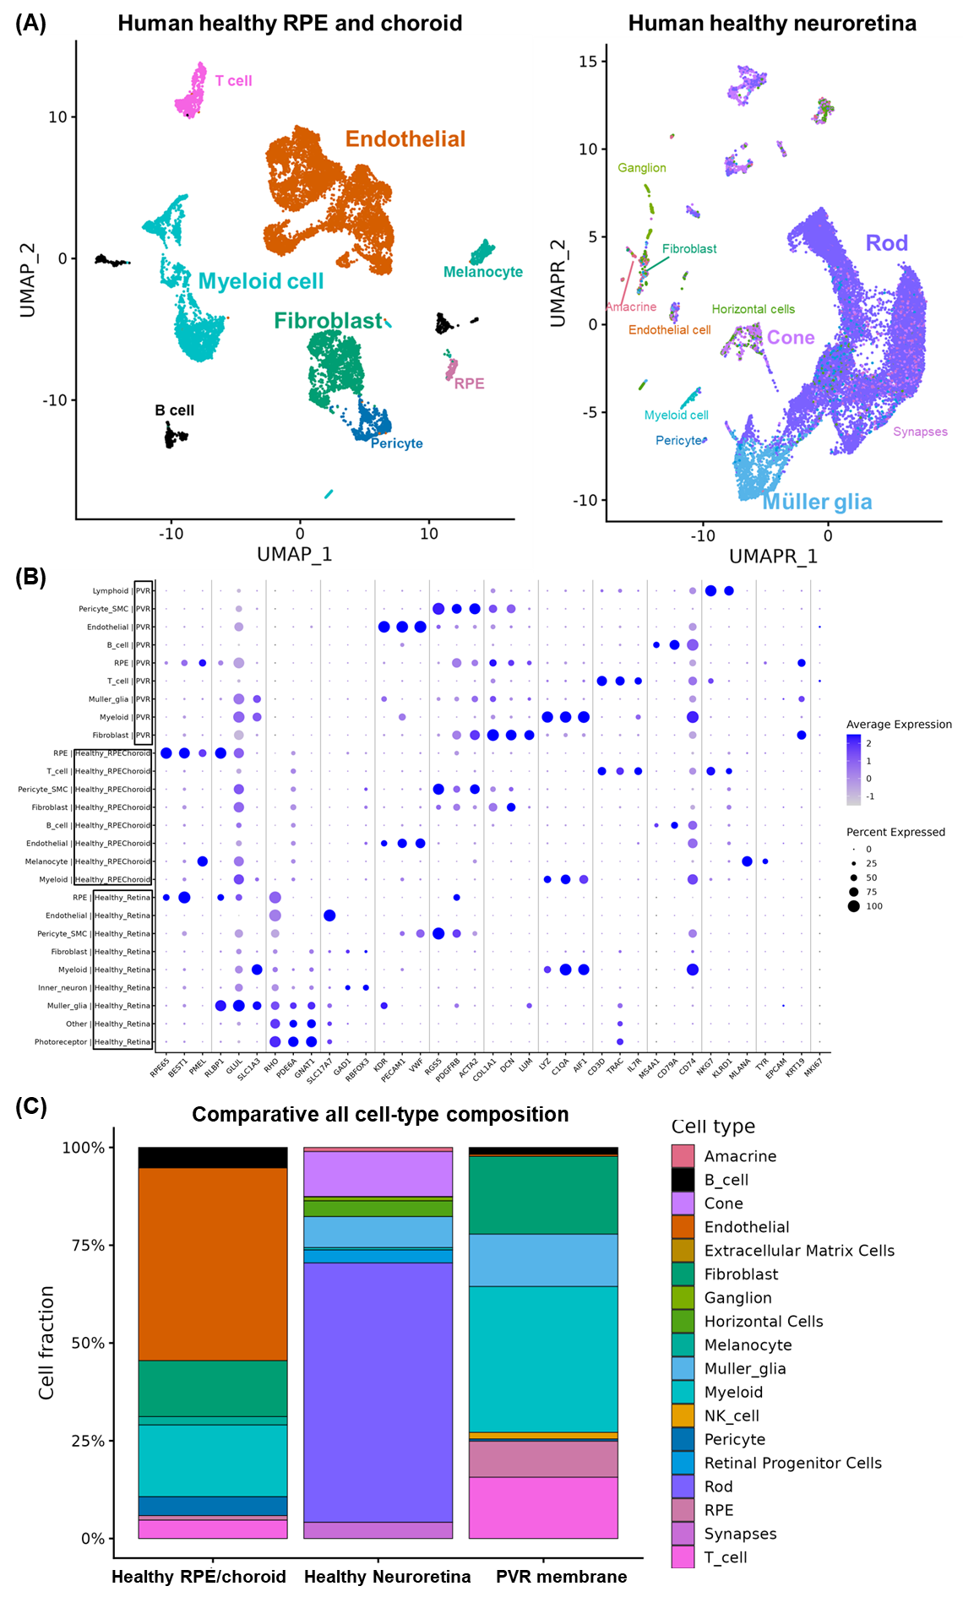
Supplementary Figure 1. Global cell-type composition in the healthy human RPE/choroid and neuroretina scRNA-seq datasets, and their comparative all cell-class structure with human PVR membrane. (A) The UMAP projections display the cell-type composition in healthy human retina, with each dot representing an individual cell colored by cell type. (B) Canonical marker expression validates major cell-type annotations across PVR, healthy RPE/choroid, and healthy neuroretina scRNA-seq datasets. Dot plots show the expression of representative markers used to confirm major classes across datasets. Rows represent major class × dataset, and columns show canonical lineage markers. Dot size indicates the percent of cells expressing each gene within the indicated group, and dot color indicates average (scaled) expression within that group (as displayed on the plot legend). (C) The stacked bar plot displays the fractional composition (proportions summing to 100%) of all cell types across the PVR membrane, healthy neuroretina, and healthy RPE/choroid datasets, allowing for comparison independent of total cell number.
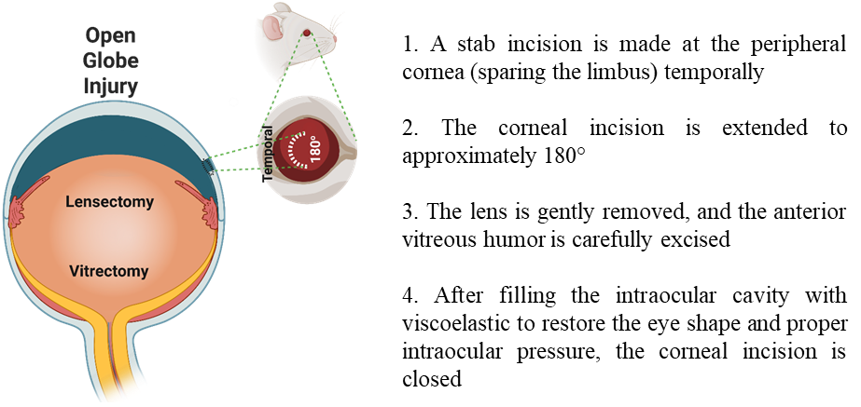
Supplementary Figure 2. A mouse model of traumatic PVR induced by open-globe injury (OGI). Created with BioRender.

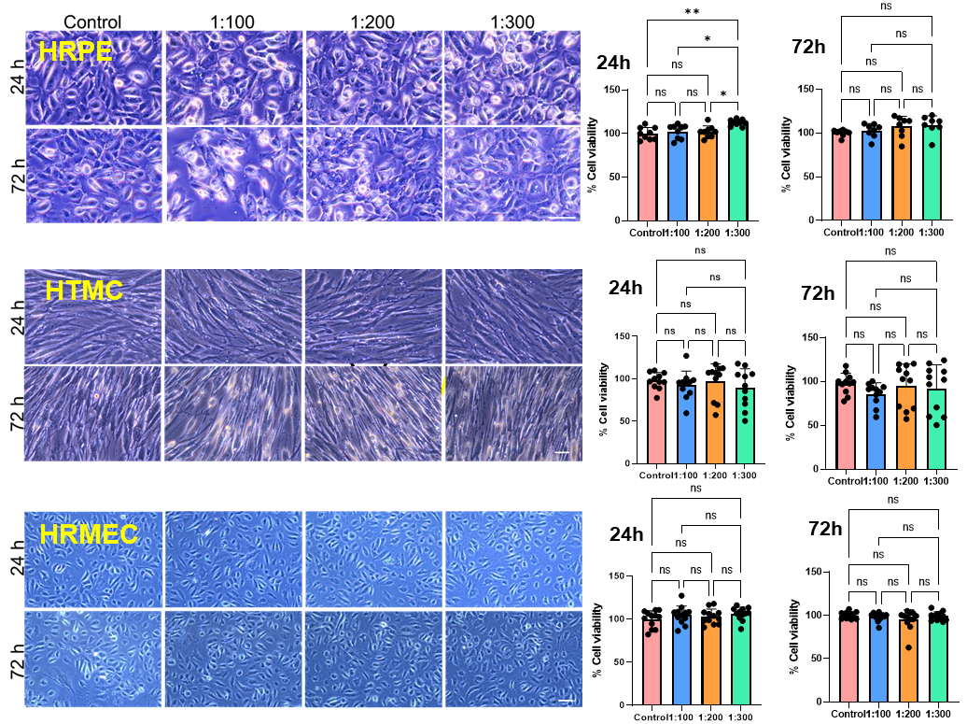Supplementary Figure 3. SSOE constantly releases oxygen for an extended period and is biocompatible with primary human intraocular cells. (A) SSOE contains optimized oxygen emulsified in the vehicle comprising 15% PFD as oxygen carrier. Once in the ambient air, SSOE continuously releases oxygen for over 15 hours following an initial burst release. The unopened formulation remains a comparable oxygen release after 3 months. (B) The concentration- and time-dependent impact of SSOE on primary human retinal pigment epithelial (HPRE) cells, trabecular meshwork cells (HTMC), and retinal microvascular endothelial cells (HRMVEC) was examined by assessing morphological changes and viability using the MTT assay. Cells were treated with SSOE at dilutions of 1:100, 1:200, and 1:300 for 24 and 72 hours. Data shown are pooled from 2-3 independent experiments (N = 6/group for morphology, and N = 8-12/group for MTT). Scale bar = 100 µm. ns, not significant, *P < 0.05, **P < 0.01, and ****P < 0.0001 by one-way ANOVA with Tukey’s post hoc multiple comparisons test.
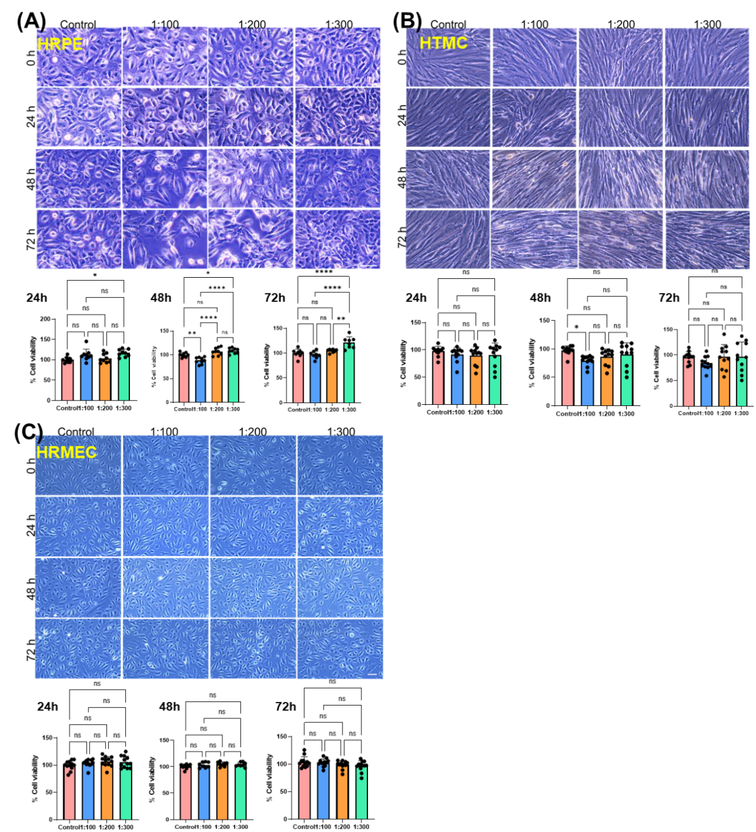
Supplementary Figure 4. Biocompatibility of the unoxygenated vehicle with primary human intraocular cells. The concentration- and time-dependent impact of the unoxygenated vehicle on primary human retinal pigment epithelial (HPRE) cells, trabecular meshwork cells (HTMC), and retinal microvascular endothelial cells (HRMVEC) was examined by assessing morphological changes and viability using the MTT assay. Cells were treated with the vehicle at dilutions of 1:100, 1:200, and 1:300 for 24, 48, and 72 hours. Data shown are pooled from 2-3 independent experiments (N = 6/group for morphology, and N = 8-12/group for MTT). Scale bar = 100 µm. ns, not significant, *P < 0.05, **P < 0.01, and ****P < 0.0001 by one-way ANOVA with Tukey’s post hoc multiple comparisons test.
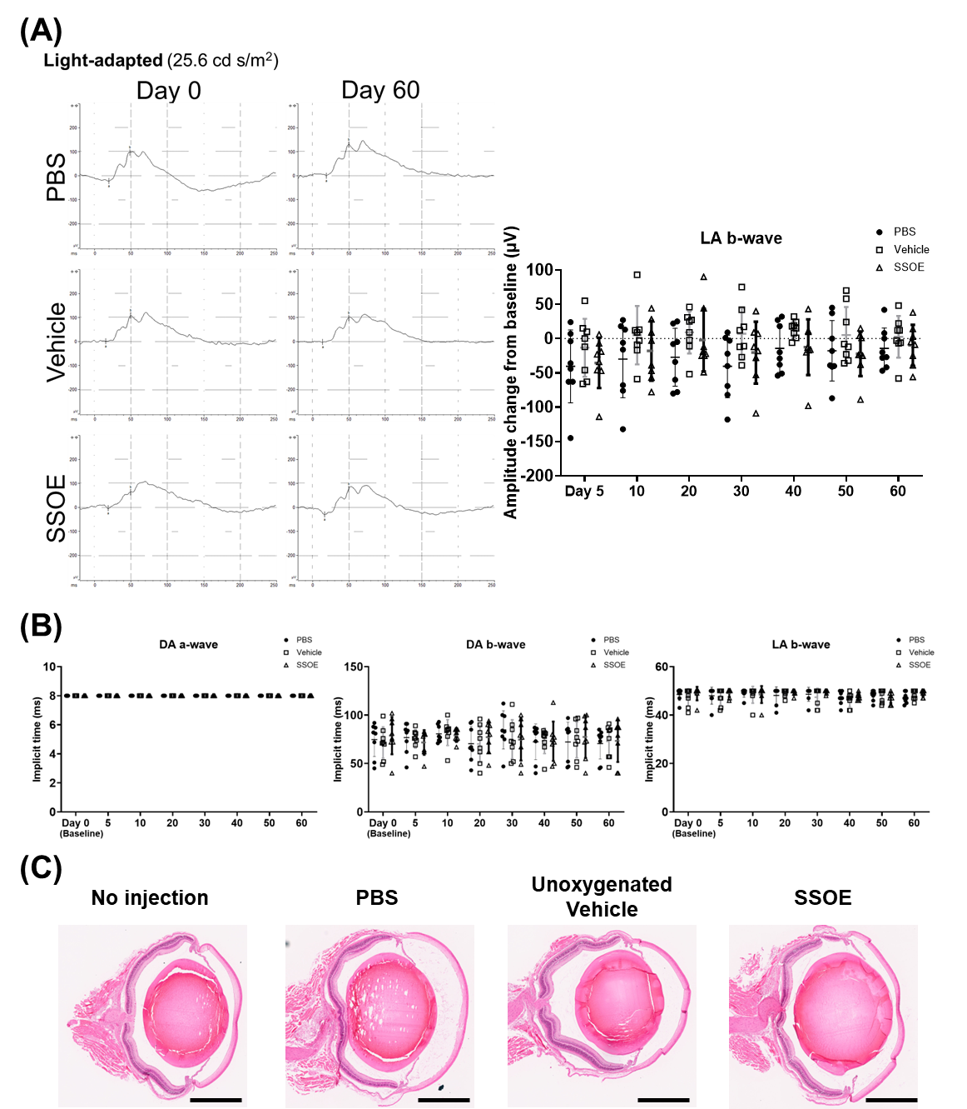
Supplementary Figure 5. Intravitreal injection of SSOE is safe in mice. Normal healthy mice were intravitreally injected with PBS, SSOE or its unoxygenated vehicle and followed for 60 days. (A) Retinal function was evaluated by full-field ERG in vivo, and representative recordings to light stimuli at 25.6 cd s/m2 for photopic light-adapted (LA) eyes at day 0 (baseline) and day 60 are shown on the left panels. The changes from baseline of LA b-wave amplitude are depicted in line charts on the lower panels. (B) The implicit times of dark- (DA) and light-adapted (LA) a-wave and b-wave are depicted in line charts. N = 8/group pooled from two independent experiments. Statistical analysis was performed using mixed-effects analysis with Tukey’s post hoc multiple comparisons test. (C) At day 60, animals were euthanized, and their eyeballs were collected for H&E staining. Representative images of 3-5 animals/group are shown. Scale bars = 1 mm.
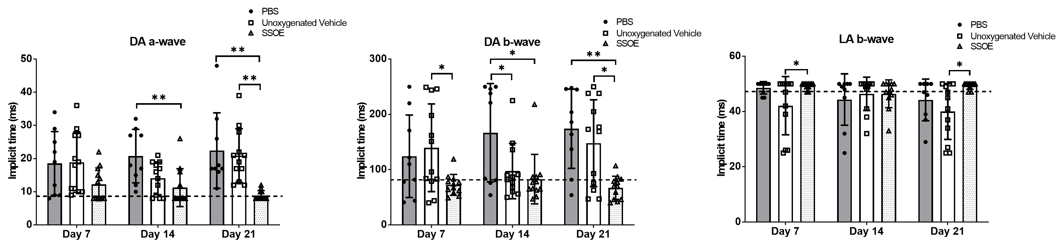
Supplementary Figure 6. Local SSOE treatment effectively preserves retinal function after OGI in mice. Mice with OGI were locally treated with a single dose of PBS, unoxygenated vehicle, or SSOE after injury, and followed for 21 days. Retinal function was evaluated by full-field ERG in vivo, and the implicit times of dark- (DA) and light-adapted (LA) a-wave and b-wave are depicted in bar charts. Dash lines indicate normal values. N = 9-12/group pooled from four independent experiments. *P < 0.05 and **P < 0.01 by one-way ANOVA with Tukey’s post hoc multiple comparisons test.

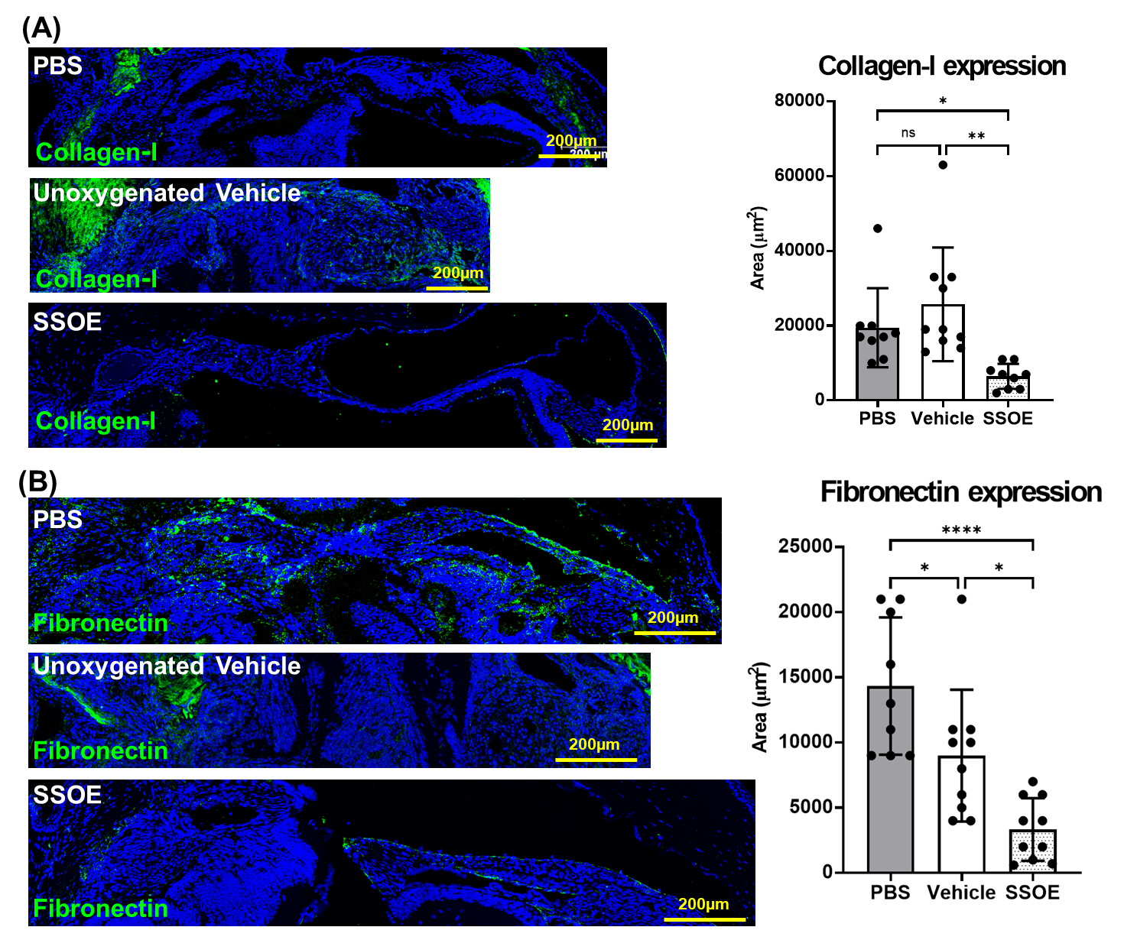
Supplementary Figure 7. Local SSOE treatment effectively reduces collagen-I and fibronectin deposition in the PVR membranes. At day 21 post-OGI, the animals were euthanized, and their eyeballs were collected for immunofluorescence staining of collagen-I (A) and fibronectin (B), with summary graphs of the staining areas per membrane section. N = 9-10/group pooled from four independent experiments. ns, not significant, *P < 0.05, **P < 0.01, and ****P < 0.0001 by one-way ANOVA with Tukey’s post hoc multiple comparisons test.

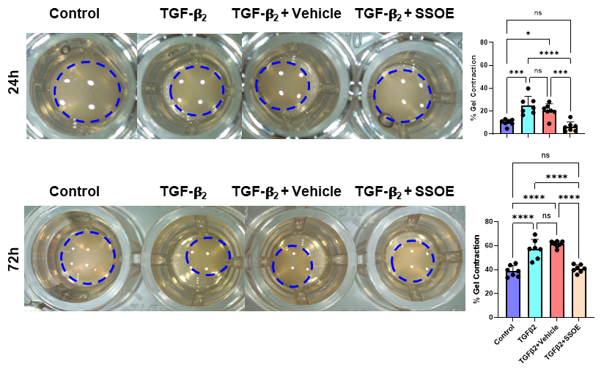
Supplementary Figure 8. SSOE reduces cell contractility in transformed human APRE-19 cells. The collagen-I gels containing APRE-19 cells were subjected to the indicated treatments. Light microscopic images were captured at the indicated time points, with representative images showing contracted gels (within the blue dashed circle). The contraction percentage from the baseline (0 hour) is summarized in the bar charts. N = 7/group pooled from two independent experiments. ns, not significant, *P < 0.05, ***P < 0.001, and ****P < 0.0001 by one-way ANOVA with Tukey’s post hoc multiple comparisons test.

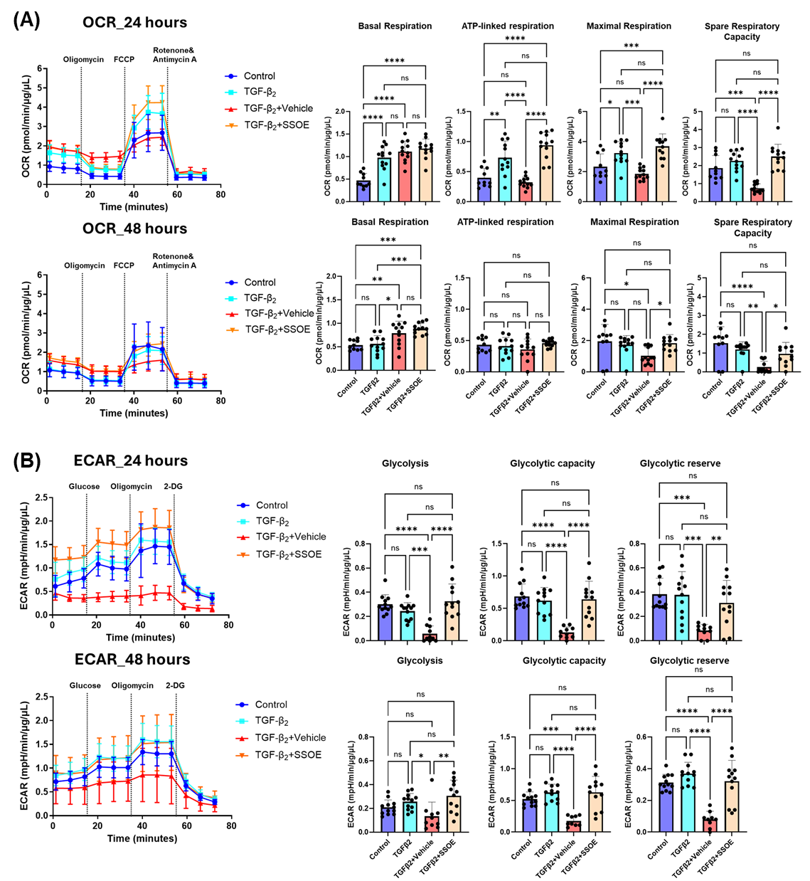
Supplementary Figure 9. Impact of SSOE on bioenergetic reprogramming during human ARPE-19 transformation in vitro. (A) Real-time measurement of oxygen consumption rate (OCR) at 24 and 48 hours to assess OXPHOS parameters: basal respiration, ATP-linked respiration, maximal respiration, and spare respiratory capacity based on responses to sequential drug injections of oligomycin, FCCP, and rotenone and antimycin A at indicated time points. (B) Real-time measurement of extracellular acidification rate (ECAR) at 24 and 48 hours to assess glycolytic function parameters: glycolysis, glycolytic capacity, and glycolytic reserve based on responses to sequential drug injections of glucose, oligomycin, and 2-DG at indicated time points. N = 10-12/group from one out of two independent experiments. ns, not significant, *P < 0.05, **P < 0.01, ***P < 0.001, and ****P < 0.0001 by one-way ANOVA with Tukey’s post hoc multiple comparisons test.

