Tables
Table 1. Prevalence of weight excess and obesity stratified by sex, temporal period and HVI-based cluster in Belo Horizonte
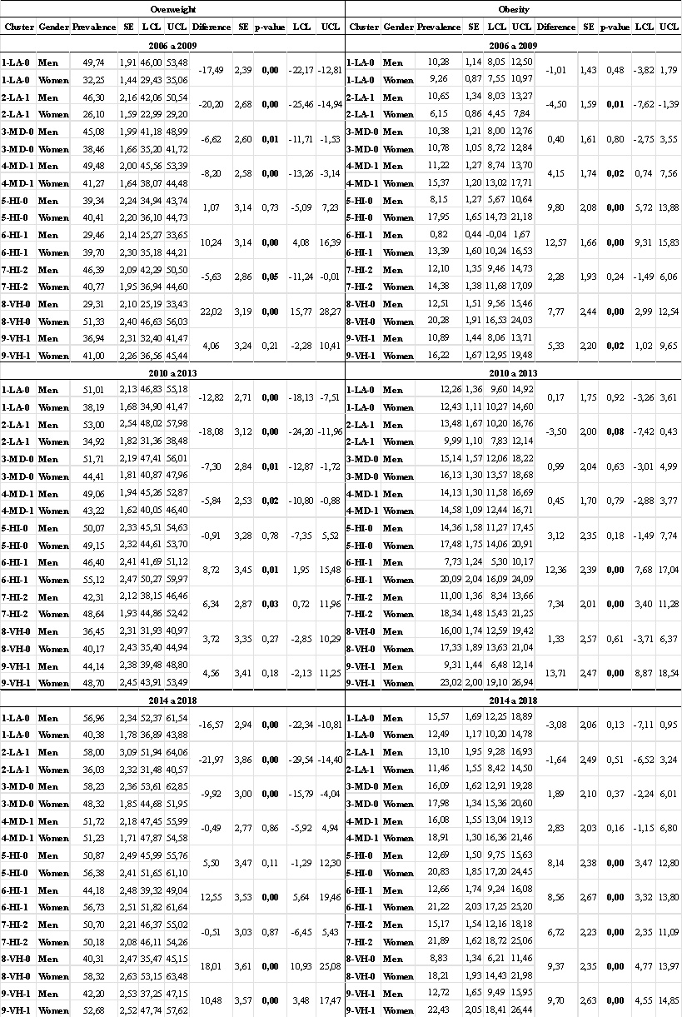
Abbreviations: SE, standard error; LCL, lower confidence limit; UCL, upper confidence limit; LA-0, low vulnerability subtype 0; LA-1, low vulnerability subtype 1; MD-0, medium vulnerability subtype 0; MD-1, medium vulnerability subtype 1; HI-1, high vulnerability subtype 0; HI-2, high vulnerability subtype 1; HI-3, high vulnerability subtype 2; VH-0, very high vulnerability subtype 0; VH-1, very high vulnerability subtype 1.

Table 2. Sample sizes by temporal period according to data source (Vigitel survey, synthetic population and combined total) in Belo Horizonte, Brazil, 2006-2018
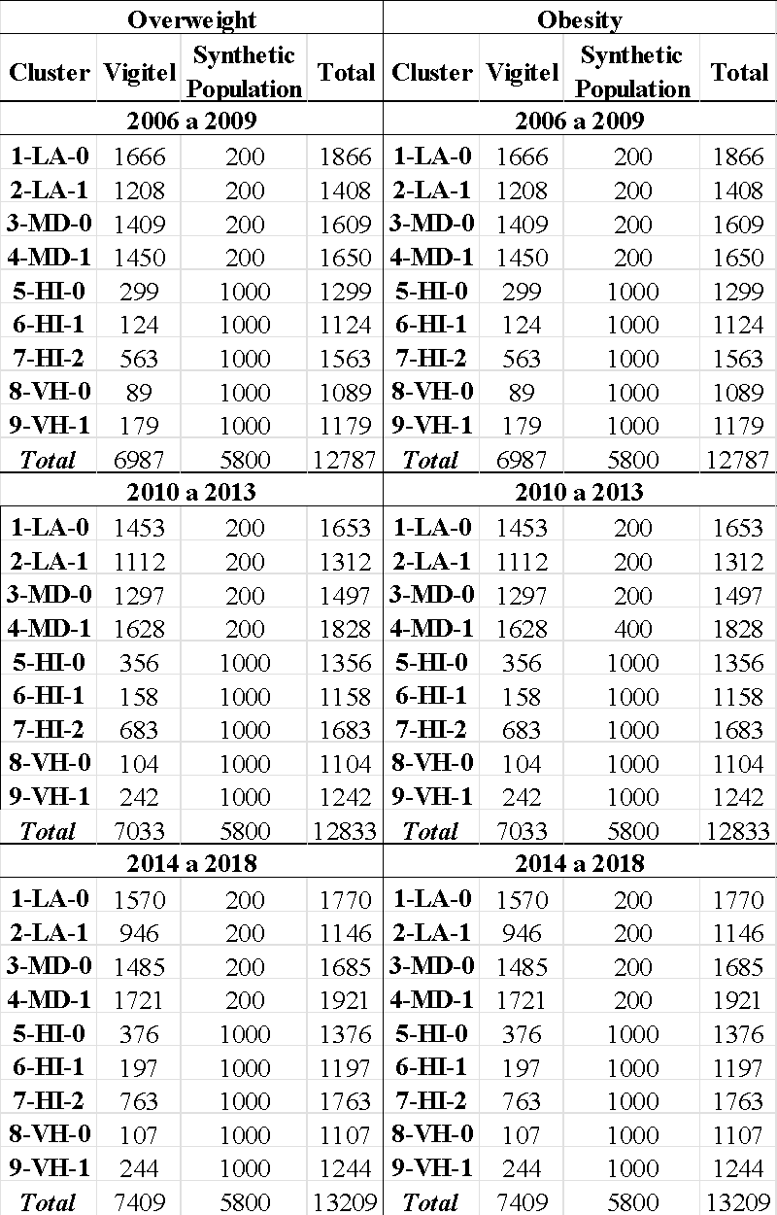
Abbreviations: LA-0, low vulnerability subtype 0; LA-1, low vulnerability subtype 1; MD-0, medium vulnerability subtype 0; MD-1, medium vulnerability subtype 1; HI-1, high vulnerability subtype 0; HI-2, high vulnerability subtype 1; HI-3, high vulnerability subtype 2; VH-0, very high vulnerability subtype 0; VH-1, very high vulnerability subtype 1.

