SUPPLEMENTAL INFORMATION
Pollutant export under a new regime of continuous transboundary sewage flow in the Tijuana River
Alexandra Grant¹, Trent Biggs², Daniel Sousa², Matthew E. Verbyla¹, Stephany Garcia³, Sneha Korat², Alina Alex¹, Elise Piazza², Jeffrey Crooks³, Douglas Liden^{4,5}, Yongping Yuan⁶, Natalie Mladenov^{1*}
¹ Department of Civil, Construction, and Environmental Engineering, San Diego State University, 5500 Campanile Drive, San Diego, CA 92182, United States of America
² Department of Geography, San Diego State University, 5500 Campanile Drive, San Diego, CA 92182, United States of America
³ Tijuana River National Estuarine Research Reserve, Imperial Beach, CA 91932, United States of America
⁴ Retired: United States Environmental Protection Agency-Region 9 Water Division, San Diego, CA, United States of America
⁵ Institute of the Americas, La Jolla, CA, 92037
⁶ United States Environmental Protection Agency-Office of Chemical Safety and Pollution Prevention, NC, United States of America

Corresponding author: Natalie Mladenov, nmladenov@sdsu.edu

Content:
Supporting Methods.
Supporting Tables S1 – S9.
Supporting Figures S1 – S10.
Supplemental References

Supporting Methods
S1. Sample collection
Water samples were collected with a telescopic sampling pole, with a bucket and rope, with a Teledyne ISCO 6700 autosampler, or by hand depending on site accessibility. All bottles used to collect samples were soaked in 10% chlorine bleach solution, soaked in a 5% hydrochloric acid bath, and autoclaved. Field blanks were collected during sampling events and analyzed using the same methods as the rest of the grab samples.

S2. Sampling of untreated wastewater from the South Bay International Wastewater Treatment Plant
At the time of this study, the South Bay International Wastewater Treatment treated up to ~11.4 x 10⁴ m³/day or 25 MGD of wastewater from Tijuana to U.S. secondary treatment standards before discharging effluent to the Pacific Ocean. SBIWTP receives the majority of its untreated influent from the City of Tijuana’s municipal collection system through the International Collector pipeline via Junction Boxes 1 and 2 (California Regional Water Quality Control Board, San Diego Region, 2025b). The SBIWTP can indirectly receive water intercepted from the Tijuana River via the PBCILA pump station, which can convey dry-weather flows from the river to the International Collector. Via Junction Boxes 1 and 2, SBIWTP can also receive influent from canyon collectors that divert transboundary flow originating from several subwatersheds within urban Tijuana. These include Stewart’s Drain, Canyon del Sol, Silva Drain, Smuggler’s Gulch, and Goat Canyon. Dry-weather flows in these canyons primarily consist of sewer spills and overflows and potable water leaks and runoff (HDR, 2020). Untreated wastewater samples from SBIWTP were collected in autoclaved 250 mL or 500 mL polypropylene bottles from a valve at the treatment plant with the guidance of a wastewater treatment plant technician. This valve conveyed instantaneous samples from the influent conveyance, not composite samples.

S3. Chemical Analyses
In the laboratory, electrical conductivity, total dissolved solids, salinity and pH were measured in triplicate in unfiltered grab samples using a Mettler Toledo SG23 Handheld pH / Conductivity Meter Field Kit. Turbidity was measured in the laboratory in triplicate using a HACH Turbidimeter; when extremely turbid samples exceeded the machine’s detection limit, samples were diluted 1:4 with ultrapure water.
Chemical oxygen demand (COD), an indicator of oxidizable organic matter, was measured using HACH COD TNT 822 reagents, with unfiltered samples digested in a HACH Digital COD Reactor Block and read using a HACH DR3900 Spectrophotometer (320 - 1100 nm). Approximately 10% of samples were run in duplicate, and standard deviations of duplicates were within 10% of mean values.
Grab samples were filtered through pre-combusted Whatman GF/F glass microfiber filters, with 47 mm diameter and 0.7 µm nominal pore size, and the filtrate was analyzed for dissolved organic carbon (DOC) and total dissolved nitrogen (TDN) using a Shimadzu TOC-L Analyzer. Samples were analyzed for DOC or TDN immediately on the day of collection or preserved to pH of ≥ 2.0 with concentrated hydrochloric acid (37%). DOC standard solutions ranging from 1 to 200 mg/L were prepared with potassium hydrogen phthalate (C₈H₅KO₄) and TDN standards ranging from 1 to 200 mg/L were prepared with potassium nitrate (KNO₃). Method detection limits (MDLs) for DOC and TDN were calculated following U.S. EPA (2016) guidelines using ultrapure water blanks (n=70). The MDLs of DOC and TDN were 0.20 mg/L and 0.15 mg/L, respectively.

S4. Laboratory optical spectroscopic analysis
The concentrations of tryptophan-like compounds (TRP) and chromophoric dissolved organic matter (CDOM) were measured using fluorescence spectroscopy. Tryptophan-like substances include amino-acids, have excitation (ex) and emission (em) wavelengths of ex 280 nm/em 350 nm, and correlate with sewage derived E. coli and other fecal indicator bacteria (Baker et al., 2015; Mladenov et al., 2024b). Humic-like CDOM substances at ex 325 nm/em 470 nm are derived from anthropogenic and natural sources, with wastewater containing high concentrations of humic like substances derived from human waste, food residue, and detergents (Hudson et al., 2007; Mendoza et al., 2020).
UV-vis absorbance and three-dimensional excitation emission fluorescence spectra were acquired on filtered water samples with a Horiba Scientific Aqualog Benchtop Fluorometer and a 1 cm pathlength quartz cuvette. Samples were analyzed within 24 hours of collection but almost always within 12 hours. Excitation emission matrices (EEMs) were collected using an integration time of 0.25 seconds with 1 nm increments over an excitation range of 240 nm to 450 nm and an emission range of 275 nm to 700 nm. As described in Wilske et al. (2020), EEMs were corrected by blank subtraction (ultrapure water sealed in a quartz cuvette), inner filter effect correction, Raman normalization, and Rayleigh scattering band removal using Matlab ver. R2024a. After analysis, Raman units were converted to parts per billion with calibration curves acquired using CDOM and TRP standards.
S5. Microbiological analyses
Total coliforms and Escherichia coli (E. coli) concentrations were quantified using the IDEXX Colilert-18 method, and enterococci concentrations were quantified using the Enterolert method, as described in Mladenov et al. (2024a). Concentrations (MPN/100 mL) were log-transformed and reported in units of log-MPN/100 mL.
Viruses and bacteria were also concentrated from samples collected on 30 April 2024 using the adsorption-extraction method (Ahmed et al. 2020; Fani et al. 2024), and the nucleic acids were extracted and purified using the MagMAX Wastewater Ultra Nucleic Acid Isolation Kit (Thermofisher), following the manufacturer’s recommended protocol. Using the QuantStudio 3 system (Applied Biosystems), sample DNA was analyzed for HF183/BacR287 and human adenovirus type 40/41 (HAdV) via quantitative polymerase chain reaction (qPCR) with TaqMan Environmental Master Mix 2.0, following previously published assays (Green et al., 2014; Jothikumar et al., 2005); and sample RNA was analyzed for pepper mild mottle virus (PMMoV) and norovirus genogroup II (NoVGII) via qPCR with reverse transcription (RT-qPCR) with TaqMan Fast Virus 1-Step Master Mix (ThermoFisher), following previously published assays (Butot et al., 2010; Haramoto et al., 2013). Standard curves consisting of 10-fold serial dilutions of standards ranging at least five orders of magnitude were performed in duplicate on each plate for each assay—standards consisted of gBlock gene fragments (Integrated DNA Technologies) containing the sequences of each amplicon plus an additional 10 bp on each end, with concentrations verified by Qubit. Standard curve efficiencies were 91%, 91%, 99%, and 93% for HF183, PMMoV, HAdV, and NoVGII, respectively, and R² values were all 0.99 or above (Table S3). The concentrations associated with the 95% probability of detection, calculated as described previously (Verbyla et al. 2016), were 2.2 gc/mL, 8.1 gc/mL, 0.66 gc/mL, and 0.70 gc/mL for HF183, PMMoV, HAdV, and NoVGII, respectively.
All reactions were performed in duplicate, and average Cq values were used to calculate sample concentrations in Microsoft Excel. Based on the results of internal amplification controls, which were used to assess for qPCR inhibition in each sample following the protocol described in US EPA (2019), there was no evidence for inhibition in any of the samples. Field blanks, method blanks, extraction blanks, and instrument blanks were analyzed for each assay, and all resulted in non-detects, as expected.

S6. Wastewater exposure experiments
Two exposure experiments were conducted to evaluate the effects of photoirradiation, dark (biodegradation) conditions, and mixing on DOC and TDN concentrations, TRP and CDOM fluorescence and total coliforms, E. coli, and enterococci concentrations in wastewater over a 24-hour period. Approximately 4 L of influent wastewater was collected from the South Bay International Wastewater Treatment Plant (SBIWTP) on 04 February 2025 and 24 March 2025. Solutions were exposed to simulated sunlight and dark conditions and kept on stir plates with stir bars at room temperature.
In Experiment 1, duplicate samples of freshwater I picked up today from Lake Morena 100% wastewater (500 mL) were exposed to simulated sunlight using a SUNTEST CPS+ solar simulator equipped with a Suncool chiller (Figure S3). The SUNTEST was set for an irradiation intensity of 470 W/m², representing average solar irradiance conditions for San Diego.
The samples were run in duplicates, with two 400 mL beakers of the same type, each filled with 350 mL of wastewater and placed into the solar simulator. There were four beakers, two light samples, and two dark samples. The intensity in the solar simulator was set to 470 W/m², which is an equivalent exposure to direct sunlight on a clear day. For the light samples, the beakers were labeled with tape indicating “LA” and “LB,” meaning Light Sample A and Light Sample B. The beakers were wrapped in aluminum foil up to the water level, with only the top exposed to sunlight, imitating the natural conditions of a water body where sunlight does not enter from the sides. The dark samples were entirely wrapped in aluminum foil to prevent exposure to light (Figure 4). Each wrapped beaker was labeled with tape, containing the following details: “DA” and “DB”. The water level in each beaker was checked every hour to ensure it remained consistent with the starting volume. Water was added to maintain the initial water level if necessary, accounting for any volume evaporated from the beakers during the experiment.

S7. Hydrologic data and statistical analyses
The wet season in San Diego, CA is from 1 October through 30 April, and the dry season is from 1 May through 30 September (California Regional Water Quality Control Board, San Diego Region, 2021). The water year (WY) is defined as starting on 1 October and ending 30 September, ensuring that a full wet season is captured within a single 12-month accounting period (U.S. Geological Survey, 2009).
Due to limited wet-weather sample availability (n = 2) for select parameters (COD, total coliforms, enterococci, pH, EC, TDS, salinity, turbidity), these variables were excluded from inferential statistical testing. However, summary statistics are presented for contextual comparison among hydrologic conditions in Table 1. Kruskal-Wallis tests were used to evaluate differences in water quality parameters among wet-weather, dry-weather, and untreated wastewater conditions. This nonparametric approach was selected due to small sample sizes (n = 5-9 per group), non-normal data distributions, and unequal variances typical of environmental concentration data. Dunn’s post-hoc tests were performed to compare groups. Although Bonferroni correction was applied to adjust for multiple comparisons, the small sample sizes make this adjustment highly conservative. Therefore, our interpretation of differences primarily relies on unadjusted p-values, while the Bonferroni-adjusted p-values were also evaluated. 2.8
Linear regression analyses were used to evaluate the relationship between distance downstream from the border and each measured water quality parameter. For each parameter, a separate ordinary least squares (OLS) regression was performed with distance (km) as the independent variable and concentration (or log-transformed concentration, where appropriate) as the dependent variable. Regression outputs were used to assess the direction and magnitude of change with distance (β coefficient), the statistical significance of the relationship (p-value), and the proportion of variance explained by distance (R²). Log₁₀ transformations were applied to microbial concentration data to improve normality and reduce heteroscedasticity prior to analysis.
S8. Dry-weather loading estimation
Dry-weather loads were estimated by pairing instantaneous flow with sample concentrations and calculating volume-weighted mean (VWM) concentrations within each event, then averaging VWMs by WY. Mean daily dry-weather loads were calculated for each WY using the average discharge on dry-weather days when flow was present. These daily loads were then scaled to annual values using a flow ratio representing the fraction of days per year with dry-weather flow. Load-relevant parameters included COD, DOC, TDN, fluorescence metrics, microbial indicators, and TDS.
$C_{VWM,dry}= \frac{Σ Q_{i}C_{i}}{Σ{ Q}_{i}}$ (1)
where $C_{VWM,dry}$ is the VWM concentration from a dry-weather sampling event, Q_{i} is the flow rate in L/min at the IBWC gage at the time of individual sample collection, and C_{i} is the concentration of the corresponding individual sample (Gómez-Gutiérrez et al., 2006).
The average $C_{VWM,dry}$for each WY was used in the following equation for mean daily load by WY, consistent with prior publications (Arreola-Serrano et al., 2022; Gómez-Gutiérrez, et al., 2006; Stein & Ackerman, 2007):
${mean daily load}_{dry weather, w/Flow}= \overline{Q_{dry}}C_{VWM,dry}$ (2)
where $\overline{Q_{dry}}$ is the average dry-weather flow for days with flow (> 0 m³/day) at the IBWC gage averaged across the entire WY (not just for sampling dates). Days with no flow (0 m³/day) were excluded from $\overline{Q_{dry}}$ since loading can only occur when flow is present.
Equation 3 provides a flow ratio that scales the yearly load estimate by the actual frequency of observed flow days for each WY. Specifically, the numerator includes only the days that met both dry-weather and transboundary flow criteria.
$flow days ratio=\frac{days with flow\left(>\frac{0 m³}{day}\right) and dry weather}{total days in water year}$ (3)
Equation 4 calculates mean yearly load from dry-weather days with flow:
${mean yearly load}_{dry weather, w/Flow}=\overline{Q_{dry}} x \overline{C_{VWM,dry}} x {days}_{dry, w/ flow}$ (4)
Where $\overline{Q_{dry}}$ is the mean dry-weather flow for days with flow (> 0 m³/day) across the border averaged across each WY and $\overline{C_{VWM,dry}}$ is the mean dry-weather volume weighted mean concentration averaged across the corresponding WY.
WQ samples were collected from 2023 to 2025, and average concentrations from this period were also applied to 2021 and 2022 flow data to estimate prior loadings. This approach assumes that pollutant concentrations remained relatively consistent across these WYs, a conservative assumption supported by comparisons to historical data (IBWC, 2020).

Supporting Tables

Table S1. Sites sampled and distance from the US-Mexico border.
Site Abbreviation | Description | Distance from US-MX border (km) | Latitude | Longitude
IBWC | IBWC Channel at the border | 1.5 | 32°32'31.81"N | 117° 3'13.85"W
DMB | Dairy Mart Rd. | 2.85 | 32°32'47.64"N | 117° 3'57.85"W
HOLL | Hollister Bridge | 4.93 | 32°33'5.17"N | 117° 5'2.90"W
BTFY | Hollister at Butterfly Preserve |  | 32°33'15.4"N | 117°05'02.8"W
STN | Saturn Blvd. | 6.25 | 32°33'33.2"N | 117°05'34.0"W
ET | Equestrian Trail | 8.35 | 32°33'32.0"N | 117°06'41.9"W
HPUP | Helicopter Pad - Upper | 8.9 | 32°33'31.25"N | 117° 7'9.94"W
HP | Helicopter Pad | 9.3 | 32°33'29.67"N | 117° 7'18.81"W
BR | Boca Rio | 10.21 | 32°33'34.17"N | 117° 7'44.27"W
TJM | Tijuana River Mouth | 10.5 | 32°33'6.64"N | 117° 7'34.50"W
IBPG | Imperial Beach Pier Gybe Camera | 13.9 | 32°34'46.58"N | 117° 8'9.41"W
IBPC | Imperial Beach Pier Café | 13.9 | 32°34'46.43"N | 117° 8'14.78"W
IBWCTP | International Boundary Water Commission, International Water Treatment Plant | 0.1 | 32°32'26.8"N | 117°03'37.4"W

Table S2. Summary of Sampling Events.

Sampling Event Date | Water Year | Sites Sampled | Last rainfall date w >0.01 in | Rainfall amount (in) | Antecedent dry days | Wet or Dry Season | Wet or Dry Weather | Sample #
9/6/2023 | 2023 | IBWC, BR | 8/21/2023 | 0.02 | 15 | dry | dry | 31
10/26/2023 | 2024 | IBWCTP | 10/10/2023 | 0.02 | 15 | dry | dry | 2
1/25/2024 | 2024 | IBWC, HOLL, BR, IBPC | 1/23/2024 | 0.07 | 1 | wet | wet | 6
1/30/2024 | 2024 | BR, IBPG, IBPC | 1/23/2024 | 0.07 | 6 | wet | dry | 8
4/30/2024 | 2024 | IBWCTP, IBWC, DMB, HOLL, STN, ET, HPUP, HP, BR, TJM, IBPG, IBPC, FB | 4/14/2024 | 0.02 | 12 | dry | dry | 40
7/29/2024 | 2024 | IBWCTP, HOLL | 5/5/2024 | 0.14 | 79 | dry | dry | 22
9/17/2024 | 2024 | IBWCTP, HOLL, BTFY, BR | 5/5/2024 | 0.14 | 126 | dry | dry | 18
10/15/2024 | 2025 | HOLL | 5/7/2024 | 2.14 | 153 | dry | dry | 4
11/8/2024 | 2025 | IBWCTP, HOLL, STN | 11/2/2024 | 0.07 | 5 | wet | dry | 6
11/22/2024 | 2025 | IBWCTP, HOLL, STN, TJM | 11/2/2024 | 0.07 | 19 | wet | dry | 5
2/4/2025 | 2025 | IBWCTP | 1/27/2025 | 0.10 | 8 | wet | dry | 2
2/19/2025 | 2025 | IBWCTP, HOLL, IBPC, IBPG, BR, TJM | 1/27/2025 | 0.10 | 22 | wet | dry | 31
3/14/2025 | 2025 | IBPC, IBWCTP, STN, HOLL | 3/13/2025 | 1.23 | 0 | wet | wet | 30
3/24/2025 | 2025 | IBWCTP | 3/17/2025 | 0.05 | 6 | wet | dry | 2
3/26/2025 | 2025 | IBPC, IBPG, HOLL, STN, IBWCTP | 3/17/2025 | 0.05 | 8 | wet | dry | 30
4/23/2025 | 2025 | HOLL, STN, ET, BR, IBWCTP | 4/3/2025 | 0.02 | 20 | dry | dry | 7

Table S3. Range of concentrations, slopes, intercepts, efficiencies, and R² values for (RT-)qPCR standard curves
Assay | Range of gBlock Concentrations | Slope | Intercept | Efficiency | R² Value
HF183 | 2.5 – 250,000 gc/rxn | -3.56 | 37.51 | 91.0% | 0.998
PMMoV | 4.7 – 468,000 gc/rxn | -3.56 | 38.19 | 91.0% | 0.995
HAdV | 2.5 – 250,000 gc/rxn | -3.36 | 36.58 | 98.6% | 0.990
NoVGII | 50 – 500,000 gc/rxn | -3.51 | 41.02 | 92.6% | 0.989

Table S4. Tijuana River average daily flow by dry, wet, and all weather and total yearly flow by water year.
Water Year | Average Daily Flow,  DRY weather (m³/day) | Average Daily Flow,  WET weather (m³/day) |  | Average Daily Flow,  ALL WEATHER (m³/day) |  | Total Yearly Flow (m³)
2021 | 2.49E+04 |  | 2.17E+05 |  | 8.23E+04 | 6.01E+07
2022 | 2.59E+04 |  | 3.62E+05 |  | 1.65E+05 | 6.01E+07
2023 | 1.33E+05 |  | 1.04E+06 |  | 3.69E+04 | 1.35E+07
2024 | 1.85E+05 |  | 8.86E+05 |  | 1.88E+05 | 6.87E+07
2025 | 1.10E+05 |  | 3.86E+05 |  | 1.14E+06 | 2.68E+08

Table S5. Tijuana River number of no-flow¹ and flow days per water year² during dry and wet seasons of WYs 2021-2024.
Water Year | # No-flow days  Dry season | # Flow days  Dry season | # No-flow days  Wet season | # Flow days  Wet season
2021 | 197 | 92 | 23 | 53
2022 | 204 | 81 | 10 | 70
2023* | 51 | 186 | 15 | 113
2024 | 0 | 256 | 0 | 110
¹ No-flow days are defined as days with 0 m³/day recorded at the IBWC Tijuana River Gage (#11013300).
² Water year starts 1 October of previous and ends 30 September of year shown in the first column.
* Between 28 December 2022 and the last sampling event on 23 April 2025, only three days (23–25 July 2023) recorded zero flow (0 m³/day).

Table S6. Significance of change in precipitation, discharge, and runoff coefficient over time for Tijuana River.
Water Years | Precipitation (P) vs time p-value | Discharge (Q) vs time p-value | Runoff Coefficient (Q/P) vs time p-value
2000-2024 | 0.243 | 0.011 | <0.001
2020-2024 | 0.516 | <0.001 | 0.018

Table S7. Statistics from KW and Dunn for Tijuana River wet-weather, dry-weather, and untreated wastewater samples.
Kruskal–Wallis Results
Parameter | n | statistic | df | p
CDOM | 22 | 3.411 | 2 | 0.182
DOC | 22 | 9.630 | 2 | 0.0081
TDN | 22 | 14.872 | 2 | 0.0006
TRP | 22 | 7.595 | 2 | 0.0224
log E. coli | 21 | 2.54 | 2 | 0.28
Dunn’s post-hoc tests with Bonferroni correction
Parameter | group1 | group2 | n1 | n2 | statistic | p | significance | p adjusted | significance  p adjusted
CDOM | TJRwet | TJRdry | 5 | 9 | 1.619754 | 0.105 | ns | 0.316 | ns
CDOM | TJRwet | TP | 5 | 8 | 1.708576 | 0.087 | ns | 0.263 | ns
CDOM | TJRdry | TP | 9 | 8 | 0.145258 | 0.885 | ns | 1 | ns
DOC | TJRwet | TJRdry | 5 | 9 | 2.27011 | 0.023 | * | 0.069 | ns
DOC | TJRwet | TP | 5 | 8 | 3.072735 | 0.002 | ** | 0.006 | **
DOC | TJRdry | TP | 9 | 8 | 0.999196 | 0.318 | ns | 0.953 | ns
TDN | TJRwet | TJRdry | 5 | 9 | 2.239432 | 0.025 | * | 0.075 | ns
TDN | TJRwet | TP | 5 | 8 | 3.84936 | 0.00012 | *** | 0.00036 | ***
TDN | TJRdry | TP | 9 | 8 | 1.94557 | 0.052 | ns | 0.155 | ns
TRP | TJRwet | TJRdry | 5 | 9 | 2.049234 | 0.040 | * | 0.121 | ns
TRP | TJRwet | TP | 5 | 8 | 2.721565 | 0.006 | ** | 0.019 | *
TRP | TJRdry | TP | 9 | 8 | 0.840733 | 0.400 | ns | 1 | ns
log E. coli | TJRwet | TJRdry | 5 | 9 | 1.566712 | 0.117 | ns | 0.352 | ns
log E. coli | TJRwet | TP | 5 | 7 | 0.72349 | 0.469379 | ns | 1 | ns
log E. coli | TJRdry | TP | 9 | 7 | -0.89341 | 0.371636 | ns | 1 | ns

Table S8. Average water quality parameter concentrations for the Tijuana River (TJR) during wet weather (N = 5 sampling dates), the Tijuana River during dry weather (N = 9 sampling dates), and for the South Bay International Wastewater Treatment Plant influent untreated wastewater (N = 8 sampling dates).
Water Quality Parameter | units | Tijuana River wet-weather | Tijuana River dry-weather | SBIWTP untreated wastewater
# of sampling events |  | 5 | 9 | 8
Total daily discharge | m³/day | 3.10 x 10⁶ | 1.12 x 10⁵ | -
COD* | mg/L | 231 (±14) | 302 (±112) | 402 (±238)
DOC | mg/L | 18 (±3) | 31 (±7) | 43 (±18)
TDN | mg/L | 12 (±4) | 34 (±4) | 47 (±12)
CDOM | ppb | 347 (±82) | 479 (±108) | 520 (±245)
Tryptophan | ppb | 218 (±89) | 495 (±216) | 789 (±633)
Total Coliforms* | log MPN/100mL | 6.40 (±0.18) | 7.10 (±0.77) | 6.92 (±0.93)
E. coli | log MPN/100mL | 6.46 (±0.29) | 6.65 (±0.76) | 6.35 (±0.90)
Enterococci* | log MPN/100mL | 5.84 (±0.04) | 5.66 (±0.70) | 5.62 (±0.88)
pH |  | 7.30 (±0.3) | 7.60 (±0.2) | 7.42 (±0.30)
EC | mS/cm | 1.22 (±1.1) | 2.18 (±0.6) | 2.04 (±0.56)
TDS | mg/L | 616 (±564) | 1165 (±438) | 976 (±548)
Salinity | ppt | 0.64 (±0.55) | 1.15 (±0.29) | 1.07 (±0.26)
Turbidity | NTU | 155 (±39) | 63 (±37) | 54 (±50)
* These parameters were measured only during 2 wet-weather events. All other parameters were measured in all five sampling events, and only those were included in significance testing. This also explains why the wet-weather average for total coliforms is lower than that for E. coli; more events contributed to the E. coli average.

Table S9. Dry-Weather concentrations in the Tijuana River compared to 2019 IBWC monitoring results and State of California Water Quality Objectives.
Water Quality Parameter | units | Dry-weather average concentration from this study | IBWC Minute 320 Sampling Results from Hollister, 2019 (IBWC, 2020) | California Regional Water Quality Control Board, San Diego Region Basin Plan (2021)
COD | mg/L | 302 | 128 | 120
DOC | mg/L | 31 | 32 | -
TDN | mg/L | 34 | 25 | -
Total Coliforms | MPN/100mL | 2.34 × 10⁷ | >239999 | 10000
E. coli | MPN/100mL | 7.84 × 10⁶ | >240000 | 126
Enterococci | MPN/100mL | 8.83 × 10⁵ | >240000 | 151
pH |  | 7.6 | 7.33 | 6.5<pH<8.5
EC | mS/cm | 2.18 | 4.13 | -
TDS | mg/L | 1165 | 1383 | 500
Turbidity | NTU | 63 | - | 20 |  |  | 20
* Dash indicates value not reported in document.

Supporting Figures

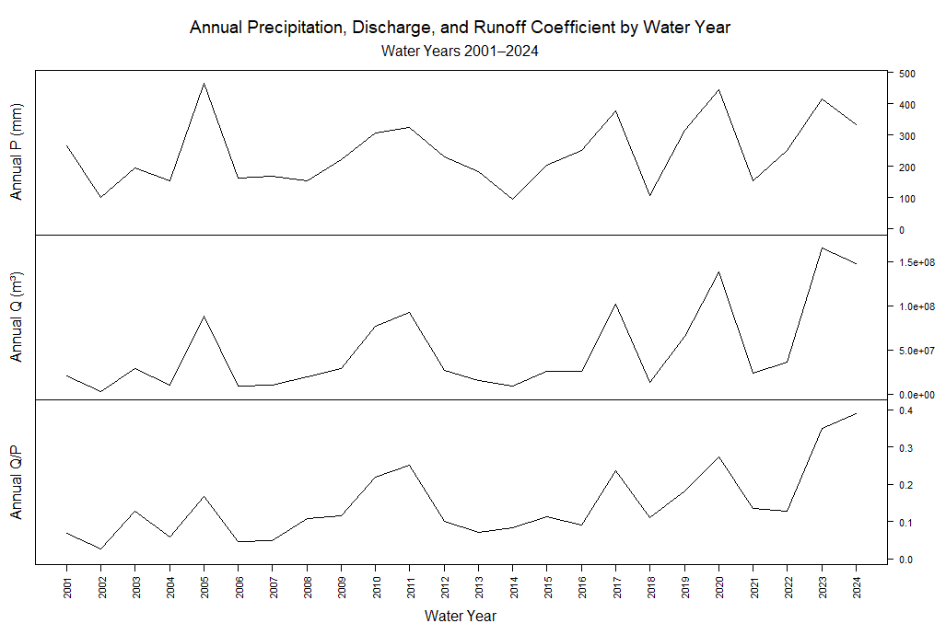
Figure S1. Annual precipitation, discharge, and runoff coefficient time series for water years 2001-2024.

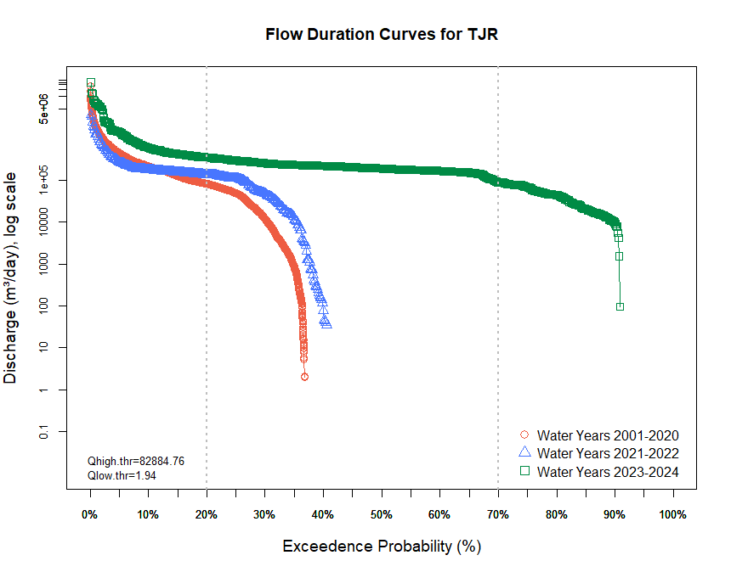
Figure S2. Flow duration curves for Tijuana River showing the exceedance probability for WYs 2001-2020, 2021-2022 (during intermittent cross-border flow) and 2023-2024 (during perennial cross-border flow).

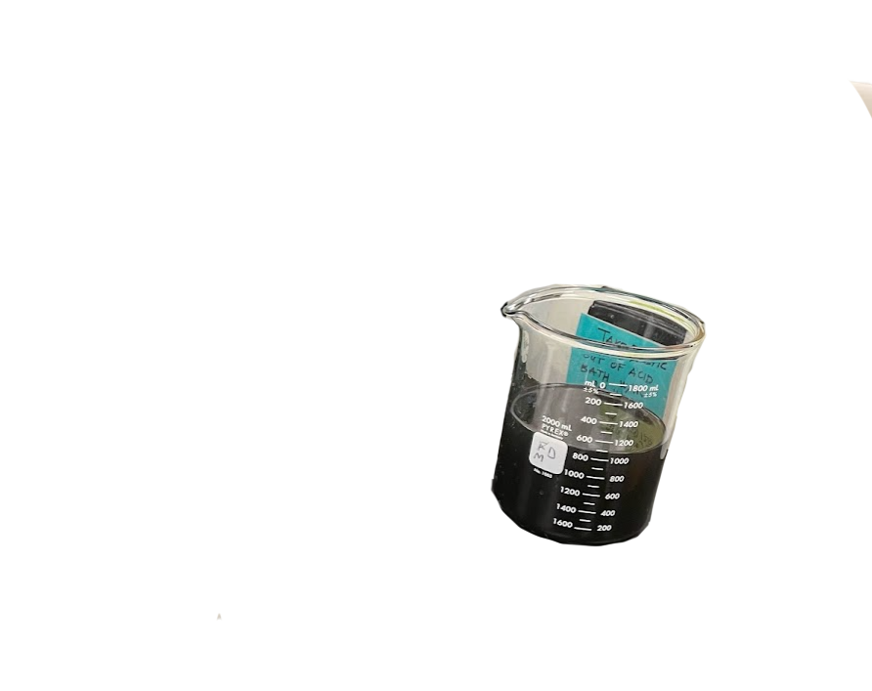

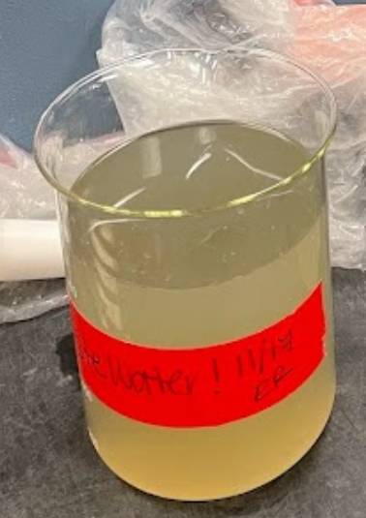
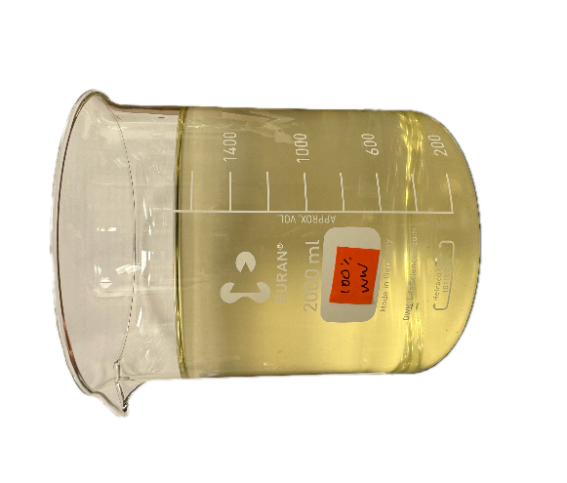
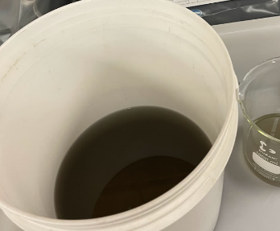

Figure S3. Photos of influent grab samples collected from the South Bay International Wastewater Treatment Plant on October 2022, November 2022, October 2023, and February 2024 (from left to right), representing the wide variability in untreated wastewater appearance and transmittance (color). All samples were collected during dry weather (to minimize effects of infiltration and inflow) and during times when the treatment plant was receiving only wastewater from sewer mains and not water from the Tijuana River.

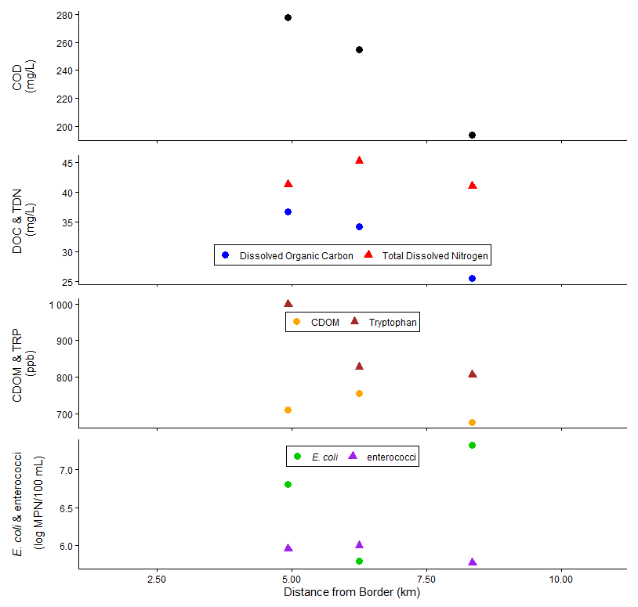
Figure S4. Spatial variability in chemical constituents (COD, DOC, and TDN), fluorescence surrogates (CDOM and TRP), microbial source tracking markers (E. coli, enterococci) with distance from the U.S.-Mexico border for longitudinal sampling event on 23 April 2025.

 | Hollister | Saturn | Equestrian Trail
 | 4.93 km from border | 6.25 km from border | 8.53 km from border
4/30/24 | 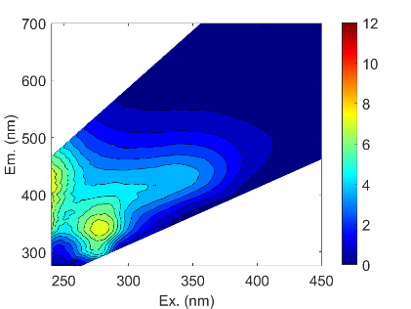 | 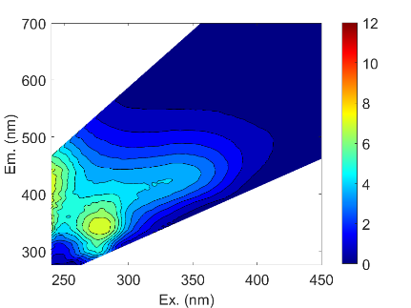 | 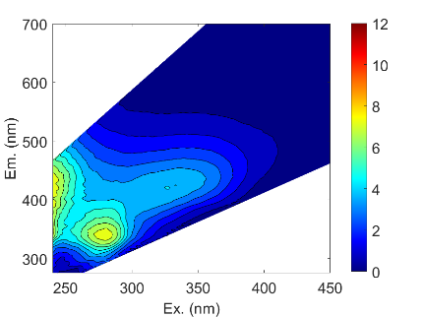
 | CDOM: 377 ppb  TRP: 360 ppb | CDOM: 386 ppb  TRP: 357 ppb | CDOM: 392 ppb  TRP: 354 ppb
4/23/25 | 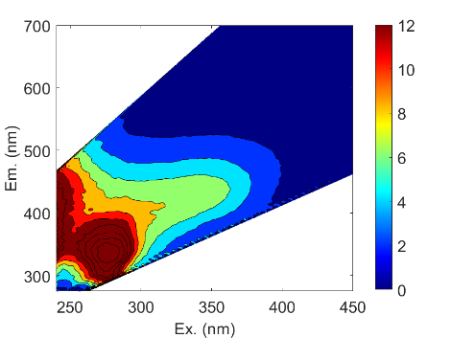 | 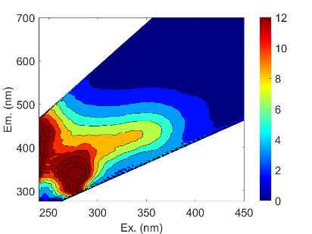 | 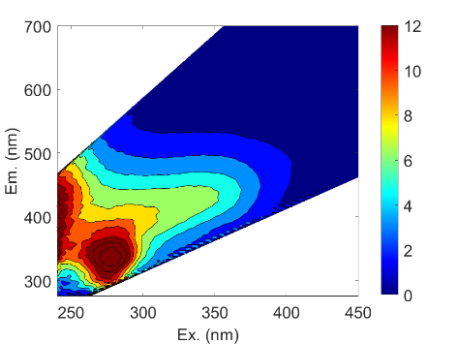
 | CDOM: 712 ppb  TRP: 998 ppb | CDOM: 757 ppb  TRP: 828 ppb | CDOM: 646 ppb  TRP: 769 ppb
 | Untreated influent | Treated effluent
4/30/24 | 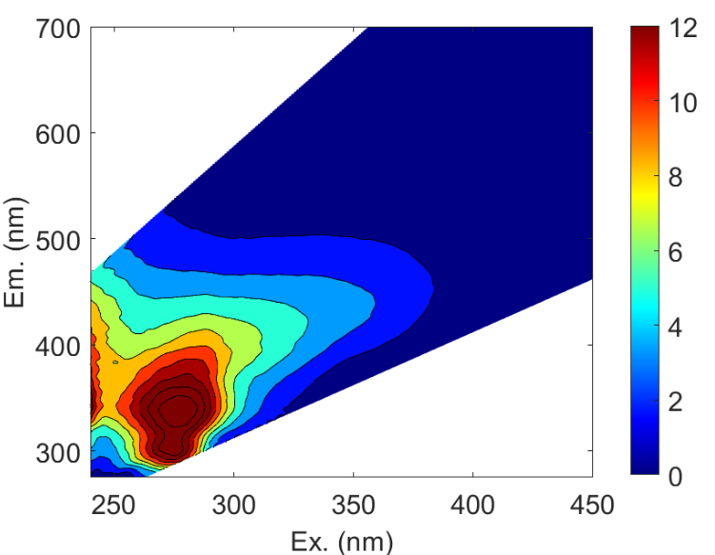 | 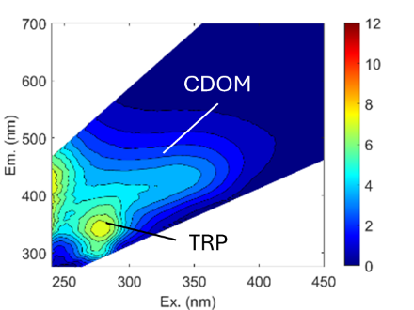

Figure S5. Excitation emission matrices for sampling dates 30 April 2024 (top) and 23 April 2025 (middle) and corresponding CDOM and TRP concentrations, compared to EEMs of untreated wastewater collected from the IBWCTP on 30 April 2024 (bottom).

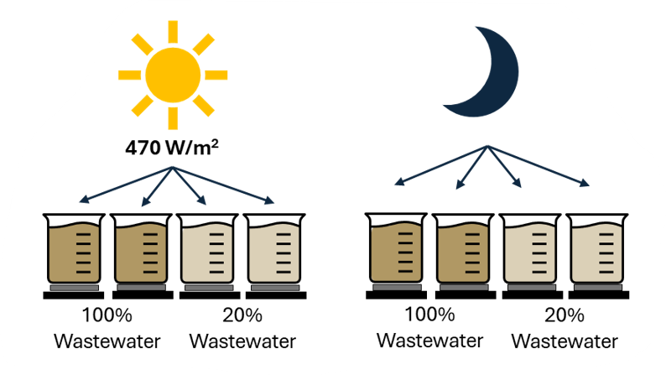

Figure S6. Experimental setup of duplicate solutions of 100% untreated wastewater and 20% untreated wastewater and 80% lake water. The 20% wastewater experiment was performed on 04 February 2025. The 100% wastewater experiment was performed on 24 March 2025. Solutions were exposed to simulated sunlight and dark conditions and kept on stir plates with stir bars at room temperature.

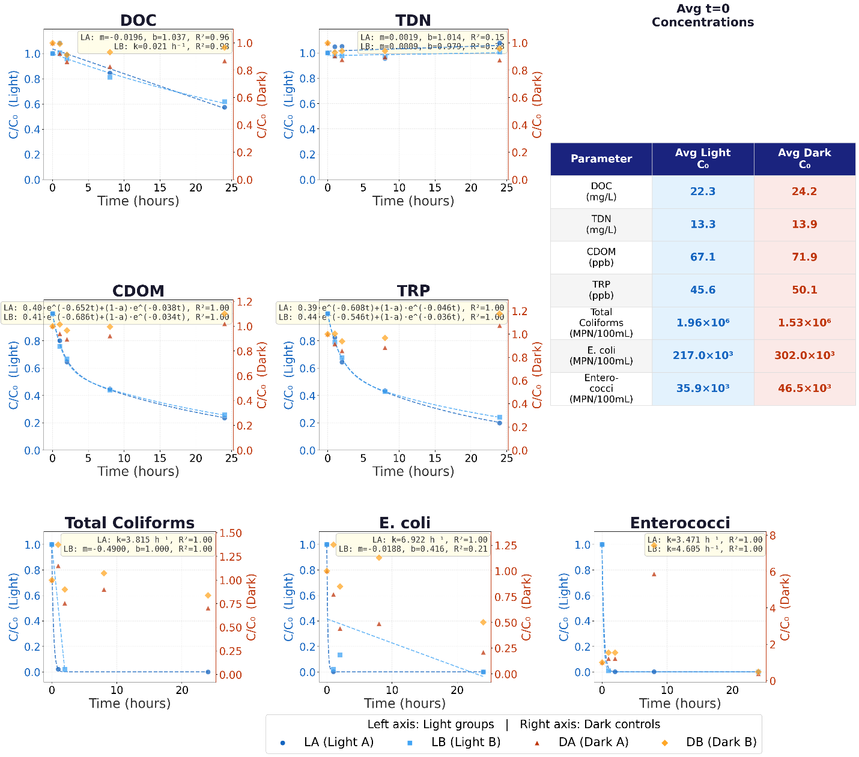
Figure S7. Change in chemical (DOC and TDN), fluorescence (CDOM and TRP), and FIB concentrations at each time point with respect to initial concentrations for solutions of 20% wastewater and 80% lake water exposed to simulated sunlight (LA and LB) and dark (DA and DB) conditions with continuous stirring. Results of duplicate experiments are shown and decay curves shown only for photoirradiated (light) samples. Table shows starting (t = 0) concentrations for each parameter.

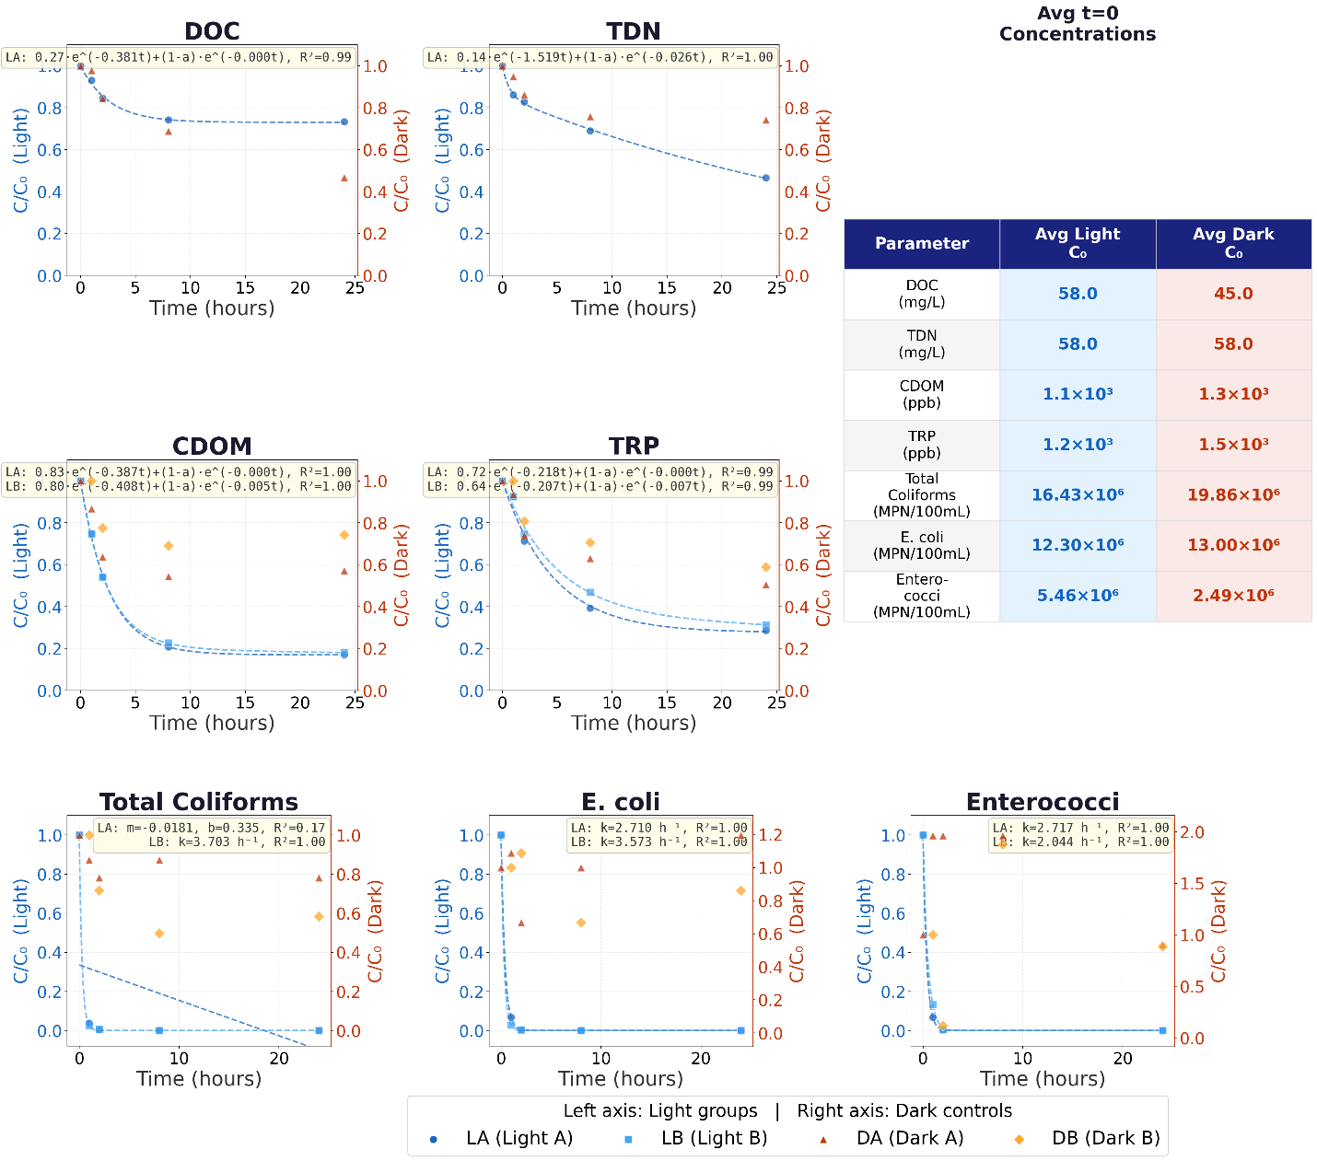
Figure S8. Change in chemical (DOC and TDN), fluorescence (CDOM and TRP), and FIB concentrations at each time point with respect to initial concentrations for solutions of 100% wastewater exposed to simulated sunlight (LA and LB) and dark (DA and DB) conditions with continuous stirring. Results of duplicate experiments are shown and decay curves shown only for photoirradiated (light) samples. Table shows starting (t = 0) concentrations for each parameter.

a)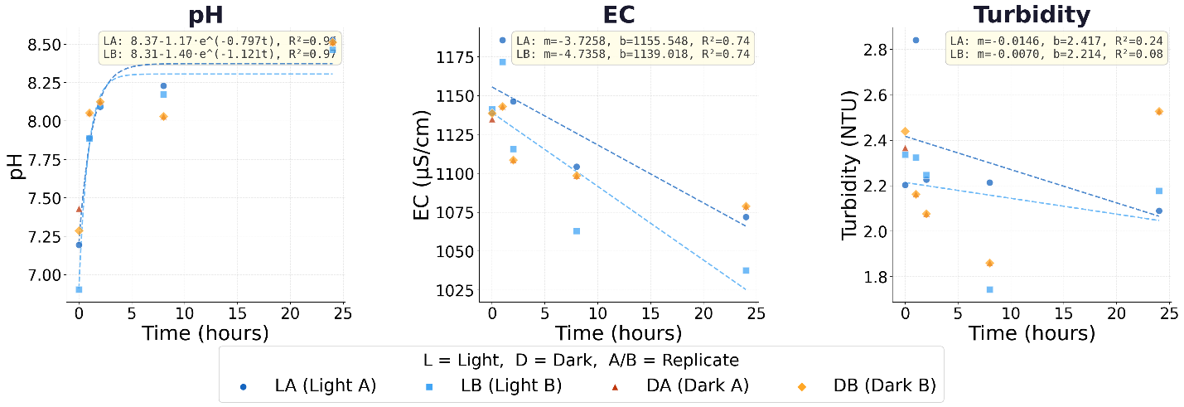
b) 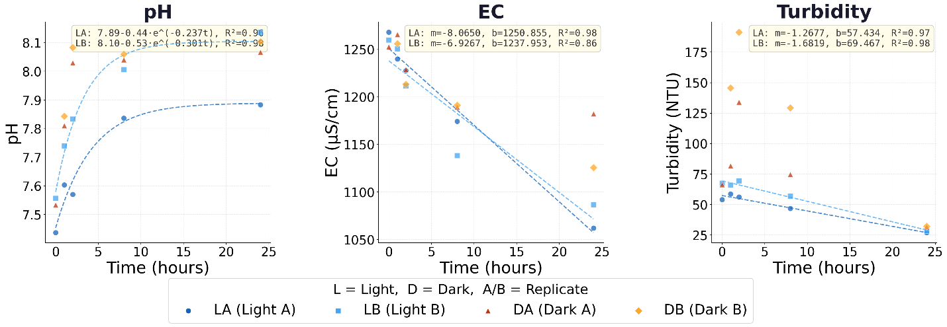
Figure S9. Changes in water quality (pH, electrical conductivity (EC), and turbidity) in a) 20% wastewater/creek water solutions and b) 100% raw wastewater solutions under simulated sunlight and dark conditions with mixing. Results of duplicate experiments are shown and linear regression lines shown only for photoirradiated (light) samples.

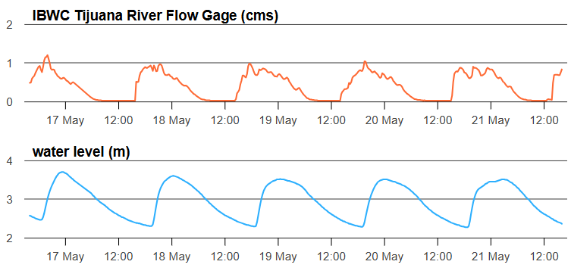
Figure S10. Example of 6 days of discharge measured at the IBWC Tijuana River gage 1.5 km downstream of the US-Mexico border (top) and water level at the Hollister Bridge site (bottom), located 4.9 km downstream of the border. The discharge peak at the IBWC gage (19:00 to 21:00) propagates to the Hollister Bridge site (with the water level peak at ~0:00) ~4 hours later.

Supplemental References

Arreola-Serrano, A. S., Mendoza-Espinosa, L. G., Hernández-Cruz, A., Daesslé, L. W., & Villada-Canela, M., 2022. Quantifying the pollutant load into the Southern California Bight from Mexican sewage discharges from 2011 to 2020. Frontiers in Water, 4. https://doi.org/10.3389/frwa.2022.993713
Baker, A., Cumberland, S. A., Bradley, C., Buckley, C., & Bridgeman, J., 2015. To what extent can portable fluorescence spectroscopy be used in the real-time assessment of microbial water quality? Science of the Total Environment, 532, 14–19. https://doi.org/10.1016/j.scitotenv.2015.05.114
Butot, S., Le Guyader, F. S., Krol, J., Putallaz, T., Amoroso, R., Sanchez, G., 2010. Evaluation of various real-time RT-PCR assays for the detection and quantitation of human norovirus. J Virol Methods 167:90-4. https://doi.org/10.1016/j.jviromet.2010.03.018
California Regional Water Quality Control Board, San Diego Region, 2021. The basin plan (Region 9). Retrieved 8 May 2025, from https://www.waterboards.ca.gov/sandiego/water_issues/programs/basin_plan/
California Regional Water Quality Control Board, San Diego Region., 2025b. South Bay – International Wastewater Treatment Plant. Retrieved 17 May 2026, https://www.waterboards.ca.gov/sandiego/water_issues/programs/iwtp/#:~:text=The%20SBIWTP%20is%20permitted%20to,lower%20Tijuana%20River%20and%20estuary.
Gómez-Gutiérrez, A. I., Jover, E., Bodineau, L., Albaigés, J., & Bayona, J. M., 2006. Organic contaminant loads into the Western Mediterranean Sea: Estimate of Ebro River inputs. Chemosphere, 65(2), 224-236. https://doi.org/10.1016/j.chemosphere.2006.02.058
HDR., 2020. Tijuana River Valley Needs and Opportunities Assessment. Final Report. https://www.sdparks.org/content/dam/sdparks/en/pdf/Resource-Management/NOA%20Final%20Report.pdf
Haramoto, E., Kitajima, M., Kishida, N., Konno, Y., Katayama, H., Asami, M., & Akiba, M., 2013. Occurrence of pepper mild mottle virus in drinking water sources in Japan. Appl Environ Microbioly, 79(23):7413-8. doi: 10.1128/AEM.02354-13.
Hudson, N., Baker, A., & Reynolds, D., 2007. Fluorescence analysis of dissolved organic matter in natural, waste and polluted waters—a reviewMendoza, L., Mladenov, N., Kinoshita, A.M., Pinongcos, F., Verbyla, M. E., & Gersberg, R., 2020. Fluorescence-based monitoring of anthropogenic pollutant inputs to an urban stream in Southern California, Science of the Total Environment, 718, 137206. https://doi.org/10.1016/j.scitotenv.2020.137206
International Boundary and Water Commission., 2020, October 27. IBWC binational study of the Tijuana River and adjacent canyons and drains: December 2018 to November 2019 [Report].
Mladenov, N., Biggs, T., Ford, K., Garcia, S., Yuan, Y., Grant, A., Piazza, E., Rivera, E., Pinongcos, F., Keely, S. P., Summerlin, C., Crooks, J. A., & Liden, D., 2024a. Evaluation of real-time fluorescence sensors and benchtop fluorescence for tracking and predicting sewage contamination in the Tijuana River Estuary at the US-Mexico border. Science of the Total Environment, 950, 175137. https://doi.org/10.1016/j.scitotenv.2024.175137
Mladenov, N., Sanfilippo, S., Panduro, L., Pascua, C., Arteaga, A., & Pietruschka, B., 2024b. Tracking performance and disturbance in decentralized wastewater treatment systems with fluorescence spectroscopy. Environmental Science: Water Research & Technology, 10(6), 1506-1516.
Stein, E., & Ackerman D., 2007. Dry-weather water quality loadings in arid, urban watersheds of the Los Angeles Basin, California, USA. Journal of the American Water Resources Association, 43(2). https://ftp.sccwrp.org/pub/download/DOCUMENTS/JournalArticles/508_dry_weather_loadings.pdf
U.S. Environmental Protection Agency, 2016. Definition and procedure for the determination of the method detection limit (Revision 2) (EPA 821‑R‑16‑006).
U.S. Environmental Protection Agency, 2019. Method 1696: Characterization of Human Fecal Pollution in Water by HF183/BacR287 TaqMan® Quantitative Polymerase Chain Reaction (qPCR) Assay (EPA 821-R-19-002).
U.S. Geological Survey, 2009. USGS water-data report. Retrieved 8 May 2025, from https://pubs.usgs.gov/wdr/#CA
Verbyla, M. E., Symonds, E. M., Kafle, R. C., Cairns, M. R., Iriarte, M., Mercado Guzmán, A., Coronado, O., Breitbart, M., Ledo, C., & Mihelcic, J. R., 2016. Managing microbial risks from indirect wastewater reuse for irrigation in urbanizing watersheds. Environmental Science & Technology, 50(13), 6803–6813. https://doi.org/10.1021/acs.est.5b05398
Wilske, C., Herzsprung, P., Lechtenfeld, O. J., Kamjunke, N., & Dumpling, W., 2020. Photochemically induced changes of dissolved organic matter in a humic-rich and forested stream. Water, 12(2), 331. https://doi.org/10.3390/w12020331

