Supplementary Information

Singlet Fission Dynamics Modulated by Molecular Configuration in Covalently Linked Pyrene Dimers, Anti- and Syn-1,2-di(pyrenyl)benzene

Jungkweon Choi,^{a,b} Siin Kim,^{a,b} Mina Ahn,^{c} Jungmin Kim, ^{a,b} Dae Won Cho,^{d} Kyung-Ryang Wee,* ^{c} Hyotcherl Ihee* ^{a,b}

ª Center for Nanomaterials and Chemical Reactions, Institute for Basic Science, Daejeon 34141, Republic of Korea
^{b} Department of Chemistry and KI for the BioCentury, Korea Advanced Institute of Science and Technology (KAIST), Daejeon 305-701, Republic of Korea
^{c} Department of Chemistry and Institute of Natural Science, Daegu University, Gyeongsan 38453, Republic of Korea
^{d} Department of Advanced Materials Chemistry, Korea University, Sejong Campus, Sejong 30019, Korea

* Corresponding authors: Kyung-Ryang Wee and Hyotcherl Ihee
E-mail: krwee@daegu.ac.kr, hyotcherl.ihee@kaist.ac.kr

Experimental Section
General: Based on standard Schlenk techniques, all of synthesis experimental procedures were performed under a dry argon condition. Reagents and solvents were purchased from commercial sources and used as received without further purification, unless otherwise stated. Deuterated solvent for NMR experiments were obtained from Merck or Cambridge Isotope Lab. Inc. All synthesized compounds were characterized by ¹H-NMR or ¹³C-NMR, and elemental analysis. The ¹H and ¹³C spectra were recorded on a Bruker500 spectrometer operating at 500 and 125 MHz, respectively, and all proton and carbon chemical shifts were measured relative to internal residual chloroform (99.5% CDCl₃) from the lock solvent. The GC-MS analysis was performed using a highly sensitive Gas Chromatograph /Mass Selective Detector spectrometer (Agilent, 7890B-5977B GC/MSD). The elemental analyses (C, H) were performed using Thermo Fisher Scientific Flash 2000 series analyzer. The crystal structure was determined by a single-crystal X-ray diffractometer at the Western Seoul Center of Korea Basic Science Institute.
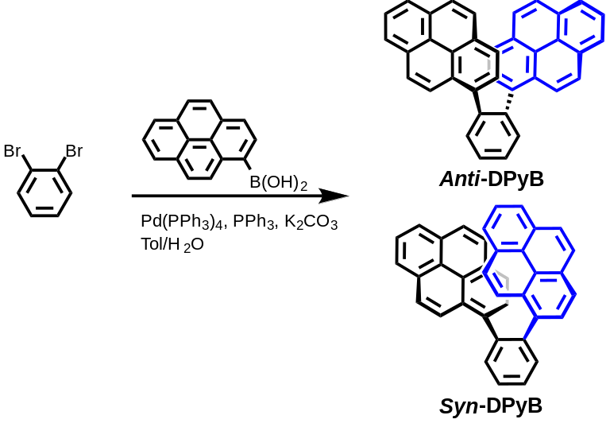
Figure S1. Synthesis route to anti- and syn-1,2-di(pyrenyl)benzene (Anti-DPyB and Syn-DPyB).

Synthesis of Anti-DPyB and Syn-DPyB: A mixture of 1,2-dibromobenzene (1.0 g, 4.24 mmol), pyrene-1-boronic acid (3.13 g, 12.7 mmol), Pd(PPh3)4 (0.24 g, 5 mol%), K₂CO₃ (5.26 g, 38.1 mmol) in Toluene/H₂O (v/v = 50 mL/10 mL) was refluxed under argon at 110 ℃ for overnight. After cooling to room temperature, deionized water (50 ml) was poured and the organic layer was separated using a separating funnel. The water layer was washed using methylene chloride (×3) for extracted remaining organic residue. After combining all of the organic solvents, the organic layer was dried over anhydrous MgSO₄ and then filtered off. The solvent was removed under reduced pressure, and the residue was purified by silica gel column chromatography using CH₂Cl₂/n-hexane (v/v = 1:6) as the eluent and obtained a mixture powder. Anti-DPyB was purified by recrystallization in CH₂Cl₂/n-hexane (v/v = 1:2) to give a pale yellow powder. Yield: 0.38 g, 19 %. ¹H NMR (500 MHz, CDCl₃, ppm) δ 8.30 (d, 1H), 8.22 (d, 1H), 8.18-8.12 (m, 3H), 8.03-8.00 (m, 2H), 7.95 (d, 2H), 7.90-7.83 (m, 3H), 7.79-7.69 (m, 5H), 7.57 (d, 1H), 7.47 (d, 1H). ¹³C NMR (125 MHz, CDCl3, ppm) δ 141.0, 136.8, 136.6, 132.5, 132.4, 131.3, 131.1, 130.9, 130.7, 130.0, 130.0, 129.3, 128.8, 128.7, 127.8, 127.4, 127.3, 127.3, 127.2, 127.2, 127.0, 127.0, 126.8, 125.8, 125.6, 125.6, 125.5, 125.0, 124.8, 124.7, 124.6, 124.6, 124.5, 124.0, 123.7. DIP-MS Calcd for [C38H22]: 478.17 m/z, Found: 478.3 m/z. Elem. Anal. Found (Calcd) for C38H22: C, 95.36 (95.37); H, 4.64 (4.63). The recrystallized filtrate was evaporated under reduced pressure further purified by silica gel column chromatography using n-hexane as the eluent to obtain Syn-DPyB of light yellow powder. Yield: 0.22 g, 11 %. ¹H NMR (500 MHz, CDCl₃, ppm) δ 8.40-8.38 (d, 2H), 8.27-8.22 (m, 4H), 8.20-8.15 (m, 5H), 8.09-8.05 (m, 3H), 7.97 (t, 1H), 7.92 (d, 1H), 7.76-7.65 (m, 5H), 6.71 (t, 1H), 6.25 (d, 1H). ¹³C NMR (125 MHz, CDCl₃, ppm) δ 141.9, 138.8, 135.3, 134.3, 134.3, 133.4, 133.3, 132.8, 131.4, 131.1, 130.7, 130.6, 130.5, 128.4, 128.0, 127.9, 127.7, 127.6, 127.3, 126.9, 126.8, 126.7, 126.6, 126.2, 125.5, 125.4, 125.3, 125.0, 124.8, 124.4, 123.4, 121.2, 120.3, 120.1, 119.8. DIP-MS Calcd for [C38H22]: 478.17 m/z, Found: 476.2 m/z. Elem. Anal. Found (Calcd) for C38H22: C, 95.34 (95.37); H, 4.66 (4.63).
Preparation of single crystal Anti-DPyB: For the crystallization of Anti-DPyB, vacuum dried pure sample was taken in a vial and dissolved in 1:2 dichloromethane/n-hexane mixed solvent. Slow evaporation of the solvent at room temperature for one month yielded the transparent square crystal, then was picked up from the vial and performed single crystal XRD study.
X-ray crystal structure analysis: The data were collected at 223(2) K using a Bruker D8 Venture equipped with IμS micro-focus sealed tube Mo Kα (λ= 0.71073 Å) and a PHOTON II 14 detector in Western Seoul Center of Korea Basic Science Institute. Preliminary unit cell constants were determined using a set of 45 narrow-frame (0.3° in ω) scans. The double pass method of scanning was used to exclude noise. Collected frames were integrated using an orientation matrix determined from narrow-frame scans. The SMART software package was used for data collection, and SAINT was used for frame integration.¹ Final cell constants were determined by global reﬁnement of xyz centroids of reﬂections harvested from the entire data set. Structure solution and reﬁnement were carried out using the SHELXTL-PLUS software package.²
Spectroscopic measurements: The steady-state UV-visible absorption and emission spectra of Anti-DPyB and Syn-DPyB were measured using a Shimadzu UV-2600 and FL spectrometer LS 55 (Perkin-Elmer), respectively. The femtosecond time-resolved absorption spectra were collected with a pump–probe transient absorption spectroscopy system. The output pulses at a wavelength of 800 nm from a Ti:sapphire amplified laser (Coherent Legend Elite) were split into the pump and probe beams. On the pump arm, the laser pulses of 800 nm were converted into the pump pulses of the wavelength of 345 nm using an optical parametric amplifier (Spectra Physics, OPAS prime). A white-light continuum pulse, which was generated by focusing the residual of the fundamental light onto a 1 mm path length quartz cell containing water, was used as a probe beam. The white light was directed to the sample cell with an optical path of 2.0 mm and detected with a CCD detector installed in the absorption spectroscopy system after the controlled optical delay. The pump pulse was chopped by a mechanical chopper synchronized to one-half of the laser repetition rate, resulting in a pair of spectra with and without the pump, from which the absorption change induced by the pump pulse was estimated.
Singular value decomposition (SVD) analysis: We applied the SVD analysis to our experimental data in the λ range of 400–700 nm. From the experimental TA spectra measured at various time delays, we can build an n_{λ} × n_{t} matrix A, where n_{λ} is the number of λ points in the TA spectrum at a given time-delay point (253 wavelength points for Anti-DPyB and Syn-DPyB) and n_{t} is the number of time-delay points (662 time delay points in the wavelength range from 400 nm to 700 nm for Anti-DPyB and Syn-DPyB). Then, the matrix A can be decomposed while satisfying the relationship of A = USV^{T}, where U is an n_{λ} × n_{t} matrix whose columns are called left singular vectors (lSVs) (i.e. time-independent λ spectra) of A, V is an n_{t} × n_{t} matrix whose columns are called right singular vectors (rSVs) (i.e. amplitude changes of U as time evolves) of A, and S is an n_{t} × n_{t} diagonal matrix whose diagonal elements are called singular values of A and can possess only non-negative values. The matrices U and V have the properties of U^{T}U = I_{nt} and V^{T}V = I_{nt}, respectively, where I_{nt} is the identity matrix. Since the diagonal elements (i.e. singular values) of S, which represent the weight of left singular vectors in U, are ordered so that s₁ ≥ s₂ ≥ ····· ≥ s_{n} ≥ 0, (both left and right) singular vectors on more left are supposed to have larger contributions to the constructed experimental data. In this manner, we can extract the time-independent transient absorption components from the lSVs and the time evolution of their amplitudes from the rSVs. The former, when combined together, can give information on the TA spectra of distinct transient species, while the latter contains information on the population dynamics of the transient species.
The singular values and autocorrelations of the corresponding singular vectors suggest that the first n_{p} singular vectors are enough to represent our experimental data because the contribution of each singular vector (lSV or rSV) to the data is proportional to its corresponding singular value and the autocorrelation of U or V matrix can serve as a good measure of the signal-to-noise ratio of the singular vectors (in this study, four and three significant singular components for the data of Anti-DPyB and Syn-DPyB, respectively). In other words, the contribution from the (n_{p} + 1)_{th} singular vectors and beyond becomes negligible. The SVD analysis results are shown in Figure S8 (Anti-DPyB in n-hexane and acetonitrile), Figure S9 (Syn-DPyB in n-hexane and acetonitrile).
To extract kinetic information, as many rSVs as n_{p} multiplied by singular values were fit by a sum of multiple exponentials sharing common relaxation times as follows:
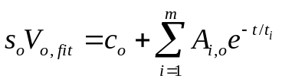 Equation (S1)
where s_{o} is oth singular value,V_{o,fit}(t) are oth rSVs try to fit, t are time delays, c_{n} is constant for V_{o,fit}(t) offset, m is the number of exponential functions, A_{i,o} is amplitude for ith exponential of V_{o,fit}(t), t_{i} is ith sharing relaxation times. The V_{o,fit}(t) are optimized by minimizing discrepancy (quantified by the test function, TF), which is the sum of the every residual between V_{o,fit}(t) and oth rSVs, V_{o}(t), as following:
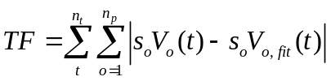 Equation (S2)
To find an appropriate number of exponentials, we performed the fitting by changing the number of exponentials. In the case of Anti-DPyB, the slowest exponential relaxation time did not converge during fitting due to the limited range of time delays, so the slowest relaxation time was fixed to 10 ns. The first four rSVs were simultaneously fitted with a sum of exponential functions with shared relaxation times. A tetra-exponential functions with the shared time constants of 3.6 ± 0.3 ps, 231 ± 19 ps, 1.75 ± 0.12 ns, and >10 ns in n-hexane and 2.8 ± 0.1 ps, 24.3 ± 0.5 ps, 495.7 ± 6.5 ps, and >10 ns in acetonitrile gave satisfactory fits as shown in Figures S11A and S11C, respectively. V_{o,fit}(t) with less than four exponential functions could not provide a satisfactory fit to V_{o} for Anti-DPyB. V_{o,fit}(t) with more than four exponential functions could fit V_{o}, but some exponential time constants show no meaningful difference, indicating that they were overfitted. The obtained relaxation time are 3.6 ± 0.3 ps, 231 ± 19 ps, 1.75 ± 0.12 ns, and >10 ns in n-hexane and 2.8 ± 0.1 ps, 24.3 ± 0.5 ps, 495.7 ± 6.5 ps, and >10 ns in acetonitrile. In the case of Syn-DPyB, the first three rSVs were simultaneously fitted with a sum of exponential functions with shared relaxation times. A tri-exponential functions with the shared time constants of 2.3 ± 0.8 ps, 9.7 ± 0.5 ps, and 6.4 ± 0.2 ns in n-hexane; 2.8 ps, 8.0 ± 0.6 ps, and 4.8 ± 0.2 ns in acetonitrile gave satisfactory fits as shown in Figures S11B and S11D, respectively. V_{o,fit}(t) with less than three exponential functions could not provide a satisfactory fit to V_{o} for Anti-DPyB. V_{o,fit}(t) with more than four exponential functions could fit V_{o}, but some exponential time constants show no meaningful difference, indicating that they were overfitted. As mentioned in the main text, the obtained relaxation time are 2.3 ± 0.8 ps, 9.7 ± 0.5 ps, and 6.4 ± 0.2 ns in n-hexane; 2.8 ps, 8.0 ± 0.6 ps, and 4.8 ± 0.2 ns in acetonitrile.
Kinetic analysis: Using the first a few singular vectors of significant singular values (that is, n_{p} principal singular vectors) obtained from the SVD analysis of the experimental data, we performed kinetic analysis. New matrices, U’, V’, and S’, can be defined by removing non-significant components from U, V, and S, respectively. In other words, U’ is an n_{λ} × n_{p} matrix containing the first n_{p} left singular vectors of U, V’ is an n_{t} × n_{p} matrix containing the first n_{p} right singular vectors of V, and S’ is an n_{p} × n_{p} diagonal matrix containing the first n_{p} singular values of S. Here we represent the time-dependent concentrations of transiently formed intermediate species, which can be calculated from a kinetic model, by a matrix C. Then, the matrix C can be related to V’ by using a parameter matrix P that satisfies V’ = CP, where C is an n_{t} × n_{p} matrix whose columns represent time-dependent concentrations of transiently formed intermediate species and P is an n_{p} × n_{p} matrix whose columns contain coefficients for the time-dependent concentrations so that the linear combination of concentrations of the n_{p} intermediates can form the n_{p} right singular vectors in V’, respectively. Once C is specified by a kinetic model with a certain set of variable kinetic parameters such as rate coefficients, P and C can be optimized by minimizing the discrepancy between V’ (from the experiment) and CP (from the kinetic theory).
Since V’ = CP, the following relationships hold:
A’ = U’S’V’^{T} = U’S’(CP)^{T} = U’S’P^{T}C^{T} = (U’S’P^{T})C^{T} Equation (S3)
where A’ is an n_{λ} × n_{t} matrix that contains the theoretical TA spectrum ΔA(λ_{i},t_{j}) at given λ and t values. Theoretical TA spectra calculated by using Equation (S3) were compared with the experimental TA spectra, and the matrix P and C were optimized by minimizing the discrepancy (quantified by least-square, LS) between the theoretical and experimental TA spectra using the Minuit¹ package:
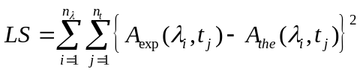 Equation (S4)
ΔA_{exp}(λ_{i},t_{j}) and ΔA_{the}(λ_{i},t_{j}) are the experimental and theoretical TA spectrum at a given point of (λ_{i},t_{j}), respectively. From Equation (S3), we can define a matrix B as B = U’S’P^{T}, that is, a linear combination of the n_{p} left singular vectors in U’ weighted by their singular values in S’ with their ratios determined by P. Then, the matrix E, an n_{t} × n_{p} matrix, contains the n_{p} time-independent TA spectra directly associated with the n_{p} intermediate species. Therefore, by optimizing the matrices P and C, we obtain both the time-dependent concentrations (see the optimized C for the kinetic model in Figures 4C, 4D, 5C and 5D) and the time-independent TA spectra of the intermediate species (see the optimized P for the kinetic model in Figures 4A, 4B, 5A and 5B).
For Anti-DPyB, considering the four exponential time constants obtained from the exponentials fitting of rSVs (Figure S11), the two exponential time-constants from emission experiments (Table 1) and five principal components from SVD analysis results (Figures S9), we decide to use the kinetic model with six time constants and five intermediate in Figure 6A. For Syn-DPyB, considering the three exponential time-constants obtained from the exponentials fitting of rSVs (Figure S11), the two exponential time constants from emission experiments (Table 1), and four principal components from SVD analysis results (Figures S10), we decide to use the kinetic model of reaction 4 in scheme 1 with five time constants and four intermediate.

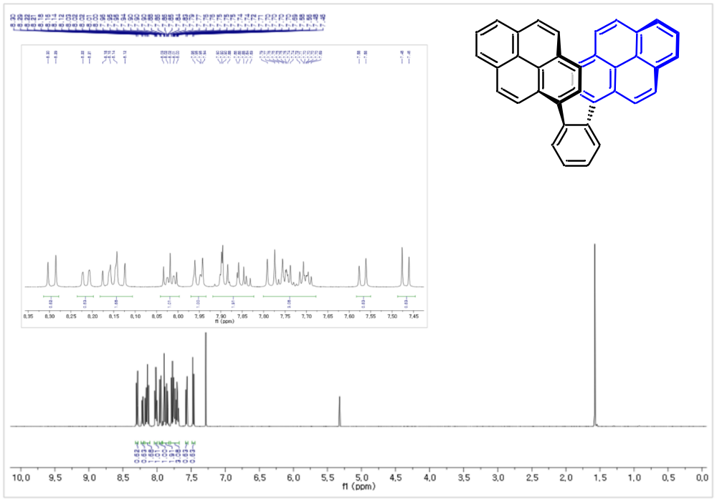

Figure S2. ¹H-NMR spectrum of Anti-DPyB in CDCl₃.

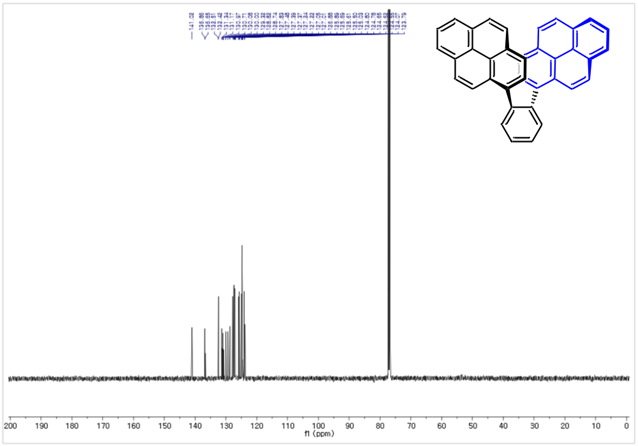

Figure S3. ¹³C-NMR spectrum of Anti-DPyB in CDCl₃.

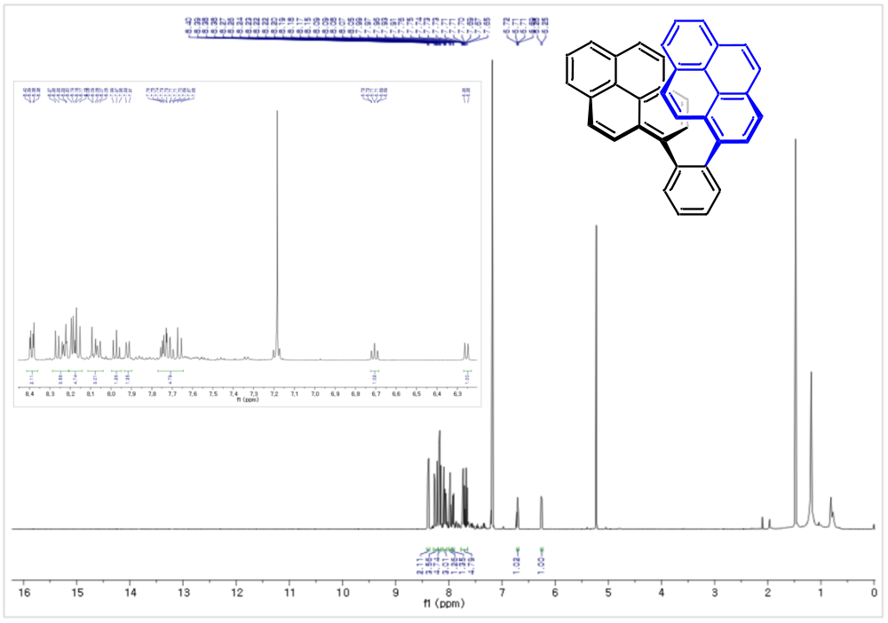

Figure S4. ¹H-NMR spectrum of Syn-DPyB in CDCl₃.

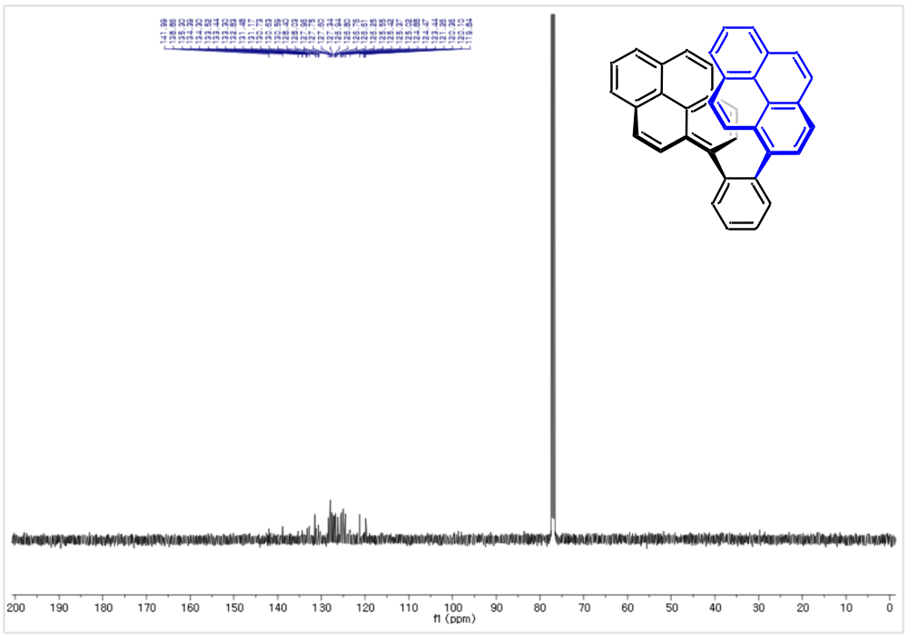

Figure S5. ¹³C-NMR spectrum of Syn-DPyB in CDCl₃.

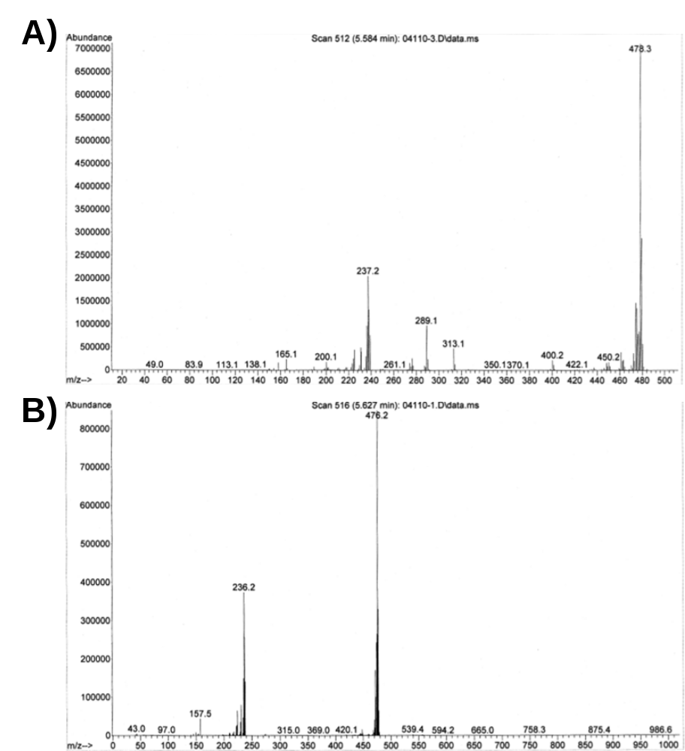

Figure S6. GC-MS data of (A) Anti-DPyB and (B) Syn-DpyB.

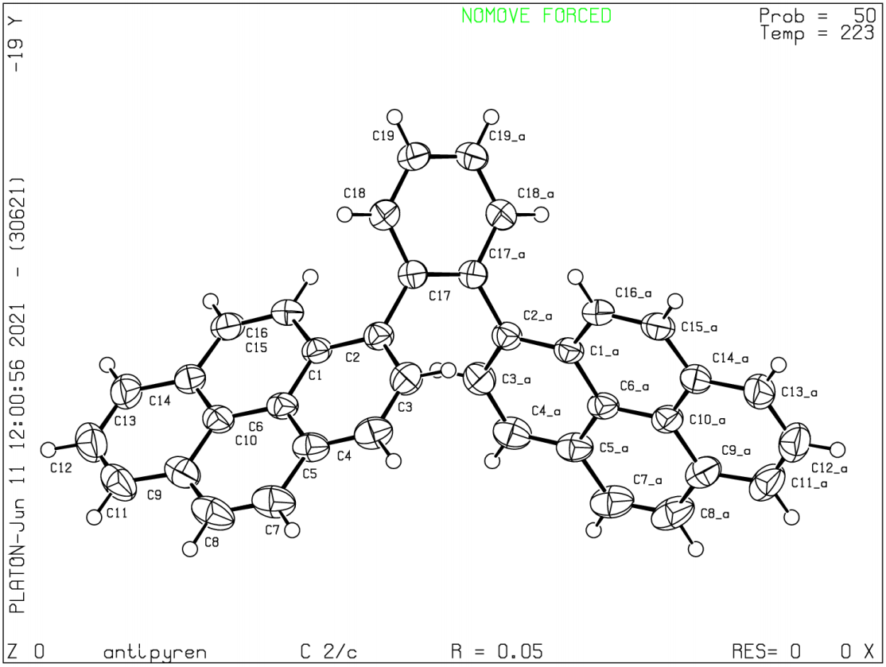

Figure S7. Thermal ellipsoid plot of Anti-DPyB.

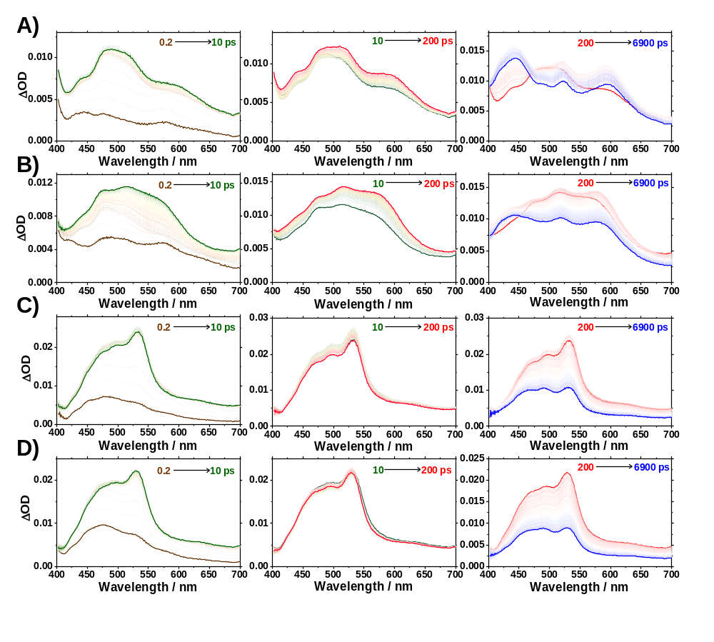

Figure S8. Transient absorption spectra. (A, B) Transient absorption spectra of Anti-DPyB in n-hexane and acetonitrile, respectively. (C, D) Transient absorption spectra of Syn-DPyB in n-hexane and acetonitrile, respectively.

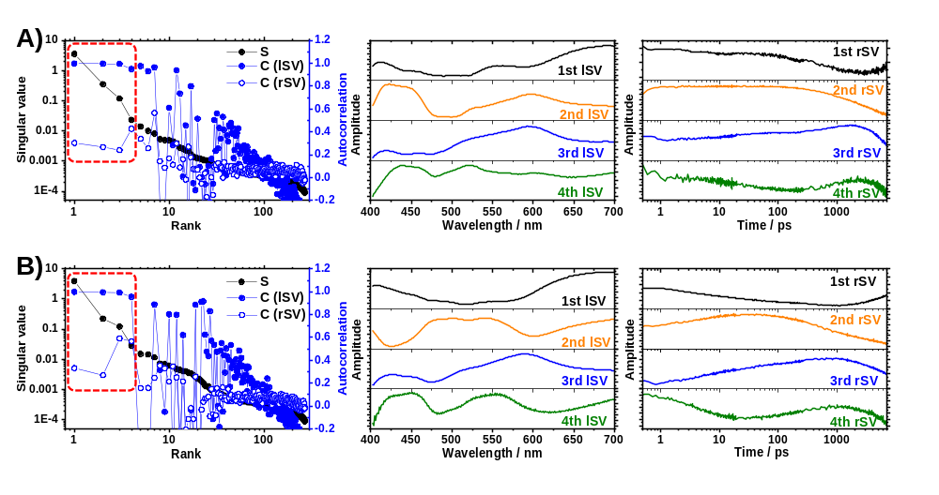

Figure S9. Singular value decomposition (SVD) analysis for the time-resolved TA spectra of Anti-DPyB in (A) n-hexane and (B) acetonitrile. Singular values and autocorrelations of lSVs and rSVs (left), the first four lSVs (middle), and the first four rSVs (right). Considering rSVs, lSVs, singular values, the number of principal components is considered five.

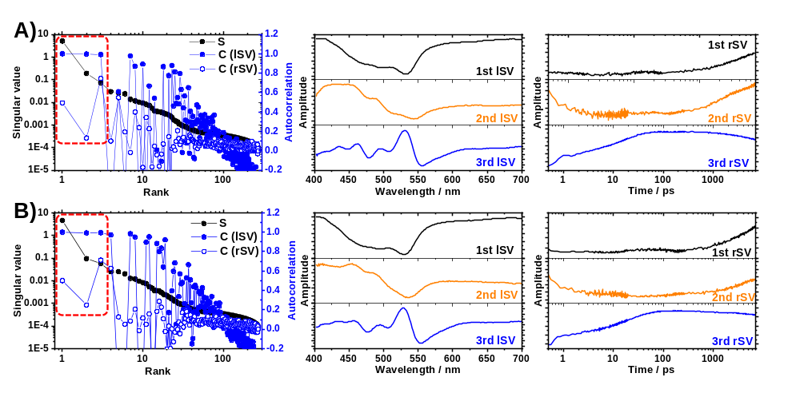

Figure S10. Singular value decomposition (SVD) analysis for the time-resolved TA spectra of Syn-DPyB in (A) n-hexane and (B) acetonitrile. Singular values and autocorrelations of lSVs and rSVs (left), the first four lSVs (middle), and the first four rSVs (right). Considering rSVs, lSVs, singular values, the number of principal components is considered four.

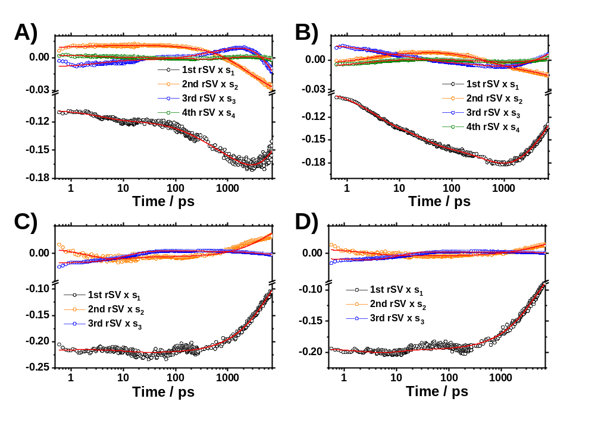

Figure S11. Singular values weighted rSVs exponential fitting results for Anti-DPyB in (A) n-hexane and (B) acetonitrile and Syn-DPyB in (C) n-hexane and (D) acetonitrile. The Singular values weighted rSVs were globally fitted by exponential functions. The number of exponentials (four exponentials for Anti-DPyB, three exponentials for Syn-DPyB) and constants are shown in Table 2.

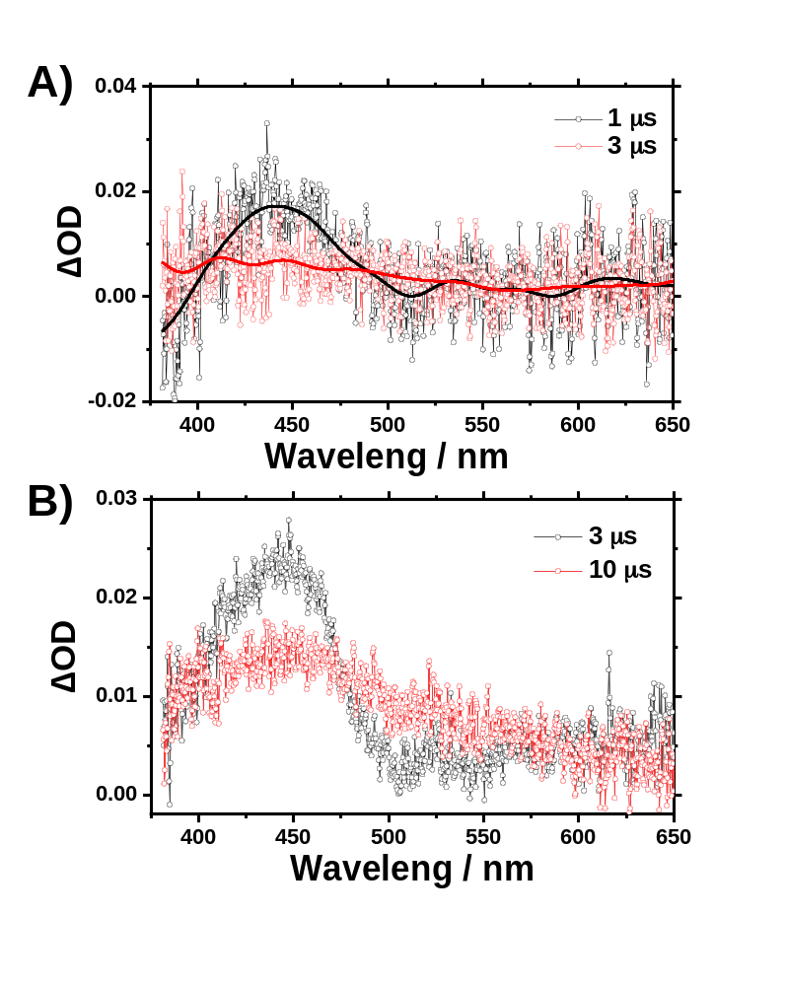

Figure S12. Nanosecond transient absorption spectra of Anti-DPyB in (A) n-hexane and (B) acetonitrile.

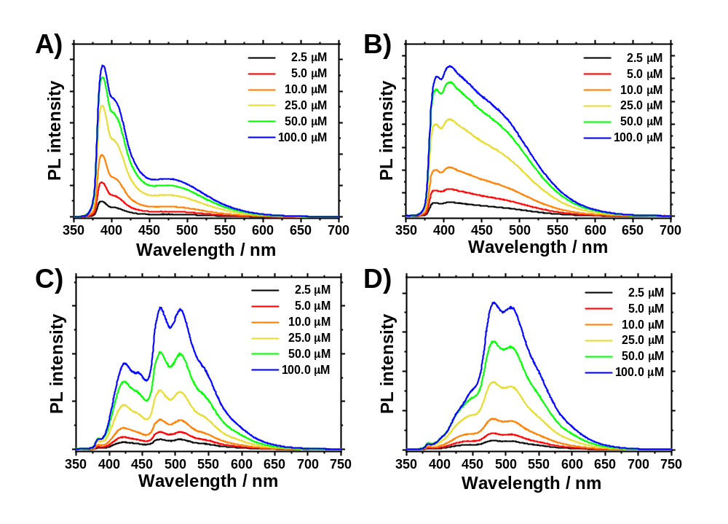

Figure S13. Concentration dependence of the emission spectra. Concentration dependence of the emission spectra of Anti-DPyB in (A) n-hexane and (B) acetonitrile and Syn-DPyB in (C) n-hexane and (D) acetonitrile.

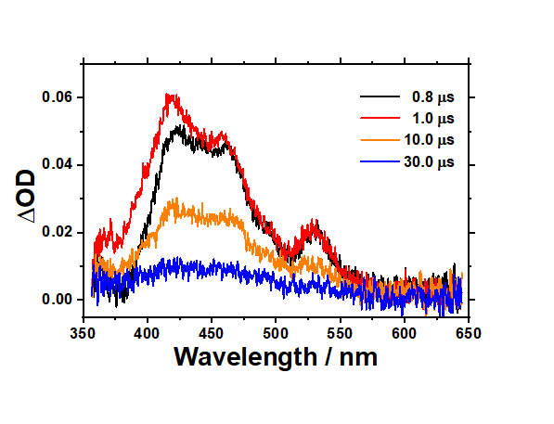
Figure S14. Nanosecond transient absorption spectra of 1-(2-bromophenyl)pyrene in dichloromethane (DCM).

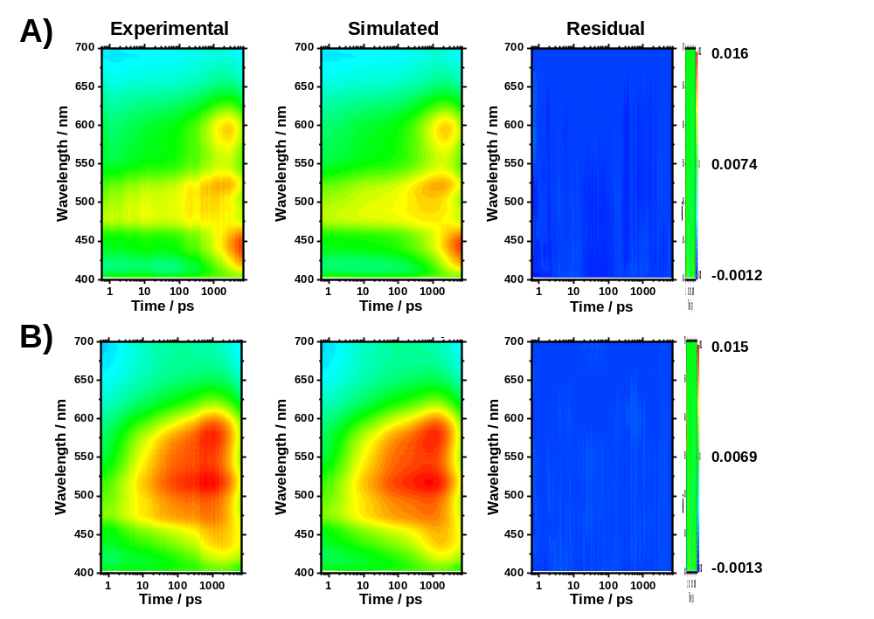

Figure S15. Time-resolved TA spectra analysis with kinetic models (reaction 2). The experimental TA spectra (left), the simulated spectra (middle) by a linear combination of the five SADS curves according to reaction (2), and residuals (right) for Anti-DPyB in (A) n-hexane and (B) acetonitrile.

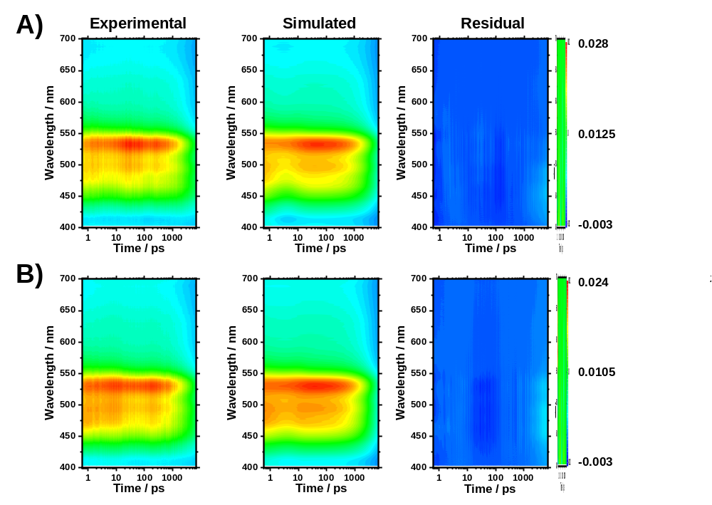

Figure S16. Time-resolved TA spectra analysis with kinetic models (reaction 4). The experimental TA spectra (left), the simulated spectra (middle) by a linear combination of the four SADS curves according to reaction (4), and residuals (right) for Syn-DPyB in (A) n-hexane and (B) acetonitrile.

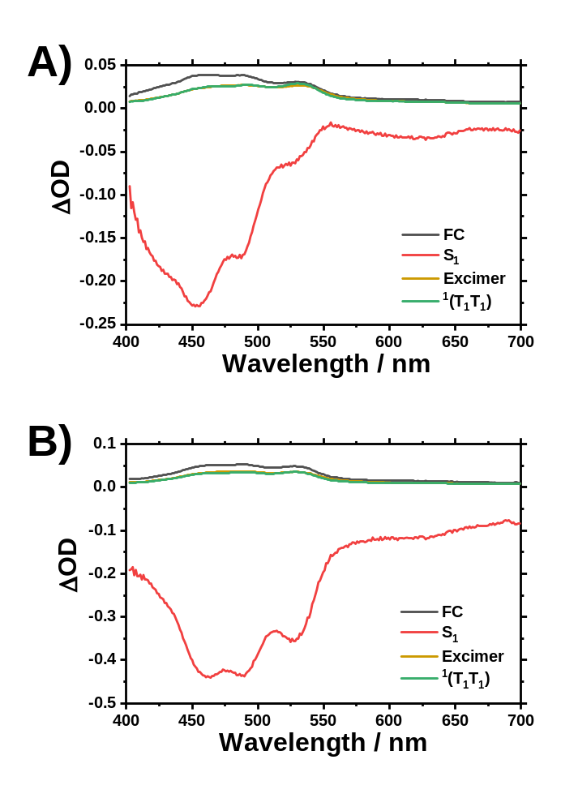

Figure S17. Species-associated difference spectra of Syn-DPyB obtained from the kinetic model for reaction 3 in (A) n-hexane and (B) acetonitrile.

Table S1. Crystal data and structure refinement for Anti-DPyB

Comp. | Anti-DPyB
CCDC number | 2089494
Empirical formula | C₃₈H₂₂
Formula weight | 478.55
Temperature | 223(2) K
Wavelength | 0.71073 Å
Crystal system | Monoclinic
Space group | C₂/c
Unit cell dimensions | a = 22.365(2) Å | α= 90°
Unit cell dimensions | b = 9.3901(7) Å | β= 115.885(3)°
Unit cell dimensions | c = 12.9994(13) Å | γ= 90°
Volume | 2456.1(4) Å³
Z | 4
Density (calculated) | 1.294 Mg/m³
Absorption coefficient | 0.073 mm⁻¹
F(000) | 1000
Crystal size | 0.320 x 0.240 x 0.120 mm³
θ range for data collection | 2.688 to 28.506°
Index ranges | -29<=h<=29, -12<=k<=12, -17<=l<=17
Reflections collected | 40705
Independent reflections | 3076 [R(int) = 0.0644]
Completeness to θ = 25.242° | 99.5 %
Absorption correction | Semi-empirical from equivalents
Max. and min. transmission | 0.7457 and 0.6261
Refinement method | Full-matrix least-squares on F²
Data / restraints / parameters | 3076 / 0 / 172
Goodness-of-fit on F² | 1.064
Final R indices [I>2σ(I)] | R₁ = 0.0478, wR₂ = 0.1178
R indices (all data) | R₁ = 0.0727, wR₂ = 0.1377
Extinction coefficient | n/a
Largest diff. peak and hole | 0.169 and -0.187 e. Å⁻³

Table S2. Atomic coordinates ( x 10⁴) and equivalent isotropic displacement parameters (Å 2 x 10³) for Anti-DPyB. U(eq) is defined as one third of the trace of the orthogonalized Uij tensor
 | X | Y | Z | U(eq)
C(1) | 3734(1) | 5147(1) | 1909(1) | 36(1)
C(2) | 4392(1) | 5463(1) | 2694(1) | 38(1)
C(3) | 4729(1) | 4530(2) | 3597(1) | 46(1)
C(4) | 4423(1) | 3340(2) | 3770(1) | 51(1)
C(5) | 3763(1) | 3031(2) | 3048(1) | 45(1)
C(6) | 3414(1) | 3935(1) | 2100(1) | 38(1)
C(7) | 3413(1) | 1837(2) | 3221(2) | 60(1)
C(8) | 2772(1) | 1589(2) | 2521(2) | 63(1)
C(9) | 2403(1) | 2483(2) | 1567(2) | 51(1)
C(10) | 2735(1) | 3645(2) | 1345(1) | 41(1)
C(11) | 1728(1) | 2259(2) | 836(2) | 64(1)
C(12) | 1393(1) | 3135(2) | -84(2) | 65(1)
C(13) | 1716(1) | 4249(2) | -316(2) | 56(1)
C(14) | 2386(1) | 4522(2) | 383(1) | 44(1)
C(15) | 2737(1) | 5671(2) | 172(1) | 47(1)
C(16) | 3370(1) | 5978(2) | 897(1) | 42(1)
C(17) | 4716(1) | 6810(2) | 2594(1) | 39(1)
C(18) | 4450(1) | 8114(2) | 2714(2) | 50(1)
C(19) | 4728(1) | 9390(2) | 2619(2) | 56(1)

Table S3. Bond lengths [Å] and angles [°] for Anti-DpyB

C(1)-C(2) | 1.4094(19)  1.4225(19)  1.438(2)  1.393(2)  1.4914(19)  1.380(2)  0.9400  1.391(2)  0.9400  1.418(2)  1.439(2)  1.428(2)  1.342(3)  0.9400  1.424(3)  0.9400  1.404(3)  1.419(2)  1.414(2)  1.373(3)  0.9400  1.377(3)  0.9400  1.396(2)  0.9400  1.429(2)  1.346(2)  0.9400  0.9400  1.396(3)  1.399(2)  1.381(2)  0.9400  1.378(4)  0.9400  119.25(13)  122.87(13)  117.87(13)  119.18(13)  120.17(13)  120.59(12)  121.50(15)  119.3  119.3  121.02(15)  119.5  119.5  118.76(14)  123.10(15)  118.13(15)  120.16(13)  120.00(13)  119.83(13)  121.49(17)  119.3  119.3  121.97(16)  119.0  119.0  118.72(18)  122.96(16)  118.32(16)  119.52(15)  120.46(13)  120.01(15)  121.11(17)  119.4  119.4  120.43(18)  119.8  119.8  120.93(19)  119.5  119.5  119.27(15)  122.52(16)  118.20(14)  121.70(15)  119.1  119.1  121.71(14)  119.1  119.1  118.93(9)  121.93(7)  119.13(13)  121.26(15)  119.4  119.4  119.76(10)  120.1
C(1)-C(6)
C(1)-C(16)
C(2)-C(3)
C(2)-C(17)
C(3)-C(4)
C(3)-H(3)
C(4)-C(5)
C(4)-H(4)
C(5)-C(6)
C(5)-C(7)
C(6)-C(10)
C(7)-C(8)
C(7)-H(7)
C(8)-C(9)
C(8)-H(8)
C(9)-C(11)
C(9)-C(10)
C(10)-C(14)
C(11)-C(12)
C(11)-H(11)
C(12)-C(13)
C(12)-H(12)
C(13)-C(14)
C(13)-H(13)
C(14)-C(15)
C(15)-C(16)
C(15)-H(15)
C(16)-H(16)
C(17)-C(17)#1
C(17)-C(18)
C(18)-C(19)
C(18)-H(18)
C(19)-C(19)#1
C(19)-H(19)
C(2)-C(1)-C(6)
C(2)-C(1)-C(16)
C(6)-C(1)-C(16)
C(3)-C(2)-C(1)
C(3)-C(2)-C(17)
C(1)-C(2)-C(17)
C(4)-C(3)-C(2)
C(4)-C(3)-H(3)
C(2)-C(3)-H(3)
C(3)-C(4)-C(5)
C(3)-C(4)-H(4)
C(5)-C(4)-H(4)
C(4)-C(5)-C(6)
C(4)-C(5)-C(7)
C(6)-C(5)-C(7)
C(5)-C(6)-C(1)
C(5)-C(6)-C(10)
C(1)-C(6)-C(10)
C(8)-C(7)-C(5)
C(8)-C(7)-H(7)
C(5)-C(7)-H(7)
C(7)-C(8)-C(9)
C(7)-C(8)-H(8)
C(9)-C(8)-H(8)
C(11)-C(9)-C(10)
C(11)-C(9)-C(8)
C(10)-C(9)-C(8)
C(14)-C(10)-C(9)
C(14)-C(10)-C(6)
C(9)-C(10)-C(6)
C(12)-C(11)-C(9)
C(12)-C(11)-H(11)
C(9)-C(11)-H(11)
C(11)-C(12)-C(13)
C(11)-C(12)-H(12)
C(13)-C(12)-H(12)
C(12)-C(13)-C(14)
C(12)-C(13)-H(13)
C(14)-C(13)-H(13)
C(13)-C(14)-C(10)
C(13)-C(14)-C(15)
C(10)-C(14)-C(15)
C(16)-C(15)-C(14)
C(16)-C(15)-H(15)
C(14)-C(15)-H(15)
C(15)-C(16)-C(1)
C(15)-C(16)-H(16)
C(1)-C(16)-H(16)
C(17)#1-C(17)-C(18)
C(17)#1-C(17)-C(2)
C(18)-C(17)-C(2)
C(19)-C(18)-C(17)
C(19)-C(18)-H(18)
C(17)-C(18)-H(18)
C(19)#1-C(19)-C(18)
C(19)#1-C(19)-H(19)
Symmetry transformations used to generate equivalent atoms:
#1 -x+1, y, -z+1/2

Table S4. Anisotropic displacement parameters (Å 2 x 10³) for Anti-DPyB. The anisotropic displacement factor exponent takes the form: -2 [ h a*U¹¹ + ... + 2 h k a* b* U¹²]
 | U11 | U22 | U33 | U23 | U13 | U12
C(1) | 41(1) | 29(1) | 43(1) | -1(1) | 22(1) | 2(1)
C(2) | 41(1) | 34(1) | 42(1) | -1(1) | 22(1) | 1(1)
C(3) | 46(1) | 47(1) | 44(1) | 2(1) | 18(1) | 4(1)
C(4) | 65(1) | 46(1) | 43(1) | 11(1) | 26(1) | 7(1)
C(5) | 62(1) | 37(1) | 47(1) | 3(1) | 34(1) | 0(1)
C(6) | 46(1) | 31(1) | 45(1) | -3(1) | 28(1) | 0(1)
C(7) | 87(1) | 46(1) | 60(1) | 9(1) | 46(1) | -5(1)
C(8) | 87(1) | 51(1) | 73(1) | -4(1) | 55(1) | -22(1)
C(9) | 61(1) | 44(1) | 66(1) | -15(1) | 44(1) | -13(1)
C(10) | 47(1) | 34(1) | 54(1) | -12(1) | 32(1) | -4(1)
C(11) | 63(1) | 60(1) | 90(1) | -28(1) | 54(1) | -24(1)
C(12) | 47(1) | 68(1) | 87(1) | -30(1) | 36(1) | -12(1)
C(13) | 43(1) | 54(1) | 67(1) | -18(1) | 21(1) | 0(1)
C(14) | 43(1) | 37(1) | 54(1) | -12(1) | 23(1) | 1(1)
C(15) | 49(1) | 33(1) | 51(1) | -1(1) | 15(1) | 4(1)
C(16) | 46(1) | 29(1) | 50(1) | 2(1) | 20(1) | 0(1)
C(17) | 37(1) | 35(1) | 43(1) | 0(1) | 14(1) | 0(1)
C(18) | 42(1) | 41(1) | 64(1) | -5(1) | 22(1) | 3(1)
C(19) | 45(1) | 34(1) | 74(1) | -5(1) | 13(1) | 4(1)

Table S5. Hydrogen coordinates ( x 10⁴) and isotropic displacement parameters (Å 2 x 10³) for Anti-DPyB

 | x | y | z | U(eq)
H(3) | 5175 | 4716 | 4100 | 55
H(4) | 4664 | 2729 | 4386 | 61
H(7) | 3639 | 1217 | 3837 | 71
H(8) | 2559 | 803 | 2664 | 76
H(11) | 1502 | 1497 | 979 | 76
H(12) | 940 | 2974 | -558 | 78
H(13) | 1482 | 4834 | -953 | 67
H(15) | 2520 | 6227 | -490 | 56
H(16) | 3581 | 6757 | 737 | 50
H(18) | 4075 | 8121 | 2863 | 60
H(19) | 4548 | 10256 | 2716 | 67

Table S6. Torsion angles [°] for Anti-DpyB

C(6)-C(1)-C(2)-C(3) | 4.1(2)
C(16)-C(1)-C(2)-C(3) | -174.22(13)
C(6)-C(1)-C(2)-C(17) | -173.05(12)
C(16)-C(1)-C(2)-C(17) | 8.6(2)
C(1)-C(2)-C(3)-C(4) | -3.0(2)
C(17)-C(2)-C(3)-C(4) | 174.17(14)
C(2)-C(3)-C(4)-C(5) | -0.3(2)
C(3)-C(4)-C(5)-C(6) | 2.3(2)
C(3)-C(4)-C(5)-C(7) | -177.33(15)
C(4)-C(5)-C(6)-C(1) | -1.1(2)
C(7)-C(5)-C(6)-C(1) | 178.56(13)
C(4)-C(5)-C(6)-C(10) | -179.89(13)
C(7)-C(5)-C(6)-C(10) | -0.2(2)
C(2)-C(1)-C(6)-C(5) | -2.1(2)
C(16)-C(1)-C(6)-C(5) | 176.31(13)
C(2)-C(1)-C(6)-C(10) | 176.69(12)
C(16)-C(1)-C(6)-C(10) | -4.88(19)
C(4)-C(5)-C(7)-C(8) | 178.47(17)
C(6)-C(5)-C(7)-C(8) | -1.2(2)
C(5)-C(7)-C(8)-C(9) | 0.5(3)
C(7)-C(8)-C(9)-C(11) | -178.80(17)
C(7)-C(8)-C(9)-C(10) | 1.6(3)
C(11)-C(9)-C(10)-C(14) | -1.6(2)
C(8)-C(9)-C(10)-C(14) | 178.05(14)
C(11)-C(9)-C(10)-C(6) | 177.42(13)
C(8)-C(9)-C(10)-C(6) | -3.0(2)
C(5)-C(6)-C(10)-C(14) | -178.72(13)
C(1)-C(6)-C(10)-C(14) | 2.5(2)
C(5)-C(6)-C(10)-C(9) | 2.3(2)
C(1)-C(6)-C(10)-C(9) | -176.49(13)
C(10)-C(9)-C(11)-C(12) | 0.5(2)
C(8)-C(9)-C(11)-C(12) | -179.11(17)
C(9)-C(11)-C(12)-C(13) | 0.7(3)
C(11)-C(12)-C(13)-C(14) | -0.7(3)
C(12)-C(13)-C(14)-C(10) | -0.4(2)
C(12)-C(13)-C(14)-C(15) | -179.73(15)
C(9)-C(10)-C(14)-C(13) | 1.5(2)
C(6)-C(10)-C(14)-C(13) | -177.46(13)
C(9)-C(10)-C(14)-C(15) | -179.10(13)
C(6)-C(10)-C(14)-C(15) | 1.9(2)
C(13)-C(14)-C(15)-C(16) | 175.41(15)
C(10)-C(14)-C(15)-C(16) | -4.0(2)
C(14)-C(15)-C(16)-C(1) | 1.5(2)
C(2)-C(1)-C(16)-C(15) | -178.65(14)
C(6)-C(1)-C(16)-C(15) | 3.0(2)
C(3)-C(2)-C(17)-C(17)#1 | 64.4(2)
C(1)-C(2)-C(17)-C(17)#1 | -118.42(19)
C(3)-C(2)-C(17)-C(18) | -114.31(17)
C(1)-C(2)-C(17)-C(18) | 62.83(19)
C(17)#1-C(17)-C(18)-C(19) | 1.8(3)
C(2)-C(17)-C(18)-C(19) | -179.44(16)
C(17)-C(18)-C(19)-C(19)#1 | 1.2(3)
Symmetry transformations used to generate equivalent atoms:
#1 -x+1, y, -z+1/2

References
1. SMART and SAINT; Bruker Analytical X-ray Division: Madison, WI, 2002. (52) Sheldrick, G. M. SHELXTL-PLUS Software Package; Bruker Analytical X-ray Division: Madison, WI, 2002.
2. Sheldrick, G. M. SHELXTL-PLUS Software Package; Bruker Analytical X-ray Division: Madison, WI, 2002.

