Supplementary method
Study Design and Data Source
This study utilized data from the FDA Adverse Event Reporting System (FAERS), a global spontaneous reporting system that collects suspected adverse drug reaction (ADR) reports from diverse reporters, including healthcare professionals, patients and their families, lawyers, and manufacturers^{[1]}. The FAERS data are publicly accessible via a user-friendly dashboard or through raw quarterly data downloads in ASCII or XML formats.
Given the timeline of secukinumab's market introduction, we extracted and merged the ASCII files from the FAERS database covering the period from the first quarter of 2015 to the first quarter of 2024^{[2]}. Data processing was conducted using R 4.4.0 software, following the overall study workflow illustrated in Supplementary Figure 1. This study adhered to the READUS-PV reporting guidelines^{[3]}.
Data Processing and Filtering
To ensure data integrity, duplicate reports were removed. For records in the DEMO table with the same caseid, only the most recent report, based on the date, was retained. Relationships between datasets were established using the primaryid field. Drug names were standardized using the MedEx_UIMA_1.8.3 system. For the preliminary screening, preferred terms (PTs) with a report count of ≥2 were selected. Suspected ADRs were encoded, categorized, and analyzed using the PTs and System Organ Classes (SOC) from version 26.1 of the Medical Dictionary for Regulatory Activities (MedDRA®) to identify the specific SOCs involved in the adverse event signals^{[4]}.
Data Analysis
In our study, commonly used disproportionality analyses in pharmacovigilance research were employed to identify potential signals between secukinumab and adverse events (AEs)^{[5]}. Continuous variables were presented as medians with interquartile ranges (IQRs), while categorical variables were expressed as percentages.
The disproportionality measures applied included the Reporting Odds Ratio (ROR), Proportional Reporting Ratio (PRR), Bayesian Confidence Propagation Neural Network (BCPNN), and Empirical Bayes Geometric Mean (EBGM)^{[1,6–8]}. These measures help compare the observed frequency ratios in exposed versus non-exposed populations using 2x2 contingency tables (Supplementary Table 1). By employing a combination of these algorithms, we aimed to detect more comprehensive and reliable signals, leveraging the unique characteristics of each method. Specific formulas and thresholds are detailed in Supplementary Table 2.
Basic Characteristics of Secukinumab-Related ADEs
In the AERs involving secukinumab, both overall and specifically for immune system-related events, the number and proportion of female patients were significantly higher than those of male patients (66.02% vs. 30.68%; 56.89% vs. 37.76%). A substantial amount of data (54.41%) did not provide age information, which was similarly observed in the overall group (63.58%). Among the recorded age data, the largest proportion of reports in both groups fell within the 45-65 age range. Most reports in both groups were submitted by consumers, with the majority of AERs originating from the United States. The most common route of administration was subcutaneous injection, and hospitalization due to drug-related adverse events was the most frequent outcome. Notably, the median time between the occurrence of the adverse event and the medication date was 30 days and 49 days, respectively, in the two groups. Additionally, there were differences in weight between the two groups, with median weights of 78 kg and 84 kg, respectively (Supplementary Table 3).

Reference
1. Sakaeda T, Tamon A, Kadoyama K, Okuno Y. Data mining of the public version of the FDA Adverse Event Reporting System. Int J Med Sci. 2013;10: 796–803. doi:10.7150/ijms.6048
2. [PDF] Data Mining Techniques in Pharmacovigilance: Analysis of the Publicly Accessible FDA Adverse Event Reporting System (AERS) | Semantic Scholar. [cited 24 Aug 2024]. Available: https://www.semanticscholar.org/paper/Data-Mining-Techniques-in-Pharmacovigilance%3A-of-the-Poluzzi-Raschi/3a9433ea1de084873edb866a96cd5e80c906e31e
3. Fusaroli M, Salvo F, Begaud B, AlShammari TM, Bate A, Battini V, et al. The REporting of A Disproportionality Analysis for DrUg Safety Signal Detection Using Individual Case Safety Reports in PharmacoVigilance (READUS-PV): Explanation and Elaboration. Drug Saf. 2024;47: 585–599. doi:10.1007/s40264-024-01423-7
4. Using MedDRA | Drug Safety. [cited 24 Aug 2024]. Available: https://link.springer.com/article/10.2165/00002018-200427080-00010
5. Raschi E, Gatti M, Gelsomino F, Ardizzoni A, Poluzzi E, De Ponti F. Lessons to be Learnt from Real-World Studies on Immune-Related Adverse Events with Checkpoint Inhibitors: A Clinical Perspective from Pharmacovigilance. Target Oncol. 2020;15: 449–466. doi:10.1007/s11523-020-00738-6
6. Bate A, Lindquist M, Edwards IR, Olsson S, Orre R, Lansner A, et al. A Bayesian neural network method for adverse drug reaction signal generation. Eur J Clin Pharmacol. 1998;54: 315–321. doi:10.1007/s002280050466
7. Dumouchel W. Bayesian Data Mining in Large Frequency Tables, with an Application to the FDA Spontaneous Reporting System. The American Statistician. 1999;53: 177–190. doi:10.1080/00031305.1999.10474456
8. Fornaro M, Fusco A, Anastasia A, Cattaneo CI, Berardis DD. Brexpiprazole for treatment-resistant major depressive disorder. Expert Opinion on Pharmacotherapy. 2019 [cited 24 Aug 2024]. Available: https://www.tandfonline.com/doi/abs/10.1080/14656566.2019.1654457

Supplementary Figure 1
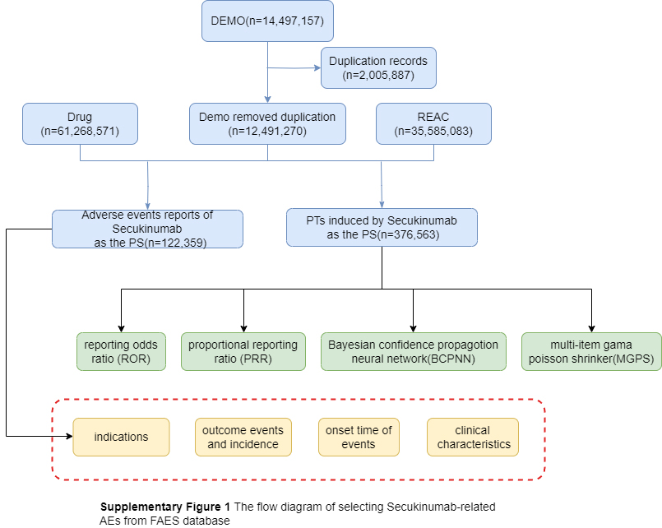
Supplementary Figure 2 Yearly Distribution of Secukinumab-Related Adverse Event Reports in FAERS (2015-2024)
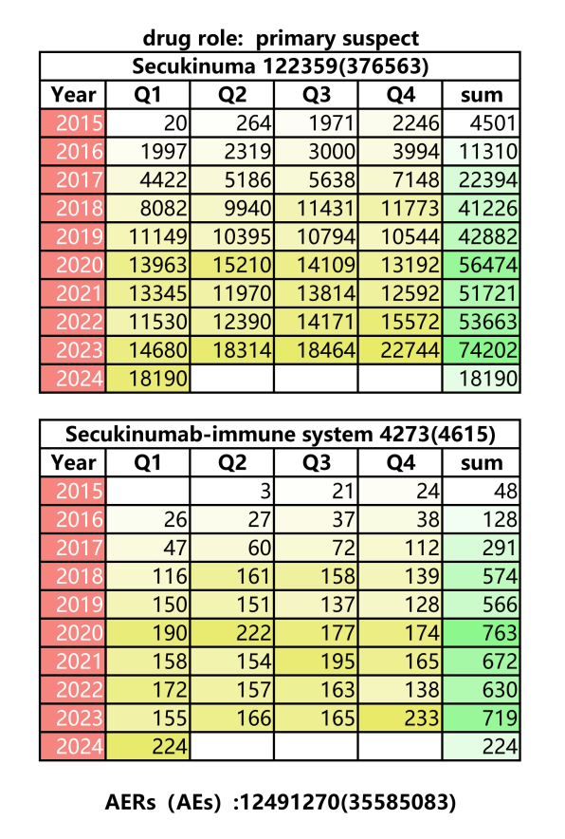
Notes：The top table shows the total number of AERs (AE) where secukinumab was the primary suspect drug, while the bottom table focuses specifically on immune system-related AERs (AE) .
Abbreviations: AERs, adverse event reports; AE, adverse event;

Table S1 Two-by-two contingency (2×2) table for disproportionality analyses.
 | Target AEs | Non-Target AEs | Total
Secukinumab | a | b | a+b
Non-Secukinumab | c | d | c+d
Total | a+c | b+d | N=a+b+c+d

Abbreviations: AEs; adverse events

Table S2 Four different types of disproportionality analysis.

Algorithms |  | Equation | Criteria
ROR | ROR = (a/c)/(b/d)  95%CI=eln(ROR)±1.96(1/a+1/b+1/c+1/d)^0.5 |  | 95% CI (lower limit) > 1, a ≥ 3
PRR |  | PRR=[a/(a+b)]/[c/(c+d)]  χ² =[(ad-bc)² (a+b + c + d)] / [(a+b) (c + d) (a+c) (b + d)] | PRR ≥ 2, χ² ≥ 4, a ≥ 3
BCPNN  MGPS |  | IC=log₂a(a+b+c+d)/((a+c) (a+b))  IC025=eln(IC)−1.96(1/a+1/b+1/c+1/d)^0.5  EBGM=a(a+b+c+d)/((a+c) (a+b))  EBGM05=eln(EBGM)−1.64(1/a+1/b+1/c+1/d)^0.5 | IC025 > 0, a ≥ 3  EBGM05 > 2, a＞0

Notes: Equation: a, number of reports containing both the target drug and the target adverse drug reaction; b, number of reports containing other adverse drug reactions of the target drug; c, number of reports containing the target adverse drug reaction of other drugs; d, number of reports containing other drugs and other adverse drug reactions. The MGPS employs an empirical Bayesian approach, whereby maximum likelihood estimates obtain a prior distribution, and the prior and likelihood are combined to obtain a posterior distribution. The fifth percentile of the posterior distribution is denoted by “EBGM05” and is interpreted as the one-sided 95% confidence lower bound for the EBGM. Abbreviations: ROR, reporting odds ratio; CI, confidence interval; χ2, chi-squared. PRR, proportional reporting ratio; BCPNN, Bayesian confidence propagation neural network; IC, information component; IC025, the lower limit of the 95% CI of the IC; MGPS, multiple gamma Poisson shrinkage; EBGM, empirical Bayesian geometric mean; EBGM05, empirical Bayesian geometric mean lower 95% CI for the posterior distribution.

Table S3 The characteristics of secukinumab associated with immune system diseases.
Characteristics | Target PT | Overall
 | (N=4273) | (N=122359)
Sex
Female | 2821(66.02) | 69605(56.89)
Male | 1311(30.68) | 46203(37.76)
Missing | 141(3.30) | 6551(5.35)
Age (IQR, years) | 51.00(42.00,60.00) | 54.00(43.00,62.00)
Age (years)
<18 | 9(0.21) | 300(0.25)
18-45 | 672(15.73) | 12242(10.00)
45-65 | 986(23.08) | 23286(19.03)
65-75 | 236(5.52) | 6418(5.25)
>=75 | 45(1.05) | 2316(1.89)
Missing | 2325(54.41) | 77797(63.58)
Weight (IQR, kg) | 78.00(68.00,95.25) | 84.00(69.39,100.43)
Reporters
Consumer | 2856(66.84) | 78624(64.26)
Pharmacist | 611(14.30) | 14069(11.50)
Physician | 565(13.22) | 17000(13.89)
health-professional | 187(4.38) | 7973( 6.52)
Reported countries
Argentina | 65(1.52) | 689(0.56)
Brazil | 270(6.32) | 1329(1.09)
Canada | 457(10.70) | 4288(3.50)
United States | 1463(34.24) | 58407(47.73)
Route
subcutaneous | 2592(60.66) | 74238(60.67)
endocervical | 29(0.68) | 73(0.06)
intramuscular | 17(0.40) | 572(0.47)
intravenous | 13(0.30) | 396(0.32)
Serious outcomes
death | 110(3.36) | 2800(6.09)
disability | 177(5.41) | 1042(2.27)
hospitalization | 727(22.23) | 11246(24.45)
life threatening | 250(7.65) | 1350(2.94)
Adverse event occurrence time-medication date(IQR, days) | 30.00(1.00,206.50) | 49.00(2.00,231.00)

This table displays basic information on reports of associated immune system diseases adverse events caused by the use of secukinumab. Continuous variables were presented as medians with interquartile ranges (IQRs), while categorical variables were expressed as percentages.

Table S4 Preferred Term (PT) level for immune-related reactions
soc | pt | Case Reports | ROR(95% CI) | PRR(95% CI) | chisq | IC(IC025) | EBGM(EBGM05)
immune system disorders | hypersensitivity | 1845 | 1.88(1.78, 2) | 1.53(1.47, 1.59) | 452.8 | 0.61(0.53) | 1.52(1.45)
immune system disorders | decreased immune responsiveness | 708 | 12.77(11.74, 13.89) | 10.97(10.14, 11.86) | 5839.07 | 3.31(3.19) | 9.93(9.26)
immune system disorders | drug hypersensitivity | 640 | 0.33(0.3, 0.36) | 0.42(0.39, 0.45) | 737.83 | -1.23(-1.35) | 0.43(0.4)
immune system disorders | immune system disorder | 274 | 3.3(2.91, 3.73) | 3.16(2.81, 3.55) | 399.4 | 1.63(1.45) | 3.09(2.79)
immune system disorders | immunodeficiency | 199 | 1.99(1.72, 2.3) | 1.95(1.7, 2.24) | 91.83 | 0.95(0.74) | 1.93(1.71)
immune system disorders | autoimmune disorder | 166 | 3.05(2.61, 3.58) | 2.98(2.55, 3.49) | 214.52 | 1.55(1.32) | 2.92(2.56)
immune system disorders | immunosuppression | 153 | 2.88(2.45, 3.4) | 2.82(2.41, 3.3) | 176.95 | 1.47(1.23) | 2.77(2.42)
immune system disorders | seasonal allergy | 137 | 1.41(1.19, 1.67) | 1.39(1.19, 1.63) | 15.43 | 0.47(0.23) | 1.39(1.2)
immune system disorders | anaphylactic reaction | 111 | 0.33(0.27, 0.39) | 0.34(0.29, 0.41) | 149.61 | -1.53(-1.8) | 0.35(0.29)
immune system disorders | rubber sensitivity | 60 | 5.9(4.54, 7.68) | 5.84(4.53, 7.53) | 227.28 | 2.48(2.1) | 5.56(4.46)
immune system disorders | sarcoidosis | 42 | 1.52(1.12, 2.07) | 1.52(1.13, 2.04) | 7.38 | 0.6(0.16) | 1.51(1.17)
immune system disorders | food allergy | 38 | 0.85(0.62, 1.17) | 0.85(0.62, 1.16) | 0.96 | -0.23(-0.68) | 0.85(0.65)
immune system disorders | anaphylactic shock | 31 | 0.21(0.15, 0.3) | 0.22(0.15, 0.31) | 88.67 | -2.18(-2.68) | 0.22(0.16)
immune system disorders | multiple allergies | 22 | 0.42(0.28, 0.64) | 0.43(0.28, 0.65) | 17.17 | -1.22(-1.82) | 0.43(0.3)
immune system disorders | allergic reaction to excipient | 12 | 0.77(0.44, 1.36) | 0.77(0.44, 1.36) | 0.82 | -0.37(-1.16) | 0.77(0.48)
immune system disorders | sensitisation | 12 | 1.8(1.02, 3.2) | 1.8(1.02, 3.18) | 4.21 | 0.84(0.04) | 1.79(1.11)
immune system disorders | type i hypersensitivity | 11 | 0.46(0.25, 0.83) | 0.46(0.26, 0.83) | 6.92 | -1.11(-1.93) | 0.46(0.28)
immune system disorders | mycotic allergy | 11 | 1.92(1.06, 3.5) | 1.92(1.07, 3.46) | 4.78 | 0.93(0.1) | 1.9(1.15)
immune system disorders | amyloidosis | 9 | 0.87(0.45, 1.69) | 0.88(0.46, 1.68) | 0.16 | -0.19(-1.09) | 0.88(0.51)
immune system disorders | dust allergy | 9 | 1.25(0.65, 2.42) | 1.25(0.64, 2.43) | 0.45 | 0.32(-0.58) | 1.25(0.72)
immune system disorders | allergy to metals | 9 | 2.16(1.11, 4.18) | 2.16(1.11, 4.21) | 5.47 | 1.09(0.19) | 2.13(1.23)
immune system disorders | allergy to animal | 9 | 1.28(0.66, 2.46) | 1.27(0.65, 2.47) | 0.53 | 0.35(-0.56) | 1.27(0.73)
immune system disorders | allergy to arthropod sting | 7 | 2.55(1.2, 5.4) | 2.55(1.21, 5.37) | 6.4 | 1.32(0.31) | 2.51(1.34)
immune system disorders | anaphylactoid reaction | 6 | 0.33(0.15, 0.74) | 0.33(0.15, 0.74) | 8.02 | -1.58(-2.65) | 0.34(0.17)
immune system disorders | type iv hypersensitivity reaction | 6 | 0.33(0.15, 0.73) | 0.33(0.15, 0.74) | 8.2 | -1.59(-2.66) | 0.33(0.17)
immune system disorders | serum sickness | 6 | 0.43(0.19, 0.97) | 0.43(0.19, 0.96) | 4.42 | -1.2(-2.27) | 0.44(0.22)
immune system disorders | allergy to chemicals | 6 | 0.69(0.31, 1.55) | 0.7(0.31, 1.56) | 0.8 | -0.52(-1.59) | 0.7(0.36)
immune system disorders | cytokine storm | 6 | 1.34(0.6, 3) | 1.34(0.6, 2.99) | 0.51 | 0.42(-0.66) | 1.34(0.68)
immune system disorders | allergy to plants | 5 | 1.71(0.7, 4.14) | 1.71(0.71, 4.13) | 1.44 | 0.76(-0.41) | 1.69(0.81)
immune system disorders | milk allergy | 4 | 1.26(0.47, 3.37) | 1.26(0.47, 3.36) | 0.21 | 0.33(-0.95) | 1.25(0.55)
immune system disorders | hypogammaglobulinaemia | 4 | 0.1(0.04, 0.28) | 0.1(0.04, 0.27) | 31.05 | -3.25(-4.52) | 0.11(0.05)
immune system disorders | haemophagocytic lymphohistiocytosis | 4 | 0.08(0.03, 0.22) | 0.08(0.03, 0.21) | 41.21 | -3.59(-4.85) | 0.08(0.04)
immune system disorders | reaction to excipient | 4 | 0.2(0.07, 0.53) | 0.2(0.08, 0.53) | 12.84 | -2.31(-3.58) | 0.2(0.09)
immune system disorders | serum sickness-like reaction | 3 | 0.76(0.24, 2.36) | 0.76(0.24, 2.37) | 0.23 | -0.4(-1.82) | 0.76(0.29)
immune system disorders | allergic oedema | 3 | 0.61(0.2, 1.91) | 0.61(0.2, 1.9) | 0.73 | -0.7(-2.12) | 0.61(0.24)
immune system disorders | autoinflammatory disease | 3 | 1.84(0.59, 5.76) | 1.84(0.59, 5.73) | 1.12 | 0.86(-0.57) | 1.82(0.7)
immune system disorders | allergy to surgical sutures | 3 | 12.39(3.72, 41.27) | 12.38(3.75, 40.92) | 27.76 | 3.47(1.95) | 11.07(4.04)
immune system disorders | allergy to arthropod bite | 3 | 1.5(0.48, 4.69) | 1.5(0.48, 4.68) | 0.49 | 0.58(-0.85) | 1.49(0.57)
immune system disorders | device allergy | 3 | 1.69(0.54, 5.28) | 1.68(0.54, 5.24) | 0.82 | 0.74(-0.69) | 1.67(0.64)
immune system disorders | type iii immune complex mediated reaction | 2 | 0.73(0.18, 2.92) | 0.73(0.18, 2.94) | 0.2 | -0.46(-2.1) | 0.73(0.23)
immune system disorders | anti-neutrophil cytoplasmic antibody positive vasculitis | 2 | 0.12(0.03, 0.49) | 0.12(0.03, 0.48) | 12.72 | -3.03(-4.66) | 0.12(0.04)
immune system disorders | eosinophilic granulomatosis with polyangiitis | 2 | 0.15(0.04, 0.59) | 0.15(0.04, 0.6) | 9.9 | -2.75(-4.39) | 0.15(0.05)
immune system disorders | immunodeficiency common variable | 2 | 0.59(0.15, 2.37) | 0.59(0.15, 2.37) | 0.56 | -0.75(-2.39) | 0.59(0.19)
immune system disorders | mite allergy | 2 | 0.44(0.11, 1.77) | 0.44(0.11, 1.77) | 1.4 | -1.17(-2.81) | 0.45(0.14)
immune system disorders | immune-mediated adverse reaction | 2 | 0.22(0.05, 0.88) | 0.22(0.05, 0.88) | 5.57 | -2.18(-3.82) | 0.22(0.07)
immune system disorders | allergy to vaccine | 2 | 0.85(0.21, 3.44) | 0.86(0.21, 3.46) | 0.05 | -0.22(-1.87) | 0.86(0.27)
immune system disorders | atopy | 2 | 1.13(0.28, 4.56) | 1.13(0.28, 4.54) | 0.03 | 0.17(-1.47) | 1.13(0.35)
immune system disorders | allergy to sting | 1 | 13.56(1.67, 110.25) | 13.56(1.67, 110.42) | 10.18 | 3.58(1.37) | 11.99(2.08)
immune system disorders | humoral immune defect | 1 | 0.35(0.05, 2.51) | 0.35(0.05, 2.48) | 1.18 | -1.49(-3.5) | 0.36(0.07)
immune system disorders | liver transplant rejection | 1 | 0.12(0.02, 0.87) | 0.12(0.02, 0.85) | 6.25 | -3.01(-5.01) | 0.12(0.02)
immune system disorders | overlap syndrome | 1 | 0.33(0.05, 2.35) | 0.33(0.05, 2.34) | 1.36 | -1.59(-3.6) | 0.33(0.06)
immune system disorders | contrast media allergy | 1 | 0.09(0.01, 0.66) | 0.09(0.01, 0.64) | 8.79 | -3.4(-5.41) | 0.09(0.02)
immune system disorders | smoke sensitivity | 1 | 0.42(0.06, 2.97) | 0.42(0.06, 2.98) | 0.82 | -1.26(-3.26) | 0.42(0.08)
immune system disorders | iodine allergy | 1 | 0.46(0.06, 3.25) | 0.46(0.06, 3.27) | 0.65 | -1.12(-3.13) | 0.46(0.09)
immune system disorders | reaction to food additive | 1 | 1.19(0.17, 8.53) | 1.19(0.16, 8.62) | 0.03 | 0.24(-1.78) | 1.18(0.23)
immune system disorders | reaction to preservatives | 1 | 0.19(0.03, 1.37) | 0.19(0.03, 1.35) | 3.39 | -2.37(-4.37) | 0.19(0.04)
immune system disorders | secondary immunodeficiency | 1 | 0.12(0.02, 0.84) | 0.12(0.02, 0.85) | 6.6 | -3.07(-5.07) | 0.12(0.02)
immune system disorders | primary amyloidosis | 1 | 0.65(0.09, 4.61) | 0.65(0.09, 4.61) | 0.19 | -0.63(-2.64) | 0.65(0.12)
immune system disorders | selective iga immunodeficiency | 1 | 1.03(0.14, 7.4) | 1.03(0.14, 7.46) | 0 | 0.04(-1.98) | 1.03(0.2)
immune system disorders | anamnestic reaction | 1 | 1.94(0.27, 14.03) | 1.94(0.27, 14.05) | 0.44 | 0.94(-1.1) | 1.92(0.37)
immune system disorders | graft versus host disease in skin | 1 | 0.06(0.01, 0.42) | 0.06(0.01, 0.43) | 14.83 | -4.05(-6.05) | 0.06(0.01)
immune system disorders | contrast media reaction | 1 | 0.08(0.01, 0.58) | 0.08(0.01, 0.57) | 10.31 | -3.6(-5.6) | 0.08(0.02)

Table S5
Adverse Drug Reaction Probability Scale
Question | Yes | No | Do Not Know | Score
1 Are there previous conclusive reports on this reaction? | +1 | 0 | 0 | +1
2. Did the adverse event appear after the suspected drug was administered? | +2 | -1 | 0 | +2
3. Did the adverse event improve when the drug was discontinued or a specific antagonist was administered? | +1 | 0 | 0 | 0
4. Did the adverse event reappear when the drug was readministered? | +2 | -1 | 0 | 0
5. Are there alternative causes that could on their own have caused the reaction? | -1 | +2 | 0 | +2
6. Did the reaction reappear when a placebo was given? | -1 | +1 | 0 | 0
7. Was the drug detected in blood or other fluids in concentrations known to be toxic? | +1 | 0 | 0 | 0
8. Was the reaction more severe when the dose was increased or less severe when the dose was decreased? | +1 | 0 | 0 | 0
9. Did the patient have a similar reaction to the same or similar drugs in any previous exposure? | +1 | 0 | 0 | 0
10. Was the adverse event confirmed by any objective evidence? | +1 | 0 | 0 | 1
 | Total Score: 6

Naranjo Algorithm - ADR Probability Scale

Score | Interpretation of Scores
Total Score  ≥9 | Definite. The reaction (1) followed a reasonable temporal sequence after a drug or in which a toxic drug level had been established in body fluids or tissues, (2) followed a recognized response to the suspected drug, and (3) was confirmed by improvement on withdrawing the drug and reappeared on reexposure.
Total Score  5 to 8 | Probable. The reaction (1) followed a reasonable temporal sequence after a drug, (2) followed a recognized response to the suspected drug, (3) was confirmed by withdrawal but not by exposure to the drug, and (4) could not be reasonably explained by the known characteristics of the patient’s clinical state.
Total Score  1 to 4 | Possible. The reaction (1) followed a temporal sequence after a drug, (2) possibly followed a recognized pattern to the suspected drug, and (3) could be explained by characteristics of the patient’s disease.
Total Score  ≤0 | Doubtful. The reaction was likely related to factors other than a drug.

Table S6 Individual case assessment of the other two cases of AAV induced by secukinumab found in FAERs

PrimaryID | CaseID | Age | Sex | FDA data | Event data | Occupation | Report country | Outcomme | Drugname | ROUTE | Product Active Ingredient | FILE
135927851 | 13592785 | NA | NA | 20170530 | NA | Occupational Therapist | United States | Other Serious | COSENTYX | Unknown | SECUKINUMAB | DRUG17Q2.txt
144349591 | 14434959 | 36 | Male | 20180125 | NA | Medical Doctor | Slovenia | Hospitalization | COSENTYX | Unknown | SECUKINUMAB | DRUG18Q1.txt

