Figure S1.TGF-β1 downregulates CaSR and upregulates α-SMA in human hepatic stellate LX-2 cells
(A) Western blot analysis and quantification of CaSR and α-SMA protein expression in LX-2 cells treated with TGF-β1. TGF-β1 stimulation resulted in decreased CaSR expression and increased α-SMA levels. Data are presented as mean ± SD (n = 3-6). *P< 0.05.

Figure S2. CaCl₂ treatment suppresses hepatic stellate cell activation in vitro and modulates hepatic Bax/Bcl-2 expression in vivo.
- CaCl₂ restores CaSR expression and reduces α-SMA levels in LX-2 cells under TGF-β1 stimulation conditions. (B) Western blot analysis and quantification of Bax and Bcl-2 expression in liver tissues from mice treated as indicated (Con,CCl₄,CCl₄+CaCl₂ ).Data are presented as mean ± SD (n = 3-6). *P< 0.05.

Figure S3. CaSR dependent calcium signaling in HSCs under different stimulation conditions.
(A) CaCl₂ induces intracellular calcium elevation in LX-2 cells in a concentration dependent manner. (B) In LX-2 cells, CaCl₂- and spermine-induced calcium responses are attenuated by the CaSR antagonist NPS-2143. (C) Spermine-induced calcium signaling is reduced in TGF-β1-activated LX-2 cells and remains sensitive to inhibition by NPS-2143.(D)In LX-2 cells, removal of extracellular calcium abolishes spermine-induced intracellular calcium elevation. (E) In LX-2 cells,chelation of intracellular calcium with BAPTA-AM partially reduces CaCl₂-induced calcium signals. Data are presented as mean ± SD (n = 3-6). *P< 0.05.

Figure S4. Supplementary evidence supporting functional coupling between CaSR and TRPV4 in HSCs.
(A) Inhibition of TRPV4 attenuates CaCl₂-mediated regulation of CaSR and α-SMA expression in activated LX-2 cells. (B-C) Western blot and immunofluorescence analyses showing reduced TRPV4 and CaSR expression in activated LX-2 cells. (D) Co-immunoprecipitation analysis confirming interaction between CaSR and TRPV4 in activated LX-2 cells. (E) Immunofluorescence co-localization analysis in LX-2 cells showing reduced membrane co-localization of CaSR and TRPV4 following HSC activation.Data are presented as mean ± SD (n = 3-6). *P< 0.05.

Figure S5. Supplementary evidence supporting the role of the CaSR–TRPV4 axis in apoptosis-related signaling in HSCs.
- Flow cytometric analysis of apoptosis in activated LX-2 cells following CaCl₂ treatment. (B) Western blot analysis of Bax and Bcl-2 expression in activated LX-2 cells following CaCl₂ treatment. (C) Inhibition of CaSR or TRPV4 attenuates CaCl₂-mediated regulation of apoptosis-related proteins in activated LX-2 cells. (D) Screening of PKC isoforms in activated LX-2 cells identifies selective involvement of PKCα. (E) Inhibition of PKCα attenuates CaCl₂-induced TRPV4 upregulation without affecting CaSR expression in LX-2 cells. (F) CaCl₂ treatment increases intracellular ROS levels in activated HSCs. (G-I) Activation of TRPV4 is associated with increased phosphorylation of JAK2, STAT3, and NF-κB p65, together with regulation of apoptosis-related proteins in activated LX-2 cells. Data are presented as mean ± SD (n = 3-6). *P< 0.05.

Figure S1

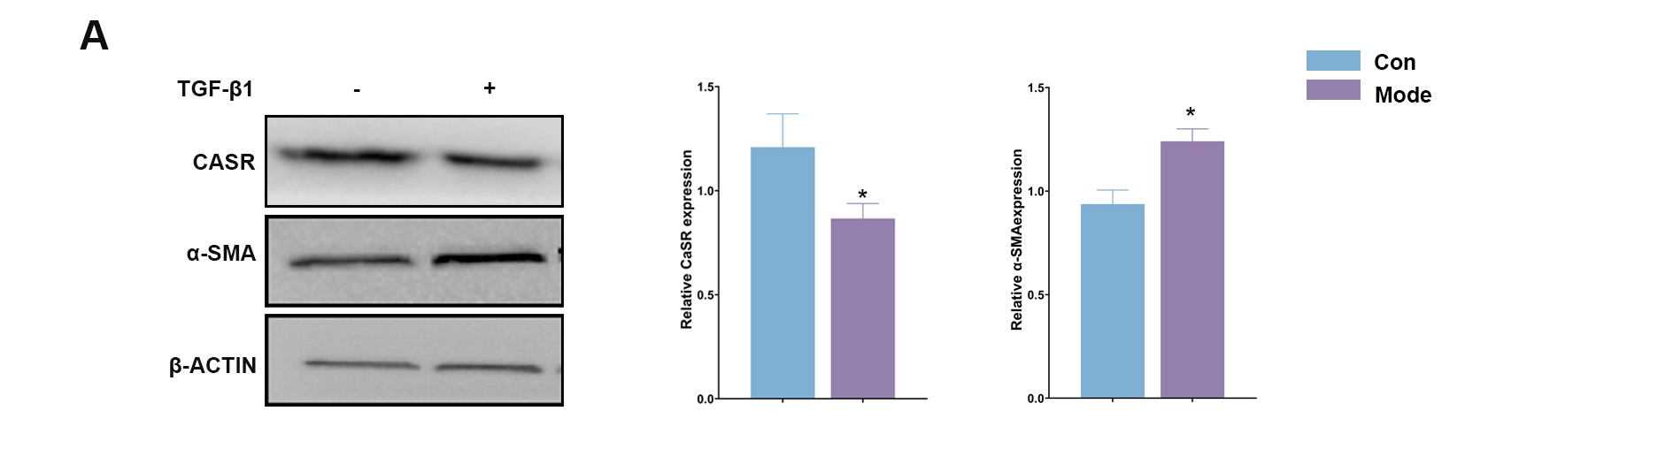

Figure S2

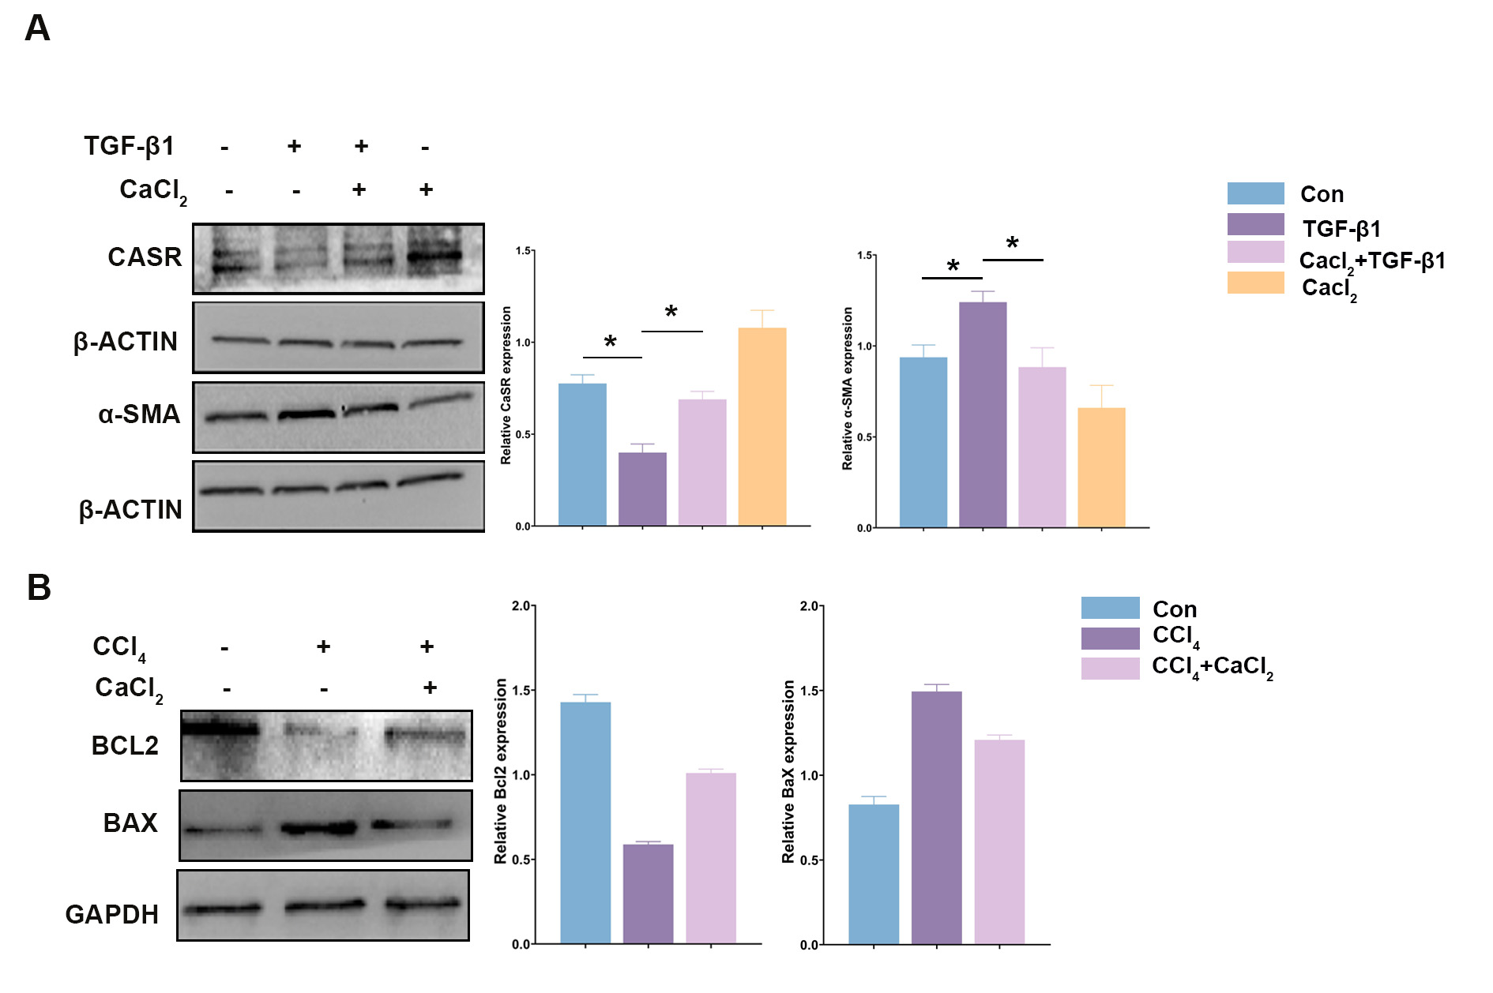

Figure S3
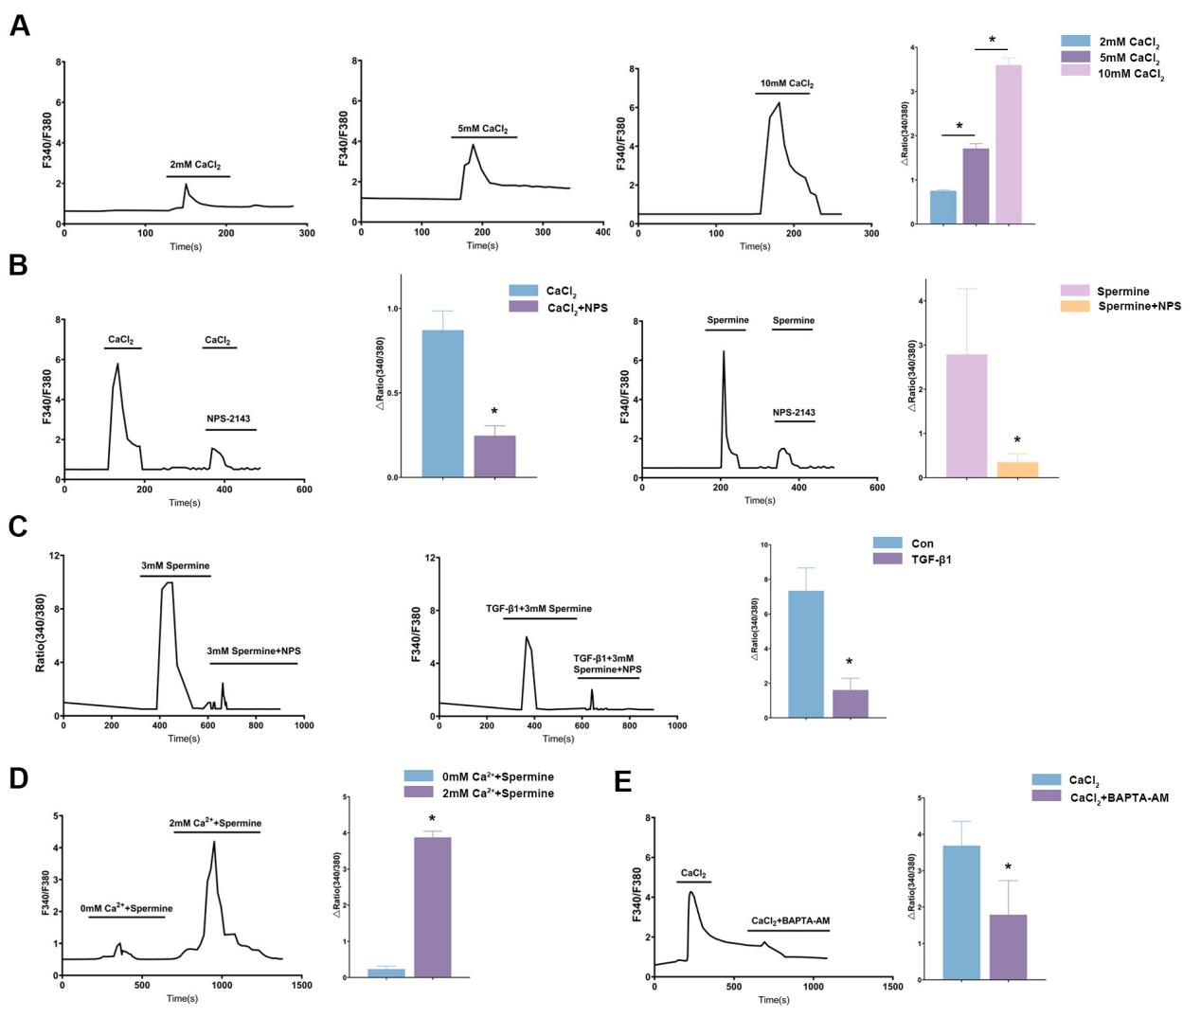

Figure S4
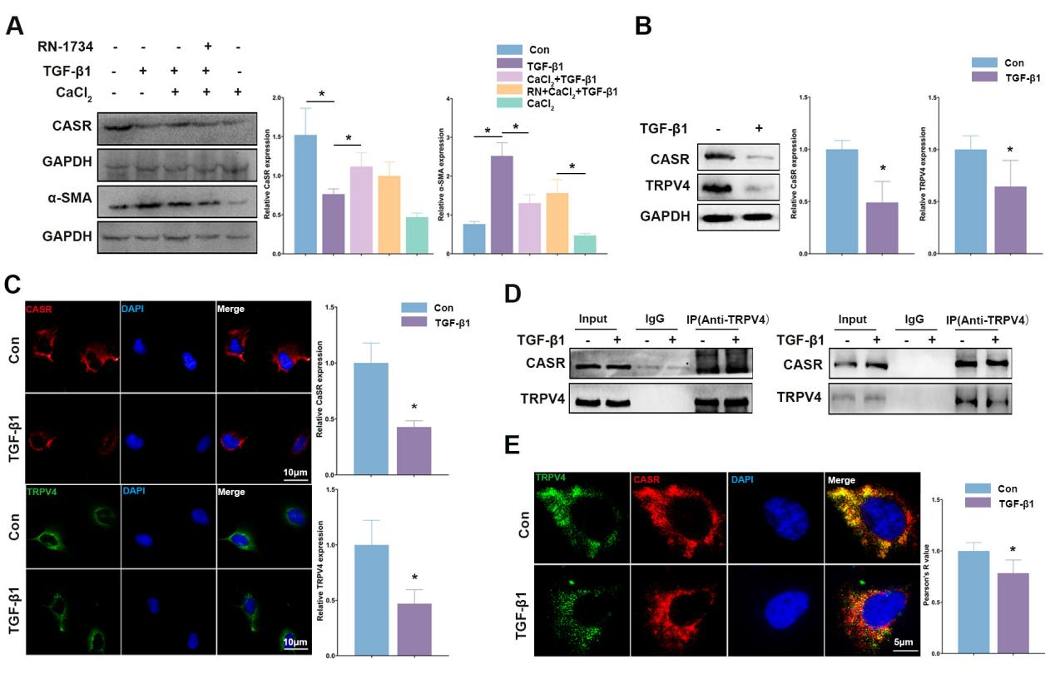
Figure S4
