Supplementary information

Ultrafast spin-orbit torques and spin-charge interconversion at oxidation-tailored NiFe/oxide interfaces

Kang Jin¹, Steffen Kober², Igor Ilyakov^{1*}, Jan-Christoph Deinert¹, Aleksandra Lindner¹, René Hübner¹, Ryszard Narkowicz¹, Anneke Reinold², Patrick Pilch², Alexey Ponomaryov¹, Thales V. A. G. de Oliveira¹, Olav Hellwig^{1,3}, Jürgen Faßbender^{1,4}, Zhe Wang², Jürgen Lindner¹, Sebastian F. Maehrlein^{1,4}, Sergey Kovalev^{2*}, Ruslan Salikhov^{1*}
¹Helmholtz-Zentrum Dresden-Rossendorf, Bautzner Landstraße 400, 01328 Dresden, Germany
²Technische Universität Dortmund, 44227, Dortmund, Germany
³Institute of Physics, Chemnitz University of Technology, Chemnitz, Germany
⁴Technische Universität Dresden, 01062 Dresden, Germany
i.ilyakov@hzdr.de
sergey.kovalev@tu-dortmund.de
r.salikhov@hzdr.de

Table of Contents
Supplementary Note 1: Ultrafast SOT detection
Supplementary Note 2: SOT-driven THz spin waves
Supplementary Note 3: Spintronic THz second harmonic generation (ST-SHG)
Supplementary Note 4: Laser-induced THz emission spectroscopy
Supplementary Note 5: Ultrafast unidirectional spin Hall magnetoresistance (USMR-SHG)
Supplementary Note 6: THz transmission measurements and analysis

Supplementary Note 1: Ultrafast SOT detection
The detection concept for ultrafast spin-orbit torque (SOT) is schematically illustrated in Fig. S1a. A single-cycle (Fig. S1d) broadband (Fig. S1e) THz pulse E_{THz}, polarized parallel to the ferromagnetic (FM) layer magnetization, is incident on an FM/non-magnet (NM) bilayer and drives an in‑plane charge current j_{c} in a metallic (FM or NM) layer. Via the spin/orbital Hall and/or Rashba-Edelstein effects, this charge current is converted into a spin current, producing a spin accumulation σ_{s} at the FM/NM interface. The resulting interfacial spin accumulation exerts a torque on the FM magnetization, launching THz‑frequency spin dynamics. An interface‑localized, broadband wave packet of nanometre‑wavelength magnons is emitted from the top surface into the depth of the FM layer [1] and reflects from the bottom interface, forming perpendicular standing spin waves (PSSWs) that are detected by magneto‑optical techniques [2]. The THz‑field‑induced PSSW modes in the FM films follow the exchange‑dominated dispersion for the spin‑wave frequency f_{swr}(k), which can be written in Kittel form [3] as
2πf_{swr} = 2πf₀ + (D_{ex}/ħ)k² (1)
In equation (1), f₀ is the uniform precession frequency, D_{ex} is the exchange stiffness parameter, ħ is the reduced Planck constant, and k = πn/d_{FM} is the wavenumber indexed by the mode order n. Here, n is the number of nodes of the standing‑wave profile in the FM = Py layer of thickness d_{FM}. These modes remain effectively unpinned owing to their high magnon energy [2].
The number (n) of experimentally observable modes is limited by (i) the Py thickness, (ii) the spectral range and spectral amplitude of the THz pulse (Fig. S1e), (iii) the mode lifetime, particularly for higher n [4], and (iv) the Py surface roughness, which becomes critical for shorter‑wavelength modes. To balance these constraints, we choose a Py thickness of 9 nm, which exceeds the spin‑diffusion length in Py while keeping the first two PSSW eigenfrequencies, n = 1 (Fig. S1b) and n = 2 (Fig. S1c), within the spectral bandwidth of the single‑cycle THz pulse (Fig. S1d,e). The n = 3 mode, with a frequency of ~0.6 THz and a wavelength of 6 nm, lies far from the spectral maximum and has a short lifetime [2,4], and therefore is not clearly resolved in our measurements.
The ultrafast SOT detection concept is also sensitive to the parity of the torques when they act at both FM surfaces. As shown in Fig. S1b, the n = 1 mode exhibits antiphase precession of the magnetization at the two interfaces and is therefore efficiently driven by torques of the same sign (i.e. the same effective spin Hall angle at both interfaces). By contrast, the n = 2 mode displays in-phase precession at the two interfaces (Fig. S1c) and is preferentially excited by torques of opposite sign, so this mode is efficiently generated when the effective spin Hall angles at the two interfaces have opposite sign.

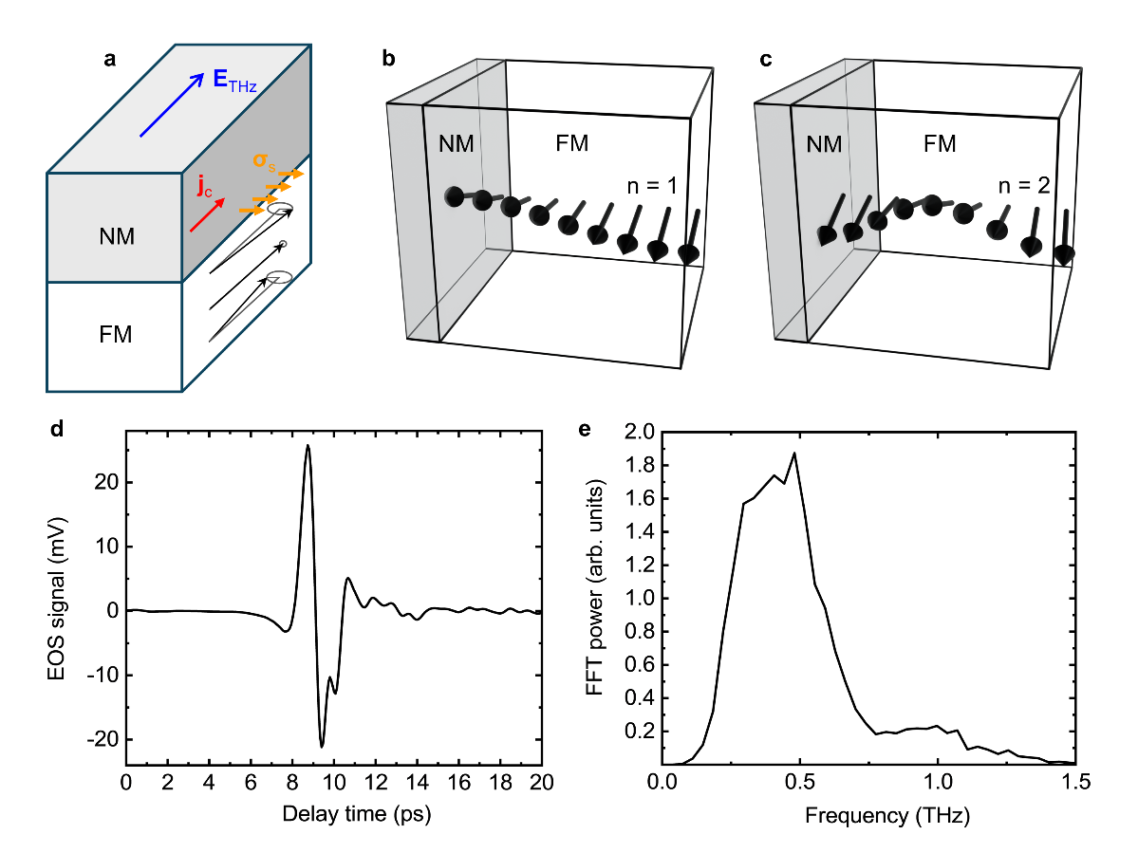
Fig. S1 | Generation of PSSW modes by a single-cycle THz pulse. a, Schematic illustration of PSSW excitation by a single‑cycle THz pulse via ultrafast SOT at FM/NM interfaces. b, c, Schematic standing‑spin-wave profiles in the FM layer for the first (n = 1) and second (n = 2) PSSW modes, respectively. d, Temporal profile of the single-cycle THz pump pulse used in the experiments, measured by electro-optical sampling in a 2-mm-thick ZnTe crystal. e, Fourier power spectrum of the THz pulse shown in d.
Supplementary Note 2: SOT-driven THz spin waves
Figures S2 and S3 summarize the time-resolved magnetization dynamics in response to the THz pump for five systems grown on quartz glass (SiO₂) substrates: Py(9 nm)/Pt(2 nm)/AlO_{x}(5 nm); AlO_{x}(5 nm)/Py(9 nm)/AlO_{x}(5 nm) (Fig. S2); Py(9 nm)/Ta(3 nm)/SiO_{x}(10 nm); Py(9 nm)/SiO_{x}(5 nm); and Py(9 nm)/AlO_{x}(5 nm) (Fig. S3). The magnetization dynamics are described by the Landau-Lifshitz-Gilbert equation
∂_{t}m = - γ(m × H_{eff}) + αm × ∂_{t}m, (2)
where m = M/M_{s} is the unit magnetization vector normalized to the magnetization at saturation M_{s}, γ is the gyromagnetic ratio, and α is the Gilbert damping parameter. The effective field H_{eff} can be written as
H_{eff} = H + H_{THz} + H_{FL} + H_{DL}, (3)
where H is the external field, H_{THz} is the magnetic-field component of the THz pump, and H_{FL} and H_{DL} are the SOT-induced field-like and damping-like effective fields, respectively, with H_{FL} ∝ (z×j) and H_{DL} ∝ (j×z)×m [5-7]. Here, j is the THz-induced current density and z is the unit vector normal to the film plane. From Eqs. (2) and (3), both the THz Zeeman torque and the field-like SOT are odd under magnetization reversal (i.e. inversion of H), whereas the damping-like SOT is even.

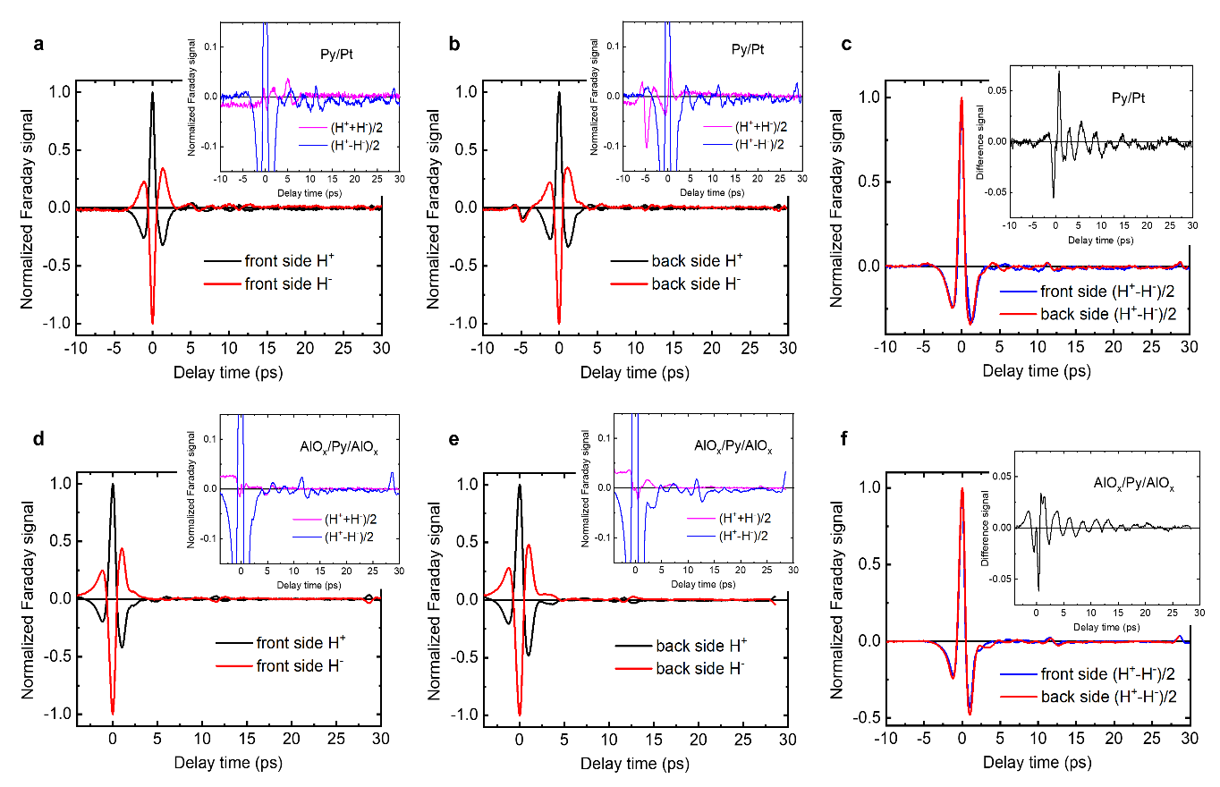
As seen in Figs. S2 and S3, all samples exhibit a Zeeman torque signal (ZTS) whose temporal shape follows the THz pulse profile and is antisymmetric under field reversal: the traces recorded at positive field (H⁺, black lines) and negative field (H⁻, red lines) have opposite sign. All time-delay traces are normalized to the ZTS peak amplitude. To verify the symmetry of the SOT-induced spin wave resonance (SWR) signals from the PSSW modes, the insets of Figs. S2a,b,d,e and Figs. S3a,b,d,e,g,h show the sum (magenta) and difference (blue) of the signals recorded for opposite field polarities. The sum, which in this case reflects the non-magnetic response, is essentially flat over the full delay range, except near the ZTS where incomplete cancellation occurs. Small residual non-magnetic features are also observed, e.g. at +5 ps for front-side-illuminated Py/Pt (Fig. S2a) and -5 ps for back-side illumination (Fig. S2b). These offsets are attributed to THz-field-induced polarization rotation of the laser probe in the quartz substrate caused by a slight misalignment between the THz and laser beams [8], producing a non-zero Faraday signal after the ZTS in the front-side configuration (Fig. S2a) and before the ZTS in the back-side configuration (Fig. S2b). In contrast, the difference traces (blue) show pronounced oscillatory behavior, demonstrating that the SWR signal is antisymmetric under magnetization reversal and therefore originates predominantly from the field-like torque, as expected from Eqs. (2) and (3).
Fig. S2 | Detection of SWR signals exploiting SOT symmetry. a, b, Single-cycle THz pump - optical probe time-delay traces for the Py/Pt sample under front-side a and back-side b THz illumination. Signals are recorded for two opposite directions of the external magnetic fields (H): black line, positive field (H⁺), red line, negative field (H⁻). Insets show the sum (magenta) and difference (blue) of the signals for opposite field directions. All traces are normalized to the peak of the Zeeman torque signal. c, Comparison of the difference signals for front-side (blue line) and back-side (red line) illumination. The inset shows the difference between the blue and red traces, isolating the SWR contribution from PSSW modes in Py. d, e, f, Same as a, b, c, but for the AlO_{x}/Py/AlO_{x} trilayer, demonstrating SWR signals with amplitudes comparable to those in Py/Pt.

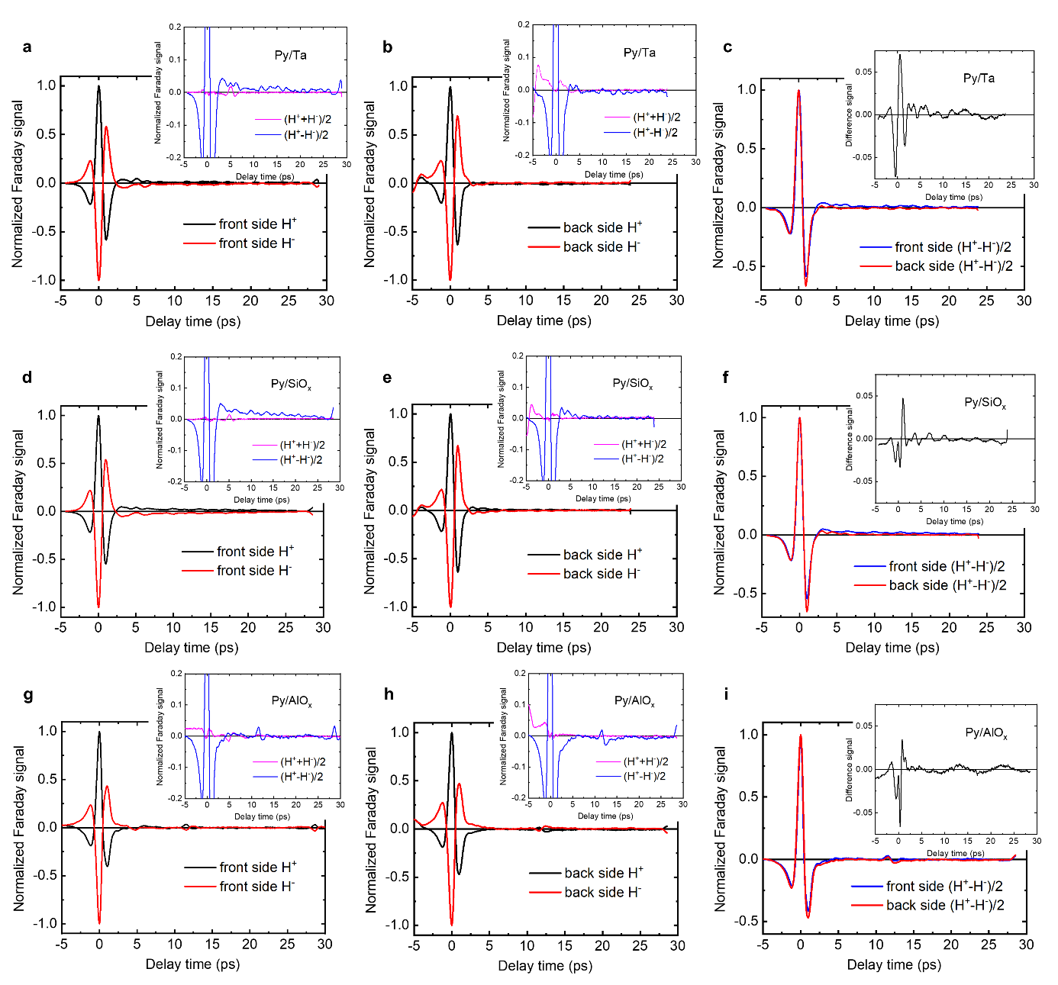
It also follows from Eqs. (2) and (3) that, unlike the ZTS, the field-like torque-driven SWR signal is expected to change sign when the layer order is inverted (front-side versus back-side illumination). Since H_{FL} ∝ (z×j), flipping the sample reverses the direction of z, and thus the sign of the field-like torque. Figures S2c,f and S3c,f,i compare the difference signals for front-side (blue) and back-side (red) illumination for all samples. The ZTS retains the same sign in both geometries, whereas the SWR contribution clearly exhibits an out-of-phase oscillatory behavior. Taking the difference between these traces isolates the SWR signal, as shown in the corresponding insets. As shown below, the THz transmission through the Py/Pt and Py/oxide samples is nearly identical, indicating that THz reflection and absorption do not differ significantly across the series. Consequently, the THz magnetic-field component in the Py layer, and thus the ZTS amplitude, are expected to be similar for all samples. This justifies using the SWR amplitude relative to the accompanying ZTS peak (i.e. the normalized traces) as a measure of the THz-SOT efficiency. Comparing the difference signals in the insets of Figs. S3c,f,i shows that the SWR amplitudes - and hence the THz-SOT efficiencies - in Py/SiO_{x} and Py/AlO_{x} are comparable to those in Py/Ta. Likewise, the SWR amplitude in the AlO_{x}/Py/AlO_{x} trilayer is similar to that in Py/Pt (insets in Figs. S2c,f), indicating comparable SOT-induced PSSW excitation efficiencies. The ratios of the SWR amplitudes (A_{SWR}) to the corresponding ZTS peak amplitudes (A_{ZTS}) are listed in Table S1.
Fig. S3 | Detection of SWR signals exploiting SOT symmetry. a, b, Magnetization dynamics in response to the THz pump of the Py/Ta sample under front-side a and back-side b THz illumination. Signals are recorded for two opposite directions of the external magnetic fields (H): black line, positive field (H⁺), red line, negative field (H⁻). Insets show the sum (magenta) and difference (blue) of the signals for opposite field directions. All traces are normalized to the peak of the Zeeman torque signal. c, Comparison of the difference signals for front-side (blue line) and back-side (red line) illumination. The inset shows the difference between the blue and red traces, isolating the SWR contribution from PSSW modes in Py. d, e, f, Same as a, b, c, but for the Py/SiO_{x} sample; g, h, i, for Py/AlO_{x}. Both Py/oxide samples demonstrate the SOT-induced PSSW excitation efficiencies comparable to those in Py/Ta.
The isolated SWR signals for all samples (Fig. S4) are fitted using a superposition of two damped cosine functions
$S_{d}\left(t\right)=a_{1}e^{\frac{-t}{τ_{1}}}\cos{(2πf_{1}}t+φ_{1})+a_{2}e^{\frac{-t}{τ_{2}}}\cos{(2πf_{2}}t+φ_{2})$, (4)
where $S_{d}\left(t\right)$ is the isolated time-domain SWR signal; $a_{1}$ and $a_{2}$ are the amplitudes of the n = 1 and n = 2 modes; $f_{1}$ and $f_{2}$ are their frequencies, $τ_{1}$ and $τ_{2}$ are the corresponding lifetimes; and $φ_{1}$ and $φ_{2}$ are phase offsets treated as a fit parameter. To minimize the influence of incomplete ZTS cancellation and residual non-magnetic features, the fits are performed starting approximately 5 ps after the ZTS peak. The fits to the experimental data are shown in Fig. S4. The extracted SWR frequencies (f_{SWR}) for the n = 1 and n = 2 modes in all samples are summarized in Table S1.
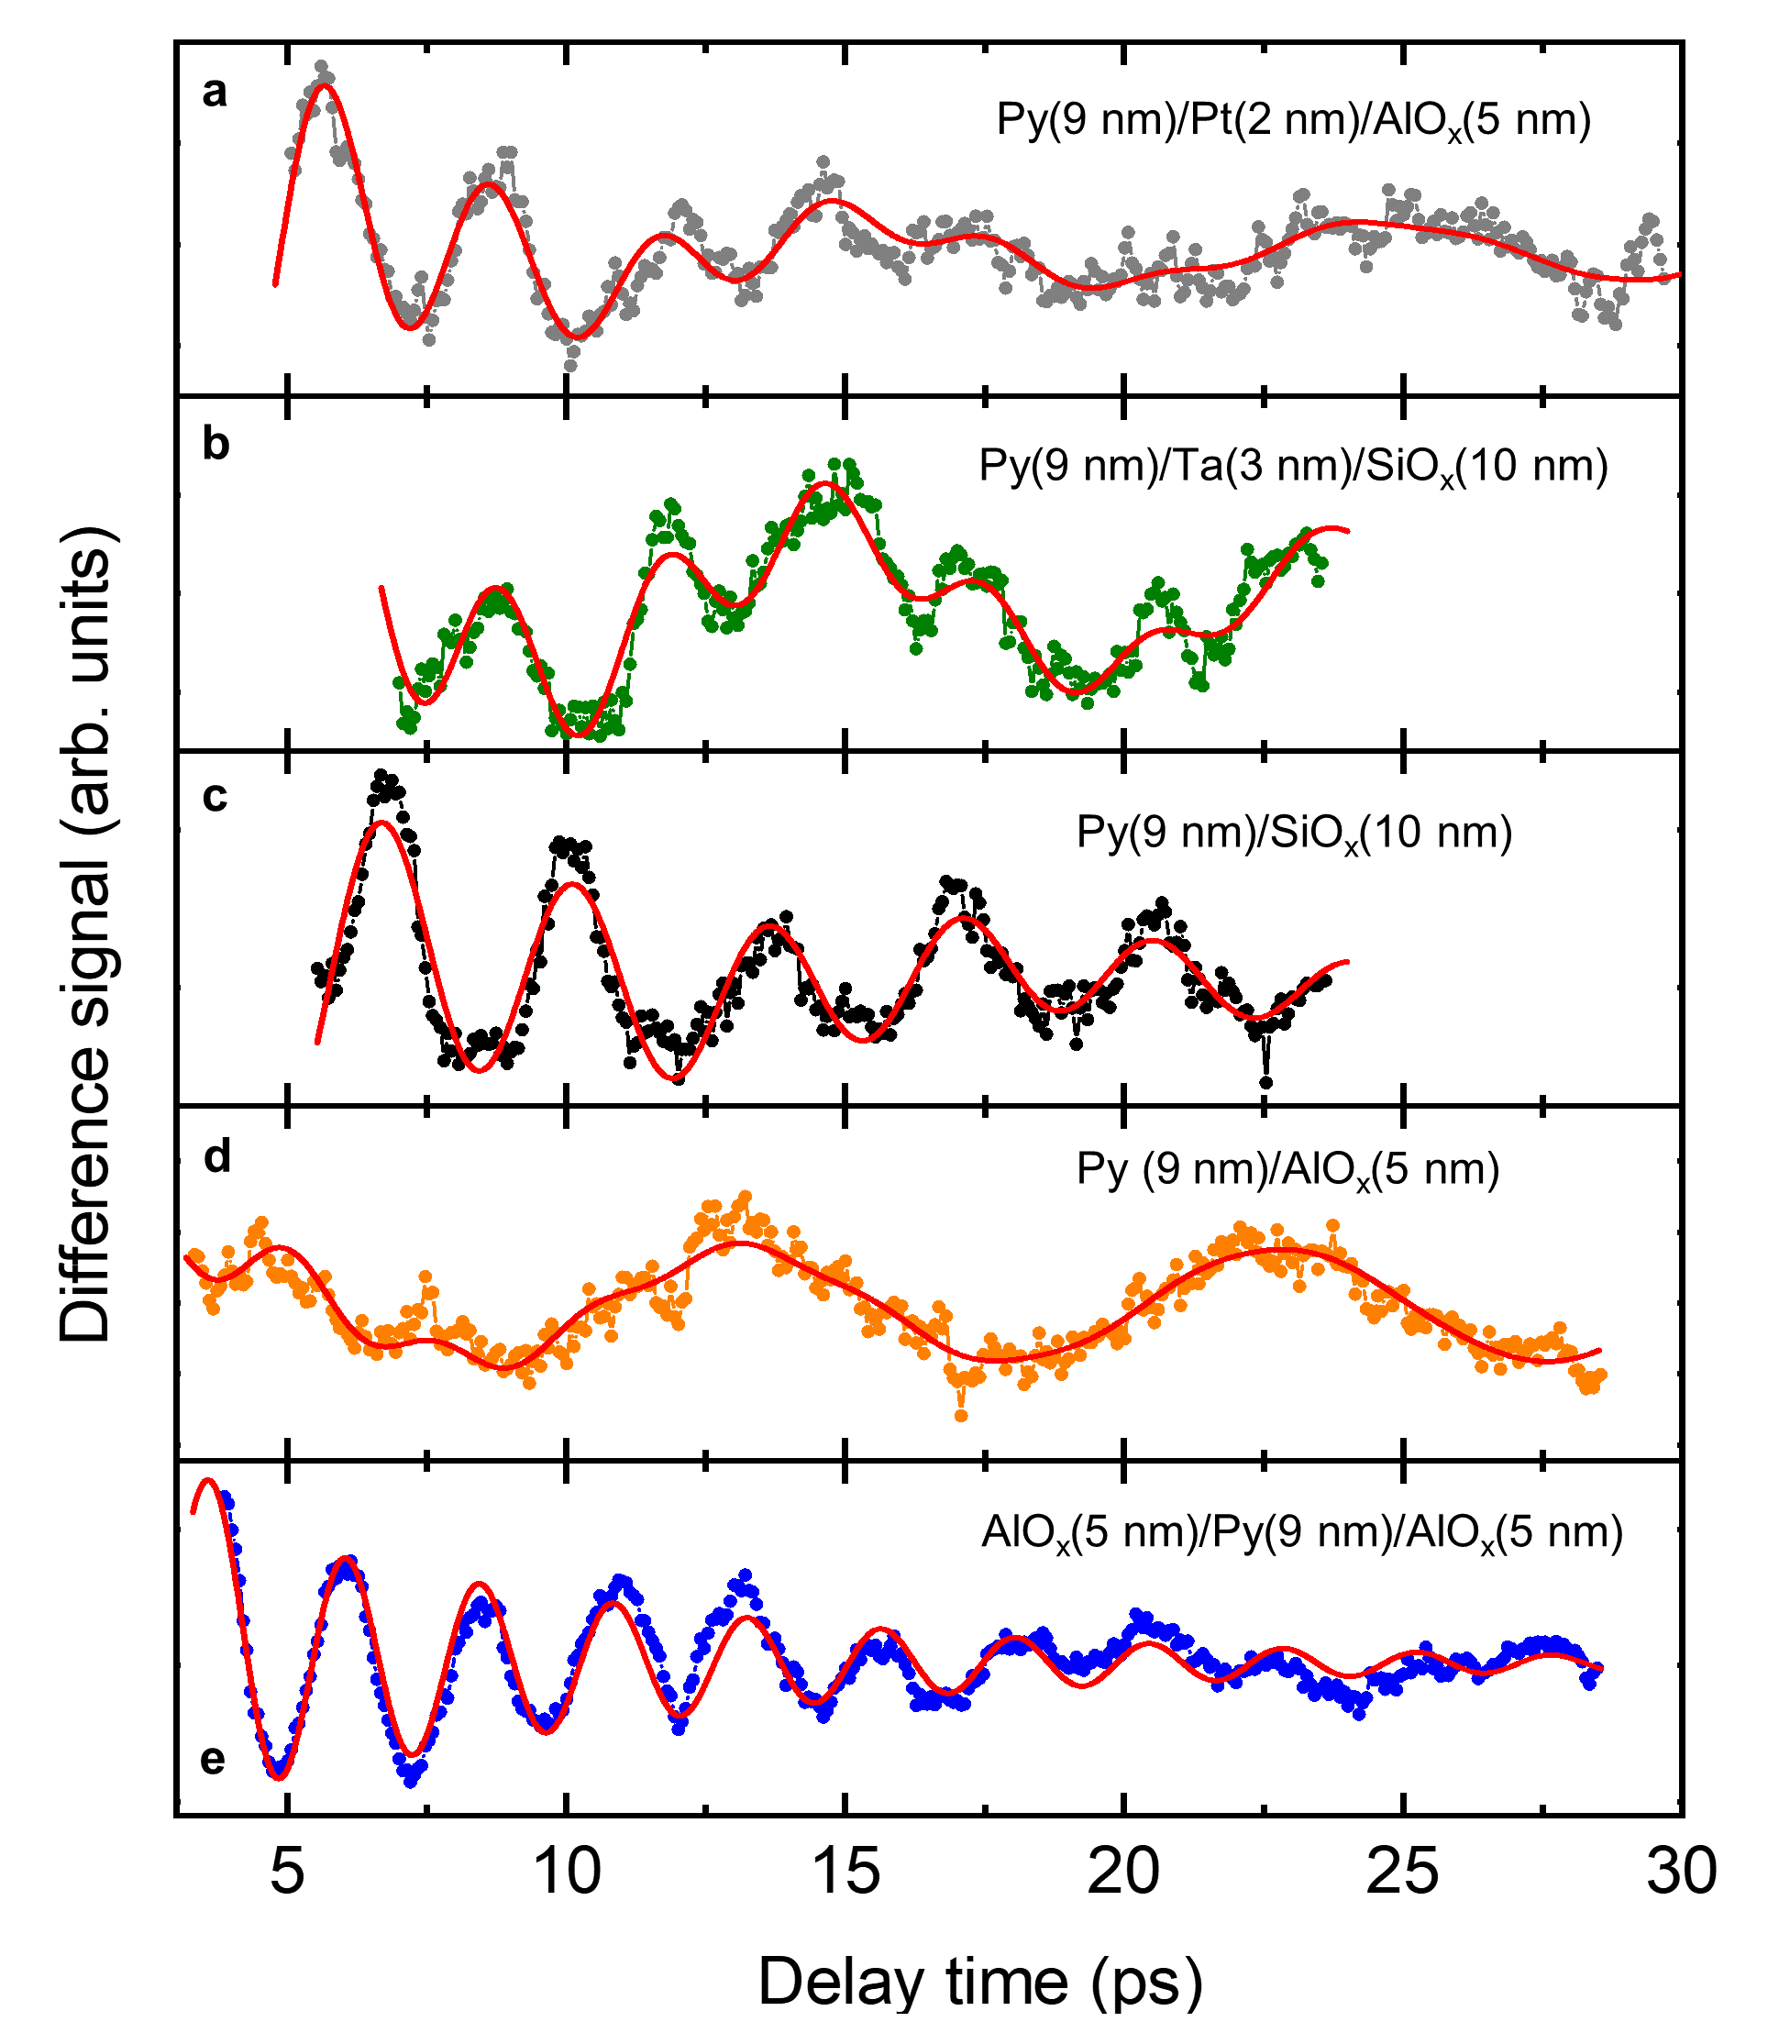
Fig. S4 | SOT-induced SWR signals. a-e Isolated spin‑wave resonance signals for the samples indicated in each panel (layer thicknesses are given in parentheses). Red lines represent fits to the data using a superposition of two damped cosine functions corresponding to the first (n = 1) and second (n = 2) PSSW modes.
Using the exchange stiffness parameter for Py obtained from the frequency–thickness dependence in Ref. [2], we calculated the effective Py thicknesses for all samples from Eq. (1), the results are listed in Table S1. The slight reduction of the effective Py thickness in Py/Pt and Py/Ta, within experimental uncertainty, is attributed to a magnetically dead layer caused by interdiffusion when heavy metals are grown on Py [9]. The further reduction of the effective Py thickness in AlO_{x}-capped samples is ascribed to Py oxidation during oxide growth, consistent with the STEM-EDXS analysis presented in the main text.
Table S1 | Parameters extracted from SWR signals (Fig. S4) for the different samples (layer thicknesses in nm are given in parentheses). A_{SWR}/A_{ZTS} denotes the ratio of the SWR amplitude to the ZTS peak amplitude, providing a comparative measure of the THz-driven SOT efficiency for different capping layers. f_{SWR} are the PSSW mode frequencies obtained from fits to the SWR traces. d_{Py} is the effective Py thickness extracted from the n = 2 PSSW mode frequency. Within experimental uncertainty, the extracted thicknesses are comparable for all samples, but AlO_{x}-capped Py consistently exhibits a reduced effective thickness, which we attribute to interfacial oxidation.
Sample | A_{SWR}/A_{ZTS} [%] | f_{SWR} (n = 1) [GHz] | f_{SWR} (n = 2) [GHz] | d_{Py} [nm]
(Sub.)/Py(9)/Pt(2)/AlO_{x}(5) | 1.5 ± 0.2 | 107 ± 20 | 332 ± 10 | 8.4 ± 0.3
(Sub.)/Py(9)/Pt(2)/SiO_{x}(10) | 1.5 ± 0.2 | 106 ± 20 | 320 ± 10 | 8.5 ± 0.3
(Sub.)/Py(9)/Ta(3)/SiO_{x}(10) | 0.7 ± 0.3 | 100 ± 30 | 342 ± 20 | 8.2 ± 0.5
(Sub.)/Py(9)/SiO_{x}(10) | 0.5 ± 0.3 | 93 ± 30 | 288 ± 20 | 9 ± 0.6
(Sub.)/Py(9)/AlO_{x}(5) | 0.5 ± 0.3 | 104 ± 20 | 374 ± 30 | 7.9 ± 0.7
(Sub.)/AlO_{x}(5)/Py(9)/AlO_{x}(5) | 1 ± 0.2 | 120 ± 40 | 416 ± 20 | 7.5 ± 0.6

Supplementary Note 3: Spintronic THz second harmonic generation (ST-SHG)
Spintronic THz second-harmonic generation (ST-SHG) shares the symmetry of spintronic THz emitters: the SHG field is polarized orthogonal to the FM magnetization and reverses its phase upon magnetization reversal and upon inversion of the stacking order (front- versus back-side illumination) [10]. This symmetry arises because, analogous to optical excitation, THz irradiation induces a transient reduction of the FM magnetization, which drives spin-current generation at FM/NM interfaces. Conversion of these spin currents into charge currents via inverse spin/orbital Hall or inverse Rashba-Edelstein effects rectifies the THz field and produces the SHG signal. Owing to the orders-of-magnitude lower photon energy, the THz excitation scheme differs from femtosecond laser pumping: multi-cycle THz pulses generate transient spin currents in each half-cycle of the pump. For circularly polarized THz excitation, the THz field amplitude does not pass through zero and no half-cycle modulation of the spin current occurs, resulting in a vanishing ST-SHG signal [10,11]. There are two key benefits of this method: (i) it avoids the complexities associated with electronic and phononic heating under laser-pulse excitation, and (ii) it directly probes spin-to-charge conversion in response to the same THz-field excitation that drives the ultrafast SOT, enabling a direct comparison with charge-to-spin conversion. The latter is also accessible via the ultrafast USMR effect [11].
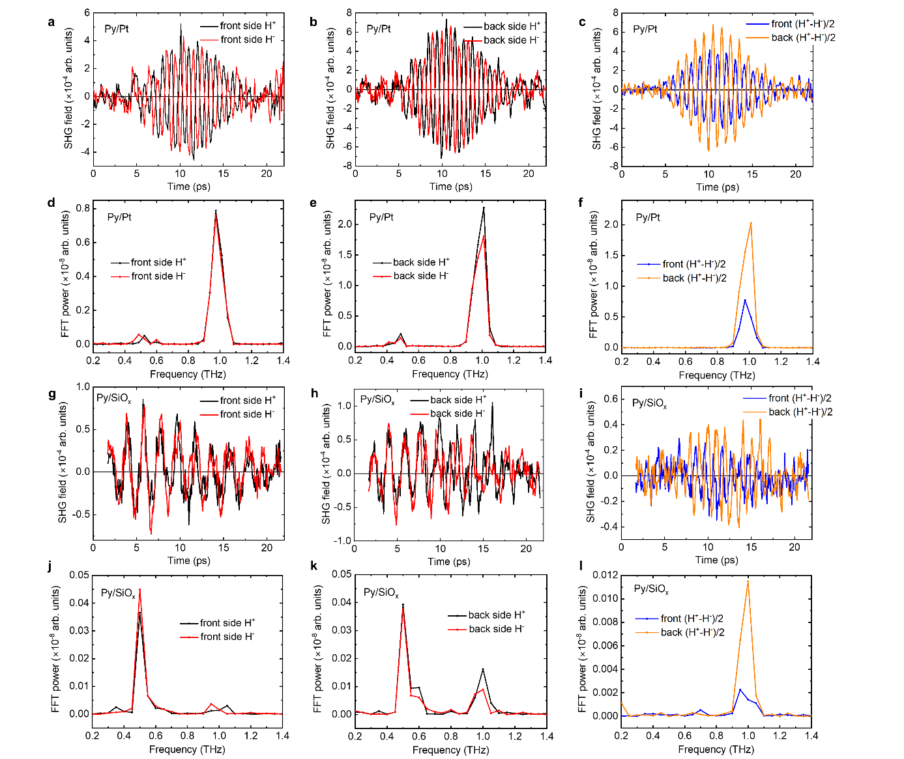
The ST-SHG signals for the Py(3 nm)/Pt(2 nm) sample under front-side (film side) and back-side (substrate side) THz illumination at a central frequency of 0.5 THz are shown in Figs. S5a and S5b, respectively. In both geometries, the SHG phase reverses by 180° upon magnetization reversal, consistent with the spintronic origin discussed above. The time-domain traces contain a residual contribution from the fundamental THz pump, most clearly visible in the corresponding FFT spectra in Figs. S5d,e. This residual fundamental component is effectively removed by taking the difference between signals recorded for opposite magnetization directions, as shown in Fig. S5c (and its FFT in Fig. S5f) for both front- and back-side illumination. The resulting difference signals for the two illumination geometries still exhibit a 180° phase shift, again in agreement with the expected spintronic symmetry. Back-side illumination yields a larger ST-SHG amplitude than front-side illumination, which we attribute to improved impedance matching of the THz field at the substrate/metal interface compared to the air/metal interface [12]: the higher refractive index of quartz (n_{sub} ≈ 2) relative to air (n_{air} ≈ 1) increases the THz field inside the metallic stack.
Fig. S5 | Detection of ST-SHG signals. a, b, THz second-harmonic generation amplitudes for the Py/Pt sample under (a) front-side and (b) back-side THz pulse illumination at a central frequency of 0.5 THz. The THz pump polarization is parallel to the Py magnetization, which is set by an in-plane magnetic field (H) applied in two opposite directions: black line: H⁺, red line: H⁻. c, Difference signals, (H⁺-H⁻)/2, for front-side (blue line) and back-side (red line) illumination. d, e, f, FFT power spectra of the time-domain signals in a, b, c, respectively. g, h, i, Same as a, b, c, but for the Py/SiO_{x} sample. j, k, l, FFT spectra of signals in g, h, i, respectively.
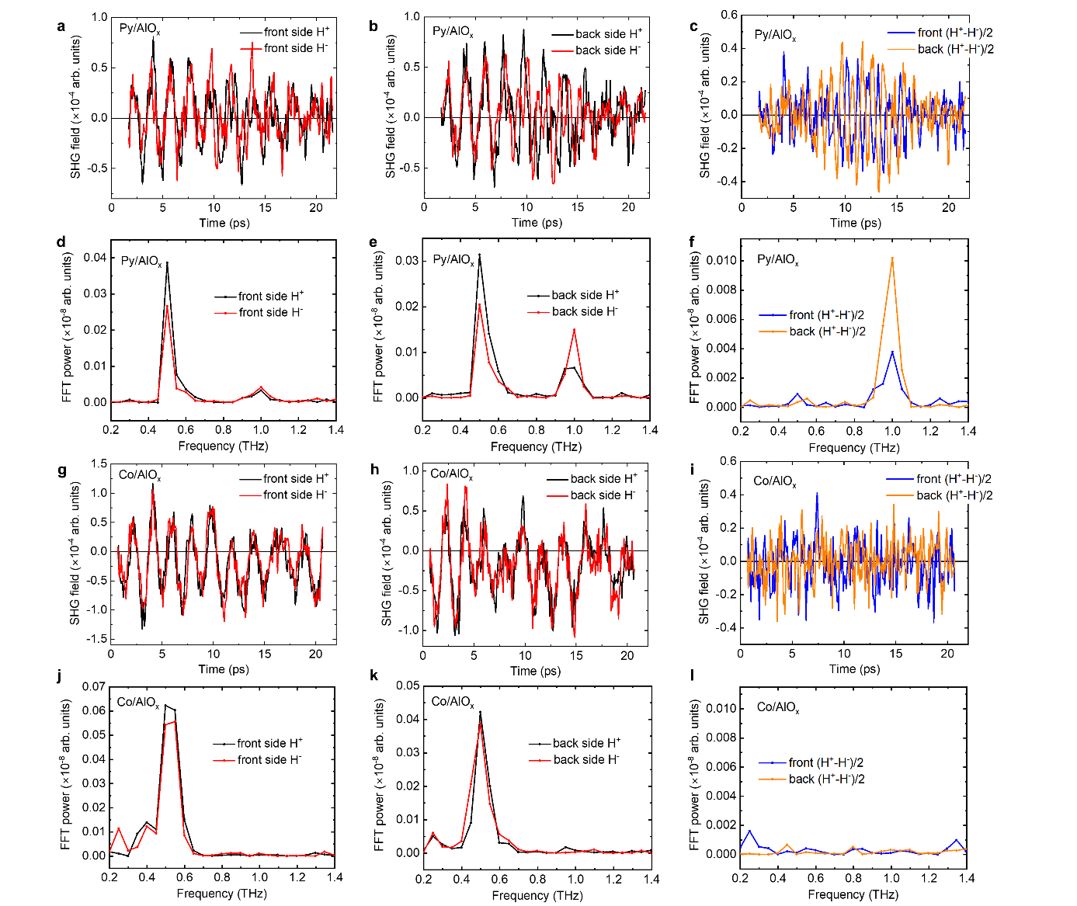
Figures S5g and S5h show ST-SHG signals for the Py(3 nm)/SiO_{x}(5 nm) sample under front- and back-side illumination, respectively. Because the ST-SHG amplitude is about 10 times smaller than in Py/Pt, the residual fundamental leakage dominates the raw time-domain traces. In the corresponding FFT spectra (Figs. S5j,k), however, a clear SHG contribution at 1.0 THz is visible. Exploiting the antisymmetric behavior under magnetization reversal, we isolate the SHG component by taking (H⁺-H⁻)/2, as shown in Fig. S5i with its FFT in Fig. S5l. The SHG spectra again display an antiphase relation between front- and back-side illumination. Although the time-domain signals in Fig. S5i are relatively noisy, the antiphase behavior becomes clearly visible after digital band-pass filtering.
Fig. S6 | Comparison of ST-SHG signals between Py/AlO_{x} and Co/AlO_{x} bilayers. a, b, THz second-harmonic generation signals for the Py/AlO_{x} sample under (a) front-side and (b) back-side THz illumination at a central frequency of 0.5 THz. The THz pump polarization is parallel to the Py magnetization, which is set by an in-plane magnetic field (H) applied in two opposite directions: black line: H⁺, red line: H⁻. c, Difference signals, (H⁺-H⁻)/2, for front-side (blue line) and back-side (red line) illumination. d, e, f, FFT power spectra of the time-domain signals in a, b, c, respectively. g, h, i, Same as a, b, c, but for the Co/AlO_{x} sample. j, k, l, FFT spectra of signals in g, h, i, respectively. The absence of a discernible ST-SHG signal in Co/AlO_{x} demonstrates that spin-to-charge conversion at the Co/AlO_{x} interface is negligible.
Figures S6a-f show the ST-SHG signals and their analysis for the Py(3 nm)/AlO_{x}(5 nm) sample, in direct analogy to the Py(3 nm)/SiO_{x}(5 nm) case discussed in Fig. S5. As in Fig. S5, panels S6a and S6b display the raw time-domain signals for front- and back-side illumination, panel S6c shows the magnetization-odd component obtained from (H⁺-H⁻)/2, and panels S6d-f present the corresponding FFT power spectra. For quantitative comparison, the ST-SHG responses of Py/AlO_{x} and Py/SiO_{x} are evaluated alongside the Py/Pt reference measured in the front-side configuration (Fig. 2b of the main text), after applying the same digital band-pass filtering. This common processing highlights the relative amplitudes and phases of the SHG signals across the three systems.
Figures S6g-i present the measurements and analysis for the Co(3 nm)/AlO_{x}(5 nm) sample. No discernible ST‑SHG signal is observed under acquisition conditions identical to those used for Py(3 nm)/AlO_{x}(5 nm). The corresponding FFT spectra in Figs. S6j-l show no detectable SHG power at 1 THz, confirming the absence of a measurable ST‑SHG response in Co/AlO_{x}.

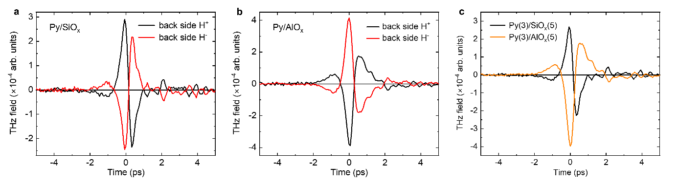
Supplementary Note 4: Laser-induced THz emission
Fig. S7 | Comparison of laser-induced THz emission between the Py/SiO_{x} and Py/AlO_{x} samples. a,b, THz emission waveforms for Py/SiO_{x} (a) and Py/AlO_{x} (b) measured under substrate-side illumination. The Py magnetization is set by an in-plane magnetic field (H) applied in two opposite directions: black line: H⁺, red line: H⁻. c, Comparison of the magnetization-odd components, (H⁺-H⁻)/2, for Py/SiO_{x} and Py/AlO_{x}. The antiphase relationship between the two waveform is evident.
As an independent proof of the opposite effective spin Hall angle (SHA) in SiO_{x}- and AlO_{x}- capped Py, we performed THz emission spectroscopy using femtosecond-laser pulses to generate spin currents [13]. Laser pulses of 100-fs duration, few 10-mW power, 800-nm central wavelength, and 1-kHz repetition rate were incident from the substrate side of the samples. A horizontal in-plane magnetic field of 50 mT was applied to saturate the Py magnetization. The emitted THz waves with vertical polarization were collected by a pair of off-axis parabolic mirrors and focused onto a 1-mm-thick ZnTe crystal for electro-optic sampling.
To isolate the spintronic contribution, the THz waveforms were recorded for opposite magnetic field directions (H⁺ and H⁻), as shown in Figs. S7a and S7b for Py/SiO_{x} and Py/AlO_{x}, respectively. The corresponding difference signals ((H⁺ - H⁻)/2) are compared in Fig. S7c and clearly exhibit an antiphase relationship, confirming the opposite sign of spin-to-charge conversion in SiO_{x}- and AlO_{x}- capped Py. Evidence for a sign inversion upon reversing the deposition sequence of Py and AlO_{x} under the same emission condition is presented in Fig. 3c of the main text.
Supplementary Note 5: Ultrafast unidirectional spin Hall magnetoresistance (USMR)
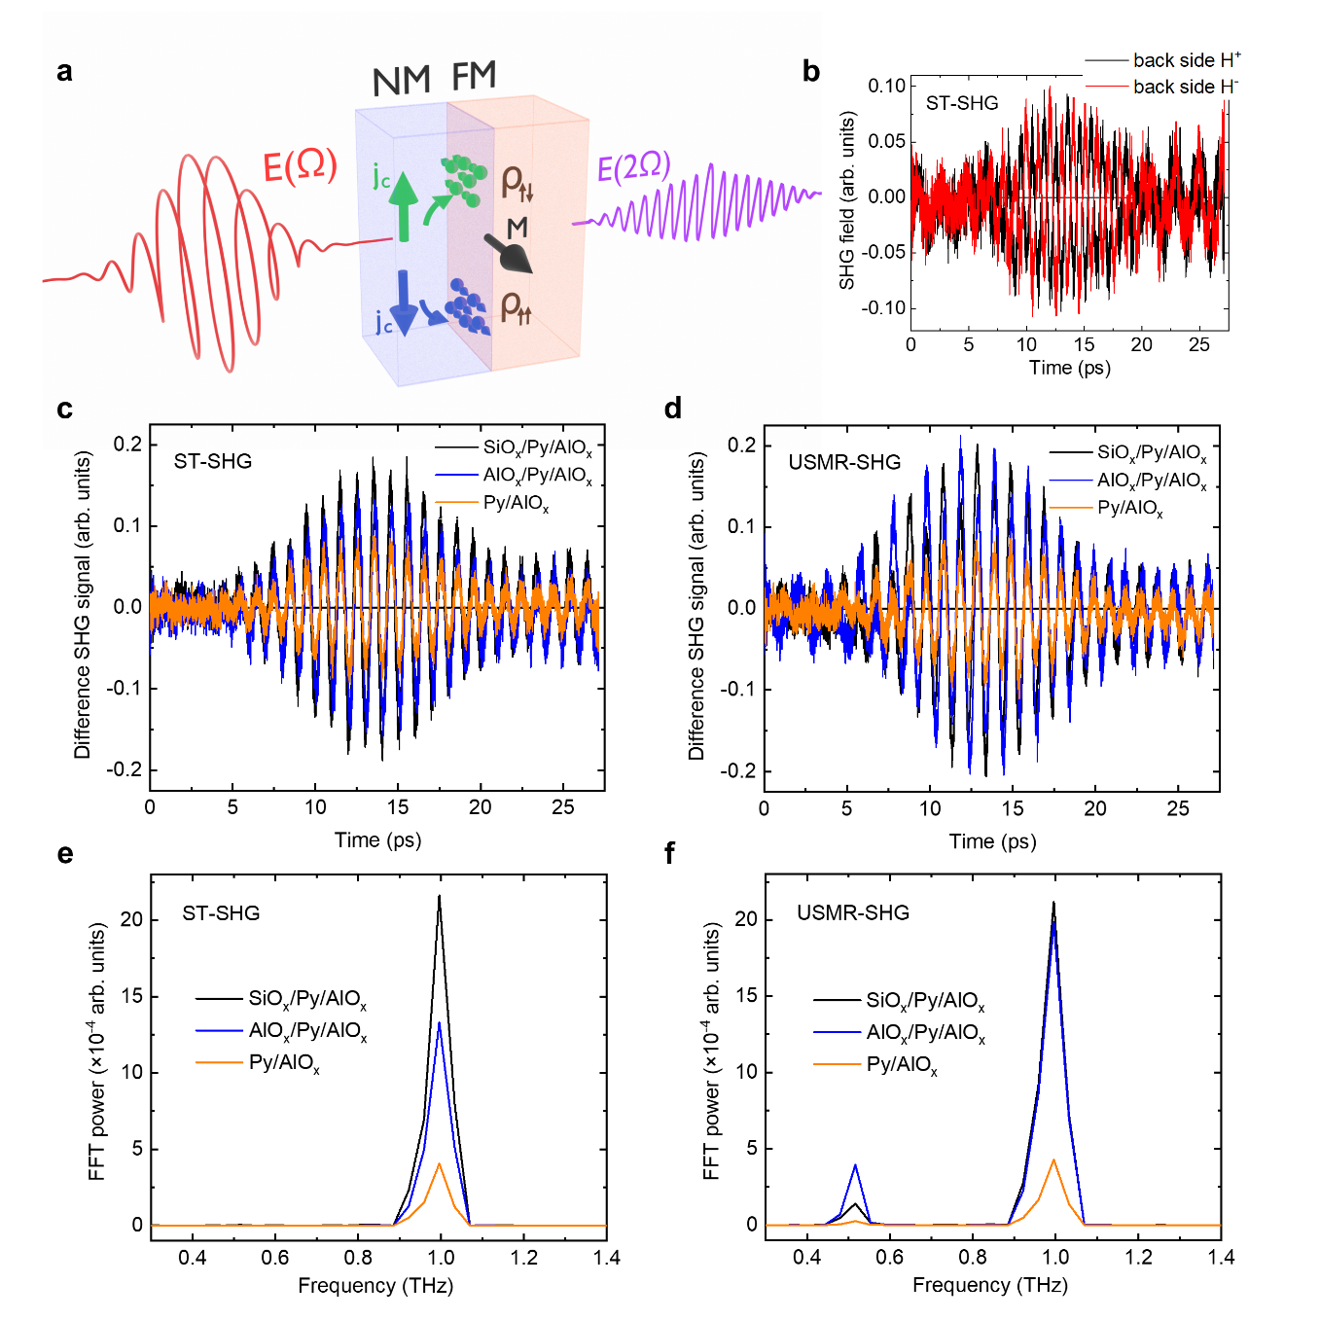
Fig. S8 | Ultrafast unidirectional spin Hall magnetoresistance (USMR-SHG). a, Schematic of the experiment. A multi-cycle circularly polarized THz field E(Ω) is incident on the FM/NM stack. The vertical component of the THz electric field drives an oscillating charge current (j_{c}) in the NM, which generates a spin accumulation at the FM/NM interface via the Rashba-Edelstein effect (REE). The interfacial spin polarization (green and blue symbols) follows the AC current direction (green and blue arrows, respectively) and is periodically aligned parallel or antiparallel to the FM magnetization (M). This modulates the interfacial resistivity ($ρ_{↑↓}$ versus $ρ_{↑↑}$), leading to a modulation of the THz absorption and, consequently, to a second-harmonic signal E(2Ω) (USMR-SHG). b, ST‑SHG signals for the Py/AlO_{x} sample under back‑side THz illumination, measured at the ELBE accelerator facility. The Py magnetization is set by an in-plane magnetic field (H) applied in two opposite directions (black: H⁺; red: H⁻). c, Comparison of isolated ST-SHG signals (magnetization-odd components, (H⁺-H⁻)/2) for the selected samples indicated in the color legend. d, Comparison of USMR-SHG signals (magnetization-odd components, (H⁺-H⁻)/2) for the same sample set. e, f, FFT spectra of the signals shown in c and d, respectively.

The spintronic THz second-harmonic generation (ST‑SHG) studies unambiguously indicate that spin‑to‑charge conversion (SCC) at Py/oxide interfaces arises from the inverse Rashba-Edelstein effect (spin and/or orbital) associated with partial oxidation of the Py surface when interfaced with off‑stoichiometric SiO_{x} and AlO_{x}. It is therefore natural to attribute the THz‑field‑induced SOT, which excites the PSSW modes, to the direct (spin/orbital) Rashba-Edelstein effect. At the same time, the direct charge‑to‑spin conversion (CSC) can also be probed in the THz range via the unidirectional spin Hall magnetoresistance (USMR) [14], which likewise gives rise to SHG [11]. The ability to access both reciprocal (SCC) and direct (CSC) spintronic processes on ultrafast timescales further underscores the advantages of multi‑cycle THz excitation over optical pumping, which does not directly probe SHE‑ or REE‑driven charge‑to‑spin conversion.
The experimental scheme is shown in Fig. S8a. To suppress the ST‑SHG contribution [10,11], we use a circularly polarized THz field E(Ω) with a central frequency of 0.5 THz incident on the FM/NM sample, with the FM magnetization now aligned horizontally. We consider only the vertical (transverse to the magnetization) component of the THz electric field, which drives vertical charge currents in the NM layer whose direction follows the THz field oscillations. These transverse currents are selected, because only currents orthogonal to the FM magnetization fulfil the symmetry requirements for the USMR effect [11,14]. The induced charge currents generate a spin accumulation at the FM/NM interface via the direct spin/orbital Rashba-Edelstein effect in the NM. In each half‑cycle, the interfacial spin polarization reverses with the current direction, becoming parallel or antiparallel to the FM magnetization. This periodically modulates the interfacial resistivity, since the antiparallel configuration leads to stronger interfacial scattering than the parallel one, analogous to giant magnetoresistance. The resulting modulation of the THz absorption at the pump frequency is a nonlinear effect that produces a second‑harmonic signal E(2Ω). Unlike ST‑SHG (which is minimized here by using circularly polarized excitation), the USMR‑SHG polarization is fixed by the pump field and remains parallel to E(Ω) when the latter is linearly polarized [11].
The use of circularly polarized THz radiation, together with additional wire-grid polarizers and THz filters to suppress residual fundamental leakage (since USMR-SHG is polarized parallel to the fundamental field), requires multiple optical elements that substantially attenuate the THz and SHG fields. As a result, table-top THz setups are not sufficient for reliable USMR-SHG detection. We therefore probe charge-to-spin conversion using the superradiant THz undulator source at the ELBE facility (Helmholtz-Zentrum Dresden-Rossendorf), which provides higher THz field strengths and repetition rates. Owing to limited beamtime, we focused on systems that account for SiO_{x}/Py and AlO_{x}/Py interfaces while also sampling both signs of the effective spin Hall angle, which depends on the deposition order of Py and AlO_{x}. Here, we present data for three representative samples: Py(3 nm)/AlO_{x}(5 nm), AlO_{x}(5 nm)/Py(3 nm)/AlO_{x}(5 nm), and SiO_{x}(5 nm)/Py(3 nm)/AlO_{x}(5 nm).
We first verify the ST‑SHG response of the selected samples in the back‑side illumination geometry. Figure S8b shows the time‑domain signals for Py/AlO_{x} recorded for opposite orientations of the Py magnetization. The 180° phase inversion of the SHG upon magnetization reversal is now clearly visible in the raw data, in contrast to the table‑top measurements (Fig. S6b) where it was obscured by fundamental leakage. Figure S8c compares the magnetization‑odd components, i.e. the difference signals (H⁺-H⁻)/2 for the three samples, with the corresponding FFT power spectra shown in Fig. S8e. The enhanced ST‑SHG amplitude in the AlO_{x}/Py/AlO_{x} trilayer relative to the Py/AlO_{x} bilayer confirms the conclusion from Fig. 2d (main text) that the effective SHA has opposite sign at the two AlO_{x}/Py interfaces. Consistent with Fig. 3b (main text), the ST‑SHG signal from SiO_{x}/Py/AlO_{x} is slightly larger than from AlO_{x}/Py/AlO_{x}, supporting the presence of a substantial spin‑to‑charge conversion contribution at the SiO_{x}/Py interface with negative SHA.
The USMR‑SHG signals for the same sample set are compared in Fig. S8d, with the corresponding FFT spectra shown in Fig. S8f. Overall, the USMR‑SHG responses closely mirror the ST‑SHG signals, indicating that the charge‑to‑spin conversion efficiency via the direct REE is comparable to the spin‑to‑charge conversion efficiency via the inverse REE. The slightly larger USMR‑SHG amplitude of the AlO_{x}/Py/AlO_{x} sample is attributed to an increased THz power from the accelerator during its measurement, following optimization of the THz source. Taken together, these data directly confirm that the ultrafast SOT at SiO_{x}/Py and AlO_{x}/Py interfaces arises from charge‑to‑spin conversion driven by spin/orbital Rashba-Edelstein effects associated with partial Py oxidation at off‑stoichiometric oxides.

Supplementary Note 6: THz transmission measurements and analysis
Estimation of the relative effective spin Hall angle
To estimate the charge-to-spin conversion efficiency - i.e. the effective spin Hall angle (SHA) - at Py/oxide interfaces relative to Py/Pt, we calculated the THz-induced current densities in the Py and Pt layers for the samples used in both ST-SHG and SOT measurements. To this end, we measured the THz transmission through these samples and determined their absorption, transmission, and reflection characteristics. For the ST-SHG sample set with 3-nm-thick Py, the transmitted THz fields are shown in Fig. S9a and compared with the incident THz pulse and with the transmission through the 1-mm-thick quartz glass (QG) substrate. Figure S9b compares the transmitted signals for Py(3 nm)/SiO_{x}(5 nm), AlO_{x}(5 nm)/Py(3 nm)/AlO_{x}(5 nm), and Py(3 nm)/Pt(2 nm). At this Py thickness, interfacing with Pt clearly reduces the THz transmittance. By contrast, the AlO_{x}(5 nm)/Py(3 nm)/AlO_{x}(5 nm) sample shows only a slight increase in transmitted amplitude relative to Py(3 nm)/SiO_{x}(5 nm), indicating that the stronger oxidation at the top AlO_{x}/Py interface (as inferred from the STEM-EDXS analysis in Fig. 4 of the main text) does not significantly alter the overall THz transmission.
Figure S9c compares the THz transmission of the sample set used for SOT studies with that of a 3‑mm‑thick quartz glass (QG) substrate, chosen to minimize parasitic THz back‑reflections from the rear surface [2]. In contrast to the 3‑nm‑Py case, interfacing 9‑nm‑thick Py with Pt does not produce any significant change in THz transmittance, as more clearly seen in Fig. S9d.
For a relative estimate of the effective SHA (θ), we use linear relations between spin current density (j_{s}) and THz-field-induced charge current density (j_{c}): j_{c} ~ θ·j_{s} for the ST-SHG measurements, and H_{FL} ~ θ·j_{c} for the SOT experiments, where H_{FL} is the field-like torque effective field. The THz-induced current densities inferred from the transmission data are listed in the last columns of Tables S2 and S3.
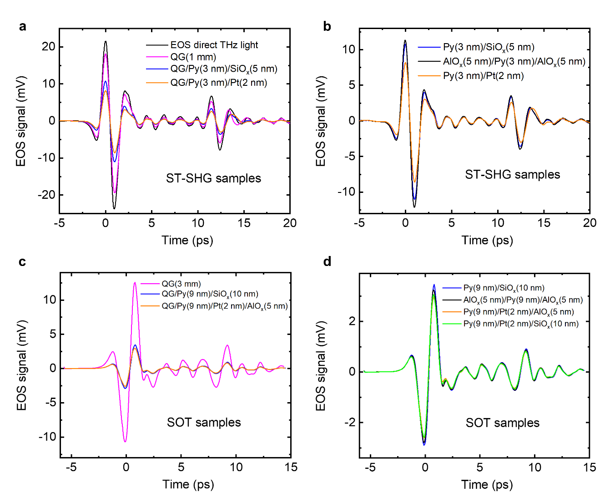
In the ST-SHG geometry, the spin current density is proportional to the absorbed THz power, i.e. (j_{s} ~ j_{c}²), which gives rise to the SHG signal [15]. From Table S2, the peak current density in Py for the Py/oxide samples is ~27 kA/m, compared to ~20 kA/m in Py/Pt, so the corresponding spin current scales as ((27/20)² ≈ 1.8). Thus, Py in the Py/oxide samples generates ~1.8 times larger spin current density than Py in Py/Pt, because the Pt layer in the latter partly shunts the THz-induced current. At the same time, the measured ST-SHG amplitude in Py/oxide is ~10 times smaller than in Py/Pt (Fig. 2b, main text). Combining these factors implies that the effective SHA at Py/oxide interfaces is roughly (1/10)/1.8 ≈ 0.05, i.e. about 5% of the SHA in Py/Pt.
Fig. S9 | THz transmission in samples used for ST-SHG and SOT measurements. a, Transmitted THz waveforms for a bare 1-mm-thick quartz glass (QG) substrate and for the ST-SHG samples Py/SiO_{x} and Py/Pt with 3-nm-thick Py, compared with the incident THz pulse. b, Comparison of transmitted THz radiation through the Py/SiO_{x} and AlO_{x}/Py/AlO_{x} samples. c, Transmitted THz waveforms for a bare 3-mm-thick quartz glass (QG) substrate and for the SOT samples Py/SiO_{x} and Py/Pt with 9-nm-thick Py layers. d, Comparison of transmitted THz radiation through the Py/SiO_{x}, AlO_{x}/Py/AlO_{x} and Py/Pt samples. The absence of any significant reduction in THz transmittance is evident.
We now cross-check this estimate using the SOT data. From Table S1, the SOT efficiency at Py/oxide is about three times smaller than at Py/Pt. The calculated current density in the Py layer of Py/Pt is 245 kA/m, while the current density in the Pt layer is only 37 kA/m (Table S3), indicating that at 9 nm thickness, Py carries most of the THz-induced current and explaining the similar THz absorption of Py/oxide and Py/Pt in Fig. S9d. Comparing the torque per current density in Pt versus Py then yields an effective SHA at the oxide interfaces of 37 kA/m / 3·245 kA/m ≈ 0.05, again about 5% of the SHA in Py/Pt.
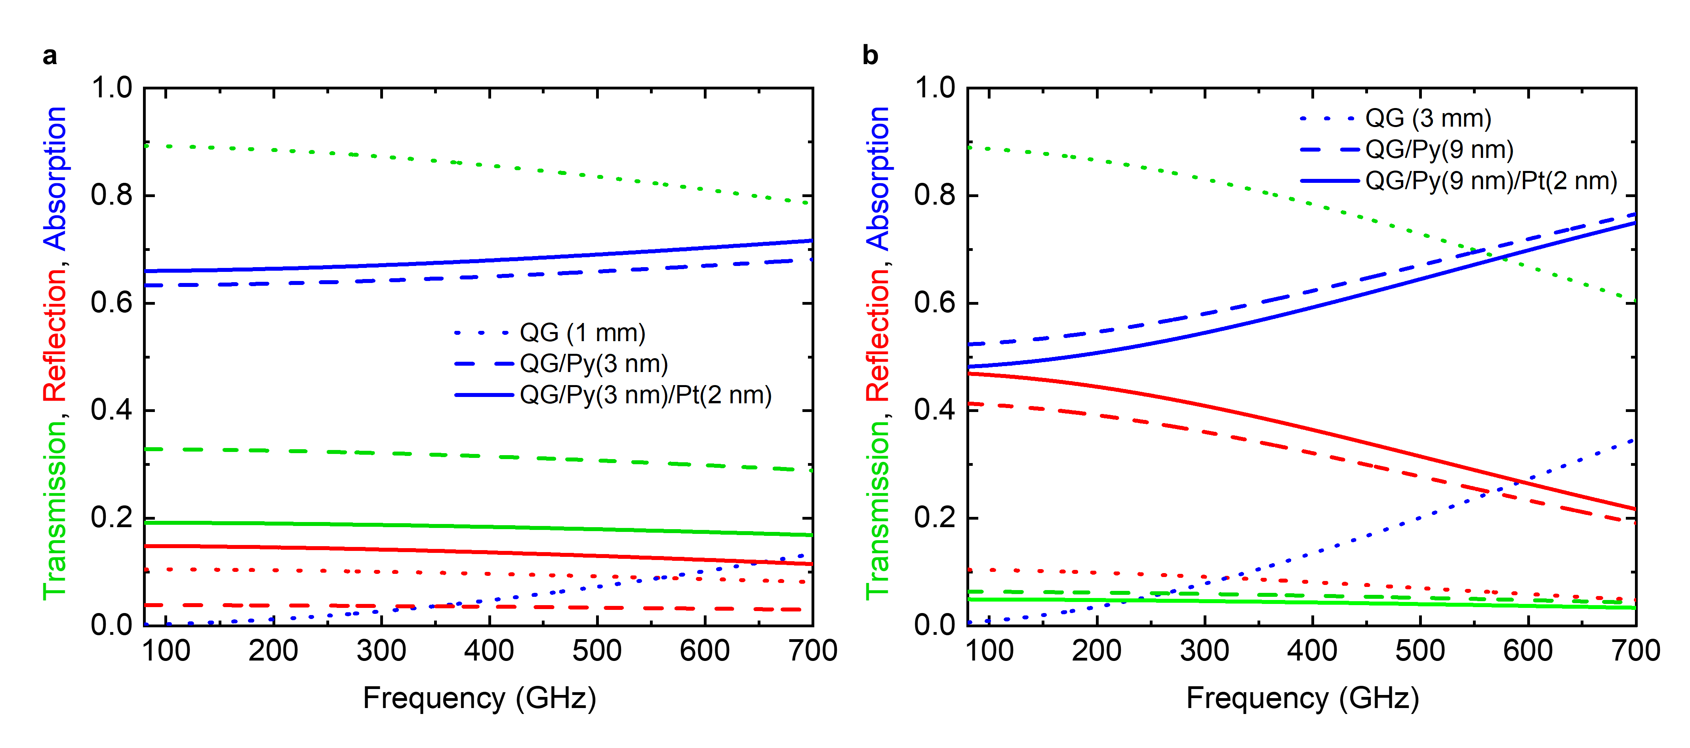
Calculation of THz-induced current densities
Fig. S10 | Simulated THz transmission, reflection, and absorption for samples used in ST-SHG and SOT measurements. a,b, Simulated power transmission (green), reflection (red), and absorption (blue) for a bare quartz glass substrate (dotted lines), quartz/Py (dashed lines), and quartz/Py/Pt (solid lines) for the samples used in the ST-SHG (a) and SOT (b) experiments.
For the ST-SHG samples, a multi-cycle THz field with a peak amplitude of ~100 kV/cm (see Methods) is incident from the substrate side (source at substrate side, detector at metallic-film side). We consider Py(3 nm) and Py(3 nm)/Pt(2 nm) grown on 1-mm-thick quartz glass (QG) substrates, using the quartz permittivity and absorption coefficients from Refs. [16,17]. From the transmission data, we obtain normalized transmission, defined as the transmitted-field amplitude relative to that of the bare QG substrate:
T_{(Py 3 nm)} / T_{(QG)} = 0.609; T_{(Py 3 nm/Pt 2 nm)} / T_{(QG)} = 0.457.
For the SOT samples, we use a single-cycle THz field with a peak amplitude of 500 kV/cm (see Methods). Here, we model Py(9 nm) and Py(9 nm)/Pt(2 nm) on 3-mm-thick QG substrates. The corresponding normalized transmittances are
T_{(Py 9 nm)} / T_{(QG)} = 0.266; T_{(Py 9 nm/Pt 2 nm)} / T_{(QG)} = 0.237.
In both experiments, the signal amplitudes are evaluated within the first THz cycle, so that multiple reflections in the substrate are not taken into account.
From the normalized transmission data, we extract the conductivities of the Py and Py/Pt layers. The total sheet conductance of the single Py layer is $G_{Py}=σ_{Py}t_{Py}$, while that of the Py/Pt layer is $G_{PyPt}=σ_{Py}t_{Py}+σ_{Pt}t_{Pt}$. The sheet conductance of a thin metallic layer G_{met} = G_{Py} or G_{PyPt} is related to the normalized transmission of the metallic layer on the dielectric substrate by the thin-film Tinkham equation [18]:
$$T_{n}=\frac{1+n_{sub}}{1+n_{sub}+η_{0}G_{met}}$$
Here, $n_{sub}$ is the refractive index of the quartz glass substrate, and $η_{0}≈376.73 Ω$ is the impedance of free space.
From the normalized transmission of the Py layer, we obtain $G_{Py}$and $σ_{Py}={G_{Py}}/{t_{Py}}.$For the Py/Pt bilayer, we treat the films as parallel conductors with conductance $G_{PyPt}$, which can be calculated from the normalized transmission amplitude of the stack. Using the previously determined $G_{Py}$ for the layer with the same thickness of Py, the Pt conductivity $σ_{Pt}$ is isolated from the total measured conductance as $σ_{Pt}=({G_{PyPt}-G_{Py})}/{t_{Pt}}$.
The peak surface current density J_{s}​ for both the single-layer and bilayer cases is driven by the local electric field E_{loc}​ existing at the substrate-metal interface. This local field is derived from the incident field in air E_{inc}​ after accounting for the substrate entry transmission
$t_{ent}=2/{(1+n_{sub})}$ and the bulk substrate propagation loss
$a_{prp}=exp (-{α_{sub}⋅d_{sub}}/2)$ over the substrate thickness $d_{sub}$ with absorption coefficient $α_{sub}$. The local field $E_{loc}$ at the metallic interface (where the wave is incident from the substrate side) is defined by the boundary condition at the metallic interface:
$$E_{loc}=\left(E_{inc}⋅t_{ent}⋅a_{prp}\right)⋅\frac{2⋅n_{sub}}{n_{sub}+1+η_{0}G_{met}}$$
The total peak surface current density $J_{s}$ for the entire stack is then:
$$J_{s}=E_{loc}⋅G_{met}$$
To determine the components of the currents flowing within the Py and Pt layers of the Py/Pt stack, we apply the parallel conductance model. The current flowing in each individual layer is proportional to that layer's specific contribution to the total conductance:
$$J_{Py}=E_{loc}⋅σ_{Py}⋅t_{Py}$$
$$J_{Pt}=E_{loc}⋅σ_{Pt}⋅t_{Pt}$$
This ensures that the sum of the individual layer currents equals the total surface current density $J_{s}$.
The material parameters obtained from the Tinkham model are imported into the HFSS simulations. We model a unit cell bounded laterally by periodic boundary conditions and terminated by Floquet ports at the top and bottom. The cell includes a section of the quartz-glass substrate, described using its frequency-dependent dielectric permittivity [16,17], and the metallic layer, which is implemented on the substrate as a layered impedance boundary.
To avoid multiple reflections within the substrate, we place the excitation port directly on the substrate surface and scale the amplitude of the incident field E_{inc} by t_{ent}⋅a_{prp}. The simulations yield the transmission, reflection, and absorption coefficients of the Py and Py/Pt layers on the quartz-glass substrate (Fig. S10), as well as the surface current densities J_{s} (Table S3), which show good agreement with those predicted by the Tinkham model (Table S2).
The simulated absorption exhibits a pronounced frequency dependence, which is particularly evident for the thicker substrates used in the SOT samples (Fig. S10b). As expected, the presence of a metal layer on the substrate strongly increases the absorption and correspondingly reduces the transmission.
The transmission, reflection, and absorption values, as well as the surface current densities and material parameters are summarized in Tables S2 and S3. The current densities used for the relative SHA estimates are highlighted in blue.

Table S2 | Tinkham model results.
SOT systems | R_{s}(Ω/sq) | G_{s}(S/sq) | j_{c} (kA/m) |  | σ(S/m) | J_{c} (kA/m)
Py/QG | 46 | 2.17E-02 | 245 | Py | 2.41E+06
Pt/Py/QG | 39.5 | 2.53E-02 | 255 | Py | 2.41E+06 | 218
 |  |  |  | Pt | 1.81E+06 | 37
SHG systems
Py/QG | 198 | 5.05E-03 | 27 | Py | 1.68E+06
Pt/Py/QG | 107 | 9.34E-03 | 37 | Py | 1.68E+06 | 20
 |  |  |  | Pt | 2.15E+06 | 17

Table S3 | HFSS simulation summary. A value of σ_{Pt} = 2e⁶ S/m was used in the HFSS simulations of all samples.
SOT | S_{21(350 GHz)} | S_{11(350GHz)} | T_{(350GHz)} | R_{(350GHz)} | A_{(350GHz)} | S_{21(QG)} | T_{(QG)} | j_{c} (kA/m) _{500kV/cm}
QG/air | 0.899 | 0.294 | 0.808 | 0.086 | 0.105
Py/QG | 0.24 | 0.584 | 0.058 | 0.341 | 0.601 | 0.267 | 0.071 | 245
Pt/Py/QG | 0.211 | 0.623 | 0.045 | 0.388 | 0.567 | 0.235 | 0.055 | 255
SHG | S_{21(500 GHz)} | S_{11(500GHz)} | T_{(500GHz)} | R_{(500GHz)} | A_{(500GHz)} | S_{21(QG)} | T_{(QG)} | J_{s}(kA/m) _{100kV/cm}
QG/air | 0.914 | 0.303 | 0.835 | 0.092 | 0.073
Py/QG | 0.554 | 0.183 | 0.307 | 0.033 | 0.660 | 0.606 | 0.367 | 27
Pt/Py/QG | 0.424 | 0.36 | 0.180 | 0.130 | 0.691 | 0.464 | 0.215 | 37

References
[1] Ulrichs, H., Razdolski, I. Micromagnetic view on magnon generation by femtosecond spin current pulses. Phys. Rev. B 98, 054429 (2018).
[2] Salikhov, R. et al. Coupling of terahertz light with nanometrewavelength magnon modes via spin-orbit torque. Nat. Phys. 19, 529–535 (2023).
[3] van Kampen, M. et al. All-optical probe of coherent spin waves. Phys. Rev. Lett. 88, 227201 (2002).
[4] Brandt, L. et al. Spin transport-induced damping of coherent THz spin dynamics in iron. arXiv:2107.12812v2 (2021). https://doi.org/10.48550/arXiv.2107.12812
[5] Garello, K. et al., Symmetry and magnitude of spin–orbit torques in ferromagnetic heterostructures. Nat. Nanotech. 8, 587–593 (2013).
[6] Montazeri, M., et al. Magneto-optical investigation of spin–orbit torques in metallic and insulating magnetic heterostructures. Nat. Commun. 6, 8958 (2015).
[7] Manchon, A., Železný, J., Miron, I.M., Jungwirth, T., Sinova, J., Thiaville, A., Garello, K., Gambardella, P. Current-induced spin-orbit torques in ferromagnetic and antiferromagnetic systems. Rev. Mod. Phys. 91, 035004 (2019).
[8] Kovalev, S. et al. Terahertz magneto-optical sampling in quartz glass. Opt. Lett. 49, 4749-4752 (2024).
[9] Kezilebieke, S., Ali, M., Shadeke, B., Gunnella, R. Magnetic properties of ultrathin Ni₈₁Fe₁₉ films with Ta and Ru capping layers. J. Phys.: Condens. Matter 25, 476003 (2013).
[10] Ilyakov, I. et al. Efficient ultrafast field-driven spin current generation for spintronic terahertz frequency conversion. Nat. Commun. 14, 7010 (2023).
[11] Salikhov, R. et al. Ultrafast unidirectional spin Hall magnetoresistance driven by terahertz light field. Nat. Commun. 16, 2249 (2025).
[12] Rouzegar, R. et al. Broadband spintronic terahertz source with peak electric fields exceeding 1.5 MV/cm. Phys. Rev. Appl. 19, 034018 (2023).
[13] Seifert, T. et al. Efficient metallic spintronic emitters of ultrabroadband terahertz radiation. Nat. Photon. 10, 483 (2016).
[14] Avci, C. et al. Unidirectional spin Hall magnetoresistance in ferromagnet/normal metal bilayers. Nat. Phys. 11, 570 (2015).
[15] Nur Koyun, H. et al. Magnetization-controlled terahertz harmonic generation with grating and cavity structures. J. Appl. Phys. 138, 143907 (2025).
[16] Naftaly, M., Miles, R.E. Terahertz time-domain spectroscopy of silicate glasses and the relationship to material properties. J. Appl. Phys. 102, 043517 (2007).
[17] Naftaly, M., Gregory, A. Terahertz and microwave optical properties of single-crystal quartz and vitreous silica and the behavior of the boson peak. Applied Sciences 11, 6733 (2021).
[18] M. Tinkham. Energy gap interpretation of experiments on infrared transmission through superconducting films. Phys. Rev. 104, 845 (1956).

