Table S2 Annotated information on chloroplast genome of Primula (* represents pseudogenes)
Gene categor | Gene group | gene
Self-replication gene | tRNA gene | trnA-UGC(2), trnC-GCA,  trnD-GUC, trnE-UUC,  trnF-GAA, trnfM-CAU,  trnG-GCC, trnG-UCC(2),  trnH-GUG, trnI-CAU(2),  trnI-GAU(2), trnK-UUU, trnL-CAA(2), trnL-UAA,  trnL-UAG, trnM-CAU(2), trnN-GUU(2), trnP-UGG,  trnQ-UUG, trnR-ACG(2),  trnR-UCU, trnS-GCU,  trnS-GGA, trnS-UGA,  trnT-GGU, trnT-UGU,  trnV-GAC(2), trnV-UAC,  trnW-CCA, trnY-GUA
Self-replication gene | rRNA gene | rrn4.5, rrn5, rrn16, rrn23
Self-replication gene | Large subunit of ribosome gene | rpl2(2), rpl14, rpl16, rpl20, rpl22, rpl23(2), rpl32, rpl33, rpl36
Self-replication gene | Small subunit of ribosome gene | rps2, rps3, rps4, rps7(2), rps8, rps11, rps12(2), rps14, rps15, rps16, rps18, rps19
Self-replication gene | DNA dependent RNA polymerase | rpoA, rpoB, rpoC1, rpoC2
 | Subunits of NADH-dehydrogenase | ndhA*, ndhB(×2)*, ndhC, ndhD, ndhE, ndhF, ndhG, ndhH, ndhI, ndhJ, ndhK
Gene related tophotosynthesis | Subunits of photosystem Ⅰ | psaA, psaB, psaC, psaI, psaJ
Gene related tophotosynthesis | Subunits of photosystem Ⅱ | psbA, psbB, psbC, psbD, psbE, psbF, psbH, psbI, psbJ, psbK, psbL, psbM, psbN, psbT, psbZ
Other gene | Subunits of cytochrome b/f complex | petA,petB, petD,petG, petL,petN
Other gene | Subunits of ATP synthase | atpA, atpB, atpE, atpF, atpH,atpI
Other gene | Large subunit of rubisco | rbcL
Other gene | Translational initiation factor | infA*
Other gene | Maturase | matK
Other gene | Protease | clpP
 | c-type cytochrom synthesis | ccsA
Other gene | Acetyl-CoA-carboxylase | accD*
 | Envelop membrane protein | cemA*
Genes with unknown functions | Hypothetical chloroplast readingframes | pafI, pafII, ycf1*, ycf2(2), ycf15*(2), orf42(2)

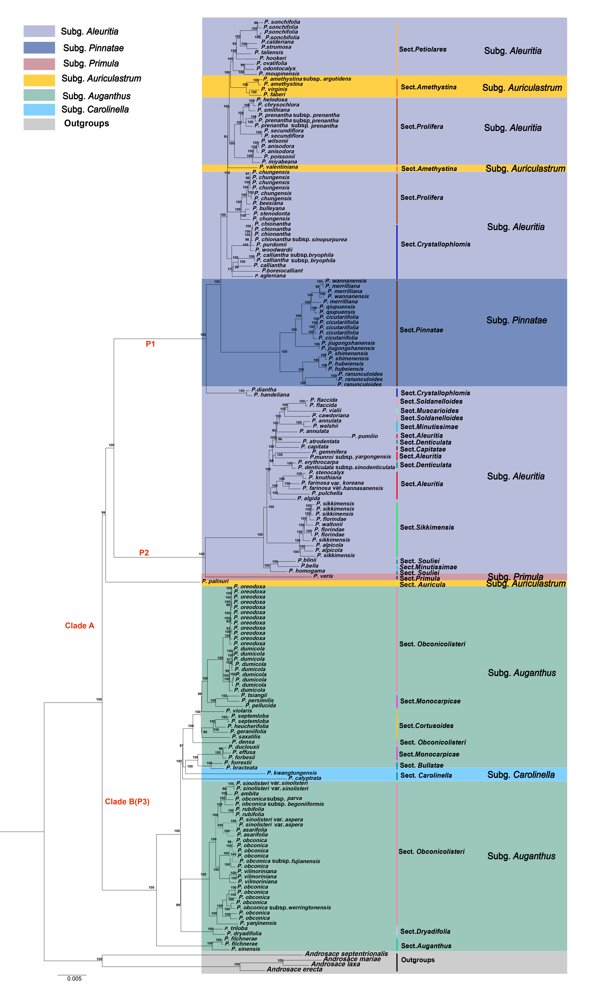
Figure S1. ML tree was reconstructed from complete plastomes of 180 individuals (106 species) and four Androsace species. Androsace, a sister genus to primula, served as the outgroup in the phylogenetic tree. Colored regions represent subgenera, while colored bars denote sectional classifications. Bootstrap support values are shown at nodes.
Figure S2 Complete time-calibrated maximum clade credibility (MCC) tree of Primula based on 180 plastome sequences. All 106 species and four outgroups are shown. Numbers adjacent to nodes indicate median ages (Mya); blue bars represent 95% HPD intervals. Branch lengths represent time (Mya)The five-pointed star represents the fossil calibration node.

