Appendix B
FigureS1 Dimension-Specific Symptom Incidence in Cervical Cancer Survivors

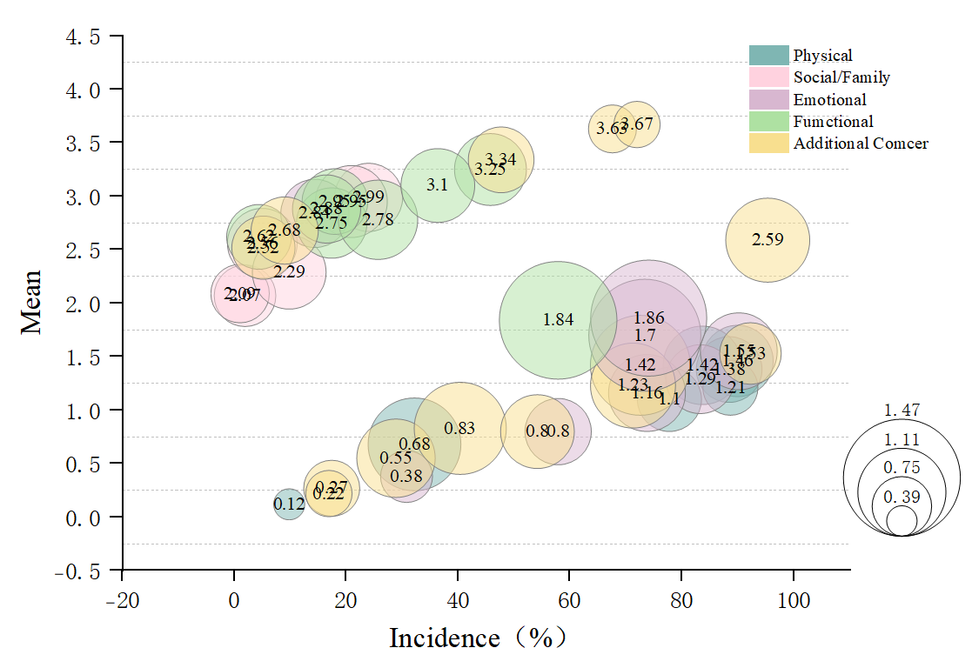

FigureS2 Standardized Centrality Indices of Symptom Cluster Network Model in patient with Cervical Cancer during rehabilitation period

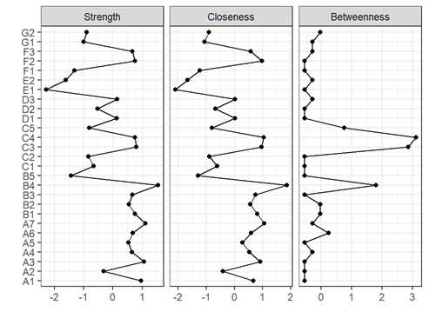

FigureS3 Line Chart of Bridge Centrality Measures for Symptom Clusters in patient with Cervical Cancer during rehabilitation period
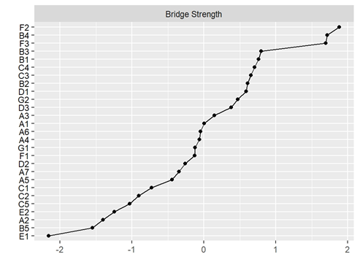

FigureS4 Stability Examination of Symptom Clusters in patient with Cervical Cancer during rehabilitation period

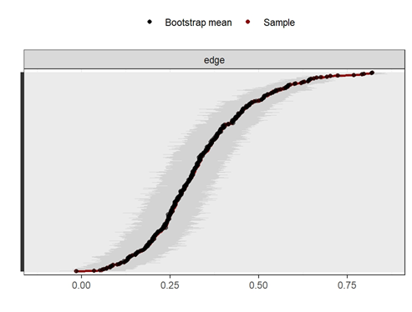

FigureS5 Accuracy Assessment of Symptom Clusters in patient with Cervical Cancer during rehabilitation period

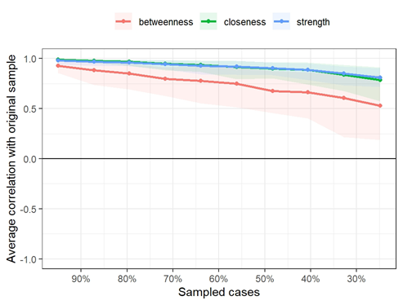

FigureS6 Accuracy Assessment of Symptom Clusters in Early-Stage Cervical Cancer Survivors (3-6 Months)
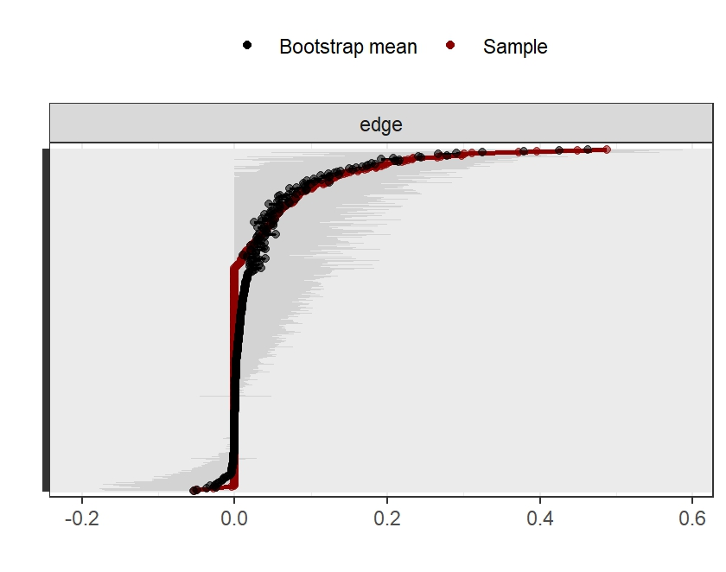

FigureS7 Accuracy Assessment of Symptom Clusters in Middle-Stage Cervical Cancer Survivors (7-12 Months)
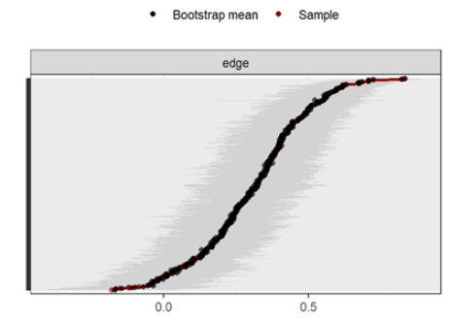

FigureS8 Accuracy Assessment of Symptom Clusters in Late-Stage Cervical Cancer Survivors (over 12 Months)
