Supplementary Information - Designing Shear-thinning Hydrogel Nanocomposites Using Mixed-variable Bayesian Optimization
  - Gourav Kumbhojkar¹, George Varghese P J², Keren Zhao², Sinan Keten^{1,3}, Jingjie Hu², Wei Chen¹
¹ Department of Mechanical Engineering, Northwestern University, Evanston, Illinois, USA.
² Department of Mechanical and Aerospace Engineering, North Carolina State University, Raleigh, NC, USA.
³ Department of Civil and Environmental Engineering, Northwestern University, Evanston, Illinois, USA.

Dataset
Table 1 shows the average G’ values of all the gels engineered.
Table 1 Measured average G' and standard deviation of engineered gels
Polymer | NC (wt%) | Polymer (wt%) | G' (mean) | G' std
Chitosan | 0.00 | 4.00 | 275.25 | 10.57
Chitosan | 1.00 | 3.00 | 40.76 | 4.32
Chitosan | 2.00 | 2.00 | 22.58 | 1.94
Chitosan | 3.00 | 1.00 | 125.47 | 5.00
Chitosan | 4.00 | 0.00 | 319.08 | 8.86
Chitosan | 0.00 | 6.00 | 6154.67 | 401.56
Chitosan | 1.50 | 4.50 | 3370.07 | 375.77
Chitosan | 3.00 | 3.00 | 730.04 | 35.29
Chitosan | 4.50 | 1.50 | 1614.40 | 90.41
Chitosan | 6.00 | 0.00 | 2105.63 | 25.64
Chitosan | 2.00 | 6.00 | 9642.70 | 1181.84
Chitosan | 4.00 | 4.00 | 4652.90 | 322.19
Chitosan | 6.00 | 2.00 | 5302.13 | 131.58
Chitosan | 8.00 | 0.00 | 4586.73 | 166.20
Chitosan | 1.45 | 6.09 | 14030.00 | 1245.20
Chitosan | 1.20 | 6.34 | 10670.00 | 1061.00
Chitosan | 1.86 | 7.24 | 24358.00 | 825.95
Alginate | 2.00 | 2.00 | 17.57 | 0.82
Alginate | 2.50 | 1.50 | 25.83 | 0.49
Alginate | 3.00 | 1.00 | 448.23 | 24.98
Alginate | 3.50 | 0.50 | 687.98 | 10.87
Alginate | 4.00 | 0.00 | 328.56 | 3.97
Alginate | 4.00 | 2.00 | 132.53 | 9.25
Alginate | 4.50 | 1.50 | 801.32 | 30.49
Alginate | 5.00 | 1.00 | 2338.23 | 14.94
Alginate | 5.50 | 0.50 | 2557.37 | 61.71
Alginate | 6.00 | 0.00 | 1563.40 | 40.17
Alginate | 5.75 | 1.25 | 3634.00 | 120.16
Alginate | 6.00 | 1.00 | 3995.13 | 179.81
Alginate | 6.50 | 0.50 | 3926.27 | 104.14
Alginate | 7.00 | 0.00 | 2926.80 | 91.04
Alginate | 3.50 | 1.50 | 114.10 | 1.83
Alginate | 4.00 | 1.00 | 819.47 | 31.93
Alginate | 4.50 | 0.50 | 1513.83 | 172.96
Alginate | 5.00 | 0.00 | 770.10 | 11.11
Alginate | 7.47 | 1.12 | 166.64 | 5.06
Alginate | 6.90 | 1.04 | 3127.14 | 1006.99
Alginate | 6.17 | 3.18 | 63.37 | 15.63
Alginate | 8.41 | 1.28 | 200.56 | 11.90
Alginate | 6.62 | 0.91 | 3127.14 | 1006.99
Alginate | 6.55 | 0.94 | 3127.14 | 1006.99
Gelatin | 0.00 | 6.00 | 413.13 | 70.16
Gelatin | 3.75 | 1.25 | 1145.07 | 72.10
Gelatin | 1.50 | 4.50 | 1297.05 | 60.13
Gelatin | 3.00 | 3.00 | 5101.44 | 154.12
Gelatin | 4.50 | 1.50 | 2414.68 | 221.89
Gelatin | 6.00 | 0.00 | 1758.14 | 50.53
Gelatin | 6.40 | 1.58 | 11225.00 | 617.82
Gelatin | 4.97 | 3.25 | 5507.90 | 463.70
Gelatin | 6.26 | 2.74 | N/A | N/A
Gelatin | 5.44 | 2.85 | N/A | N/A

Model validation
SI Figure 1 compares the predictive performance of the standard Gaussian Process (GP) and the Latent Variable Gaussian Process (LVGP) models using leave-one-out cross-validation (LOOCV). For each material system (chitosan, alginate, and gelatin), the top two rows show predicted versus true means with corresponding predictive uncertainty, while the bottom panels summarize performance using $R^{2}$and negative log predictive density (NLPD).
Under LOOCV, both models demonstrate strong predictive accuracy for chitosan and alginate. In contrast, substantial differences emerge for gelatin. Both models exhibit reduced predictive accuracy, reflected by negative $R^{2}$values (GP: −0.52; LVGP: −0.19), indicating that predictions are worse than a mean-only baseline under LOOCV. This can be attributed to limited amount of data available for gelatin (total 6 data points). However, the probabilistic performance differs markedly. The standard GP yields a significantly higher NLPD (12.63) compared to the LVGP (8.76). Because NLPD penalizes both prediction error and poor uncertainty quantification, this large increase indicates that the GP is not only inaccurate but also poorly calibrated for gelatin, assigning low probability density to the observed outcomes. In contrast, the LVGP provides significantly better uncertainty quantification, even when prediction accuracy is low.
The predicted-versus-true plots further illustrate this behavior. For chitosan and alginate, predictions cluster tightly around the identity line with relatively narrow error bars. For gelatin, predictions are more dispersed, and the GP exhibits larger deviations from the identity line. Notably, the LVGP’s predictive intervals better accommodate the observed variability, contributing to its improved NLPD despite modest gains in $R^{2}.$
GP classification model which is used to predict feasibility of gelatin-based gel formulations is evaluated using LOOCV where it shows F1 score of 0.69. SI Figure 1(d) shows the confusion matrix with True Positive (TP), False Positive (FP), True Negative (TN), and False Negative (FN) predictions by the model.

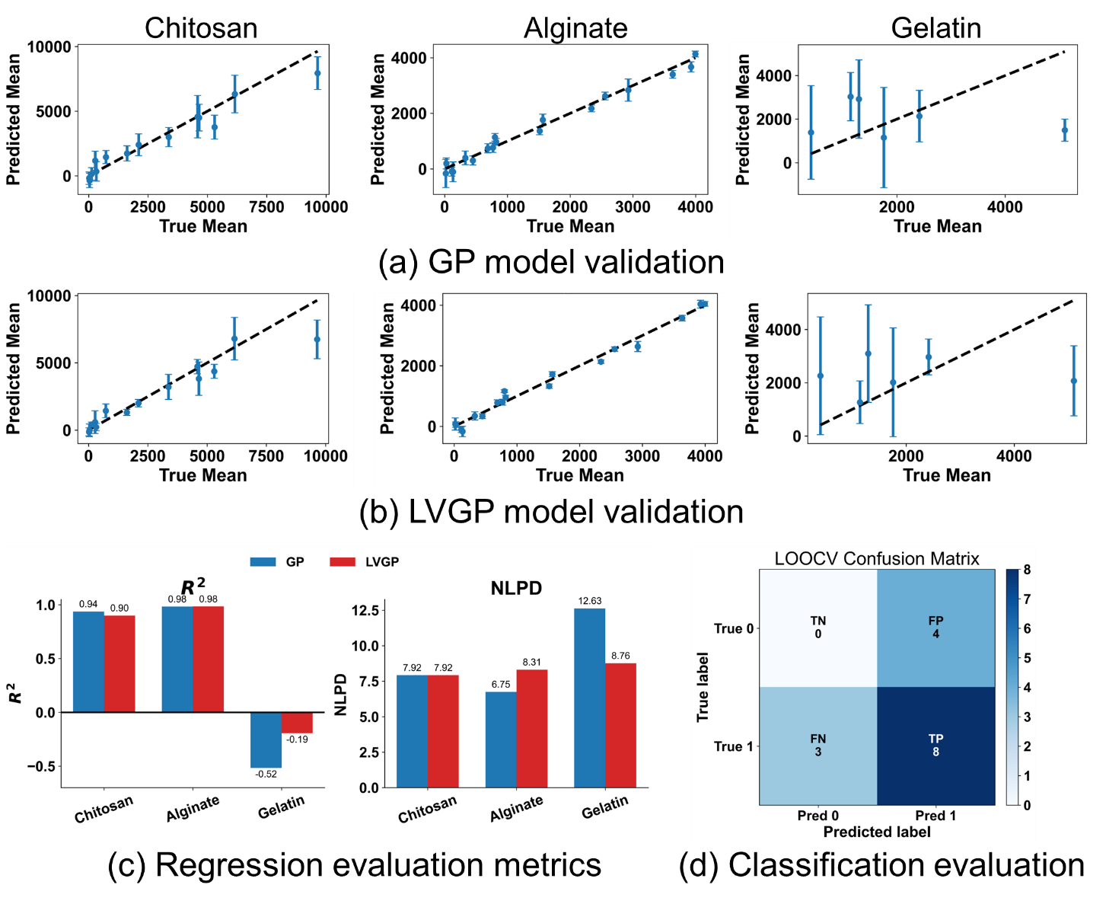
SI Figure 1. Model validation using leave-one-out cross-validation for (a) GP and (b) LVGP model. (c) Both models fit well on chitosan and alginate dataset. LVGP shows improvement in prediction on gelatin dataset. LVGP also shows better uncertainty quantification as shown by negative log predictive density (NLPD). (d) GP classification model fit to predict the feasibility of gelatine-based gels shows F1 score of 0.69 providing reasonable prediction of feasible formulations.

