Supplementary Table 1. List of DMRs in different mutants.
Supplementary Table 2. List of RDM15-dependent siRNA cluster regions.
Supplementary Table 3. Data of RDM15 histone peptide array assay.
Supplementary Table 4. RDM15 IP-MS/MS.
Supplementary Table 5. Summary of X-Ray diffraction data and structure refinement statistics.
Supplementary Table 6. Primer information.

Supplementary Table 5. Summary of X-Ray diffraction data and structure refinement statistics.

Primers | Sequences
RDM15-nLUC-F | ACGGGGGACGAGCTCGGTACCATGTCGGATTCTGATAAAGAGCTC
RDM15-nLUC-R | CGCGTACGAGATCTGGTCGACTCGCTTCCTCTTCTTACCGGACTT
RDM15-cLUC-F | TACGCGTCCCGGGGCGGTACCATGTCGGATTCTGATAAAGAGCTC
RDM15-cLUC-R | ACGAAAGCTCTGCAGGTCGACTCGCTTCCTCTTCTTACCGGACTT
NRPE3B-nLUC-F | ACGGGGGACGAGCTCGGTACCATGGACGGTGTCACCTACCAAAGA
NRPE3B-nLUC-R | CGCGTACGAGATCTGGTCGACTCCTTCACGCATATGGGCACCGAG
NRPE3B-cLUC-F | TACGCGTCCCGGGGCGGTACCATGGACGGTGTCACCTACCAAAGA
NRPE3B-cLUC-R | ACGAAAGCTCTGCAGGTCGACTCCTTCACGCATATGGGCACCGAG
RDM15-YN-F | ATTTACGAACGATAGTTAATTAACATGTCGGATTCTGATAAAGAGCTC
RDM15-YN-R | ACTGCCACCTCCTCCACTAGTTCGCTTCCTCTTCTTACCGGACTT
RDM15-YC-F | ATTTACGAACGATAGTTAATTAACATGTCGGATTCTGATAAAGAGCTC
RDM15-YC-R | ACTGCCACCTCCTCCACTAGTTCGCTTCCTCTTCTTACCGGACTT
NRPE3B-YN-F | ATTTACGAACGATAGTTAATTAACATGGACGGTGTCACCTACCAAAGA
NRPE3B-YN-R | ACTGCCACCTCCTCCACTAGTTCCTTCACGCATATGGGCACCGAG
Supplementary Table 6. Primer information.

Supplementary Figures
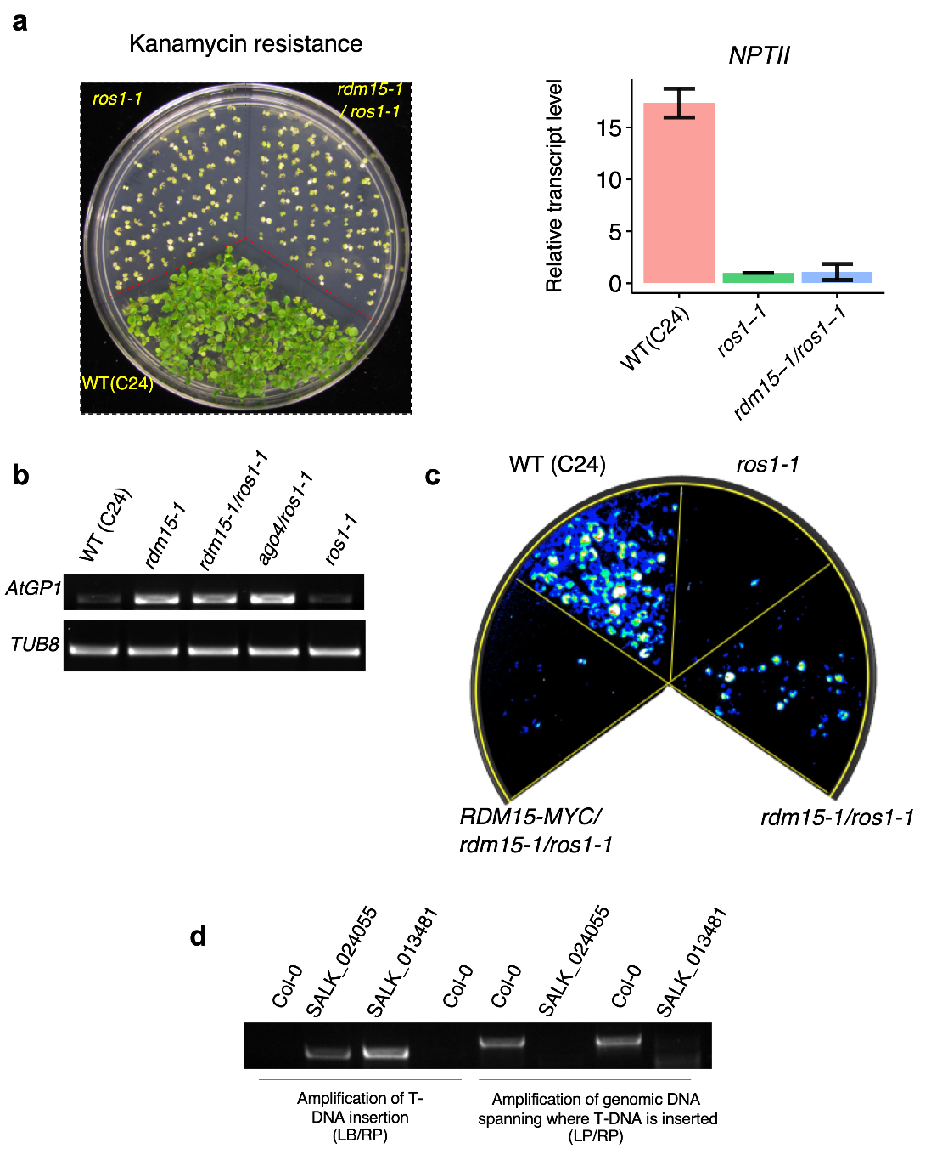
Supplementary Figure 1. RDM15 functions as a silencing factor in RdDM.
a. Effect of rdm15-1 on the kanamycin-resistant phenotype in the ros1-1 background. WT (C24) carries 35S-NPTII, the expression of which leads to kanamycin-resistance. In the ros1-1 background, the rdm15 mutation failed to rescue the kanamycin-resistant phenotype (left) and 35S-NPTII expression (right). b. RT-PCR analysis of transcript levels of endogenous AtGP1, which is a canonical RdDM target, in the WT (C24), rdm15-1, rdm15-1/ros1-1, ago4/ros1-1, and ros1-1 genotypes. c. Complementation of rdm15-1/ros1-1 by RDM15-MYC. The WT, ros1-1, rdm15-1ros1-1, and RDM15-MYC/rdm15-1ros1-1 plants were grown for 10 days and imaged after cold treatment (48 h, 4°C). Compared to rdm15-1ros1-1, RDM15-MYC/rdm15-1ros1-1 showed weaker luminescence emission.
d. rdm15-2 and rdm15-3 plants containing T-DNA insertions were confirmed by PCR amplification and agarose gel electrophoresis.

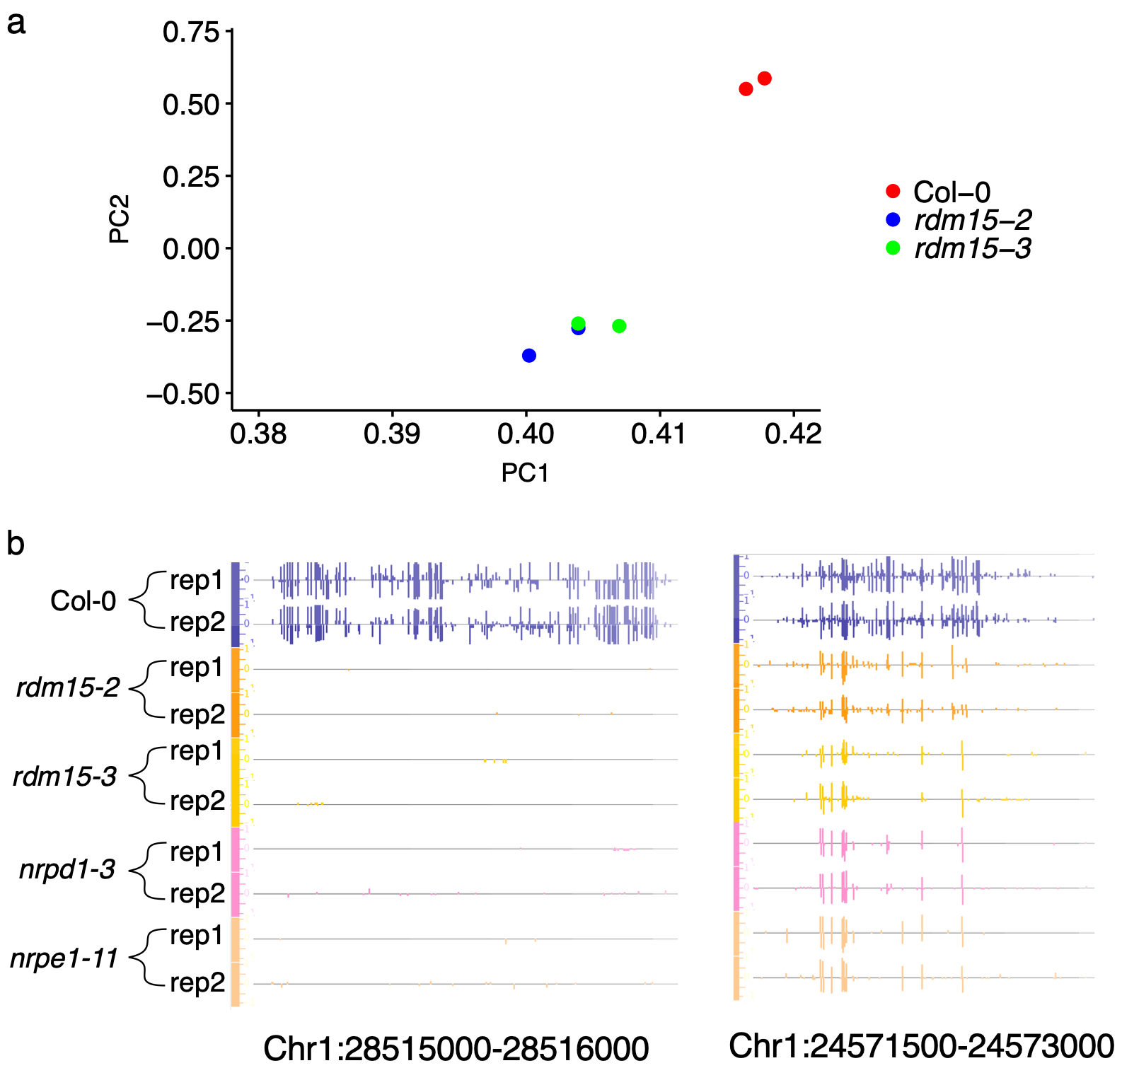

Supplementary Figure 2. Effect of rdm15 on genomic cytosine methylation.
a. Principal components analysis of DNA methylomes of Col-0, rdm15-2, and rdm15-3 with two biological replicates. b. DNA methylation levels of representative rdm15 DMRs in Col-0, rdm15-2, rdm15-3, nrpd1-3, and nrpe1-11.
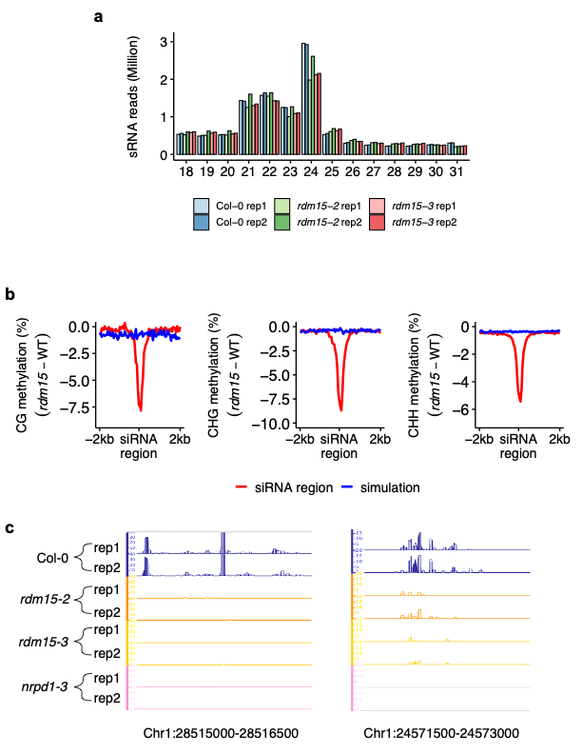
Supplementary Figure 3. Effect of rdm15 on the accumulation of siRNAs.
a. Genome-wide siRNA profiles of Col-0, rdm15-2, and rdm15-3 with two biological replicates. b. Change of CG CHG and CHH methylation levels (rdm15-WT) at RDM15-dependent siRNA regions. Control regions were randomly selected regions that were simulated with the lengths of RDM15-dependent siRNA regions. c. IGB display of the siRNA levels at several rdm15 hypo-DMRs.

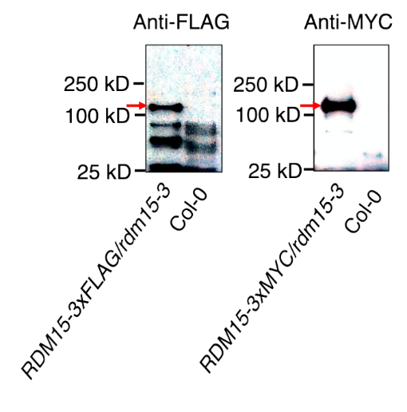
Supplementary Figure 4. Western blot showing RDM15 protein accumulation in RDM15-3MYC/rdm15-3 and RDM15-3FLAG/rdm15-3 plants.
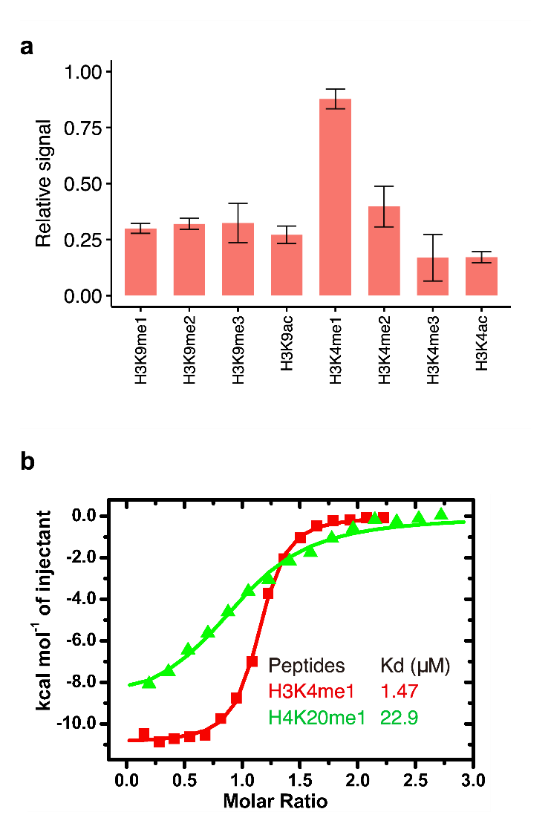
Supplementary Figure 5. The RDM15 tudor domain specifically recognizes the H3K4me1 mark. a. Histone peptide array assay showing the binding preference of RDM15 to H3K4me1. Error bar represents s.d. (n=3). b. ITC binding curves between the RDM15 tudor domain and H3K4me1 and H4K20me1 peptides indicate that H3K4me1 is the optimal binding partner for RDM15.
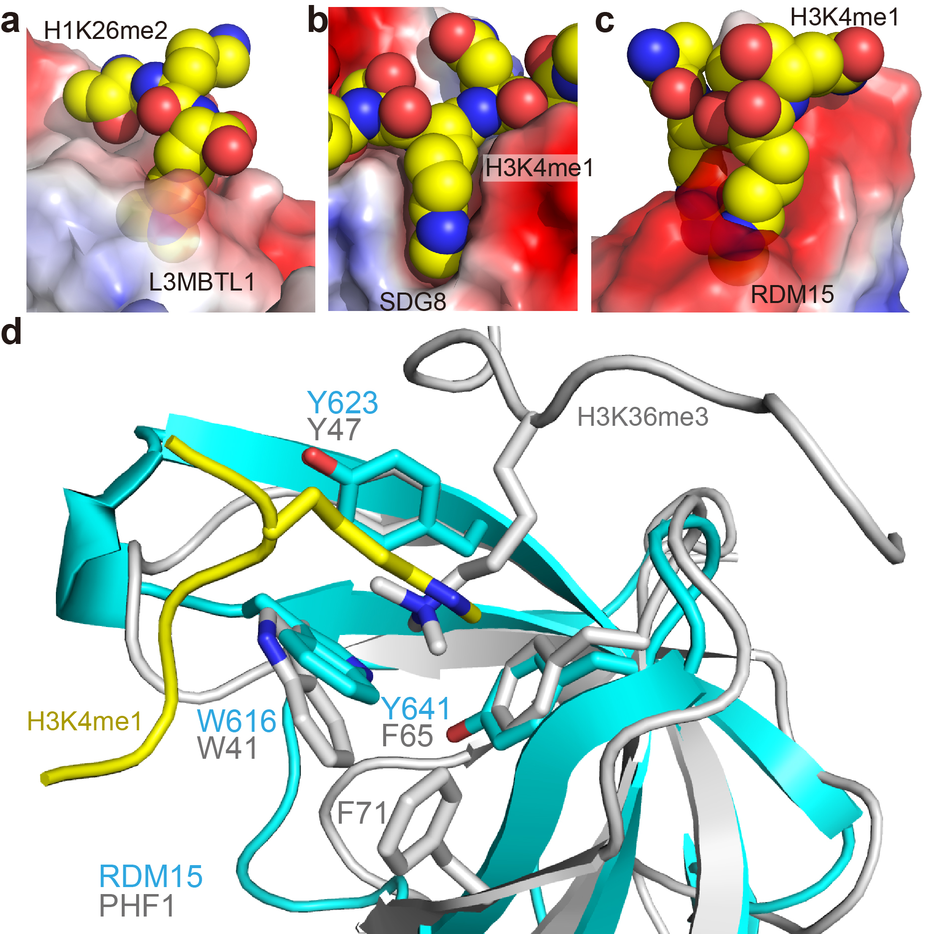
Supplementary Figure 6. The RDM15 tudor domain enables the recognition of lower methyllysine. a-c. Structures of the L3MBTL1-H1K26me2 complex (a, PDB code: 2RHI), SDG8-H3K4me1 complex (b, PDB code: 5YVX), and RDM15-H3K4me1 complex (c, in this study), with reader proteins in electrostatics surface view and histone peptide in space-filling representation. L3MBTL1 and SDG8 use deep surface cavities to specifically recognize the lower methylation states of methyllysine; in these interactions, the side chains of the methyllysines are almost fully buried in a cavity of the protein, and this serves as a physical shape-based size selection filter to control methylation status. RDM15 uses a surface groove pocket to recognize methyllysine. The RDM15 tudor domain can form hydrogen bonds with two monomethylammonium protons of monomethyllysine to enhance the binding affinity, so as to obtain the selectivity for lower methylation state. d. Superposition of RDM15-H3K4me1 (in cyan and yellow) and PHF1-H3K36me3 (in silver, PDB code: 4HCZ) complexes reveals that although they have a similar aromatic cage, the peptides adopt opposite orientations. PHF1 has a broader aromatic cage, which is capable of recognizing higher methylation states. In contrast, RDM15 has a narrow cage, which is suitable for recognizing lower methylation states.

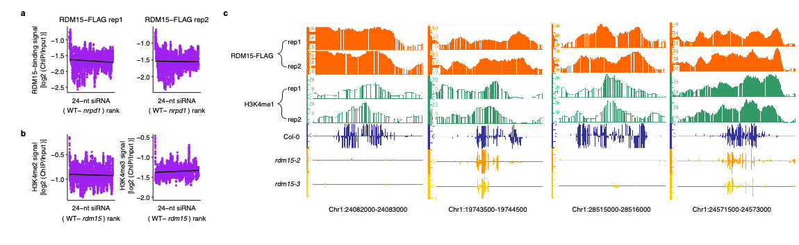
Supplementary Figure 7. Enrichment of RDM15 at RDM15-targeted regions. a. Change of siRNAs (WT vs. nrpd1) at Pol IV-only siRNA regions was not correlated with RDM15 enrichment. b. Change of siRNAs (WT vs. rdm15) at RDM15-dependent siRNA regions was not correlated with H3K4me2 or H3K4me3 enrichment. c. RDM15 and H3K4me1 enrichment and DNA methylation levels of several RDM15-targeted regions

