Supplementary Materials

Supplementary Fig. 1 | Age and tumor volume distributions by seizure status. A) Age at surgery in patients with and without seizures at presentation. B) Tumor volume at surgery in patients with and without seizures at presentation. Boxes indicate IQR with median line, whiskers show 1.5×IQR. Individual data points overlaid.
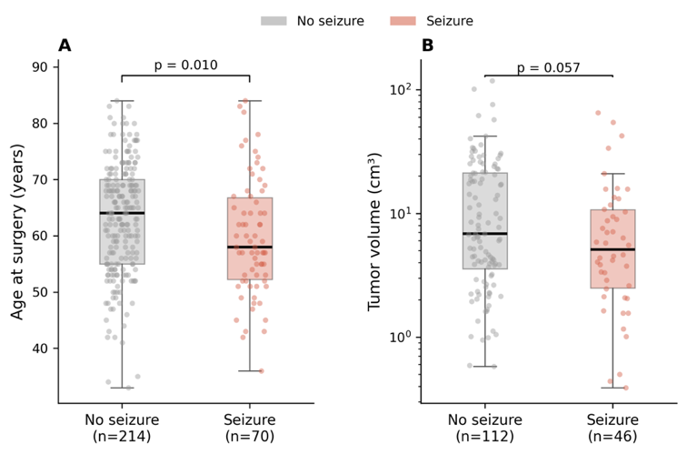

Supplementary Table 1. Uni- and multivariable logistic regression for predictors of seizure at presentation.
Variable | Univariable OR (95% CI) | p value | Multivariable OR (95% CI) | p value
Age <60 years | 2.20 (1.27-3.81) | 0.005 | 2.65 (1.43-4.91) | 0.002
Prior/concurrent ICB | 1.91 (0.99-3.66) | 0.053 | 2.59 (1.24-5.42) | 0.012
ICP symptoms | 0.49 (0.28-0.85) | 0.011 | 0.43 (0.23-0.81) | 0.009
Cortical location | 2.68 (1.00-7.20) | 0.050 | 2.19 (0.79-6.10) | 0.133
Parietal lobe | 2.40 (1.29-4.44) | 0.005 | --- | ---
Single brain metastasis | 1.08 (0.57-2.03) | 0.813 | --- | ---
Tumor volume >7 cm³ | 0.73 (0.36-1.46) | 0.373 | --- | ---

Multivariable model includes age <60, ICB, ICP symptoms, and cortical location (N=244). Cortical location was included as a covariate but did not reach significance; parietal lobe, single BM, and tumor volume were tested in univariable analysis only. OR = odds ratio; CI = confidence interval.

