Supplementary
Material and methods
Tree basal area was calculated from stem diameter (d0) measurements using standard geometric conversion and summed at the plot level (Dietrich et al. 2023). Soil carbon fractions (LC, labile organic carbon; ROC, recalcitrant organic carbon; SOC, soil organic carbon; and SIC, soil inorganic carbon) were determined by Rock-Eval thermal analysis following standard protocols, based on temperature-resolved hydrocarbon release during programmed pyrolysis and oxidation (Disnar et al. 2003). Soil microbial biomass carbon (MBC) and basal respiration were determined using an O₂ microcompensation system following substrate-induced respiration (SIR) (Scheu 1992). Briefly, the maximum initial respiratory response (MIRR) after glucose addition was used to calculate MBC (38 × MIRR) (Beck et al. 1997), and basal respiration was derived from oxygen consumption prior to substrate addition. Gravimetric soil water content was determined from fresh subsamples by oven-drying.

References

Beck T, Joergensen RG, Kandeler E, Makeschin F, Nuss E, Oberholzer HR, et al (1997) An inter-laboratory comparison of ten different ways of measuring soil microbial biomass C. Soil Biol Biochem 29:1023–1032. https://doi.org/10.1016/S0038-0717(97)00030-8
Dietrich P, Ferlian O, Huang Y, Luo S, Quosh J, Eisenhauer N (2023) Tree diversity effects on productivity depend on mycorrhizae and life strategies in a temperate forest experiment. Ecology 104:e3896. https://doi.org/10.1002/ecy.3896
Disnar JR, Guillet B, Keravis D, Di-Giovanni C, Sebag D (2003) Soil organic matter (SOM) characterization by Rock-Eval pyrolysis: scope and limitations. Org Geochem 34:327–343. https://doi.org/10.1016/S0146-6380(02)00239-5
Scheu S (1992) Automated measurement of the respiratory response of soil microcompartments: active microbial biomass in earthworm faeces. Soil Biol Biochem 24:1113–1118. https://doi.org/10.1016/0038-0717(92)90061-2

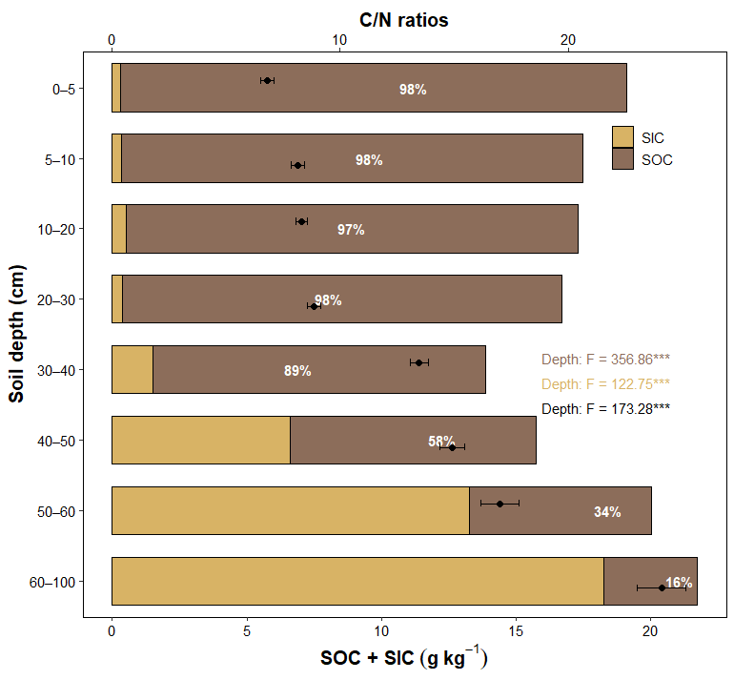
Fig. S1 Depth-dependent partitioning of soil organic carbon (SOC) and inorganic carbon (SIC) within total soil carbon (TC), and depth profiles of soil C:N ratios. Stacked bars show mean SOC and SIC concentrations at each soil depth, with percentages indicating the SOC proportion of TC. Points and error bars overlaid on bars represent mean soil C:N ratios ± standard errors. F-statistics from linear mixed-effects models indicate significant depth effects on SOC (brown), SIC (yellow), and C:N ratios (black); ***P < 0.001.

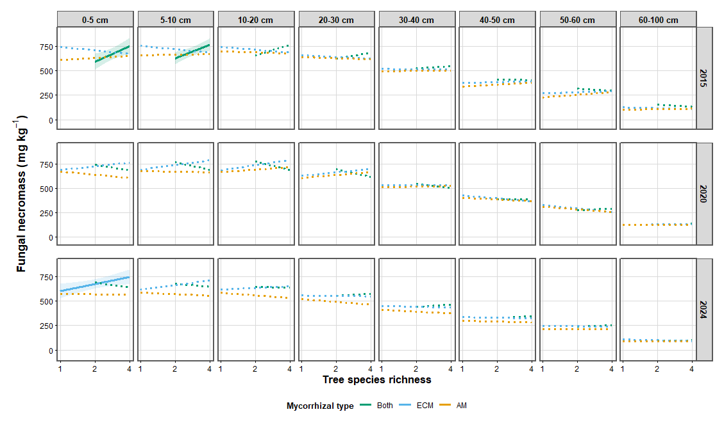
Fig. S2 Depth-specific responses of fungal necromass concentrations to tree species richness across mycorrhizal types. Relationships between tree species richness and concentrations in microbial necromass are shown across eight soil depths over time. Lines represent fitted values from linear mixed-effects models, and shaded areas indicate 95% confidence intervals. Solid lines denote significant richness effects, whereas dashed lines indicate non-significant relationships.

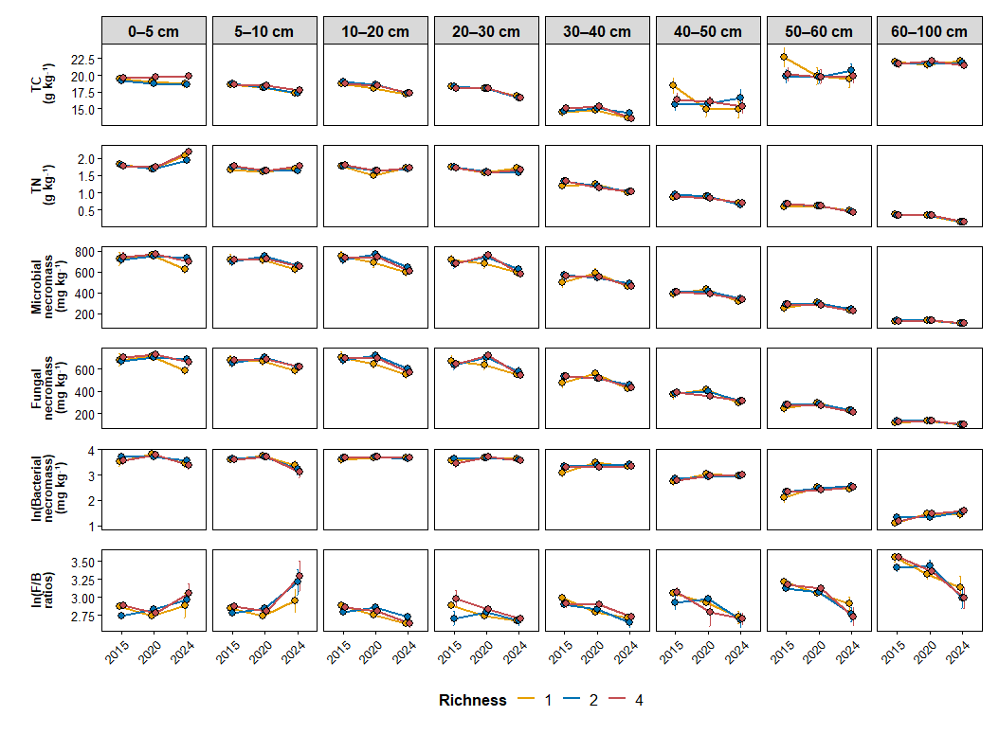

Fig. S3 Depth-specific temporal dynamics of soil carbon, nitrogen, and microbial necromass across tree species richness levels. Temporal changes in TC, TN, total microbial necromass, fungal necromass, bacterial necromass (ln-transformed), and F/B ratios (ln-transformed) are shown across eight soil depths. Points and error bars represent mean ± standard errors. Colors denote tree species richness levels (1, 2, and 4 species). Lines connect mean values across sampling years (2015, 2020, and 2024) to illustrate temporal trajectories within each depth.

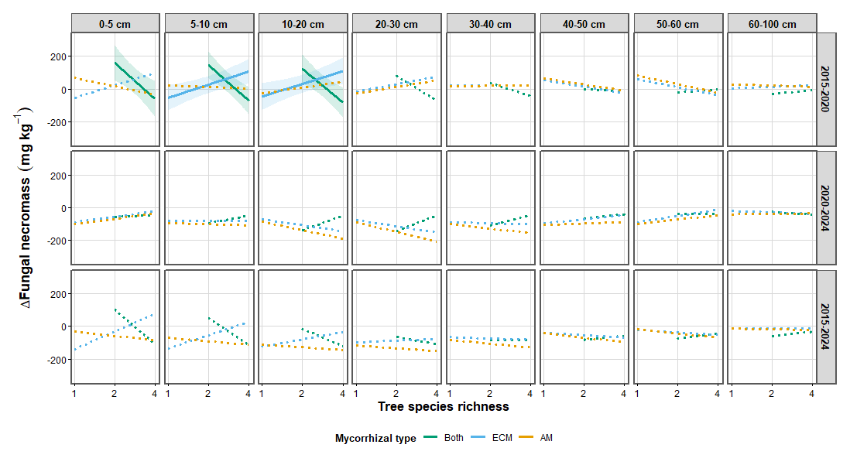
Fig. S4 Depth-specific responses of fungal necromass change rates to tree species richness across mycorrhizal types. Relationships between tree species richness and changes in microbial necromass are shown for three-time intervals (2015-2020, 2020-2024, and 2015-2024) across eight soil depths. Lines represent fitted values from linear mixed-effects models, and shaded areas indicate 95% confidence. Solid lines denote significant richness effects, whereas dashed lines indicate non-significant relationships.

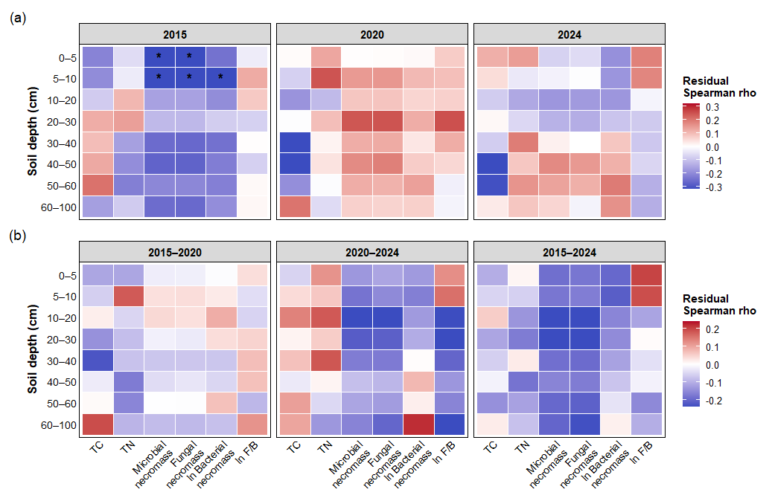 Fig. S5 Residual associations between stand basal area and soil properties across the soil profile. (a) Residual Spearman correlations between plot-level basal area and soil properties for each sampling year. (b) Residual Spearman correlations between changes in basal area and changes in soil properties across three temporal intervals. Correlations were calculated after accounting for tree species richness, mycorrhizal type, and block effects. Colors indicate the direction and strength of the correlation coefficients (rho), and asterisks denote significant relationships after false discovery rate (FDR) correction within each interval. Soil properties include total soil carbon (TC), total soil nitrogen (TN), microbial necromass, fungal necromass, ln bacterial necromass, and ln F/B. Colors indicate the strength and direction of correlations (red: positive; blue: negative). Asterisks denote significant correlations (*P < 0.05).

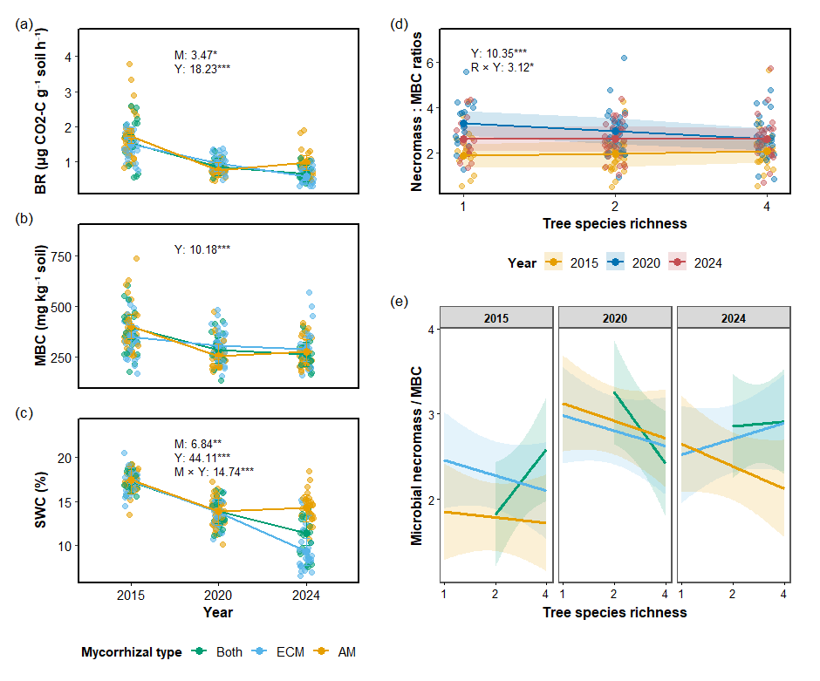
Fig. S6 Temporal dynamics of soil microbial properties and their relationships with tree species richness across mycorrhizal types. (a-c) Basal respiration (BR), microbial biomass carbon (MBC), and soil water content (SWC) in 0-10 cm across years and mycorrhizal types. Points show observations and lines indicate model-estimated means. (d) Relationship between tree species richness and the ratio of microbial necromass to MBC in 0-10 cm across years. (e) Model-predicted relationships between tree species richness and microbial necromass-to-MBC ratios within each year and mycorrhizal type. In (d-e), lines represent fitted values from linear mixed-effects models with 95% confidence intervals. Statistics in (a-d) indicate significant main and interactive effects of mixed-effects ANOVA.

