The Environmental Footprint of Retail Foods at Scale: A Multi-Country Analysis

Supplementary Information

Supplementary Methods
Description and Processing of Food Data

Data for retail food products used in this research came from two sources – foodDB¹ and Open Food Facts (https://world.openfoodfacts.org/data). FoodDB is a web tool that collects data for food products from food retailer’s websites. We used an extract of 262,711 products from 9 food retailers based in the UK and Ireland. About 36,000 of these products did not have any listed ingredients – these products were retained during training of the product categorization models (to increase the representativeness of the training data), but they were dropped before estimating product composition and impacts. From the remaining products, about 5,000 products identified as Alcoholic Beverages and Non-Food were dropped. Another ~10,000 products were removed as their ingredient information only contained allergen advice or other labels, leaving about 212,000 products. Our composition algorithm then excluded ~36,000 products where it could not reliably identify at least 75% of the composition. We further removed ~72,000 products with duplicated names, resulting in 104,250 foodDB products.

Open Food Facts is a publicly available dataset, which relies on crowdsourcing to collect information about food products available around the world. We used an extract of over 3 million products from Open Food Facts. Dropping countries with fewer than 1,000 unique products left around 2.5 million products, and filtering out products with no listed ingredients resulted in 961,989 products, for which product categories were predicted. About 550,000 of these products were in languages other than English – the non-English products were first identified using the ‘langdetect’ module on Python (which is based on Google’s language detection), and then translated using Python’s ‘googletrans’ library (which uses the Google Translate API). These language detection and translation libraries are not 100% accurate, but these tools gave us satisfactory results in terms of speed and accuracy, and any inaccuracies were filtered out in the subsequent steps used to clean ingredient strings and to estimate product composition. After categorizing these products, removing Alcoholic Beverages and Non-Food items leaves about 932,000 products. We could not use all these products as the ingredient lists could not be cleaned or formatted into the desired pattern for many products. It was important to bring the ingredient lists into a format that could be parsed by the algorithm that estimates composition. We used the ‘regex’ library to clean and format ingredient strings as best as possible, and removed products which could not be cleaned, leaving about 642,000 products. Of these, removing products for which the composition algorithm was able to identify less than 75% of the composition (~150,000), and ~106,000 products with duplicated product names, left 385,419 products from Open Food Facts.

Out of 489,669 products from the two databases, we dropped ~6,000 products for which all five environmental indicators (land use, greenhouse gas emissions, biodiversity loss, eutrophication, and water stress) were estimated as 0. This occurred when products consisted only of zero-impact ingredients (e.g., salt or water) or when all their ingredients lacked environmental estimates (e.g., vitamins, minerals, certain food additives). We then removed approximately 8,000 products from the analysis, based on manual checks of estimated composition, for example, if products were classified into categories for seafood, but they had no relevant ingredients identified as such. This resulted in a total of 474,955 products spanning 74 countries, used for comparative analyses of environmental impacts across food types and geographies.

Categorization of Food Products
While both foodDB and Open Food Facts contain some information about categorizations, the categories are not uniform across the two datasets, countries, and stores. It is important to categorize food products as the algorithm to estimate composition relies on the products being sorted into a set of food categories consistent across datasets, countries, and stores.

Manual categorization of food products can be extremely challenging and time consuming. Hence, we developed a machine learning pipeline to automate the categorization of food products. We chose the categories provided by the UK National Diet and Nutrition Survey (NDNS) to sort products into. The primary reason for this choice was the availability of ~60,000 products sorted into these categories, which could be used as labels for training the machine learning model(s). These labels came from a few different sources: i) almost 20,000 of these were obtained using fuzzy matching, ii) almost 40,000 were obtained with the help of Chat GPTs API in combination with manual verification, iii) a few hundred were labelled manually by researchers². Note that these labels could be inaccurate at times, as it wasn’t possible to manually verified all labels assigned using fuzzy matching or Chat GPT.

Supplementary Table 1 shows the categories provided by NDNS. Some categories were modified for relevance and to remove redundancies. A category for ‘Not food’ was added to identify and filter out non-food products from the food product datasets. Overall, there are 18 parent categories, 53 main categories, and 104 subcategories.

Machine learning models were trained to predict categories based on product descriptions, i.e. product names and the listed ingredients. These product names and listed ingredients were first converted into features using the Sentence-BERT (SBERT) model, specifically the all-mnet-base-v2 variant³. This approach has been validated in previous work classifying food products in Canadian supermarkets⁴. SBERT is a modification of the Bidirectional Encoder Representations from Transformers (BERT) framework, designed to generate semantically meaningful sentence embeddings while maintaining computational efficiency. SBERT employs a Siamese network architecture to produce fixed-length sentence embeddings that enables direct comparison between sentence vectors. The pre-trained all-mpnet-base-v2 model was readily available for use with the Sentence Transformers module on Python. This model was trained on more than 1 billion training pairs and can be leveraged without extensive domain-specific fine-tuning. Prior to embedding extraction, the product names and ingredients were converted to lower case and concatenated. The merged string was then fed into the SBERT encoder, yielding 768-dimensional dense vectors that encapsulate the contextual information for each product.

We first focused on categorizing all data in foodDB, with a very high degree of accuracy. This involved an iterative process of training machine learning models, predicting on unlabeled data, and refining labelled data to then train better models (see flowchart in Supplementary Figure 1). A parent model was used to classify products into parent categories, and sub models were used to further classify products in each parent category into subcategories. This was done to make the classification task easier for the models – instead of classifying products into 104 subcategories with a single model, we divide the task between 12 models, with each model classifying products into at most 18 classes at a time. Products sorted into the following parent categories were not subdivided further – savoury snacks, nuts and seeds, alcoholic beverages, commercial toddlers foods and drinks, dietary supplements, artificial supplements, and not food. Main categories were imputed based on the predicted subcategories.

The model at the parent category level was first refined through several iterations (Supplementary Figure 1). After each round of training, predictions were manually verified by sampling 100 products randomly from the entire dataset and from subsets of products allotted to each parent category. These sampled products could contain both labelled and unlabeled data, which helps assess performance on unlabeled products too. Products that were misclassified were used to add similar products to the training dataset and to correct any incorrect labels (if present) might be causing the misclassification. Once, we had reached a satisfactory level of confidence in the performance of the parent category classification model, we moved on to the subcategory level models. This choice was not based on model performance on the training data (that remained stable throughout the iterations), but on the quality of predictions on the randomly sampled data used for manual evaluation.

A similar process was followed for each subcategory to refine the quality of labels and hence the trained models. The manual evaluations at the subcategory level modelling were also used to make corrections at the parent category level, when products were incorrectly classified into the wrong parent category. Hence, after several iterations for subcategory level classification model for each parent category, a few rounds of corrections were done on the parent category level. Note, that no model retraining at the parent category was performed at this stage. Instead, products that were still systematically misclassified were manually corrected. Again, once a satisfactory level of performance was observed on the randomly sampled products at both parent category and subcategory levels, we stopped the iterative process of prediction correction and model refinement.

Random Forest classifiers were used for each classification task. The performance on labelled data was comparable across classification models such as random forest, LDA (linear discriminant analysis), and KNN (k-nearest neighbors), but random forest models did better at predicting categories for the non-labelled products. Supplementary Figure 2 shows a visual representation of the product categorizations. Each point corresponds to a specific food product, and the colors are based on assigned categories. The figure shows distinct clusters where products of the same category are grouped closely together, indicating strong similarities in their feature representations. Areas where different colors overlap may indicate categories with overlapping characteristics.
Supplementary Table 2 reports the performance metrics of the classification models at the end of all iterations. Hyperparameters of the Random Forest models are also provided in the table. An 80-20 train-test split was used across all classification tasks. The number of products used for training came out to be higher than the original number of available labels due to the addition of labels manually during the iterations. Note that the labels themselves can occasionally be incorrect (despite the many iterations), meaning that performance metrics can be marginally better or worse than those reported here. We report three performance metrics for both training and testing sets to comprehensively assess model effectiveness and to minimize the risks of overfitting and underfitting.
- Accuracy measures the fraction of correct predictions out of all predictions made.
- Balanced accuracy calculates the average recall obtained across all classes, giving equal weight to each class.
- Weighted F1-socre computes the harmonic mean of precision and recall for each class, weighted by the number of true instances in each class.
Precision, for any given class, measures the ratio of correctly predicted positive observations to the total predicted positives. And recall measures the ratio of correctly predicted positive observations to all actual positive instances.
It is important to note, that the reported performance metrics did not vary significantly throughout the multiple iterations, as the models consistently performed well on the labelled data – on both train and test sets. The primary purpose of the iterations was to enhance performance on the unlabeled data, though this improvement could only be assessed manually and, therefore, cannot be reported quantitatively. Initially, without iterations (e.g., adding labels or correcting parent categories), we observed systematic biases in predictions – for instance, brown bread being classified as white bread or spices like turmeric being misclassified into vegetable categories instead of miscellaneous ones. While accuracy on the unlabeled data initially ranged between 70-80% across categorization tasks, iterations raised it to 85-95%. More importantly, precision (assessed by manually sampling products assigned to each class), which was initially below 60% for certain parent or subcategories, improved significantly after iterations, reaching closer to 90%.

Deep learning models were not utilized so far in the categorization process due to their complexity and the extensive hyperparameter tuning they require compared to simpler classification models. The classification of foodDB products was highly iterative and manual, prompting us to adopt simpler machine learning approaches. However, once we achieved a satisfactory level of accuracy in categorizing the foodDB products, we had developed a large, high-quality labeled training dataset. This dataset enabled us to leverage deep learning models effectively. In the next phase of the categorization process, we trained deep learning models on the entire foodDB dataset of 262,711 products to categorize the Open Food Facts food products. These models were trained only once, as the extensive and high-quality labeled dataset ensured robust performance, such that further iterative refinement was not necessary at this stage.

Supplementary Table 3 presents the hyperparameters used in the deep learning classification models and their performance metrics, evaluated using an 80-20 train-test split. These trained models were subsequently applied to categorize the products in the Open Food Facts dataset. Supplementary Table 4 shows products sourced from foodDB (262,711) and Open Food Facts (961,989), classified into 104 subcategories.

Algorithm to estimate composition of products
We follow the same methodology for estimating composition of products as described by Clark et al.⁵, with a few additional steps to expand the geographic focus of the algorithm to outside the United Kingdom. First, the raw ingredient texts strings underwent extensive cleaning to remove extraneous information. Specifically, any text related to allergen warnings or ingredient sourcing details, such as indications for organic production or fair-trade certification, was removed. This ensured that only the pertinent ingredient information remained for subsequent parsing and analysis. This level of cleaning was sufficient for the data from foodDB, however the data from Open Food Facts was much messier. The ingredient lists in foodDB followed a fixed format, i.e. ingredients were separated by commas, with a percentage, if available, provided in brackets after ingredient name. If an ingredient contains sub-ingredient lists, those follow the same format as the ingredient lists and are placed inside a pair of brackets after the ingredient name and corresponding percentage (if available). This consistent format is crucial for accurate parsing of information provided in back-of-backage ingredient lists.
Open Food Facts text was not always in the same format – i) the order of ingredient names, corresponding percentages, and sub-ingredient list was not always consistent, ii) the lists sometimes used a punctuation mark other than a comma to separate ingredients, iii) some stray non-English words not translated by the translation algorithm were sometimes present in the lists, iv) cooking instructions and several other kinds of information were sometimes concatenated with ingredient lists, v) there were special characters, vi) and incorrect parentheses, vii) and several other formats for allergen warnings, sourcing information, organic labels etc. After some basic cleaning that removed special characters, replaced parentheses, removed different formats of labels, we first identified Open Food Facts products that only contained the types of characters present in foodDB, i.e. alphabets, numbers, percentage signs, parentheses, commas, decimal points. For these products, we performed further cleaning, and then ensured that they were brought into the desired structure. For all other products, we filtered products that only contained a hyphen or a colon in addition to foodDB characters. After removing these undesired characters, we then performed the same cleaning as before to bring these into the desired format. We also identified some non-English words and translated them manually. Finally, products that were too dirty, i.e. they contained too many undesired characters, and followed completely different structures were dropped from the analysis (~30% of products), to avoid introducing noise into our results.
Once the data were cleaned, the next major step was to parse the ingredient lists into their individual components. Each product's ingredient text, originally provided as a single string, was systematically split into discrete ingredients using delimiters such as commas and semi-colons. Moreover, the method was designed to handle compound ingredients that included embedded lists; for example, a fortified wheat flour entry might include additional ingredients listed in parentheses. These embedded lists were extracted separately, and a hierarchical labelling system was employed (e.g., V1 for the first ingredient, V2 for the second ingredient, and V2.1 for the first ingredient within an embedded list under the second ingredient). This structured labelling ensured that both the order and the nested relationships among ingredients were preserved, which is critical for subsequent estimation procedures that rely on ingredient positioning.
For ingredients with explicit percent composition information provided on the package, the extraction process utilized regular expressions to detect numerical percentages. Specifically, patterns such as “[0-9]{1,3}(\s)?%” or “[0-9]{1,3}(\.)[0-9]{1,2}(\s)?%” were used to extract the percentage values from the text. In instances where multiple percentages were identified for a single ingredient, a series of logical criteria was applied to determine the most appropriate value. These criteria ensured that the percent composition for any ingredient did not exceed the theoretical maximum based on its position in the list, maintained the expected descending order of ingredients, and did not cause the sum of all ingredient percentages to exceed 100%. This methodological approach provided a reliable baseline for ingredients with provided composition data, setting a benchmark for the estimation of missing values.
To estimate ingredient composition when unknown, ingredients were first mapped to a set of 110 agricultural commodities observed in the environmental datasets. This mapping also enabled integration of product composition, once estimated, with the environmental data. A three-step sorting process was employed to map ingredients to agricultural commodities, based on tailored search terms for each commodity. First, the search terms were used to count how many times each ingredient could potentially match each commodity, without yet mapping it to a specific commodity. Next, ingredients were assigned to the commodity with the fewest matches, thus favoring less common but more specific commodity categories. Finally, ingredients were further classified into sub-categories using additional search terms. After completing these steps, ingredients identified as water and salt were mapped to one of these commodities, only if they had not already been sorted into any of the other commodity categories. The tailored search terms and their mappings to environmental‐database commodities were the same as those used in Clark et al.⁵.
For ingredients without explicitly reported percent composition, values were estimated using prior knowledge from similar products and known ingredient proportions, informed by product categorization into parent, main, and subcategories. Similar products were defined as those belonging to the same geographic cluster and hierarchical category. To improve comparability, countries with similar food cultures were grouped into geographic clusters (Supplementary Table 5) so that products within the same category were more likely to share composition patterns. Missing percent composition was then estimated based on the average proportion of that ingredient when appearing in the same position within the ingredient list of other products in the same sub-category, main category, or parent category, in that order of preference, within the relevant country group. If the same ingredient did not occur in the same position within those categories, the average proportion of the nth ingredient from similar products in the same hierarchical group was used instead. When these methods were insufficient, additional techniques such as linear interpolation between known values were applied. For ingredients appearing within embedded lists, estimated proportions were adjusted by multiplying the parent ingredient’s estimated percentage by the relative proportion of the embedded ingredient.
The final step in the process involved a series of iterative logic checks designed to ensure that all estimated values were plausible and internally consistent. These checks enforced that the ingredient percentages adhered to the expected ordering (where each ingredient’s composition should be equal to or greater than that of any subsequent ingredient), that no single ingredient exceeded the theoretical maximum based on its position, and that the total composition of all ingredients summed precisely to 100%. In cases where certain ingredients’ estimates could not be refined further, such as when an ingredient’s percentage matched that of its neighbour, the algorithm anchored those values to avoid implausible outcomes like negative percentages or overestimation of the final ingredient’s contribution.
Throughout this process, robust quality control measures were implemented to maintain the integrity of the analysis. Only products in which at least 75% of the total mass could be accurately recognized and sorted into predefined food categories were included in the final dataset. This ensured that the conclusions drawn from the analysis were based on high-quality, well-categorized data. We estimated compositions for roughly 4.81 million of the 5.21 million ingredient entries – covering about 80% of the total ingredient mass in our dataset of 474,955 products. See Supplementary Figure 3 for the distribution of ingredient counts by food group and geography. For further technical details and nuances of the methodology, please refer to the published work by Clark et al.⁵.
Estimation of product-level environmental impacts

We employed the approach used by Clark et al.⁵ to estimate environmental impacts, with one important modification – the environmental datasets were paired with country level bilateral trade flow data to account for ingredient sourcing.

The environmental data in this analysis were derived primarily from a meta-analysis of life cycle assessments (LCAs) provided by Poore and Nemecek⁶, which cover over 40,000 food production systems. Because the primary LCA database contained limited information on capture fisheries, data from the Blue Foods Assessment were incorporated to better represent seafood production⁷. The commodities from these environmental databases were condensed into 110 categories, which were the ones all ingredients were sorted into previously while estimating ingredient composition. We condensed the production systems into categories, such that every category had at least 5 unique observations. Commodities with fewer than 5 unique observations were grouped together to create a larger category, such as ‘Other Fruits’. When possible, we paired organic ingredients and organic products with organic life cycle estimates, but only when at least 5 observations of production systems for that ingredient were available. If there were fewer than 5 organic observations for that ingredient, we instead randomly sampled across all production systems during the Monte Carlo analysis (described below).

Trade flow data was obtained from FAOSTAT⁸ and FishStat⁹. We used national-level production and bilateral trade data from the FAO. Trade flows were obtained for each food category of interest, as given in the environmental databases. The national-scale data from the FAO requires some pre-processing to address the following discrepancies – i) the trade volumes reported by the importing countries did not always match those reported by the exporting countries, and ii) the total reported exports from some countries exceeded the volumes produced and imported together, because of misreported transactions or countries reporting re-exported imports as their exports. Discrepancies between the volume of trade reported by the importer and exporter are resolved using a reliability index approach similar to the one outlined by Gehlhar¹⁰. Furthermore, to resolve the second issue, a re-export algorithm proposed by Croft et al.¹¹ is used to obtain ‘flows’ – the algorithm ensures that the total exports from a country never exceed its production and total imports; and it also links the source of production with the destination of import. For the fisheries data, only the second step was employed, and the imports were used directly without applying the reliability index approach (as FishStat reports exports and re-exports separately, which are not directly comparable with imports). We used data over a few years to remove any year-on-year noise from the data. We averaged the FAOSTAT data over 2017-2021 and the FishStat data over 2019-2022. These were the latest years available at the time of accessing these data.

Supplementary Table 6 lists the FAO commodities mapped to each LCA category. We matched trade data at the top LCA category level because many fine subcategories were not distinguished in FAO data (e.g., red vs white wine; types of wheat), or were sparsely represented in the LCA dataset (e.g., chickpeas). Aggregating at the top level provided cleaner, more consistent trade weights. Production and trade data for all commodities (except fisheries) were sourced from FAOSTAT’s Production and Detailed Trade Matrix datasets. For fisheries, we sourced production figures from FAOSTAT Food Balance Sheets and trade volumes from FishStat. For each produced commodity and year, we implemented the two preprocessing steps, i.e., reconciling import-export discrepancies and then correcting any negative consumption from re-exports. For each produced commodity, such as wheat, we aggregate trade data for both its unprocessed and processed forms (e.g., wheat grain, wheat germ, and wheat and meslin flour). For fisheries, we split the production and trade data into two groups – Fish and Crustaceans – and aggregated production and trade within each group. Finally, we sum the resolved data for all FAO commodities in each LCA category by year, then average those annual totals across all years. Note that some miscellaneous cereal and oil crops are included in the Wheat and Rye (Bread) LCA category – this is because their LCA values are calculated by scaling Wheat and Rye (Bread) LCA data using predefined ratios^{5,6}. Similarly, LCA values for animal fats, certain cheese types, and some other categories are derived from other LCA categories using predefined ratios (e.g., pig meat, cheese) and are therefore not mapped separately to FAO commodities.

For most processed commodities that are traded, we assume that the main products and their by-products balance each other – so no conversion factors are applied, e.g. wheat germ and flour, cheese and whey, soybean oil and cake. For certain traded items, however, we apply conversion factors to align them with their produced counterparts. For example, dry cassava, cassava flour, cassava starch and tapioca are converted to fresh cassava using factors of 2.5, 4, 5, and 5, respectively¹²⁻¹⁴, and potato tapioca is converted to fresh potato with a factor of 5¹⁵. We also derived global average conversion factors for oils and sugars (excluding soybean oil, since its cake by-product is also traded, which offsets the oil conversion) using FAOSTAT Food Balance Sheets (FBS) and Supply Utilization Accounts (SUA). For each oil, the factor equals the ratio of global oil + cake supply to oil supply (as given by SUA). For sugars, it is the ratio of globally processed sugar crops to total supply of sugars and sweeteners (as given by FAO Food Balance Sheets).

Finally, to avoid double counting across overlapping LCA categories, we used FAOSTAT Supply Utilization Accounts (SUA) to split production and trade between processed and unprocessed products for the following commodities – olives, coconuts, groundnuts, linseed, hempseed, sunflower seed, safflower seed, sesame seed, soya beans, and milk. For each producing country, we calculated the share of each commodity processed into oil or cheese and applied those shares to the country’s production and exports. The processed shares became the volumes for products such as soybean oil or cheese, and the remainder represented the unprocessed commodity (e.g., soybeans or milk). We did not perform this split for soybeans versus tofu or for beef from beef versus dairy herds, since FAOSTAT lacks distinct identifiers for those pairs. Instead, we used the same country-level production and trade data to identify sourcing for soybeans and tofu, and for beef from beef and dairy herds, assuming comparable sourcing patterns. Finally, because FAOSTAT trade data does not distinguish between raw and refined sugar from sugar cane vs sugar beet, we split raw and refined sugar exports in proportion to each country’s sugar cane and sugar beet production.

For each country, we used the trade flow data to estimate the share of each ingredient, i.e., LCA food category, sourced from every origin country. Then, for each source country, we reweighted its LCA production systems so that their total matches that country’s sourcing share, while preserving the systems’ relative proportions in global production. For example, if Country A sources 50% of an ingredient from Country B, and Country B has three production systems with global shares of 10%, 8%, and 7%, we scaled those to 20%, 16%, and 14% for Country A’s consumption. When no LCA data was available for a given ingredient in a source country (e.g. Brazil), we used other data in its place, in this order: the country’s intermediate geographic region (South America), its sub-region (Latin America), its broader region (Americas), and finally global production systems. Supplementary Table 7 shows this mapping from countries to geographic regions. Finally, if reweighting by all source countries left us with fewer than five production‐system entries for any ingredient, we reverted to the original global‐weighted data to avoid introducing bias. This procedure produced environmental datasets specific to each country, that accurately reflect each ingredient’s true sourcing profile.

To estimate the environmental impact of each food product, the composition estimates were then integrated with production system-level environmental performance data via a Monte Carlo analysis. In this analysis, for each commodity, production system data were randomly selected – with the selections weighted by the production systems’ weights as determined using the trade flows data earlier. This process was repeated 3,000 times to generate mean impact estimates, variance, and range for five environmental indicators: greenhouse gas emissions, land use, scarcity weighted water use, eutrophication potential, and biodiversity loss. For seafood products, a 50:50 split between capture fisheries and aquaculture systems was assumed, with slight variations between fish types, to reflect FAO estimates¹⁶.

Ingredient-level shares of each product’s impact were computed by pooling across the 3,000 Monte Carlo draws. For each indicator, we summed each ingredient’s impact over all draws and divided by the summed product-level total. For interpretability, shares were calculated for 55 top-level LCA commodity categories rather than the finer set of 110 commodities.

Additionally, another set of impacts were computed, without taking ingredient sourcing into account, to help assess the influence of ingredient sourcing on product impacts. These calculations were also performed using a Monte Carlo analysis, but for these calculations, the environmental data was not weighted by ingredient sourcing, but rather based on the production systems’ share in global production.

Each environmental indicator was then scaled from 0 (no impact) to 100 (highest observed impact across all products), and these scaled scores were averaged to create a composite environmental impact score for each product. This composite score was further normalized so that all products could be directly compared on a 0-100 scale. For the sourcing-agnostic analysis, indicators and scores were normalized using the minimum and maximum values from the sourcing-informed results. Consequently, the lowest and highest composite scores of the sourcing-agnostic impacts could mathematically be different from 0 and 100.

For further details on the specific search terms used or the Monte Carlo analysis, please refer to the original published work by Clark et al.⁵.

Reliability index approach
The reliability index approach outlined by Gehlhar¹⁰ is used to resolve discrepancies between the volume of trade reported by the importer and exporter in the bilateral trade dataset. An accuracy level (Supplementary Equation 1) is computed for each bilateral trading pair, and this captures the quality of match between the importer and exporter reported quantities. The value of $AL$ should be closer to 0 for the match to be more accurate, and a threshold of 0.2 is used to separate accurate from non-accurate matches, i.e. a match is accurate only if the difference between the reported imports and exports is less than 20%. Then, for each country, it becomes possible to construct an importer reliability index ($RIM$), and an exporter reliability index ($RIX$), which are given by Supplementary Equations 2 and 3 respectively. An importer’s reliability is measured by the proportion of total imports it reports accurately, and similarly an exporter’s reliability is measured by the proportion of its total exports it reports reliably. Finally, for each bilateral trading pair, the value reported by the more reliable partner is accepted as the trade flow between those countries.
Equation 1 calculates the accuracy level ($AL$) of a transaction from region $r$ to region $s$, for which the value of trade reported by the importer is $M_{r,s}$ and that reported by the exporter is $X_{r,s}$:
$AL_{r,s}=2×\frac{\left|M_{r,s}-X_{r,s}\right|}{M_{r,s}+X_{r,s}}$
Equation 2 calculates the reliability index of import region $s$ as:
$RIM{}_{s}=\frac{M_{s}^{A}}{M_{s}^{T}}$ , where
$M_{s}^{T}=\sum_{r}{M_{r,s}}$ $∀s$, and
$M_{s}^{A}=\sum_{r}{M_{r,s}}$ $∀s$where $AL_{r,s}≤0.2$
Equation 3 calculates the reliability index of export region $r$ as:
$RIX{}_{r}=\frac{X_{r}^{A}}{X_{r}^{T}}$ , where
$X_{r}^{T}=\sum_{s}{X_{r,s}}$ $∀r$, and
$X_{r}^{A}=\sum_{s}{X_{r,s}}$ $∀r$where $AL_{r,s}≤0.2$

Re-export algorithm
The bilateral trade dataset harmonized using the reliability index approach is fed into a re-export algorithm along with the production dataset from FAO. The re-export algorithm proposed by Croft et al.¹¹ ensures that the total exports from a country never exceed its production and total imports; and it also links the source of production with the destination of import. The algorithm uses the production and export matrices $P$ and $E$, and applies an iterative approach to produce a domestic supply matrix $D$.
$P=\left[\begin{matrix}p_{1} \\ p_{2} \\ ⋮ \\ p_{n}\end{matrix}\right]$
$E=\left[\begin{matrix}0 & e_{12} & … & e_{1n} \\ e_{21} & 0 & … & e_{2n} \\ ⋮ & ⋮ & ⋱ & ⋮ \\ e_{n1} & e_{n2} & … & 0\end{matrix}\right]$

$D=\left[\begin{matrix}d_{11} & d_{12} & … & d_{1n} \\ d_{21} & d_{22} & … & d_{2n} \\ ⋮ & ⋮ & ⋱ & ⋮ \\ d_{n1} & d_{n2} & … & d_{nn}\end{matrix}\right]$

where, $p_{i}$ is the production in country $i$; $e_{ij}$ are the exports from country $i$ to $j$; and $d_{ij}$ is the quantity of country $j$’s domestic supply that originates from country $i$. The sum of rows of matrix $D$ equals the countries’ production, and the sum of columns equals the countries’ domestic supply (or consumption). The diagonal elements correspond to the produce that stays within the countries. The non-diagonal elements of matrix $D$ are referred to as ‘flows’ in this study, i.e., $d_{ij|ij}$ gives the food flow from $i$ to $j$. Croft et al.¹¹ list all the algorithm steps and also provide MATLAB code for implementing it to obtain the domestic supply matrix $D$.

Aggregate Food Categories Used in Figures

To prepare our results for visualization, we consolidated the original 102 categories (Supplementary Table 8) into 37 broader groups using many-to-one mappings. In most cases, similar items were merged – so all types of bread became a single bread category. However, dairy alternatives were carved out from the broader dairy group – any product with no dairy ingredients but containing plant-based ingredients (coconut, nut, soy, oat, etc.) was reassigned into the dairy alternatives category. We also recategorized some mixed dishes based on composition, e.g., cereal based dishes such as pasta or pizza containing more than 20% of an animal product (such as seafood, poultry) were moved into one of the meat categories, and specific meat products (e.g., poultry or pork) with less than 40% of the named animal ingredient (e.g., Thai red chicken curry) were reassigned into the meat dishes category. We used a quick manual review to flag obvious misclassifications, like a meat dish with no animal ingredients, or coffee beans classified into beans and pulses, and corrected them when the true composition was clear; otherwise, those items were dropped. In total, this recategorization process removed about 8,000 products from our analysis set.

In this consolidated view, meat, dairy, and eggs (25.3%) and cereal products (23.9%) together account for nearly half the sample. The rest breaks down into fruits, vegetables, and nuts (16.4%), miscellaneous items (14.2%), sugar and confectionery (10.9%), and non-alcoholic beverages (9.3%). Note that these categories can overlap, for example, some cereal products include meat and vegetables, and certain vegetable-based products contain grains like rice.

Confidence in Environmental Impact Estimates Across Geographies and Categories

We quantified confidence in each product’s environmental‐footprint estimate as the product of three scores: classification certainty, composition completeness, and LCA‐data coverage.
Classification certainty reflects how confidently a product was assigned to its food category. All foodDB entries, which have been extensively validated, received a 95% certainty. For Open Food Facts, we started at 95% and adjusted based on model probabilities: if only the parent‐category probability ≥ 0.5, certainty dropped to 90%; if only the subcategory probability ≥ 0.5, it dropped to 85%; and if both probabilities are below 0.5, it was 80%. These probabilities are the classification models’ likelihood scores for each possible class, with the highest‐scoring class chosen as the product’s category.
Composition completeness measures how much of a product’s ingredient breakdown comes directly from back‐of‐package data. We calculated it as: 50% + 0.5 × (% of ingredients by weight identified on the label), so that more complete labels yield higher confidence.
LCA‐data coverage captures the extent to which each ingredient’s source country has LCA data, with fallbacks to broader regions as needed. For each ingredient, we computed coverage as: (% supply covered by country LCA data × 1) + (% supply estimated using intermediate regional LCA data × 0.9) + (% supply estimated using sub-regional LCA data × 0.8) + (% supply estimated using regional LCA data × 0.7) + (% supply estimated using global LCA data × 0.6). For seafood ingredients, we calculated coverage as 0.5 × standard calculation + 0.5 × 70, to reflect wild‐caught versus farmed sources. We then averaged these LCA‐coverage scores across all ingredients, weighting by their identified composition share (so unidentified composition further lowered this score).
Finally, overall confidence for each product was calculated as the product of its three component scores. Figure 2 presents the average confidence by geography and food category – the colorbar in the figure is qualitative because the computed absolute scores are not interpretable on their own, but their relative ordering is. Supplementary Figure 4 displays each component score separately, with numerical colorbars reflecting the actual calculated values. Classification scores remain high across all regions and categories. In contrast, composition scores are particularly low in the USA and Canada and exhibit substantial variation across categories worldwide. LCA coverage scores peak in Europe and are lowest in Africa. Although the absolute numbers depend on our scoring method and are not inherently meaningful, their relative ordering provides valuable insights into the disaggregated scores.

Supplementary Figures
Supplementary Figure 1: Overview of Machine Learning Pipeline to Categorize Food Products in foodDB

Supplementary Figure 2: Three levels of categories predicted for 262,711 products in foodDB. The t-Distributed Stochastic Neighbor Embedding (t-SNE) algorithm was used for dimensionality reduction of the original 768-dimensional feature vectors into a two-dimensional space. Given the large number of categories, only the 18 parent categories are accompanied by a legend, whereas the 53 main and 104 subcategories are presented without corresponding legends to avoid cluttering the visualization.

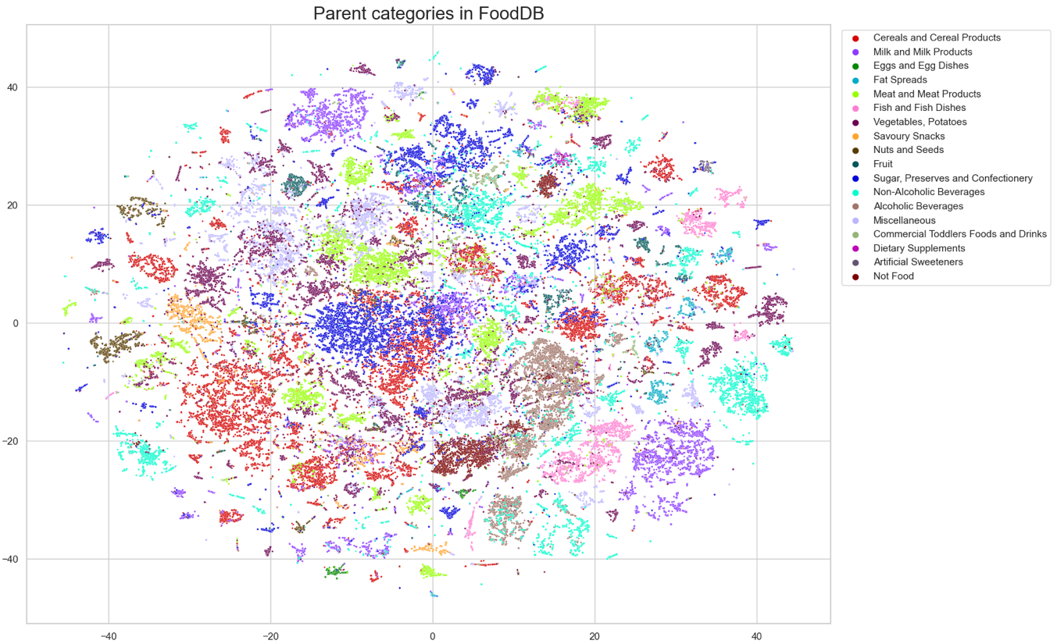
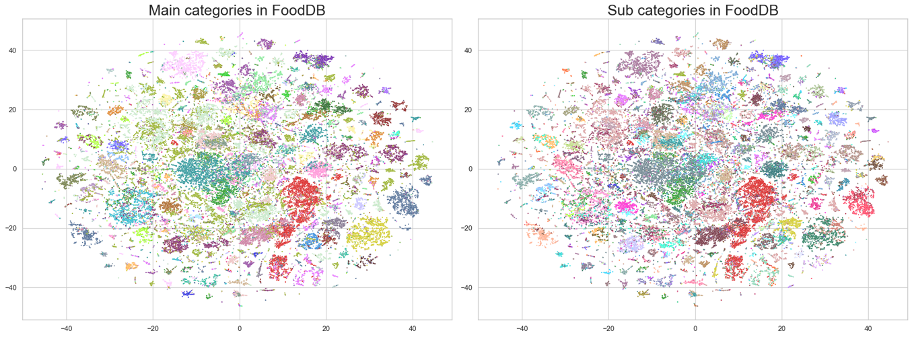

Supplementary Figure 3: Distribution of ingredient counts in food products by geography and category.

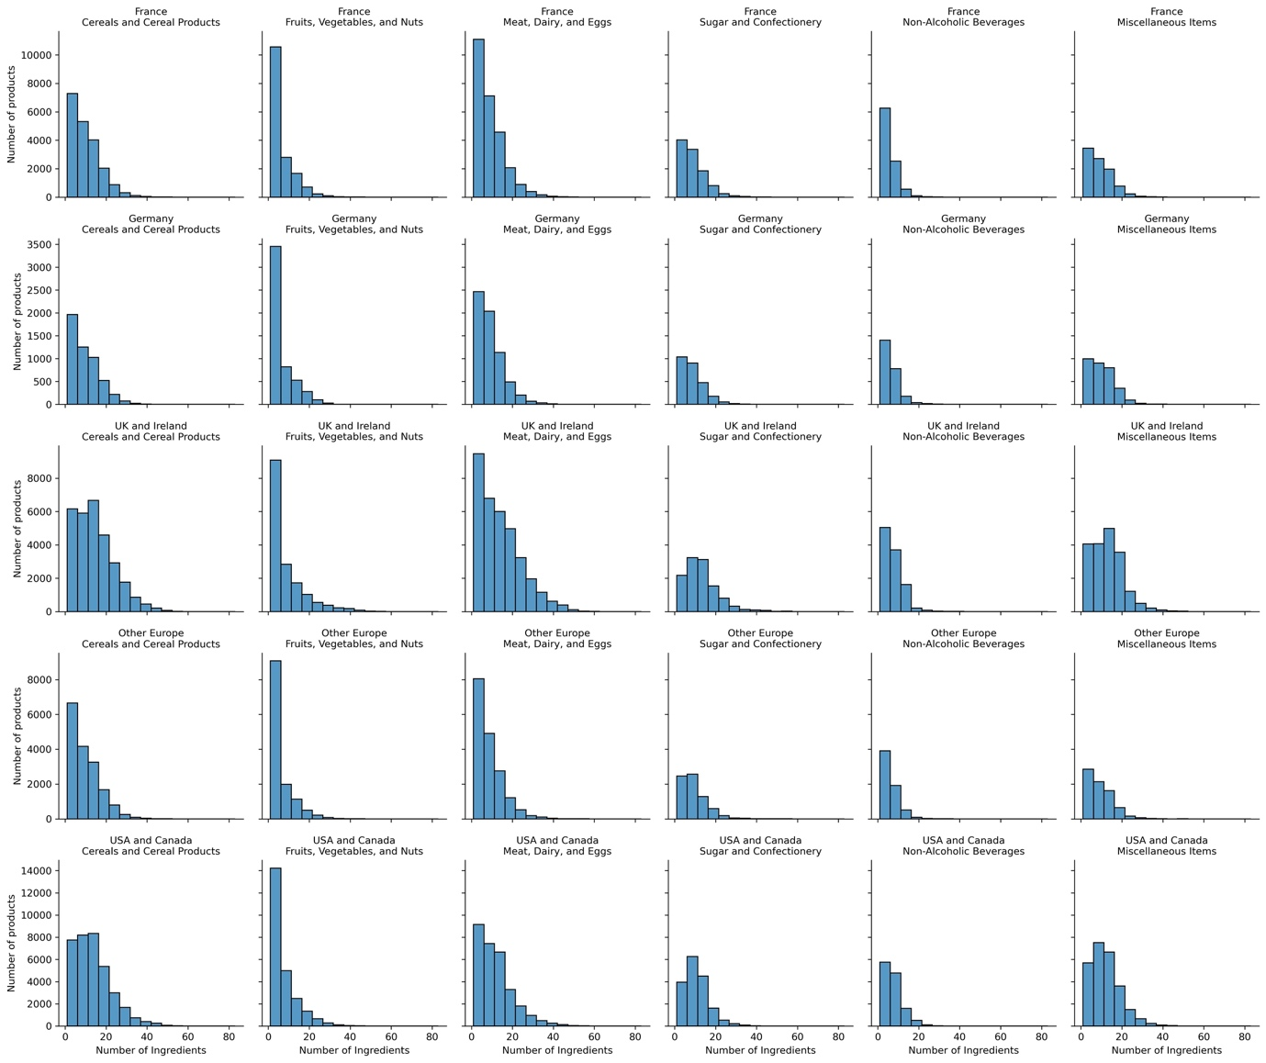

Supplementary Figure 4: Component scores used to quantify confidence in environmental impact estimates for products across geographies and categories – classification certainty, composition completeness, and LCA coverage.

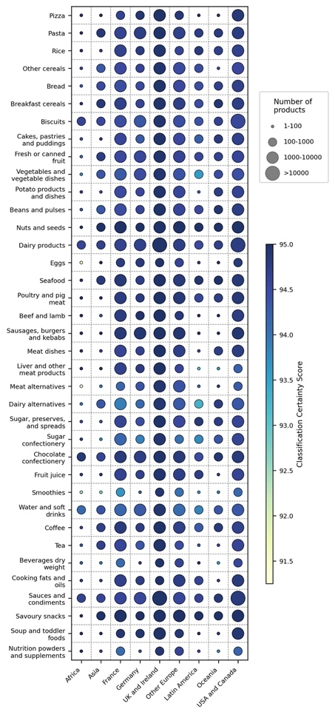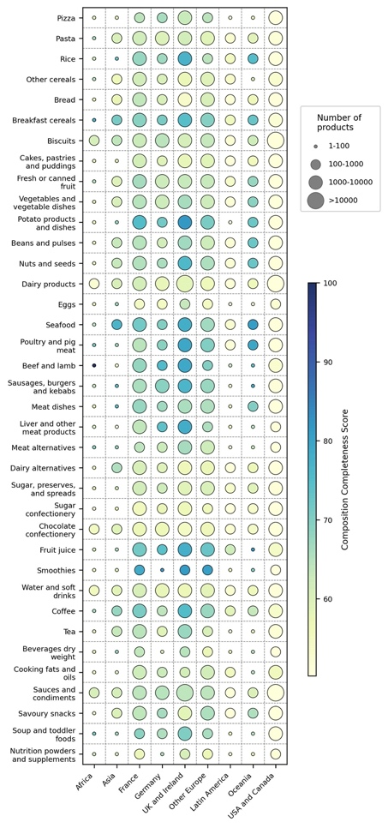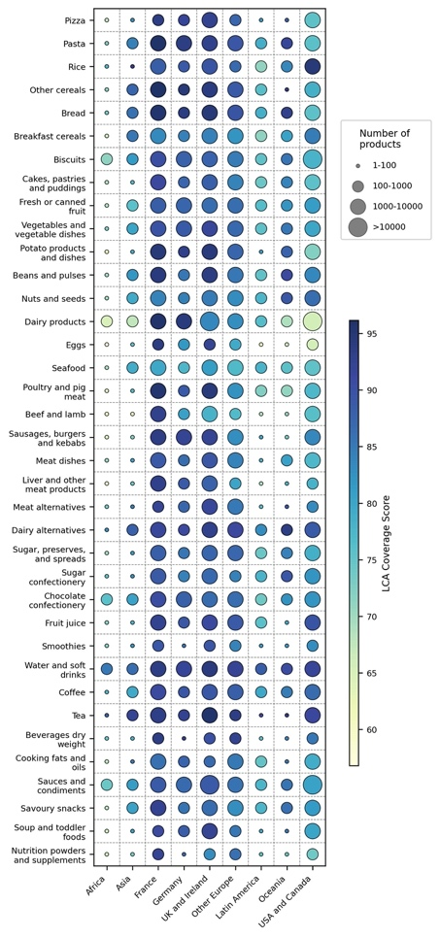

Supplementary Figure 5: Distribution of food products from different categories, only showing the five regions with sufficiently large product samples.

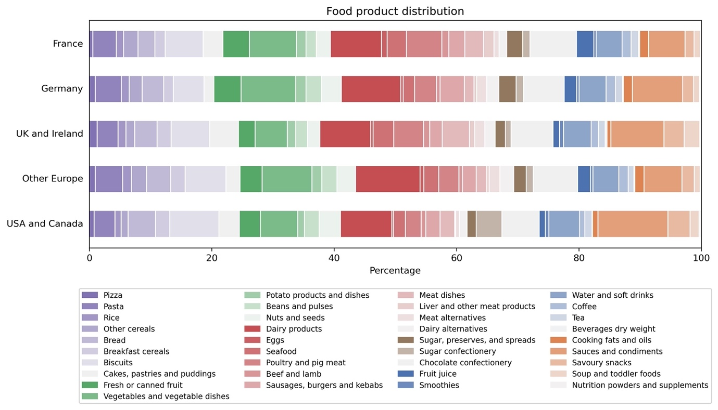
Supplementary Figure 6: Environmental impact scores per 100 g of products across countries. Each data point corresponds to the mean environmental impact across all Monte Carlo simulations for a single product.

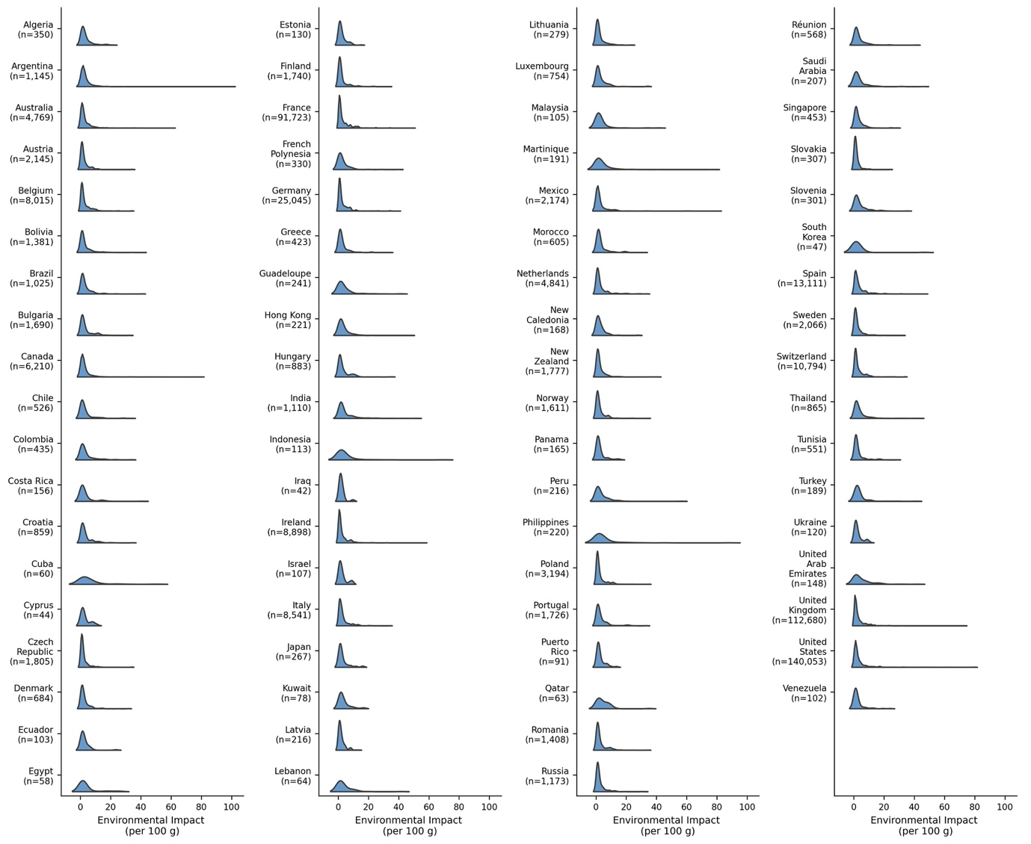

Supplementary Figure 7: Environmental impact versus beef content for a sample of beef-containing products across geographies. For each region, up to 20 products were selected at random (all 18 available Asian and 7 African items are shown). Each point represents one product, and its environmental impact corresponds to the mean of its Monte Carlo simulation outputs. The lowest-impact beef products are typically broths or stocks.

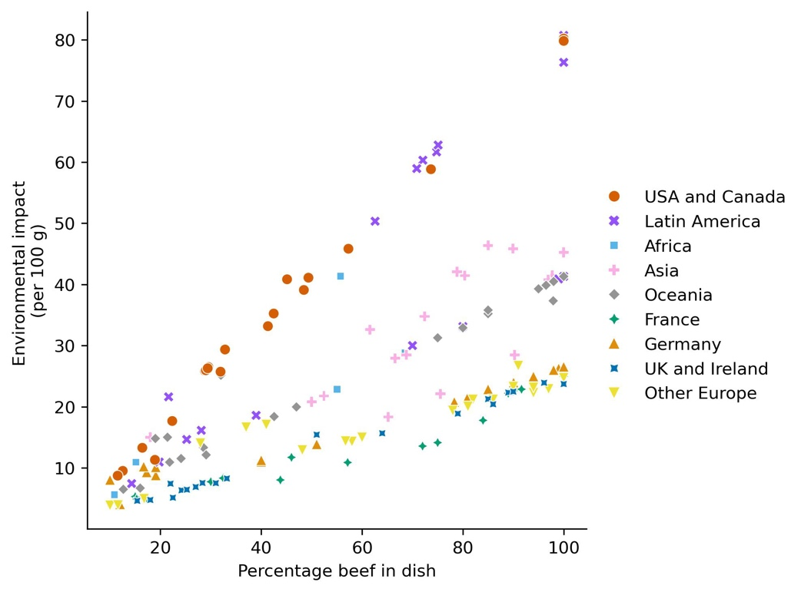
Supplementary Figure 8: Environmental impact of different types of dairy products across geographies (per 100 g). For each category, the bars span the 10th to 90th percentile impacts of food products; the mean (black line) and median (white dot) impacts for each category are overlaid. For each product, the impact is given by the mean of its Monte Carlo simulation outputs. Categories with fewer than 30 products are omitted and instead indicated by star markers.

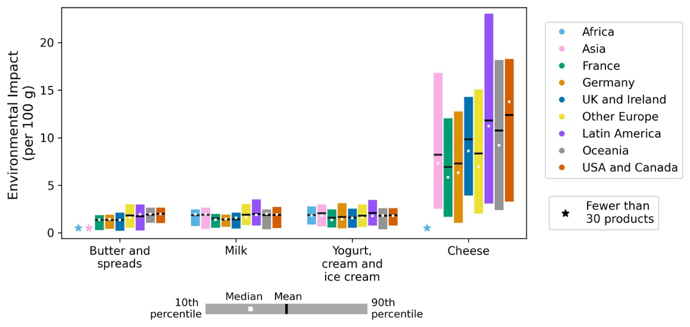

Supplementary Figure 9: Disaggregated environmental footprints by five impact metrics (land use, GHG emissions, biodiversity loss, eutrophication, water use) for all food categories across five regions. For each category, the bars span the 10th to 90th percentile impacts of food products; the mean (white line) and median (black dot) impacts for each category are overlaid. For each product, the impact is given by the mean of its Monte Carlo simulation outputs.

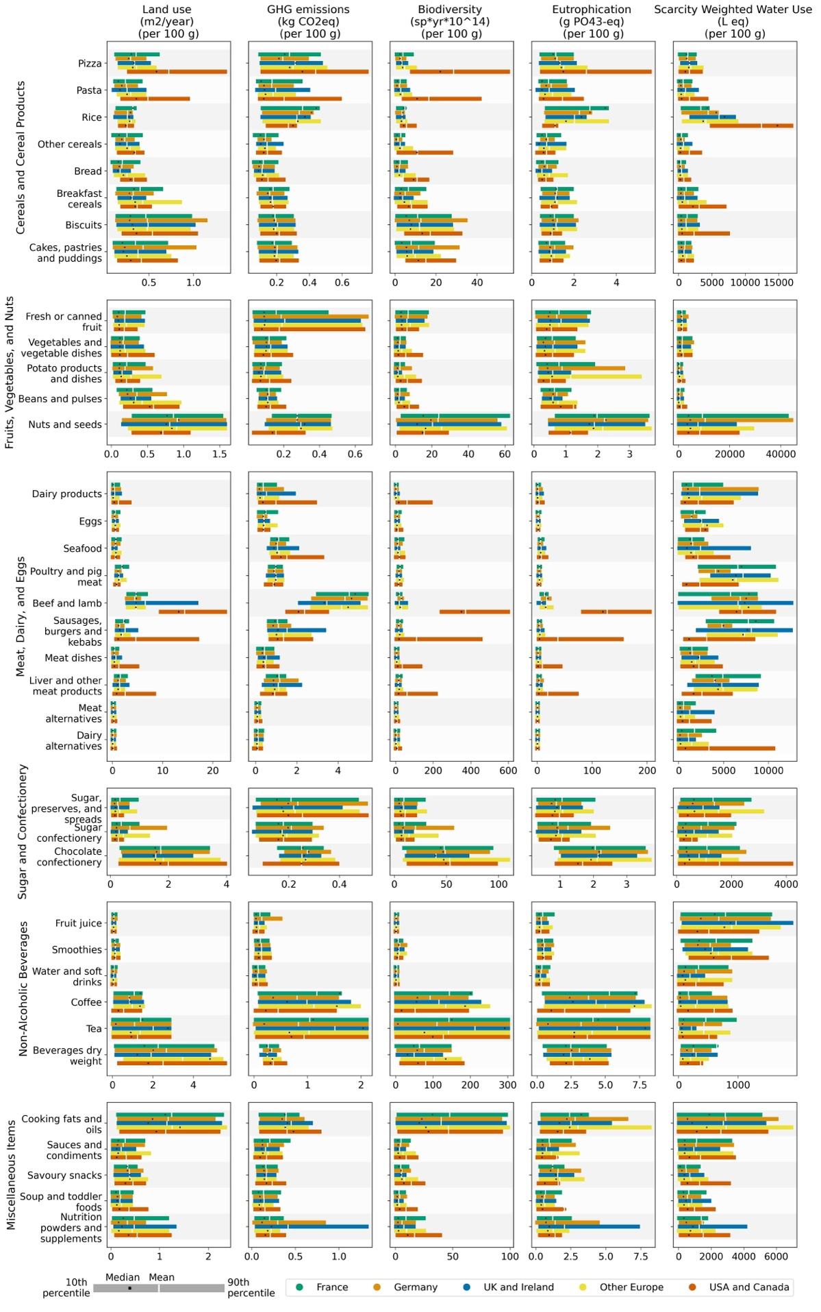
Supplementary Figure 10: GHG emissions vs. scarcity-weighted water use for 100 randomly selected products in each of nine categories (rice, nuts and seeds, dairy products, seafood, beef and lamb, dairy alternatives, chocolate confectionery, coffee, cooking fats and oils).

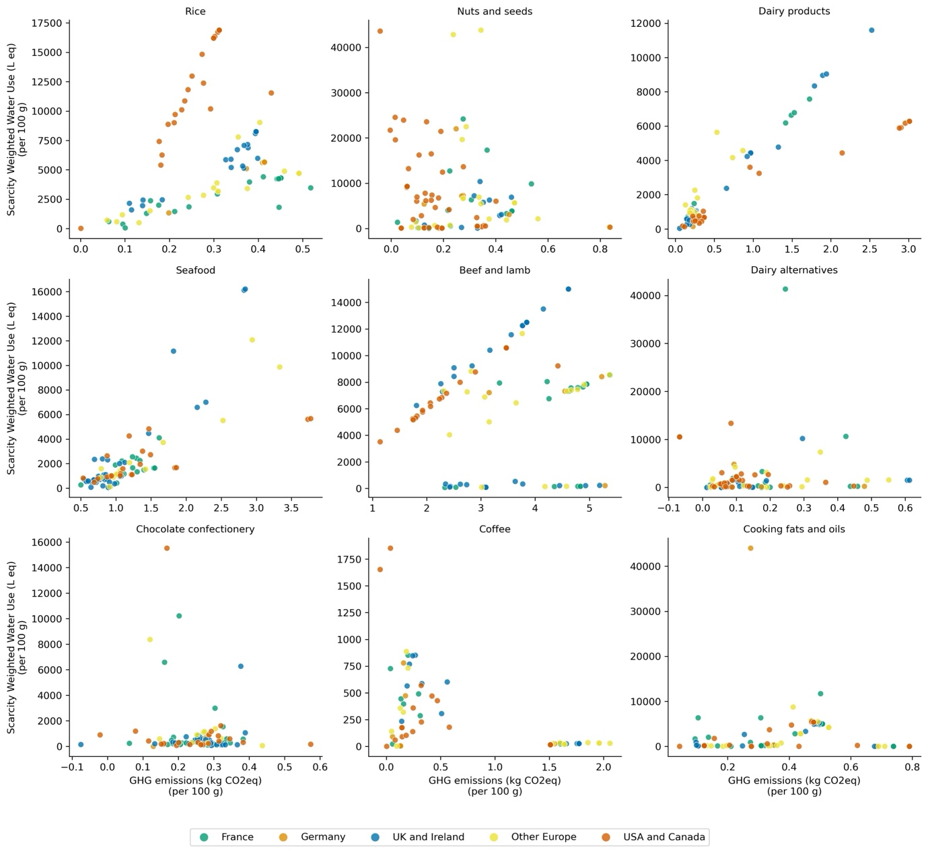

Supplementary Figure 11: Food product composition across geographies, categorized by food groups. Each bar represents the proportion of ingredients in different impact groups within a food category, where blue indicates the lowest impact ingredients, and red indicates the highest impact ingredients.

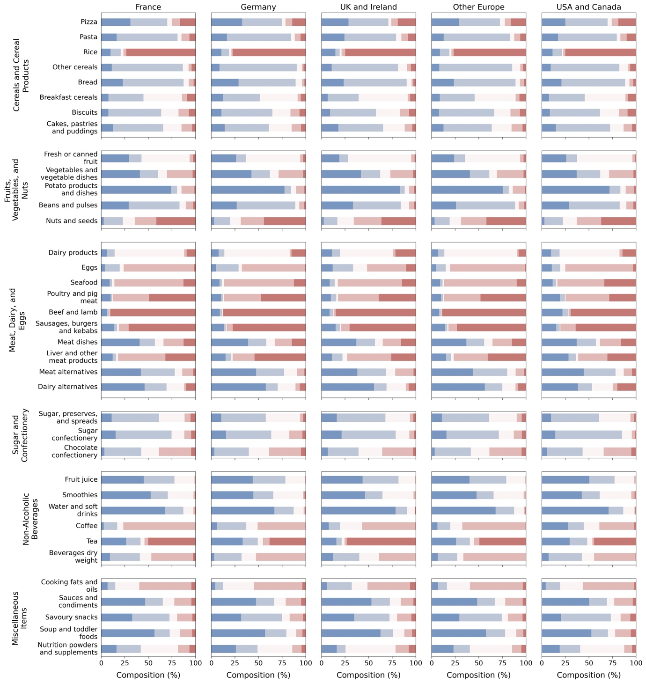
Supplementary Figure 12: Environmental impact of food categories across geographies (per 100 g), computed without accounting for ingredient sourcing. For each category, the bars span the 10th to 90th percentile impacts of food products; the mean (black line) and median (white dot) impacts for each category are overlaid. For each product, the impact is given by the mean of its Monte Carlo simulation outputs. Categories with fewer than 30 products are omitted and instead indicated by star markers.

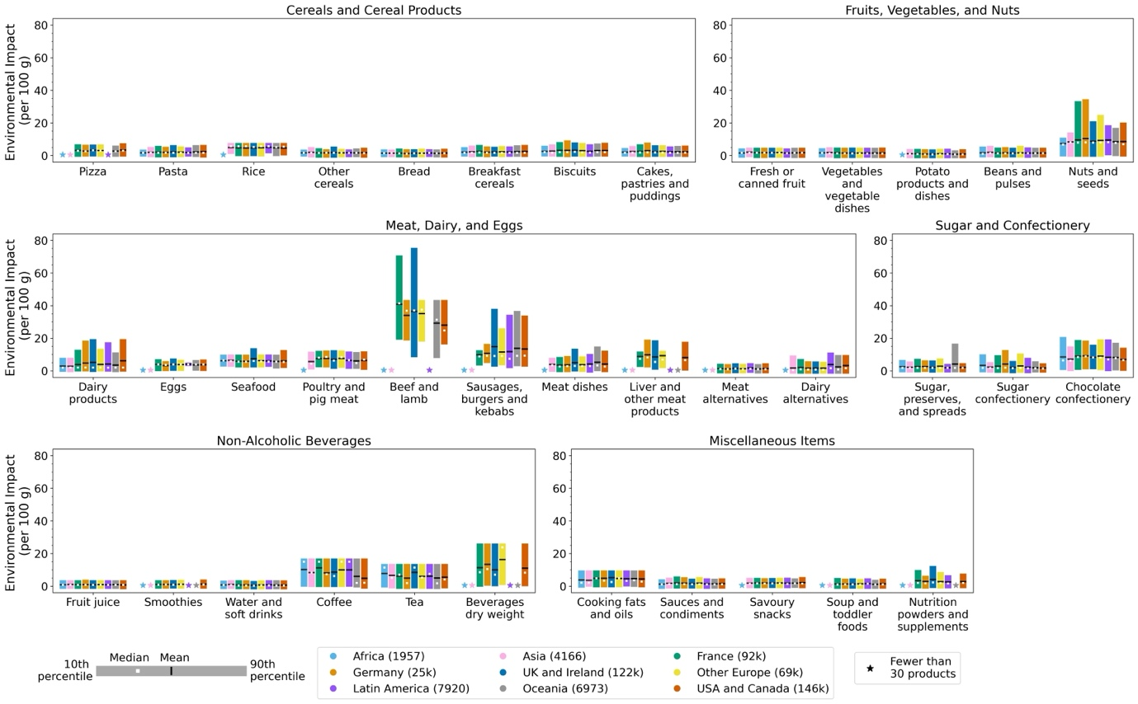
Supplementary Tables

Supplementary Table 1: Categories used to classify products, derived from UK National Diet and Nutrition Survey (NDNS)

Parent category | Main category | Subcategory
Cereals and Cereal Products | Pasta, rice and other cereals | Pizza
Cereals and Cereal Products | Pasta, rice and other cereals | Pasta
Cereals and Cereal Products | Pasta, rice and other cereals | Rice
Cereals and Cereal Products | Pasta, rice and other cereals | Other cereals
Cereals and Cereal Products | Bread | White bread (not high fibre, not multiseed bread)
Cereals and Cereal Products | Bread | Wholemeal bread
Cereals and Cereal Products | Bread | Brown, granary and wheatgerm bread
Cereals and Cereal Products | Bread | Other bread
Cereals and Cereal Products | Breakfast cereals | High fibre breakfast cereals
Cereals and Cereal Products | Breakfast cereals | Other breakfast cereals (not high fibre)
Cereals and Cereal Products | Biscuits | Biscuits
Cereals and Cereal Products | Buns, cakes, pastries and fruit pies | Fruit pies
Cereals and Cereal Products | Buns, cakes, pastries and fruit pies | Buns cakes and pastries
Cereals and Cereal Products | Puddings | Cereal based milk puddings
Cereals and Cereal Products | Puddings | Sponge puddings
Cereals and Cereal Products | Puddings | Other cereal based puddings
Milk and Milk Products | Whole milk | Whole milk
Milk and Milk Products | Semi-skimmed milk | Semi-skimmed milk
Milk and Milk Products | 1% Milk | 1% Milk
Milk and Milk Products | Skimmed milk | Skimmed milk
Milk and Milk Products | Other milk and cream | Infant formula
Milk and Milk Products | Other milk and cream | Cream (including imitation cream)
Milk and Milk Products | Other milk and cream | Other milk
Milk and Milk Products | Cheese | Cottage cheese
Milk and Milk Products | Cheese | Cheddar cheese
Milk and Milk Products | Cheese | Other cheese
Milk and Milk Products | Yogurt, fromage frais and other dairy desserts | Yogurt
Milk and Milk Products | Yogurt, fromage frais and other dairy desserts | Fromage frais and other dairy desserts
Milk and Milk Products | Ice cream | Ice cream
Eggs and Egg Dishes | Eggs and egg dishes | Manufactured egg products including ready meals
Eggs and Egg Dishes | Eggs and egg dishes | Other eggs and egg dishes including homemade
Fat Spreads | Butter | Butter
Fat Spreads | Polyunsaturated margarine and oils | Polyunsaturated margarine
Fat Spreads | Polyunsaturated margarine and oils | Polyunsaturated oils
Fat Spreads | Low fat spread | Polyunsaturated low fat spread
Fat Spreads | Low fat spread | Low fat spread not polyunsaturated
Fat Spreads | Margarine and other cooking fats and oils not polyunsaturated | Block margarine
Fat Spreads |  | Soft margarine not polyunsaturated
Fat Spreads |  | Other cooking fats and oils not polyunsaturated
Fat Spreads | Reduced fat spread | Reduced fat spread (polyunsaturated)
Fat Spreads | Reduced fat spread | Reduced fat spread (not polyunsaturated)
Meat and Meat Products | Bacon and ham | Bacon and ham
Meat and Meat Products | Beef, veal and dishes | Beef and veal
Meat and Meat Products | Lamb and dishes | Lamb
Meat and Meat Products | Pork and dishes | Pork
Meat and Meat Products | Coated chicken and turkey | Manufactured coated chicken/turkey products
Meat and Meat Products | Chicken and turkey dishes | Other chicken and turkey
Meat and Meat Products | Liver, products and dishes | Liver and dishes
Meat and Meat Products | Burgers and kebabs | Burgers and kebabs purchased
Meat and Meat Products | Sausages | Sausages
Meat and Meat Products | Meat pies and pastries | Meat pies and pastries
Meat and Meat Products | Other meat and meat products | Other meat products
Fish and Fish Dishes | White fish coated or fried | White fish coated or fried
Fish and Fish Dishes | Other white fish, shellfish and fish dishes | Other white fish
Fish and Fish Dishes | Other white fish, shellfish and fish dishes | Shellfish
Fish and Fish Dishes | Other white fish, shellfish and fish dishes | Canned tuna
Fish and Fish Dishes | Oily fish | Oily fish
Vegetables, Potatoes | Vegetables | Carrots
Vegetables, Potatoes | Vegetables | Other vegetables
Vegetables, Potatoes | Vegetables | Tomatoes
Vegetables, Potatoes | Vegetables | Peas
Vegetables, Potatoes | Vegetables | Green beans
Vegetables, Potatoes | Vegetables | Baked beans
Vegetables, Potatoes | Vegetables | Leafy green vegetables
Vegetables, Potatoes | Vegetables | Beans and pulses (including ready meal and homemade dishes)
Vegetables, Potatoes | Vegetables | Meat alternatives (including ready meals and homemade dishes)
Vegetables, Potatoes | Vegetables | Other vegetable products and dishes
Vegetables, Potatoes | Chips, fried and roast potatoes and potato products | Chips purchased including takeaway
Vegetables, Potatoes | Chips, fried and roast potatoes and potato products | Other fried/roast/baked potatoes
Vegetables, Potatoes | Other potatoes, potato salads and dishes | Other potato products and dishes
Savoury Snacks | Crisps and savoury snacks | Crisps and savoury snacks
Nuts and Seeds | Nuts and seeds | Nuts and seeds
Fruit | Fruit | Apples and pears not canned
Fruit | Fruit | Citrus fruit
Fruit | Fruit | Bananas
Fruit | Fruit | Canned fruit in juice
Fruit | Fruit | Canned fruit in syrup
Fruit | Fruit | Other fruit not canned
Sugar, Preserves and Confectionery | Sugars, preserves and sweet spread | Sugar
Sugar, Preserves and Confectionery | Sugars, preserves and sweet spread | Preserves
Sugar, Preserves and Confectionery | Sugars, preserves and sweet spread | Sweet spreads fillings and icing
Sugar, Preserves and Confectionery | Sugar confectionery | Sugar confectionery
Sugar, Preserves and Confectionery | Chocolate confectionery | Chocolate confectionery
Non-Alcoholic Beverages | Fruit juice | Fruit juice
Non-Alcoholic Beverages | Fruit juice | Smoothies
Non-Alcoholic Beverages | Soft drinks, not diet | Soft drinks not low calorie concentrated
Non-Alcoholic Beverages | Soft drinks, not diet | Soft drinks not low calorie carbonated
Non-Alcoholic Beverages | Soft drinks, not diet | Soft drinks not low calorie, ready to drink, still
Non-Alcoholic Beverages | Soft drinks, diet | Soft drinks low calorie concentrated
Non-Alcoholic Beverages | Soft drinks, diet | Soft drinks low calorie carbonated
Non-Alcoholic Beverages | Soft drinks, diet | Soft drinks low calorie, ready to drink, still
Non-Alcoholic Beverages | Tea, coffee and water | Coffee
Non-Alcoholic Beverages | Tea, coffee and water | Tea
Non-Alcoholic Beverages | Tea, coffee and water | Herbal tea
Non-Alcoholic Beverages | Tea, coffee and water | Bottled water still or carbonated
Alcoholic Beverages | Alcoholic beverages | Alcoholic beverages
Miscellaneous | Miscellaneous | Beverages dry weight
Miscellaneous | Miscellaneous | Soup
Miscellaneous | Miscellaneous | Nutrition powders and drinks
Miscellaneous | Miscellaneous | Savoury sauces pickles gravies and condiments
Commercial Toddlers Foods and Drinks | Commercial toddlers foods and drinks | Commercial toddlers foods and drinks
Dietary Supplements | Dietary supplements | Dietary supplements
Artificial Sweeteners | Artificial sweeteners | Artificial sweeteners
Not Food | Not food | Not food

Supplementary Table 2: Performance of Random Forest classification models on labelled foodDB data

Categorization | Hyperparameters | n | num classes | Accuracy |  | Balanced accuracy |  | F1-score (weighted)
 |  |  |  | train | test | train | test | train | test
Parent categories | num trees: 200,  min leaf samples:5,  weights: balanced | 68,407 | 18 | 0.99 | 0.91 | 0.99 | 0.89 | 0.99 | 0.91
Cereals and Cereal Products | num trees: 400,  min leaf samples:4,  max tree depth: 20,  weights: balanced | 13,999 | 16 | 0.99 | 0.93 | 0.99 | 0.91 | 0.99 | 0.93
Milk and Milk Products | num trees: 400,  min leaf samples:10,  max tree depth: 10,  weights: balanced | 6,348 | 13 | 0.98 | 0.94 | 0.99 | 0.92 | 0.98 | 0.94
Eggs and Egg Dishes | num trees: 400,  min leaf samples:10,  max tree depth: 20,  weights: balanced | 515 | 2 | 0.99 | 0.98 | 0.99 | 0.98 | 0.99 | 0.98
Fat Spreads | num trees: 400,  min leaf samples:10,  max tree depth: 20,  weights: balanced | 1,460 | 10 | 0.96 | 0.89 | 0.96 | 0.89 | 0.96 | 0.90
Meat and Meat Products | num trees: 500,  min leaf samples:10,  max tree depth: 20,  weights: balanced | 8,679 | 11 | 0.97 | 0.92 | 0.98 | 0.92 | 0.97 | 0.92
Fish and Fish Dishes | num trees: 500,  min leaf samples:10,  max tree depth: 20,  weights: balanced | 2,808 | 5 | 0.98 | 0.96 | 0.98 | 0.95 | 0.98 | 0.96
Vegetables, Potatoes | num trees: 500,  min leaf samples:10,  max tree depth: 20,  weights: balanced | 6,282 | 13 | 0.97 | 0.89 | 0.98 | 0.90 | 0.97 | 0.89
Fruit | num trees: 500,  min leaf samples:10,  max tree depth: 20,  weights: balanced | 1,572 | 6 | 0.99 | 0.94 | 0.99 | 0.90 | 0.99 | 0.94
Sugar, Preserves and Confectionery | num trees: 500,  min leaf samples:10,  max tree depth: 20,  weights: balanced | 6,141 | 5 | 0.99 | 0.96 | 0.99 | 0.94 | 0.99 | 0.96
Non-Alcoholic Beverages | num trees: 400,  min leaf samples:10,  max tree depth: 25,  weights: balanced | 8,042 | 12 | 0.98 | 0.89 | 0.98 | 0.89 | 0.98 | 0.89
Miscellaneous | num trees: 500,  min leaf samples:10,  max tree depth: 20,  weights: balanced | 5,718 | 4 | 0.99 | 0.98 | 0.99 | 0.98 | 0.99 | 0.98

Supplementary Table 3: Performance of Deep Learning classification models on all foodDB data

Categorization | Hyperparameters | n | num classes | Accuracy |  | Balanced accuracy |  | F1-score (weighted)
 |  |  |  | train | test | train | test | train | test
Parent categories | dense layers: 3  dense neurons: 512 batch size: 128 epochs: 100 dropout: 0.2 | 262,711 | 18 | 0.98 | 0.94 | 0.99 | 0.95 | 0.98 | 0.94
Cereals and Cereal Products | dense layers: 2 dense neurons: 256 batch size: 64 epochs: 100 dropout: 0.2 | 52,426 | 16 | 0.98 | 0.93 | 0.99 | 0.96 | 0.98 | 0.93
Milk and Milk Products | dense layers: 2 dense neurons: 256 batch size: 64 epochs: 100 dropout: 0.4 | 23,239 | 13 | 0.99 | 0.96 | 0.99 | 0.94 | 0.99 | 0.96
Egg and Egg Dishes | dense layers: 1 dense neurons: 32 batch size: 16 epochs: 50 dropout: 0.4 | 1,315 | 2 | 0.99 | 0.99 | 0.99 | 0.99 | 0.99 | 0.99
Fat Spreads | dense layers: 1 dense neurons: 32 batch size: 16 epochs: 50 dropout: 0.4 | 3,811 | 10 | 0.99 | 0.92 | 0.99 | 0.88 | 0.99 | 0.93
Meat and Meat Products | dense layers: 2 dense neurons: 256 batch size: 64 epochs: 100 dropout: 0.2 | 26,837 | 11 | 0.99 | 0.95 | 0.99 | 0.95 | 0.99 | 0.95
Fish and Fish Dishes | dense layers: 1 dense neurons: 64 batch size: 32 epochs: 50 dropout: 0.4 | 9,302 | 5 | 0.98 | 0.95 | 0.99 | 0.95 | 0.98 | 0.95
Vegetables, Potatoes | dense layers: 1 dense neurons: 64 batch size: 32  epochs: 50 dropout: 0.4 | 23,757 | 13 | 0.97 | 0.91 | 0.98 | 0.94 | 0.97 | 0.91
Fruit | dense layers: 1 dense neurons: 64 batch size: 32 epochs: 50 dropout: 0.4 | 7,343 | 6 | 0.98 | 0.97 | 0.99 | 0.98 | 0.98 | 0.97
Sugar, Preserves and Confectionery | dense layers: 2 dense neurons: 256 batch size: 64 epochs: 100 dropout: 0.2 | 25,822 | 5 | 0.99 | 0.98 | 0.99 | 0.97 | 0.99 | 0.98
Non-Alcoholic Beverages | dense layers: 1 dense neurons: 128 batch size: 32 epochs: 50 dropout: 0.4 | 25,994 | 12 | 0.97 | 0.91 | 0.98 | 0.91 | 0.97 | 0.91
Miscellaneous | dense layers: 2 dense neurons: 256 batch size: 64 epochs: 100 dropout: 0.2 | 27,598 | 4 | 0.99 | 0.99 | 0.99 | 0.99 | 0.99 | 0.99

Supplementary Table 4: Distribution of food products in different categories, as predicted by machine learning models

Parent category | Main category | Subcategory | foodDB | Open Food Facts
Cereals and Cereal Products | Pasta, rice and other cereals | Pizza | 2,324 | 8,609
Cereals and Cereal Products | Pasta, rice and other cereals | Pasta | 7,507 | 31,603
Cereals and Cereal Products | Pasta, rice and other cereals | Rice | 2,981 | 8,486
Cereals and Cereal Products | Pasta, rice and other cereals | Other cereals | 3,154 | 14,742
Cereals and Cereal Products | Bread | White bread (not high fibre, not multiseed bread) | 4,575 | 23,350
Cereals and Cereal Products | Bread | Wholemeal bread | 605 | 1,368
Cereals and Cereal Products | Bread | Brown, granary and wheatgerm bread | 655 | 962
Cereals and Cereal Products | Bread | Other bread | 1,220 | 5,561
Cereals and Cereal Products | Breakfast cereals | High fibre breakfast cereals | 3,840 | 14,727
Cereals and Cereal Products | Breakfast cereals | Other breakfast cereals (not high fibre) | 1,206 | 4,923
Cereals and Cereal Products | Biscuits | Biscuits | 13,742 | 63,625
Cereals and Cereal Products | Buns, cakes, pastries and fruit pies | Fruit pies | 283 | 839
Cereals and Cereal Products | Buns, cakes, pastries and fruit pies | Buns cakes and pastries | 8,126 | 29,991
Cereals and Cereal Products | Puddings | Cereal based milk puddings | 392 | 765
Cereals and Cereal Products | Puddings | Sponge puddings | 429 | 149
Cereals and Cereal Products | Puddings | Other cereal based puddings | 1,387 | 3,187
Milk and Milk Products | Whole milk | Whole milk | 375 | 2,239
Milk and Milk Products | Semi-skimmed milk | Semi-skimmed milk | 436 | 1,610
Milk and Milk Products | 1% Milk | 1% Milk | 41 | 503
Milk and Milk Products | Skimmed milk | Skimmed milk | 218 | 557
Milk and Milk Products | Other milk and cream | Infant formula | 105 | 196
Milk and Milk Products | Other milk and cream | Cream (including imitation cream) | 704 | 4,701
Milk and Milk Products | Other milk and cream | Other milk | 3,368 | 16,341
Milk and Milk Products | Cheese | Cottage cheese | 120 | 1,258
Milk and Milk Products | Cheese | Cheddar cheese | 1,845 | 3,514
Milk and Milk Products | Cheese | Other cheese | 4,544 | 36,675
Milk and Milk Products | Yogurt, fromage frais and other dairy desserts | Yogurt | 6,166 | 22,402
Milk and Milk Products | Yogurt, fromage frais and other dairy desserts | Fromage frais and other dairy desserts | 1,381 | 6,055
Milk and Milk Products | Ice cream | Ice cream | 3,936 | 15,917
Eggs and Egg Dishes | Eggs and egg dishes | Manufactured egg products including ready meals | 681 | 1,155
Eggs and Egg Dishes | Eggs and egg dishes | Other eggs and egg dishes including homemade | 634 | 2,917
Fat Spreads | Butter | Butter | 474 | 2,976
Fat Spreads | Polyunsaturated margarine and oils | Polyunsaturated margarine | 78 | 224
Fat Spreads | Polyunsaturated margarine and oils | Polyunsaturated oils | 424 | 2,677
Fat Spreads | Low fat spread | Polyunsaturated low fat spread | 133 | 432
Fat Spreads | Low fat spread | Low fat spread not polyunsaturated | 19 | 53
Fat Spreads | Margarine and other cooking fats and oils not polyunsaturated | Block margarine | 100 | 416
Fat Spreads |  | Soft margarine not polyunsaturated | 31 | 48
Fat Spreads |  | Other cooking fats and oils not polyunsaturated | 1,972 | 7,532
Fat Spreads | Reduced fat spread | Reduced fat spread (polyunsaturated) | 225 | 804
Fat Spreads | Reduced fat spread | Reduced fat spread (not polyunsaturated) | 355 | 331
Meat and Meat Products | Bacon and ham | Bacon and ham | 3,042 | 13,396
Meat and Meat Products | Beef, veal and dishes | Beef and veal | 3,769 | 10,716
Meat and Meat Products | Lamb and dishes | Lamb | 996 | 567
Meat and Meat Products | Pork and dishes | Pork | 1,527 | 5,444
Meat and Meat Products | Coated chicken and turkey | Manufactured coated chicken/turkey products | 1,724 | 2,977
Meat and Meat Products | Chicken and turkey dishes | Other chicken and turkey | 7,359 | 20,896
Meat and Meat Products | Liver, products and dishes | Liver and dishes | 282 | 1,730
Meat and Meat Products | Burgers and kebabs | Burgers and kebabs purchased | 800 | 2,202
Meat and Meat Products | Sausages | Sausages | 3,275 | 19,653
Meat and Meat Products | Meat pies and pastries | Meat pies and pastries | 2,034 | 1,484
Meat and Meat Products | Other meat and meat products | Other meat products | 2,029 | 5,524
Fish and Fish Dishes | White fish coated or fried | White fish coated or fried | 1,700 | 2,159
Fish and Fish Dishes | Other white fish, shellfish and fish dishes | Other white fish | 1,202 | 3,046
Fish and Fish Dishes | Other white fish, shellfish and fish dishes | Shellfish | 1,605 | 6,710
Fish and Fish Dishes | Other white fish, shellfish and fish dishes | Canned tuna | 882 | 2,801
Fish and Fish Dishes | Oily fish | Oily fish | 3,913 | 15,261
Vegetables, Potatoes | Vegetables | Carrots | 416 | 2,220
Vegetables, Potatoes | Vegetables | Other vegetables | 4,720 | 18,444
Vegetables, Potatoes | Vegetables | Tomatoes | 1,664 | 6,590
Vegetables, Potatoes | Vegetables | Peas | 727 | 2,408
Vegetables, Potatoes | Vegetables | Green beans | 237 | 985
Vegetables, Potatoes | Vegetables | Baked beans | 700 | 1,011
Vegetables, Potatoes | Vegetables | Leafy green vegetables | 2,155 | 5,831
Vegetables, Potatoes | Vegetables | Beans and pulses (including ready meal and homemade dishes) | 3,176 | 16,520
Vegetables, Potatoes | Vegetables | Meat alternatives (including ready meals and homemade dishes) | 2,987 | 10,379
Vegetables, Potatoes | Vegetables | Other vegetable products and dishes | 4,075 | 22,233
Vegetables, Potatoes | Chips, fried and roast potatoes and potato products | Chips purchased including takeaway | 884 | 3,589
Vegetables, Potatoes | Chips, fried and roast potatoes and potato products | Other fried/roast/baked potatoes | 533 | 2,569
Vegetables, Potatoes | Other potatoes, potato salads and dishes | Other potato products and dishes | 1,483 | 5,796
Savoury Snacks | Crisps and savoury snacks | Crisps and savoury snacks | 6,460 | 22,492
Nuts and Seeds | Nuts and seeds | Nuts and seeds | 5,057 | 25,226
Fruit | Fruit | Apples and pears not canned | 747 | 4,684
Fruit | Fruit | Citrus fruit not canned | 292 | 818
Fruit | Fruit | Bananas | 118 | 631
Fruit | Fruit | Canned fruit in juice | 782 | 3,190
Fruit | Fruit | Canned fruit in syrup | 227 | 1,855
Fruit | Fruit | Other fruit not canned | 5,177 | 17,476
Sugar, Preserves and Confectionery | Sugars, preserves and sweet spread | Sugar | 1,266 | 4,717
Sugar, Preserves and Confectionery | Sugars, preserves and sweet spread | Preserves | 3,828 | 16,040
Sugar, Preserves and Confectionery | Sugars, preserves and sweet spread | Sweet spreads fillings and icing | 1,248 | 4,038
Sugar, Preserves and Confectionery | Sugar confectionery | Sugar confectionery | 5,713 | 33,691
Sugar, Preserves and Confectionery | Chocolate confectionery | Chocolate confectionery | 13,767 | 60,817
Non-Alcoholic Beverages | Fruit juice | Fruit juice | 2,623 | 14,169
Non-Alcoholic Beverages | Fruit juice | Smoothies | 1,219 | 3,158
Non-Alcoholic Beverages | Soft drinks, not diet | Soft drinks not low calorie concentrated | 974 | 3,145
Non-Alcoholic Beverages | Soft drinks, not diet | Soft drinks not low calorie carbonated | 5,420 | 17,027
Non-Alcoholic Beverages | Soft drinks, not diet | Soft drinks not low calorie, ready to drink, still | 1,058 | 5,011
Non-Alcoholic Beverages | Soft drinks, diet | Soft drinks low calorie concentrated | 611 | 186
Non-Alcoholic Beverages | Soft drinks, diet | Soft drinks low calorie carbonated | 3,120 | 5,491
Non-Alcoholic Beverages | Soft drinks, diet | Soft drinks low calorie, ready to drink, still | 2,469 | 13,563
Non-Alcoholic Beverages | Tea, coffee and water | Coffee | 3,646 | 9,037
Non-Alcoholic Beverages | Tea, coffee and water | Tea | 2,296 | 7,401
Non-Alcoholic Beverages | Tea, coffee and water | Herbal tea | 1,615 | 5,279
Non-Alcoholic Beverages | Tea, coffee and water | Bottled water still or carbonated | 943 | 4,282
Alcoholic Beverages | Alcoholic beverages | Alcoholic beverages | 15,150 | 22,295
Miscellaneous | Miscellaneous | Beverages dry weight | 682 | 1,298
Miscellaneous | Miscellaneous | Soup | 3,590 | 7,861
Miscellaneous | Miscellaneous | Nutrition powders and drinks | 527 | 2,286
Miscellaneous | Miscellaneous | Savoury sauces pickles gravies and condiments | 22,799 | 75,679
Commercial Toddlers Foods and Drinks | Commercial toddlers foods and drinks | Commercial toddlers foods and drinks | 2,488 | 1,444
Dietary Supplements | Dietary supplements | Dietary supplements | 622 | 3,360
Artificial Sweeteners | Artificial sweeteners | Artificial sweeteners | 404 | 1,108
Not Food | Not food | Not food | 5,086 | 5,673
Total |  |  | 262,711 | 961,989

Supplementary Table 5: Country groupings for product composition estimation

Country group | Countries
1 | Australia, Canada, Ireland, New Zealand, United Kingdom, United States
2 | Austria, Belgium, France, Germany, Luxembourg, Netherlands, Switzerland
3 | Italy, Portugal, Spain
4 | Denmark, Estonia, Finland, Latvia, Lithuania, Norway, Sweden
5 | Bulgaria, Croatia, Czech Republic, Hungary, New Caledonia, Poland, Romania, Russia, Slovakia, Slovenia, Ukraine
6 | Algeria, Cyprus, Egypt, Greece, Israel, Lebanon, Morocco, Tunisia, Turkey
7 | Argentina, Bolivia, Brazil, Chile, Costa Rica, Colombia, Cuba, Ecuador, French Polynesia, Guadeloupe, India, Iraq, Kuwait, Martinique, Mexico, Panama, Peru, Puerto Rico, Qatar, Reunion, Saudi Arabia, United Arab Emirates, Venezuela
8 | Hong Kong, Indonesia, Japan, Malaysia, Philippines, Singapore, South Korea, Thailand

Supplementary Table 6: FAO commodities used to compute production and trade for all LCA food categories

LCA Food Category | FAO Commodities Produced | FAO Commodities Traded | Notes
Wheat & Rye (Bread) | Wheat | Wheat  Germ of wheat  Wheat and meslin flour | Oil converted to oil crops using processing factors.  Production and trade split between oil crops and oil.
Wheat & Rye (Bread) | Rye | Rye  Flour of rye  Bran of rye
Wheat & Rye (Bread) | Millet | Millet  Flour of millet  Bran of millet
Wheat & Rye (Bread) | Sorghum | Sorghum  Flour of sorghum  Bran of sorghum
Wheat & Rye (Bread) | Buckwheat | Buckwheat  Flour of buckwheat
Wheat & Rye (Bread) | Quinoa | Quinoa
Wheat & Rye (Bread) | Canary seed | Canary seed
Wheat & Rye (Bread) | Fonio | Fonio
Wheat & Rye (Bread) | Mixed grain | Mixed grain  Flour of mixed grain  Bran of mixed grain
Wheat & Rye (Bread) | Triticale | Triticale
Wheat & Rye (Bread) | Cereals n.e.c. | Cereals n.e.c.  Flour of cereals, n.e.c.  Bran of cereals, n.e.c.
Wheat & Rye (Bread) | Groundnuts, excluding shelled | Groundnuts, excluding shelled  Groundnuts, shelled  Prepared groundnuts  Groundnut oil
Wheat & Rye (Bread) | Linseed | Linseed  Oil of linseed
Wheat & Rye (Bread) | Hempseed | Hempseed
Wheat & Rye (Bread) | Safflower seed | Safflower seed  Safflower-seed oil, crude
Wheat & Rye (Bread) | Sesame seed | Sesame seed  Oil of sesame seed
Wheat & Rye (Bread) | Castor oil seeds | Castor oil seed  Oil of castor beans
Wheat & Rye (Bread) | Cotton seed | Cottonseed oil
Wheat & Rye (Bread) | Coconuts, in shell | Coconuts, in shell  Coconuts, desiccated  Coconut oil
Wheat & Rye (Bread) | Mustard seed | Mustard seed  Mustard seed oil, crude
Maize (Meal) | Maize (corn) | Maize (corn)  Germ of maize  Flour of maize  Bran of maize  Cake of maize  Forage and silage, maize
Barley (Beer) | Barley | Barley  Barley flour and grits  Barley, pearled  Bran of barley  Pot barley
Oatmeal | Oats | Oats  Oats, rolled  Bran of oats
Rice | Rice | Rice, paddy (rice milled equivalent)  Flour of rice
Potatoes | Potatoes | Potatoes  Potatoes, frozen  Tapioca of potatoes | Processing factors applied to convert traded commodities into equivalent quantities of crops.  Tapioca of potatoes: 5
Potatoes | Sweet potatoes | Sweet potatoes
Potatoes | Yams | Yams
Potatoes | Taro | Taro
Potatoes | Edible roots ad tubers with high starch or inulin content n.e.c., fresh | Edible roots ad tubers with high starch or inulin content n.e.c., fresh
Cassava | Cassava, fresh | Cassava, dry  Cassava, fresh  Flour of cassava  Starch of cassava  Tapioca of cassava | Processing factors applied to convert traded commodities into equivalent quantities of crops.  Cassava dry: 2.5  Flour of cassava: 4  Starch of cassava: 5  Tapioca of cassava: 5
Cane Sugar | Sugar cane | Sugar cane  Refined sugar  Raw cane or beet sugar (centrifugal only) | Sugar converted to sugar crops using processing factors  Refined sugar and raw sugar flows split between sugar cane and sugar beet
Beet Sugar | Sugar beet | Sugar beet  Refined sugar  Raw cane or beet sugar (centrifugal only)
Other Pulses | Bambara beans, dry | Bambara beans, dry
Other Pulses | Beans, dry | Beans, dry
Other Pulses | Broad beans and horse beans, dry | Broad beans and horse beans, dry
Other Pulses | Lentils, dry | Lentils, dry
Other Pulses | Other pulses, n.e.c. | Other pulses, n.e.c.  Flour of pulses
Other Pulses | Chick peas, dry | Chick peas, dry
Other Pulses | Cow peas, dry | Cow peas, dry
Other Pulses | Pigeon peas, dry | Pigeon peas, dry
Other Pulses | Peas, dry | Peas, dry
Other Pulses | Lupins
Peas | Peas, green | Peas, green
Nuts | Almonds, in shell | Almonds, in shell  Almonds, shelled | Oil converted to oil crops using processing factors.  Production and trade split between oil crops and oil.
Nuts | Cashew nuts, in shell | Cashew nuts, in shell  Cashew nuts, shelled
Nuts | Hazelnuts, in shell | Hazelnuts, in shell  Hazelnuts, shelled
Nuts | Chestnuts, in shell | Chestnuts, in shell
Nuts | Walnuts, in shell | Walnuts, in shell  Walnuts, shelled
Nuts | Sunflower seed | Sunflower seed  Sunflower-seed oil, crude
Nuts | Brazil nuts, in shell | Brazil nuts, in shell  Brazil nuts, shelled
Nuts | Pistachios, in shell | Pistachios, in shell
Nuts | Other nuts (excluding wild edible nuts and groundnuts), in shell, n.e.c. | Other nuts (excluding wild edible nuts and groundnuts), in shell, n.e.c.
Nuts | Linseed | Linseed  Oil of linseed
Nuts | Hempseed | Hempseed
Nuts | Safflower seed | Safflower seed  Safflower-seed oil, crude
Nuts | Poppy seed | Poppy seed
Nuts | Sesame seed | Sesame seed  Oil of sesame seed
Groundnuts | Groundnuts, excluding shelled | Groundnuts, excluding shelled  Groundnuts, shelled  Prepared groundnuts  Groundnut oil | Oil converted to oil crops using processing factors.  Production and trade split between oil crops and oil.
Soymilk | Soya beans | Cake of soya beans  Soya beans  Soya curd  Soya paste  Soya sauce  Soya bean oil | Production and trade split between oil crops and oil.
Tofu | Soya beans | Cake of soya beans  Soya beans  Soya curd  Soya paste  Soya sauce  Soya bean oil | Production and trade split between oil crops and oil.
Soybean oil | Soya beans | Cake of soya beans  Soya beans  Soya curd  Soya paste  Soya sauce  Soya bean oil | Production and trade split between oil crops and oil.
Palm oil | Oil palm fruit | Palm oil | Oil converted to oil crops using processing factors
Sunflower oil | Sunflower seed | Sunflower seed  Sunflower-seed oil, crude | Oil converted to oil crops using processing factors  Production and trade split between oil crops and oil.
Rapeseed Oil | Rape or colza seed | Rape or colza seed  Rapeseed or canola oil, crude | Oil converted to oil crops using processing factors
Olive oil | Olives | Olives  Olives preserved  Olive oil | Oil converted to oil crops using processing factors  Production and trade split between oil crops and oil.
Tomatoes | Tomatoes | Paste of tomatoes  Tomato juice  Tomatoes  Tomatoes, peeled (o/t vinegar)
Onions & Leeks | Onions and shallots, green | Onions and shallots, green
Onions & Leeks | Onions and shallots, dry (excluding dehydrated) | Onions and shallots, dry (excluding dehydrated)
Onions & Leeks | Leeks and other alliaceous vegetables | Leeks and other alliaceous vegetables
Root Vegetables | Carrots and turnips | Carrots and turnips
Brassicas | Cabbages | Cabbages
Brassicas | Cauliflowers and broccoli | Cauliflowers and broccoli
Other Vegetables | Cucumbers and gherkins | Cucumbers and gherkins
Other Vegetables | Pumpkins, squash and gourds | Pumpkins, squash and gourds
Other Vegetables | Artichokes | Artichokes
Other Vegetables | Lettuce and chicory | Lettuce and chicory
Other Vegetables | Broad beans and horse beans, green | Broad beans and horse beans, green
Other Vegetables | Other beans, green | Other beans, green
Other Vegetables | String beans | String beans
Other Vegetables | Asparagus | Asparagus
Other Vegetables | Chillies and peppers, green (Capsicum spp. and Pimenta spp.) | Chillies and peppers, green (Capsicum spp. and Pimenta spp.)
Other Vegetables | Eggplants (aubergines) | Eggplants (aubergines)
Other Vegetables | Green corn (maize) | Green corn (maize)
Other Vegetables | Green garlic | Green garlic
Other Vegetables | Mushrooms and truffles | Canned mushrooms  Dried mushrooms  Mushrooms and truffles
Other Vegetables | Okra | Okra
Other Vegetables | Other vegetables, fresh n.e.c. | Other vegetables, fresh n.e.c.  Other vegetables provisionally preserved  Other vegetable juices  Sweet corn, frozen  Sweet corn, prepared or preserved  Vegetables frozen  Vegetables preserved (frozen)  Vegetables preserved nes (o/t vinegar)  Vegetables, dehydrated  Vegetable products, fresh or dry n.e.c.  Vegetables, pulses and potatoes, preserved by vinegar or acetic acid
Other Vegetables | Spinach | Spinach
Citrus Fruit | Oranges | Orange juice  Orange juice, concentrated  Oranges
Citrus Fruit | Lemons and limes | Juice of lemon  Lemon juice, concentrated  Lemons and limes
Citrus Fruit | Tangerines, mandarins, clementines | Juice of tangerine  Tangerines, mandarins, clementines
Citrus Fruit | Pomelos and grapefruits | Grapefruit juice  Grapefruit juice, concentrated  Pomelos and grapefruits
Citrus Fruit | Other citrus fruit, n.e.c. | Citrus juice, concentrated n.e.c.  Juice of citrus fruit n.e.c.  Other citrus fruit, n.e.c.
Bananas | Bananas | Bananas
Bananas | Plantains and cooking bananas | Plantains and cooking bananas
Apples | Apples | Apple juice  Apple juice, concentrated  Apples
Berries & Grapes | Strawberries | Strawberries
Berries & Grapes | Raspberries | Raspberries
Berries & Grapes | Blueberries | Blueberries
Berries & Grapes | Cranberries | Cranberries
Berries & Grapes | Gooseberries | Gooseberries
Berries & Grapes | Other berries and fruits of the genus vaccinium n.e.c. | Other berries and fruits of the genus vaccinium n.e.c.
Berries & Grapes | Grapes | Grape juice  Grapes
Wine | Wine | Wine
Other Fruit | Pears | Pears | Oil converted to oil crops using processing factors  Production and trade split between oil crops and oil.
Other Fruit | Peaches and nectarines | Peaches and nectarines
Other Fruit | Plums and sloes | Plums and sloes  Plums, dried
Other Fruit | Apricots | Apricots,  Apricots, dried
Other Fruit | Avocados | Avocados
Other Fruit | Watermelons | Watermelons
Other Fruit | Cantaloupes and other melons | Cantaloupes and other melons
Other Fruit | Kiwi fruit | Kiwi fruit
Other Fruit | Olives | Olives  Olives preserved  Olive oil
Other Fruit | Cashewapple | Cashewapple
Other Fruit | Dates | Dates
Other Fruit | Figs | Figs  Figs, dried
Other Fruit | Locust beans (carobs) | Locust beans (carobs)
Other Fruit | Mangoes, guavas and mangosteens | Juice of mango  Mangoes, guavas and mangosteens  Mango pulp
Other Fruit | Other fruits, n.e.c. | Fruit prepared n.e.c.  Juice of fruits n.e.c.  Other fruit n.e.c., dried  Other fruits, n.e.c.  Raisins
Other Fruit | Other tropical fruits, n.e.c. | Other tropical fruit, dried  Other tropical fruits, n.e.c.
Other Fruit | Papayas | Papayas
Other Fruit | Pineapples | Juice of pineapples, concentrated  Pineapple juice  Pineapples  Pineapples, otherwise prepared or preserved
Other Fruit | Coconuts, in shell | Coconuts, in shell  Coconuts, desiccated  Coconut oil
Other Fruit | Cherries | Cherries
Other Fruit | Currants | Currants
Other Fruit | Other pome fruits
Other Fruit | Other stone fruits | Other stone fruits
Other Fruit | Persimmons | Persimmons
Other Fruit | Quinces | Quinces
Other Fruit | Sour cherries | Sour cherries
Coffee | Coffee, green | Coffee, green  Coffee husks and skins  Coffee, decaffeinated or roasted
Dark Chocolate | Cocoa beans | Cocoa beans
Bovine Meat (beef herd) | Beef and Buffalo Meat, primary | Bovine meat, salted, dried or smoked  Meat of buffalo, fresh or chilled  Meat of cattle boneless, fresh or chilled  Meat of cattle with the bone, fresh or chilled  Sausages and similar products of meat, offal or blood of beef and veal
'Bovine Meat (dairy herd) | Beef and Buffalo Meat, primary | Bovine meat, salted, dried or smoked  Meat of buffalo, fresh or chilled  Meat of cattle boneless, fresh or chilled  Meat of cattle with the bone, fresh or chilled  Sausages and similar products of meat, offal or blood of beef and veal
Lamb & Mutton | Sheep and Goat Meat | Meat of goat, fresh or chilled  Meat of sheep, fresh or chilled
Pig Meat | Meat of pig with the bone, fresh or chilled | Meat of pig boneless, fresh or chilled  Meat of pig with the bone, fresh or chilled  Pig meat, cuts, salted, dried or smoked (bacon and ham)  Sausages and similar products of meat, offal or blood of pig
Poultry Meat | Meat of chickens, fresh or chilled | Meat of chickens, fresh or chilled
Poultry Meat | Meat of turkeys, fresh or chilled | Meat of turkeys, fresh or chilled
Poultry Meat | Meat of sucks, fresh or chilled | Meat of sucks, fresh or chilled
Poultry Meat | Meat of geese, fresh or chilled | Meat of geese, fresh or chilled
Poultry Meat | Meat of pigeons and other birds n.e.c., fresh, chilled or frozen | Meat of pigeons and other birds n.e.c., fresh, chilled or frozen
Milk | Milk, total | Butter and ghee of sheep milk  Butter of cow milk  Butter of goat milk  Buttermilk, curdled and acidified milk  Buttermilk, dry  Casein  Cheese from milk of goats, fresh or processed  Cheese from milk of buffalo, fresh or processed  Cheese from milk of sheep, fresh or processed  Cheese from skimmed cow milk  Cheese from whole cow milk  Cream, fresh  Dairy products n.e.c.  Ghee from buffalo milk  Ghee from cow milk  Ice cream and other edible ice  Processed cheese  Raw milk of cattle  Raw milk of sheep  Reconstituted milk  Skim milk and whey powder  Skim milk of cows  Skim milk, condensed  Skim milk, evaporated  Standardized milk  Whey cheese  Whey, condensed  Whey, dry  Whey, fresh  Whole milk powder  Whole milk, condensed  Whole milk, evaporated  Yoghurt  Yoghurt, with additives | Production and trade split between milk and cheese.
Cheese | Milk, total | Butter and ghee of sheep milk  Butter of cow milk  Butter of goat milk  Buttermilk, curdled and acidified milk  Buttermilk, dry  Casein  Cheese from milk of goats, fresh or processed  Cheese from milk of buffalo, fresh or processed  Cheese from milk of sheep, fresh or processed  Cheese from skimmed cow milk  Cheese from whole cow milk  Cream, fresh  Dairy products n.e.c.  Ghee from buffalo milk  Ghee from cow milk  Ice cream and other edible ice  Processed cheese  Raw milk of cattle  Raw milk of sheep  Reconstituted milk  Skim milk and whey powder  Skim milk of cows  Skim milk, condensed  Skim milk, evaporated  Standardized milk  Whey cheese  Whey, condensed  Whey, dry  Whey, fresh  Whole milk powder  Whole milk, condensed  Whole milk, evaporated  Yoghurt  Yoghurt, with additives | Production and trade split between milk and cheese.
Eggs | Eggs Primary | Hen eggs in shell, fresh  Eggs from other birds in shell, fresh, n.e.c.  Eggs, dried  Eggs, liquid
Fish | Freshwater Fish  Demersal Fish  Pelagic Fish  Marine Fish, Other | All items in FishStat under SITC codes 34 (Fish, fresh (live or dead), chilled or frozen), 35 (Fish, dried, salted or in brine; smoked fish), 37 (Fish, aqua. invertebrates, prepared, preserved, n.e.s.)
Crustaceans | Crustaceans  Cephalopods  Molluscs, Other | All items in FishStat under SITC code 36 (Crustaceans, mollusks and aquatic invertebrates)

Supplementary Table 7: Mapping of countries to geographic regions (restricted to countries with available product or LCA data)

Country | Intermediate Region Name | Sub-region Name | Region Name
Algeria |  | Northern Africa | Africa
Egypt |  | Northern Africa | Africa
Morocco |  | Northern Africa | Africa
Tunisia |  | Northern Africa | Africa
Kenya | Eastern Africa | Sub-Saharan Africa | Africa
Mauritius | Eastern Africa | Sub-Saharan Africa | Africa
Reunion | Eastern Africa | Sub-Saharan Africa | Africa
Uganda | Eastern Africa | Sub-Saharan Africa | Africa
Cameroon | Middle Africa | Sub-Saharan Africa | Africa
South Africa | Southern Africa | Sub-Saharan Africa | Africa
Benin | Western Africa | Sub-Saharan Africa | Africa
Ghana | Western Africa | Sub-Saharan Africa | Africa
Ivory Coast | Western Africa | Sub-Saharan Africa | Africa
Cuba | Caribbean | Latin America and the Caribbean | Americas
Guadeloupe | Caribbean | Latin America and the Caribbean | Americas
Martinique | Caribbean | Latin America and the Caribbean | Americas
Puerto Rico | Caribbean | Latin America and the Caribbean | Americas
Costa Rica | Central America | Latin America and the Caribbean | Americas
Mexico | Central America | Latin America and the Caribbean | Americas
Nicaragua | Central America | Latin America and the Caribbean | Americas
Panama | Central America | Latin America and the Caribbean | Americas
Argentina | South America | Latin America and the Caribbean | Americas
Bolivia | South America | Latin America and the Caribbean | Americas
Brazil | South America | Latin America and the Caribbean | Americas
Chile | South America | Latin America and the Caribbean | Americas
Colombia | South America | Latin America and the Caribbean | Americas
Ecuador | South America | Latin America and the Caribbean | Americas
Peru | South America | Latin America and the Caribbean | Americas
Venezuela | South America | Latin America and the Caribbean | Americas
Canada |  | Northern America | Americas
United States |  | Northern America | Americas
China |  | Eastern Asia | Asia
Hong Kong |  | Eastern Asia | Asia
Japan |  | Eastern Asia | Asia
South Korea |  | Eastern Asia | Asia
Indonesia |  | South-eastern Asia | Asia
Malaysia |  | South-eastern Asia | Asia
Philippines |  | South-eastern Asia | Asia
Singapore |  | South-eastern Asia | Asia
Thailand |  | South-eastern Asia | Asia
Vietnam |  | South-eastern Asia | Asia
Bangladesh |  | Southern Asia | Asia
India |  | Southern Asia | Asia
Iran, Islamic Republic of |  | Southern Asia | Asia
Nepal |  | Southern Asia | Asia
Cyprus |  | Western Asia | Asia
Iraq |  | Western Asia | Asia
Israel |  | Western Asia | Asia
Kuwait |  | Western Asia | Asia
Lebanon |  | Western Asia | Asia
Qatar |  | Western Asia | Asia
Saudi Arabia |  | Western Asia | Asia
Turkey |  | Western Asia | Asia
United Arab Emirates |  | Western Asia | Asia
Bulgaria |  | Eastern Europe | Europe
Czech Republic |  | Eastern Europe | Europe
Hungary |  | Eastern Europe | Europe
Poland |  | Eastern Europe | Europe
Romania |  | Eastern Europe | Europe
Russia |  | Eastern Europe | Europe
Slovakia |  | Eastern Europe | Europe
Ukraine |  | Eastern Europe | Europe
Denmark |  | Northern Europe | Europe
Estonia |  | Northern Europe | Europe
Finland |  | Northern Europe | Europe
Ireland |  | Northern Europe | Europe
Latvia |  | Northern Europe | Europe
Lithuania |  | Northern Europe | Europe
Norway |  | Northern Europe | Europe
Sweden |  | Northern Europe | Europe
United Kingdom |  | Northern Europe | Europe
Croatia |  | Southern Europe | Europe
Greece |  | Southern Europe | Europe
Italy |  | Southern Europe | Europe
Portugal |  | Southern Europe | Europe
Slovenia |  | Southern Europe | Europe
Spain |  | Southern Europe | Europe
Austria |  | Western Europe | Europe
Belgium |  | Western Europe | Europe
France |  | Western Europe | Europe
Germany |  | Western Europe | Europe
Luxembourg |  | Western Europe | Europe
Netherlands |  | Western Europe | Europe
Switzerland |  | Western Europe | Europe
Australia |  | Australia and New Zealand | Oceania
New Zealand |  | Australia and New Zealand | Oceania
New Caledonia |  | Melanesia | Oceania
French Polynesia |  | Polynesia | Oceania

Supplementary Table 8: Aggregate categories used for analyzing and visualizing estimated environmental impacts

Parent category | Subcategory | Aggregated category | Aggregated group
Cereals and Cereal Products | Pizza | Pizza | Cereals and Cereal Products
Cereals and Cereal Products | Pasta | Pasta | Cereals and Cereal Products
Cereals and Cereal Products | Rice | Rice | Cereals and Cereal Products
Cereals and Cereal Products | Other cereals | Other cereals | Cereals and Cereal Products
Cereals and Cereal Products | Brown, granary and wheatgerm bread | Bread | Cereals and Cereal Products
Cereals and Cereal Products | Other bread | Bread | Cereals and Cereal Products
Cereals and Cereal Products | White bread (not high fibre, not multiseed bread) | Bread | Cereals and Cereal Products
Cereals and Cereal Products | Wholemeal bread | Bread | Cereals and Cereal Products
Cereals and Cereal Products | High fibre breakfast cereals | Breakfast cereals | Cereals and Cereal Products
Cereals and Cereal Products | Other breakfast cereals (not high fibre) | Breakfast cereals | Cereals and Cereal Products
Cereals and Cereal Products | Biscuits | Biscuits | Cereals and Cereal Products
Cereals and Cereal Products | Buns cakes and pastries | Cakes, pastries and puddings | Cereals and Cereal Products
Cereals and Cereal Products | Fruit pies | Cakes, pastries and puddings | Cereals and Cereal Products
Cereals and Cereal Products | Cereal based milk puddings | Cakes, pastries and puddings | Cereals and Cereal Products
Cereals and Cereal Products | Other cereal based puddings | Cakes, pastries and puddings | Cereals and Cereal Products
Cereals and Cereal Products | Sponge puddings | Cakes, pastries and puddings | Cereals and Cereal Products
Fruit | Apples and pears not canned | Fresh or canned fruit | Fruits, Vegetables, and Nuts
Fruit | Bananas | Fresh or canned fruit | Fruits, Vegetables, and Nuts
Fruit | Canned fruit in juice | Fresh or canned fruit | Fruits, Vegetables, and Nuts
Fruit | Canned fruit in syrup | Fresh or canned fruit | Fruits, Vegetables, and Nuts
Fruit | Citrus fruit not canned | Fresh or canned fruit | Fruits, Vegetables, and Nuts
Fruit | Other fruit not canned | Fresh or canned fruit | Fruits, Vegetables, and Nuts
Vegetables, Potatoes | Carrots | Vegetables and vegetable dishes | Fruits, Vegetables, and Nuts
Vegetables, Potatoes | Green beans | Vegetables and vegetable dishes | Fruits, Vegetables, and Nuts
Vegetables, Potatoes | Leafy green vegetables | Vegetables and vegetable dishes | Fruits, Vegetables, and Nuts
Vegetables, Potatoes | Other vegetables | Vegetables and vegetable dishes | Fruits, Vegetables, and Nuts
Vegetables, Potatoes | Peas | Vegetables and vegetable dishes | Fruits, Vegetables, and Nuts
Vegetables, Potatoes | Tomatoes | Vegetables and vegetable dishes | Fruits, Vegetables, and Nuts
Vegetables, Potatoes | Other vegetable products and dishes | Vegetables and vegetable dishes | Fruits, Vegetables, and Nuts
Vegetables, Potatoes | Chips purchased including takeaway | Potato products and dishes | Fruits, Vegetables, and Nuts
Vegetables, Potatoes | Other fried/roast/baked potatoes | Potato products and dishes | Fruits, Vegetables, and Nuts
Vegetables, Potatoes | Other potato products and dishes | Potato products and dishes | Fruits, Vegetables, and Nuts
Vegetables, Potatoes | Baked beans | Beans and pulses | Fruits, Vegetables, and Nuts
Vegetables, Potatoes | Beans and pulses (including ready meal & homemade dishes) | Beans and pulses | Fruits, Vegetables, and Nuts
Nuts and Seeds | Nuts and Seeds | Nuts and seeds | Fruits, Vegetables, and Nuts
Milk and Milk Products | 1% Milk | Dairy products  and  Dairy Alternatives | Meat, Dairy, and Eggs
Milk and Milk Products | Infant formula | Dairy products  and  Dairy Alternatives | Meat, Dairy, and Eggs
Milk and Milk Products | Other milk | Dairy products  and  Dairy Alternatives | Meat, Dairy, and Eggs
Milk and Milk Products | Semi-skimmed milk | Dairy products  and  Dairy Alternatives | Meat, Dairy, and Eggs
Milk and Milk Products | Skimmed milk | Dairy products  and  Dairy Alternatives | Meat, Dairy, and Eggs
Milk and Milk Products | Whole milk | Dairy products  and  Dairy Alternatives | Meat, Dairy, and Eggs
Milk and Milk Products | Cheddar cheese | Dairy products  and  Dairy Alternatives | Meat, Dairy, and Eggs
Milk and Milk Products | Cottage cheese | Dairy products  and  Dairy Alternatives | Meat, Dairy, and Eggs
Milk and Milk Products | Other cheese | Dairy products  and  Dairy Alternatives | Meat, Dairy, and Eggs
Fat Spreads | Butter | Dairy products  and  Dairy Alternatives | Meat, Dairy, and Eggs
Fat Spreads | Low fat spread not polyunsaturated | Dairy products  and  Dairy Alternatives | Meat, Dairy, and Eggs
Fat Spreads | Polyunsaturated low fat spread | Dairy products  and  Dairy Alternatives | Meat, Dairy, and Eggs
Fat Spreads | Block margarine | Dairy products  and  Dairy Alternatives | Meat, Dairy, and Eggs
Fat Spreads | Soft margarine not polyunsaturated | Dairy products  and  Dairy Alternatives | Meat, Dairy, and Eggs
Fat Spreads | Polyunsaturated margarine | Dairy products  and  Dairy Alternatives | Meat, Dairy, and Eggs
Fat Spreads | Reduced fat spread (not polyunsaturated) | Dairy products  and  Dairy Alternatives | Meat, Dairy, and Eggs
Fat Spreads | Reduced fat spread (polyunsaturated) | Dairy products  and  Dairy Alternatives | Meat, Dairy, and Eggs
Milk and Milk Products | Cream (including imitation cream) | Dairy products  and  Dairy Alternatives | Meat, Dairy, and Eggs
Milk and Milk Products | Yogurt | Dairy products  and  Dairy Alternatives | Meat, Dairy, and Eggs
Milk and Milk Products | Ice cream | Dairy products  and  Dairy Alternatives | Meat, Dairy, and Eggs
Milk and Milk Products | Fromage frais and other dairy desserts | Dairy products  and  Dairy Alternatives | Meat, Dairy, and Eggs
Eggs and Egg Dishes | Manufactured egg products including ready meals | Eggs | Meat, Dairy, and Eggs
Eggs and Egg Dishes | Other eggs and egg dishes including homemade | Eggs | Meat, Dairy, and Eggs
Fish and Fish Dishes | Oily fish | Seafood | Meat, Dairy, and Eggs
Fish and Fish Dishes | Canned tuna | Seafood | Meat, Dairy, and Eggs
Fish and Fish Dishes | Other white fish | Seafood | Meat, Dairy, and Eggs
Fish and Fish Dishes | White fish coated or fried | Seafood | Meat, Dairy, and Eggs
Fish and Fish Dishes | Shellfish | Seafood | Meat, Dairy, and Eggs
Meat and Meat Products | Other chicken and turkey | Poultry and pig meat | Meat, Dairy, and Eggs
Meat and Meat Products | Manufactured coated chicken/turkey products | Poultry and pig meat | Meat, Dairy, and Eggs
Meat and Meat Products | Bacon and ham | Poultry and pig meat | Meat, Dairy, and Eggs
Meat and Meat Products | Pork | Poultry and pig meat | Meat, Dairy, and Eggs
Meat and Meat Products | Beef and veal | Beef and lamb | Meat, Dairy, and Eggs
Meat and Meat Products | Lamb | Beef and lamb | Meat, Dairy, and Eggs
Meat and Meat Products | Burgers and kebabs purchased | Sausages, burgers and kebabs | Meat, Dairy, and Eggs
Meat and Meat Products | Sausages | Sausages, burgers and kebabs | Meat, Dairy, and Eggs
Meat and Meat Products | Meat pies and pastries | Meat dishes | Meat, Dairy, and Eggs
Meat and Meat Products | Liver and dishes | Liver and other meat products | Meat, Dairy, and Eggs
Meat and Meat Products | Other meat products | Liver and other meat products | Meat, Dairy, and Eggs
Vegetables, Potatoes | Meat alternatives (including ready meals and homemade dishes) | Meat alternatives | Meat, Dairy, and Eggs
Artificial Sweeteners | Artificial Sweeteners | Sugar, preserves, and spreads | Sugar and Confectionery
Sugar, Preserves and Confectionery | Preserves | Sugar, preserves, and spreads | Sugar and Confectionery
Sugar, Preserves and Confectionery | Sugar | Sugar, preserves, and spreads | Sugar and Confectionery
Sugar, Preserves and Confectionery | Sweet spreads fillings and icing | Sugar, preserves, and spreads | Sugar and Confectionery
Sugar, Preserves and Confectionery | Sugar confectionery | Sugar confectionery | Sugar and Confectionery
Sugar, Preserves and Confectionery | Chocolate confectionery | Chocolate confectionery | Sugar and Confectionery
Non-Alcoholic Beverages | Fruit juice | Fruit juice | Non-Alcoholic Beverages
Non-Alcoholic Beverages | Smoothies | Smoothies | Non-Alcoholic Beverages
Non-Alcoholic Beverages | Soft drinks low calorie carbonated | Water and soft drinks | Non-Alcoholic Beverages
Non-Alcoholic Beverages | Soft drinks low calorie concentrated | Water and soft drinks | Non-Alcoholic Beverages
Non-Alcoholic Beverages | Soft drinks low calorie, ready to drink, still | Water and soft drinks | Non-Alcoholic Beverages
Non-Alcoholic Beverages | Soft drinks not low calorie carbonated | Water and soft drinks | Non-Alcoholic Beverages
Non-Alcoholic Beverages | Soft drinks not low calorie concentrated | Water and soft drinks | Non-Alcoholic Beverages
Non-Alcoholic Beverages | Soft drinks not low calorie, ready to drink, still | Water and soft drinks | Non-Alcoholic Beverages
Non-Alcoholic Beverages | Bottled water still or carbonated | Water and soft drinks | Non-Alcoholic Beverages
Non-Alcoholic Beverages | Coffee (made up weight) | Coffee | Non-Alcoholic Beverages
Non-Alcoholic Beverages | Herbal tea (made up) | Tea | Non-Alcoholic Beverages
Non-Alcoholic Beverages | Tea (made up) | Tea | Non-Alcoholic Beverages
Miscellaneous | Beverages dry weight | Beverages dry weight | Non-Alcoholic Beverages
Fat Spreads | Other cooking fats and oils not polyunsaturated | Cooking fats and oils | Miscellaneous Items
Fat Spreads | Polyunsaturated oils | Cooking fats and oils | Miscellaneous Items
Miscellaneous | Savoury sauces pickles gravies & condiments | Sauces and condiments | Miscellaneous Items
Savoury Snacks | Savoury Snacks | Savoury snacks | Miscellaneous Items
Commercial Toddlers Foods and Drinks | Commercial Toddlers Foods and Drinks | Soup and toddler foods | Miscellaneous Items
Miscellaneous | Soup | Soup and toddler foods | Miscellaneous Items
Dietary Supplements | Dietary Supplements | Nutrition powders and supplements | Miscellaneous Items
Miscellaneous | Nutrition powders and drinks | Nutrition powders and supplements | Miscellaneous Items

Supplementary Table 9: Pairwise correlations between different environmental indicators

Metric 1 | Metric 2 | Correlation
Land use | GHG emissions | 0.62
Land use | Biodiversity loss | 0.71
Land use | Eutrophication | 0.80
Land use | Water stress | 0.24
GHG emissions | Biodiversity loss | 0.52
GHG emissions | Eutrophication | 0.45
GHG emissions | Water stress | 0.31
Biodiversity loss | Eutrophication | 0.63
Biodiversity loss | Water stress | 0.10
Eutrophication | Water stress | 0.18

Supplementary Table 10: Pairwise correlations between impacts computed with vs without accounting for ingredient sourcing.

Food Group | Food Category | Correlation
Food Group | Food Category | Land use | GHG emissions | Biodiversity loss | Eutrophication | Water  stress | Composite
Cereals and Cereal Products | Pizza | 0.77 | 0.93 | 0.52 | 0.72 | 0.81 | 0.89
Cereals and Cereal Products | Pasta | 0.72 | 0.93 | 0.59 | 0.65 | 0.75 | 0.82
Cereals and Cereal Products | Rice | 0.89 | 0.75 | 0.74 | 0.59 | 0.53 | 0.58
Cereals and Cereal Products | Other cereals | 0.76 | 0.84 | 0.63 | 0.66 | 0.77 | 0.79
Cereals and Cereal Products | Bread | 0.77 | 0.94 | 0.56 | 0.76 | 0.74 | 0.83
Cereals and Cereal Products | Breakfast cereals | 0.91 | 0.61 | 0.60 | 0.80 | 0.86 | 0.83
Cereals and Cereal Products | Biscuits | 0.98 | 0.54 | 0.67 | 0.88 | 0.91 | 0.83
Cereals and Cereal Products | Cakes, pastries and puddings | 0.98 | 0.66 | 0.67 | 0.89 | 0.93 | 0.85
Fruits, Vegetables, and Nuts | Fresh or canned fruit | 0.95 | 0.97 | 0.56 | 0.89 | 0.93 | 0.93
Fruits, Vegetables, and Nuts | Vegetables and vegetable dishes | 0.84 | 0.92 | 0.69 | 0.79 | 0.77 | 0.79
Fruits, Vegetables, and Nuts | Potato products and dishes | 0.92 | 0.92 | 0.61 | 0.81 | 0.76 | 0.86
Fruits, Vegetables, and Nuts | Beans and pulses | 0.71 | 0.82 | 0.33 | 0.69 | 0.78 | 0.67
Fruits, Vegetables, and Nuts | Nuts and seeds | 0.94 | 0.42 | 0.44 | 0.66 | 0.97 | 0.97
Meat, Dairy, and Eggs | Dairy products | 0.85 | 0.93 | 0.58 | 0.86 | 0.91 | 0.96
Meat, Dairy, and Eggs | Eggs | 0.79 | 0.76 | 0.69 | 0.84 | 0.68 | 0.71
Meat, Dairy, and Eggs | Seafood | 0.73 | 0.87 | 0.68 | 0.71 | 0.91 | 0.90
Meat, Dairy, and Eggs | Poultry and pig meat | 0.75 | 0.96 | 0.61 | 0.67 | 0.73 | 0.84
Meat, Dairy, and Eggs | Beef and lamb | 0.27 | 0.56 | -0.18 | 0.19 | 0.89 | 0.10
Meat, Dairy, and Eggs | Sausages, burgers and kebabs | 0.59 | 0.84 | 0.52 | 0.72 | 0.73 | 0.69
Meat, Dairy, and Eggs | Meat dishes | 0.65 | 0.85 | 0.44 | 0.63 | 0.77 | 0.71
Meat, Dairy, and Eggs | Liver and other meat products | 0.67 | 0.84 | 0.21 | 0.47 | 0.74 | 0.66
Meat, Dairy, and Eggs | Meat alternatives | 0.78 | 0.92 | 0.61 | 0.88 | 0.84 | 0.84
Meat, Dairy, and Eggs | Dairy alternatives | 0.97 | 0.48 | 0.50 | 0.92 | 0.99 | 0.96
Sugar and Confectionery | Sugar, preserves, and spreads | 0.94 | 0.78 | 0.65 | 0.81 | 0.96 | 0.90
Sugar and Confectionery | Sugar confectionery | 0.95 | 0.57 | 0.73 | 0.80 | 0.93 | 0.80
Sugar and Confectionery | Chocolate confectionery | 0.99 | 0.34 | 0.53 | 0.94 | 0.96 | 0.64
Non-Alcoholic Beverages | Fruit juice | 0.89 | 0.98 | 0.56 | 0.94 | 0.80 | 0.85
Non-Alcoholic Beverages | Smoothies | 0.92 | 0.94 | 0.59 | 0.92 | 0.96 | 0.93
Non-Alcoholic Beverages | Water and soft drinks | 0.98 | 0.85 | 0.73 | 0.90 | 0.90 | 0.89
Non-Alcoholic Beverages | Coffee | 0.97 | 0.93 | 0.91 | 0.97 | 0.95 | 0.93
Non-Alcoholic Beverages | Tea | 0.99 | 0.99 | 0.98 | 0.99 | 0.87 | 0.99
Non-Alcoholic Beverages | Beverages dry weight | 0.98 | 0.26 | 0.37 | 0.93 | 0.99 | 0.53
Miscellaneous Items | Cooking fats and oils | 0.94 | 0.96 | 0.84 | 0.62 | 0.92 | 0.92
Miscellaneous Items | Sauces and condiments | 0.69 | 0.91 | 0.58 | 0.75 | 0.84 | 0.83
Miscellaneous Items | Savoury snacks | 0.84 | 0.95 | 0.58 | 0.87 | 0.67 | 0.85
Miscellaneous Items | Soup and toddler foods | 0.64 | 0.91 | 0.43 | 0.62 | 0.83 | 0.80
Miscellaneous Items | Nutrition powders and supplements | 0.87 | 0.83 | 0.59 | 0.62 | 0.93 | 0.85
Overall |  | 0.70 | 0.83 | 0.57 | 0.66 | 0.91 | 0.80

Supplementary References

1. Harrington, R. A., Adhikari, V., Rayner, M., & Scarborough, P. (2019). Nutrient composition databases in the age of big data: foodDB, a comprehensive, real-time database infrastructure. BMJ open, 9(6), e026652.
2. Kennedy, J., Clark, M., Stewart, C., Runions, R., Vonderschmidt, A., Frank, S., Scarborough, P., Comrie, F., McDonald, A., & McNeill, G. (2025). Impact of reducing meat and dairy consumption on nutrient intake, health, cost of diets and the environment: A simulation among adults in Scotland.
3. Reimers, N., & Gurevych, I. (2019). Sentence-bert: Sentence embeddings using siamese bert-networks. arXiv preprint arXiv:1908.10084.
4. Hu, G., Ahmed, M., & L'Abbé, M. R. (2023). Natural language processing and machine learning approaches for food categorization and nutrition quality prediction compared with traditional methods. The American Journal of Clinical Nutrition, 117(3), 553–563.
5. Clark, M., Springmann, M., Rayner, M., Scarborough, P., Hill, J., Tilman, D., Macdiarmid, J. I., Fanzo, J., Bandy, L., & Harrington, R. A. (2022). Estimating the environmental impacts of 57,000 food products. Proceedings of the National Academy of Sciences, 119(33), e2120584119.
6. Poore, J., & Nemecek, T. (2018). Reducing food’s environmental impacts through producers and consumers. Science, 360(6392), 987–992.
7. Gephart, J. A., Henriksson, P. J., Parker, R. W., Shepon, A., Gorospe, K. D., Bergman, K., Eshel, G., Golden, C. D., Halpern, B. S., & Hornborg, S. (2021). Environmental performance of blue foods. Nature, 597(7876), 360–365.
8. FAO. (2023). FAOSTAT.
9. FAO. (2024). FishStat
10. Gehlhar, M. (1996). Reconciling bilateral trade data for use in GTAP. GTAP Technical papers, 11.
11. Croft, S. A., West, C. D., & Green, J. M. (2018). Capturing the heterogeneity of sub-national production in global trade flows. Journal of Cleaner Production, 203, 1106–1118.
12. Mejía‐Agüero, L. E., Galeno, F., Hernández‐Hernández, O., Matehus, J., & Tovar, J. (2012). Starch determination, amylose content and susceptibility to in vitro amylolysis in flours from the roots of 25 cassava varieties. Journal of the Science of Food and Agriculture, 92(3), 673–678.
13. Elisabeth, D. A. A., Utomo, J. S., Byju, G., & Ginting, E. (2022). Cassava flour production by small scale processors, its quality and economic feasibility. Food Science and Technology, 42, e41522.
14. Chisenga, S. M., Workneh, T. S., Bultosa, G., & Alimi, B. A. (2019). Progress in research and applications of cassava flour and starch: a review. Journal of food science and technology, 56, 2799–2813.
15. Robertson, T. M., Alzaabi, A. Z., Robertson, M. D., & Fielding, B. A. (2018). Starchy carbohydrates in a healthy diet: the role of the humble potato. Nutrients, 10(11), 1764.
16. FAO. (2020). The state of world fisheries and aquaculture. sustainability in action.

Impact estimates for products with duplicated names were highly correlated (across both foodDB and Open Food Facts). Correlations for the different environmental metrics were as follows – Land use (0.90), GHG emissions (0.93), Eutrophication (0.87), Biodiversity loss (0.90), Water stress (0.91).

