Additional file 1: Table S1.Literature search strategy

PubMed search strategy.

Search | Terms
#1 | ("Adolescent"[Mesh] OR "Minors"[Mesh] OR adolescent*[Title/Abstract] OR teen*[Title/Abstract] OR youth*[Title/Abstract] OR "young  adult*"[Title/Abstract] OR student*[Title/Abstract])
#2 | ("subthreshold depression"[Title/Abstract] OR "subclinical  depression"[Title/Abstract] OR "minor depression"[Title/Abstract] OR "subsyndromal depression"[Title/Abstract] OR "mild  depression"[Title/Abstract] OR "sub-threshold depression"[Title/Abstract] OR "sub-clinical depression"[Title/Abstract])
#3 | "2013/01/01"[Date - Publication]: "2026/03/31"[Date - Publication]
#4 | #1AND #2 AND #3

Web of Science search strategy:

Search | Terms
#1 | TS= (adolescent* OR teen* OR youth* OR "young adult*" OR student*)
#2 | TS= ("subthreshold depress*" OR "subclinical depress*" OR "minor depress*" OR "subsyndromal depress*" OR "mild depress*" OR "sub-threshold depress*" OR "sub-clinical depress*")
#3 | PY= (2013-2026)
#4 | #1AND #2 AND #3

Embase search strategy:

Search | Terms
#1 | ('adolescent'/exp OR adolescent*: ab,ti OR teen*: ab,ti OR youth*: ab,ti OR student*: ab,ti OR 'young adult*': ab,ti)
#2 | ('subthreshold depression'/exp OR 'subthreshold depression': ab, ti OR 'subclinical depression': ab, ti OR 'minor depression': ab, ti OR 'subsyndromal depression': ab, ti OR 'mild depression': ab, ti)
#3 | [2013-2026]/py
#4 | #1AND #2 AND #3

Cochrane Library (Trials & Reviews) search strategy:

Search | Terms
#1 | ([mh Adolescent] OR (adolescent* OR teen* OR youth* OR student*): ti,ab,kw)
#2 | ((subthreshold depress* OR subclinical depress* OR minor depress* OR subsyndromal depress* OR mild depress*): ti,ab,kw)
#3 | #1AND #2

CINAHL search strategy:

Search | Terms
S1 | ((MH "Adolescence+") OR TI (adolescent* OR teen* OR youth* OR student*) OR AB (adolescent* OR teen* OR youth* OR student*))
S2 | (TI ("subthreshold depress*" OR "subclinical depress*" OR "minor depress*" OR "subsyndromal depress*" OR "mild depress*") OR AB ("subthreshold depress*" OR "subclinical depress*" OR "minor depress*" OR "subsyndromal depress*" OR "mild depress*"))
S3 | DT 20130101-20260331
S4 | #1AND #2 AND #3

Ovid search strategy:

Search | Terms
#1 | exp Adolescent/
#2 | (adolescent* or teen* or youth* or student* or "young adult*"). ti, ab,kf.
#3 | #1 OR #2
#4 | ("subthreshold depress*" or "subclinical depress*" or "minor depress*" or "subsyndromal depress*" or "mild depress*" or "sub-threshold depress*"). ti, ab,kf.
#5 | #3AND #4
#6 | limit 5 to yr="2013 - 2026"

Search strategy for Chinese databases
CNKI - Professional Search
SU=('adolescent' + 'middle school student' + 'college student' + 'youth' + 'children' + 'student' + 'senior high school student' + 'junior high school student')

AND
SU= ('subthreshold depression'+'subclinical depression'+'mild depression'+'hidden depression'+'subsyndromal depression'+'minor depression')
Publication time: 2013-01-01 to 2026-03-31

Wanfang Data Knowledge Service Platform
Subject: ("adolescent" OR "middle school student" OR "college student" OR "youth" OR "children" OR "student" OR "senior high school student" OR "junior high school student")

AND
Subject: ("subthreshold depression" OR "subclinical depression" OR "mild depression" OR "hidden depression" OR "subsyndromal depression" OR "minor depression")
Publication date: 0l January 20l3 to 3l March 2026

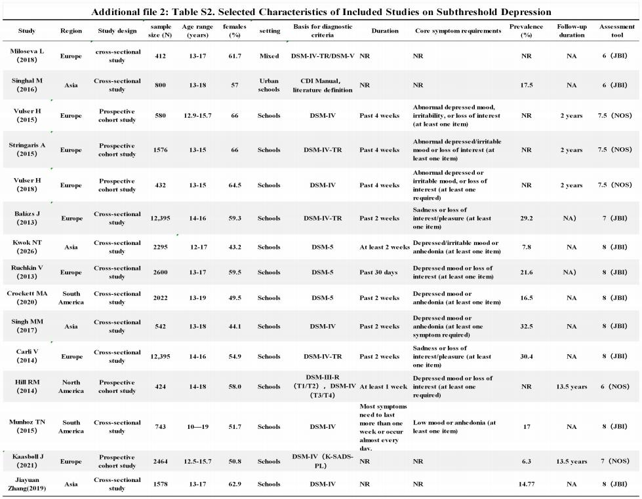

Additional file 3: Table S3.Literature Quality Assessment Table

Table S3-1 Analytical Cross-Sectional Studies (JBI)

Study | 1 | 2 | 3 | 4 | 5 | 6 | 7 | 8
Miloseva L (2017) | Yes | Yes | Yes | Yes | No | No | Yes | Yes
Singhal M（2016） | Yes | Yes | Yes | Yes | No | No | Yes | Yes
Balázs J（2013） | Yes | Yes | Yes | Yes | No | Yes | Yes | Yes
Kwok NT（2026） | Yes | Yes | Yes | Yes | Yes | Yes | Yes | Yes
Ruchkin V（2023） | Yes | Yes | Yes | Yes | Yes | Yes | Yes | Yes
Crockett MA（2020） | Yes | Yes | Yes | Yes | Yes | Yes | Yes | Yes
Singh MM（2017） | Yes | Yes | Yes | Yes | Yes | Yes | Yes | Yes
Carli V（2014） | Yes | Yes | Yes | Yes | Yes | Yes | Yes | Yes
Munhoz TN（2015） | Yes | Yes | Yes | Yes | Yes | Yes | Yes | Yes
Jiayua Zhang（2019） | Yes | Yes | Yes | Yes | Yes | Yes | Yes | Yes

Note. Meaning of the numbers in the table.
1. Were the criteria for inclusion in the sample clearly defined?
2. Were objective, standard criteria used for measurement of the condition?
3. Was the exposure measured in a valid and reliable way?
4. Were the outcomes measured in a valid and reliable way?
5. Were confounding factors identified?
6. Were strategies to deal with confounding factors stated?
7. Was appropriate statistical analysis used?
8. Were the study subjects and the setting described in detail?

Table S3-2 Cohort Studies (NOS)

Study | 1 | 2 | 3 | 4 | 5 | 6 | 7 | 8
Vulser H（2015） | 0.5 | 1 | 1 | 1 | 2 | 1 | 1 | 0
Stringaris A（2015） | 0.5 | 1 | 1 | 1 | 2 | 1 | 1 | 0
Vulser H（2018） | 0.5 | 1 | 1 | 1 | 1.5 | 1 | 1 | 0.5
Hill RM（2014） | 0.5 | 1 | 1 | 1 | 0 | 1 | 1 | 0.5
Kaasbøll J（2021） | 0.5 | 1 | 1 | 1 | 1.5 | 1 | 1 | 0

Note. Meaning of the numbers in the table.
1. Representativeness of the Exposed Cohort
2. Selection of the Non-Exposed Cohort
3. Ascertainment of Exposure
4. Demonstration That Outcome of Interest Was Not Present at Start of Study
5. Comparability of Cohorts on the Basis of the Design or Analysis
6. Assessment of Outcome
7. Was Follow-Up Long Enough for Outcomes to Occur
8. Adequacy of Follow Up of Cohorts

Additional file 4: Figure S1.forest subgroup region
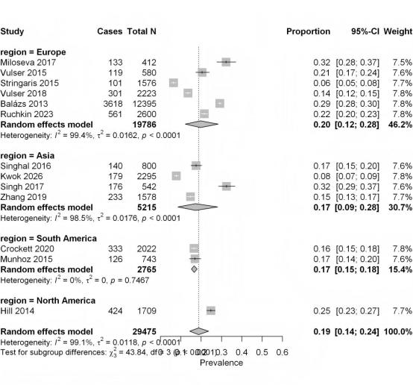

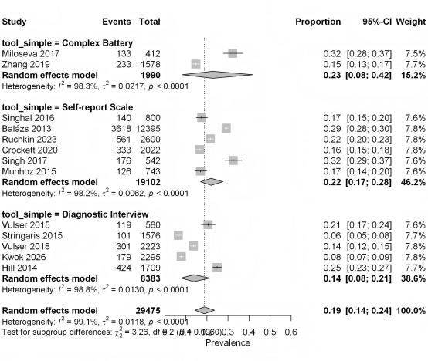

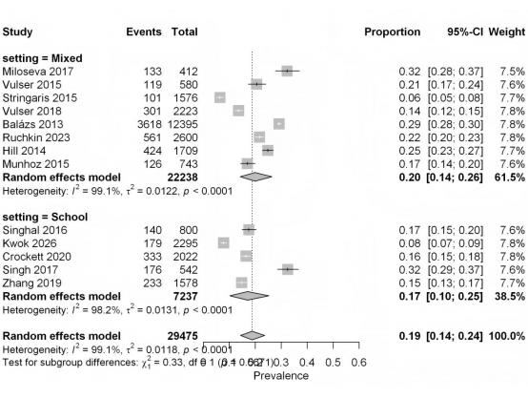

Additional file 5: Figure S4. funnel plots
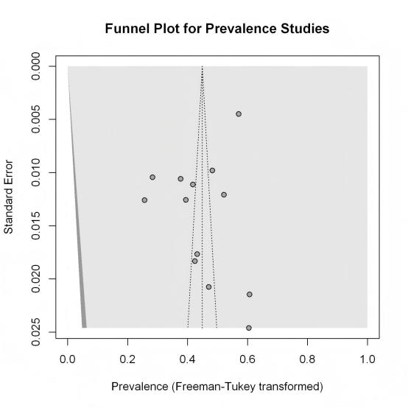

Additional file 6: Figure S5. Leave-one-out sensitivity analysis

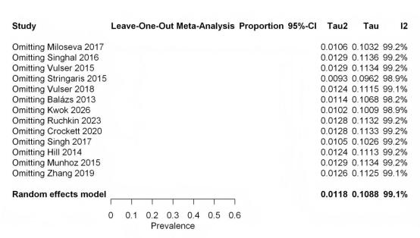

Additional file 7: Figure S6. Exclusion of identified outliers(Stringaris etal., 2015)

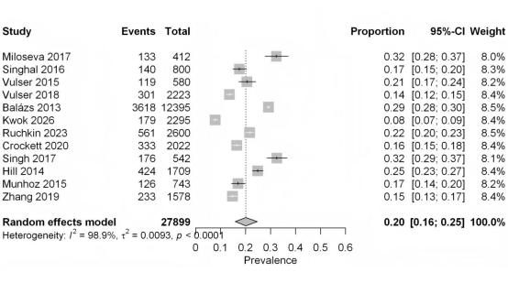

List of Inclusion and Exclusion Criteria

Category | Inclusion Criteria | Exclusion  Criteria
Population | Adolescents aged 12–19 years. Studies  including participants <12 years or > 19 years were included if adolescent subgroup data  could be extracted. | Age <12 years or >19 years; inability to  separate  adolescent  subgroup data.
Exposure | Subthreshold depression (SD): Clearly  defined using validated screening tools (e.g., PHQ-9 score 5–9, CES-D score 16–20, BDI score 10–15) or symptom/duration criteria, not meeting MDD diagnostic criteria. | No clear  operational  definition;  diagnosed with  MDD and data not separable.
Comparison | For risk factor and outcome analyses:  compared with adolescents without  subthreshold depression. No direct  comparison required for prevalence studies. | ——
Outcome | ① Prevalence; ② Effect size of risk factors; ③ Conversion rate to MDD. | None of the above outcomes  reported.
Study  Design | Cross-sectional study, cohort study  (prospective/retrospective), case-control study. Only baseline data extracted from RCTs. | Qualitative study, review, case  report, conference abstract, animal  experiment.
Setting | Community, school, primary care settings. Clinical settings included only if data could be separated. | Pure inpatient  sample with no  separable SD data.
Time Range | January 1, 2013 – March 31, 2026 | Earlier than 2013 or later than  March 31, 2026.
Language | English, Chinese | Other languages

Appendix: Important Amendments
The key amendments to this study protocol are as follows:

1. Change to data analysis software
Meta-analysis, heterogeneity testing, publication bias assessment, and figure generation were originally planned to be performed using RevMan 5.4. They are now conducted using the R statistical environment (packages: meta, metaphor). This is a methodological optimization and does not alter the study objectives, eligibility criteria, data extraction procedures, outcome measures, or core statistical logic.

2. Revision of the author team
During the implementation of the study, Yu Jianjiao was added as co-first author, and Fu Yanfen was added as co-corresponding author. All newly added authors have made substantial contributions to literature screening, data extraction, methodological guidance, or manuscript revision, and meet the authorship criteria of academic journals.

3. Correction to eligibility criteria
The time range for literature search is January 1, 2013 to March 31, 2026. The date of April 30, 2026 stated in the original protocol was a clerical error.

Date of amendment: Sunday, May 17, 2026

