Supporting Information
Construction of Waterborne Polyurethane Composites via Phytate-Chitosan-Modied Boron Nitride and DOPO Derivative Synergy: A route to flame retardancy and multifunctional performance

Yanling Yue¹, Bingyue Huang¹, Deyu Liu¹, Shaoyuan Wu¹, Jinghan Hu¹, Shiyi Ming¹, Xingyu Guan¹,Yi Zhang¹*, Kui Wang¹, Weijiang Huang¹, Wei Yan¹*
- School of Materials Science and Engineering, Guiyang University, Guiyang 550005, P.R. China
Corresponding author: yikizhang1991@163.com，yw2410@gyu.edu.cn

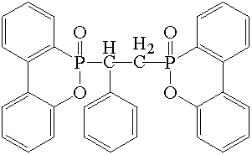
Fig.S1. DIDOPO structural formula.

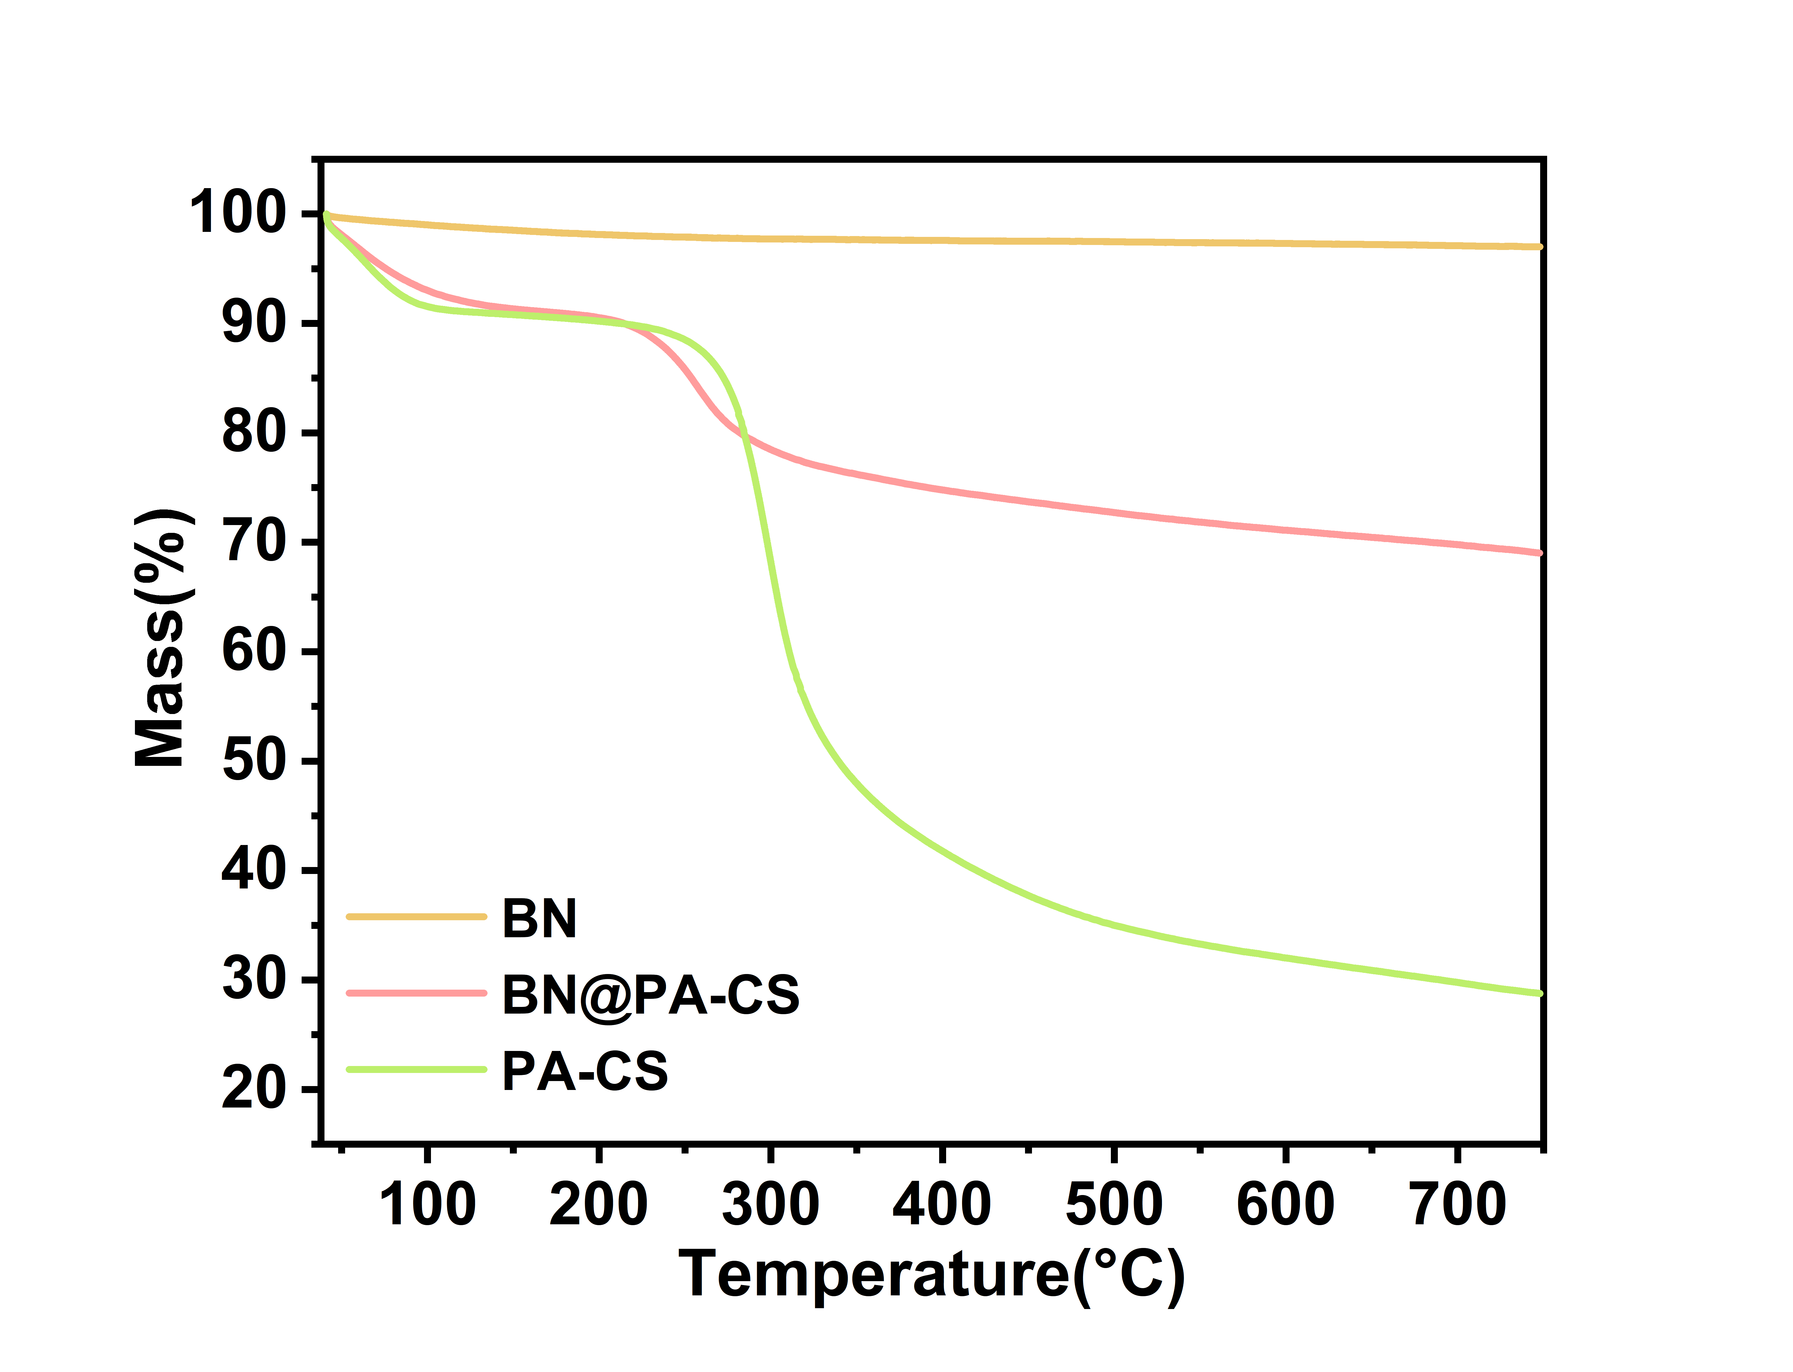
Fig. S2 shows the TGA curves of BN, BN@PA-CS, and PA-CS.

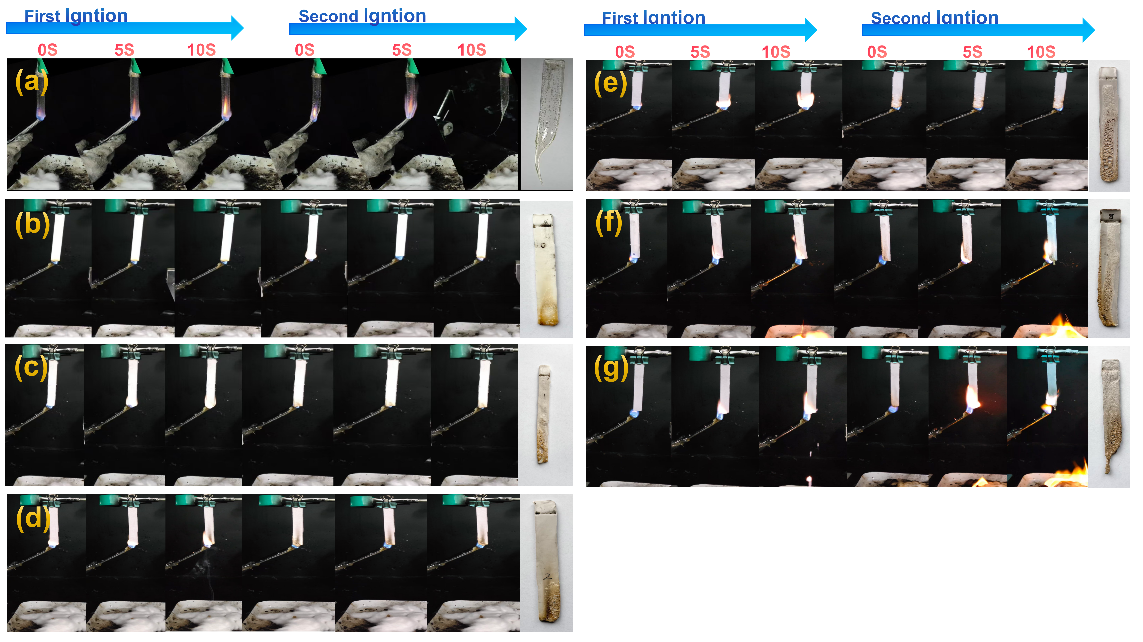
(a) wpu,
(b)WPU/DIDOPO9, (c) WPU/BN@PA-CS1/DIDOPO8, (d)WPU/BN@PA-CS2/DIDOPO7
(e) WPU/BN@PA-CS7/DIDOPO2,(f) WPU/BN@PA-CS8/DIDOPO1,(g)WPU/BN@PA-CS9

Fig. S3.The photos of the vertical burning test with WPU composites.

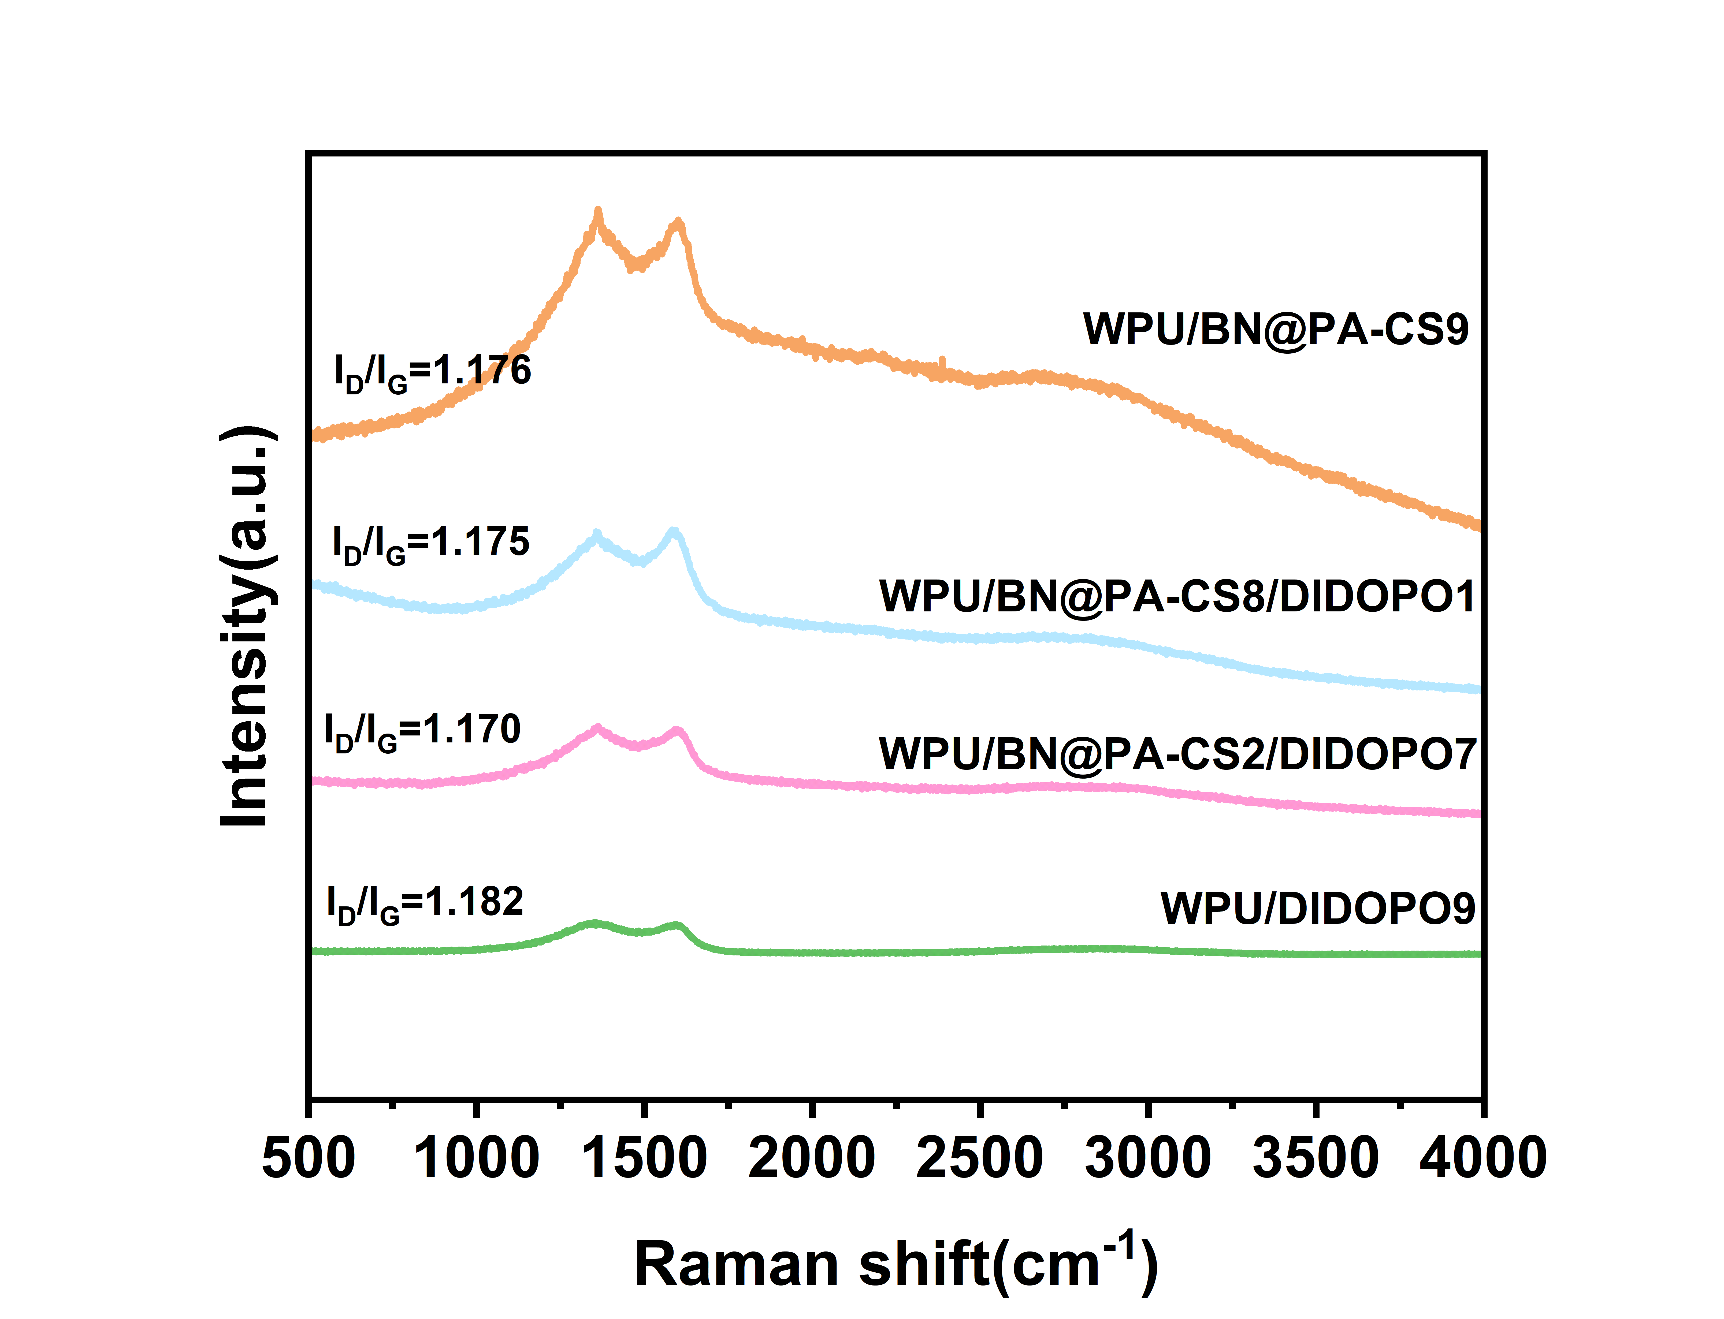
Fig. S4 The Raman spectroscopy spectrum of the WPU composite material

