Effect of radical scavenging extender on the chemical stability of anion exchange membrane under alkaline conditions
Ara Cho¹⁺, Min Suc Cha²⁺, Seung Won Baek¹⁺, Se In Park¹, Jeong Bang Ko¹, Dae Hwan Shin¹, Dong Chan Kim¹, Sungjun Kim³, Jang Yong Lee^{1*}

Affiliations
¹ Division of Chemical, Biomolecular and Energy Engineering, Konkuk University, Seoul 05029, Republic of Korea
² Water Energy Research Center, K-water Research Institute, Korea Water Resources Corporation, Daejeon 34045, Republic of Korea
³ Hydrogen Energy Research Center, Korea Research Institute of Chemical Technology, Daejeon 34114, Republic of Korea.

*E-mail: ljyljy78@konkuk.ac.kr
⁺ These authors contributed equally: Ara Cho, Min Suc Cha, Seung Won Baek
Supporting Information
Fig. S1 ¹H NMR spectrum of (a) BrPPO-x, (b) QPPO-35-DATMP, (c) QPPO-35-DMHA,
and (d) QPPO-35-TMA.

Fig. S2 (a) ¹H NMR spectra of QPPO-35-TEMPO before (top) and after (bottom) quenched by pentafluorophenyl hydrazine. (b) ¹⁹F NMR spectra of QPPO-35-TEMPO after quenched by pentafluorophenyl hydrazine (top) and pentafluorophenyl hydrazine (bottom).

Fig. S3 Comparison of EPR spectra QPPO-35-DATMP and QPPO-35-TEMPO.

Fig. S4 Characterization of QPPO-x-W AEMs. (a) Water uptake and dimensional variation of synthetic ionomers at 25 °C, (b) OH⁻ conductivity of synthesized membranes as a function of temperature and (c) Cl⁻ conductivity of synthesized membranes as a function of temperature.

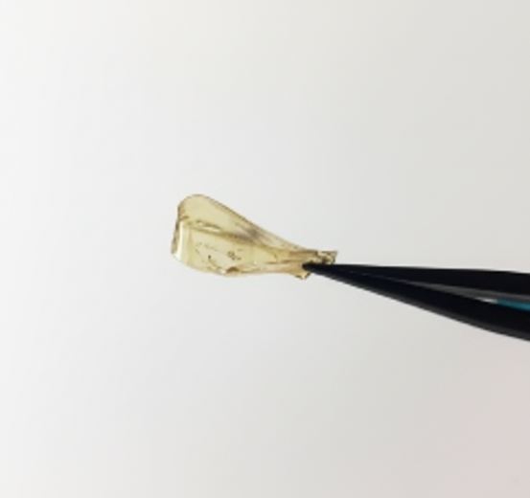
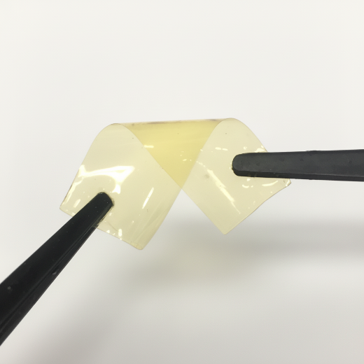
Fig. S5 Digital photos of QPPO-35-TEMPO after chemical stability test (Top: folding, Bottom: twisting).

Fig. S6 FT-IR spectra of QPPO-35-TEMPO before (top) and after (bottom) chemical stability test.

Fig. S7 The schematic molecular structure of HQPC-TMA-2.4.

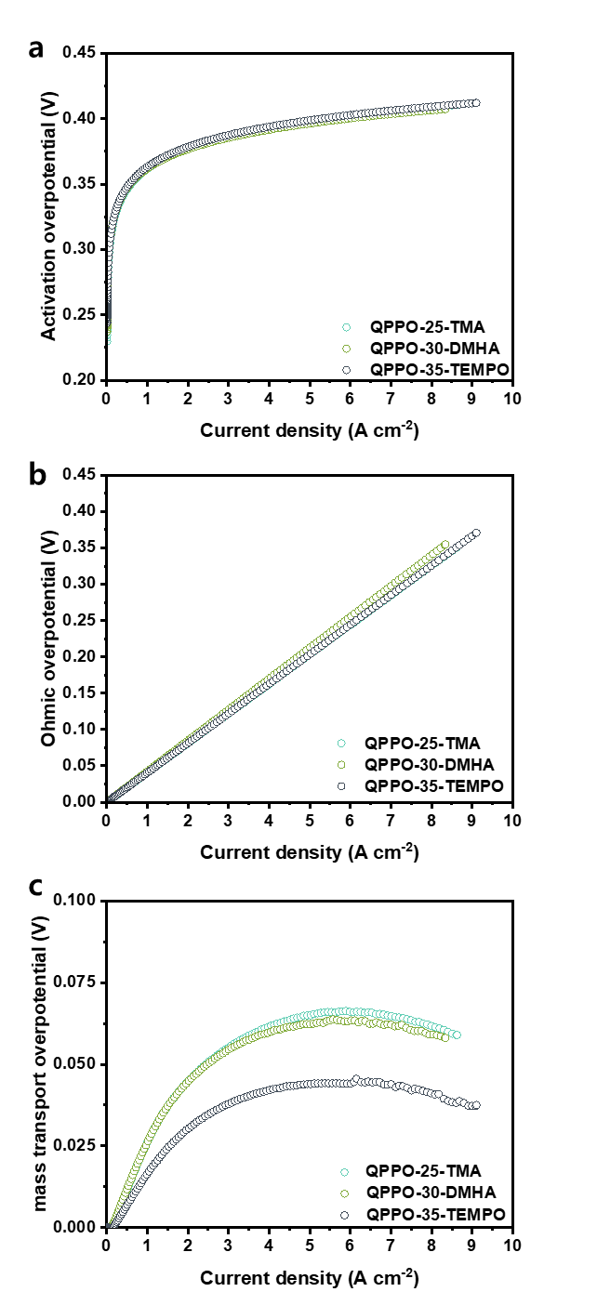
Fig. S8 Calculated overpotentials of the 1.0 M KOH-fed AEMWEs (80 °C) with different anode ionomers. (a) Activation overpotential, (b) ohmic overpotential, and (c) mass-transport overpotential.

Table S1 Mechanical and electrochemical properties of synthesized membranes.
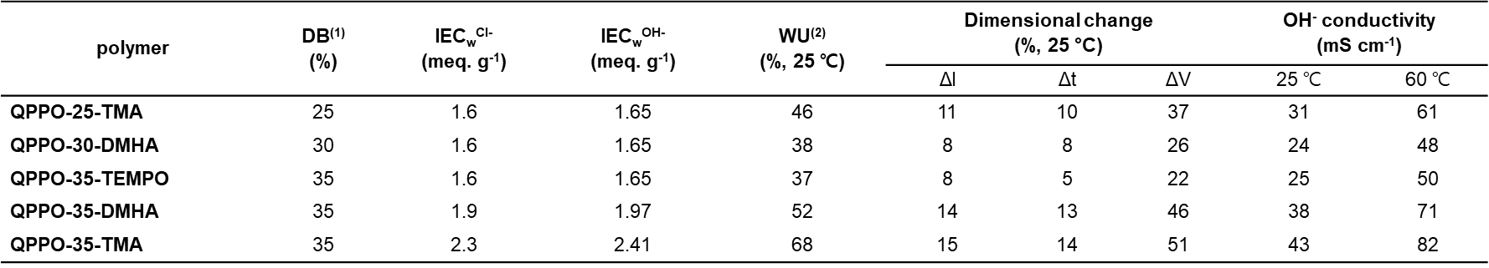
Table S2 Detailed conditions of AEMWE single-cell with different QPPO-x-W membranes.
Components | QPPO-TMA | QPPO-DMHA | QPPO-DATMP | QPPO-TEMPO
Anode PTL | Ni Paper
Anode CL | NiFe alloy (2.0 mg_{NiFe}/cm²)
Anode Ionomer | HQPC-TMA-2.4 (I/Cat = 0.15)
Membrane | QPPO-25-TMA (50 – 60 μm) | QPPO-30-DMHA (50 – 60 μm) | QPPO-35-DATMP (50 – 60 μm) | QPPO-35-TEMPO (50 – 60 μm)
Cathode CL | PtRu/C (0.4 mg_{PtRu}/cm²)
Cathode Ionomer | HQPC-TMA-2.4 (I/Cat = 0.2)
Cathode PTL | Carbon Paper w/MPL (JNT-30-A3)
Bipolar Plates | Ni-coated SUS 316 / 1-channel serpentine flow field (2.2×2.3 cm²)

Table S3 Detailed conditions of AEMFC single-cell with different QPPO-x-W membranes.
Components | QPPO-TMA | QPPO-DMHA | QPPO-DATMP | QPPO-TEMPO
Anode GDL | Carbon Paper w/MPL (JNT-30-A3)
Anode CL | 60 wt.% PtRu/C (0.4 mg_{PtRu}/cm²)
Anode Ionomer | HQPC-TMA-2.4 (I/Cat = 0.2)
Membrane | QPPO-25-TMA (50 – 60 μm) | QPPO-30-DMHA (50 – 60 μm) | QPPO-35-DATMP (50 – 60 μm) | QPPO-35-TEMPO (50 – 60 μm)
Cathode CL | 60 wt.% Pt/C (0.4 mg_{Pt}/cm²)
Cathode Ionomer | HQPC-TMA-2.4 (I/Cat = 0.2)
Cathode GDL | Carbon Paper w/MPL (JNT-30-A3)
Bipolar Plates | Graphite / 1-channel serpentine flow field (2.2×2.3 cm²)

Table S4 Detailed conditions of AEMWE single-cell with different QPPO-x-W ionomers on anode.
Components | QPPO-TMA | QPPO-DMHA | QPPO-TEMPO
Anode PTL | Ni Paper
Anode CL | NiFe alloy (2.0 mg_{NiFe}/cm²)
Anode Ionomer | QPPO-25-TMA (I/Cat = 0.15) | QPPO-30-DMHA (I/Cat = 0.15) | QPPO-35-TEMPO (I/Cat = 0.15)
Membrane | QPC-TMA-2.4 (50 μm)
Cathode CL | PtRu/C (0.4 mg_{PtRu}/cm²)
Cathode Ionomer | HQPC-TMA-2.4 (I/Cat = 0.2)
Cathode PTL | Carbon Paper w/MPL
Bipolar Plates | Ni-coated SUS 316 / 1-channel serpentine flow field (2.2×2.3 cm²)

