Supplementary materials

Tables

 | Forward | Reverse
Vegf-a | AAAAACGAAAGCGCAAGAAA | TTTCTCCGCTCTGAACAAGG
Col1a2 | TGCAGTAACTTCGTGCCTAG | ACGTGGTCCTCTGTCTCCA
Ang-1 | GGGGGAGGTTGGACAGTAA | CATCAGCTCAATCCTCAGC
Ldha | TGTGGCAGACTTGGCTGAGA | CTGAGGAAGACATCCTCATTGATTC
Actb | GGCTGTATTCCCCTCCATCG | CCAGTTGGTAACAATGCCATGT
Supplementary Table 1: Mouse primers used for RT-qPCR.

 | Upregulated | Downregulated
1 | F630028O10Rik | Neu2
2 | Tpsab1 | Ttn
3 | Apcdd1 | Klra17
4 | Cpa3 | Smoc1
5 | Rcan1 | Adamts17
6 | Rgs18 | Tnrc6b
7 | Islr | Atp1a2
8 | Aldh3a1 | Tnnt3
9 | Plac8 | Myh4
10 | Aqp1 | Fxyd1
11 | Gch1 | Dusp13
12 | S100a9 | Cdnf
13 | Ehf | Podn
14 | Lyve1 | 1810032O08Rik
15 | Tnn | Adam22
16 | Tnfrsf9 | Sgce
17 | Nr4a3 | Cmss1
18 | Uck2 | Tcap
19 | Ddit4 | Gpr153
20 | Cxcl1 | Gm15564
21 | Cry1 | Ckm
22 | Tnfrsf21 | Srrm2
23 | Ctsg | Car3
24 | Slpi | Des
25 | Lum | Rnf207
26 | Sncg | Acsbg1
27 | Pdia4 | Ckm
28 | Mrgprb1 | Eln
29 | Ttyh1 | Myl1
30 | Tpmt | Mybpc2
31 | Sectm1b | Pdlim3
32 | Prf1 | Sfrp2
33 | Gzmd | Cilp
34 | Rpsa-ps10 | Cygb
35 | Mrgprb2 | Nrap
36 | 1700071M16Rik | Cit
37 | Scara5 | Gm12563
38 | Ptgs2 | Mfap4
39 | Notum | Gm15662
40 | Gzmf | Pag1
41 | Ccl9 | Cspg4
42 | Mmp3 | Pdzrn3
43 | Adgrf1 | Cisd3
44 | 1110038B12Rik | Hhipl1
45 | Ggt1 | Flnc
46 | Mmp13 | Cdo1
47 | Nr4a1 | Cacna1g
48 | Ppp1r10 | Xirp2
49 | Gzmg | Neb
50 | Cstf2 | Cpxm1
Supplementary Table 2: Top 50 upregulated and downregulated genes from RNA-Sequencing analysis comparing Kin1 WT and Kin1 KO tumours.

Figures

Supplementary Figure 1: | Confirmation of induced hypoxia in cSCC 2D cultures in vitro. mRNA expression of hypoxic marker Ldha at normal and hypoxic conditions in Kin1 WT and Kin1 KO cSCC cells. Data obtained from three independent experiments (mean ± SD). p-values were obtained from one-way ANOVA test followed by Tukey post-hoc test; *p < 0.05.

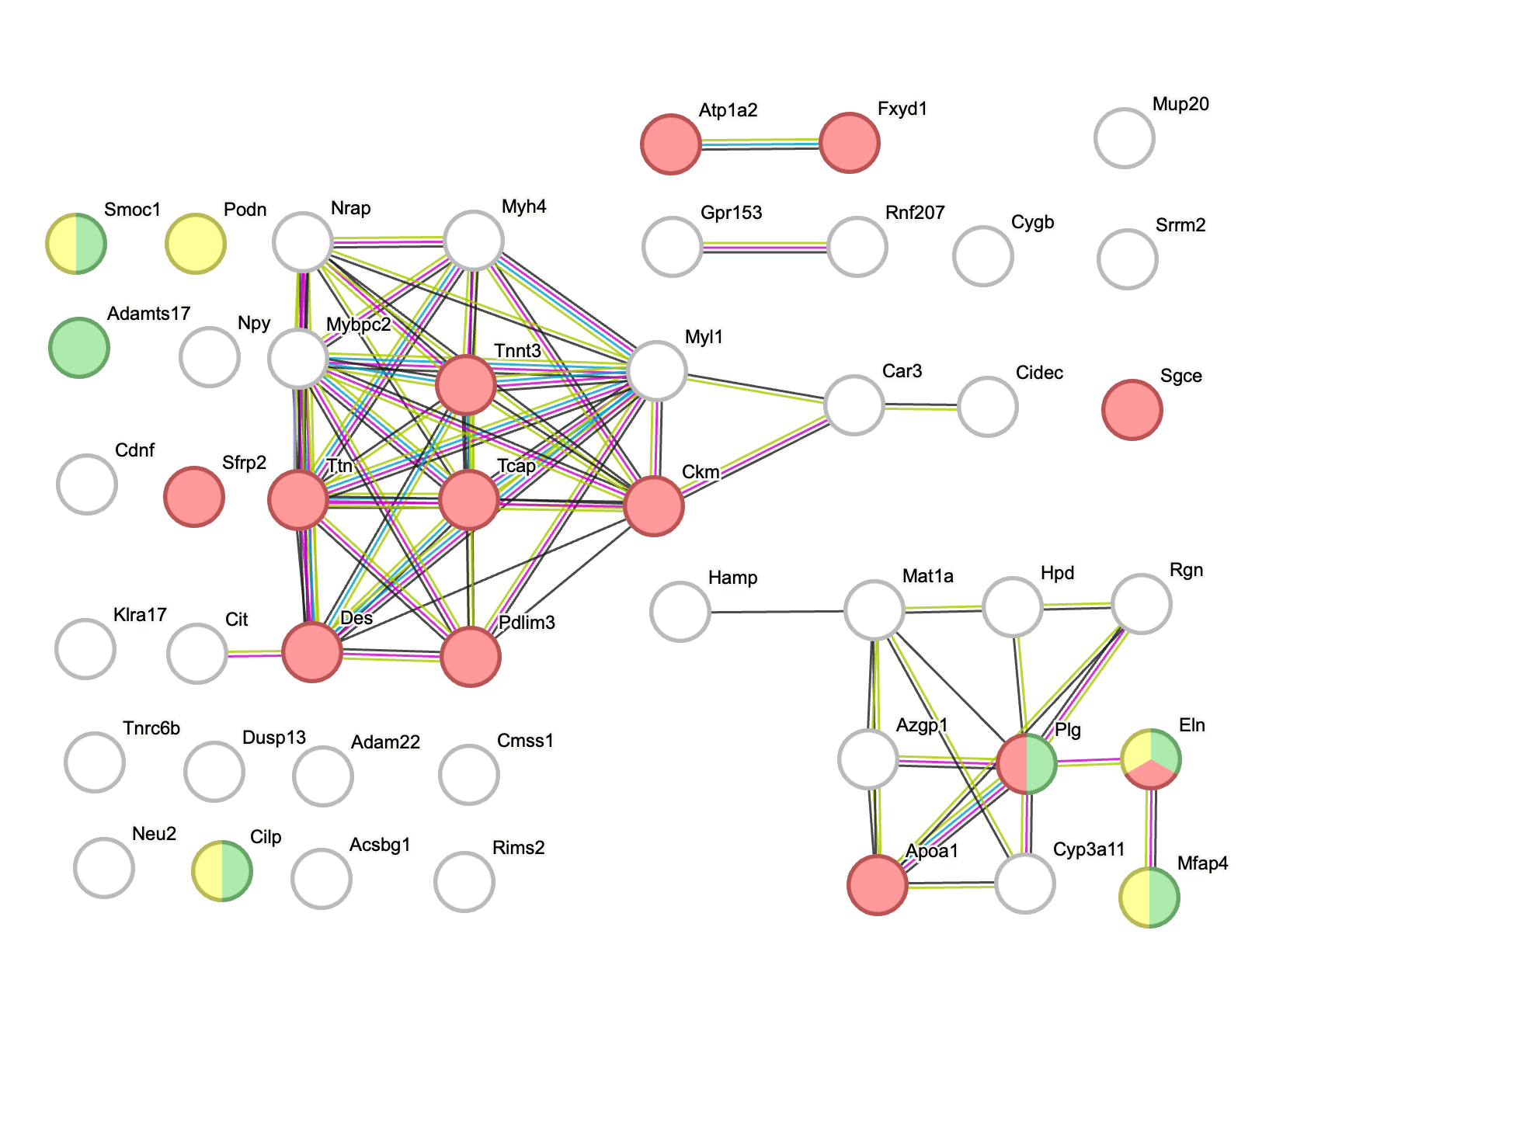
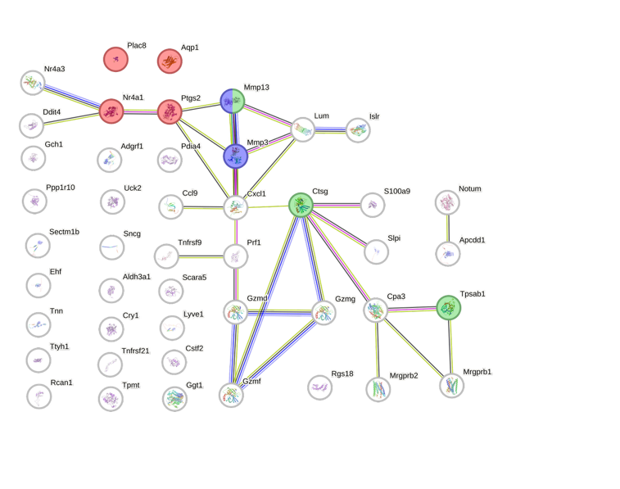
Downregulated genes in Kin1 KO
Upregulated genes in Kin1 KO
a
b

Extracellular matrix disassembly​​
Metabolism of angiotensins​​
Abnormal vascular permeability

Collagen-containing extracellular matrix
Extracellular matrix
Abnormal cardiovascular system physiology

Supplementary Figure 2 | Differentially expressed genes in Kin1 KO tumours linked to tumourigenic features. STRING analysis of upregulated (a) and downregulated (b) genes from RNA-Sequencing analysis comparing Kin1 WT and Kin1 KO tumours (n= 3 tumours).

b Collagen volume (3D) vs inter-bifurcation λ (3D)
a Hypoxic fraction vs vascular density (3D)
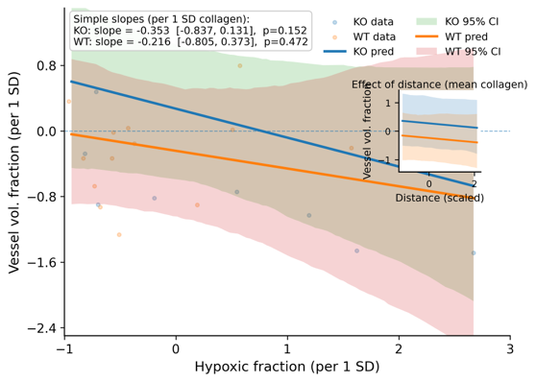
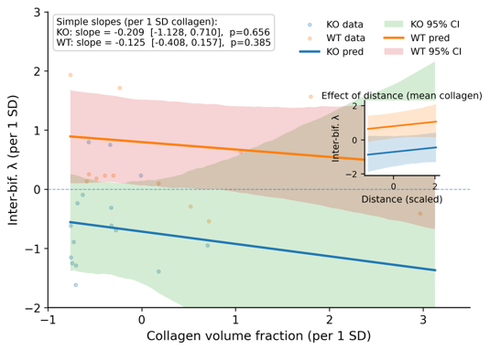

Supplementary Figure 3 | Further relationships between vascular features, hypoxia and collagen in Kin1 WT and Kin1 KO tumours. (a) Vessel volume fraction from 3D vessel reconstructions vs hypoxic fraction from 2D cross-sections of the same region, (b) Vascular inter-bifurcation λ (the ratio of vessel length-to-diameter) from 3D reconstructions vs collagen volume fraction, also from 3D. Solid lines represent genotype-specific regressions (KO, blue; WT, orange) with shaded 95% confidence intervals. Insets show the effect of radial distance, confirming independence from spatial gradients.

