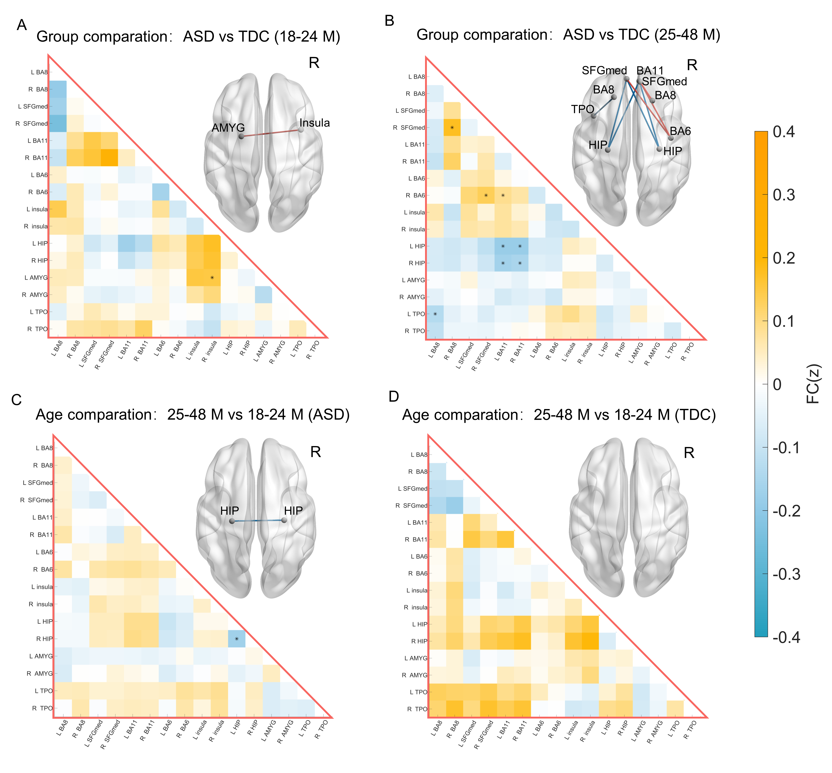
Figure S1. Functional connectivity of the prefrontal four-stream integration network in toddlers with ASD and TDC.
This control model evaluates the functional integration across four prefrontal streams: motor (BA 8), emotional (BA 9), mnemonic (BA 10), and sensory (BA 11), along with associated structural targets. (A) Group comparison between ASD and TDC in the 18–24 month cohort. (B) Group comparison between ASD and TDC in the 25–48 month cohort. (C) Age-related changes in FC within the ASD group (25–48 months vs. 18–24 months). (D) Age-related changes in FC within the TDC group (25–48 months vs. 18–24 months). Matrices represent group-level differences in Fisher’s z-transformed Pearson correlation coefficients. The color bar indicates the strength of connectivity differences FC(z), where warm colors (red) represent increased FC and cool colors (blue) represent decreased FC. Asterisks (*) denote connections that survived FDR correction (p < 0.05). Significant connections are visualized on the 3D brain surfaces.
Abbreviations: AMYG, amygdala; BA6, Brodmann area 6 (supplementary motor area); BA8, Brodmann area 8 (dorsal superior frontal gyrus); BA11, Brodmann area 11 (medial orbitofrontal cortex and rectus gyrus); HIP, hippocampus; SFGmed, medial superior frontal gyrus (representing BA 9 and 10); TPO, temporal pole.

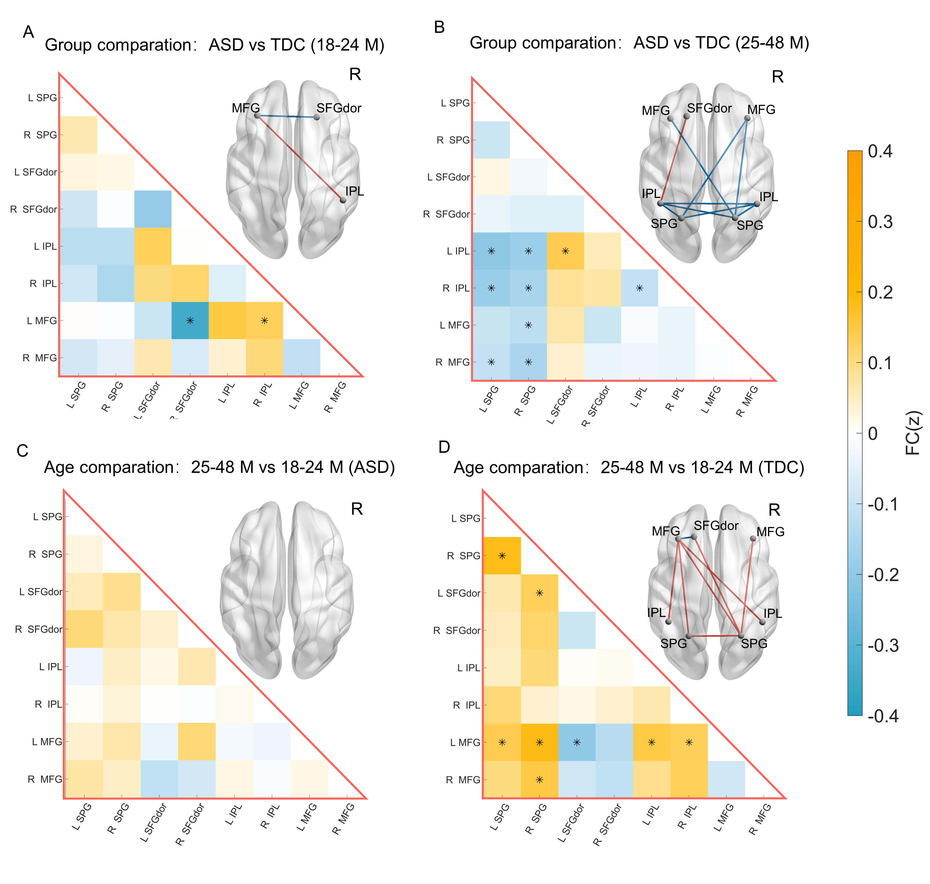
Figure S2. Functional connectivity of higher-order cognitive networks in toddlers with ASD and TDC.
Connectivity matrices and 3D visualizations for each cohort and age comparison. Statistical thresholds, color scales, and visualization parameters are identical to those described in Figure 2.
Abbreviations: IPL, inferior parietal lobule; MFG, middle frontal gyrus; SFGdor, dorsal superior frontal gyrus; SPG, superior parietal gyrus.
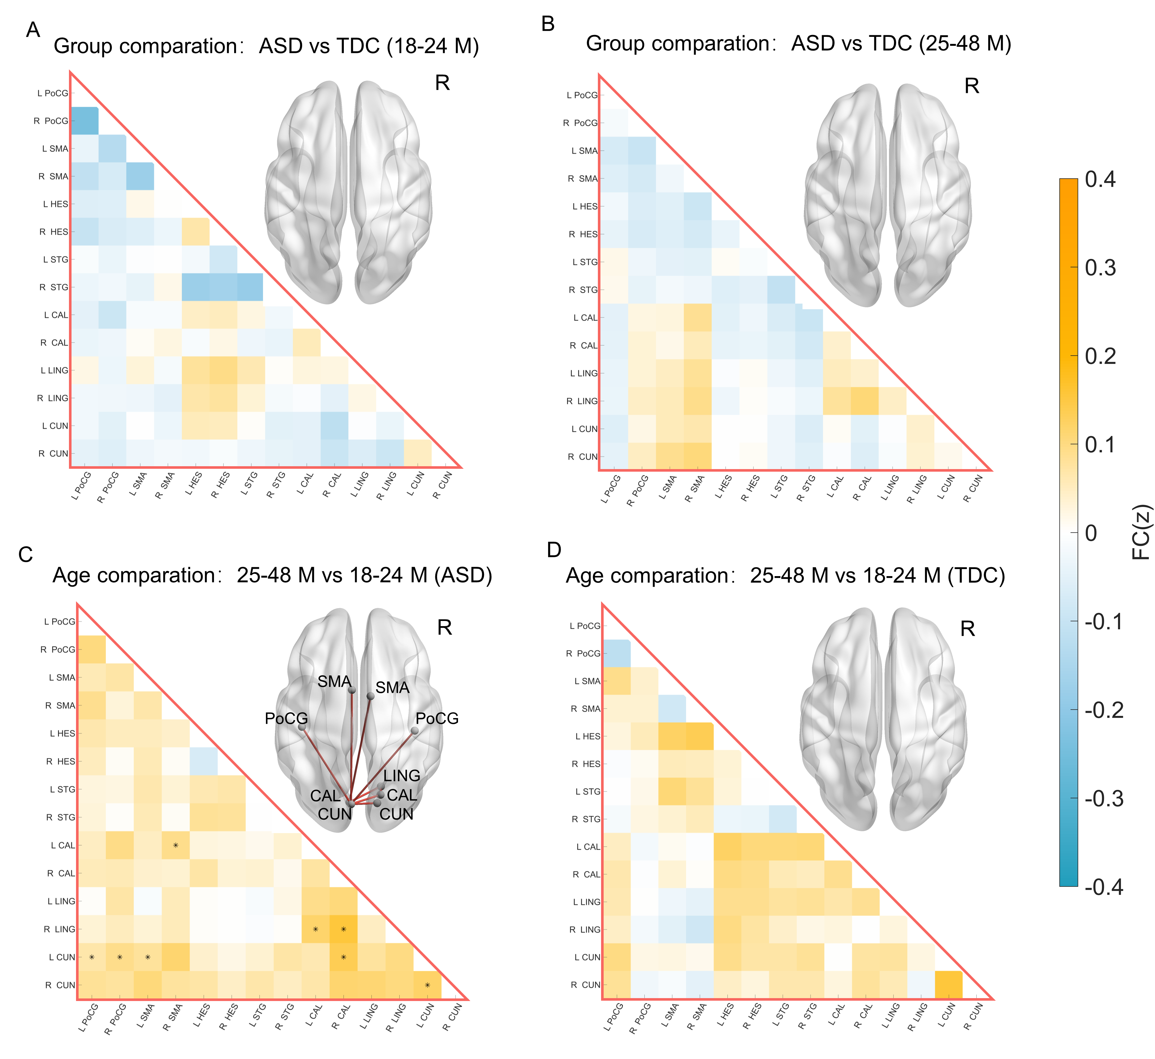
Figure S3. FC between brain regions of primary sensorimotor networks in toddlers with ASD and TDC.
This control model includes regions for low-level sensory and motor processing. (A–D) Group and age-related comparisons of functional connectivity. All visualization and statistical conventions (e.g., color bar and FDR correction) follow Figure 2.
Abbreviations: CAL, calcarine cortex; CUN, cuneus; HES, Heschl’s gyrus; LIN, lingual gyrus; POST, postcentral gyrus; SMA, supplementary motor area; STG, superior temporal gyrus

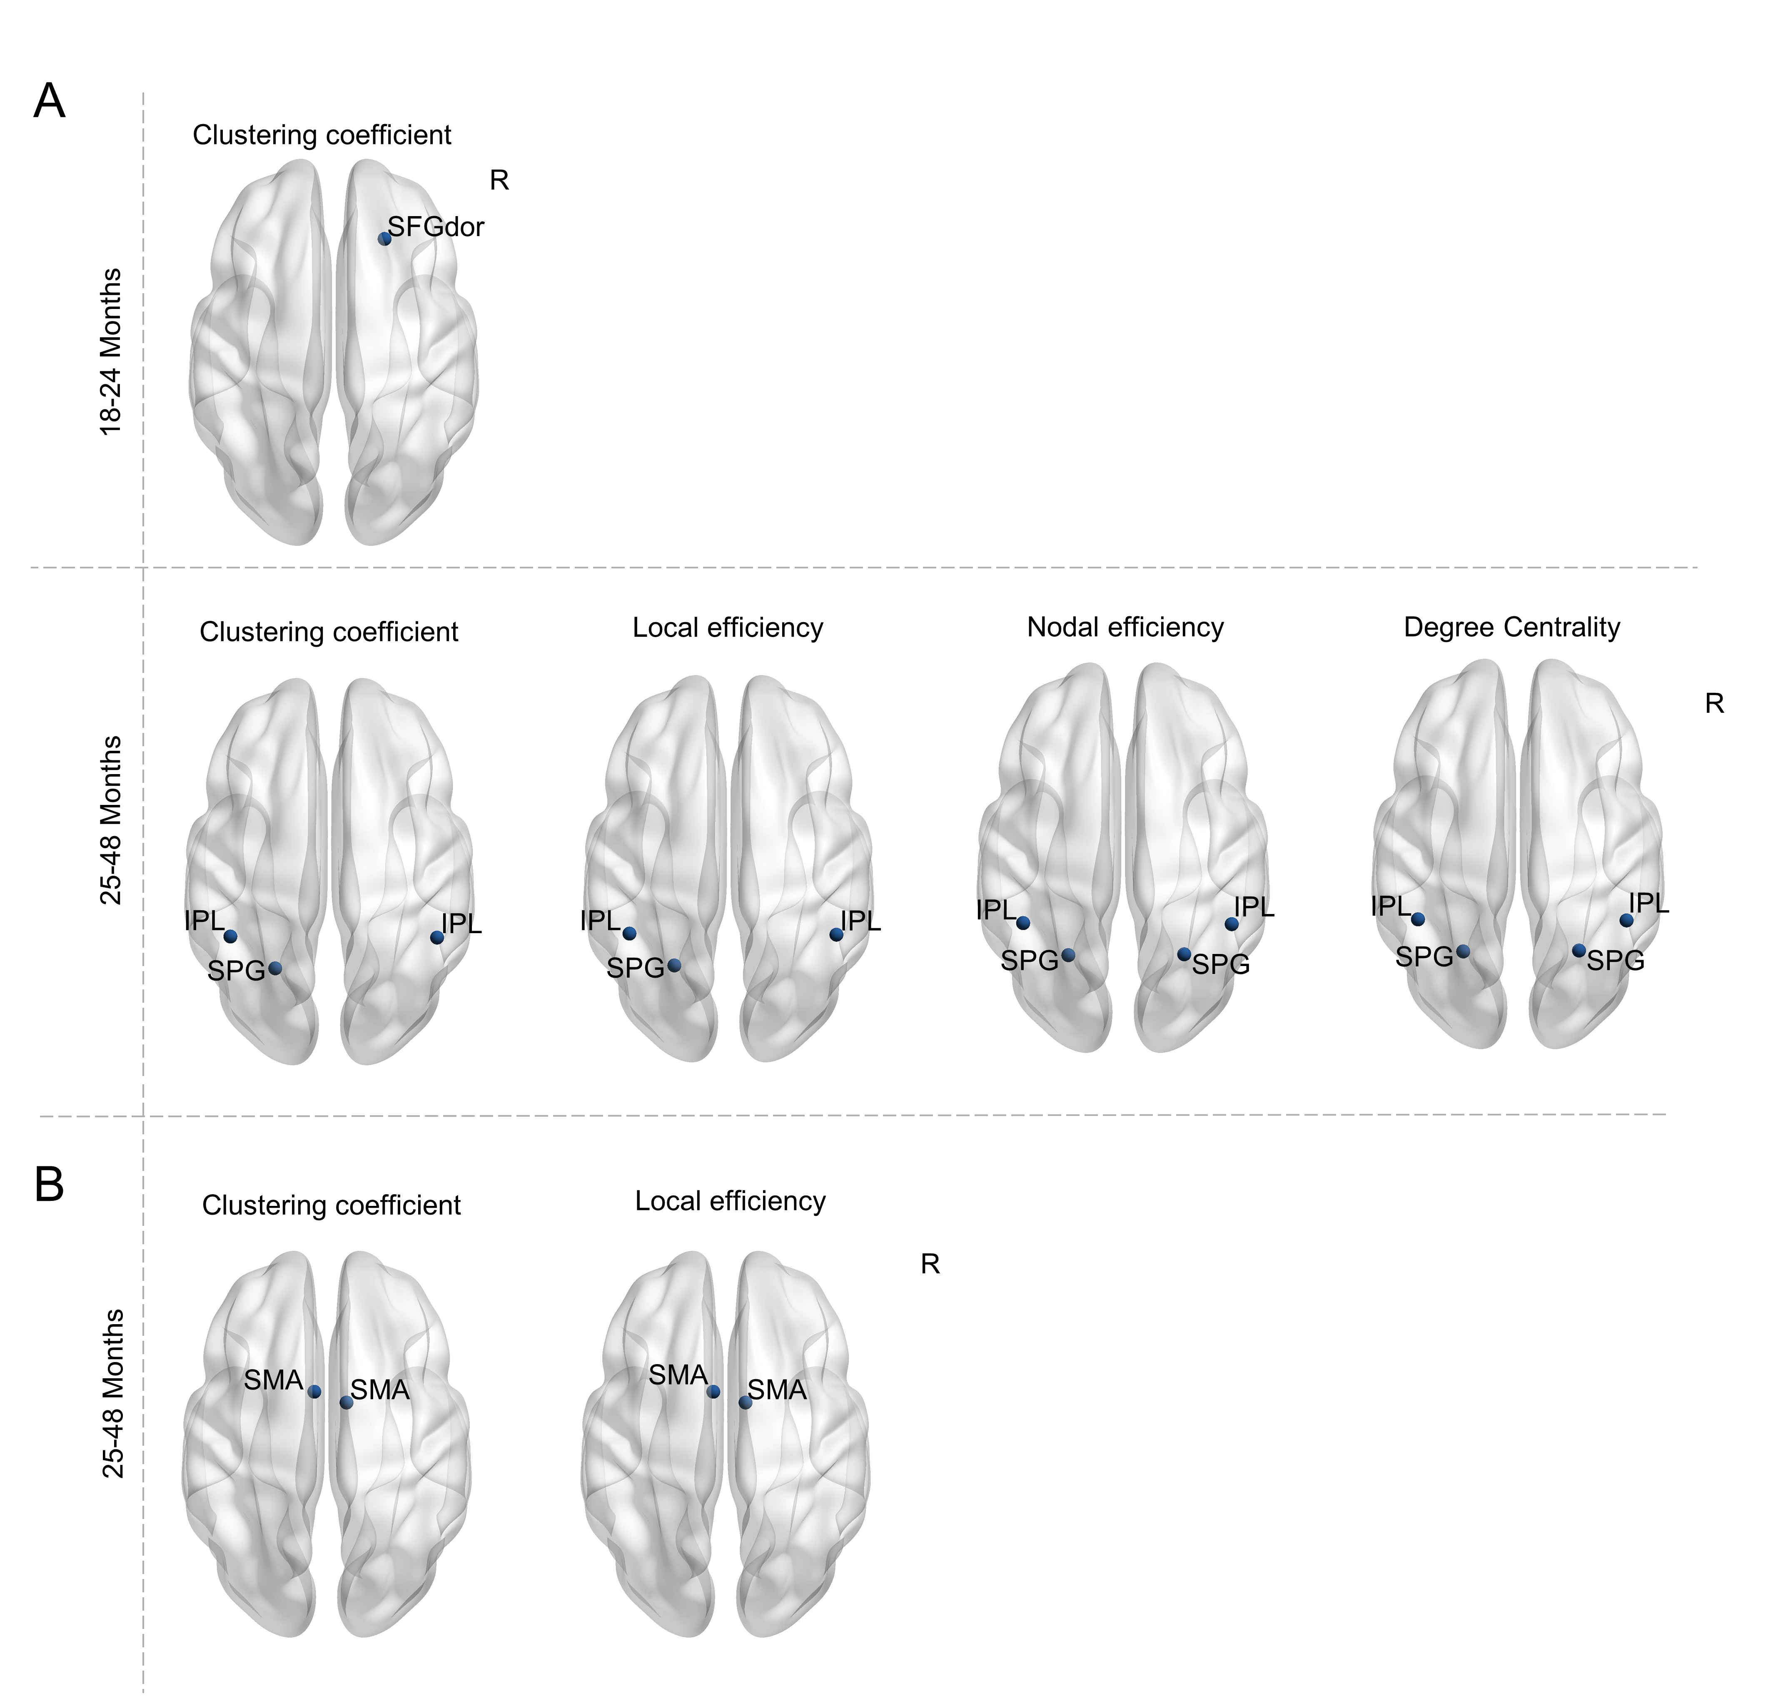Figure S4. Altered nodal topological properties of control networks in toddlers with ASD.
- Nodal graph theory indices for higher-order cognitive networks. (B) Nodal graph theory indices for primary sensorimotor networks. Spheres represent significant nodal properties (including clustering coefficient, local efficiency, nodal efficiency, and degree centrality) that differed between ASD and TDC. The red sphereindicate significantly higher topological values in the ASD group, while blue spheres indicate significantly lower values compared to TDC. All displayed nodal properties survived FDR correction at p < 0.05.
Abbreviations: IPL, inferior parietal lobule; SFGdor, dorsal superior frontal gyrus; SMA, supplementary motor area; SPG, superior parietal gyrus; L, left hemisphere; R, right hemisphere.

Table S1. Abnormal functional connectivity of self-networks in ASD
Brain regions | Functional connectivity
18-24 Months | ASD > TDC | ASD < TDC
Exteroceptive-self
L.TPJ | L.mPFC | —
R.TPJ | L.mPFC, R. L.mPFC, R.ACC,RPCC | —
25-48 Months
Interoceptive-self
R.INS | L.TPJ
L.Thal |  | L.PMC,R.PMC
Exteroceptive-self
L.TPJ | R.PMC,L.R.ACC | —
R.TPJ | L.mPFC, R. R.ACC | —
Mental-self
L.ACC | L.PCC, | —
R.ACC | L.R.PCC, | —
Brain regions are the core brain regions of self-network, and the functional connectivity means abnormal FC between the brain regions of self-network. L.means left hemisphere; R.means right hemispher; abbreviations of the brain regions: INS: insula; Thal: thalamus; TPJ: temporo parietal junction; mPFC: medial prefrontal cortex; ACC: anterior cingulate cortex; PMC: premotor cortex; PCC: posterior cingulate cortex

Table S2. Functional connectivity of self-networks in age group comparison
Brain regions | Functional connectivity
ASD  Interoceptive-self | 25-48 Months > 18-24 Months | 25-48 Months < 18-24 Months
L.Thal | — | R.Thal
TDC
Interoceptive-self
L.Insula | — | L.TPJ
Mental-self
R.ACC | — | L.PCC
L.means left hemisphere; R.means right hemispher; abbreviations of the brain regions: Thla: thalamus; INS: Insula; TPJ: temporo-parietal junction; ACC: anterior cingulate cortex; PCC: posterior cingulate cortex

