Table S1. Summary table of capture and immobilisation methods, and collar types for all tracked jackals
ID | Capture method | Immobilization | Collar type
IT1 | Recovered after traffic collision | Intramuscular injection of 100 mg tiletamine and zolazepam (Zoletil for injection, Virbac) | Vectronic GPS-GSM Vertex lite
IT2 | Recovered after traffic collision |  | Vectronic GPS-GSM Vertex lite
SL1 | Foot-hold traps LPC EZ Grip #4 (LPC) | Intramuscular injection of medetominine HCl (1mg/ml) and ketamine (100mg/ml) solution | Vectronic GPS-GSM Vertex lite
SL2 | Foot-hold traps LPC EZ Grip #4 (LPC) |  | Vectronic GPS-GSM Vertex lite
SL3 | Foot-hold traps LPC EZ Grip #4 (LPC) |  | Vectronic GPS-GSM Vertex lite
SL4 | Foot-hold traps LPC EZ Grip #4 (LPC) |  | Vectronic GPS-GSM Vertex lite
CR1 | Foot-hold traps LPC EZ Grip #7 (LPC) | Intramuscular injection of  100 mg tiletamine and  zolazepam (Zoletil, Virbac) | Vectronic  GPS-GSM  Vertex  PLUS
SR1 | Foot snare traps Belisle 6” (Wildlife Control Supplies, LLC) | Intramuscular injection of 100 mg tiletamine and zolazepam (Zoletil for injection, Virbac) | Vectronic GPS-GSM Vertex lite
SR2 | Foot snare traps Belisle 6” (Wildlife Control Supplies, LLC) |  | Vectronic GPS-GSM Vertex lite
SR3 | Foot snare traps Belisle 6” (Wildlife Control Supplies, LLC) |  | Vectronic GPS-GSM Vertex lite
SR4 | Foot snare traps Belisle 6” (Wildlife Control Supplies, LLC) |  | Vectronic GPS-GSM Vertex lite
SR5 | Foot snare traps Belisle 6” (Wildlife Control Supplies, LLC) |  | Vectronic GPS-GSM Vertex lite

Table S2. Sensitivity analysis of search radius and search window on the number of clusters detected
radius | 100 | 200 | 300 | 350 | 400 | 450 | 500 | 600 | 700
days
2 | 35 | 51 | 64 | 67 | 71 | 74 | 73 | 79 | 86
3 | 38 | 55 | 65 | 70 | 70 | 75 | 73 | 80 | 84
4 | 39 | 56 | 65 | 71 | 71 | 75 | 73 | 81 | 84
5 | 40 | 56 | 64 | 71 | 71 | 76 | 74 | 81 | 87

Table S3. Distribution of recorded and simulated fixes across Corine Land cover categories
Grouped category | CLC category | True (used) points |  | False (available) points
Forests | Broad leaved forest | 434 | 206 | 14594 | 5525
Forests | Coniferous forest | 434 | 123 | 14594 | 3827
Forests | Mixed forest | 434 | 105 | 14594 | 5242
Agriculture | Non irrigated arable land | 223 | 101 | 10370 | 5157
Agriculture | Land principally occupied by agriculture with significant areas of natural vegetation | 223 | 66 | 10370 | 2779
Agriculture | Complex cultivation patterns | 223 | 51 | 10370 | 2092
Agriculture | Vineyards | 223 | 5 | 10370 | 239
Agriculture | Fruit trees and berry plantations | 223 | 0 | 10370 | 103
Urban areas | Discontinuous urban fabric | 49 | 43 | 3478 | 2474
Urban areas | Industrial or commercial units | 49 | 5 | 3478 | 457
Urban areas | Sport and leisure facilities | 49 | 1 | 3478 | 67
Urban areas | Road and rail networks and associated land | 49 | 0 | 3478 | 217
Urban areas | Mineral extraction sites | 49 | 0 | 3478 | 137
Urban areas | Green urban areas | 49 | 0 | 3478 | 67
Urban areas | Dump sites | 49 | 0 | 3478 | 57
Urban areas | Construction sites | 49 | 0 | 3478 | 2
Grasslands | Pastures | 26 | 14 | 2362 | 1110
Grasslands | Natural grasslands | 26 | 11 | 2362 | 1053
Grasslands | Sparsely vegetated areas | 26 | 1 | 2362 | 103
Grasslands | Moors and heartland | 26 | 0 | 2362 | 93
Grasslands | Bare rocks | 26 | 0 | 2362 | 3
Shrubs | Transitional woodland shrub | 168 | 156 | 4485 | 3944
Shrubs | Sclerophyllous vegetation | 168 | 12 | 4485 | 541
Water | Water courses | 3 | 3 | 634 | 459
Water | Water bodies | 3 | 0 | 634 | 175
Marshes | Inland marshes | 0 | 0 | 197 | 197

Table S4. Comparison of resource selection models across buffer sizes around resting-site clusters.
Buffer (km) | Full model expression | AIC | ΔAIC | AUC | ΔAUC | Concordance | Δ Concordance
0.8 | UrbanAreas + Forests + Agriculture + Grasslands + dist_water + dist_roads + UrbanAreas:dist_water + Forests:dist_water + Grasslands:dist_water + Agriculture:dist_roads + Grasslands:dist_roads | 8078.513 | 192.998 | 0.5979 | -0.0582 | 0.636 | -0.082
1 | UrbanAreas + Forests + Agriculture + Grasslands + dist_water + dist_roads + UrbanAreas:dist_water + Forests:dist_water + Grasslands:dist_water + Agriculture:dist_roads + Grasslands:dist_roads | 8059.706 | 174.191 | 0.6015 | -0.0546 | 0.634 | -0.084
2 | UrbanAreas + Forests + Agriculture + Grasslands + dist_water + dist_roads + elevation100 + slope10 + UrbanAreas:dist_water + Forests:dist_water + Agriculture:dist_water + Grasslands:dist_water + Forests:dist_roads + Agriculture:dist_roads + Grasslands:dist_roads | 7998.434 | 112.919 | 0.617 | -0.0391 | 0.667 | -0.051
3 | UrbanAreas + Agriculture + Grasslands + dist_water + dist_roads + elevation100 + UrbanAreas:dist_water + Agriculture:dist_water + Grasslands:dist_water + Agriculture:dist_roads | 7952.643 | 67.128 | 0.6352 | -0.0209 | 0.697 | -0.021
4 | UrbanAreas + Agriculture + Grasslands + dist_water + dist_roads + elevation100 + UrbanAreas:dist_water + Grasslands:dist_water + Agriculture:dist_roads | 7923.006 | 37.491 | 0.642 | -0.0141 | 0.704 | -0.014
4.5 | UrbanAreas + Agriculture + Grasslands + dist_water + dist_roads + elevation100 + UrbanAreas:dist_water + Grasslands:dist_water + Agriculture:dist_roads | 7920.139 | 34.624 | 0.643 | -0.0131 | 0.713 | -0.005
5 | UrbanAreas + Agriculture + Grasslands + dist_water + dist_roads + elevation100 + UrbanAreas:dist_water + Grasslands:dist_water + Agriculture:dist_roads | 7885.546 | 0 | 0.6561 | 0 | 0.718 | 0
5.5 | UrbanAreas + Forests + Agriculture + Grasslands + dist_water + dist_roads + elevation100 + UrbanAreas:dist_water + Forests:dist_water + Grasslands:dist_water + Agriculture:dist_roads | 7908.549 | 23.034 | 0.6458 | -0.0103 | 0.717 | -0.001
6 | UrbanAreas + Forests + Agriculture + Grasslands + dist_water + dist_roads + elevation100 + UrbanAreas:dist_water + Grasslands:dist_water + Agriculture:dist_roads | 7906.567 | 21.052 | 0.6537 | -0.0024 | 0.714 | -0.004

Table S5. Overview of dispersal events for the tracked jackals

ID | Start time of dispersal | End time of dispersal | Total time travelled | Dispersal type | Minimum cumulative distance traveled (km)* | Furthest distance from starting home range (centroid) (km) | Distance between home ranges (centroid) (km) | Elevation changes between home ranges (centroid) (m) | Number of rest clusters | Number of higway crossings | Straightness index | Sinuosity index
CR1 | 11/4/2021 | 11/25/2021 | 20 days and 14 h | Long | 100.79 | 41.3 | 39.86 | -572.08 | 4 | / | 0.39 | 9.69
CR1 | 12:02:00 | 03:00:00
IT2 | 3/6/2022 | 3/7/2022 | 23h | Short | 19.76 | 9.6 | 20.74 | 23.28 | / | / | 0.79 | 2.67
IT2 | 03:02:00 | 03:00:00
IT2 | 7/1/2022 | 09/1/2022 | 1 day and 13h | Short | 15.66 | 5.95 | 9.66 | 178.49 | / | / | 0.63 | 9.53
IT2 | 19:01:00 | 9:00:00
SL2 | 5/11/2023 | 12/3/2023 | 27 days and 2 h | Long | 292.12 | 90.05 | 79.15 | 188.85 | 4 | 20 | 0.3 | 9.48
SL2 | 22:10:00 | 00:30:00
SL2 | 9/28/2023 | 28/9/2023 | 13h | Short | 10.32 | 5.46 | 6.44 | 8.99 | / | / | 0.85 | /
SL2 | 07:30:00 | 21:10:00
SL4 | 20/2/2019 | 10/3/2019 | 17 days and 3 h | Long | 253.48 | 142.84 | 145.68 | 496.58 | 2 | 4 | 0.71 | 7.74
SL4 | 22:15:00 | 01:20:00
SR1 | 7/5/2022 | 5/7/2022 | 58 days and 9 h | Long | 472.96 | 85.88 | 7.89 | 2.24 | 6 | 12 | 0.02 | 10.99
SR1 | 20:00:00 | 5:00:00
SR2 | 9/8/2020 | 11/9/2020 | 2 days and 6 h | Short | 26.79 | 9.71 | 6.92 | -13.67 | / | 2 | 0.21 | 14.84
SR2 | 21:00:00 | 3:01:00
SR4 | 26/4/2020 | 27/6/2020 | 61 days and 9 h | Long | 558.19 | 94.28 | 5.27 | 1.36 | 12 | 21 | 0.03 | 9.83
SR4 | 18:00:00 | 3:00:00

Table S6. Full output of Resting place selection model
Predictor | β | SE | z | p | OR | 95% CI
UrbanAreas | 0.011 | 0.2403 | 0.046 | 0.964 | 1.01 | 0.63–1.62
Agriculture | −1.1302 | 0.1282 | −8.815 | <0.001 | 0.32 | 0.25–0.42
Grasslands | −0.1627 | 0.2905 | −0.560 | 0.576 | 0.85 | 0.48–1.50
dist_water | 0.2562 | 0.0309 | 8.29 | <0.001 | 1.29 | 1.22–1.37
dist_roads | −1.5078 | 0.2834 | −5.321 | <0.001 | 0.22 | 0.13–0.39
elevation100 | −0.1174 | 0.0174 | −6.757 | <0.001 | 0.89 | 0.86–0.92
UrbanAreas × dist_water | −3.3665 | 0.7125 | −4.725 | <0.001 | 0.03 | 0.009–0.14
Grasslands × dist_water | −0.5544 | 0.1911 | −2.902 | 0.0037 | 0.57 | 0.40–0.84
Agriculture × dist_roads | 2.7859 | 0.3763 | 7.402 | <0.001 | 16.21 | 7.75–33.90

Table S7. Summary of Home range and core region sizes in km²
ID | 50 % UD | 95% UD | 99% UD | Type
CR1 | 0.10 | 2.68 | 7.03 | First order
IT1 | 2.34 | 21.14 | 41.97 | First order
IT2 | 1.01 | 11.41 | 20.46 | First order
IT2 | 2.86 | 41.65 | 67.64 | Second order
IT2 | 12.80 | 91.14 | 140.49 | Third order
SL1 | 1.04 | 9.33 | 18.79 | First order
SL2 | 0.84 | 7.49 | 15.48 | First order
SL2 | 1.57 | 8.80 | 13.92 | Second order
SL2 | 3.47 | 26.26 | 49.86 | Third order
SL3 | 3.92 | 38.45 | 81.29 | First order
SL4 | 0.84 | 6.47 | 12.78 | First order
SL4 | 0.97 | 10.99 | 22.53 | Second order
SR1 | 2.57 | 22.55 | 31.38 | First order
SR1 | 1.80 | 11.14 | 16.94 | Second order
SR2 | 0.82 | 11.09 | 20.19 | First order
SR2 | 0.32 | 1.60 | 2.54 | Second order
SR3 | 2.22 | 21.58 | 35.22 | First order
SR4 | 1.20 | 20.26 | 42.57 | First order
SR4 | 3.11 | 13.27 | 19.96 | Second order
SR5 | 0.71 | 4.90 | 10.53 | First order
median | 1.39 | 11.27 | 20.32
IQR | 0.84–2.64 | 8.47–21.82 | 15.09–42.12

Table S8. Summary of home range composition by Land use category
SR5 | SR4 (second) | SR4 (first) | SR3 | SR2 (second) | SR2 (first) | SR1 (second) | SR1 (first) | CR1 | SL4 (Second) | SL4 (first) | SL3 | SL2 (third) | SL2 (second) | SL2 (first) | SL1 | IT2 (third) | IT2 (second) | IT2 (first) | IT1 | ID
0.00 | 0.00 | 0.00 | 0.00 | 0.00 | 0.00 | 0.00 | 0.00 | 0.00 | 0.00 | 0.00 | 0.00 | 0.00 | 0.00 | 0.00 | 0.00 | 0.00 | 0.00 | 0.00 | 19.09 | Beaches - dunes - sands | Land cover category change (%)
28.88 | 0.00 | 0.00 | 4.91 | 0.00 | 15.30 | 4.65 | 5.07 | 3.58 | 25.05 | 75.56 | 31.36 | 0.00 | 3.05 | 4.25 | 0.00 | 24.25 | 53.53 | 43.04 | 4.40 | Broad-leaved forest | Land cover category change (%)
10.17 | 54.99 | 0.00 | 0.00 | 0.00 | 0.00 | 43.96 | 0.00 | 0.00 | 0.00 | 0.00 | 6.90 | 2.95 | 0.00 | 0.00 | 2.93 | 20.65 | 6.03 | 0.00 | 7.72 | Complex cultivation patterns | Land cover category change (%)
0.00 | 0.00 | 0.00 | 0.00 | 0.00 | 0.00 | 0.00 | 0.00 | 0.00 | 3.14 | 0.00 | 15.60 | 50.91 | 7.16 | 46.19 | 50.78 | 3.68 | 2.73 | 7.33 | 0.00 | Coniferous forest | Land cover category change (%)
0.00 | 0.00 | 0.00 | 0.00 | 0.00 | 0.00 | 0.00 | 0.00 | 17.72 | 0.00 | 0.00 | 0.00 | 0.00 | 0.00 | 0.00 | 0.00 | 0.00 | 0.00 | 0.00 | 0.00 | Construction sites | Land cover category change (%)
6.13 | 0.94 | 1.48 | 0.06 | 0.00 | 0.00 | 0.65 | 0.00 | 0.00 | 0.00 | 0.00 | 0.23 | 4.27 | 0.00 | 0.00 | 0.00 | 2.12 | 0.97 | 4.37 | 0.04 | Discontinuous urban fabric | Land cover category change (%)
3.40 | 4.90 | 0.00 | 0.00 | 0.00 | 0.00 | 4.37 | 0.00 | 0.00 | 0.00 | 0.00 | 0.00 | 0.00 | 0.00 | 0.00 | 0.00 | 0.15 | 0.00 | 0.00 | 3.40 | Industrial or commercial units | Land cover category change (%)
0.00 | 5.94 | 1.31 | 0.00 | 0.00 | 0.00 | 10.08 | 1.76 | 36.35 | 3.88 | 12.54 | 7.63 | 0.00 | 20.86 | 3.03 | 1.18 | 7.42 | 11.27 | 8.94 | 28.87 | Land principally occupied by agriculture with significant areas of natural vegetation | Land cover category change (%)
0.00 | 0.66 | 1.63 | 0.00 | 0.00 | 0.00 | 0.48 | 0.08 | 0.00 | 0.00 | 0.00 | 0.00 | 0.00 | 0.00 | 0.00 | 0.00 | 0.00 | 0.00 | 0.00 | 0.00 | Mineral extraction sites | Land cover category change (%)
0.00 | 0.00 | 0.00 | 0.00 | 0.00 | 0.00 | 0.00 | 0.00 | 0.00 | 14.08 | 0.00 | 9.30 | 12.25 | 55.40 | 33.98 | 4.12 | 11.11 | 7.05 | 7.46 | 0.00 | Mixed forest | Land cover category change (%)
0.00 | 0.00 | 0.00 | 0.00 | 0.00 | 0.00 | 0.00 | 0.00 | 0.00 | 0.00 | 0.00 | 0.00 | 0.76 | 0.00 | 0.00 | 0.00 | 0.00 | 0.00 | 0.00 | 0.00 | Moors and heathland | Land cover category change (%)
0.00 | 0.00 | 0.00 | 0.00 | 0.00 | 0.00 | 0.00 | 0.00 | 0.00 | 33.01 | 0.00 | 2.71 | 6.91 | 0.00 | 0.00 | 3.18 | 0.68 | 0.00 | 0.00 | 0.00 | Natural grasslands | Land cover category change (%)
46.12 | 9.54 | 89.02 | 84.22 | 100.00 | 76.24 | 13.55 | 80.40 | 0.00 | 0.00 | 0.00 | 0.00 | 0.46 | 0.00 | 0.00 | 0.00 | 8.86 | 0.00 | 0.00 | 28.39 | Non-irrigated arable land | Land cover category change (%)
0.00 | 0.00 | 0.00 | 0.00 | 0.00 | 6.11 | 0.00 | 0.00 | 0.02 | 4.35 | 0.00 | 6.34 | 18.79 | 13.53 | 12.47 | 23.08 | 4.14 | 0.62 | 0.00 | 0.00 | Pastures | Land cover category change (%)
0.00 | 5.16 | 0.00 | 0.00 | 0.00 | 0.00 | 1.32 | 0.00 | 0.00 | 0.00 | 0.00 | 0.00 | 0.00 | 0.00 | 0.00 | 3.60 | 1.60 | 0.00 | 0.00 | 0.00 | Road and rail networks and associated land | Land cover category change (%)
0.00 | 0.00 | 0.00 | 0.00 | 0.00 | 0.00 | 0.00 | 0.00 | 0.00 | 0.19 | 0.00 | 0.00 | 0.00 | 0.00 | 0.00 | 0.00 | 0.00 | 0.00 | 0.00 | 0.00 | Sclerophyllous vegetation | Land cover category change (%)
0.00 | 0.00 | 0.00 | 0.00 | 0.00 | 0.00 | 0.00 | 0.00 | 0.00 | 0.00 | 0.00 | 0.00 | 0.00 | 0.00 | 0.00 | 0.00 | 0.00 | 0.06 | 0.00 | 0.00 | Sparsely vegetated areas | Land cover category change (%)
0.00 | 0.00 | 3.60 | 2.58 | 0.00 | 0.00 | 0.00 | 0.00 | 0.00 | 0.00 | 0.00 | 0.00 | 0.00 | 0.00 | 0.00 | 0.00 | 0.39 | 0.00 | 0.00 | 0.00 | Sport and leisure facilities | Land cover category change (%)
0.00 | 17.79 | 2.76 | 8.09 | 0.00 | 2.34 | 20.78 | 11.76 | 42.33 | 16.30 | 11.90 | 18.79 | 2.70 | 0.00 | 0.09 | 11.13 | 2.30 | 17.74 | 27.57 | 8.09 | Transitional woodland-shrub | Land cover category change (%)
0.00 | 0.00 | 0.00 | 0.00 | 0.00 | 0.00 | 0.00 | 0.00 | 0.00 | 0.00 | 0.00 | 1.13 | 0.00 | 0.00 | 0.00 | 0.00 | 12.64 | 0.00 | 1.29 | 0.00 | Vineyards | Land cover category change (%)
5.30 | 0.00 | 0.00 | 0.00 | 0.00 | 0.00 | 0.00 | 0.00 | 0.00 | 0.00 | 0.00 | 0.00 | 0.00 | 0.00 | 0.00 | 0.00 | 0.00 | 0.00 | 0.00 | 0.00 | Water bodies | Land cover category change (%)
0.00 | 0.07 | 0.20 | 0.14 | 0.00 | 0.00 | 0.16 | 0.93 | 0.00 | 0.00 | 0.00 | 0.00 | 0.00 | 0.00 | 0.00 | 0.00 | 0.00 | 0.00 | 0.00 | 0.00 | Water courses | Land cover category change (%)
9.53 | 11.67 | 6.71 | 2.64 | 0.00 | 0.00 | 6.82 | 0.08 | 17.72 | 0.00 | 0.00 | 0.23 | 4.27 | 0.00 | 0.00 | 3.60 | 4.26 | 0.97 | 4.37 | 3.45 | Artificial surfaces | Parent category land cover category change (%)
56.28 | 70.47 | 90.33 | 84.22 | 100.00 | 82.35 | 67.59 | 82.17 | 36.37 | 8.23 | 12.54 | 22.01 | 22.19 | 34.38 | 15.50 | 27.19 | 53.71 | 17.93 | 10.23 | 64.98 | Agricultural areas | Parent category land cover category change (%)
28.88 | 17.79 | 2.76 | 13.00 | 0.00 | 17.65 | 25.43 | 16.83 | 45.91 | 91.77 | 87.46 | 77.76 | 73.54 | 65.62 | 84.50 | 69.21 | 42.02 | 81.11 | 85.40 | 31.58 | Forests and seminatural areas | Parent category land cover category change (%)
0.00 | 0.07 | 0.20 | 0.14 | 0.00 | 0.00 | 0.16 | 0.93 | 0.00 | 0.00 | 0.00 | 0.00 | 0.00 | 0.00 | 0.00 | 0.00 | 0.00 | 0.00 | 0.00 | 0.00 | Wetlands | Parent category land cover category change (%)

Table S9. Summary of percentual land cover changes between starting and ending home ranges for dispersing jackals. * means were calcualated with 0s excluded.
Mean Alpine-Dinaric* | Mean Pannonian* | Mean* | SR4 | SR2 | SR1 | SL4 | SL2 (second) | SL2 (first) | IT2 (second) | IT2 (first) | ID
-14.71 | -7.86 | -12.75 | 0.00 | -15.30 | -0.42 | -50.51 | -3.05 | -1.20 | -29.28 | 10.49 | Broad-leaved forest | Corine land cover category change (%)
7.87 | 49.48 | 24.51 | 54.99 | 0.00 | 43.96 | 0.00 | 2.95 | 0.00 | 14.62 | 6.03 | Complex cultivation patterns | Corine land cover category change (%)
0.84 | 0.00 | 0.84 | 0.00 | 0.00 | 0.00 | 3.14 | 43.74 | -39.02 | 0.95 | -4.59 | Coniferous forest | Corine land cover category change (%)
0.67 | 0.05 | 0.42 | -0.54 | 0.00 | 0.65 | 0.00 | 4.27 | 0.00 | 1.16 | -3.41 | Discontinuous urban fabric | Corine land cover category change (%)
0.15 | 4.64 | 3.14 | 4.90 | 0.00 | 4.37 | 0.00 | 0.00 | 0.00 | 0.15 | 0.00 | Industrial or commercial units | Corine land cover category change (%)
-2.64 | 6.47 | -0.04 | 4.63 | 0.00 | 8.32 | -8.65 | -20.86 | 17.82 | -3.85 | 2.33 | Land principally occupied by agriculture with significant areas of natural vegetation | Corine land cover category change (%)
0.00 | -0.28 | -0.28 | -0.96 | 0.00 | 0.40 | 0.00 | 0.00 | 0.00 | 0.00 | 0.00 | Mineral extraction sites | Corine land cover category change (%)
-0.80 | 0.00 | -0.80 | 0.00 | 0.00 | 0.00 | 14.08 | -43.15 | 21.43 | 4.06 | -0.41 | Mixed forest | Corine land cover category change (%)
0.76 | 0.00 | 0.76 | 0.00 | 0.00 | 0.00 | 0.00 | 0.76 | 0.00 | 0.00 | 0.00 | Moors and heathland | Corine land cover category change (%)
10.15 | 0.00 | 10.15 | 0.00 | 0.00 | 0.00 | 33.01 | 6.91 | 0.00 | 0.68 | 0.00 | Natural grasslands | Corine land cover category change (%)
4.66 | -40.86 | -22.65 | -79.48 | 23.76 | -66.85 | 0.00 | 0.46 | 0.00 | 8.86 | 0.00 | Non-irrigated arable land | Corine land cover category change (%)
2.96 | -6.11 | 1.45 | 0.00 | -6.11 | 0.00 | 4.35 | 5.26 | 1.06 | 3.52 | 0.62 | Pastures | Corine land cover category change (%)
1.60 | 3.24 | 2.69 | 5.16 | 0.00 | 1.32 | 0.00 | 0.00 | 0.00 | 1.60 | 0.00 | Road and rail networks and associated land | Corine land cover category change (%)
0.19 | 0.00 | 0.19 | 0.00 | 0.00 | 0.00 | 0.19 | 0.00 | 0.00 | 0.00 | 0.00 | Sclerophyllous vegetation | Corine land cover category change (%)
0.39 | -3.60 | -1.61 | -3.60 | 0.00 | 0.00 | 0.00 | 0.00 | 0.00 | 0.39 | 0.00 | Sport and leisure facilities | Corine land cover category change (%)
-3.65 | 7.24 | 0.43 | 15.03 | -2.34 | 9.02 | 4.40 | 2.70 | -0.09 | -15.44 | -9.83 | Transitional woodland-shrub | Corine land cover category change (%)
5.67 | 0.00 | 5.67 | 0.00 | 0.00 | 0.00 | 0.00 | 0.00 | 0.00 | 12.64 | -1.29 | Vineyards | Corine land cover category change (%)
0.00 | -0.45 | -0.45 | -0.12 | 0.00 | -0.77 | 0.00 | 0.00 | 0.00 | 0.00 | 0.00 | Water courses | Corine land cover category change (%)

Text Box S1. Mannual changes to segement classification post MigrO proccessing
1. For SR1, the first two weeks of tracking were assigned to a home-range cluster, because afterwards the jackal crossed the 600 m-wide Sava River and moved directionally over ~90 km, representing dispersive behavior (Figure S8, Supplementary). Due to track similarity, SR4’s dispersal start was also shifted 12 h (4 fixes) later using the Sava River as a reference (Figure S11, Supplementary).
2. CR1 was stationary only a few days post release before dispersing 50 km north of the release site (Figure S7, Supplementary). MigrO classified this as pre-cluster, but we reclassified it as dispersal based on distance and directional movement.

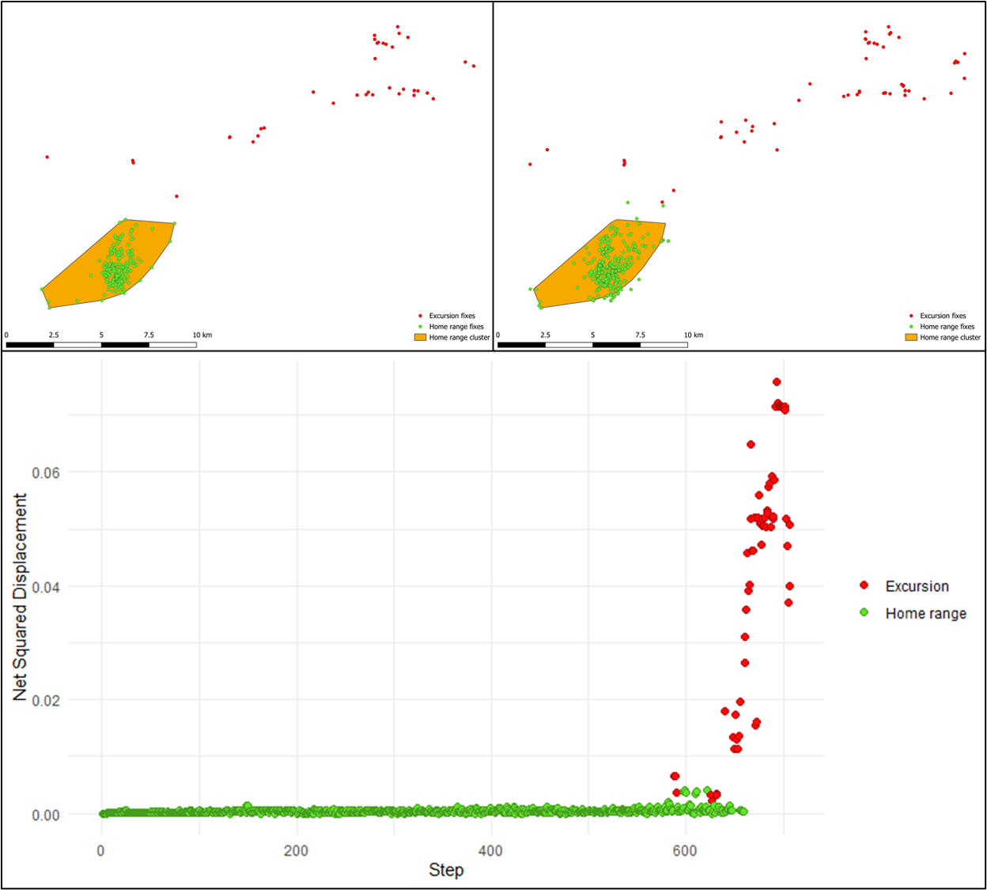

Figure S1. Movement classification for individual IT1 before (panel a) and after correction (panel b), with the corresponding Net Squared Displacement (NSD) used to confirm the final classification (panel c).
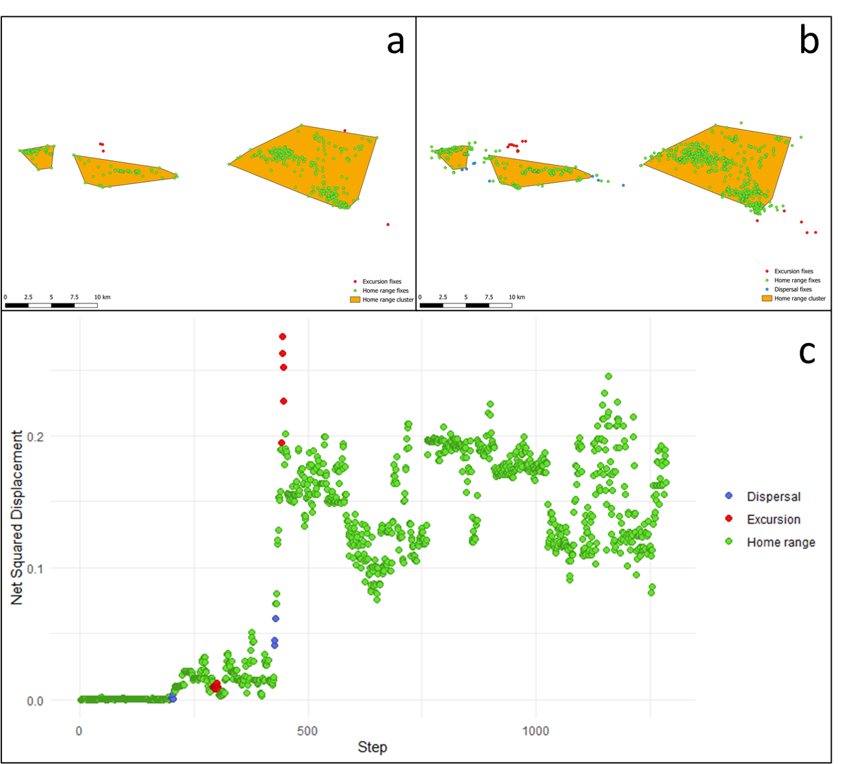
Figure S2. Movement classification for individual IT2 before (panel a) and after correction (panel b), with the corresponding Net Squared Displacement (NSD) used to confirm the final classification (panel c).

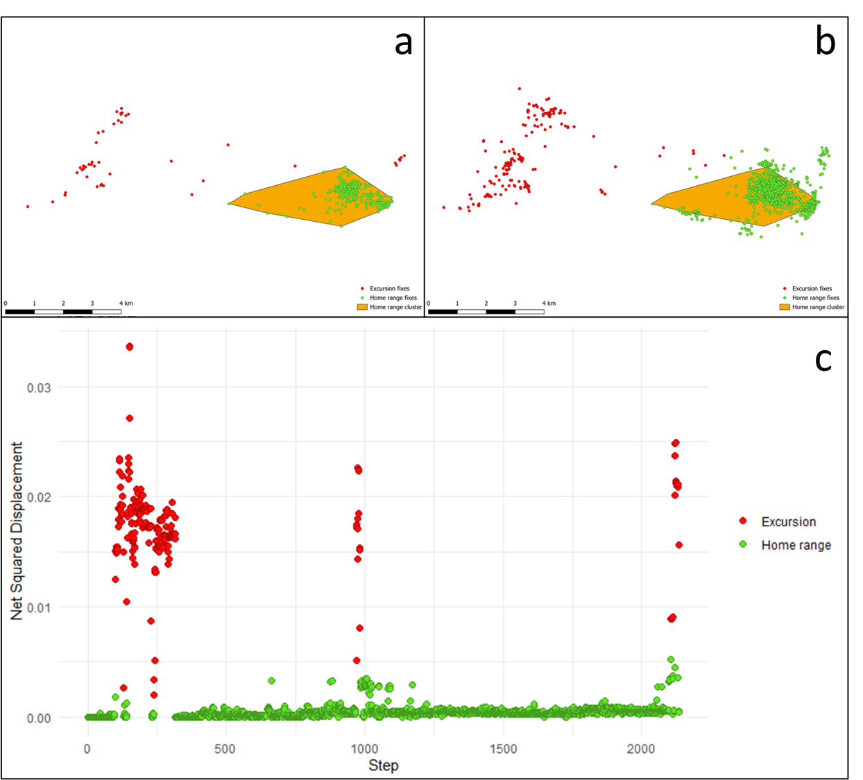
Figure S3. Movement classification for individual SL1 before (panel a) and after correction (panel b), with the corresponding Net Squared Displacement (NSD) used to confirm the final classification (panel c).

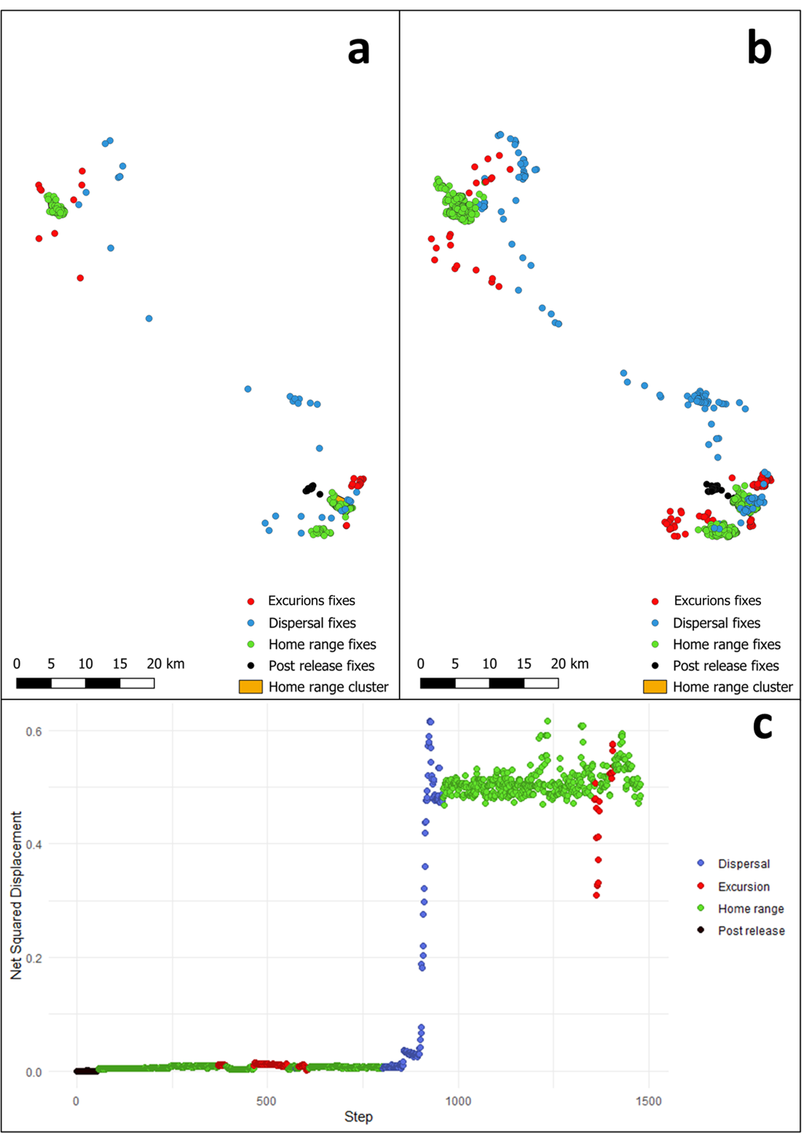
Figure S4. Movement classification for individual SL2 before (panel a) and after correction (panel b), with the corresponding Net Squared Displacement (NSD) used to confirm the final classification (panel c).
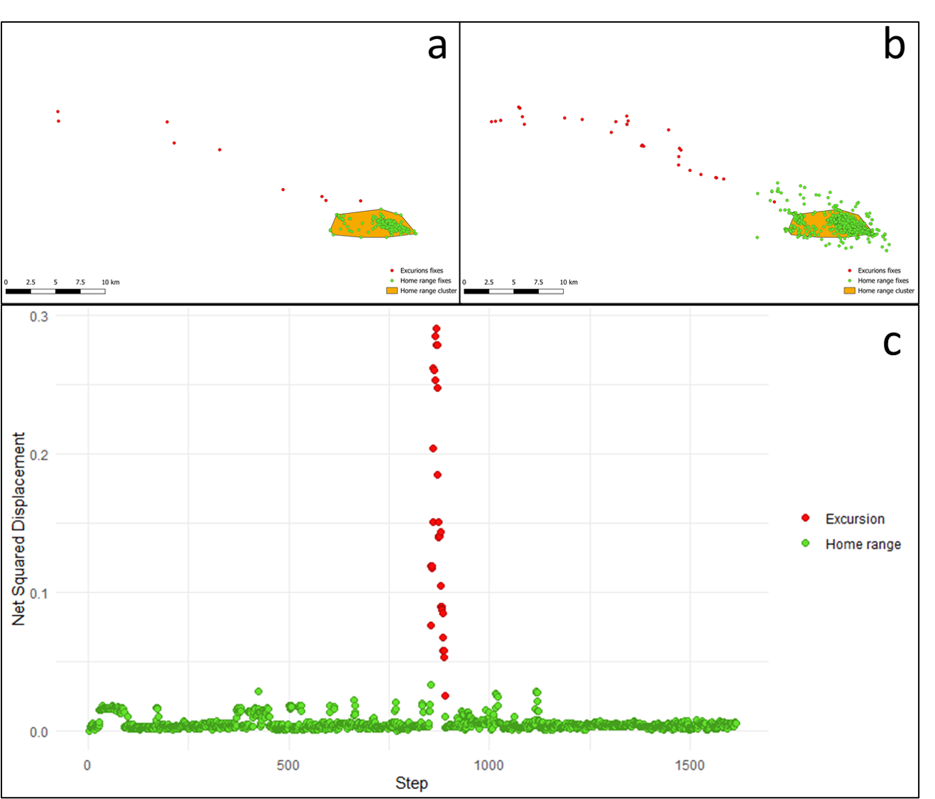
Figure S5. Movement classification for individual SL3 before (panel a) and after correction (panel b), with the corresponding Net Squared Displacement (NSD) used to confirm the final classification (panel c).

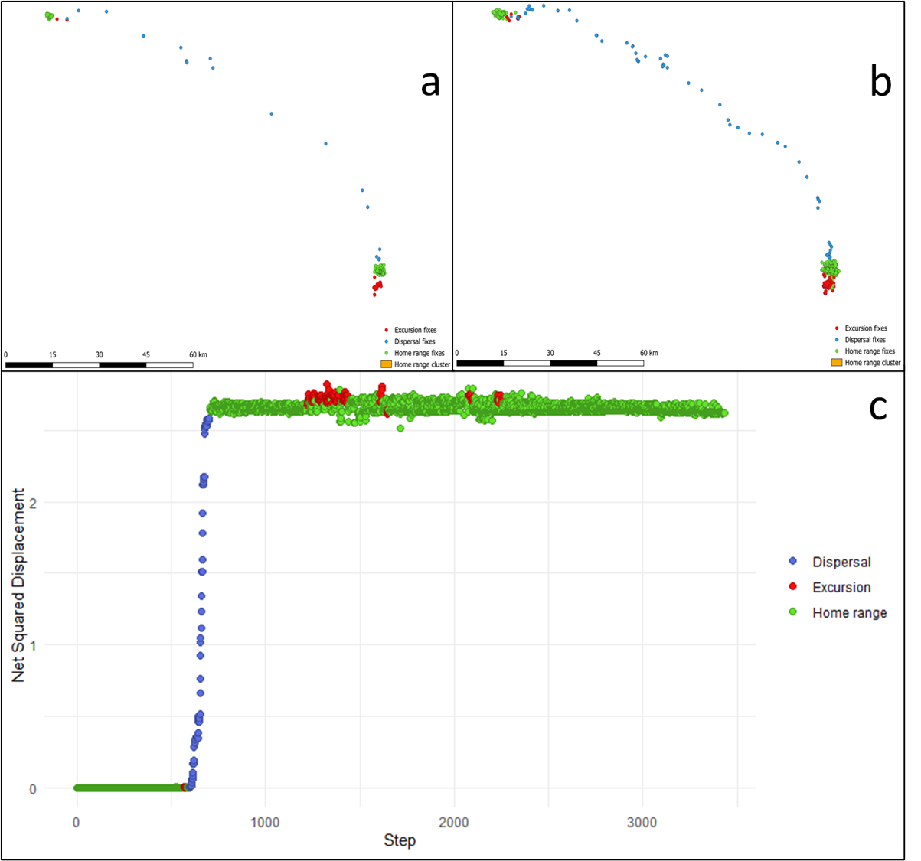
Figure S6. Movement classification for individual SL4 before (panel a) and after correction (panel b), with the corresponding Net Squared Displacement (NSD) used to confirm the final classification (panel c).

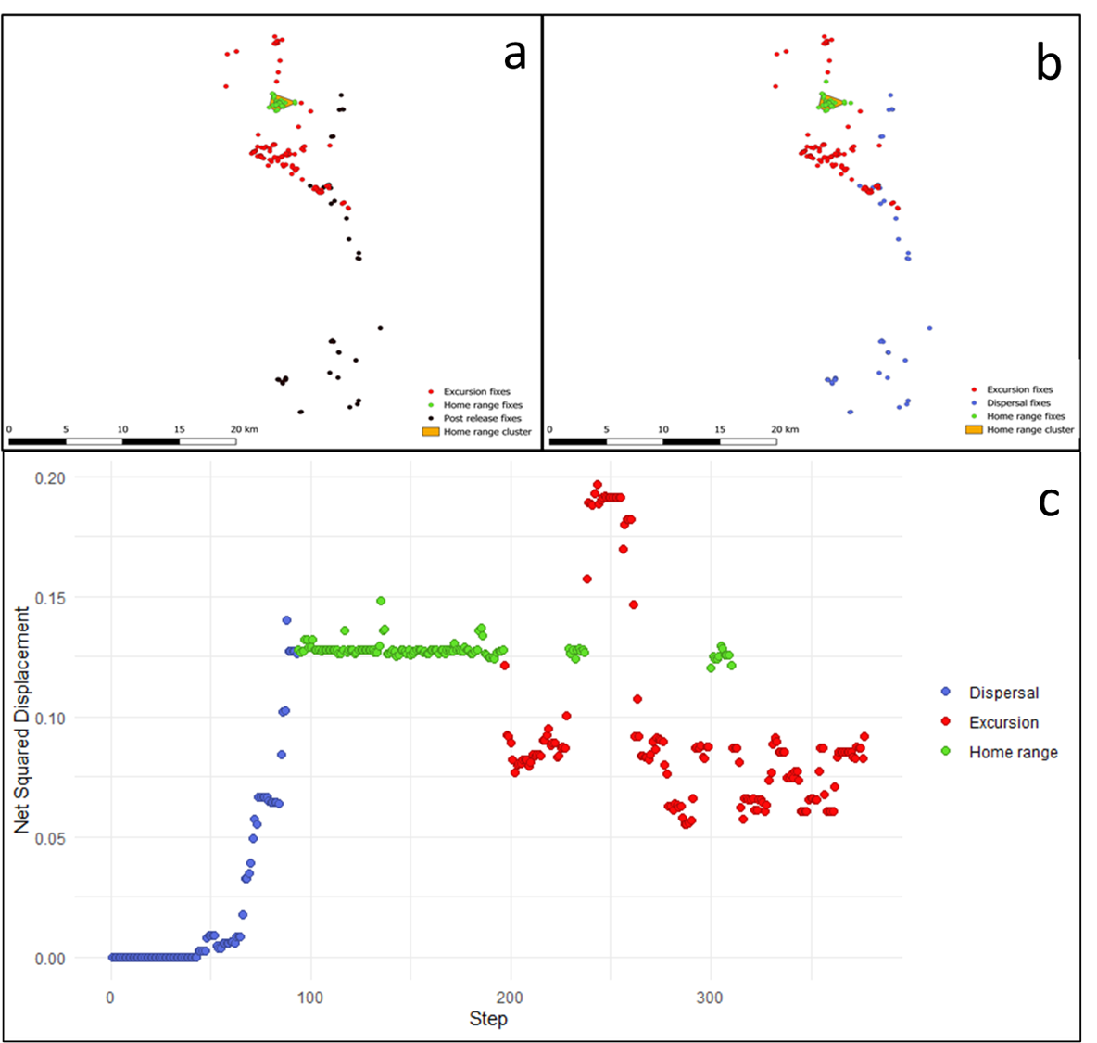
Figure S7. Movement classification for individual CR1 before (panel a) and after correction (panel b), with the corresponding Net Squared Displacement (NSD) used to confirm the final classification (panel c).

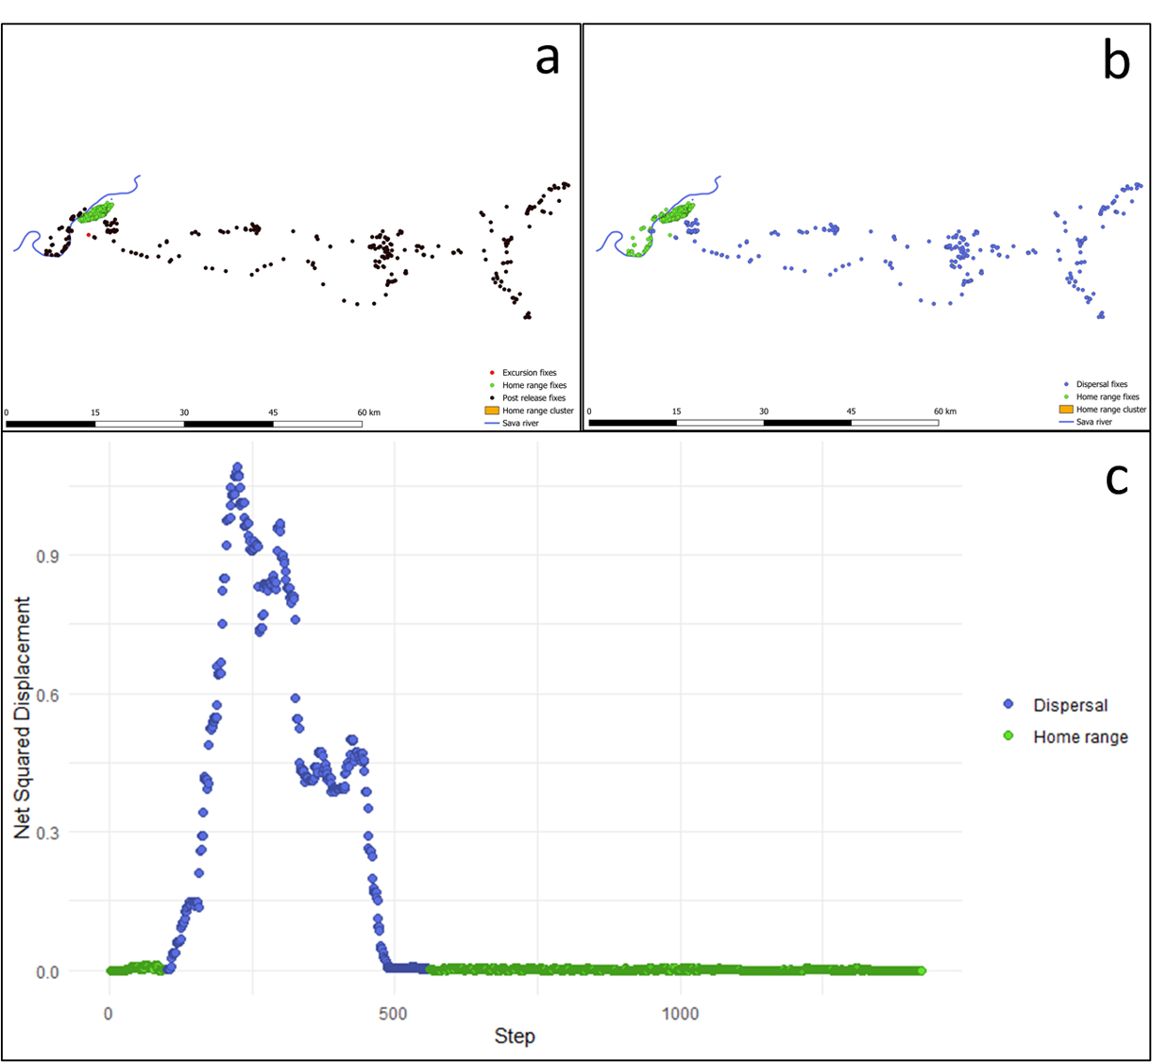
Figure S8. Movement classification for individual SR1 before (panel a) and after correction (panel b), with the corresponding Net Squared Displacement (NSD) used to confirm the final classification (panel c).

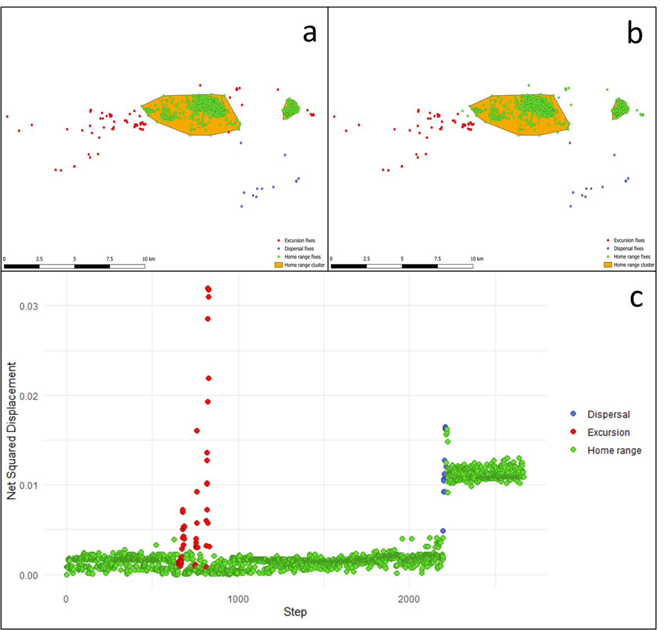
Figure S9. Movement classification for individual SR2 before (panel a) and after correction (panel b), with the corresponding Net Squared Displacement (NSD) used to confirm the final classification (panel c).

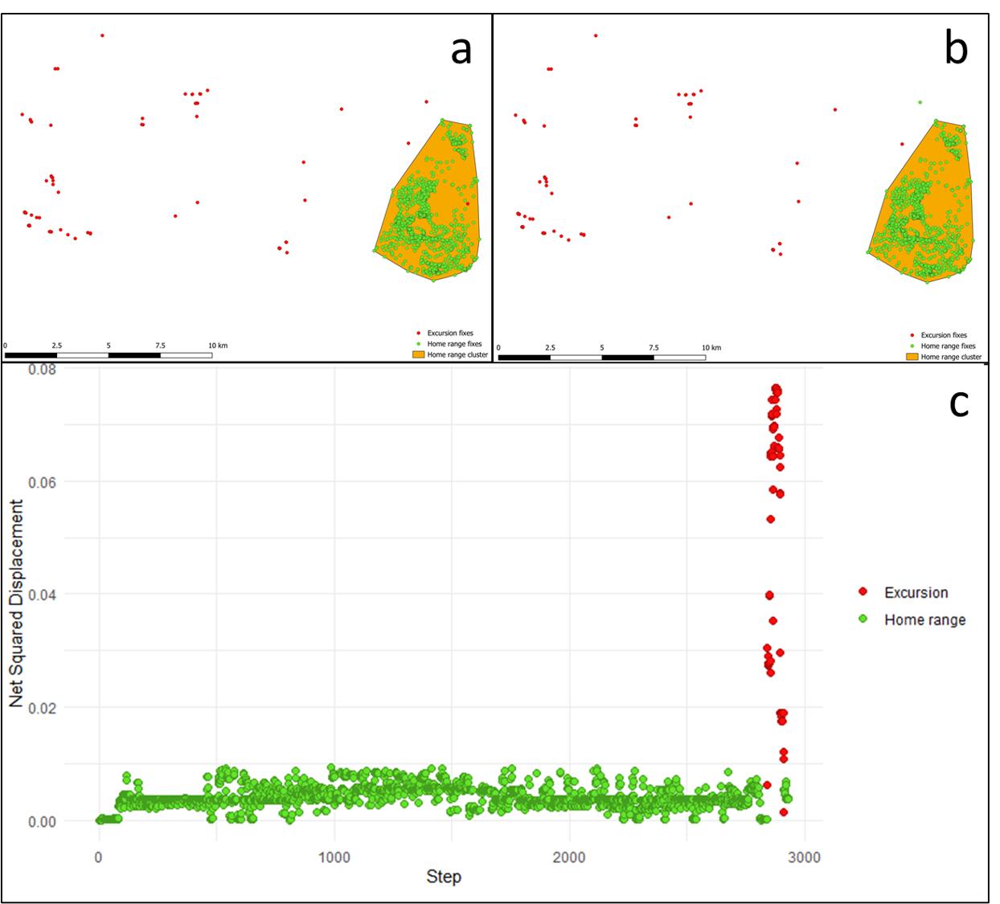
Figure S10. Movement classification for individual SR3 before (panel a) and after correction (panel b), with the corresponding Net Squared Displacement (NSD) used to confirm the final classification (panel c).

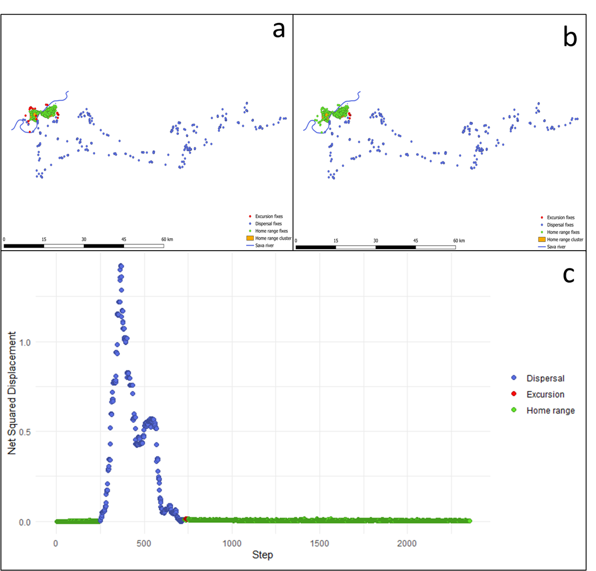
Figure S11. Movement classification for individual SR4 before (panel a) and after correction (panel b), with the corresponding Net Squared Displacement (NSD) used to confirm the final classification (panel c).

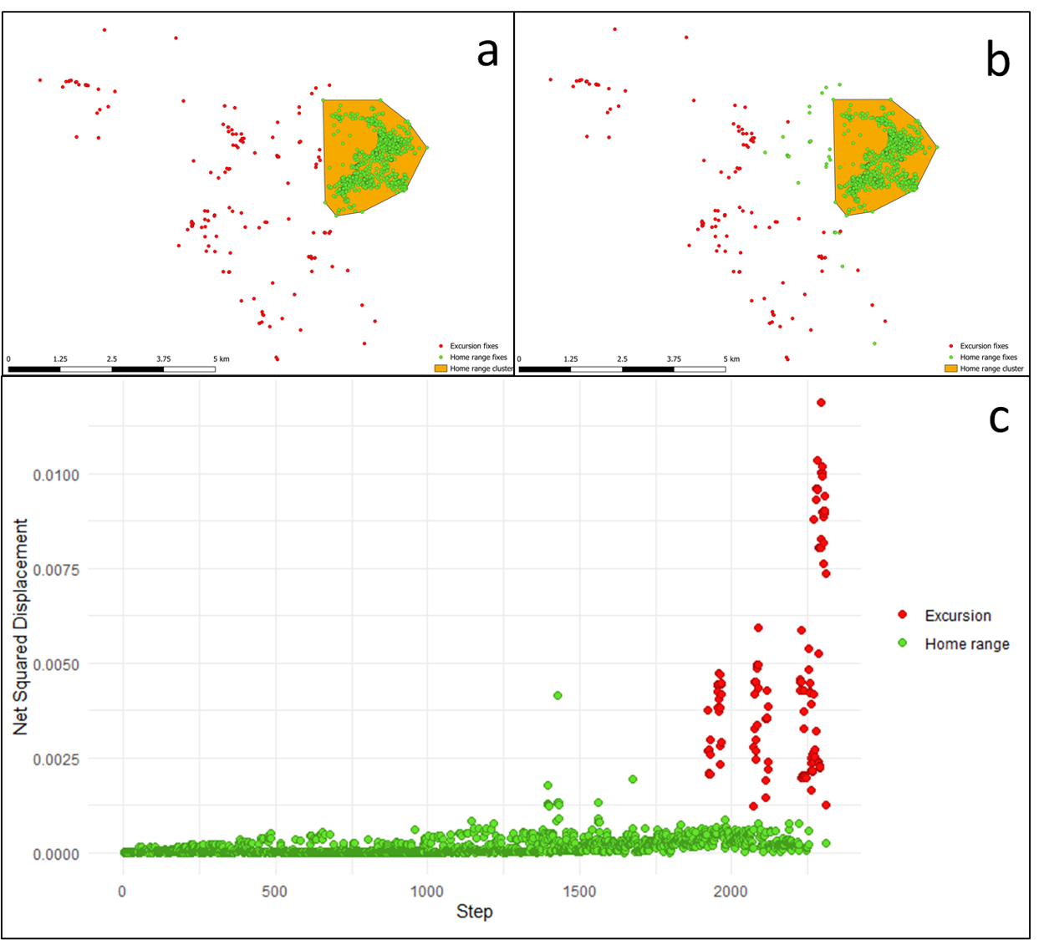
Figure S12. Movement classification for individual SR5 before (panel a) and after correction (panel b), with the corresponding Net Squared Displacement (NSD) used to confirm the final classification (panel c).

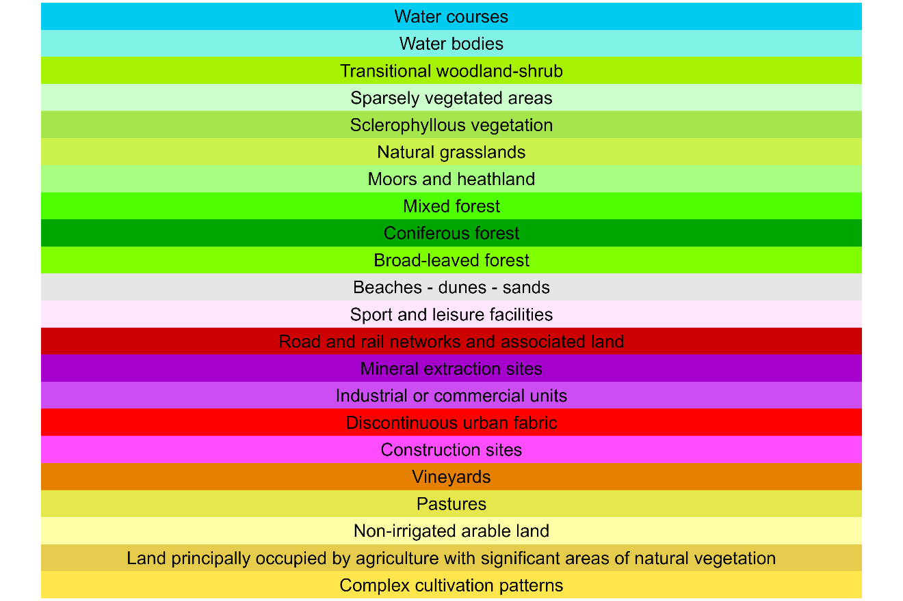
Figure S13. Color coded legend of Corine Land Cover (CLC) categories for Figures F14-F19

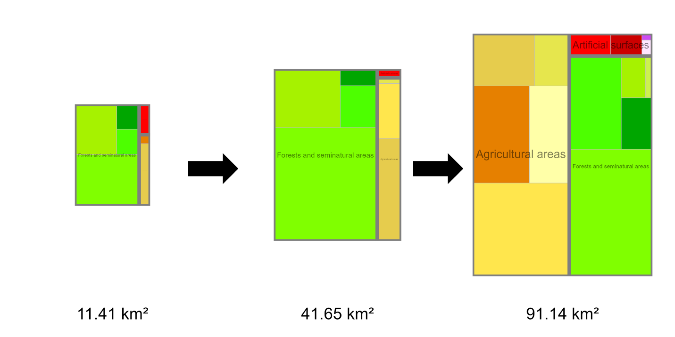
Figure S14. Treemap plots showing home range composition for each HR of IT2. Colors indicate individual CORINE Land Cover (CLC) categories, grouped by parent category. The size of each plot corresponds to the HR size, indicated in km² below each treemap. The color-coded legend is shown in Figure S13.
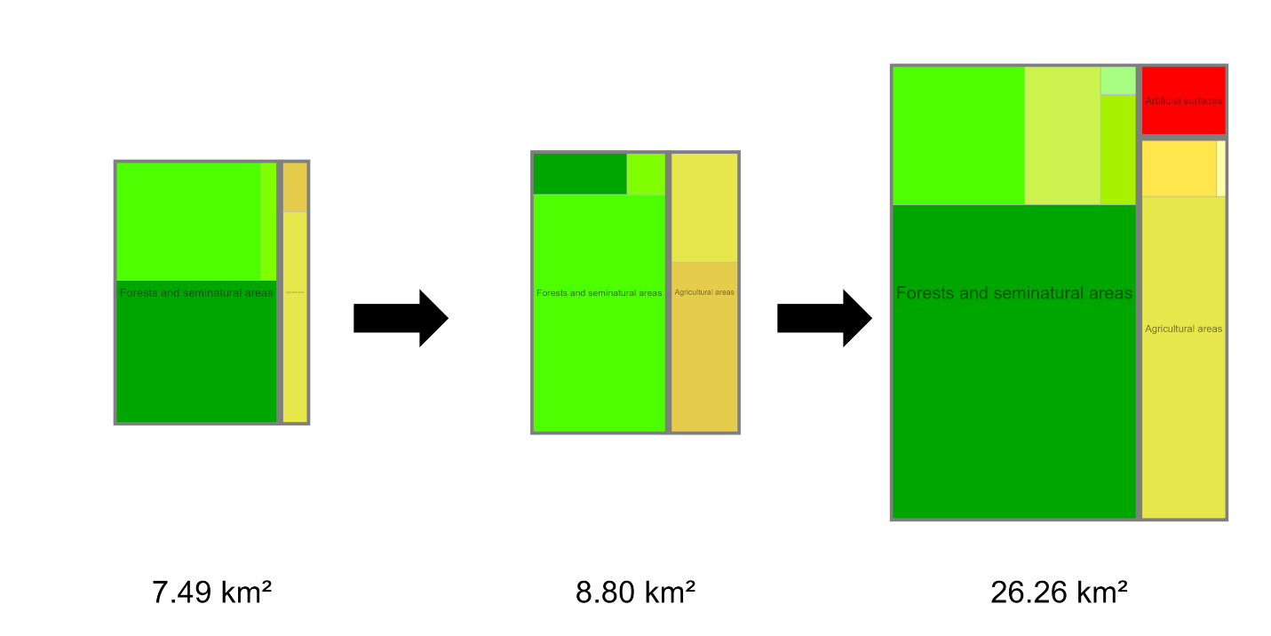
Figure S15. Treemap plots showing home range composition for each HR of SL2. Colors indicate individual CORINE Land Cover (CLC) categories, grouped by parent category. The size of each plot corresponds to the HR size, indicated in km² below each treemap. The color-coded legend is shown in Figure S13.

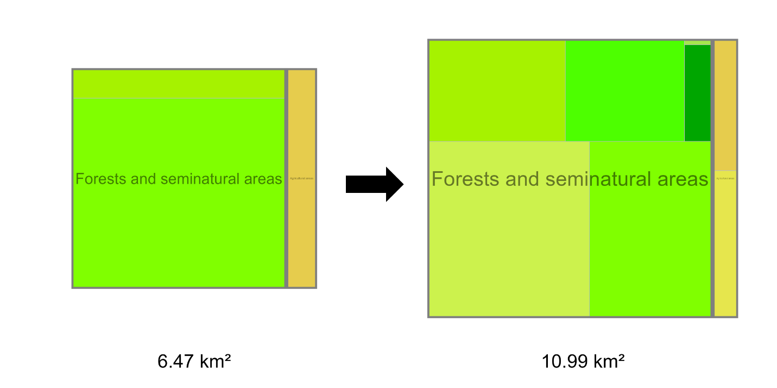
Figure S16. Treemap plots showing home range composition for each HR of SL4. Colors indicate individual CORINE Land Cover (CLC) categories, grouped by parent category. The size of each plot corresponds to the HR size, indicated in km² below each treemap. The color-coded legend is shown in Figure S13.

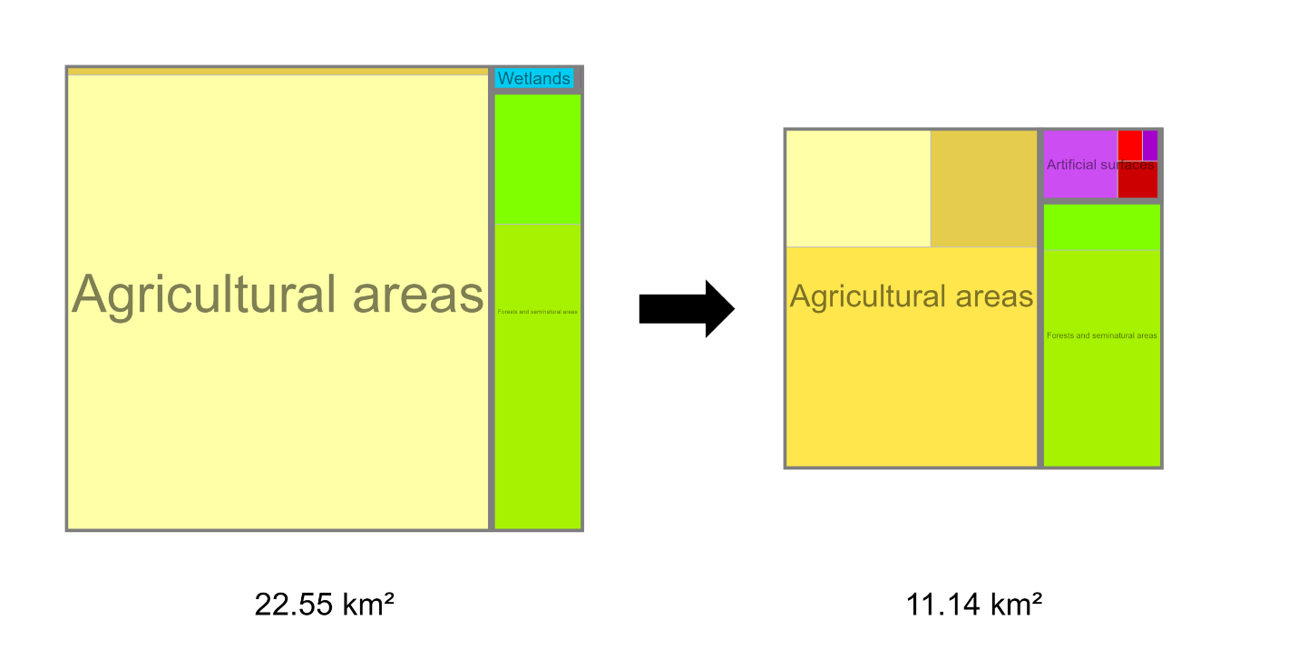
Figure S17. Treemap plots showing home range composition for each HR of SR1. Colors indicate individual CORINE Land Cover (CLC) categories, grouped by parent category. The size of each plot corresponds to the HR size, indicated in km² below each treemap. The color-coded legend is shown in Figure S13.

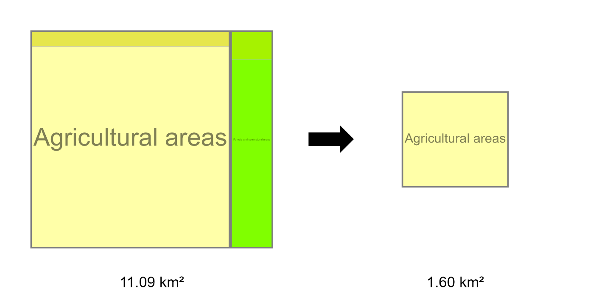
Figure S18. Treemap plots showing home range composition for each HR of SR2. Colors indicate individual CORINE Land Cover (CLC) categories, grouped by parent category. The size of each plot corresponds to the HR size, indicated in km² below each treemap. The color-coded legend is shown in Figure S13.

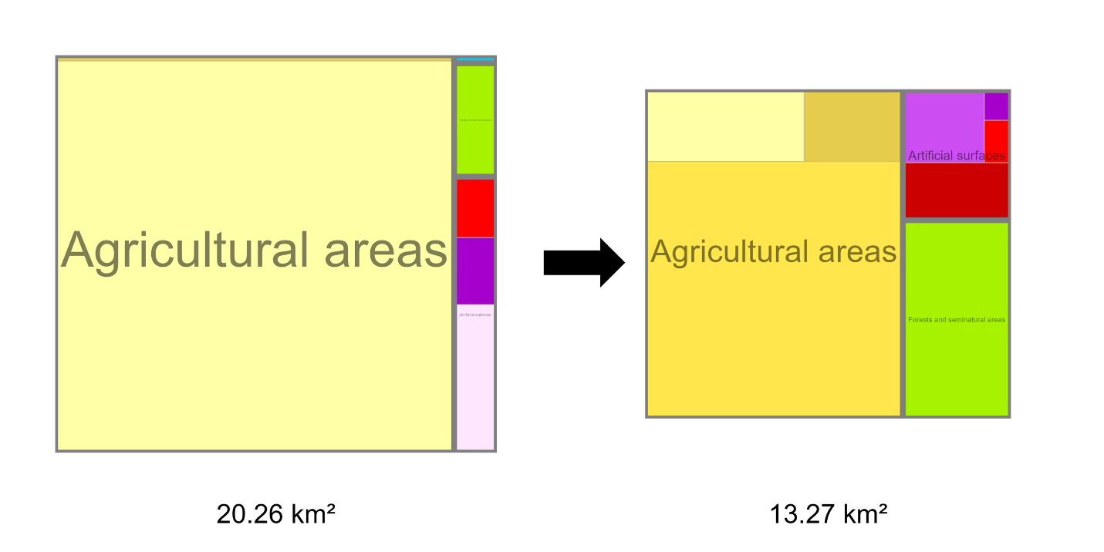
Figure S19. Treemap plots showing home range composition for each HR of SR4. Colors indicate individual CORINE Land Cover (CLC) categories, grouped by parent category. The size of each plot corresponds to the HR size, indicated in km² below each treemap. The color-coded legend is shown in Figure S13.

