Supplementary Information
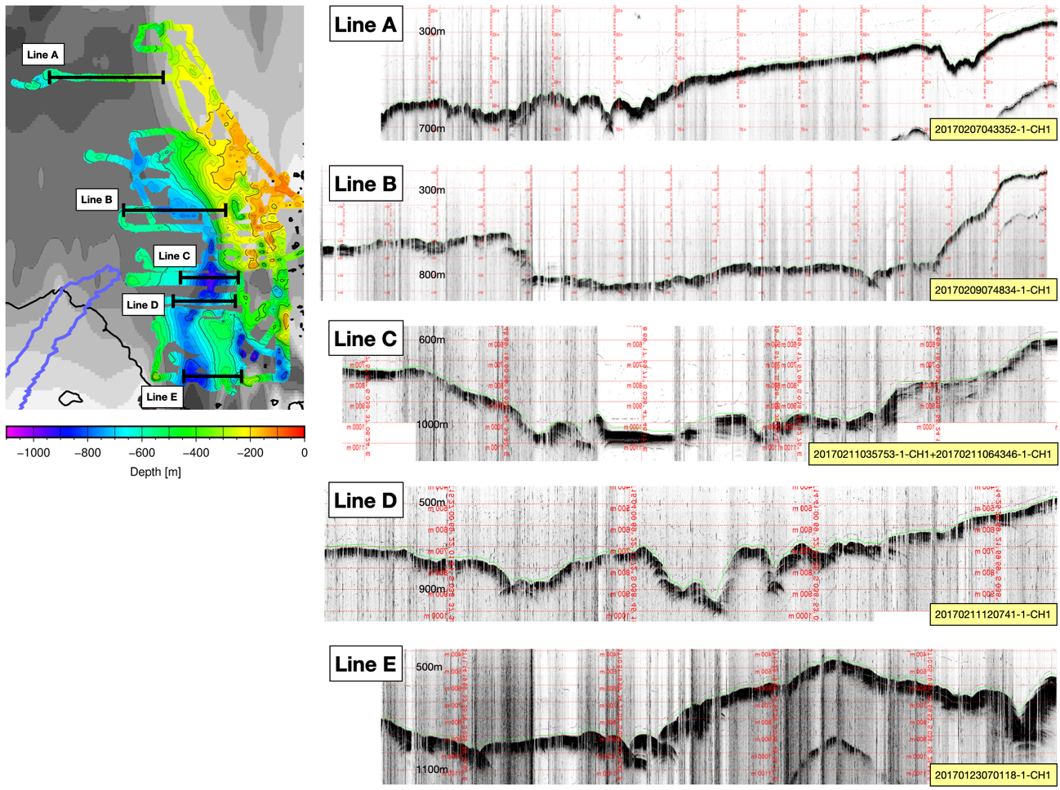
Supplementary Figure S1. Representative sub-bottom profiler records from Lützow-Holm Bay. Locations of Lines A–E are shown on the bathymetric map at left. Corresponding Bathy-2010 sub-bottom profiler sections are shown at right. Green lines indicate the interpreted seafloor reflector. Water depths are indicated for reference.

