Supplement

Unifying the records of individuals with multiple patids
As stated in the main body of the paper, the starting point was unifying the CPRD_MPSids. However, some CPRD_MPSIDs were linked to patids with differing years of birth (sometimes by several years). Examination of the records revealed they probably pertained to different individuals, so were removed from the linking process. Secondary care data was not available for all patids (so, for example, one subject may have a patid linked with a CPRD_MPSid and another which did not as it was not linked with a secondary care record). Therefore, similarities in codings of certain events and prescriptions were used, alongside registration periods and years of birth, as follows:
- Any patid who had exactly the same registration start and end dates and was born in the same year as another patid was found to have practically identical records when they were examined manually. These subjects were therefore labelled with a ‘same_registration’ identifier. This helped identify simple duplicated records.
- Any patid with the same year of birth as another patid was considered to relate to the same patient if the records matched at least two pieces of information from the following list: first date of a diabetes observation, a first glycaemic test (test result and date) and a first medication prescription. Though not all subjects had data available on diabetes diagnosis observations, glycaemic tests AND prescriptions, most had at least two. Matching on only one piece of information (for example two individuals prescribed metformin on the same day but lacking information on glycaemia and a formal diagnostic sign of diabetes) was not found to identify patids pertaining to the same patient specifically enough.
These three items of information (the CPRD_MPSid, the same registration identifier and the identifier elucidated from similarity in the clinical records) were used to create networks of patids and unify them under a new individual_id. The R coding process is described in detail in plain language, with a sample dataset and code chunks that can be played to see how the code identifies duplicate IDs, in the R markdown file available in the github repository (https://github.com/gabriellegoldet/GDM).

Discordant dates of death
Note linkage to ONS was only available for n= ~517,000 patids. The following steps were undertaken to assign a single date of death for individuals who had died.
- For individuals with a single patid, if there was discord between the ONS and CPRD dates of death, the ONS date of death was used as these are known to be more reliable.
- If only a CPRD date of death or an ONS date of death was present, this was determined to be the correct date of death for individuals with a single patid.
- If a patid was assigned two different ONS dates of death, the earliest date was selected UNLESS the dates were separated by more than 6 months. Examination of the primary care records showed that the earlier ONS date was often erroneous, with clear evidence of clinical events occurring after the earlier date of death. The later ONS date often aligned closely with the CPRD date of death. When there was discord between ONS dates of death and they were separated by more than 6 months, the CPRD date of death was used.
- For individuals with multiple patids with discordant dates of death between their ONS and CPRD date of death, the ONS date was selected. If, however, their patids included two different ONS dates of death, the same approach was used as point 3 above.
Any individual whose date of death preceded their registration was excluded as their records were felt to be unreliable (n = 667). In addition, any individual whose date of death was on the day of diabetes diagnosis or before it was excluded as this scenario suggests delayed GP recording of diabetes data.

Data cleaning of erroneous dates
There were 3761 patids with an erroneous first observation from the diabetes code list, i.e prior to their year of birth. Additionally, the n=26 patids with codings for diabetes within the first two years of life were examined manually, given that diabetes in infancy is so rare (1 in 89,000 live births, [13]).
In both sets of cases, if the diagnosis was type 2 diabetes, the date was assumed to be erroneous and the next earliest record of a medcodeid in the patids record was sought as the earliest diabetes diagnosis. If it was type 1 diabetes or the type of diabetes was uncertain, whether or not that first very early date of diagnosis was retained depended on whether there was other information on diabetes within the following years. If subsequent information on diabetes was separated by a number of years from the first early code, the date of the first early code was not retained and was instead replaced by the next available date. In addition, if the date was in the format “01-01-YYYY”, the date was assumed to be unreliable (similarly to the approach in MASTERMIND – ref 12 in main text) and the date was also replaced by the next available date. Where no next available date was found, the date was removed and not replaced.
A similar process for glycaemic test dates and medication prescriptions was undertaken. There were 398 patids with glycaemic tests and 817 patids with prescription issue dates that antedated birth. In these cases, the subsequent dates found were always reasonable and therefore those later glycaemic tests/prescriptions were carried forward in the process of defining the first date of diabetes diagnosis. Again, for patids without a subsequent prescription or glycaemic tests, those dated erroneously were simply removed and not replaced.
Lastly, one medocdeid on the diabetes code-list pertains to the XPERT program, which is an educational lifestyle programme for those with T2DM which was founded in the year 2000. For the 6 patids whose coding relating to the XPERT program was prior to 2000, the next earliest observation of diabetes was used.

Pregnancy and GDM codings
As alluded to in the main text (Formation of GDM cohort section), there is clear lack of data on historical pregnancies, and particularly on GDM coding. Figure A1 below shows density of GDM coding (orange) and pregnancy coding not related to GDM (grey) over the years. GDM codings are even more concentrated in the period post-1990 than other pregnancy codings, demonstrating reduced pregnancy coding prior to 1990.
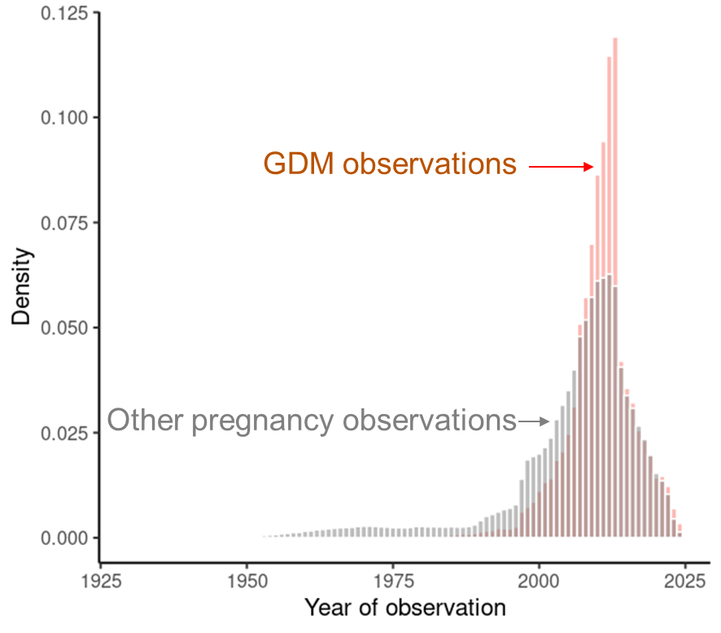
Figure A1: Density of GDM codings and pregnancy codings unrelated to GDM over the last 100 years.

