Supplementary Information

Protecting benzylic C–H bonds by deuteration doubles the operational lifetime of
deep blue Ir-phenylimidazole dopants in phosphorescent OLEDs

Hye Jin Bae¹, Jong Soo Kim¹, Alexander Yakubovich², Jinhoon Jeong^{4,5}, Sangho Park¹, Jun Chwae¹, Satoko Ishibe¹, Won-Joon Son³, Yongsik Jung¹, Sunghan Kim¹, Hyeonho Choi^{1,*}, and Mu-Hyun Baik^{4,5,*}
¹Samsung Advanced Institute of Technology (SAIT), Samsung Electronics Co., Ltd., 130 Samsung-ro, Suwon, 16678, Republic of Korea
²Samsung R&D Institute Russia (SRR), Samsung Electronics Co., Ltd., 12 Dvintsev Street, Moscow 127018, Russia
³Data and Information Technology (DIT) Center, Samsung Electronics Co., Ltd., Hwaseong, 18448, Republic of Korea
⁴Department of Chemistry, Korea Advanced Institute of Science and Technology (KAIST), Daejeon 34141, Republic of Korea
⁵Center for Catalytic Hydrocarbon Functionalizations, Institute for Basic Science (IBS), Daejeon 34141, Republic of Korea
E-mail: hono.choi@samsung.com; mbaik2805@kaist.ac.kr

Experimental procedure
The bis(1,5-cyclooctadiene)iridium(I) tetrafluoroborate was purchased from Colonial Metals Inc. The starting materials based phenylimidazole ligands 2-bromo-1-(4-(tert-butyl)-2,6-dimethylphenyl)-1H-imidazole, 2-bromo-1-(4-(tert-butyl)-2,6-dimethylphenyl)-1H-imidazole(d), 2-bromo-1-mesityl-1H-imidazole, 2-bromo-1-mesityl-1H-imidazole(d), 2-bromo-1-(2,6-diisopropylphenyl)-1H-imidazole, 2-bromo-1-(2,6-diisopropylphenyl)-1H-imidazole(d), 2-methyl-5-(4,4,5,5-tetramethyl-1,3,2-dioxaborolan-2-yl)benzonitrile, 2-methyl-5-(4,4,5,5-tetramethyl-1,3,2-dioxaborolan-2-yl)benzonitrile(d) were purchased from HANCHAM. All other Chemicals were purchased from Commercial sources (Sigma-Aldrich Co., Tokyo Chemical Industry Co.) and used without further purification. NMR spectra were recorded on a Bruker ASCEND 500 at 500 MHz for ¹H and ¹³C using deuterated solvent CD₂Cl₂. Elemental analyses were performed on a PE 2400 Series Ⅱ (PerkinElmer) by the Environmental Analysis Laboratory at Samsung Advanced Institute of Technology. The MLADI-TOF mass spectra were obtained using a Bruker Ultraflex III TOF/TOF 200 spectrometer. The Ultraviolet–Visible (UV-Vis) absorption spectra and phosphorescence PL spectra were recorded on a Varian model UV-Vis-NIR spectrophotometer 5000 and a HITACHI F7000 spectrometer. Thermogravimetric analysis (TGA) was done by a TA Discovery instrument under nitrogen at a heating rate of 10ºC min⁻¹. Emission lifetimes were measured on Fluo time 300. The cyclic voltammetry (CV) were performed in nitrogen-purged DMF with a three-electrode cell configuration composed a carbon working electrode, a platinum wire counter electrode, and a saturated Ag/AgCl as a reference electrode. Ferrocene was used as the standard reference. Purity & Mass of the dopants was examined by performing Liquid Chromatograph Mass Spectrometer-Ion Trap-Time of Flight (LCMS-IT-TOF) analyses. The LCMS-IT-TOF consisted of LC-30A Nexera SR system instrument (Shimadzu) connected to a hybrid mass spectrometer IT-TOF equipped with an electrospray ionization source. FT-IR spectra were measured on a Varian 670infrared spectrophotometer.

Synthesis
General procedure : synsthesis of tris(1-(4-(tert-butyl)-2,6-dimethylphenyl)-2-(3-cyanophenyl)-1H-imidazole)iridium(Ⅲ) (Ir1) as a representative.
3-(1-(4-(tert-butyl)-2, 6-dimethylphenyl)-1H-imidazol-2-yl)benzonitrile (Ir1L) (6.0 g, 18.21 mmol) and Ir(COD)₂BF₄ (2.27 g, 4.55 mmol) were added into NMP (1-methyl-2-pyrrolidinone) (60 mL) at room temperature under N₂. The reaction solution was stirred at 180 ºC for 4 hours. After cooling to room temperature, water was added to quench the reaction and the aqueous layer was extracted with CH₂Cl₂ (3 × 30 mL). The organic layer was dried over MgSO₄. The crude product was purified by column chromatography (eluent: dichloromethane: n-hexane = 9:1) to afford a yellow solid (1.7 g, 32%). ¹H NMR (500 MHz, CD₂Cl₂): δ (ppm) 7.33 (s, 3H), 7.32 (s, 3H), 6.93 (d, J = 1.4 Hz, 3H), 6.80, 6.81 (ABq, J_{AB} =7.3 Hz, 6H), 6.76 (d, J = 1.4 Hz, 3H), 6.25 (s, 3H), 2.10 (s, 9H), 1.85 (s, 9H), 1.40 (s, 27H); ¹³C NMR (126 MHz, CD₂Cl₂): 169.2, 154.9, 154.2, 138.1, 137.8, 135.9, 135.3, 133.2, 131.3, 126.8, 126.7, 126.5, 124.3, 121.8, 121.4, 102.6, 31.6, 18.2, 17.9; MALDI-TOF/MS: 1177.42 [(M + H)⁺]. Anal. Calcd. for C₆₆H₆₆IrN₉ : C, 67.32; H, 5.65; N, 10.71. Found : C, 66.8; H, 5.7; N, 10.8
Synthesis of tris(1-mesityl-2-(3-cyanophenyl)-1H-imidazole)iridium(Ⅲ) (Ir2). The compound was prepared in the same procedure as of Ir1 (1.5 g, 25%). ¹H NMR (500 MHz, CD₂Cl₂): δ (ppm) 7.13 (br. s, 3H), 7.12 (br. s, 3H), 6.87 (d, J = 1.5 Hz, 3H), 6.80, 6.82 (ABq, J_{AB} =7.6 Hz, 6H), 6.73 (d, J = 1.4 Hz, 3H), 6.40 (br. s, 3H), 2.43 (s, 9H), 2.05 (s, 9H), 1.81 (s, 9H); ¹³C NMR (126 MHz, CD₂Cl₂): 169.4, 154.7, 140.6, 138.2, 137.8, 136.2, 135.6, 133.2, 131.4, 130.4, 130.3, 126.5, 124.1, 122.1, 121.5, 102.5, 21.5, 17.9, 17.7; MALDI-TOF/MS: 1051.32 [(M + H)⁺]. Anal. Calcd. for C₄₅H₂₉N₅ : C, 65.12; H, 4.60; N, 11.99. Found : C, 65.1; H, 4.6; N, 12.2
Synthesis of tris(1-mesityl-2-(3-cyano-4-methylphenyl)-1H-imidazole)iridium(Ⅲ) (Ir3). The compound was prepared in the same procedure as of Ir1 (0.6 g, 18%). ¹H NMR (500 MHz, CD₂Cl₂): δ (ppm) 7.14 (s, 3H), 7.11 (s, 3H), 1 6.71 (d, J = 1.4 Hz, 3H), 6.66 (s, 3H), 6.36 (s, 3H), 2.43 (s, 9H), 2.17 (s, 9H), 2.08 (s, 9H), 1.80 (s, 9H); ¹³C NMR (126 MHz, CD₂Cl₂): 169.5, 154.9, 140.9, 140.7, 139.2, 136.1, 135.6, 135.5, 133.4, 130.3, 130.2, 126.5, 124.3, 121.5, 120.8, 103.1, 21.5, 20.5, 18.0, 17.6; MALDI-TOF/MS: 1093.41 [(M + H)⁺]. Anal. Calcd. for C₄₅H₂₉N₅ : C, 65.91; H, 4.98; N, 11.53. Found : C, 65.4; H, 4.9; N, 11.5
Synthesis of tris(1-(2,6-diisopropylphenyl)-2-(3-cyanophenyl)-1H-imidazole)iridium(Ⅲ) (Ir4). The compound was prepared in the same procedure as of Ir1 (1.1 g, 25%). ¹H NMR (500 MHz, CD₂Cl₂): δ (ppm) 7.63 (t, J = 7.6 Hz, 3H), 7.43 (dd, J = 7.8, 1.2 Hz, 3H), 7.41 (dd, J = 7.8, 1.2 Hz, 3H), 6.98 (d, J = 1.4 Hz, 3H), 6.81 (dd, J = 7.9, 1.8 Hz, 3H), 6.80 (d, J = 1.5 Hz, 3H), 6.75 (d, J = 7.9 Hz, 3H), 6.27 (d, J = 1.8 Hz, 3H), 2.60 (septet, J = 6.8 Hz, 3H), 2.16 (septet, J = 6.8 Hz, 3H), 1.23 (d, J = 6.9 Hz, 9H), 1.01 (d, J = 6.8 Hz, 9H), 0.95 (d, J = 6.8 Hz, 9H), 0.95 (d, J = 6.9 Hz, 9H); ¹³C NMR (126 MHz, CD₂Cl₂): 169.2, 156.1, 146.8, 146.2, 138.3, 137.5, 133.1, 131.6, 131.2, 126.2, 125.6, 125.3, 125.2, 123.5, 121.2, 102.2, 29.2, 28.8, 24.8, 24.6, 23.5, 23.4; MALDI-TOF/MS: 1177.42 [(M + H)⁺]. Anal. Calcd. for C₆₆H₆₆IrN₉ : C, 67.32; H, 5.65; N, 10.71. Found : C, 67.0; H, 5.6; N, 10.8
Synthesis of tris(1-(4-(tert-butyl)-2,6-dimethylphenyl)-2-(3-cyanophenyl)-1H-imidazole)iridium(Ⅲ)-d₂₄ (Ir1D). The compound was prepared in the same procedure as of Ir1 (1.3 g, 29%). ¹H NMR (500 MHz, CD₂Cl₂): δ (ppm) 7.35 (d, J = 2.3 Hz, 3H), 7.33 (d, J = 2.2 Hz, 3H), 6.95 (s, 0.6H), 6.82, 6.82 (ABq, J_{AB} =7.1 Hz, 6H), 6.78 (d, J = 1.4 Hz, 1H), 6.27 (s, 2.5H), 2.08-2.10 (m, 0.8H), 1.83-1.86 (m, 0.8H), 1.42 (s, 27H); ¹³C NMR (126 MHz, CD₂Cl₂): 169.2, 154.8, 154.8, 154.1, 138.1, 137.8, 137.7, 135.8, 135.7, 135.2, 135.2, 133.3, 131.2, 126.8, 126.7, 126.5, 126.4, 124.3, 121.9, 121.7, 121.4, 102.6, 102.5, 35.2, 31.6, 17.1-17.9 (m).; MALDI-TOF/MS: 1199.53 [(M + H)⁺].
Synthesis of tris(1-mesityl-2-(3-cyanophenyl)-1H-imidazole)iridium(Ⅲ)-d₃₃ (Ir2D). The compound was prepared in the same procedure as of Ir1 (1.7 g, 27%). ¹H NMR (500 MHz, CD₂Cl₂): δ (ppm) 7.13 (d, J = 1.9 Hz, 3H), 7.11 (d, J = 1.9 Hz, 3H), 6.88 (s, 0.7H), 6.81, 6.83 (ABq, J_{AB} =7.5 Hz, 6H), 6.73 (s, 0.8H), 6.40 (s, 2.6H), 2.40-2.43 (m, 1.2H), 2.03-2.06 (m, 1.1H), 1.78-1.81 (m, 1.1H); ¹³C NMR (126 MHz, CD₂Cl₂): 169.3, 154.7, 154.7, 140.8, 140.7, 138.2, 137.8, 136.0, 135.5, 135.5, 133.3, 131.4, 130.4, 130.3, 126.3, 124.1, 122.0, 121.5, 102.5, 20.6-21.2 (m), 16.8-17.6 (m); MALDI-TOF/MS: 1079.51 [(M + H)⁺]. Anal. Calcd. for C₄₅H₂₉N₅ : C, 84.48; H, 4.57; N, 10.95. Found : C, 84.4; H, 4.6; N, 11.0
Synthesis of tris(1-mesityl-2-(3-cyano-4-methylphenyl)-1H-imidazole)iridium(Ⅲ)-d₄₂ (Ir3D). The compound was prepared in the same procedure as of Ir1 (0.7 g, 26%). ¹H NMR (500 MHz, CD₂Cl₂): δ (ppm) 7.14 (d, J = 2 Hz, 3H), 7.11 (d, J = 2Hz, 3H), 6.83 (s, 0.6H), 6.71 (s, 0.8H), 6.6 (s, 3H), 6.36 (s, 2.2H), 2.38-2.42 (m, 0.7H), 2.13-2.15 (m, 0.9H), 2.03-2.05 (m, 0.7H), 1.78-1.80 (m, 0.7H); ¹³C NMR (126 MHz, CD₂Cl₂): 169.5, 154.9(, 154.9), 140.7, 140.6, 139.2, 136.0, 135.5, 135.4, 133.4, 130.2, 126.3, 124.2, 121.4, 120.9, 103.1(, 103.1), 20.6-21.0 (m), 19.5-20.1 (m), 16.6-17.4 (m); MALDI-TOF/MS: 1128.64 [(M + H)⁺].
Synthesis of tris(1-(2,6-diisopropylphenyl)-2-(3-cyanophenyl)-1H-imidazole)iridium(Ⅲ)-d₅₁ (Ir4D). The compound was prepared in the same procedure as of Ir1 (0.8 g, 22%). ¹H NMR (500 MHz, CD₂Cl₂): δ (ppm) 7.63 (t, J = 7.8 Hz, 0.8H), 7.4-7.42(br. d, 6H), 6.98 (s, 0.4H), 6.81 (dd, J = 7.9, 1.6 Hz, 3H), 6.80 (s, 1.3H), 6.76 (d, J = 7.9 Hz, 3H), 6.27 (d, J = 1.1 Hz, 2.9H), 2.57-2.63 (m, 0.5H), 2.13-2.19 (m, 0.5H), 1.19-1.24 (m, 4.7H), 0.97-1.02 (m, 4.7H), 0.90-0.95 (m, 9.2H); ¹³C NMR (126 MHz, CD₂Cl₂): 169.2, 156.1, 156.1, 146.8, 146.2, 138.3, 137.6, 133.1, 131.6, 131.2, 126.1, 125.6, 125.5, 125.3, 125.2, 125.2, 123.5, 123.3, 121.2, 102.2, 28.5-28.8 (m), 24.7, 24.0-24.6 (m), 22.7-23.4 (m); MALDI-TOF/MS: 1207.59 [(M + H)⁺].

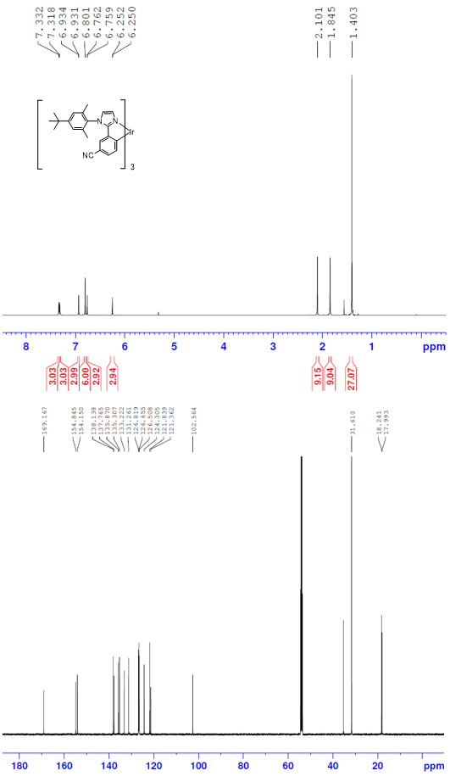
Figure S1. ¹H (top) and ¹³C (bottom) spectrum of Ir1.
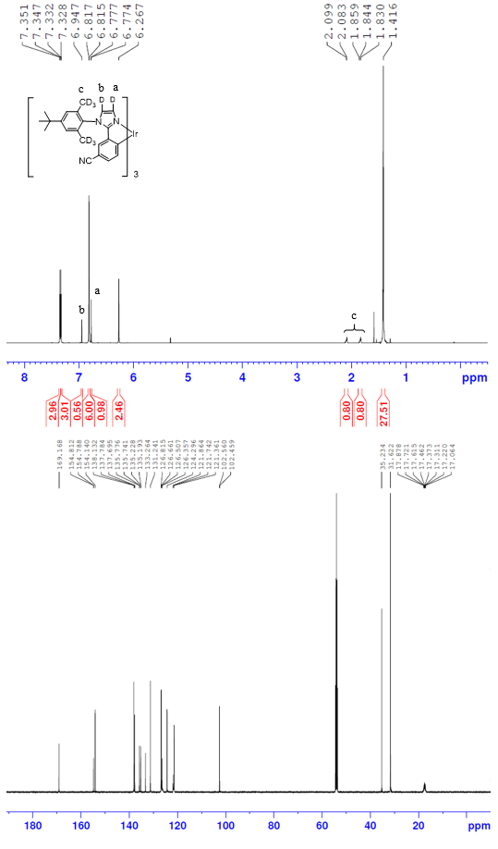
Figure S2. ¹H (top) and ¹³C (bottom) spectrum of Ir1D.
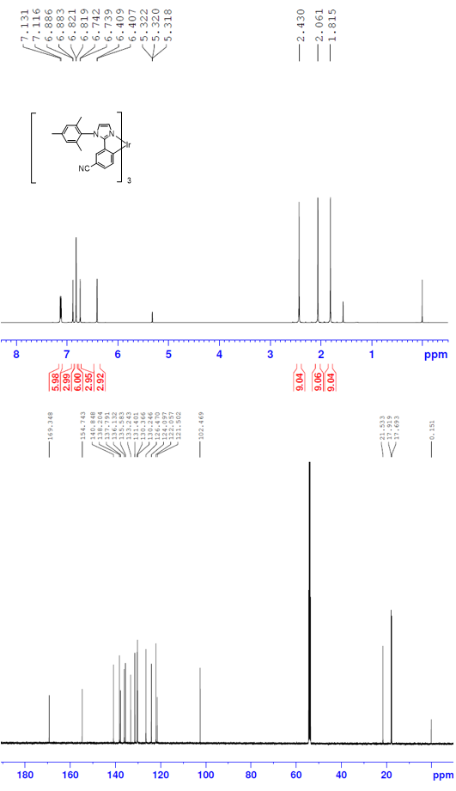
Figure S3. ¹H (top) and ¹³C (bottom) spectrum of Ir2.
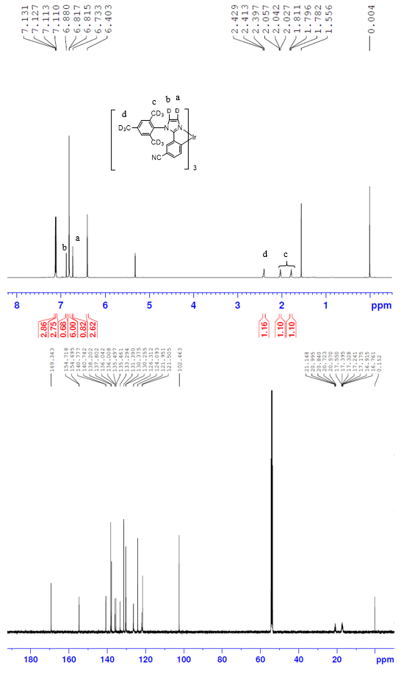
Figure S4. ¹H (top) and ¹³C (bottom) spectrum of Ir2D.
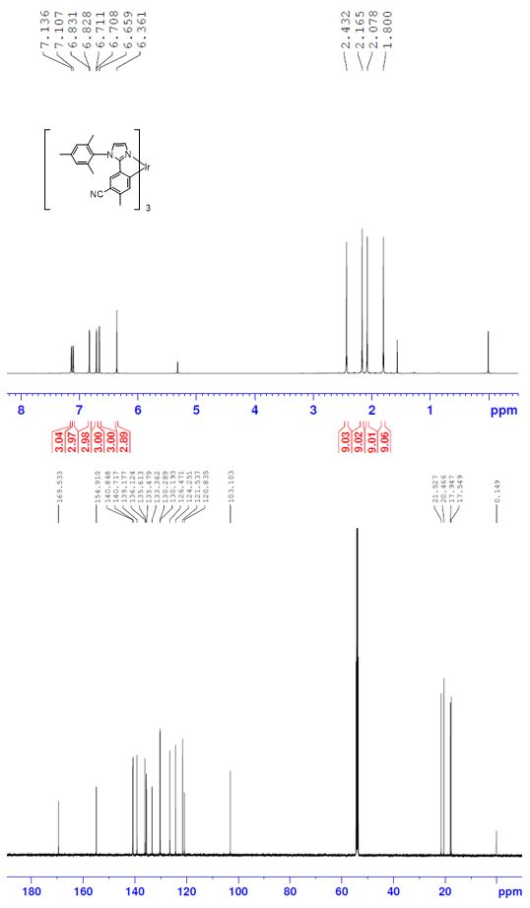
Figure S5. ¹H (top) and ¹³C (bottom) spectrum of Ir3.
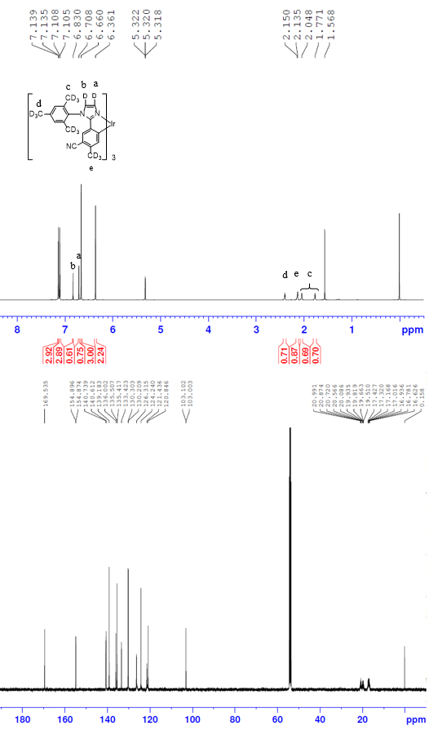
Figure S6. ¹H (top) and ¹³C (bottom) spectrum of Ir3D.
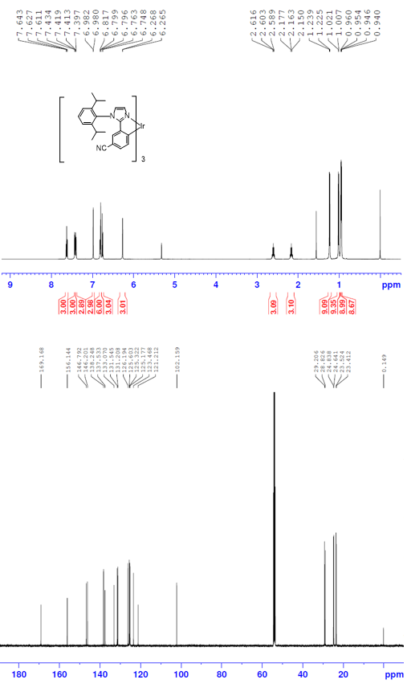
Figure S7. ¹H (top) and ¹³C (bottom) spectrum of Ir4.
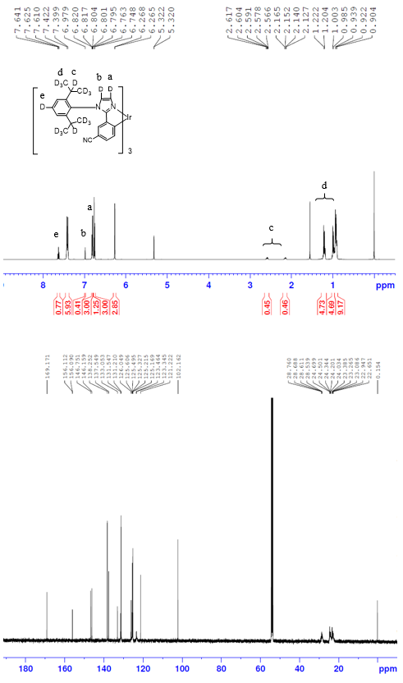
Figure S8. ¹H (top) and ¹³C (bottom) spectrum of Ir4D.
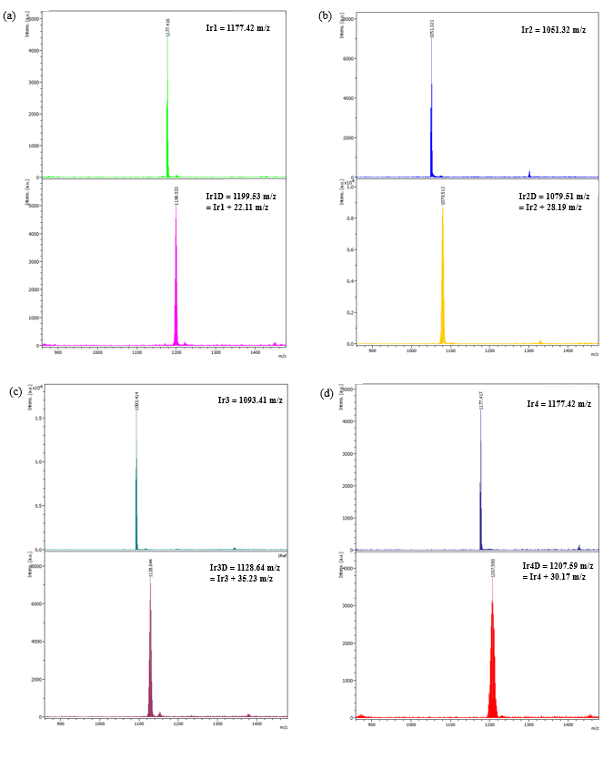
Figure S9. MALDI-TOF spectra (a) Ir1–1D, (b) Ir2–2D and (c) Ir3–3D, (d) Ir4–4D.
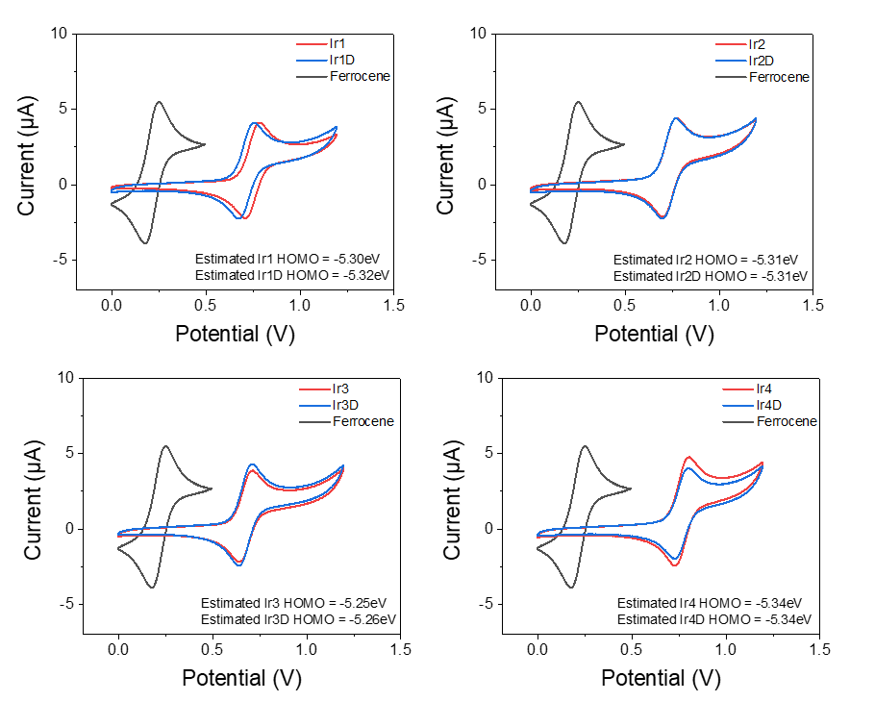
Figure S10. CV spectra of (a) Ir1–1D, (b) Ir2–2D and (c) Ir3–3D, (d) Ir4–4D.
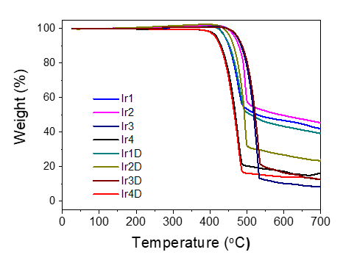
Figure S11. TGA curves of Ir1–4 and Ir1D–4D.
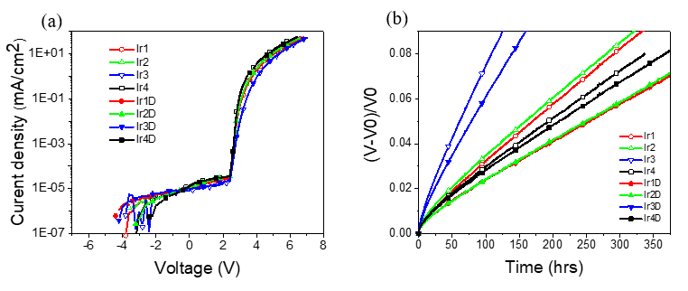
Figure S12. Device performances. (a) J-V-L characteristics, (b) normalized voltage rise during operational life time for each Ir complexes doped OLED devices.
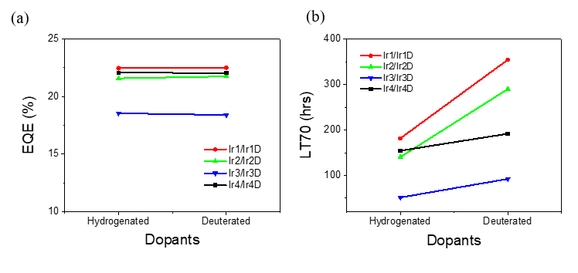
Figure S13. Summarized (a) EQE and (b) life time variation in accordance with substitution of deuteration for Ir complexes doped OLED devices.

Computational Details
The free energy in solution phase G(sol) has been calculated as follows:
G(sol) = G(gas) + G(solv)
G(gas) = H(gas) + TS(gas)
H(gas) = E(SCF) + ZPE
∆E(SCF) = ∑E(SCF) for products – ∑E(SCF) for reactants
∆G(sol) = ∑G(sol) for products – ∑G(sol) for reactants
G(gas) is the free energy in has phase; G(solv) is the free energy of solvation as computed using the continuum solvation model; H(gas) is the enthalpy in gas phase; T is the temperature; S(gas) is the entropy in gas phase; E(SCF) is the self-consistent field energy; ZPE is the zero-point energy.

Table S1. Computed energy components for DFT-optimized structures
 | E(SCF)/(eV)  cc-pVTZ(-f) /LACV3P | ZPE/(kcal/mol)  LACVP** | S(gas)/(cal/(mol*K))  LACVP** | G(solv)/(kcal/mol)  LACVP**
1 | –20343.446 | 162.80 | 74.03 | –25.22
2 | –85707.905 | 737.42 | 330.84 | –15.12
2(D) | –85707.905 | 735.38 | 331.53 | –15.12
TS | –106050.795 | 898.71 | 390.10 | –32.40
TS(D) | –106050.795 | 897.41 | 390.40 | –32.40
3 | –106050.885 | 900.66 | 395.22 | –32.93
Energies for BDE calculations in eV

H (doublet) | –13.634
Ir1_1 (doublet) | –85691.631
Ir1_2 (doublet) | –85691.577
Ir1_3 (doublet) | –85692.947
Ir1_4 (doublet) | –85692.037
Ir1_5 (doublet) | –85692.059
Ir1_6 (doublet) | –85692.087
Ir1_7 (doublet) | –85692.012
Ir1_8 (doublet) | –85692.410
Ir2_T₁ (triplet) | –76088.433
Ir2_1 (doublet) | –76072.213
Ir2_2 (doublet) | –76072.109
Ir2_3 (doublet) | –76073.472
Ir2_4 (doublet) | –76072.487
Ir2_5 (doublet) | –76072.524
Ir2_6 (doublet) | –76072.610
Ir2_7 (doublet) | –76072.541
Ir2_9 (doublet) | –76073.486
Ir3_T₁ (triplet) | –79295.384
Ir3_1 (doublet) | –79279.175
Ir3_2 (doublet) | –79279.103
Ir3_3 (doublet) | –79280.448
Ir3_4 (doublet) | –79279.491
Ir3_5 (doublet) | –79279.528
Ir3_6 (doublet) | –79279.590
Ir3_9 (doublet) | –79280.461
Ir3_10 (doublet) | –79280.499
Ir4_T₁ (triplet) | –85707.718
Ir4_1 (doublet) | –85691.466
Ir4_2 (doublet) | –85691.393
Ir4_3 (doublet) | –85692.857
Ir4_4 (doublet) | –85691.808
Ir4_5 (doublet) | –85691.785
Ir4_6 (doublet) | –85691.862
Ir4_7 (doublet) | –85691.813
Ir4_11 (doublet) | –85692.232
Ir4_12 (doublet) | –85691.801

In 2(D) and TS(D), a benzyl hydrogen participating in the H-abstraction reaction is deuterated.
In the denotation of “IrX_N” in BDE calculations, “X” means the number of iridium dopants and “N” indicates the position of the homolytically dissociated hydrogen. The “IrX_T₁” means that T₁ state of the IrX. (Ir1_T₁ is same with 2)

Figure S14. HOMO/LUMO of Ir1–4 in the ground state S₀. (Isodensity value = 0.03 a.u.)

Table S2. Results on calculated HOMO/LUMO energy levels in the ground S₀ state and spin density on Ir atom in T₁ state are summarized
 | Ir1 | Ir2 | Ir3 | Ir4
HOMO (eV) | –5.637 | –5.608 | –5.500 | –5.749
LUMO (eV) | –1.376 | –1.318 | –1.200 | –1.456
Spin density on Ir | 0.237 | 0.247 | 0.223 | 0.252

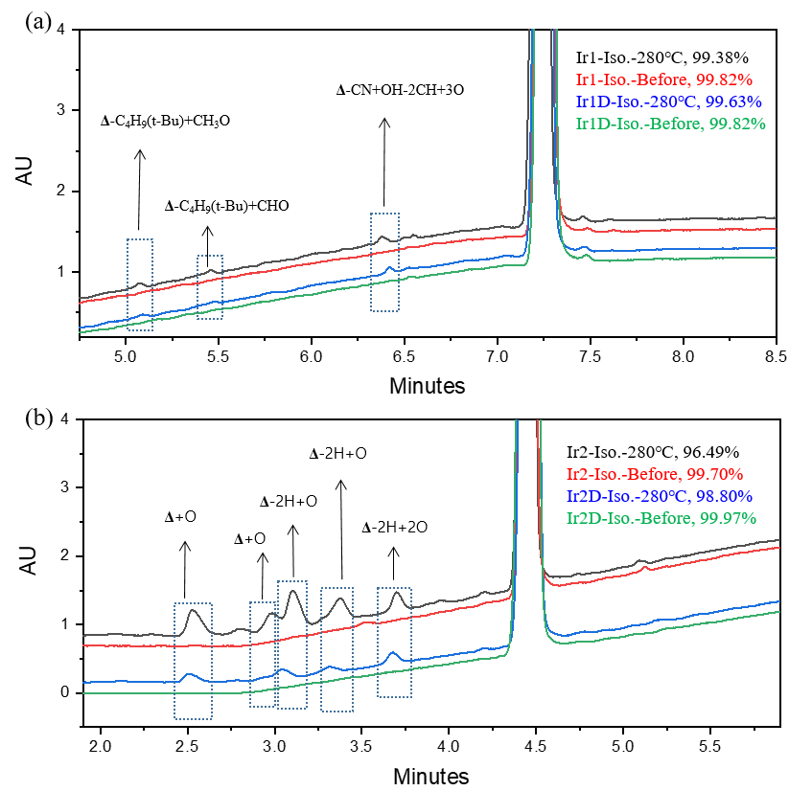
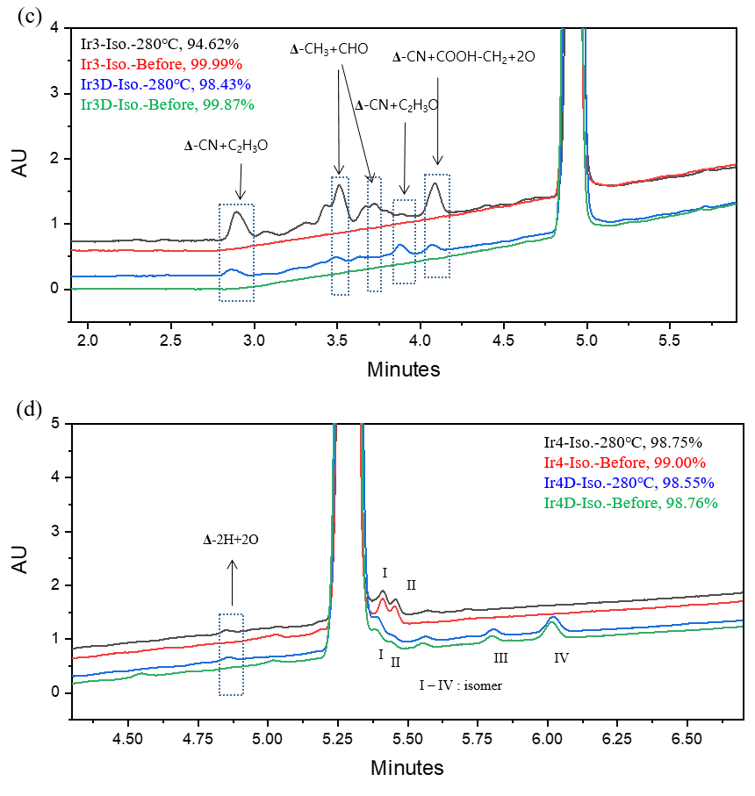
Figure S15. Before and after isothermal LC-MASS spectra and proposed mass assignments for the unknow impurities of (a) Ir1–1D, (b) Ir2–2D and (c) Ir3–3D, (d) Ir4–4D.
Figure S16 shows FT-IR spectra of hydrogenated Ir1–4 and deuterated Ir1D–4D. The C–H stretching frequencies of Ir1–4 observed at 2900~3100 cm^{–1}. The C–D stretching frequencies of Ir1D–4D is expected to be observed ~2200 cm^{–1}, but it is difficult to observe because it overlaps with the strong peak of C≡N stretching frequencies. It can be seen that the decrease of the C–H stretching frequencies of 2900~3100 cm^{–1} in the FT-IR spectra of Ir1D–4D is by deuterium. However, in the case of Ir1D, the decrease is small due to tert-butyl.

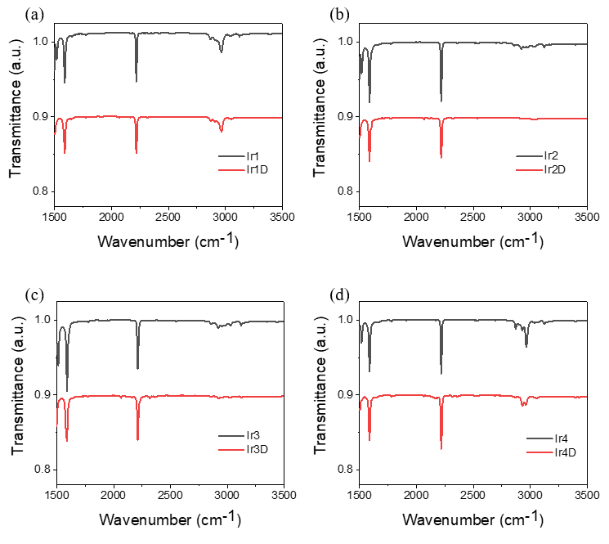
Figure S16. FT-IR spectra of (a) Ir1–1D, (b) Ir2–2D and (c) Ir3–3D, (d) Ir4–4D.
Table S3. Cartesian Coordinates of the Optimized Geometries.

===============================
1
===============================
N 0.356528401 -0.389536440 -1.581056595
C -0.668675959 -0.949274600 -0.833167493
C 1.071210623 0.498947352 -0.792095900
C -0.621479988 -0.412419051 0.475054681
C -1.588756561 -1.928524494 -1.213107347
C 0.498195767 0.519132197 0.501561344
C -1.538528919 -0.836333156 1.415877461
C 1.031366587 1.350123405 1.466490507
C 2.140494347 1.320366740 -1.155686975
C 2.129797697 2.156340361 1.122376919
H 0.613747299 1.391080976 2.467304945
C 2.668715000 2.144319296 -0.166363344
H 2.560772657 2.811313152 1.872912765
H 3.504695654 2.793314695 -0.403861821
H 2.534049511 1.325999260 -2.166089773
C -2.510235071 -2.335701466 -0.252892882
H -1.576356292 -2.364601135 -2.205845833
C -2.491088629 -1.797173977 1.035790086
H -3.247006416 -3.089770079 -0.507885456
H -3.219970226 -2.136705875 1.764822721
H -1.526674628 -0.447126925 2.428846598
C 0.629726768 -0.679009080 -2.933946133
C 1.930548668 -1.026706457 -3.313785315
C -0.406485140 -0.610811532 -3.871703386
C 2.188075542 -1.310631633 -4.647626877
C -0.129231930 -0.891337514 -5.202200413
C 1.163277268 -1.242144585 -5.591007233
H 2.710818768 -1.108828425 -2.563815594
H -1.399450779 -0.302467853 -3.560292482
H 3.188973188 -1.600581765 -4.950587273
H -0.920823932 -0.821835458 -5.941245079
H 1.372754931 -1.462651730 -6.633022308

===============================
2
===============================
N 0.382426322 1.730975151 0.083303362
C 1.245456696 1.366599798 -0.903022826
C -0.834913611 1.141653657 -0.186380833
C -0.673157215 0.429720998 -1.342504978
N 0.614191532 0.576922894 -1.767126679
H -1.387192965 -0.161848232 -1.895321012
H -1.683547497 1.292811155 0.462707311
C 2.630158663 1.722813129 -1.159859776
C 3.110867739 1.247260213 -2.416969299
C 3.440290213 2.450688839 -0.291518092
C 4.446203232 1.537948728 -2.738697767
C 4.760928631 2.725360870 -0.656235099
C 5.262277126 2.262719393 -1.882075548
H 3.071633577 2.811905861 0.661387086
H 4.837284565 1.207725763 -3.697125196
H 6.289891243 2.485965014 -2.155670643
C 5.572411537 3.487922430 0.234531403
N 6.203833103 4.115416050 0.982130408
C 0.649061441 2.664237022 1.129218817
C 0.537304163 4.031002045 0.843138993
C 1.103466511 2.192346573 2.360157490
C 0.934418201 4.927399635 1.829145193
C 1.490143299 3.134057045 3.316535711
C 1.438693047 4.506260395 3.065757990
H 0.875670791 5.989755630 1.606338978
H 1.870161057 2.767768145 4.264626980
N 4.082390785 -3.224612236 -3.397081614
C 3.555623293 -2.027040243 -3.878609419
C 3.481399298 -3.483652592 -2.185261488
N 2.619292974 -1.580114841 -2.957756996
C 2.591960430 -2.453613520 -1.939552188
H 3.723814011 -4.366947174 -1.614498496
H 1.950098276 -2.307460785 -1.082579255
C 3.824515820 -1.262246728 -4.993485928
C 3.013142347 -0.007733144 -5.077074051
C 4.761624813 -1.570016980 -6.038736343
C 3.172823668 0.785413802 -6.205718994
C 4.851968765 -0.734139502 -7.121045589
H 5.394727230 -2.446995258 -5.985911369
C 4.055539131 0.458037853 -7.240204811
H 2.598702908 1.705300689 -6.281453133
H 4.171967983 1.090515733 -8.113182068
N 6.526322842 -1.348067999 -8.998061180
C 5.776085854 -1.067607164 -8.155143738
C 6.352540493 -3.944290400 -3.857202530
C 4.984726906 -4.051060200 -4.118529320
C 4.489868164 -4.833796024 -5.170836926
C 7.235927105 -4.613271236 -4.706882477
C 5.408745766 -5.480107307 -5.990216255
C 6.791309357 -5.359654427 -5.800007343
H 8.299304962 -4.500027657 -4.522196293
H 5.029433727 -6.060792446 -6.827375412
Ir 1.779985070 0.247550741 -3.537452221
C -0.396883965 0.284430563 -5.469264984
N -1.204455018 -0.342764437 -6.366117954
C -1.069874883 -1.702538133 -6.169927597
N 0.223626196 -0.626621783 -4.724359035
C -0.177966326 -1.860538125 -5.145759106
H -1.613003016 -2.409362555 -6.778090477
H 0.202465221 -2.764155626 -4.693566799
C 0.938287973 1.912115932 -4.307790279
C -0.113377087 1.691204548 -5.244799614
C -0.793154478 2.743412971 -5.852689266
C 1.257051468 3.248566389 -4.019842625
C -0.437000543 4.057558060 -5.541724205
H -1.590775490 2.569935560 -6.565590858
C 0.590134382 4.307443619 -4.620412827
H 2.066631556 3.461164474 -3.327205181
H 0.862210631 5.334377289 -4.391679764
C -1.129299641 5.125840187 -6.184889793
N -1.706260085 5.977371693 -6.726367474
C -1.893941164 0.284268439 -7.448314190
C -1.160892963 0.605140924 -8.593731880
C -3.238208771 0.642755687 -7.297362804
C -1.801699042 1.342530727 -9.591697693
C -3.830470324 1.374145746 -8.322524071
C -3.126637220 1.761548042 -9.470959663
H -1.224006295 1.612232447 -10.469798088
H -4.867172718 1.677732587 -8.200149536
C -5.055202007 1.934579492 -11.063625336
C -3.811284065 2.650441647 -10.512215614
C -4.231837749 3.966126680 -9.832551003
C -2.887532473 2.987922192 -11.686231613
H -5.563915253 2.572610617 -11.795164108
H -4.781305790 0.997821569 -11.560792923
H -5.774791241 1.698114753 -10.273671150
H -4.701699257 4.634485722 -10.563179016
H -4.953655243 3.795301914 -9.027629852
H -3.369339228 4.483981133 -9.399869919
H -1.996806860 3.533898592 -11.357748032
H -2.566127539 2.089221478 -12.224305153
H -3.420166492 3.626159191 -12.398819923
C 1.955088973 5.549930573 4.057752132
C 0.814428329 6.508205414 4.436066151
C 2.496491909 4.912178040 5.339717388
C 3.096674919 6.338856697 3.390422583
H -0.006078423 5.968665123 4.921309948
H 1.178763866 7.272376060 5.131824493
H 0.406142116 7.024001122 3.561451197
H 2.853259087 5.695906162 6.015851021
H 1.724167228 4.344354153 5.870554924
H 3.340887070 4.245373726 5.135000706
H 3.506176472 7.075222969 4.091376305
H 3.909473419 5.674318790 3.078458071
H 2.752500772 6.881019592 2.504148483
C 7.746129036 -5.994100571 -6.812350273
C 7.451496601 -5.405279160 -8.204054832
C 7.530487537 -7.515699387 -6.837197781
C 9.214489937 -5.717124462 -6.476281643
H 7.570001125 -4.316586018 -8.210407257
H 8.139636040 -5.828086376 -8.944959641
H 6.432200909 -5.628739357 -8.534049988
H 6.502710819 -7.777105331 -7.107913017
H 8.196662903 -7.979607105 -7.573388100
H 7.743556023 -7.957937717 -5.858027935
H 9.495387077 -6.129708290 -5.500935078
H 9.857382774 -6.183539391 -7.229843616
H 9.433191299 -4.643908024 -6.475710392
C -3.983657360 0.300903589 -6.038566113
H -5.014808655 0.659550667 -6.084817886
H -4.003363609 -0.779886544 -5.861407757
H -3.504108429 0.758664846 -5.165248871
C 0.284359515 0.215950802 -8.716929436
H 0.903648496 0.746019304 -7.984531403
H 0.432251513 -0.853048563 -8.530422211
H 0.668198466 0.446869582 -9.713387489
C 3.014647961 -4.889290810 -5.446552277
H 2.783886671 -5.650699139 -6.195648670
H 2.445003510 -5.112919807 -4.538188457
H 2.656216383 -3.922275543 -5.821998119
C 6.847455502 -3.059338570 -2.748518229
H 6.460085392 -3.373774290 -1.773269057
H 7.939035892 -3.065185308 -2.699477673
H 6.516523361 -2.025022507 -2.899959803
C 1.243405342 0.717528343 2.609097004
H 1.577733517 0.523025692 3.630904913
H 0.297802359 0.188397765 2.449851274
H 1.975893021 0.276095122 1.922667265
C 0.067870073 4.496396065 -0.505461872
H 0.777518630 4.210677147 -1.290449142
H -0.892922401 4.045992851 -0.776954889
H -0.043879937 5.583070755 -0.527979732

===============================
TS
===============================
N -0.085820697 1.772907257 0.318870783
C 0.753162563 1.305253148 -0.642168164
C -1.308073044 1.166121244 0.140848085
C -1.176903725 0.336562097 -0.940203786
N 0.102780998 0.427083760 -1.403340816
H -1.907048941 -0.302765906 -1.413000584
H -2.139597893 1.382491469 0.793951273
C 2.116906643 1.664627433 -0.990006089
C 2.574334145 1.053690791 -2.194538593
C 2.937001705 2.520784378 -0.256398261
C 3.880757570 1.344945788 -2.616600752
C 4.230607033 2.783443451 -0.710516989
C 4.702133179 2.194941759 -1.892329216
H 2.600037575 2.988934994 0.659654140
H 4.248076439 0.913838565 -3.542448759
H 5.707958698 2.418606758 -2.235837936
C 5.059516907 3.661847830 0.048263408
N 5.719358921 4.376928806 0.682570577
C 0.288599074 2.685810089 1.351995587
C 0.158453748 4.060492039 1.117234230
C 0.924655497 2.177124023 2.484559774
C 0.729507327 4.925409317 2.045055389
C 1.478719473 3.088432074 3.385352373
C 1.426099420 4.466933727 3.172142267
H 0.659281433 5.993665218 1.856833339
H 1.995935082 2.693424702 4.253710270
N 3.776639938 -3.446246386 -2.535044432
C 3.165579081 -2.328782320 -3.116860390
C 3.247608423 -3.556963682 -1.243929267
N 2.216212988 -1.831215143 -2.238616467
C 2.315599680 -2.550601006 -1.101463079
H 3.579528570 -4.320497990 -0.556924880
H 1.712851644 -2.320776463 -0.233109459
C 3.441648960 -1.669388056 -4.306052208
C 2.527111053 -0.569010913 -4.592571735
C 4.459909439 -2.010793924 -5.237390995
C 2.639910460 0.062622547 -5.828826904
C 4.501317978 -1.353535891 -6.454402447
H 5.214168072 -2.753590345 -5.011543751
C 3.592416525 -0.320584983 -6.775114536
H 1.985374212 0.897490978 -6.057745934
H 3.665854216 0.180325747 -7.734724045
N 6.297546387 -2.142685652 -8.142317772
C 5.493541718 -1.763362527 -7.394541740
C 5.705948830 -4.857663155 -3.036815405
C 4.414733887 -4.412730694 -3.323028088
C 3.749644995 -4.861464024 -4.520070553
C 6.362226963 -5.643644333 -3.994168520
C 4.488254070 -5.604775429 -5.467590332
C 5.796087742 -5.999529362 -5.238453865
H 7.380998611 -5.945112705 -3.772868156
H 3.982927322 -5.883367538 -6.389096737
Ir 1.265312433 -0.168386325 -3.097399235
C -0.818766654 -0.623342872 -5.077145100
N -1.534724712 -1.452296734 -5.881649017
C -1.402023673 -2.732168674 -5.386329651
N -0.240918189 -1.336556792 -4.110843182
C -0.594606400 -2.644503355 -4.287362099
H -1.893910527 -3.567516804 -5.860265255
H -0.278894633 -3.417930126 -3.606947899
C 0.338101685 1.277178884 -4.156111240
C -0.602509379 0.811773479 -5.118593216
C -1.262927771 1.688918114 -5.975112915
C 0.538376629 2.661213875 -4.064303875
C -1.006449699 3.057225704 -5.878164291
H -1.965101480 1.336295485 -6.721161366
C -0.116484068 3.545230150 -4.911563396
H 1.255357742 3.048387051 -3.345907211
H 0.066831298 4.614002705 -4.847027779
C -1.666139007 3.940457582 -6.784318447
N -2.212338209 4.631843567 -7.541121006
C -2.151829004 -1.096525550 -7.121987343
C -1.346562028 -1.065185189 -8.262894630
C -3.495272160 -0.705838203 -7.143845558
C -1.913315296 -0.590056241 -9.446344376
C -4.010869980 -0.239241153 -8.349664688
C -3.234019041 -0.146386355 -9.512840271
H -1.281155944 -0.546100914 -10.326558113
H -5.046425343 0.090966426 -8.368864059
C 6.398603916 -4.441157341 -1.773661494
H 6.207586288 -3.384944201 -1.557413578
H 6.040853024 -5.018279076 -0.911799192
H 7.478029251 -4.591213226 -1.847273707
C 2.350678921 -4.721440315 -4.679496765
H 1.812962174 -3.978664160 -4.095231533
H 1.925160050 -4.949090481 -5.657188892
C 0.096687451 -1.475895286 -8.202374458
H 0.685377717 -0.778860331 -7.595568657
H 0.216922432 -2.462956667 -7.743875027
H 0.537540078 -1.506218195 -9.201542854
C -4.316424370 -0.714879453 -5.886157990
H -5.363084316 -0.486794949 -6.100377560
H -4.272531033 -1.684860229 -5.379436970
H -3.947005510 0.035683502 -5.176303387
C 1.095809340 0.696156263 2.671842337
H 1.863010883 0.307079643 1.989567876
H 1.411394715 0.466925085 3.692309141
H 0.169456691 0.149878681 2.466832399
C -0.498428464 4.567328453 -0.135753065
H 0.052209575 4.243310452 -1.027489424
H -1.520841599 4.188775063 -0.240521371
H -0.538148999 5.659037113 -0.142576441
C 6.551463127 -6.781229973 -6.311855316
C -3.834562540 0.468741775 -10.778995514
C 2.130887032 5.474358082 4.082888603
C 1.098524213 6.461235046 4.651988506
H 0.344478458 5.940167904 5.251486301
H 1.596185684 7.195744991 5.294441700
H 0.578911424 7.012446404 3.862030506
C 2.850081205 4.794958591 5.251760960
H 3.340563774 5.553979397 5.869075298
H 2.154773712 4.245412827 5.896100998
H 3.626520634 4.104787350 4.904322624
C 3.175875902 6.237658024 3.248284817
H 3.706897736 6.957492352 3.880670547
H 3.915832996 5.558029652 2.812053680
H 2.713259459 6.797400475 2.429300070
C 5.818926334 -8.111974716 -6.558798790
H 4.794832706 -7.951550961 -6.914330482
H 6.342654228 -8.698714256 -7.320924759
H 5.774322033 -8.712327003 -5.642209530
C 7.991274834 -7.089631081 -5.895376682
H 8.032490730 -7.712994576 -4.994995594
H 8.495623589 -7.638965607 -6.696093082
H 8.565061569 -6.174513340 -5.714142799
C 6.579239845 -5.954681873 -7.609282970
H 7.068857193 -4.986857891 -7.460864067
H 7.126240730 -6.498272419 -8.386981964
H 5.573070526 -5.755124092 -7.991344452
C -5.063986301 -0.345631272 -11.213606834
H -5.512580395 0.100717649 -12.107888222
H -4.787012577 -1.378474593 -11.451399803
H -5.834335804 -0.372889161 -10.436479568
C -4.253688812 1.916966081 -10.466700554
H -4.659918785 2.392732382 -11.366283417
H -5.025526047 1.961230040 -9.691857338
H -3.401668072 2.512257814 -10.121510506
C -2.835478783 0.494957238 -11.939204216
H -1.952216625 1.098142982 -11.702587128
H -2.506093025 -0.512053549 -12.219060898
H -3.309328794 0.941788495 -12.819122314
N 1.311250091 -6.889817715 -3.452469826
C 0.902754962 -7.698767185 -4.601595402
C 0.078298137 -6.296811581 -2.954820156
C -0.462763608 -7.520529747 -4.837955475
C 1.732918382 -8.462146759 -5.400692940
C -0.984793961 -6.639548779 -3.794420719
C -1.042326093 -8.151330948 -5.936532497
C -2.250501633 -6.122807980 -3.519835234
C -0.039665252 -5.453701973 -1.865047455
C -2.401881218 -5.280151844 -2.419381618
H -3.101271391 -6.370810032 -4.147943020
C -1.315213084 -4.949791908 -1.602190137
H -3.382522106 -4.869585514 -2.193205833
H -1.460708857 -4.282334805 -0.756967783
H 0.821008742 -5.186274529 -1.256695151
C 1.133496881 -9.089910507 -6.494253159
H 2.790650368 -8.579389572 -5.183591843
C -0.231515586 -8.933600426 -6.756480694
H 1.739089608 -9.709292412 -7.150196552
H -0.668264866 -9.433676720 -7.616714001
H -2.101125956 -8.037630081 -6.150225163
C 2.165624380 -7.561182499 -2.470625877
C 1.578868389 -8.196897507 -1.380348921
C 3.539136648 -7.599061489 -2.680105925
C 2.393916845 -8.861250877 -0.470866114
C 4.342787266 -8.266541481 -1.758868694
C 3.775203466 -8.892066002 -0.653829277
H 0.501960874 -8.172722816 -1.242970824
H 3.986113787 -7.126180172 -3.546709538
H 1.944080591 -9.360030174 0.382549435
H 5.417553425 -8.290535927 -1.915752053
H 4.406046867 -9.409996033 0.063084245
H 1.886065125 -5.958974361 -3.931412220

===============================
3
===============================
N -0.189317346 1.737607479 0.174521893
C 0.649717093 1.151519418 -0.718785465
C -1.451911569 1.236367583 -0.049749441
C -1.342193127 0.348694593 -1.085458040
N -0.036467481 0.298938543 -1.477502584
H -2.103937149 -0.244431660 -1.568261862
H -2.293810606 1.559755087 0.542994022
C 2.063652277 1.342764497 -0.985823452
C 2.517321110 0.684166431 -2.166521311
C 2.935207605 2.072779417 -0.181029573
C 3.884407520 0.766839504 -2.471203804
C 4.284389973 2.150172472 -0.531286776
C 4.759850979 1.489063382 -1.673389196
H 2.590302706 2.586876154 0.707756758
H 4.255321026 0.287216127 -3.372534275
H 5.812073708 1.563470364 -1.932765126
C 5.158306122 2.921204567 0.291298777
N 5.845124245 3.558546543 0.977761269
C 0.163361996 2.784331083 1.083863735
C 0.130660653 4.106152534 0.622652113
C 0.626312017 2.447936773 2.356493711
C 0.627878189 5.091711044 1.468225121
C 1.113040924 3.476604700 3.165935040
C 1.151008487 4.803771019 2.734696627
H 0.630145788 6.116460800 1.107194185
H 1.496063948 3.213156939 4.146514416
N 3.234474897 -3.812986135 -2.994391680
C 2.710613966 -2.634652615 -3.499849081
C 2.725642204 -3.979362488 -1.710437298
N 1.848888636 -2.114212036 -2.566989899
C 1.890410423 -2.911949635 -1.475633502
H 3.027751923 -4.804384232 -1.082567215
H 1.325265527 -2.681236506 -0.583828449
C 3.001319408 -1.921111584 -4.667679310
C 2.268323660 -0.660276473 -4.778478146
C 3.898696661 -2.304875612 -5.697240353
C 2.453648806 0.101706296 -5.934019089
C 4.031338215 -1.504321694 -6.816181660
H 4.491731167 -3.206537485 -5.630088806
C 3.308067799 -0.292475402 -6.959812164
H 1.936330318 1.051284790 -6.024512291
H 3.448662281 0.317859054 -7.845027924
N 5.662529469 -2.329947710 -8.647545815
C 4.930557251 -1.941487074 -7.833010197
C 5.365177631 -4.831991196 -3.554077625
C 3.994674683 -4.715269566 -3.769447327
C 3.357433796 -5.394070625 -4.859215736
C 6.118798256 -5.609167576 -4.448029995
C 4.172978401 -6.179183483 -5.713594913
C 5.554240704 -6.255936623 -5.559333801
H 7.190357208 -5.656937122 -4.287399769
H 3.687378407 -6.679449558 -6.547076225
Ir 1.096354008 -0.264728576 -3.220225573
C -1.103344321 -0.200842395 -5.111969471
N -1.956633329 -0.828600943 -5.960907459
C -1.936833143 -2.172713757 -5.656734467
N -0.556609392 -1.099402547 -4.292954445
C -1.059210539 -2.325745344 -4.619888306
H -2.539937973 -2.876776695 -6.209224701
H -0.771678984 -3.219590187 -4.087212563
C 0.365416914 1.405359030 -4.086718082
C -0.700727284 1.191133738 -5.004963398
C -1.280253649 2.246883869 -5.705715656
C 0.812806904 2.720227957 -3.908003807
C -0.804369867 3.542895317 -5.500976563
H -2.087901831 2.088836432 -6.410304070
C 0.244489744 3.779193640 -4.602528095
H 1.647750378 2.912782431 -3.240678072
H 0.613618612 4.792021275 -4.467686176
C -1.388109207 4.612377167 -6.242815971
N -1.876226068 5.463101864 -6.864826679
C -2.577402592 -0.218872651 -7.096234798
C -1.805840254 -0.056139924 -8.249306679
C -3.865935326 0.312788725 -6.974495411
C -2.344621420 0.705899954 -9.287514687
C -4.354669094 1.063695431 -8.038883209
C -3.599638224 1.307481647 -9.194872856
H -1.736747622 0.853223562 -10.173509598
H -5.343138218 1.505075455 -7.941842556
C 6.020496368 -4.092329025 -2.424081087
H 5.695641518 -3.046870232 -2.403209925
H 5.751530170 -4.523549080 -1.451377511
H 7.108559608 -4.116594315 -2.515398264
C 1.972962022 -5.276206493 -5.105369568
H 1.338363647 -4.632058144 -4.509697437
H 1.525875688 -5.794374466 -5.946689606
C -0.416903764 -0.621095240 -8.340662956
H 0.276090026 -0.083532348 -7.682751656
H -0.383015335 -1.672768593 -8.037197113
H -0.032788984 -0.547785044 -9.360708237
C -4.649149418 0.144790292 -5.703469276
H -5.657948017 0.550042808 -5.809969902
H -4.732651234 -0.907816172 -5.413158417
H -4.161756516 0.669688940 -4.872650146
C 0.679637313 1.014439225 2.801224470
H 1.406994462 0.447838098 2.206442118
H 0.974326849 0.941829085 3.850505114
H -0.288884401 0.518840432 2.681823254
C -0.366181612 4.432814598 -0.756338239
H 0.298141092 4.021151543 -1.524526477
H -1.359036803 4.010538101 -0.943373144
H -0.422732681 5.513713360 -0.905088127
C 6.400103092 -6.967072964 -6.618107796
C -4.151526451 2.240345955 -10.274665833
C 1.788568020 5.924816132 3.557433605
C 0.765396059 7.048927307 3.787157536
H -0.103053167 6.682889938 4.345001221
H 1.223216057 7.859515667 4.364524364
H 0.405549198 7.477614880 2.846856117
C 2.282407522 5.433116436 4.919876099
H 2.726336956 6.268009186 5.471172333
H 1.463653564 5.034031391 5.528578758
H 3.053145885 4.661308765 4.819395542
C 2.994972467 6.470501900 2.771157265
H 3.489795208 7.263119221 3.343244791
H 3.730094671 5.682260513 2.575294971
H 2.694308043 6.894536018 1.807882190
C 6.000166893 -8.447513580 -6.692456722
H 4.936100483 -8.577908516 -6.912672520
H 6.568779469 -8.949892044 -7.481764793
H 6.213931084 -8.957987785 -5.746480942
C 7.899143696 -6.881489754 -6.316206932
H 8.155456543 -7.363342285 -5.365647793
H 8.459229469 -7.394715786 -7.103613853
H 8.250083923 -5.844424248 -6.288650513
C 6.137163639 -6.293795586 -7.978407860
H 6.371394157 -5.224533081 -7.950774670
H 6.758362293 -6.758296967 -8.751690865
H 5.092790127 -6.396223545 -8.289839745
C -5.484304905 1.685640812 -10.803881645
H -5.893798828 2.358087301 -11.565614700
H -5.346988201 0.699199975 -11.259573936
H -6.233054638 1.589911819 -10.011337280
C -4.377064228 3.628969431 -9.650004387
H -4.750688553 4.325162888 -10.408978462
H -5.112308502 3.597773075 -8.839952469
H -3.447808027 4.039059162 -9.240559578
C -3.188076496 2.392585039 -11.454405785
H -2.227044582 2.816106319 -11.143426895
H -3.003565788 1.435831666 -11.955224037
H -3.620974779 3.072803259 -12.194774628
N 2.215890884 -7.546505451 -2.958695650
C 2.411444902 -8.715381622 -3.853715658
C 0.761115491 -7.288716793 -3.008442879
C 1.188427329 -9.059988022 -4.432929039
C 3.611307383 -9.334054947 -4.117582798
C 0.165373877 -8.166927338 -3.916458845
C 1.171363950 -10.119614601 -5.343282223
C -1.205656528 -8.031816483 -4.159269333
C 0.095555559 -6.300217152 -2.319433212
C -1.906338692 -7.037298203 -3.483707905
H -1.712045908 -8.688170433 -4.858893871
C -1.276932240 -6.183355331 -2.571812153
H -2.972044468 -6.926038265 -3.663188934
H -1.854511142 -5.428972244 -2.046772003
H 0.611731470 -5.633478642 -1.635140657
C 3.574126720 -10.392148972 -5.031615734
H 4.535197735 -9.023391724 -3.640988588
C 2.367179871 -10.771900177 -5.628308296
H 4.490259647 -10.918470383 -5.277703762
H 2.363677502 -11.598591805 -6.332671165
H 0.245359764 -10.429286003 -5.816460609
C 2.810826302 -7.703571796 -1.624422669
C 2.071166039 -8.296948433 -0.610557914
C 4.130517483 -7.309895992 -1.443769693
C 2.674794197 -8.479555130 0.629083216
C 4.719884872 -7.500382423 -0.197024554
C 3.994017124 -8.083708763 0.837981939
H 1.044767857 -8.603772163 -0.782776117
H 4.690507889 -6.862107754 -2.259603977
H 2.109074116 -8.938434601 1.434261441
H 5.750220299 -7.194848537 -0.041155387
H 4.456062794 -8.229728699 1.809621930
H 2.658603907 -6.739420891 -3.444473982

Table S4. Vibrational Frequencies (in cm^{–1}) of the Optimized Geometries

===============================
1
===============================
65.32 72.06 78.72 110.46 146.91 195.94
243.99 275.75 283.42 321.29 405.20 413.87
426.50 430.85 440.25 493.07 503.31 556.98
601.85 610.69 621.53 637.57 644.33 707.81
717.05 726.22 760.26 762.94 774.19 782.58
791.95 861.70 890.28 905.48 932.34 958.94
963.19 976.50 977.41 996.82 1003.19 1012.11
1013.61 1019.65 1029.13 1054.56 1060.34 1062.55
1075.70 1128.08 1133.74 1172.41 1199.55 1202.62
1202.98 1222.64 1233.26 1256.05 1306.33 1334.60
1348.47 1360.23 1388.48 1400.18 1445.66 1479.55
1486.88 1501.47 1521.28 1530.72 1542.32 1625.42
1640.91 1643.03 1655.01 1657.03 1691.58 3228.55
3233.31 3233.83 3234.07 3239.34 3242.66 3243.41
3246.84 3249.61 3249.78 3252.93 3258.02 3258.27
===============================
2
===============================
12.00 14.09 17.00 17.94 19.73 21.25
24.79 25.45 27.49 31.32 31.93 34.62
39.26 42.28 44.39 50.49 51.37 51.86
77.03 79.38 79.93 82.69 87.81 89.34
91.38 98.54 100.78 104.63 112.65 114.29
116.14 119.94 127.82 128.61 128.75 132.74
138.67 142.97 145.25 153.78 156.50 159.01
159.72 165.40 169.86 184.70 187.05 188.42
200.60 211.18 214.39 232.42 236.55 237.84
241.12 243.77 244.39 246.38 247.10 248.60
252.37 256.28 263.45 271.43 271.91 272.09
281.06 288.97 290.14 290.35 290.89 293.37
296.61 302.03 308.29 316.53 319.21 320.57
324.46 328.39 330.97 334.21 354.84 355.20
355.73 359.89 360.54 376.49 379.04 382.02
383.39 383.58 384.16 405.68 421.68 422.15
422.96 427.67 429.01 429.72 442.86 450.37
451.13 457.47 467.70 472.89 489.12 490.80
508.49 524.00 525.20 526.15 526.28 528.92
541.82 542.96 543.42 547.96 550.43 552.66
554.51 572.70 573.53 574.69 575.43 577.09
592.95 596.83 599.14 602.86 603.02 613.51
621.51 622.91 630.94 633.35 656.58 662.12
662.62 665.75 673.06 673.92 678.22 690.86
704.43 705.44 705.96 728.56 735.08 735.33
753.21 755.86 762.93 763.97 764.52 795.31
798.93 818.72 819.82 820.89 843.53 854.31
854.38 857.21 857.56 860.14 861.62 863.65
866.42 899.72 900.27 901.44 908.72 909.23
910.71 914.05 922.94 926.58 932.98 941.59
943.04 944.01 951.37 951.47 951.97 959.21
960.21 961.40 967.22 967.67 968.53 970.59
972.22 975.32 978.64 978.91 979.95 984.80
994.65 999.01 1007.90 1010.37 1024.90 1025.28
1025.83 1051.51 1053.50 1053.70 1055.05 1055.14
1055.43 1056.03 1057.47 1057.59 1058.67 1059.36
1061.07 1062.50 1063.06 1064.94 1068.02 1070.38
1070.76 1087.79 1101.97 1107.75 1119.53 1120.57
1137.05 1158.10 1167.11 1173.22 1173.93 1181.47
1182.00 1188.56 1190.11 1192.26 1228.84 1229.99
1231.97 1246.72 1246.80 1246.99 1248.89 1249.65
1250.95 1252.58 1266.87 1268.35 1274.40 1275.48
1276.89 1293.64 1295.34 1295.45 1308.67 1312.43
1313.15 1337.16 1338.60 1341.43 1348.61 1354.90
1356.25 1368.40 1370.67 1371.69 1376.03 1379.55
1383.92 1397.43 1407.93 1408.41 1408.67 1411.00
1411.31 1411.46 1411.89 1413.96 1416.41 1420.18
1420.59 1420.91 1426.38 1426.87 1427.31 1440.54
1441.51 1442.84 1443.05 1443.42 1454.88 1466.03
1467.13 1467.21 1474.73 1475.18 1483.42 1489.07
1489.17 1489.44 1489.56 1489.92 1490.02 1490.17
1490.20 1490.39 1490.58 1491.21 1492.83 1492.89
1493.43 1496.50 1496.81 1497.03 1497.41 1508.44
1508.94 1509.61 1515.13 1515.43 1515.52 1518.65
1518.75 1519.01 1524.93 1531.97 1532.39 1533.61
1538.49 1539.54 1553.65 1554.26 1560.34 1563.95
1566.38 1583.75 1593.24 1594.26 1600.01 1602.50
1645.84 1660.77 1665.02 1667.22 1672.41 1675.61
1683.49 1683.86 1685.61 2361.28 2371.57 2372.41
3055.55 3056.36 3056.37 3056.81 3057.84 3057.94
3058.01 3061.86 3061.92 3062.36 3062.69 3062.78
3062.85 3067.05 3068.63 3126.23 3131.18 3131.40
3131.62 3137.13 3138.83 3140.34 3140.61 3140.68
3141.75 3141.92 3142.06 3144.32 3144.38 3144.94
3147.51 3147.62 3147.73 3150.26 3150.83 3151.04
3153.41 3153.43 3154.58 3164.27 3166.25 3166.29
3167.73 3168.38 3169.56 3205.83 3207.05 3207.84
3208.57 3210.36 3212.06 3226.51 3227.79 3230.38
3231.34 3232.15 3242.91 3252.05 3252.58 3258.08
3291.55 3301.05 3302.27 3317.12 3323.60 3324.30
===============================
2(D)
===============================
12.05 14.13 17.23 17.98 19.80 21.50
24.70 25.21 27.88 31.31 31.87 34.92
39.11 42.27 44.34 50.14 51.38 51.83
76.56 79.42 79.91 82.73 86.66 89.19
91.15 98.65 100.77 104.65 112.67 114.15
116.40 119.21 122.50 127.78 128.59 130.83
134.29 140.70 145.22 151.04 153.99 156.63
159.04 164.99 169.74 183.48 187.02 188.40
200.45 211.28 214.42 231.84 236.51 237.74
240.87 243.64 244.11 245.59 246.93 248.47
252.30 256.00 263.26 268.26 271.73 271.93
280.38 288.88 290.09 290.21 290.88 293.21
296.03 301.91 308.17 314.09 319.21 320.56
324.34 328.28 330.79 333.83 354.79 355.11
355.76 359.92 360.51 376.47 378.72 381.24
383.36 383.51 384.15 404.09 421.26 422.07
422.23 427.67 428.65 429.60 439.43 449.78
451.11 456.50 467.56 472.60 489.07 490.69
507.02 517.28 524.03 525.18 526.29 528.90
539.99 542.94 543.40 547.47 549.72 552.69
554.50 571.09 572.92 573.62 575.42 577.10
592.55 596.77 599.12 601.73 602.88 610.44
621.16 622.77 630.94 633.33 656.57 662.09
662.66 664.37 673.09 673.95 678.37 691.27
702.51 704.71 705.52 727.35 734.99 735.16
752.81 755.51 757.22 763.96 764.43 795.35
798.88 817.66 819.81 820.87 842.39 854.03
854.18 856.93 859.26 860.10 861.68 863.52
865.65 866.57 900.20 901.40 901.62 909.15
910.63 910.74 918.75 922.87 926.40 933.12
941.57 942.86 944.01 951.36 951.39 951.99
959.47 960.21 961.41 967.15 967.66 968.52
970.50 972.21 975.26 978.90 979.96 985.94
992.69 994.62 998.91 1007.87 1010.36 1015.09
1025.26 1025.85 1051.82 1053.40 1053.73 1054.29
1055.13 1055.41 1056.01 1057.58 1057.85 1058.65
1058.86 1061.03 1061.97 1062.56 1063.03 1070.36
1070.77 1087.18 1101.98 1107.81 1119.48 1120.45
1134.49 1157.92 1166.52 1173.18 1173.87 1181.45
1181.92 1187.26 1189.99 1192.23 1228.05 1229.91
1231.86 1246.72 1246.79 1246.97 1248.53 1249.64
1250.93 1252.10 1266.63 1267.57 1268.33 1275.31
1276.78 1283.86 1295.30 1295.40 1303.10 1309.63
1312.47 1313.11 1326.94 1337.61 1338.77 1341.46
1354.61 1356.06 1357.70 1368.41 1370.74 1372.42
1377.55 1379.57 1383.92 1400.40 1408.13 1408.41
1408.65 1410.99 1411.33 1411.45 1411.86 1413.96
1416.85 1420.22 1420.95 1425.65 1426.30 1426.95
1440.54 1441.47 1442.81 1443.03 1443.38 1457.01
1465.82 1466.02 1467.14 1474.59 1474.91 1475.22
1489.03 1489.13 1489.55 1489.93 1489.98 1490.09
1490.25 1490.43 1490.60 1491.20 1492.66 1492.78
1492.87 1493.36 1496.50 1496.82 1496.98 1502.25
1508.42 1509.00 1515.09 1515.43 1515.47 1518.60
1518.74 1518.96 1522.42 1531.96 1532.35 1533.48
1538.42 1539.56 1553.70 1554.21 1559.26 1563.88
1566.30 1584.30 1593.17 1594.21 1599.99 1602.54
1640.12 1660.64 1665.02 1667.19 1672.42 1675.50
1683.00 1683.49 1685.63 2281.44 2359.84 2371.62
2372.42 3056.37 3056.38 3056.81 3057.84 3057.95
3058.02 3061.88 3061.89 3062.35 3062.70 3062.78
3062.86 3067.03 3068.62 3079.43 3131.20 3131.43
3131.59 3137.11 3138.81 3140.36 3140.61 3140.69
3141.75 3141.93 3142.06 3144.33 3144.38 3144.94
3147.52 3147.62 3147.73 3150.27 3150.83 3151.05
3153.42 3153.44 3154.57 3156.03 3166.26 3166.30
3167.71 3168.38 3169.56 3205.85 3207.06 3207.82
3208.61 3210.39 3212.01 3226.54 3227.76 3230.38
3231.36 3232.15 3242.72 3252.06 3252.55 3258.16
3291.56 3301.07 3302.32 3317.14 3323.61 3324.31
===============================
TS
===============================
–669.85 9.57 14.12 16.98 19.13 19.62
21.20 22.42 26.97 27.62 30.24 32.23
35.33 36.20 36.91 38.35 40.99 43.28
45.10 45.92 51.52 51.75 58.15 61.19
68.22 77.14 78.99 80.20 82.01 87.46
89.83 94.25 96.92 98.59 101.03 103.75
111.95 113.26 115.35 120.03 120.65 124.77
129.78 134.25 136.19 137.83 143.62 147.66
149.52 154.11 159.85 161.92 165.74 167.21
171.66 187.25 189.05 192.37 201.63 206.63
211.22 217.09 227.29 233.58 236.60 238.32
240.49 243.01 244.55 245.84 247.53 249.91
251.23 257.26 262.64 269.17 269.28 271.88
273.66 285.16 287.97 289.11 291.32 294.05
295.08 298.93 301.68 308.00 308.49 318.60
319.37 320.11 323.03 323.52 326.21 330.15
340.84 353.84 355.13 357.86 359.48 362.79
373.47 378.21 378.69 381.52 382.69 384.29
397.97 419.36 421.17 422.20 423.68 425.39
426.06 428.48 432.29 435.77 443.05 446.72
448.91 451.65 459.52 463.33 466.93 467.89
483.36 485.94 493.04 495.56 508.59 523.37
524.99 525.87 528.93 529.68 538.28 541.25
542.20 543.62 548.56 551.23 554.18 556.46
569.53 573.04 573.56 574.48 576.92 581.11
594.17 596.00 598.21 603.50 611.65 612.27
620.11 621.93 623.48 625.22 626.32 630.16
632.62 634.98 640.92 646.64 654.40 658.80
663.51 664.60 672.39 674.39 687.99 695.17
696.78 705.28 717.91 730.71 739.97 742.66
743.33 748.48 756.88 759.68 760.79 761.69
762.27 764.72 774.87 778.78 792.77 796.50
797.74 800.51 817.02 819.51 820.36 844.16
847.04 855.06 856.22 860.00 861.59 862.40
864.47 866.14 868.17 869.10 888.42 891.96
895.36 899.98 903.17 904.75 913.60 913.65
916.14 923.85 927.51 930.45 931.48 939.73
942.14 944.43 949.22 951.32 951.55 952.39
957.72 958.56 960.36 961.02 964.14 967.68
968.53 969.02 969.42 971.00 972.38 977.15
979.03 979.53 996.27 998.55 998.74 999.20
1000.66 1006.16 1010.45 1012.77 1014.26 1017.06
1020.74 1024.22 1024.94 1026.25 1026.89 1050.74
1052.51 1054.46 1054.50 1054.57 1054.69 1055.68
1056.59 1057.10 1057.48 1058.61 1059.87 1060.15
1062.88 1063.34 1064.08 1065.09 1067.23 1069.74
1070.21 1092.09 1099.96 1102.22 1107.08 1116.13
1119.64 1127.50 1135.99 1148.29 1155.13 1165.69
1172.90 1173.95 1175.16 1181.65 1185.28 1187.62
1195.05 1195.81 1197.64 1199.62 1206.32 1213.47
1217.29 1220.68 1228.18 1230.54 1234.17 1244.05
1246.24 1246.58 1248.67 1249.24 1250.15 1252.33
1266.10 1267.28 1267.32 1275.65 1276.39 1277.65
1284.34 1294.78 1296.13 1296.21 1308.36 1312.34
1314.94 1316.98 1336.43 1339.64 1341.49 1346.59
1352.25 1354.46 1355.67 1367.75 1370.83 1372.76
1378.78 1379.93 1382.12 1383.45 1390.09 1391.26
1396.15 1406.28 1407.82 1409.57 1409.90 1411.03
1412.11 1412.71 1413.08 1418.19 1420.87 1421.55
1422.50 1426.83 1427.37 1430.60 1433.58 1436.75
1439.64 1439.81 1444.15 1444.53 1444.87 1446.65
1459.60 1465.58 1466.32 1473.24 1473.83 1476.64
1487.13 1488.75 1488.84 1489.50 1490.25 1490.37
1490.61 1490.71 1490.89 1491.08 1492.03 1492.85
1493.82 1494.64 1496.22 1496.30 1497.81 1505.57
1506.37 1508.00 1508.08 1510.90 1513.62 1515.66
1516.14 1517.22 1519.44 1519.64 1519.74 1523.21
1527.22 1530.53 1531.79 1532.30 1533.14 1538.63
1540.92 1543.42 1546.62 1546.83 1553.88 1560.91
1564.87 1571.75 1591.20 1593.08 1594.54 1600.28
1604.01 1607.04 1635.51 1666.11 1666.19 1667.86
1670.37 1670.68 1675.28 1678.03 1679.08 1682.09
1682.33 1687.65 1693.51 2376.30 2379.85 2380.71
3050.72 3054.93 3056.76 3057.71 3059.36 3059.37
3059.38 3059.43 3060.51 3061.90 3063.69 3064.56
3066.63 3068.78 3128.14 3128.62 3130.91 3132.97
3133.01 3138.46 3141.71 3142.46 3142.78 3144.04
3144.17 3144.66 3145.06 3145.97 3146.47 3148.76
3149.55 3150.67 3150.73 3152.15 3152.91 3153.06
3154.23 3158.64 3169.17 3169.72 3170.19 3170.28
3173.31 3207.56 3209.73 3211.36 3212.11 3216.08
3217.02 3217.59 3218.98 3223.47 3225.98 3226.21
3226.55 3228.49 3232.31 3232.63 3233.89 3234.03
3234.87 3236.64 3238.19 3238.69 3240.82 3242.54
3242.98 3250.22 3255.59 3256.01 3256.26 3268.56
3281.14 3302.94 3311.99 3312.52 3324.63 3336.52
===============================
TS(D)
===============================
-540.52 9.57 14.12 16.98 19.13 19.62
21.20 22.42 26.96 27.62 30.23 32.23
35.33 36.20 36.90 38.34 40.98 43.28
45.10 45.92 51.52 51.75 58.12 61.17
68.18 77.04 78.88 80.19 82.01 87.46
89.81 94.24 96.88 98.57 101.02 103.74
111.93 113.25 115.34 120.03 120.65 124.71
129.77 134.11 136.19 137.82 143.62 147.66
149.52 154.10 159.83 161.87 165.73 167.20
171.65 187.24 189.05 192.33 201.33 206.63
211.21 217.08 227.25 233.57 236.60 238.28
240.38 242.97 244.44 245.84 247.45 249.91
251.22 257.25 262.63 268.75 269.20 271.86
273.65 285.13 287.97 289.11 291.31 294.04
295.07 298.88 301.62 307.64 308.28 318.59
319.27 319.70 322.95 323.52 326.16 330.12
340.47 353.74 355.13 357.86 359.47 362.79
373.40 376.92 378.20 381.15 382.66 384.28
391.33 419.36 420.93 422.01 423.68 425.27
426.05 428.48 432.13 435.13 442.63 446.16
448.89 451.60 456.92 463.33 466.92 467.86
483.35 485.93 491.33 494.41 507.31 523.37
524.99 525.87 528.89 529.60 535.76 541.25
542.11 543.62 547.63 551.15 553.72 556.45
569.53 571.75 573.04 574.46 576.92 581.06
592.29 595.55 598.19 602.63 607.09 611.62
619.61 621.58 622.19 624.82 625.86 630.00
632.62 633.68 639.42 646.48 652.94 657.02
663.51 664.60 672.39 674.38 684.87 695.11
696.72 705.28 717.69 729.43 739.75 742.32
743.24 748.42 756.81 759.49 760.30 760.78
762.27 764.05 774.17 777.71 792.69 796.50
797.72 800.49 817.02 819.49 820.36 838.57
844.78 855.00 856.21 859.99 861.59 862.33
864.47 866.08 868.16 869.03 875.93 891.89
894.19 899.17 903.17 904.75 908.64 913.56
913.60 916.14 923.85 930.23 931.45 939.72
942.14 944.40 949.21 951.32 951.54 952.39
956.27 958.37 960.36 961.02 964.03 967.61
968.53 969.02 969.17 970.76 972.28 977.14
979.03 979.53 995.48 998.39 998.61 998.86
1000.48 1006.15 1010.40 1012.54 1014.07 1015.98
1017.07 1022.01 1024.23 1024.94 1025.82 1029.78
1049.63 1050.75 1054.44 1054.50 1054.67 1054.70
1056.13 1056.59 1056.84 1057.10 1058.61 1058.77
1059.94 1062.97 1063.37 1064.08 1065.65 1067.84
1069.74 1070.21 1082.81 1085.74 1098.31 1101.81
1107.07 1116.09 1119.64 1126.89 1134.95 1148.38
1155.06 1165.54 1172.75 1173.79 1175.15 1181.64
1185.27 1187.62 1195.05 1195.17 1196.50 1199.70
1203.01 1213.95 1217.15 1217.88 1228.18 1230.53
1234.17 1244.06 1246.24 1246.58 1248.92 1249.24
1250.15 1263.00 1266.13 1267.26 1267.32 1269.74
1275.98 1277.64 1281.58 1294.38 1296.13 1296.21
1308.43 1312.35 1314.94 1320.87 1336.43 1339.64
1342.76 1351.45 1354.46 1354.65 1355.66 1367.75
1370.82 1372.59 1378.82 1379.93 1382.05 1383.44
1390.11 1392.68 1398.48 1406.32 1407.82 1409.57
1409.90 1412.11 1412.70 1413.08 1418.19 1420.87
1421.55 1422.48 1426.83 1427.37 1430.59 1433.59
1436.75 1439.64 1439.81 1444.16 1444.67 1444.87
1447.70 1465.56 1466.32 1472.06 1473.82 1473.99
1487.09 1488.72 1488.82 1489.49 1490.25 1490.37
1490.61 1490.70 1490.89 1491.07 1492.02 1492.71
1492.85 1493.82 1494.69 1496.22 1496.30 1502.24
1504.88 1508.00 1508.06 1510.39 1510.72 1512.97
1515.66 1516.14 1516.89 1519.44 1519.64 1519.74
1524.56 1530.04 1531.78 1532.29 1532.89 1538.62
1540.91 1542.43 1545.66 1546.69 1553.88 1560.90
1564.85 1571.45 1591.19 1593.06 1594.32 1600.28
1604.01 1606.91 1635.34 1666.11 1666.19 1667.42
1670.33 1670.38 1675.28 1676.68 1677.94 1682.09
1682.33 1686.63 1691.85 2376.30 2379.85 2380.71
3050.72 3054.93 3056.76 3057.71 3059.36 3059.37
3059.38 3059.43 3060.51 3061.90 3063.69 3064.56
3066.63 3068.78 3128.14 3128.62 3130.91 3132.97
3133.01 3138.46 3141.71 3142.46 3142.78 3144.01
3144.15 3144.66 3145.06 3145.97 3146.47 3148.76
3149.55 3150.67 3150.73 3152.15 3152.91 3153.06
3154.23 3158.64 3169.17 3169.72 3170.19 3170.28
3173.31 3207.56 3209.73 3211.36 3212.11 3216.08
3217.02 3217.59 3218.98 3223.47 3225.98 3226.21
3226.55 3228.49 3232.31 3232.63 3233.89 3234.03
3234.87 3236.64 3238.19 3238.69 3240.82 3242.54
3242.98 3250.13 3255.59 3256.01 3256.25 3268.56
3281.14 3302.94 3311.99 3312.52 3324.63 3336.52
===============================
3
===============================
11.98 16.67 17.90 19.52 21.67 23.08
24.55 25.82 27.75 28.87 30.08 31.99
32.81 35.83 37.32 42.40 42.49 44.57
46.86 49.37 51.17 53.67 55.48 65.54
70.65 76.77 80.97 81.32 87.33 89.84
93.02 95.85 99.41 100.17 102.92 108.23
109.62 111.57 112.25 115.46 116.38 119.88
126.40 128.79 133.20 138.45 143.26 147.17
151.27 152.52 154.14 162.91 165.53 169.28
182.46 186.60 187.00 188.77 198.50 201.00
212.12 217.23 225.55 231.52 235.01 235.76
240.40 241.00 243.90 244.43 248.14 251.94
254.79 256.93 261.90 264.97 271.40 272.35
276.63 282.09 288.54 288.90 289.53 291.96
296.53 301.66 302.08 306.44 309.49 315.04
318.96 319.50 322.04 325.27 326.24 331.46
343.69 355.53 357.15 357.33 359.27 361.01
372.64 376.69 382.11 382.95 383.37 384.80
410.32 418.26 419.90 420.64 422.58 423.88
424.49 425.34 428.91 439.27 442.21 447.94
448.23 448.89 455.85 463.44 463.76 469.15
485.06 485.31 487.60 500.37 518.22 521.53
523.60 524.55 525.59 528.54 537.54 538.82
539.70 544.73 549.51 552.26 555.33 555.62
559.51 567.52 572.77 573.85 577.02 579.72
595.40 597.83 598.49 599.45 608.46 613.50
619.21 621.29 624.86 625.26 626.73 627.29
628.57 631.57 643.77 651.79 662.36 664.45
670.13 671.85 673.19 674.62 686.32 703.27
704.55 708.98 714.00 725.17 735.83 742.54
743.64 744.47 748.06 749.90 758.47 759.59
760.88 762.84 763.44 770.71 771.70 782.66
796.13 799.63 813.71 817.67 820.70 824.93
840.78 856.72 858.90 859.42 860.17 861.42
861.46 863.46 864.68 867.17 869.73 870.51
875.83 877.35 887.03 903.35 903.94 904.08
914.03 914.27 919.17 931.39 933.76 937.11
938.31 939.83 943.02 947.34 949.04 952.35
952.46 952.52 953.96 960.60 960.83 961.93
964.90 968.63 969.63 970.41 971.50 973.45
977.24 980.43 986.39 995.26 996.84 997.76
1000.18 1003.38 1005.84 1006.07 1006.70 1009.68
1014.98 1020.48 1023.54 1025.06 1025.77 1047.46
1051.27 1054.27 1054.35 1054.57 1055.11 1056.30
1056.86 1057.27 1057.53 1058.20 1058.51 1059.45
1062.86 1062.95 1065.25 1067.38 1069.49 1070.50
1087.05 1097.76 1102.72 1106.80 1112.08 1117.19
1119.52 1126.77 1134.60 1144.65 1167.11 1171.13
1173.42 1175.49 1176.43 1178.10 1182.64 1183.47
1190.03 1191.98 1194.11 1197.39 1200.95 1203.25
1210.74 1220.84 1229.09 1230.28 1234.30 1244.68
1246.47 1246.91 1248.36 1249.04 1251.63 1259.21
1266.23 1267.54 1269.45 1275.13 1275.93 1276.99
1283.64 1288.12 1292.39 1296.17 1296.76 1304.48
1312.61 1313.63 1333.76 1336.39 1338.73 1340.73
1342.90 1354.63 1355.93 1366.76 1367.69 1369.10
1371.11 1376.89 1381.94 1383.23 1383.70 1385.91
1395.59 1404.12 1408.95 1409.89 1410.29 1411.08
1412.42 1412.67 1412.71 1413.64 1416.82 1420.93
1421.71 1425.83 1426.98 1427.46 1437.95 1438.38
1441.65 1443.73 1444.49 1444.70 1445.85 1449.06
1459.30 1465.01 1466.74 1473.11 1473.40 1482.16
1485.72 1487.55 1489.40 1489.63 1490.56 1490.72
1490.96 1491.13 1491.19 1491.55 1492.21 1492.42
1493.06 1493.23 1495.57 1496.32 1496.70 1501.39
1504.68 1507.42 1508.21 1509.41 1516.02 1516.03
1518.23 1519.06 1519.83 1519.92 1519.99 1525.00
1528.64 1531.70 1531.93 1532.79 1538.16 1539.28
1540.84 1541.98 1545.99 1546.89 1551.00 1561.94
1564.44 1589.04 1591.92 1594.37 1597.96 1599.30
1606.22 1625.95 1636.04 1644.47 1664.50 1665.36
1667.29 1672.14 1674.62 1676.02 1681.30 1681.68
1683.64 1688.26 2370.75 2381.92 2382.24 3057.53
3058.01 3058.26 3058.34 3060.04 3060.34 3060.64
3060.71 3060.80 3064.63 3064.86 3065.74 3067.32
3070.61 3130.34 3131.42 3132.70 3136.71 3141.32
3141.34 3143.99 3144.12 3144.13 3145.36 3145.83
3146.05 3146.43 3149.06 3150.28 3150.94 3151.20
3151.67 3153.03 3153.52 3154.64 3155.67 3157.32
3160.51 3170.61 3170.65 3170.83 3172.20 3174.86
3205.63 3212.42 3215.29 3216.97 3217.43 3218.14
3219.43 3219.99 3225.41 3227.01 3227.35 3229.18
3232.47 3232.83 3234.03 3234.58 3237.76 3239.38
3239.81 3240.23 3243.22 3243.92 3245.74 3248.55
3249.52 3251.62 3258.11 3259.66 3272.30 3289.86
3300.86 3303.99 3310.53 3315.68 3323.99 3325.61

