Table S1. Crop-specific nitrogen input categories used for subgroup analysis
Crop | N level | Range (kg N ha⁻¹) | Mean (kg N ha⁻¹) | Sample size (n)
Wheat | Low | 52–141 | 132.90 | 21
Wheat | Medium | 141–180 | 169.41 | 26
Wheat | High | 180–270 | 202.00 | 13
Barley | Low | 52–112 | 85.64 | 22
Barley | Medium | 112–148.5 | 133.18 | 12
Barley | High | 148.5–178 | 158.17 | 16
Note: Nitrogen categories were derived using crop-specific equal-frequency tertile grouping to maintain balanced subgroup sizes and improve treatment-effect estimation stability.
Table S2. Overview of datasets and variables used in the study
Data Type | Source | Temporal Coverage | Spatial Resolution | Key Variables
Crop Type | IACS-LFL | 2008–2023 | Field boundary level | Crop type, sowing season, fertilizer type
Remote Sensing | Landsat 5 (pre-2016), Sentinel-2 (2016–2023), ERA5-Land | 2008–2023 | 30 m; 10 m; 0.1° | Seasonal NDVI, surface soil moisture
Climate | ERA5-Land (temperature), CHIRPS v2.0 (precipitation), SPEIbase v2.6 (drought) | 2008–2023 | 0.1°; 0.05°; 0.5° | Annual mean temperature, GDD, heat stress days (>30°C), seasonal precipitation, SPEI
Yield and Fertilization | FCU of TUM PTC | 2008–2018 | Field boundary level | Plot-level yield, fertilizer type and amount
Additional metrics were developed to capture rotation dynamics, reflecting temporal changes in functional group composition (Table S3).
Table S3. Crop Rotation Indicators
Indicator | Description | Purpose
Structural Richness (SR) | Number of distinct crop species within the rotation sequence. | To measure crop-level rotational diversity.
Structural Shannon Index (H′S) | Shannon index capturing both richness and evenness of crop species in the sequence. | To assess the structural complexity and balance of crop types.
Functional Richness (FR) | Number of distinct functional crop groups (cereal, legume, leaf) in the rotation. | To evaluate diversity in ecological functions of crops in the sequence.
Functional Shannon Index (H′F) | Shannon index based on the distribution of functional crop groups. | To assess functional balance and complexity within crop rotations.
Switch Count | Total number of functional group transitions within the sequence. | To capture the frequency of functional group changes over time.
Switch Ratio | Normalized transition frequency per year | To normalize transition frequency across years.
Mono Repeat | Maximum consecutive years of monoculture (same crop). | To assess the persistence of monoculture practices.
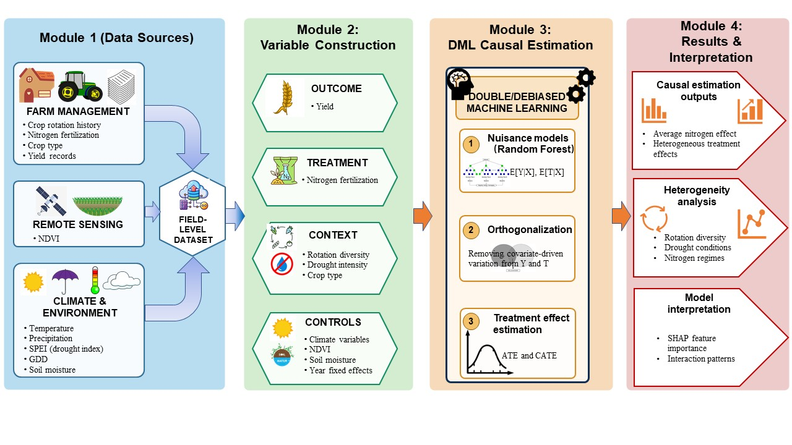
Figure S1. Conceptual framework of the double machine learning (DML) approach used to estimate heterogeneous nitrogen treatment effects under varying crop rotation diversity and climatic conditions
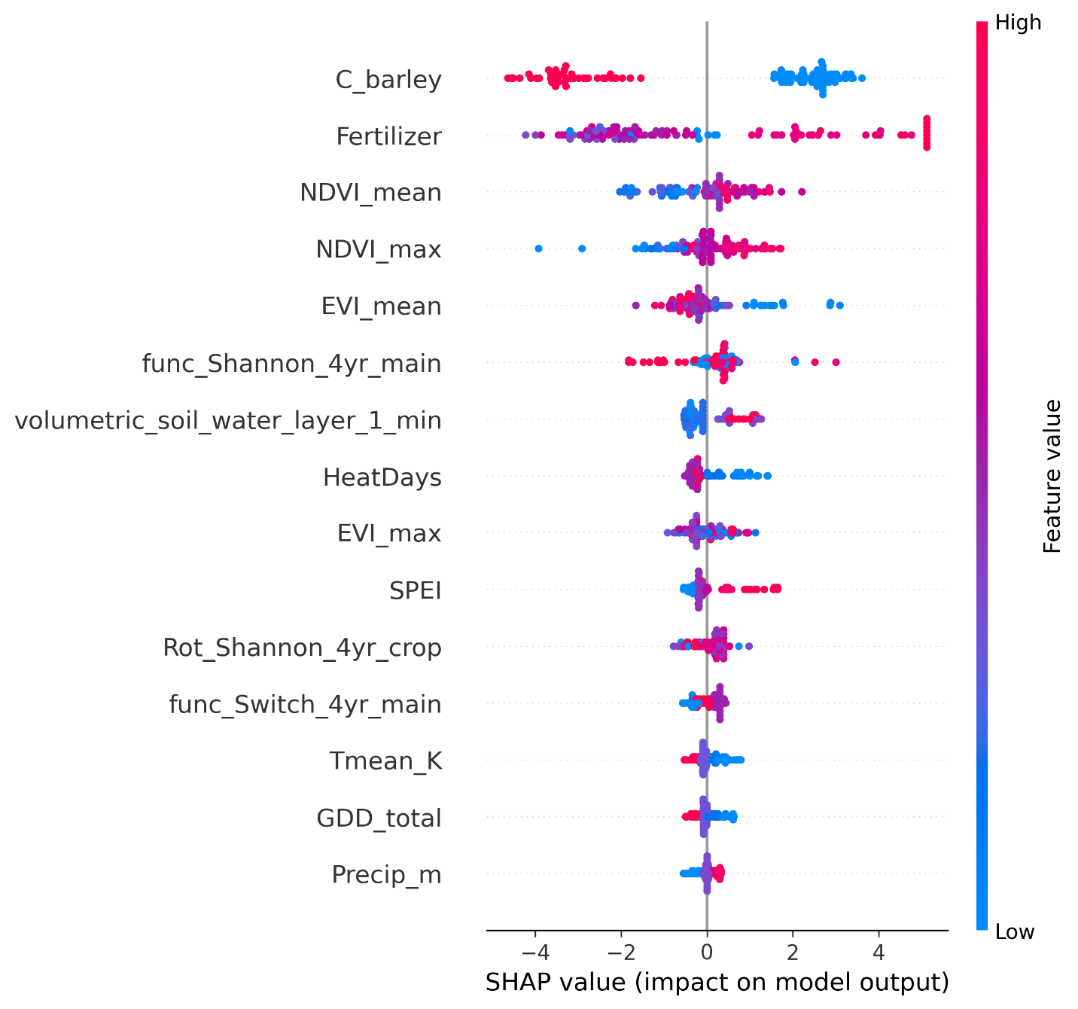
Figure S2. SHAP summary plot for the machine-learning components of the DML models. The figure displays SHapley Additive exPlanations (SHAP) values for the fitted models, summarizing the relative contribution of covariates to model predictions. Each point represents an observation, colored by the feature value (blue = low, red = high). SHAP interpretation was applied only to the machine-learning nuisance models within the DML framework and should not be interpreted as evidence of causal importance.
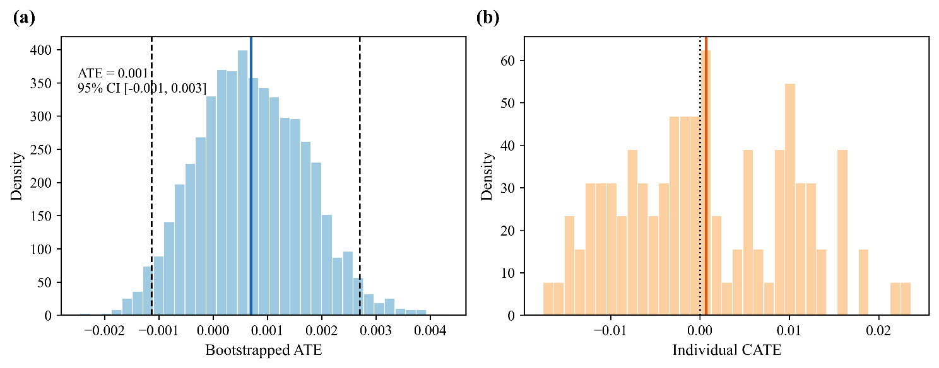
Figure S4. Bootstrap uncertainty of nitrogen treatment-effect estimates. Distribution of cluster-bootstrap ATE estimates based on 3000 parcel-level resamples and distribution of individual CATE estimates.
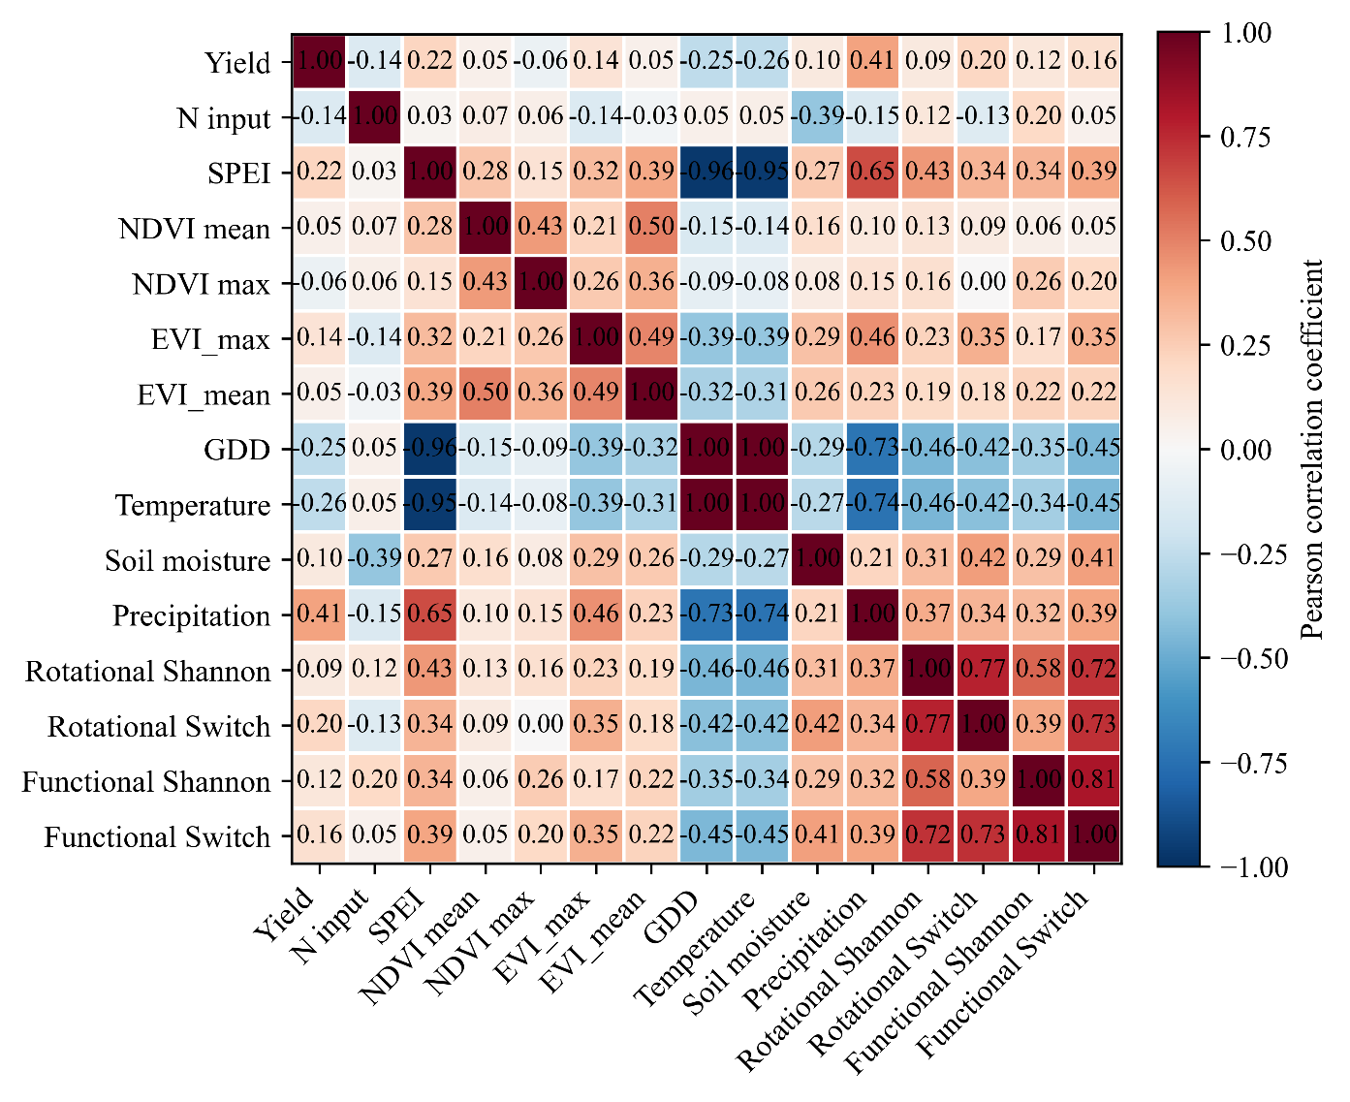
Figure S5. Correlation matrix of model covariates. Pearson correlation coefficients among yield, nitrogen input, vegetation, climate, and soil moisture variables used in the modelling framework.

