Contents of this file
Figure S1. Distribution of climate analogues of optimal conditions for salmon aquaculture through time according to the level of agreement among ESMs for projections across CMIP6 scenarios.
Figure S2- (a) Area available in km² high confidence (≥75% of agreement of ESMs) analogues of optimal and suitable conditions areas over time (2021-2100) across SSP scenarios. In (a) all the marine territories (b) Commonwealth waters, (c) State waters, (d) high seas.
Figure S3. Distribution of climate analogues of optimal conditions for salmon aquaculture through time according to the level of agreement among ESMs for projections across CMIP6 scenarios, considering constraints
Table S1. Documented salmon mortality events in Tasmanian aquaculture operations: locations, timing, and source documentation

Table S2. Adaptation trigger onset for suitable climate analogues — the decade in which the available area falls below the current Tasmanian finfish lease size (25.88 km²), reported under unconstrained (climate-only) and constrained (climate plus spatial restrictions) framings, by CMIP6 scenario and marine jurisdiction.
Table S3. Adaptation trigger onset for optimal climate analogues — the decade in which the available area falls below the current Tasmanian finfish lease size (25.88 km²), reported under unconstrained (climate-only) and constrained (climate plus spatial restrictions) framings, by CMIP6 scenario and marine jurisdiction.
We here supplement the main text with figures showing the distribution of climate analogues of optimal conditions for salmon aquaculture through time according to the level of agreement among ESMs for projections across SSP scenarios with (Figure S1) and without constraints (Figures S3), similar figures showing the analogues of suitable conditions are in the main text (Figures 2 and 4). The supporting information also contains the results of the area availability of high-confidence analogues in square kilometres over time and climate scenarios (Figure S2). Figures S1 and S2 show results for the climate analogues without constraints, whereas Figure S3 shows results for the climate analogues with constraints on aquaculture. Additionally, we show a table of documented mass mortality of Salmo salar (Table S1) and present tables of adaptation triggers for both analogues of optimal (Table S3) and suitable (Table S2) conditions
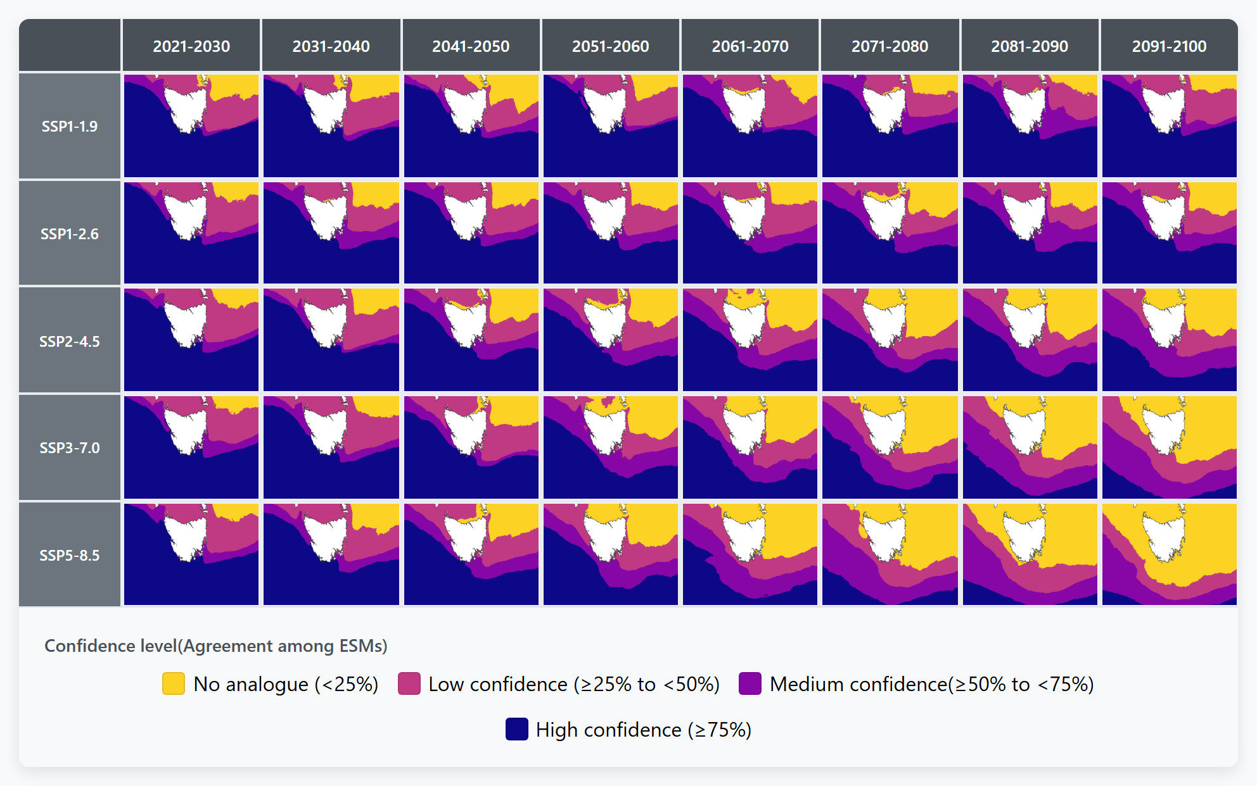
Figure S1. Distribution of climate analogues of optimal conditions for salmon aquaculture through time according to the level of agreement among ESMs for projections across SSP scenarios.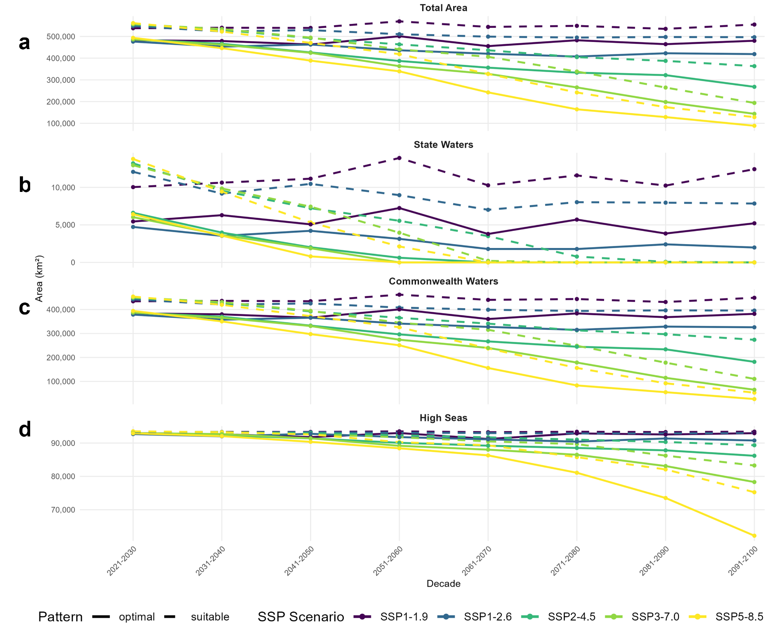
Figure S2. (a) Area available (in km²) of high-confidence (≥75% of agreement of ESMs) analogues of optimal and suitable conditions areas over time (2021-2100) across SSP scenarios. In (a) all the marine territories (b) Commonwealth waters, (c) State waters, (d) high seas.
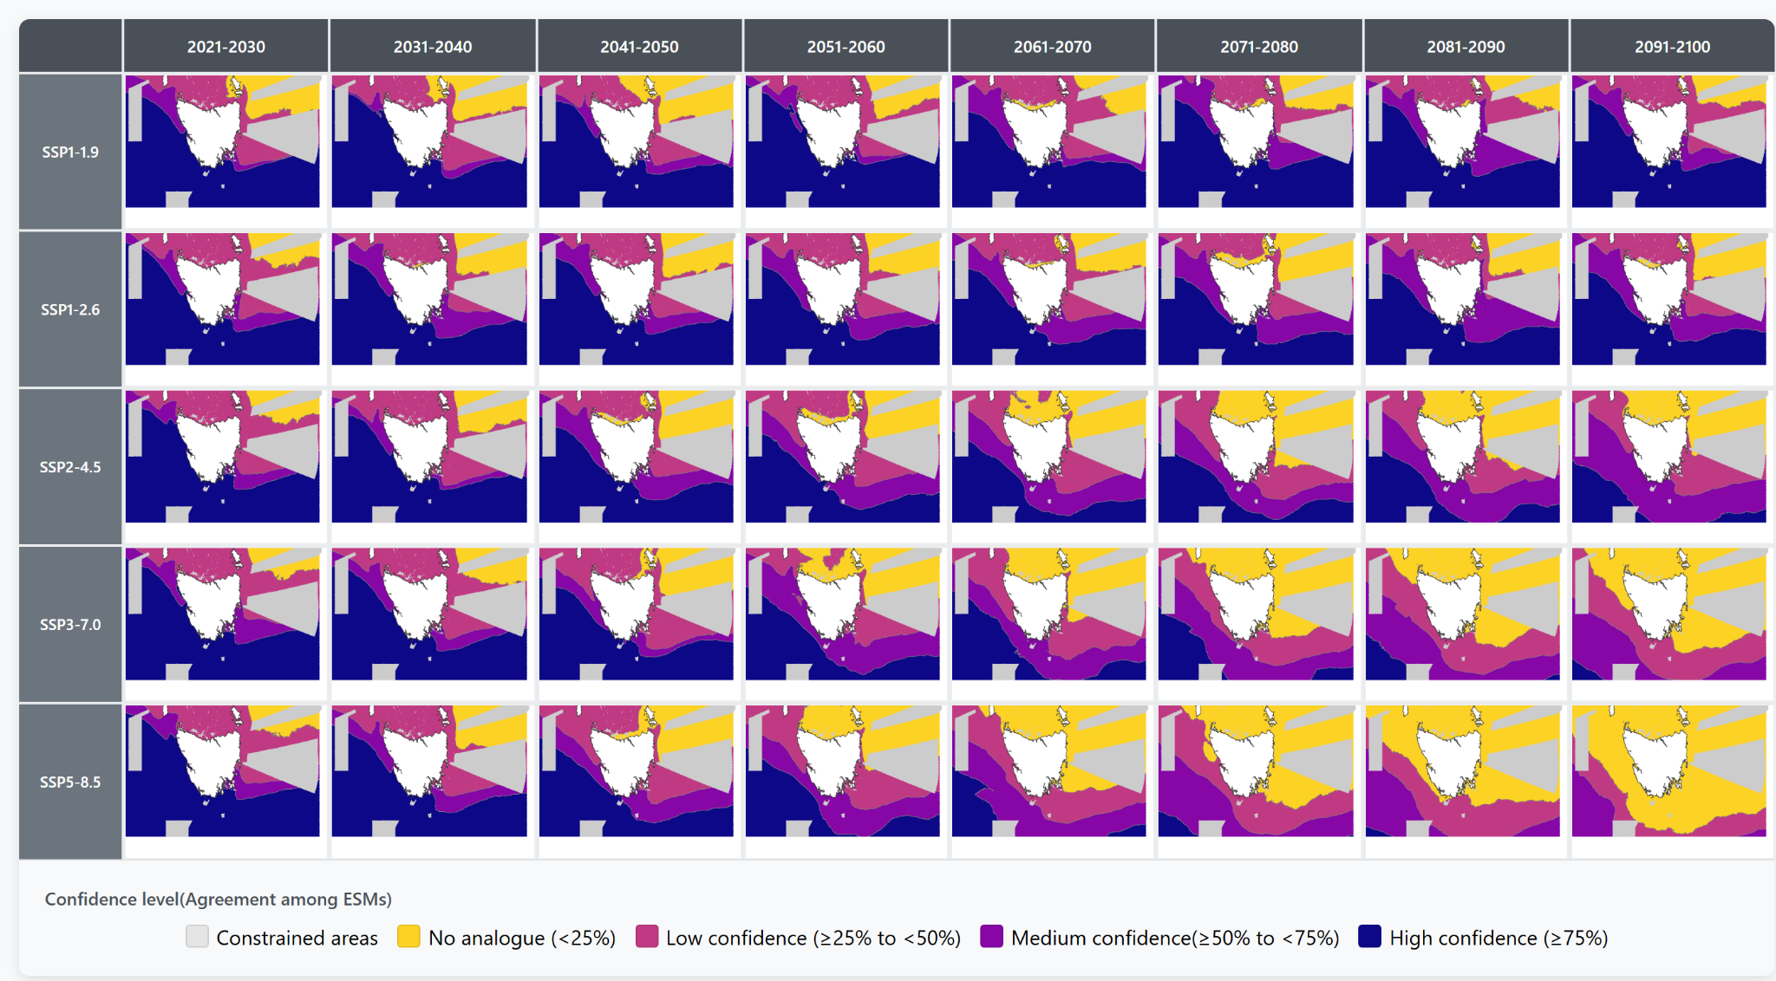
Figure S3. Distribution of climate analogues of optimal conditions for salmon aquaculture through time according to the level of agreement among ESMs for projections across SSP scenarios considering constraints.

Table S1. Documented salmon mortality events in Tasmanian aquaculture operations: locations, timing, and source documentation
locality | Period of occurrence | Occurrences | Link | date
Tamar River | 30 January to 08 of february | Petuna’s Rowella 60,000 salmon dying blamed on high seawater temperatures | Another Mass Fish Kill in Tas Aquaculture - Tasmanian Times  Warm water blamed for Petuna salmon die-off | 09/02/2022
Okehampton Bay, near Triabunna. | december 13th 2023 | Salmon death in Tassal’s farm | Bob Brown Foundation claims thousands of salmon have died in Tassal pens due to marine heatwave - ABC News | 15/12/2023
Okehampton Bay, near Triabunna. | 28 November 2022 | Salmon death in Tassal’s farm | Bob Brown Foundation claims thousands of salmon have died in Tassal pens due to marine heatwave - ABC News | 15/12/2023
Macquarie harbor | September (2023) to March (2024). | 1,149 tonnes of salmon died /Month | Mortality (kg) (September 2023 | 75,443 October 2023 | 107,126 November 2023 | 118,134 December 2023 | 265,740 January 2024 | 313,895 February 2024 | 172,064 March 2024 | 97,393 | Big Stink Over Mass Salmon Mortality - Tasmanian Times  1,150 tonnes of dead salmon removed from Macquarie Harbour in six months - Pulse Tasmania | 24/10/2024
Macquarie harbor | January 2024 | 313 tonnes of salmon died | About one in 10 farmed salmon in Macquarie Harbour died over a seven-month period, documents show - ABC News | 24/10/2024

Table S2. Adaptation trigger onset for suitable climate analogues — the decade in which the available area falls below the current Tasmanian finfish lease size (25.88 km²), reported under unconstrained (climate-only) and constrained (climate plus spatial restrictions) framings, by SSP scenario and marine jurisdiction.
SSP | Unconstrained |  |  | Constrained
SSP | State Waters | Commonwealth | High Seas | State Waters | Commonwealth | High Seas
SSP 1-1.9 | Never | Never | Never | Never | Never | Never
SSP 1-2.6 | Never | Never | Never | 2031–2040 | Never | Never
SSP 2-4.5 | 2091–2100 | Never | Never | 2031–2040 | Never | Never
SSP 3-7.0 | 2071–2080 | Never | Never | 2041–2050 | 2091–2100 | Never
SSP 5-8.5 | 2061–2070 | Never | Never | 2031–2040 | 2081–2090 | Never
Note. Triggers reported as the first decade in which the relevant high-confidence analogue area falls below 25.88 km². Under the unconstrained framing, the high-confidence area within a jurisdiction is compared directly to 25.88 km². Under the constrained framing, the net available area (high-confidence area minus the constraint footprint) is compared to 25.88 km². "Never" indicates the trigger is not reached within the 21st century (2021–2100).

Table S3. Adaptation trigger onset for optimal climate analogues — the decade in which the available area falls below the current Tasmanian finfish lease size (25.88 km²), reported under unconstrained (climate-only) and constrained (climate plus spatial restrictions) framings, by SSP scenario and marine jurisdiction.
SSP | Unconstrained |  |  | Constrained
SSP | State Waters | Commonwealth | High Seas | State Waters | Commonwealth | High Seas
SSP 1-1.9 | Never | Never | Never | 2021–2030 | Never | Never
SSP 1-2.6 | Never | Never | Never | 2021–2030 | Never | Never
SSP 2-4.5 | Pre-2100* | Never | Never | 2021–2030 | Never | Never
SSP 3-7.0 | Pre-2100* | Never | Never | 2021–2030 | 2081–2090 | Never
SSP 5-8.5 | Pre-2100* | Never | Never | 2021–2030 | 2071–2080 | Never
Note. Triggers reported as the first decade in which the relevant high-confidence analogue area falls below 25.88 km². Under the unconstrained framing, the high-confidence area within a jurisdiction is compared directly to 25.88 km². Under the constrained framing, the net available area (high-confidence area minus the constraint footprint) is compared to 25.88 km². "Never" indicates the trigger is not reached within the 21st century. *Pre-2100 indicates that the unconstrained optimal-analogue area in State Waters declines to 0 km² by 2091–2100 but per-decade trajectories were not available to pinpoint the exact trigger year.

