Model-based estimation of microbial biomass and functional community structure parameters in organic co-contaminated groundwater via respiratory quinone profiling
Moye Luo ^{1,2}, Lixiang Zhu ^{1,2}, Xin Zhu ¹, Qinjun Liang ^{1,2}, Tao Long ¹, Manjun Zhan ³, Xiaodong Zhang ^{1*}, Ran Yu ^{2*}

Contents of this file
1. Detailed protocols for DNA extraction, PCR amplification, read quality control, OTU clustering, and taxonomic annotation.
2. Detailed modeling procedures and performance evaluation for microbial parameter estimation using quinone profiles.
3. Tables S1 to S4.
4. Figures S1 to S4.

Introduction
This Supplementary Information provides additional materials to support the study as follows. Detailed protocols for DNA extraction, PCR amplification, read quality control, OTU clustering, and taxonomic annotation are provided in Supplementary Methods (Supplementary Material 1). Detailed modeling procedures and performance evaluation for microbial parameter estimation using quinone profiles (Supplementary Material 2). Operating conditions for the quantification of respiratory quinones by HPLC (Table S1). Diversity index values for respiratory quinone profile (Table S2.). The disparity index (%) of respiratory quinone profile for each group (Table S3.). Numbers of mutual OTUs between experimental groups (Table S4.). Variations in quinone profiles across experimental groups (Figure S1). Total quinone content of each group at different periods (Figure S2). Changes in the MTOC content in each group at different periods (Figure S3). Venn diagram of OTUs in different groups (Figure S4).

Supplementary Material 1. Detailed protocols for DNA extraction, PCR amplification, read quality control, OTU clustering, and taxonomic annotation
Total DNA Extraction and Detection. Before DNA extraction, the slurry from the microcosm system was centrifuged, and the supernatant was carefully removed. Next, 2 mL of nucleic acid protection solution was added to the remaining solid phase, mixed thoroughly, and transferred to a 5 mL centrifuge tube, then stored at -80°C until DNA extraction. Total DNA was extracted using the Mag-bind Soil DNA Extraction Kit (E.Z.N.A, OMEGA, USA) following the manufacturer’s protocols.
PCR Amplification. The bacterial 16S rDNA V3-V4 region was amplified using primers 341f (5’-CCCTA CACGA CGCTC TTCCG ATCTG-3’) and 806r (5’-GGACT ACNNG GGTAT CTAAT-3’) for polymerase chain reaction (PCR). The PCR program consisted of an initial denaturation at 95°C for 2 minutes, followed by 25 cycles of denaturation (95°C for 30 seconds), annealing (55°C for 30 seconds), and extension (72°C for 30 seconds), with a final extension at 72°C for 5 minutes. PCR products were detected using 2% agarose gel electrophoresis. PCR products with fragments larger than 400 bp were purified and quantified using the Fluorometer (Qubit 2.0, Invitrogen, USA). The purified products were then pooled equimolar and paired-end sequenced (2 × 250) on an Illumina MiSeq platform by Sangon Biotech (Shanghai) Co., Ltd.
Data Optimization. Raw sequencing reads were quality-controlled using fastp software, and low-quality reads were filtered. Paired-end reads were then merged and matched using FLASH software (V1.2.3) (minimum overlap length: 10 bp, maximum mismatch rate in overlap region: 0.2). Samples were distinguished based on their barcodes and primer regions.
OTU Clustering and Taxonomic Annotation. OTU clustering of the quality-controlled sequences was performed using UPARSE (v1.2.0) software with a similarity threshold of 97%. The main steps included: removal of singleton sequences, extraction of non-redundant sequences, and clustering into OTUs while simultaneously removing chimeric sequences. The sequence with the highest abundance in each OTU was chosen as the representative sequence, and an OTU table was generated. Representative sequences at the 97% similarity level were taxonomically annotated using the RDP Classifier（v2.12） with the SILVA 16S rRNA database (release 138) at a 70% identity threshold.

Supplementary Material 2. Detailed modeling procedures and performance evaluation for microbial parameter estimation using quinone profiles.
(1) Development of a respiratory quinone-based model for the relative abundance of BTEX degraders (${\text{X}}_{\text{B, A}\text{er}}$)
The multiple linear regression results for the relationship between respiratory quinones and the relative abundance of obligate BTEX degraders (${\text{X}}_{\text{B, A}\text{er}}$) are shown in Table SM1-1. In the construction of the multifactor regression model, the coefficients presented in the equation are the unstandardized regression coefficients (B), which represent the original values of each independent variable's effect on the dependent variable, assuming all other variables remain constant. The significance of each coefficient is assessed using the t-test, which examines whether the coefficient differs significantly from a given value, typically zero, to evaluate whether the corresponding predictor variable significantly affects the dependent variable. The t-values are interpreted in conjunction with their p-values, which indicates the probability of observing such a t-value under the null hypothesis.
In this model, the t-values of MK-9 and MK-7(H₂) were -0.056 and -0.491, with p-values of 0.096 and 0.064, respectively—both above the 0.05 threshold—indicating that these variables do not significantly contribute to the model and their coefficient estimates should be rejected. The standardized regression coefficients (β), derived from standardized input variables, eliminated the influence of units and magnitude, allowing for direct comparison of the relative influence of different variables. The β values for MK-9 and MK-7(H₂) were -0.020 and -0.134, suggesting limited contribution to the estimation of ${\text{X}}_{\text{B, A}\text{er}}$.
The Variance Inflation Factor (VIF) was used to assess multicollinearity, where VIF >10 indicated problematic collinearity. In this study, all VIF values were below 10 (maximum 2.760), suggesting acceptable levels of multicollinearity and reliable parameter estimates. Furthermore, the residual histogram followed a normal distribution, with a mean close to 0 and standard deviation close to 1, consistent with the assumptions of normality in linear regression. The P–P plot also confirms this (Fig. SM1-1).
In conclusion, the model for the relative abundance of BTEX degraders based on respiratory quinones was presented in Eq. SM1-1.
${\overline{\text{X}}}_{\text{B, A}\text{er}}$= -0.341-1.480×${\overline{\text{Q}}}_{\text{MK-6}}$+ 33.896×${\overline{\text{Q}}}_{\text{MK-7(H}\text{2}\text{)}}$-1.237×${\overline{\text{Q}}}_{\text{MK-8(H}\text{2}\text{)}}$ | Eq. SM1-1

Where:
${\overline{\text{X}}}_{\text{B, A}\text{er}}$ represented the relative abundance of obligatory aerobic BTEX-degraders.
${\overline{\text{Q}}}_{\text{i}}$ denoted the relative proportion of the i-th quinone species in the quinone profile.

Table SM1-1 Multiple linear regression coefficients for respiratory quinone - BTEX degraders ${\text{X}}_{\text{B, A}\text{er}}$
Predictor | Unstandardized Coefficient (B) | Standardized Coefficient (β) | t | p-value | VIF
Constant | -0.341 | - | -0.842 | 0.042 | -
MK-9 | -1.480 | -0.020 | -0.056 | 0.096 | 2.427
MK-8(H2) | 5.341 | 0.324 | 1.011 | 0.034 | 1.872
MK-7 | 33.896 | 0.172 | 0.554 | 0.049 | 1.750
MK-7(H2) | -1.237 | -0.134 | -0.491 | 0.064 | 1.349
MK-6 | 10.101 | 0.402 | 1.032 | 0.033 | 2.760

(a) (b)
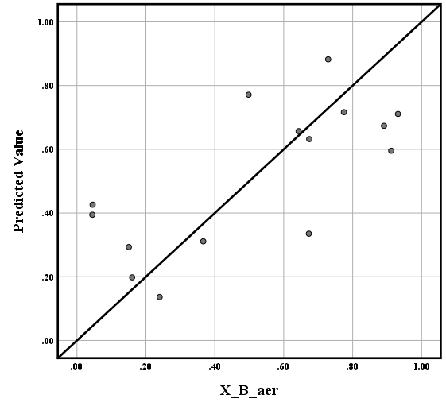
(c)
Fig. SM1-1 Residual regression plots (a), normal P-P plots (b) and Predicted vs. Observed value scatter plot (c) for the respiratory quinone - BTEX degraders ${\text{X}}_{\text{B, A}\text{er}}$ model

(2) Development of a respiratory quinone-based model for the relative abundance of aerobic BTEX and chlorinated ethenes degraders (${\text{X}}_{\text{B\&C, Aer}}$)
The multiple linear regression results for estimating the relative abundance of aerobic BTEX and chlorinated ethene degraders (${\text{X}}_{\text{B\&C, Aer}}$) based on the respiratory quinone profile were presented in Table SM1-2. The approach for analyzing regression coefficients followed that described in Section (1). Among the predictor variables, MK-8(H₂) exhibited a relatively low t-value (0.211) and a p-value of 0.084, which exceeds the significance threshold of 0.05. Therefore, its regression coefficient was excluded from the final model. The residual histogram of the revised regression model approximated a normal distribution, and the P-P plot also confirmed the assumption of normality (Fig. SM1-2). The model for the relative abundance of aerobic BTEX and CEs degraders was expressed in Eq. SM1-2:

${\overline{\text{X}}}_{\text{B\&C, Aer}}$= -0.117+52.718×${\overline{\text{Q}}}_{\text{MK-7(H}\text{2}\text{)}}$+0.441×${\overline{\text{Q}}}_{\text{MK-8(H}\text{2}\text{)}}$+ 3.464×${\overline{\text{Q}}}_{\text{MK-9}}$ | Eq. SM1-2

Where:
${\overline{\text{X}}}_{\text{B\&C, A}\text{er}}$ represents the relative abundance of aerobic BTEX and chlorinated ethene-degraders.
${\overline{\text{Q}}}_{\text{i}}$ denoted the relative proportion of the i-th quinone species in the quinone profile.

Table SM1-2 Multiple linear regression coefficients for respiratory quinone - aerobic BTEX & CEs degraders ${\text{X}}_{\text{B\&C, Aer}}$
Predictor | Unstandardized Coefficient (B) | Standardized Coefficient (β) | t | p-value | VIF
Constant | -0.117 |  | -0.556 | 0.023 | -
MK-7(H2) | 52.718 | 0.353 | 0.813 | 0.044 | 3.101
MK-8 | 2.591 | 0.230 | 0.693 | 0.050 | 1.810
MK-8(H2) | 0.441 | 0.063 | 0.211 | 0.084 | 1.463
MK-9 | 3.464 | 0.182 | 0.537 | 0.026 | 1.892
(a) (b)
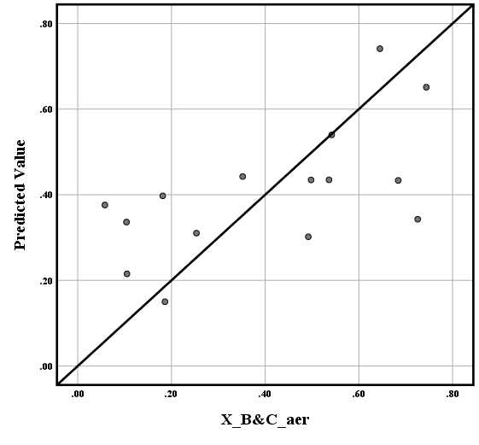
(c)
Fig. SM1-2 Residual regression plots (a), normal P-P plots (b) and Predicted vs. Observed value scatter plot (c) for the respiratory quinone - aerobic BTEX & CEs degraders ${\text{X}}_{\text{B\&C, Aer}}$ model

(3) Development of a respiratory quinone-based model for the relative abundance of anaerobic chlorinated ethenes degraders (${\text{X}}_{\text{C, An}}$)
The results of the multiple linear regression analysis for estimating the relative abundance of obligate anaerobic chlorinated ethene (CE) degraders (${\text{X}}_{\text{C, An}}$) based on the respiratory quinone profile were summarized in Table SM1-3. The approach for analyzing regression coefficients followed that described in Section (1). All regression parameters for the predictor variables in this model met the acceptance criteria. The histogram of model residuals approximated a standard normal distribution, and the P–P plot confirmed the normality assumption (Fig. SM1-3). Therefore, the model for the relative abundance of obligatory anaerobic CEs degraders was given by Eq. SM1-3:

${\overline{\text{X}}}_{\text{C, An}}$= -0.300+1.732×${\overline{\text{Q}}}_{\text{MK-7}}$+18.149×${\overline{\text{Q}}}_{\text{MK-7(H2)}}$+2.558×${\overline{\text{Q}}}_{\text{MK-9}}$+ 0.760× ${\overline{\text{Q}}}_{\text{MK-11}}$ | Eq. SM1-3

Where:
${\overline{\text{X}}}_{\text{C, An}}$ represents the relative abundance of anaerobic chlorinated ethenes degraders.
${\overline{\text{Q}}}_{\text{i}}$ denoted the relative proportion of the i-th quinone species in the quinone profile.

Table SM1-3 Multiple linear regression coefficients for respiratory quinone - CEs degraders ${\text{X}}_{\text{C, An}}$
Predictor | Unstandardized Coefficient (B) | Standardized Coefficient (β) | t | p-value | VIF
Constant | -0.300 |  | -2.270 | 0.005
MK-7 | 1.732 | 0.319 | 1.258 | 0.024 | 1.547
MK-7(H2) | 18.149 | 0.279 | 1.093 | 0.030 | 1.566
MK-9 | 2.558 | 0.309 | 1.052 | 0.032 | 2.070
MK-11 | 0.760 | 0.444 | 2.089 | 0.006 | 1.082
(a) (b)
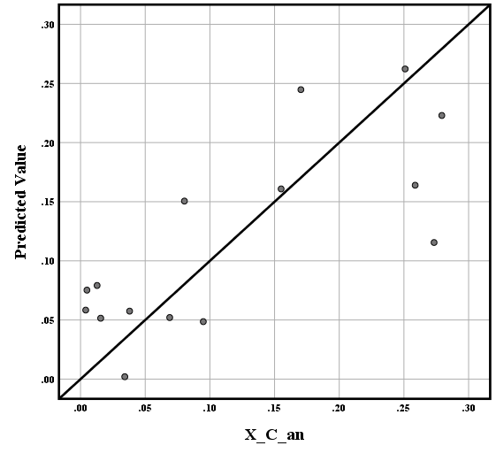
(c)
Fig. SM1-3 Residual regression plots (a), normal P-P plots (b) and Predicted vs. Observed value scatter plot (c) for the respiratory quinone - CEs degraders ${\text{X}}_{\text{C, An}}$ model

(4) Development of a respiratory quinone-based model for the relative abundance of anaerobic BTEX and chlorinated ethenes degraders (${\text{X}}_{\text{B\&C, An}}$)
The multiple linear regression results for estimating the relative abundance of anaerobic BTEX and chlorinated ethene degraders (${\text{X}}_{\text{B\&C, An}}$) based on the respiratory quinone profile were presented in Table SM1-4. The approach for analyzing regression coefficients followed that described in Section (1). Among the predictor variables, MK-8 had a low t-value (0.465) and a p-value of 0.065, which exceeded the significance threshold of 0.05. Therefore, the regression coefficient for MK-8 was excluded from the final model. The residual histogram of the revised regression model approximated a standard normal distribution, and the P–P plot also supported the assumption of normality (Fig. SM1-4). Accordingly, the model for the relative abundance of anaerobic BTEX and CEs degraders was given in Eq. SM1-4:

${\overline{\text{X}}}_{\text{B\&C, An}}$= -0.283-12.215×${\overline{\text{Q}}}_{\text{MK-6}}$+18.998×${\overline{\text{Q}}}_{\text{UQ-6}}$+2.253×${\overline{\text{Q}}}_{\text{UQ-8}}$ | Eq. SM1-4

Where:
${\overline{\text{X}}}_{\text{B\&C, An}}$ represents the relative abundance of anaerobic BTEX and chlorinated ethene-degraders.
${\overline{\text{Q}}}_{\text{i}}$ denoted the relative proportion of the i-th quinone species in the quinone profile.

Table SM1-4 Multiple linear regression coefficients for respiratory quinone - Anaerobic CEs & BTEX degraders ${\text{X}}_{\text{B\&C, An}}$
Predictor | Unstandardized Coefficient (B) | Standardized Coefficient (β) | t | p-value | VIF
Constant | -0.283 |  | -1.179 | 0.027 | -
MK-6 | -12.215 | -0.253 | -1.115 | 0.029 | 1.032
MK-8 | 1.086 | 0.109 | 0.465 | 0.065 | 1.108
UQ-6 | 18.998 | 0.166 | 0.670 | 0.050 | 1.234
UQ-9 | 2.253 | 0.606 | 2.579 | 0.003 | 1.109

(a) (b)
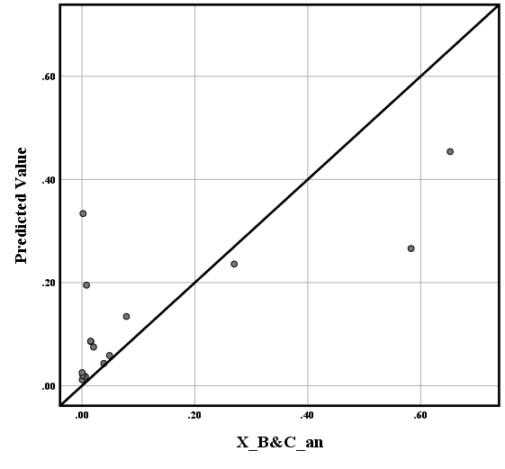
(c)
Fig. SM1-4 Residual regression plots (a), normal P-P plots (b) and Predicted vs. Observed value scatter plot (c) for the respiratory quinone - Anaerobic CEs & BTEX degraders ${\text{X}}_{\text{B\&C, An}}$ model

Table S1 Operating conditions for the quantification of respiratory quinones by HPLC.
HPLC Conditions | UQ | MK
Column Temperature (°C) | 35 | 30
Wavelength (nm) | 275 | 270
Mobile Phase | Methanol-Isopropanol (3:2) | Acetonitrile-Isopropanol (3:1)
Flow Rate (mL/min) | 0.5 | 1.0

Table S2 Values of diversity indices for respiratory quinone profile.
Sample | DQ | H’
A1 | 7.12 | 1.62
A2 | 7.27 | 1.71
A3 | 8.04 | 1.94
A4 | 8.36 | 1.93
A5 | 8.20 | 1.96
B1 | 8.52 | 1.82
B2 | 8.80 | 1.90
B3 | 9.35 | 2.00
B4 | 9.77 | 2.05
B5 | 9.95 | 2.09
C1 | 8.57 | 1.89
C2 | 8.89 | 1.95
C3 | 9.26 | 2.02
C4 | 9.51 | 2.01
C5 | 9.68 | 2.06

Table S3 The disparity index (%) of respiratory quinone profile for each group
Sample | A1 | A2 | A3 | A4 | A5 | B1 | B2 | B3 | B4 | B5 | C1 | C2 | C3 | C4 | C5
A1 |  | 17.78 | 30.65 | 31.99 | 31.63 | 8.22 | 23.24 | 38.37 | 41.78 | 42.42 | 14.10 | 25.32 | 38.77 | 50.73 | 49.07
A2 |  |  | 24.66 | 28.28 | 28.57 | 17.22 | 11.68 | 35.01 | 39.53 | 39.65 | 15.06 | 21.59 | 34.72 | 48.76 | 46.94
A3 |  |  |  | 7.62 | 7.16 | 28.19 | 18.32 | 17.10 | 21.93 | 21.28 | 24.92 | 17.27 | 17.06 | 30.89 | 29.53
A4 |  |  |  |  | 4.79 | 29.20 | 20.70 | 15.97 | 14.89 | 18.36 | 25.98 | 18.81 | 15.61 | 23.96 | 25.88
A5 |  |  |  |  |  | 28.89 | 21.95 | 13.82 | 14.94 | 17.15 | 25.73 | 16.42 | 15.13 | 23.87 | 25.38
B1 |  |  |  |  |  |  | 19.12 | 30.58 | 36.10 | 35.34 | 6.52 | 19.11 | 33.93 | 45.15 | 42.98
B2 |  |  |  |  |  |  |  | 25.94 | 29.19 | 30.70 | 15.89 | 11.51 | 24.78 | 38.30 | 37.49
B3 |  |  |  |  |  |  |  |  | 9.77 | 19.10 | 27.20 | 18.02 | 7.22 | 16.33 | 26.79
B4 |  |  |  |  |  |  |  |  |  | 15.32 | 30.89 | 20.28 | 8.06 | 10.57 | 21.81
B5 |  |  |  |  |  |  |  |  |  |  | 30.66 | 23.16 | 18.70 | 17.04 | 8.57
C1 |  |  |  |  |  |  |  |  |  |  |  | 13.50 | 29.51 | 38.93 | 37.36
C2 |  |  |  |  |  |  |  |  |  |  |  |  | 18.84 | 28.29 | 29.87
C3 |  |  |  |  |  |  |  |  |  |  |  |  |  | 16.33 | 24.91
C4 |  |  |  |  |  |  |  |  |  |  |  |  |  |  | 18.01
C5

Table S4 Numbers of mutual OTUs between experimental groups
 | BS | NA | BS | PCE+BZ_L | PCE+BZ_H
BS | 306
NA | 819 | 99
BS | 576 | 534 | 148
PCE+BZ_L | 553 | 655 | 523 | 177
PCE+BZ_H | 661 | 823 | 574 | 732 | 272

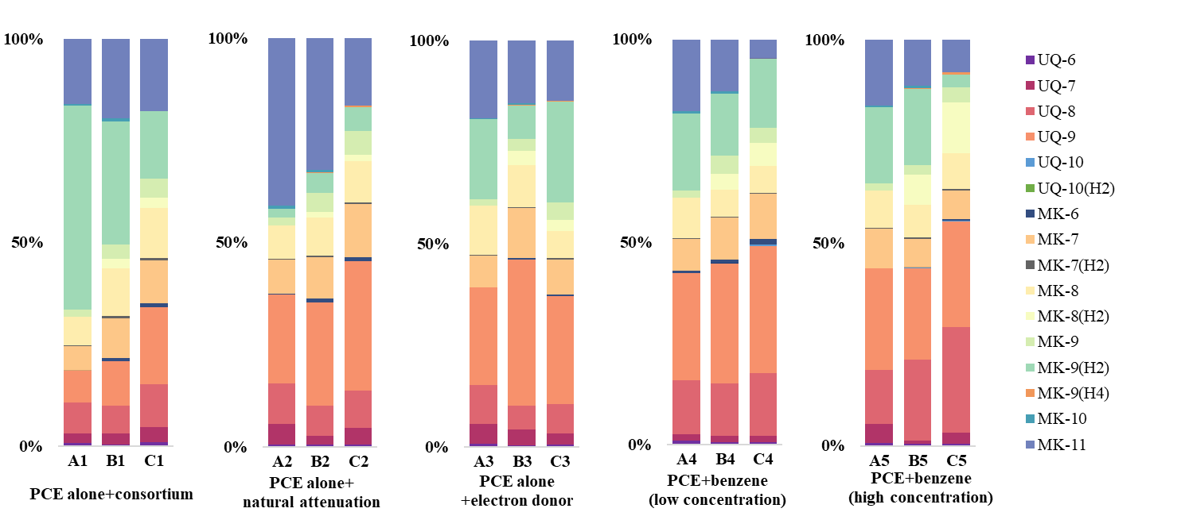

Figure S1 Variations in quinone profiles across experimental groups. (UQ and MK represent ubiquinones [2,3-dimethoxy-5-methyl-6-polyisoprenyl-1,4-benzoquinone] and menaquinones [2-methyl-3-polyisoprenyl-1,4-naphthoquinone], respectively; the numbers following the hyphen indicate the number of isoprenoid units and the degree of hydrogenation of the double bonds in the side chain.)

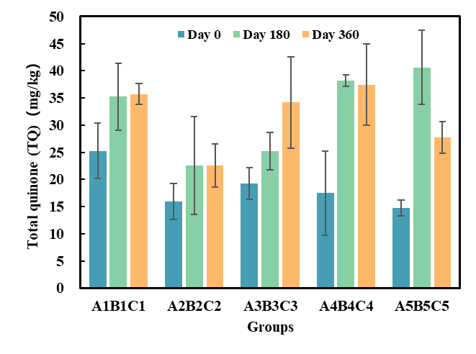

Figure S2 Total quinone content of each group at different periods

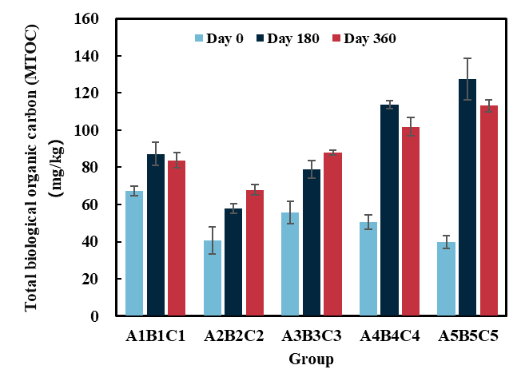
图5-3

Figure S3 Changes in the MTOC content in each group at different periods

Figure S4 Venn diagram of OTUs in different group

