Graphical Abstract

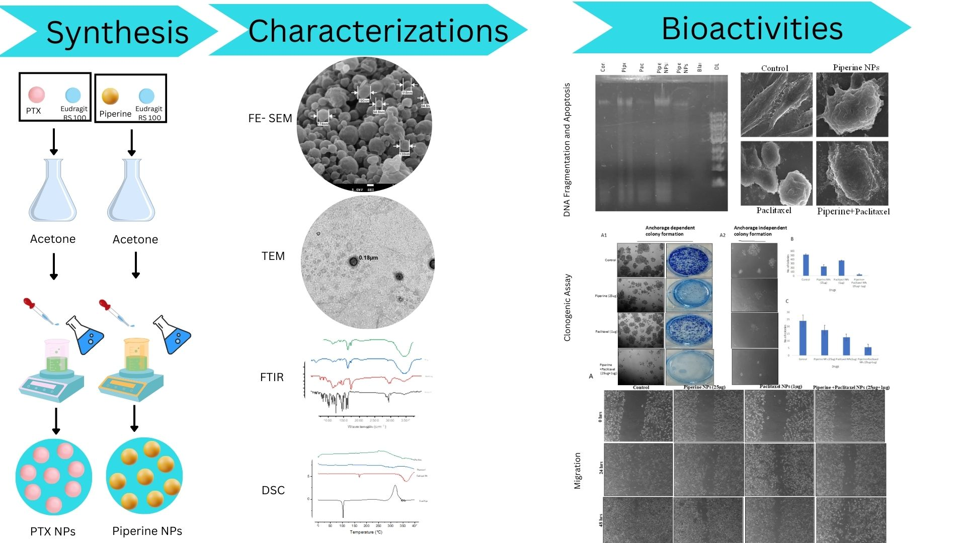

Graphical Abstract representing the synthesis, characterization and Results of Piperine and Paclitaxel nanoparticles

