Table.S1 Design of relevant primer
Primer Name | Application | Primer Sequence（5’-3’）
PtoJAZ10#F | Amplify the target gene | TCCTGAAACCGCCCAAATGACT
PtoJAZ10#R | Amplify the target gene | CTAGCATGGGGCACATCTGAA
Kan#F | Genetic modification identification | ATGACTGGGCACAACAGACAATC
Kan#R | Genetic modification identification | TATGTCCTGATAGCGGTCCGC
35s#F | Genetic modification identification | ATGCCATCATTGCGATAAAGG
35s#R | Genetic modification identification | ATGCCATCATTGCGATAAAGG
PtoJAZ1#F | RT-qPCR | ATGCCCAACCAAGACTGCAT
PtoJAZ1#R | RT-qPCR | CTAGCTGCTTTGATGATTGGCC
PtoJAZ2#F | RT-qPCR | ATGGCAATCAGTTCTCAAACAAGTC
PtoJAZ2#R | RT-qPCR | CTATCAAAAAGCTGTTGTTGATCAGTT
PtoJAZ15#F | RT-qPCR | ATGGTGGAAGTGTTGTCGTGTTT
PtoJAZ15#R | RT-qPCR | CTATAGGATTGGGCATGTGGGG
PtoJAZ21#F | RT-qPCR | ATGATGATATATCCCCTGAGAAGGC
PtoJAZ21#R | RT-qPCR | CTAGTTGACCCACTCCCTGATTG
PtoJAZ23#F | RT-qPCR | ATGGGTCTCCTGCTCAATTGAC
PtoJAZ23#R | RT-qPCR | CTAGAGCATGGTGGAGTAGACATGA
PtoJAZ26#F | RT-qPCR | ATGAAGAGATCGCTCCAAAGGTT
PtoJAZ26#R | RT-qPCR | CTATACGTCTTTATGCACCAATATAACTCC
PtoJAZ32#F | RT-qPCR | ATGCAAACATCGCCCTACAATG
PtoJAZ32#R | RT-qPCR | CTAGGCTTTGAAGATAAGTCTTGAAGA
PtoJAZ36#F | RT-qPCR | ATGCAAGCTGAATTGCCTATTG
PtoJAZ36#R | RT-qPCR | CTAGAGGTTTTCCAAAGCAACCTG
107824706#F | RT-qPCR | ATGTGGCCTCTGAAGACGAGG
107824706#R | RT-qPCR | CTAGCAATGACATCCAACTCAACC
107785558#F | RT-qPCR | ATGTTCTCAAAGGCTCAGAACTTGT
107785558#R | RT-qPCR | CTAGACTCTGCCTTATACACTCTGTACTCG
107770318#F | RT-qPCR | ATGTGGCCAGGAGAAGCACA
107770318#R | RT-qPCR | CTATCATCTCCTGATAGGCGCAT
107785405#F | RT-qPCR | ATGTGTGTGTTGCCTTTGTTCCA
107785405#R | RT-qPCR | CTATCAACAATTGGACTCTTAGCAATAG
107803673#F | RT-qPCR | ATGCGAATTTGTATATGCACAGTGA
107803673#R | RT-qPCR | CTATCAACAATTGGACTCTTAGCAATAG
107803683#F | RT-qPCR | ATGGCAAGATTCTAGCTATGGATATTA
107803683#R | RT-qPCR | CTACAAATATGAAATCATATGATCCATGG
107794434#F | RT-qPCR | ATGGCTTTATTCAAGTGTTTAGGGT
107794434#R | RT-qPCR | CTAGACCGCGACAAATTCATAGTAA
107789811#F | RT-qPCR | ATGCTATTGGTCATCTCAGCTCTTT
107789811#R | RT-qPCR | CTAGTTGCACCAGATTTGAGATTGTT
107789006#F | RT-qPCR | ATGAATCCCTTTATGGTGCCG
107789006#R | RT-qPCR | CTATGCGGATAATGATGAGACTGTTG
107799734#F | RT-qPCR | ATGGGCTTTGACCTGGGAAA
107799734#R | RT-qPCR | CTATCATTACCAAAAGCTCCATAAGG
107782531#F | RT-qPCR | ATGCAGAAAATGTAACTTCACTGGA
107782531#R | RT-qPCR | CTAGTAGCACTTCGGCATGAACA
107827260#F | RT-qPCR | ATGGCGGTGGCGATTCGT
107827260#R | RT-qPCR | CTACGCCTTGAACCAGCCG

Table.S2 Genetic information and physicochemical characteristics of PtoJAZ gene family
Gene name | Gene ID number | Size(aa) | MW(Da) | PI | GRAVY
PtoJAZ1 | P.x_tomentosa14743 | 269 | 29082.72 | 9.24 | -0.555
PtoJAZ2 | P.x_tomentosa15542 | 298 | 33499.78 | 10.15 | -0.496
PtoJAZ3 | P.x_tomentosa18185 | 269 | 29240.84 | 9.13 | -0.594
PtoJAZ4 | P.x_tomentosa11227 | 269 | 29132.74 | 9.11 | -0.561
PtoJAZ5 | P.x_tomentosa12036 | 182 | 20210.15 | 9.91 | -0.624
PtoJAZ6 | P.x_tomentosa41215 | 366 | 40334.32 | 5.7 | -0.658
PtoJAZ7 | P.x_tomentosa39630 | 345 | 37848.49 | 6.26 | -0.708
PtoJAZ8 | P.x_tomentosa43264 | 345 | 37896.47 | 6.26 | -0.735
PtoJAZ9 | P.x_tomentosa56064 | 199 | 22060.11 | 9.77 | -0.527
PtoJAZ10 | P.x_tomentosa56853 | 265 | 28774.3 | 9.15 | -0.698
PtoJAZ11 | P.x_tomentosa57767 | 199 | 22146.28 | 9.83 | -0.531
PtoJAZ12 | P.x_tomentosa58554 | 267 | 29131.81 | 9.08 | -0.645
PtoJAZ13 | P.x_tomentosa54367 | 199 | 22060.11 | 9.77 | -0.527
PtoJAZ14 | P.x_tomentosa55150 | 265 | 28793.39 | 9.26 | -0.669
PtoJAZ15 | P.x_tomentosa61223 | 235 | 25023.4 | 6.83 | -0.426
PtoJAZ16 | P.x_tomentosa61798 | 276 | 29866.01 | 8.86 | -0.395
PtoJAZ17 | P.x_tomentosa63390 | 235 | 25237.71 | 8.24 | -0.472
PtoJAZ18 | P.x_tomentosa63971 | 276 | 29866.01 | 8.86 | -0.395
PtoJAZ19 | P.x_tomentosa59197 | 235 | 25078.42 | 7.62 | -0.455
PtoJAZ20 | P.x_tomentosa59633 | 276 | 29816.88 | 9.01 | -0.455
PtoJAZ21 | P.x_tomentosa05927 | 296 | 31105.02 | 9.25 | -0.337
PtoJAZ22 | P.x_tomentosa08312 | 296 | 31105.02 | 9.25 | -0.337
PtoJAZ23 | P.x_tomentosa23024 | 338 | 35532.22 | 8.62 | -0.273
PtoJAZ24 | P.x_tomentosa26760 | 338 | 35504.19 | 8.81 | -0.270
PtoJAZ25 | P.x_tomentosa24990 | 338 | 35560.27 | 8.62 | -0.266
PtoJAZ26 | P.x_tomentosa48232 | 154 | 17702.36 | 9.64 | -0.642
PtoJAZ27 | P.x_tomentosa47084 | 154 | 17775.49 | 9.64 | -0.645
PtoJAZ28 | P.x_tomentosa49212 | 154 | 17729.38 | 9.64 | -0.659
PtoJAZ29 | P.x_tomentosa74797 | 392 | 41152.26 | 9.48 | -0.382
PtoJAZ30 | P.x_tomentosa73781 | 392 | 41123.23 | 9.25 | -0.328
PtoJAZ31 | P.x_tomentosa75512 | 392 | 41152.31 | 9.53 | -0.383
PtoJAZ32 | P.x_tomentosa72672 | 772 | 84300.73 | 8.41 | -0.499
PtoJAZ33 | P.x_tomentosa70455 | 772 | 84046.44 | 8.41 | -0.490
PtoJAZ34 | P.x_tomentosa71558 | 777 | 84754.29 | 8.41 | -0.488
PtoJAZ35 | P.x_tomentosa43738 | 254 | 27727.75 | 7.65 | -0.406
PtoJAZ36 | P.x_tomentosa46114 | 286 | 31761.42 | 7.58 | -0.445
PtoJAZ37 | P.x_tomentosa44829 | 291 | 32336.15 | 8.55 | -0.384
PtoJAZ38 | P.x_tomentosa86348 | 182 | 20226.10 | 9.85 | -0.636
PtoJAZ39 | P.x_tomentosa87467 | 182 | 20226.10 | 9.85 | -0.636

Table.S3 PtoJAZ family protein secondary structure
Gene name | Alpha helix(%) | Random coil(%) | Extended strand(%)
PtoJAZ1 | 15.24 | 80.67 | 4.09
PtoJAZ2 | 21.14 | 70.47 | 8.39
PtoJAZ3 | 13.75 | 82.16 | 4.09
PtoJAZ4 | 12.64 | 84.01 | 3.35
PtoJAZ5 | 23.63 | 70.88 | 5.49
PtoJAZ6 | 16.67 | 78.42 | 4.92
PtoJAZ7 | 17.10 | 77.68 | 5.22
PtoJAZ8 | 19.13 | 75.94 | 4.93
PtoJAZ9 | 20.10 | 73.37 | 6.53
PtoJAZ10 | 13.58 | 83.02 | 3.40
PtoJAZ11 | 19.60 | 71.36 | 9.05
PtoJAZ12 | 11.61 | 83.15 | 5.24
PtoJAZ13 | 20.10 | 73.37 | 6.53
PtoJAZ14 | 12.45 | 84.15 | 3.40
PtoJAZ15 | 8.09 | 86.38 | 5.53
PtoJAZ16 | 12.68 | 83.33 | 3.99
PtoJAZ17 | 8.51 | 86.81 | 4.68
PtoJAZ18 | 12.68 | 83.33 | 3.99
PtoJAZ19 | 8.51 | 86.81 | 4.68
PtoJAZ20 | 11.23 | 83.33 | 5.43
PtoJAZ21 | 8.45 | 85.47 | 6.08
PtoJAZ22 | 8.45 | 85.47 | 6.08
PtoJAZ23 | 11.83 | 82.84 | 5.33
PtoJAZ24 | 10.95 | 84.02 | 5.03
PtoJAZ25 | 11.83 | 82.84 | 5.33
PtoJAZ26 | 14.94 | 74.03 | 11.04
PtoJAZ27 | 15.58 | 75.97 | 8.44
PtoJAZ28 | 16.88 | 74.03 | 9.09
PtoJAZ29 | 7.91 | 87.24 | 4.85
PtoJAZ30 | 6.89 | 87.76 | 5.36
PtoJAZ31 | 8.93 | 87.24 | 3.83
PtoJAZ32 | 28.63 | 57.25 | 14.12
PtoJAZ33 | 23.83 | 65.41 | 23.83
PtoJAZ34 | 31.40 | 56.50 | 12.10
PtoJAZ35 | 11.02 | 83.07 | 5.91
PtoJAZ36 | 12.59 | 76.92 | 10.49
PtoJAZ37 | 12.71 | 76.63 | 10.65
PtoJAZ38 | 23.08 | 71.43 | 5.49
PtoJAZ39 | 23.08 | 71.43 | 5.49

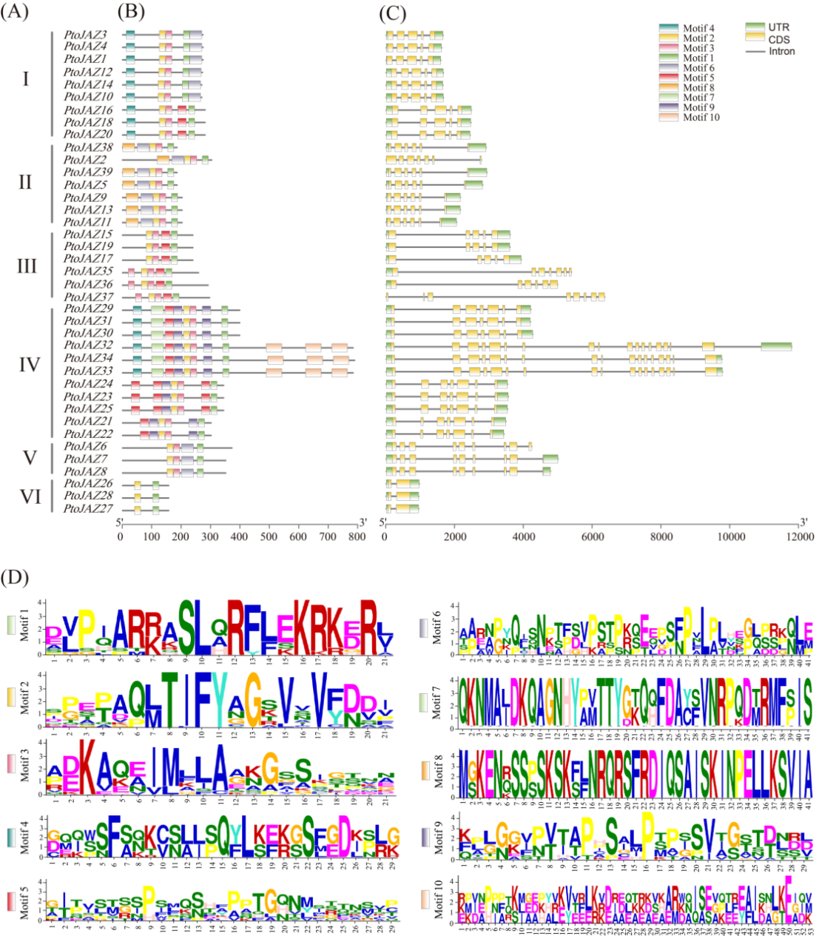
Fig.S1. Motif composition, gene structure, and motifs logo of the JAZ gene family in Poplar 741. (A) Subfamily classification of JAZ gene family members in Poplar 741. (B) Protein motif analysis of the JAZ gene family in Poplar 741. (C) Gene structure of the JAZ family in Poplar 741. (D) Logos of the 10 identified motifs.

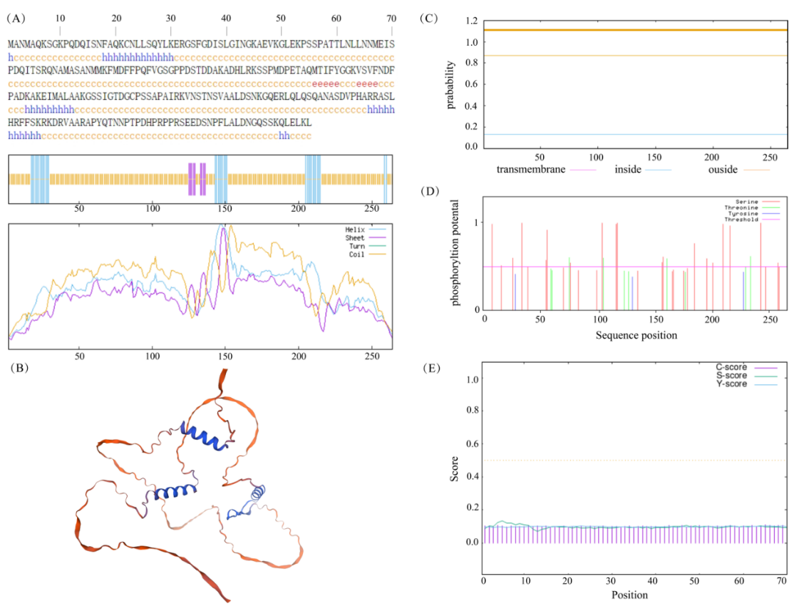
Fig.S2. Prediction of secondary and tertiary structures and key features of the PtoJAZ10 protein. (A) Secondary structure: α-helix (blue), β-turn (green), extended strand (red), random coil (purple). (B) Tertiary structure of PtoJAZ10 protein. (C) Transmembrane structure of PtoJAZ10 protein. (D) Phosphorylation sites of PtoJAZ10 protein. (E) Signal peptide prediction for PtoJAZ10 protein.

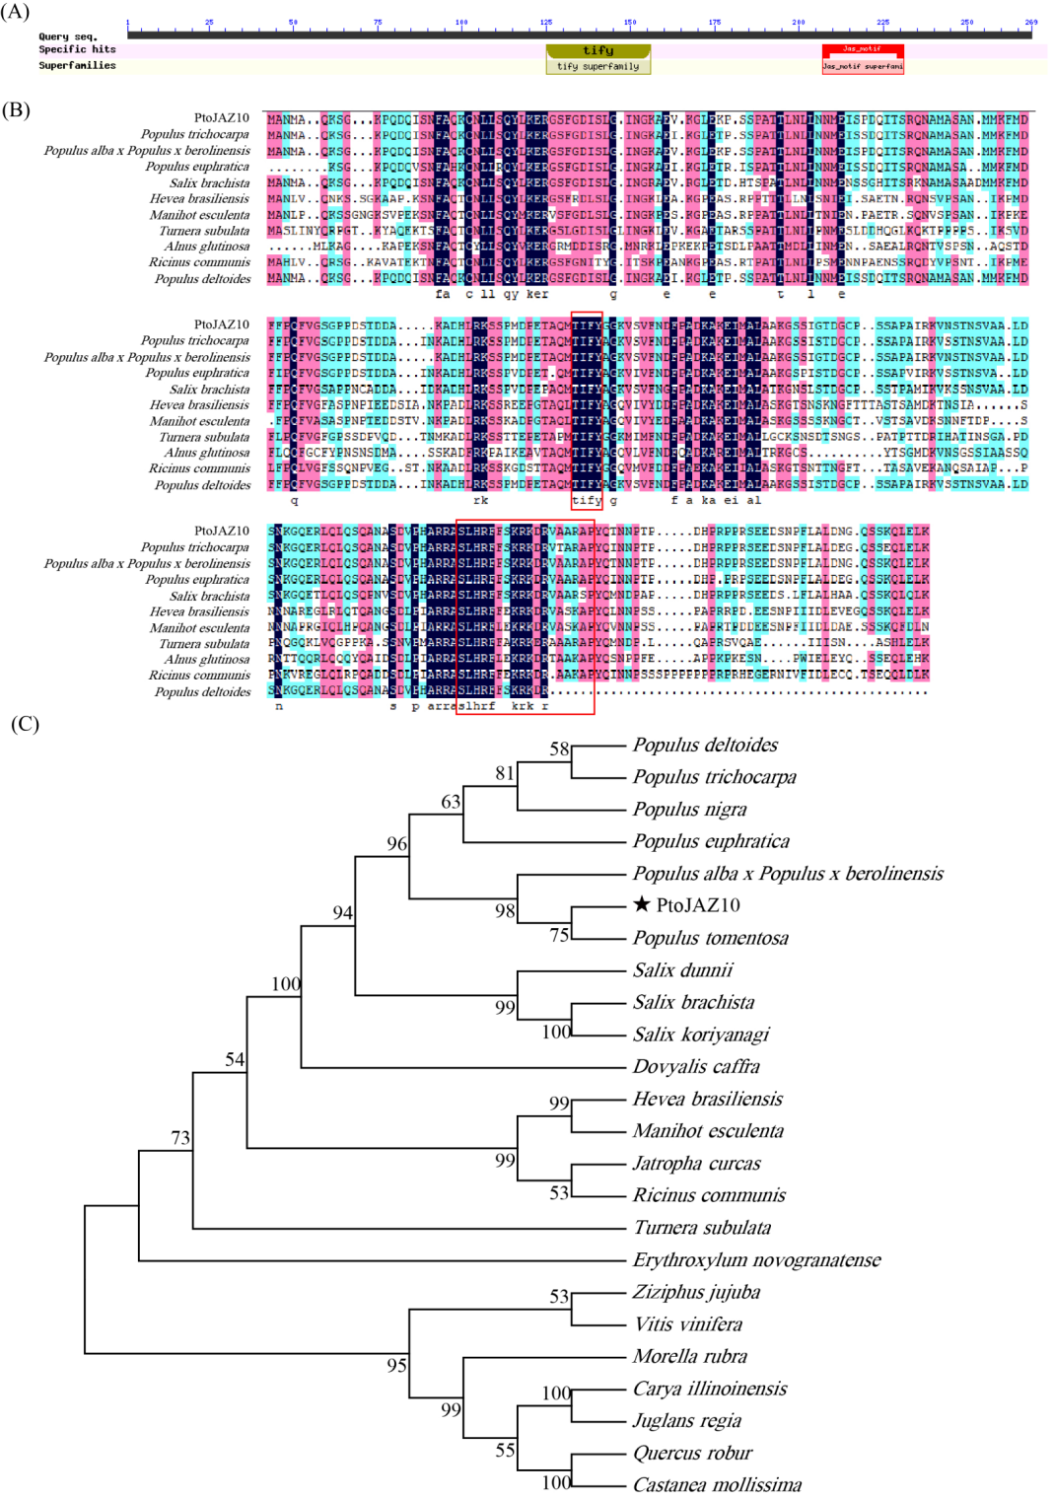
Fig.S3. Sequence alignment of 10 proteins and phylogenetic tree construction from 24 species.

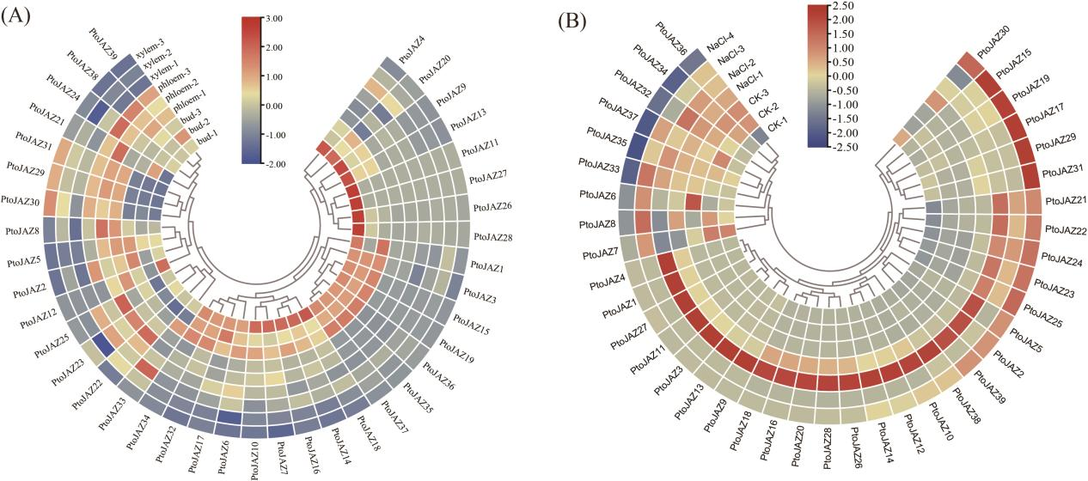
Fig.S4. Transcriptome-based expression profiles of the PtoJAZ gene family. (A) Expression patterns of PtoJAZ family genes in different tissues. (B) Expression profiles of PtoJAZ genes in response to salt stress.
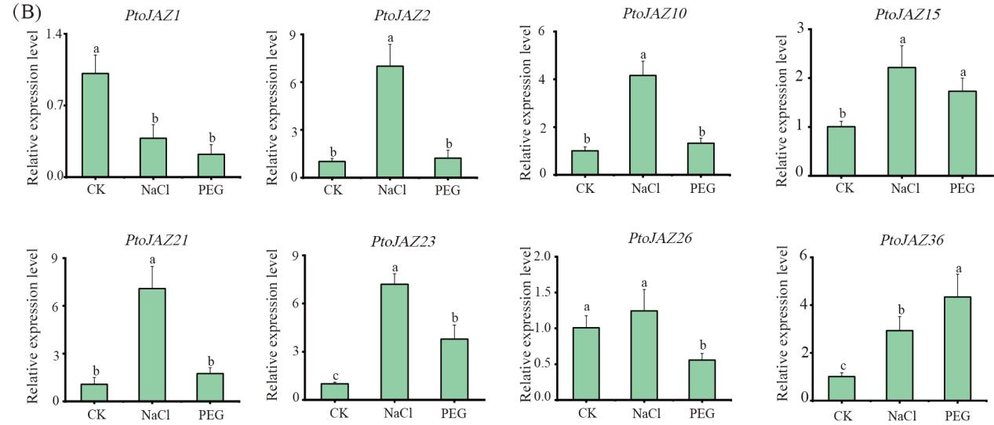
Fig.S5. RT-qPCR analysis of PtoJAZ genes after salt and drought treatments. Data in the figure are shown as means ± standard deviation (SD) from three biological replicates, with multiple comparisons performed using Duncan's test (p < 0.05).

Below is the original uncropped image of Figure 8A.
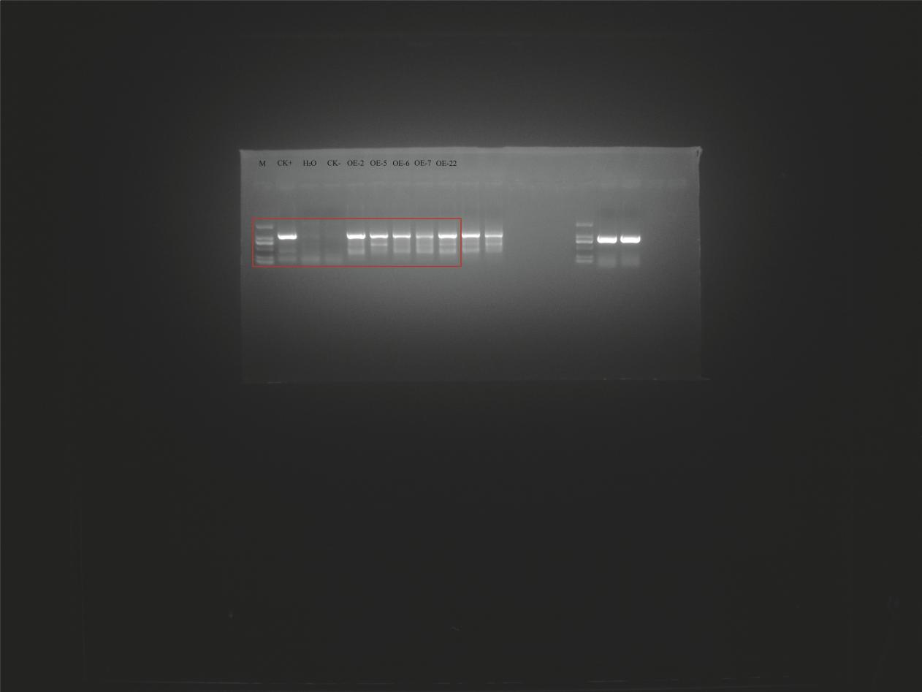
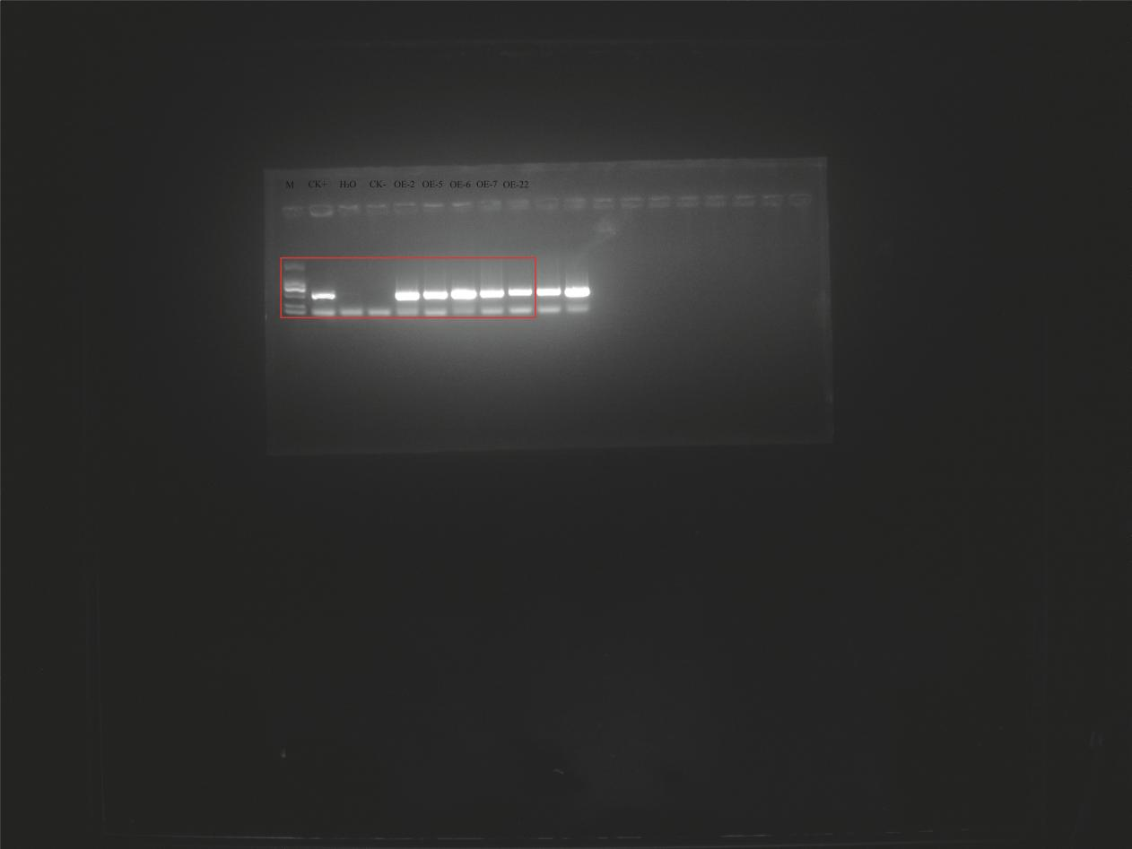
Original blots: PCR detection of the 35S::PtoJAZ10 transgene (top) and the NPTII selectable marker (bottom) in tobacco. M, 2000 bp DNA ladder; CK+, positive control; CK−, negative control.

