SUPPLEMENTARY INFORMATION

The emergence of subaerial crust and onset of weathering 3.7 billion years ago
Desiree L. Roerdink, Yuval Ronen, Harald Strauss, Paul R.D. Mason

1. Paleoarchean barite occurrences
Deposit | Location | Age | Depositional environment | Metamorphic  facies | Refs
Londozi | Theespruit Fm, Lower Onverwacht Group, Swaziland | 3520 Ma  (zircon U-Pb) | Marine volcanic-hydrothermal environment, mafic pillow lavas and felsic volcanic tuffs | Amphibolite | (1-3)
North Pole | Dresser Fm, Warrawoona Group, Western Australia | 3490 Ma  (galena Pb-Pb model age) | Hydrothermally-influenced marine volcanic caldera, chert with mafic lavas and felsic volcaniclastic rocks | Prehnite-pumpellyite to lower greenschist | (4-6)
Vergelegen | Kromberg/ Hooggenoeg Fm, Upper Onverwacht Group, South Africa | 3410 Ma  (stratigraphic correlation) ª | Marine volcanic-hydrothermal environment, chert with mafic and ultramafic lavas | Lower-middle greenschist | (3, 7)
Stentor/  Amo | Bien Venue Fm, Fig Tree Group, South Africa | 3260 Ma  (zircon U-Pb) | Marine volcanic-hydrothermal environment, calc-alkaline lavas and clastic sedimentary rocks | Upper greenschist | (8)
Barite Valley | Mapepe Fm, Fig Tree Group, South Africa | 3260 to 3230 Ma ^{b}  (zircon U-Pb) | Hydrothermally-influenced foreland basin, chert with clastic sedimentary rocks and both primary and reworked barite | Lower greenschist | (3, 9)
Sargur | Ghattihosahalli Schist Belt, Sargur Group, India | 3200 Ma  (Pb/Pb whole rock) | Marine volcanic-hydrothermal environment, mafic and ultramafic lavas with quartzite | Amphibolite | (10, 11)

Table S1 Overview of Paleoarchean barite deposits. ª The age of 3410 Ma is based on stratigraphic correlations with the Buck Reef Chert as outlined in Roerdink et al. (2012). Recent zircon dating of a felsic volcanic rock taken ca. 10-20 m below the barite horizon revealed an older age of 3537 Ma (12), but the stratigraphic relationship between the barite and the felsic schist is unclear as the contact between the two units is not exposed. The stratigraphy in this part of the greenstone belt is highly compressed. ^{b} The average age of 3245 Ma is used in this study.
2. Barite photographs with ⁸⁷Sr/⁸⁶Sr values
A selection of barite samples is shown in Figure S1 below, with bladed and granular crystal morphologies and measured Sr isotope values for each drilling location.

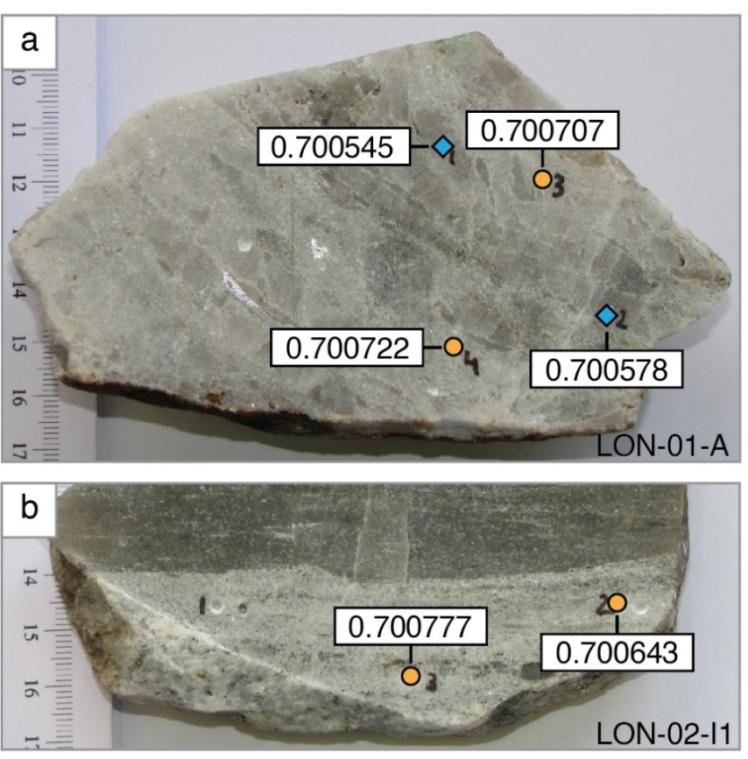
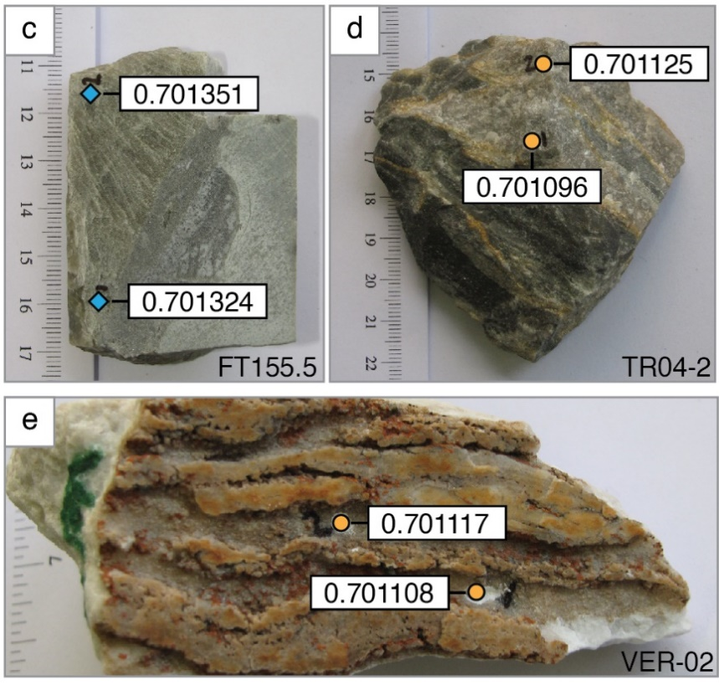

Figure S1 Bladed (blue diamonds) and granular (yellow circles) barite with measured ⁸⁷Sr/⁸⁶Sr values in barite from (a) Londozi (outcrop sample LON-01-A), (b) Londozi (outcrop sample LON-02-I1), (c) Barite Valley (drill core sample FT155.5), (d) Stentor/Amo (outcrop sample TR04-2) and (e) Vergelegen (outcrop sample VER-02).
3. Measured isotope ratios and Rb/Sr
Reported Sr, S and O isotope values are listed in Supplementary Table S2 (Excel file).

A subset of samples was analyzed for Rb and Sr concentrations to confirm our approach of reporting measured ⁸⁷Sr/⁸⁶Sr values instead of initial values. Rb is easily leached and measured concentrations are therefore likely to reflect Rb levels of the barite samples. However, Sr may only be partially leached from the samples due to poorly soluble mineral phases, leading to artificially high Rb/Sr ratios. Reported Sr concentrations from the leached fractions are significantly lower than average Sr concentrations measured in the barites using previously performed electron microprobe analyses (13). Based on these Sr concentrations, Rb/Sr ratios are very low (Table S3) and would require corrections for in situ Rb decay less than our analytical precision on Sr isotope analyses (2σ = 0.000009).

Sample | Age (Ma) | Rb_{leach} (ppm) | Sr_{leach}  (ppm) | Sr_{in situ} ª  (ppm) | Rb/Sr
LON-02-A1 1 | 3520 | 2.2 | 2281 | 10993 | 0.000199
LON-02-B1 3 | 3520 | 0.1 | 1398 | 10993 | 0.000006
LON-01-A1 | 3520 | 0.0 | 1850 | 10993 | 0.000003
LON-01-E1 | 3520 | 0.1 | 2471 | 10993 | 0.000010
VER-02 2 | 3410 | 1.6 | 2290 | 7526 | 0.000218
TR-03-2 | 3260 | 4.2 | 1705 | 8371 | 0.000497
TR-04-2 1 | 3260 | 0.1 | 3619 | 8371 | 0.000011
FT-173 | 3245 | 1.0 | 2742 | 7188 | 0.000135
BV-06-1 | 3245 | <0.6 | 2742 | 7188 | 0.000083

Table S3 Rb/Sr ratios in a subset of samples with the highest and lowest ⁸⁷Sr/⁸⁶Sr values measured per deposit. ª In situ values represent the average of 5 electron microprobe measurements for a representative barite from each location.

4. Metamorphic alteration of Sr isotope values
To explain the higher ⁸⁷Sr/⁸⁶Sr measured in granular versus bladed barite, we tested if the Sr isotopic composition in granular barite could have formed by recrystallization in the presence of a metamorphic or metasomatic fluid. Based on the calculations by Whitford et al. (14), we calculated for each deposit the composition of a fluid (Sr concentration and ⁸⁷Sr/⁸⁶Sr) that is required to change ⁸⁷Sr/⁸⁶Sr from the average value in the bladed barite to the highest measured ⁸⁷Sr/⁸⁶Sr in the granular barite (Table S4). We assumed a Sr concentration of 7000 ppm for each of the barite, and performed calculations for water-rock ratios of 1 (upper limit for metamorphic reactions without fluid addition) and 10 (commonly observed upper limit for metamorphic reactions with fluids) (15).

Deposit | Average ⁸⁷Sr/⁸⁶Sr bladed barite | Highest ⁸⁷Sr/⁸⁶Sr granular barite
Londozi | 0.700562 | 0.701004
Vergelegen | 0.700841 | 0.701117
Barite Valley | 0.701290 | 0.701478
Sargur | 0.701333 | 0.701989

Table S4 Average ⁸⁷Sr/⁸⁶Sr in bladed barite and highest ⁸⁷Sr/⁸⁶Sr in granular barite samples for each deposit (no bladed barite was measured at Stentor/Amo), as used for alteration calculations.

Results (Fig. S2) demonstrate that for a metamorphic fluid with ⁸⁷Sr/⁸⁶Sr of 0.703 (estimated composition of continental crust at 3.2 Ga, i.e. the main metamorphic event for the Londozi, Vergelegen and Barite Valley barites) to 0.706 (crust at 2.5 Ga, i.e. the main metamorphic event for the Sargur barite), the higher ⁸⁷Sr/⁸⁶Sr values in the granular barite can be explained by resetting with a metamorphic fluid with ~100-1000 ppm Sr. Such Sr levels fall within the range of Sr concentrations observed in metamorphic fluids from different geological settings (83-1964 ppm Sr) (16). Lower Sr concentrations would be required for fluids with higher ⁸⁷Sr/⁸⁶Sr, for example from incongruent leaching feldspar minerals in the crust.

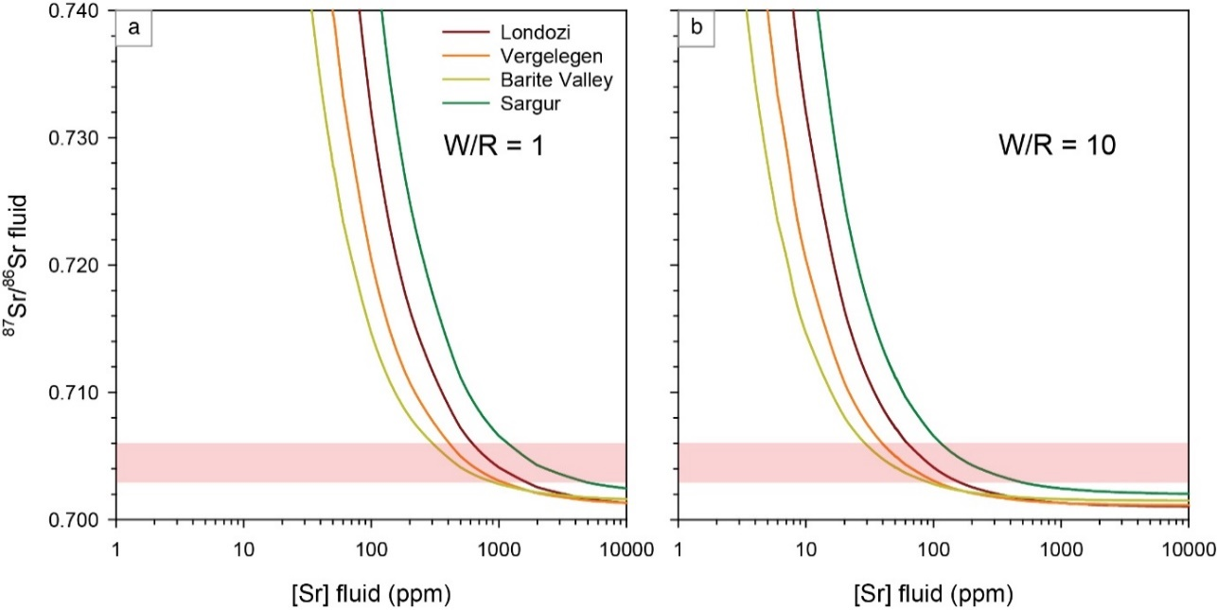

Figure S2 Modeled compositions of hydrothermal fluids required to shift ⁸⁷Sr/⁸⁶Sr from the average value measured in the bladed barite to the highest value in granular barite for each deposit. Red box indicates plausible fluid compositions based on the estimated composition of the continental crust between 3.2 Ga and 2.5 Ga. Required Sr concentrations in the metamorphic fluids are obtained from the intersection between the red box and the curves. (a) Calculations for a water-rock ratio of 1. (b) Calculations for a water-rock ratio of 10.

5. Saturation indices
Table S5 provides the used solubility products for barite and calculated saturation indices for various mixtures of hydrothermal fluid and seawater, with [SO₄²⁻]_{SW} = [SO₄²⁻]_{HF} = 8 µM, [NaCl]_{SW} = [NaCl]_{HF} = 0.6 M, T_{SW} = 20°C and T_{HF} = 150°C.

%HF | 0 | 10 | 20 | 30 | 40 | 50 | 60 | 70 | 80 | 90 | 100
T_{mix} | 20 | 33 | 46 | 59 | 72 | 85 | 98 | 111 | 124 | 137 | 150
log K_{sp} | -8.58 | -8.44 | -8.31 | -8.20 | -8.09 | -8.00 | -7.92 | -7.85 | -7.79 | -7.74 | -7.71
SI 75% | -0.12 | -0.05 | -0.03 | -0.04 | -0.06 | -0.08 | -0.10 | -0.12 | -0.13 | -0.13 | -0.12
SI 90% | -0.05 | 0.03 | 0.04 | 0.04 | 0.02 | 0.00 | -0.02 | -0.04 | -0.05 | -0.05 | -0.05
SI 99% | 0.00 | 0.07 | 0.09 | 0.08 | 0.06 | 0.04 | 0.02 | 0.00 | -0.01 | -0.01 | 0.00

Table S5 Calculated saturation indices for mixtures of hydrothermal fluid and seawater, with T_{mix} as the temperature of the mixture in °C, log K_{sp} as the temperature-dependent solubility product for barite in 0.6M NaCl, and SI 75%, SI 90% and SI 99% as the saturation indices assuming Ba concentrations in the hydrothermal fluid and seawater at 75%, 90% and 99% of solubility levels. Mixtures oversaturated with respect to barite are shown in bold green font.
6. Appearance of siliciclastic sediments in the rock record

Age | Location | Stratigraphic unit | Rock type | Refs
>3700 Ma | Isua Greenstone Belt, Greenland | - | Conglomerate (disputed (17)) | (18)
3430-3350 Ma | Eastern Pilbara craton, Western Australia | Strelley Pool Fm | Sandstone | (19)
3270-3250 Ma | Eastern Pilbara craton, Western Australia | Sulphur Springs Group, Leilira Fm | Sandstone, wacke | (20)
3260-3230 Ma | Kaapvaal craton, Barberton Greenstone Belt, South Africa | Fig Tree Group, Mapepe Fm | Shale, greywacke | (21)
3230-3080 Ma | Kaapvaal craton, Barberton Greenstone Belt, South Africa | Moodies Group | Sandstone, conglomerate, siltstone, shale | (22)
2960-2840 Ma | Kaapvaal craton, Barberton Greenstone Belt, South Africa | Mozaan Group | Sandstone, conglomerate, siltstone, shale | (23)
<3230 Ma | Dharwar craton, India | Sargur Group | Quartzite | (24)
2910-2720 Ma | Chitradurga Schist Belt, Dharwar craton, India | Bababudan Group | Quartzite | (25)

Table S6 Appearances of clastic sedimentary rocks in the rock record

7. Area of emerged crust
We assess the required area of emerged crust in the Paleoarchean by comparison of area-normalized weathering fluxes on the modern and early Earth, as outlined below. To obtain weathering fluxes for the Paleoarchean, we assume Sr isotopic mass balance as follows:

$${\left({{}_{}^{87}{Sr}}/{{}_{}^{86}{Sr}}\right)}_{SW}= \frac{F_{H}}{F_{H}+F_{W}} {\left({{}_{}^{87}{Sr}}/{{}_{}^{86}{Sr}}\right)}_{H}+ \frac{F_{W}}{F_{H}+F_{W}} {\left({{}_{}^{87}{Sr}}/{{}_{}^{86}{Sr}}\right)}_{W}$$

where (⁸⁷Sr/⁸⁶Sr)_{SW}, (⁸⁷Sr/⁸⁶Sr)_{H} and (⁸⁷Sr/⁸⁶Sr)_{W} represent the Sr isotopic compositions of seawater, hydrothermal input and weathering inputs, and F_{H} and F_{W} represent hydrothermal and weathering fluxes. We use the average seawater composition at 3.52 Ga, 3.41 Ga and 3.24 Ga obtained from our Sr isotope trend, and use the composition of the depleted mantle and continental crust for hydrothermal and weathering inputs. Based on previously estimated hydrothermal fluxes (26), we calculate weathering fluxes and flux ratios shown in Table S7.
Age | (⁸⁷Sr/⁸⁶Sr)_{SW} | (⁸⁷Sr/⁸⁶Sr)_{H} | (⁸⁷Sr/⁸⁶Sr)_{W} | F_{H} | F_{W} | F_{H}/F_{W}
3.52 Ga | 0.700480 | 0.699889 | 0.702328 | 4.20E+10 | 1.34E+10 | 3.1
3.41 Ga | 0.700792 | 0.699986 | 0.702627 | 4.00E+10 | 1.76E+10 | 2.3
3.24 Ga | 0.701250 | 0.700132 | 0.703076 | 3.80E+10 | 2.33E+10 | 1.6

Table S7 Calculated weathering fluxes and flux ratios (F_{H}/F_{W}) throughout the Paleoarchean. Sr isotopic compositions of the hydrothermal and weathering fluxes are based on trends for the depleted mantle and continental crust (see main text for details). Fluxes are given in mol Sr/year.

Our flux ratios are of a similar order of magnitude to previous estimates (26, 27).

We compare our results with present day weathering fluxes by normalization against the area of emerged continental crust. Based on a current global riverine Sr flux of 47.6 x 10⁹ mol/year (28) and 29% of the Earth’s surface (total 5.1 x 10⁸ km²) being emerged continental crust (29), we obtain a globally averaged weathering flux of 322 mol Sr/km²/year. Following the same reasoning, we obtain weathering fluxes of 658 to 1140 mol Sr/km²/year for the Paleoarchean assuming that only 4% of Earth’s surface consisted of emerged felsic crust (30). Some Archean sedimentary rocks show relatively high values for the chemical index of alteration (e.g. 31, 32) and high atmospheric CO₂ levels would have resulted in more rapid silicate weathering rates than today (33). However, the lack of physical erosion and mountainous topography may have limited element fluxes in the Paleoarchean (34), which would complicate a 2-4 times increase in the Archean Sr flux relative to the modern Earth. Instead, if we assume a weathering flux similar to today (322 mol Sr/km²/year) for the Paleoarchean, then we calculate that 8 to 14% of the Earth’s surface area must have been emerged felsic crust

References
1. D. L. Roerdink, P. R. D. Mason, M. J. Whitehouse, F. M. Brouwer, Reworking of atmospheric sulfur in a Paleoarchean hydrothermal system at Londozi, Barberton Greenstone Belt, Swaziland. Precambrian Res. 280, 195-204 (2016).
2. C. M. Barton, Geology and mineral resources of Northwest Swaziland (Barberton Greenstone Belt). Bulletin of the Swaziland Geological Survey and Mines Department 10 (1982).
3. T. O. Reimer, Archean sedimentary baryte deposits of the Swaziland Supergroup (Barberton Mountain Land, South Africa). Precambrian Res. 12, 393-410 (1980).
4. R. Buick, J. S. R. Dunlop, Evaporitic sediments of Early Archaean age from the Warrawoona Group, North Pole, Western Australia. Sedimentology 37, 247-277 (1990).
5. J. S. R. Dunlop (1978) Shallow-water sedimentation at North Pole, Pilbara block, Western Australia. in Geology Department and University Extension publication no. 2 (University of Western Australia, Perth, WA), pp 30-38.
6. W. Nijman, K. H. de Bruijne, M. E. Valkering, Growth fault control of Early Archaean cherts, barite mounds and chert-barite veins, North Pole Dome, Eastern Pilbara, Western Australia. Precambrian Res. 95, 247-274 (1999).
7. T. O. Reimer, Archaean baryte deposits of Southern Africa. J. Geol. Soc. India 35, 131-150 (1990).
8. E. A. Kohler, C. R. Anhaeusser, Geology and geodynamic setting of Archaean silicic metavolcaniclastic rocks of the Bien Venue Formation, Fig Tree Group, northeast Barberton greenstone belt, South Africa. Precambrian Res. 116, 199-235 (2002).
9. T. K. Heinrichs, T. Reimer, A sedimentary barite deposit from the Archean Fig Tree Group of the Barberton Mountain Land (South Africa). Econ. Geol. 72, 1426-1441 (1977).
10. T. C. Devaraju, M. M. Raith, B. Spiering, Mineralogy of the Archean barite deposit of Ghattihosahalli, Karnataka, India. Can. Mineral. 37, 603-617 (1999).
11. É. Muller et al., Primary sulfur isotope signatures preserved in high-grade Archean barite deposits of the Sargur Group, Dharwar Craton, India. Precambrian Res. 295, 38-47 (2017).
12. A. Kröner et al., Chronology of the oldest supracrustal sequences in the Palaeoarchaean Barberton Greenstone Belt, South Africa and Swaziland. Precambrian Res. 279, 123-143 (2016).
13. K. Oostingh (2012) Analysis of Rare Earth Element concentrations in barite (BaSO₄). (Utrecht University).
14. D. J. Whitford, M. J. Korsch, M. Solomon, Strontium isotope studies of barites: implications for the origin of base metal mineralization in Tasmania. Econ. Geol. 87, 953-959 (1992).
15. M. Bau, Rare-earth element mobility during hydrothermal and metamorphic fluid-rock interaction and the significance of the oxidation state of europium. Chem. Geol. 93, 219-230 (1991).
16. B. W. D. Yardley, 100th Anniversary Special Paper: Metal Concentrations in Crustal Fluids and Their Relationship to Ore Formation. Econ. Geol. 100, 613-632 (2005).
17. C. M. Fedo, Setting and origin for problematic rocks from the >3.7 Ga Isua Greenstone Belt, southern west Greenland: Earth’s oldest coarse clastic sediments. Precambrian Res. 101, 69-78 (2000).
18. C. M. Fedo, J. S. Myers, P. W. U. Appel, Depositional setting and paleogeographic implications of earth's oldest supracrustal rocks, the >3.7 Ga Isua Greenstone belt, West Greenland. Sediment. Geol. 141-142, 61-77 (2001).
19. D. R. Lowe, Restricted shallow-water sedimentation of Early Archean stromatolitic and evaporitic strata of the Strelley Pool Chert, Pilbara Block, Western Australia. Precambrian Res. 19, 239-283 (1983).
20. R. Buick et al., Geochronology and stratigraphic relationships of the Sulphur Springs Group and Strelley Granite: a temporally distinct igneous province in the Archaean Pilbara Craton, Australia. Precambrian Res. 114, 87-120 (2002).
21. D. R. Lowe, G. R. Byerly, Stratigraphy of the west-central part of the Barberton Greenstone belt, South Africa. Geol. Soc. Am. Spec. Pap. 329, 1-36 (1999).
22. C. Heubeck, D. R. Lowe, Sedimentary petrography and provenance of the Archean Moodies Group, Barberton greenstone belt. SPECIAL PAPERS-GEOLOGICAL SOCIETY OF AMERICA, 259-286 (1999).
23. B. Beukes, A lithostratigraphic-sedimentological reference profile for the Late Archaean Mozaan Group, Pongola Sequence: application to sequence stratigraphy and correlation with the Witwatersrand Supergroup. S. Afr. J. Geol. 94, 44-69 (1991).
24. M. Ramakrishnan, D. Venkata, A. Kröner, Middle Archaean age of Sargur Group by single grain zircon dating and geochemical evidence for the clastic origin of metaquartzite from JC Pura Greenstone belt, Karnataka. J. Geol. Soc. India 44, 605-616 (1994).
25. T. Hokada et al., An appraisal of Archaean supracrustal sequences in Chitradurga schist belt, western Dharwar Craton, southern India. Precambrian Res. 227, 99-119 (2013).
26. B. S. Kamber, Archean mafic–ultramafic volcanic landmasses and their effect on ocean–atmosphere chemistry. Chem. Geol. 274, 19-28 (2010).
27. A. M. Satkoski, D. R. Lowe, B. L. Beard, M. L. Coleman, C. M. Johnson, A high continental weathering flux into Paleoarchean seawater revealed by strontium isotope analysis of 3.26 Ga barite. Earth Planet. Sci. Lett. 454, 28-35 (2016).
28. B. Peucker-Ehrenbrink, G. J. Fiske, A continental perspective of the seawater 87Sr/86Sr record: A review. Chem. Geol. 510, 140-165 (2019).
29. W. D. Mooney, "1.11 - Crust and Lithospheric Structure - Global Crustal Structure" in Treatise on Geophysics (Second Edition), G. Schubert, Ed. (Elsevier, Oxford, 2015), https://doi.org/10.1016/B978-0-444-53802-4.00010-5, pp. 339-390.
30. N. Flament, N. Coltice, P. F. Rey, The evolution of the 87Sr/86Sr of marine carbonates does not constrain continental growth. Precambrian Res. 229, 177-188 (2013).
31. A. M. Hessler, D. R. Lowe, Weathering and sediment generation in the Archean: An integrated study of the evolution of siliciclastic sedimentary rocks of the 3.2Ga Moodies Group, Barberton Greenstone Belt, South Africa. Precambrian Res. 151, 185-210 (2006).
32. C. M. Fedo, K. A. Eriksson, E. J. Krogstad, Geochemistry of shales from the Archean (~3.0 Ga) Buhwa Greenstone Belt, Zimbabwe: Implications for provenance and source-area weathering. Geochim. Cosmochim. Acta 60, 1751-1763 (1996).
33. D. R. Lowe, M. M. Tice, Geologic evidence for Archean atmospheric and climatic evolution: Fluctuating levels of CO2, CH4, and O2 with an overriding tectonic control. Geology 32, 493-496 (2004).
34. J. Hao, A. H. Knoll, F. Huang, R. M. Hazen, I. Daniel, Cycling phosphorus on the Archean Earth: Part I. Continental weathering and riverine transport of phosphorus. Geochim. Cosmochim. Acta 273, 70-84 (2020).

