Prognostic value of circulating H3K27Me3-nucleosomes in newly diagnosed lung cancer patients

Supplemental Information

FIGURES
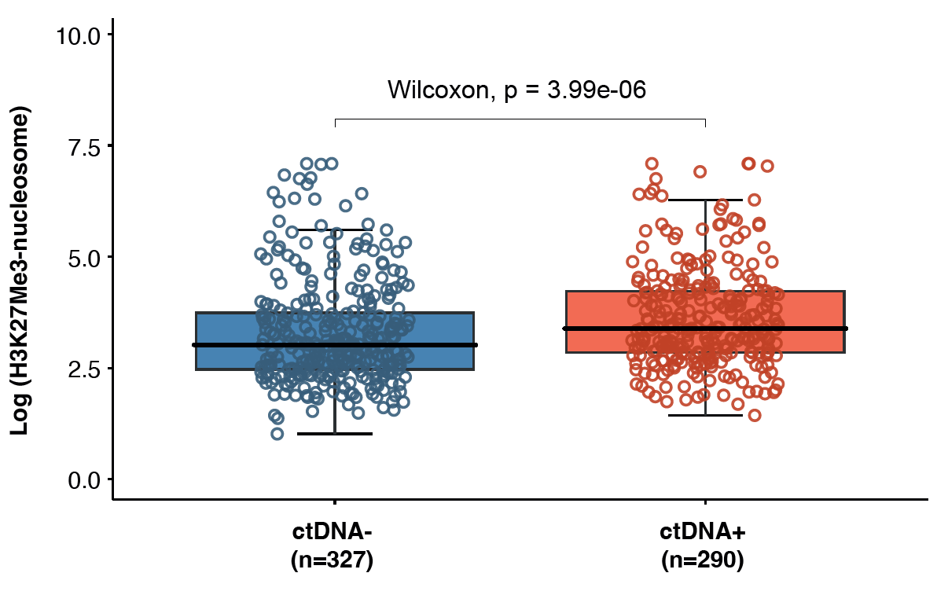

Figure S1: Higher circulating H3K27Me3-nucleosome levels in ctDNA+ patients compared to ctDNA - patients: Box plots show median, interquartile range for H3K27Me3-nucleosome levels in ctDNA positive patients (ctDNA+) compared to ctDNA negative patients (ctDNA -). Statistical comparison was performed using Wilcoxon rank–sum test (p-value = 3.99*10⁻⁶).

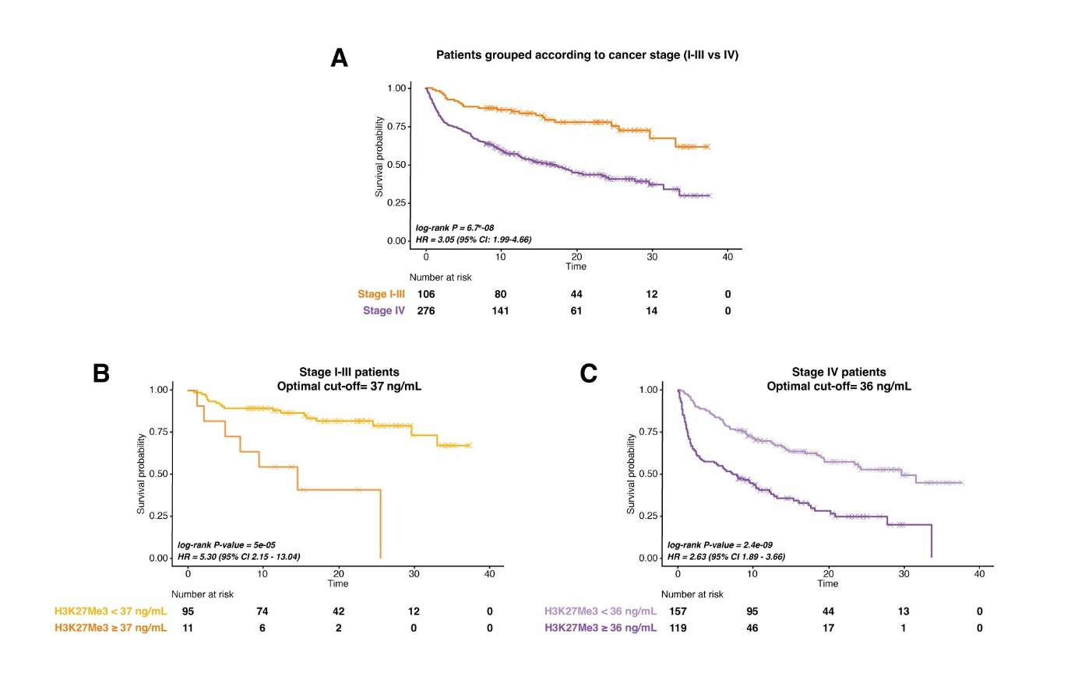
Figure S2: Kaplan-Meier curves in patients according to cancer stage. (A) Distinct survival probabilities according to cancer stage: Stage I-III patients (purple) have higher survival probabilities (RMST 24.7 months) than Stage IV patients (orange; RMST 16.6 months). (B) Optimal H3K27Me3-nucleosome cut-off value of 37 ng/mL classifies stage I-III patients in two groups with different survival outcomes: in light orange, K-M curve for patients with H3K27Me3 levels below the optimal cut-off (RMST 25.8 months) and in deep orange shows higher survival probabilities compared to K-M curve for patients with H3K27Me3 levels above the optimal cut-off (RMST 14.7 months). (C) Optimal H3K27Me3-nucleosome cut-off value of 36 ng/mL classifies stage IV patients in two groups with different survival: patients with H3K27Me3 levels below the optimal cut-off (light purple) have higher survival probabilities (RMST 20.3 months) than patients with H3K27Me3 levels above the optimal cut-off 36 ng/mL (dark purple; RMST 11.6 months). For each panel, the between-group comparison (log-rank test: P value, hazard ratio [HR], and 95% confidence interval [CI]) and the number of patients at risk are reported. Tick marks indicate censored individuals.

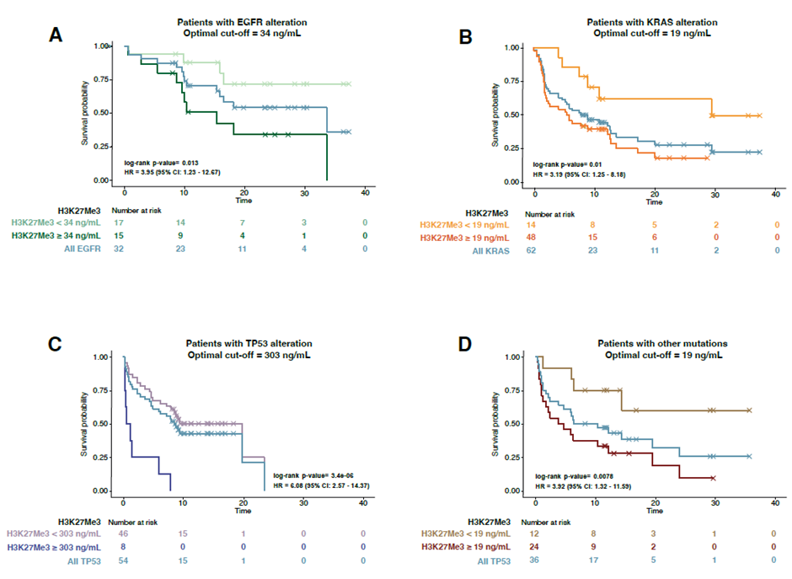
Figure S3: Kaplan-Meier curves in patients according to ctDNA mutations groups. (A) Optimal H3K27Me3-nucleosome cut-off value of 34 ng/mL classifies EGFR patients in two groups with different survival outcomes. In light green, K-M curve for patients with H3K27Me3 levels below the optimal cut-off (RMST 24.8 months), in dark green, K-M for patients with H3K27Me3 levels above the optimal cut-off (RMST 16.4 months) and in grey K-M for all EGFR patients (RMST 20.9 months). (B) Optimal H3K27Me3-nucleosome cut-off value of 19 ng/mL classifies KRAS patients in two groups with different survival outcomes. In light orange, K-M curve for patients with H3K27Me3 levels below the optimal cut-off (RMST 21.4 months), in dark orange, K-M for patients with H3K27Me3 levels above the optimal cut-off (RMST 10.3 months) and in grey K-M for all KRAS patients (RMST 12.8 months). (C) Optimal H3K27Me3-nucleosome cut-off value of 303 ng/mL classifies TP53 patients in two groups with different survival outcomes. In light blue, K-M curve for patients with H3K27Me3 levels below the optimal cut-off (RMST 13 months), in dark blue, K-M for patients with H3K27Me3 levels above the optimal cut-off (RMST 2.2 months) and in grey K-M for all TP53 patients (RMST 11.4 months). (D) Optimal H3K27Me3-nucleosome cut-off value of 19 ng/mL classifies other mutation patients in two groups with different survival outcomes. In light brown, K-M curve for patients with H3K27Me3 levels below the optimal cut-off (RMST 21.4 months), in dark brown, K-M for patients with H3K27Me3 levels above the optimal cut-off (RMST 9.2 months) and in grey K-M for all patients in other mutations group (RMST 13.2 months). For each panel, the between-group comparison (log-rank test: P value, hazard ratio [HR], and 95% confidence interval [CI]) and the number of patients at risk are reported. Tick marks indicate censored individuals.
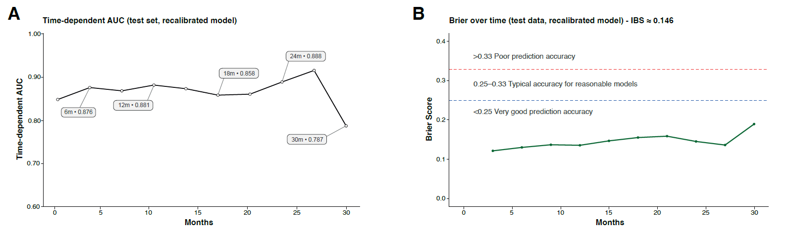
Figure S4. Model performance validation. (A) Time-dependent area under the ROC curve (AUC) on TEST (recalibrated model). Line and points show the AUC for the recalibrated model at 6, 12, 18, 24, and 30 months; labels on the points report the exact AUC values. (B) Brier score on TEST (recalibrated model). Line and points show the Brier score over time with dashed reference lines at 0.25 and 0.33 for interpretability. The integrated Brier score (IBS) over 0–30 months is reported on the panel title.

TABLES
Table S1. Distribution of patients included in the survival analyses according to ctDNA status, cancer stage, and H3K27Me3-nucleosome levels.

 |  | Cancer stage | n | %
ctDNA- | H3K27Me3  < 57 ng/mL | Stage I-III | 87 | 33
ctDNA- | H3K27Me3  < 57 ng/mL | Stage IV | 103 | 39
ctDNA- | H3K27Me3  < 57 ng/mL | No confirmed cancer stage | 75 | 28
ctDNA- | H3K27Me3  ≥ 57 ng/mL | Stage I-III | 5 | 8
ctDNA- | H3K27Me3  ≥ 57 ng/mL | Stage IV | 38 | 58
ctDNA- | H3K27Me3  ≥ 57 ng/mL | No confirmed cancer stage | 22 | 34
ctDNA+ | H3K27Me3  < 123 ng/mL | Stage I-III | 13 | 8
ctDNA+ | H3K27Me3  < 123 ng/mL | Stage IV | 115 | 75
ctDNA+ | H3K27Me3  < 123 ng/mL | No confirmed cancer stage | 25 | 17
ctDNA+ | H3K27Me3  ≥ 123 ng/mL | Stage I-III | 1 | 3
ctDNA+ | H3K27Me3  ≥ 123 ng/mL | Stage IV | 20 | 63
ctDNA+ | H3K27Me3  ≥ 123 ng/mL | No confirmed cancer stage | 10 | 33

Table S2. Cox coefficients from the development set and post-fit recalibration.
Covariate | ß | HR | HR low | HR high | p | Significance | Calibration  slope (y) | ß recal | HR recal | HR recal  low | HR recal  high
H3K27Me3 ≥ 56 ng/mL | 0.852 | 2.345 | 1.606 | 3.425 | 0.0000103 | *** | 1.181 | 0.006 | 2.735 | 1.749 | 4.277
Cancer stage IV | 0.713 | 2.041 | 1.212 | 3.436 | 0.0072748 | *** | 1.181 | 0.842 | 2.322 | 1.255 | 4.294
EGFR | -0.486 | 0.615 | 0.262 | 1.443 | 0.2639001 |  | 1.181 | -0.573 | 0.564 | 0.206 | 1.541
KRAS | 0.618 | 1.854 | 1.130 | 3.044 | 0.0145762 | * | 1.181 | 0.729 | 2.073 | 1.155 | 3.721
TP53 | 0.511 | 1.666 | 0.919 | 3.019 | 0.0923499 |  | 1.181 | 0.603 | 1.827 | 0.906 | 3.686
Other mutation | 0.824 | 2.279 | 1.322 | 3.929 | 0.0030291 | ** | 1.181 | 0.973 | 2.645 | 1.390 | 5.030
Age | 0.032 | 1.033 | 1.017 | 1.049 | 0.0000518 | *** | 1.181 | 0.038 | 1.039 | 1.020 | 1.058

β_train (log-HR), HR, 95% Wald CI, and two-sided p-values come from the Cox model fitted on train data set. Recalibrated effects are β_recal = γ·β_train and HR_recal = exp(β_recal). Reference categories: (H3K27Me3 cut-off 56ng/mL) = Low; (Cancer stage group) = I–III; (ctDNA mutation group) = ctDNA-; Age per 1-year increase.

MATERIAL AND METHODS

Composition of panels used in this study

Plasma SeqSenseiTM - SYSMEX:
BRAF (NM_004333) (c.1383-1431, c.1742-1813), EGFR (NM_005228) (c.2116-2177, c.225-2279, c.2284-2325, c.2361-2403, c.2565-2620), KRAS (NM_004985) (c.34-102, c.169-228, c.326-352, c.419-445), PIK3CA (NM_006218) (c.1611-1659, c.3118-3195).

Comprehensive SOPHiA GENETICS panel:
ABCF3 (NM_018358.2 (exons '8)), AKT1 (NM_005163.2, NM_001014431.1, NM_001014432.1), ALK (NM_004304.4), AR (NM_000044.3), ARID1A (NM_006015.4 (exons '1,3-9,11-12,14-18,20 ), NM_139135.2 (exons '1,3-9,11-12,14-18,20)), ARID2 (NM_152641.3 (exons '8,13,15), NM_001347839.1 (exons '8,13,15)), B2M (NM_004048.2(exons '1-2 )), BAP1 (NM_004656.3), BCL2 (NM_000633.2, NM_000657.2), BCL2L1 (NM_001191.3, NM_138578.2, NM_001317919.1, NM_001317920.1, NM_001317921.1, NM_001322239.1, NM_001322240.1, NM_001322242.1), BRAF (NM_004333.4), CARD11 (NM_032415.5 (exons '3-9 ), NM_001324281.1 (exons '4-10 )), CCND1 (NM_053056.2), CCND2 (NM_001759.3), CCNE1 (NM_001238.3, NM_001322259.1, NM_001322261.1, NM_001322262.1), CDK4 (NM_000075.3), CDK6 (NM_001259.6, NM_001145306.1), CDKN2A (NM_000077.4, NM_058197.4), CTNNB1 (NM_001904.3 (exons '2-5,7-8,10-15), NM_001098209.1 (exons '2-5,7-8,10-15), NM_001098210.1 (exons '2-5,7-8,10-15), NM_001330729.1 (exons '4-6,8-9,11-16)), DDR2 (NM_006182.2 (exons '17), NM_001014796.1 (exons '18)), DICER1 (NM_030621.4 (exons '26-28), NM_177438.2 (exons '24-26), NM_001195573.1 (exons '23-24), NM_001271282.2 (exons '24-26), NM_001291628.1 (exons '24-26)), EGFR (NM_005228.4, NM_201282.1, NM_201283.1, NM_201284.1, NM_001346897.1, NM_001346898.1, NM_001346899.1, NM_001346900.1, NM_001346941.1), EIF1AX (NM_001412.3 (exons '1-2,6)), ELOB (NM_207013.2 (exons '5)), ERBB2 (NM_004448.3, NM_001005862.2, NM_001289936.1, NM_001289937.1, NM_001289938.1), ERBB4 (NM_005235.2, NM_001042599.1), ESR1 (NM_000125.3, NM_001122740.1, NM_001122741.1, NM_001122742.1, NM_001291230.1, NM_001291241.1, NM_001328100.1), FBXW7 (NM_018315.4 (exons '6-10 ), NM_033632.3 (exons '7-11), NM_001013415.1 (exons '6-10)), FGFR1 (NM_015850.3 (exons '12,14), NM_023105.2 (exons '11,13), NM_023106.2 (exons '11,13), NM_023110.2 (exons '12,14), NM_001174063.1 (exons '12,14), NM_001174064.1 (exons '13,15), NM_001174065.1 (exons '12,14), NM_001174066.1 (exons '11,13), NM_001174067.1 (exons '13,15)), FGFR2 (NM_000141.4, NM_022970.3, NM_023029.2, NM_001144913.1, NM_001144914.1, NM_001144915.1, NM_001144916.1, NM_001144917.1, NM_001144918.1, NM_001144919.1, NM_001320654.1, NM_001320658.1), FGFR3 (NM_000142.4, NM_022965.3, NM_001163213.1), FOXL2 (NM_023067.3), GNA11 (NM_002067.4 (exons '4-5)), GNAQ (NM_002072.4), HIST1H3B (NM_003537.3), GNAS (NM_000516.5 (exons '8-9), NM_080425.3 (exons '8-9), NM_080426.3 (exons '7-8), NM_001077488.3 (exons '8-9), NM_001077489.3 (exons '7-8), NM_001309840.1 (exons '8-9), NM_001309861.1 (exons '8-9)), H3F3A (NM_002107.4 (exons '2)), H3F3B (NM_005324.4 (exons '2)), HRAS (NM_176795.4), IDH2 (NM_002168.3 (exons '4), NM_001289910.1 (exons '4), NM_001290114.1 (exons '2)), INSRR (NM_014215.2 (exons '19)), JAK1 (NM_002227.3 (exons '5,9,11,19), NM_001320923.1 (exons '6,10,12,20), NM_001321852.1 (exons '5,9,11,19), NM_001321853.1 (exons '7,11,13,21), NM_001321854.1 (exons '6,10,12,20), NM_001321855.1 (exons '6,10,12,20), NM_001321856.1 (exons '5,9,11,19), NM_001321857.1 (exons '5,9,11,19)), JAK2 (NM_004972.3 (exons '12,14), NM_001322194.1 (exons '12,14), NM_001322195.1 (exons '11,13), NM_001322196.1 (exons '11,13), NM_001322198.1 (exons '12,14), NM_001322199.1 (exons '12,14), NM_001322204.1 (exons '9,11)), KCNMB3 (NM_001163677.1 (exons '4)), KEAP1 (NM_012289.3, NM_203500.1), KIT (NM_000222.2, NM_001093772.1), KMT2C (NM_170606.2 (exons '1-11,16-18,23,25,27,29,32,34-35,44-45,47-48,51)), KRAS (NM_004985.4, NM_033360.3), LRP1B (NM_018557.2 (exons '2,4-5,7,9-10,12-13,16,20-21,27,29,35,44-47,50,52,54,58,61,69-71,73,76,81-82,85,90)), LTBP4 (NM_003573.2 (exons '17-18), NM_001042544.1 (exons '17-18), NM_001042545.1 (exons '14-15)), MAP2K1 (NM_002755.3 (exons '2-4,6-7,11)), MCL1 (NM_021960.4, NM_182763.2, NM_001197320.1), MCM3AP (NM_003906.4 (exons '2,11)), MET (NM_000245.3, NM_001127500.2, NM_001324401.1, NM_001324402.1), MRPS9 (NM_182640.2 (exons '1)), MSH2 (NM_000251.2 (exons '5), NM_001258281.1 (exons '6)), MYOD1 (NM_002478.4 (exons '1)), NCK1 (NM_006153.5 (exons '3), NM_001190796.2 (exons '2), NM_001291999.1 (exons '3)), NOTCH1 (NM_017617.4 (exons '34)), NOTCH2 (NM_024408.3 (exons '34)), NRAS (NM_002524.4), NRG1 (NM_004495.3, NM_013956.4, NM_013957.4, NM_013958.3, NM_013959.3, NM_013960.4, NM_013964.4, NM_001159995.2, NM_001159996.2, NM_001159999.2, NM_001160001.2, NM_001160002.1, NM_001160004.2, NM_001160005.1, NM_001160007.1, NM_001160008.1, NM_001322197.1, NM_001322201.1, NM_001322202.1, NM_001322205.1, NM_001322206.1, NM_001322207.1), NTRK1 (NM_002529.3, NM_001007792.1, NM_001012331.1), NTRK2 (NM_006180.4, NM_001007097.2, NM_001018064.2, NM_001018065.2, NM_001018066.2, NM_001291937.1), NTRK3 (NM_002530.3, NM_001007156.2, NM_001012338.2, NM_001243101.1, NM_001320134.1, NM_001320135.1), PDGFRA (NM_006206.5 (exons '12-23), NM_001347827.1 (exons '12-16), NM_001347828.1 (exons '13-24), NM_001347829.1 (exons '12-23), NM_001347830.1 (exons '12-23)), PFDN6 (NM_014260.3 (exons '5), NM_001185181.2 (exons '4), NM_001265595.1 (exons '5), NM_001265596.1 (exons '5)), PGAP3 (NM_033419.4 (exons '1), NM_001291726.1 (exons '1), NM_001291728.1 (exons '1), NM_001291730.1 (exons '1), NM_001291732.1 (exons '1), NM_001291733.1 (exons '1)), PIK3CA (NM_006218.3), POLE (NM_006231.3), PPIH (NM_006347.3 (exons '3), NM_001330510.1 (exons '3)), PTEN (NM_000314.6, NM_001304718.1), PTPN11 (NM_002834.4 (exons '3), NM_080601.2 (exons '3), NM_001330437.1 (exons '3 )), RABEP1 (NM_004703.5 (exons '17 ), NM_001083585.2 (exons '16 ), NM_001291581.1 (exons '16)), RAC1 (NM_006908.4 (exons '2-3), NM_018890.3 (exons '2-3)), RAF1 (NM_002880.3 (exons '7,10,12-15)), RB1 (NM_000321.2), STK11 (NM_000455.4), RET (NM_020630.4 (exons '10-11,13,15-16), NM_020975.4 (exons '10-11,13,15-16)), ROS1 (NM_002944.2 (exons '1,4,6-7,9-12,14-20,23-24,26-29,31-34,36,38-43)), SEC63 (NM_007214.4 (exons '16)), SF3B1 (NM_012433.3 (exons '13-18)), SLC15A4 (NM_145648.3 (exons '5)), SMAD4 (NM_005359.5 (exons '8-12)), STT3A (NM_152713.4 (exons '18), NM_001278503.1 (exons '19), NM_001278504.1 (exons '17)), TERT (NM_198253.2 (exons '8-9,13), NM_001193376.1 (exons '8-9,12)), TP53 (NM_000546.5, NM_001126112.2, NM_001126113.2, NM_001126114.2, NM_001126115.1, NM_001126116.1, NM_001126117.1, NM_001126118.1, NM_001276695.1, NM_001276696.1, NM_001276697.1, NM_001276698.1, NM_001276699.1, NM_001276760.1, NM_001276761.1), UBE2Z (NM_023079.4 (exons '6)), ULK4 (NM_017886.3 (exons '36-37), NM_001322501.1 (exons '35-36)), USP4 (NM_003363.3 (exons '3), NM_199443.2 (exons '3), NM_001251877.1 (exons '3)).

Targeted SOPHiA GENETICS panel:
SNV alterations: AKT1 NM_001382431.1 (exons 4), ALK NM_004304.5 (exons 21-25), BRAF NM_004333.6 (exons 11,15), CD74 NM_001025159.3 (exons 6), EGFR NM_005228.5 (exons 12,18-21), ERBB2 NM_004448.4 (exons 7-8,17-22), ESR1 NM_000125.4 (exons 4-8), FGFR2 NM_000141.5 (exons 7,9,12-14), FGFR3 NM_000142.5 (exons 7,9,12,14,18), Hotspots in CDS : Chr. 4 Start : 1803381, End : 1803500, IDH1 NM_005896.4 (exons 4), KIF5B NM_004521.3 (exons 17), KIT NM_000222.3 (exons 8-9,11,13-14,17), KRAS NM_004985.5 (exons 2-4), MEN1 NM_001370251.2 (exons 2-7,9-11), NM_000244.4, NM_130799.3, MET NM_000245.4 (exons 13-19), NPM1 NM_002520.7 (exons 6), NRAS NM_002524.5 (exons 2-4), PDGFRA NM_006206.6 (exons 12,14,18), PIK3CA NM_006218.4 (exons 2-3,5,8,10,21), PTEN NM_000314.8, RET NM_020975.6 (exons 8,10-16), ROS1 NM_002944.3 (exons 32-34,37-38,41), STK11 NM_000455.5, TP53 NM_000546.6
Fusions / rearrangements: ALK NM_004304 Intron 17,19, FGFR2 NM_000141 Intron 17, FGFR3 NM_000142 Intron 17; exon 18, RET NM_020975 Intron 11; exon 11, ROS1 NM_002944 Intron 31,32,33,34; exon 32,33,34, EML4 NM_019063 Intron 6,13,18,20, KIF5B NM_004521 Intron 15,16,24, SLC34A2 NM_006424 Intron 4, EZR NM_001111077 Intron 10, CD74 NM_001025159 Intron 6.

TRIPOD + AI Checklist: Prediction Model Development and Validation
Section/Topic | Item |  | Checklist Item | Page
Title and abstract
Title | 1 | D;E | Identify the study as developing or evaluating the performance of a multivariable prediction model, the target population, and the outcome to be predicted | Title
Abstract | 2 | D;E | See TRIPOD+AI for Abstracts checklist | Abstract
Introduction
Background | 3a | D;E | Explain the healthcare context (including whether diagnostic or prognostic) and rationale for developing or evaluating the prediction model, including references to existing models | Introduction, § 3-4
Background | 3b | D;E | Describe the target population and the intended purpose of the prediction model in the context of the care pathway, including its intended users (eg, healthcare professionals, patients, public). | Introduction, § 4
Background | 3c | D;E | Describe any known health inequalities between sociodemographic groups | n/a
Objectives | 4 | D;E | Specify the study objectives, including whether the study describes the development or validation of a prediction model (or both) | Introduction, § 4
Methods
Data | 5a | D;E | Describe the sources of data separately for the development and evaluation datasets (eg, randomised trial, cohort, routine care or registry data), the rationale for using these data, and representativeness of the data | Methods, § 1 and 7
Data | 5b | D;E | Specify the dates of the collected participant data, including start and end of participant accrual; and, if applicable, end of follow-up | Methods, § 1 and 6
Participants | 6a | D;E | Specify key elements of the study setting (eg, primary care, secondary care, general population) including the number and location of centres. | Methods, § 1
Participants | 6b | D;E | Describe eligibility criteria for participants. | Methods, § 1
Participants | 6c | D;E | Give details of any treatments received, and how they were handled during model development or evaluation, if relevant | Not relevant
Data preparation | 7 | D;E | Describe any data pre-processing and quality checking, including whether this was similar across relevant sociodemographic groups | Methods, § 5
Outcome | 8a | D;E | Clearly define the outcome that is being predicted and the time horizon, including how and when assessed, the rationale for choosing this outcome, and whether the method of outcome assessment is consistent across sociodemographic groups | Methods, § 7
Outcome | 8b | D;E | If outcome assessment requires subjective interpretation, describe the qualifications and demographic characteristics of the outcome assessors | n/a
Outcome | 8c | D;E | Report any actions to blind assessment of the outcome to be predicted | Methods, § 1 and 8.2
Predictors | 9a | D;E | Describe the choice of initial predictors (eg, literature, previous models, all available predictors) and any pre-selection of predictors before model building | Introduction and Methods § 2-7
Predictors | 9b | D;E | Clearly define all predictors, including how and when they were measured (and any actions to blind assessment of predictors for the outcome and other predictors) | Methods § 2-7
Predictors | 9c | D;E | If predictor measurement requires subjective interpretation, describe the qualifications and demographic characteristics of the predictor assessors | n/a
Sample size | 10 | D;E | Explain how the study size was arrived at (separately for development and evaluation), and justify that the study size was sufficient to answer the research question. Include details of any sample size calculation | Methods §7
Missing data | 11 | D;E | Describe how missing data were handled. Provide reasons for omitting any data | Methods §6 and 7 and Fig 1
Analytical  Methods  Analytical  Methods | 12a | D | Describe how the data were used (eg, for development and evaluation of model performance) in the analysis, including whether the data were partitioned, considering any sample size requirements | Methods §5, 6 and 7
Analytical  Methods  Analytical  Methods | 12b | D | Depending on the type of model, describe how predictors were handled in the analyses (functional form, rescaling, transformation, or any standardisation) | Methods §5, 6 and 7
Analytical  Methods  Analytical  Methods | 12c | D | Specify the type of model, rationale†, all model building steps, including any hyperparameter tuning, and method for internal validation | Methods §7
Analytical  Methods  Analytical  Methods | 12d | D;E | Describe if and how any heterogeneity in estimates of model parameter values and model performance was handled and quantified across clusters (eg, hospitals, countries). See TRIPOD-Cluster for additional considerations‡ | n/a
Analytical  Methods  Analytical  Methods | 12e | D;E | Specify all measures and plots used (and their rationale) to evaluate model performance (eg, discrimination, calibration, clinical utility) and, if relevant, to compare multiple models | n/a
Analytical  Methods  Analytical  Methods | 12f | E | Describe any model updating (eg, recalibration) arising from the model evaluation, either overall or for particular sociodemographic groups or settings | Methods §5, 6 and 7
Analytical  Methods  Analytical  Methods | 12g | E | For model evaluation, describe how the model predictions were calculated (eg, formula, code, object, application programming interface) | Methods §7
Class imbalance | 13 | D;E | If class imbalance methods were used, state why and how this was done, and any subsequent methods to recalibrate the model or the model predictions | n/a
Fairness | 14 | D;E | For validation, identify any differences from the development data in setting, eligibility criteria, outcome, and predictors. | n/a
Model output | 15 | D | Specify the output of the prediction model (eg, probabilities, classification). Provide details and rationale for any classification and how the threshold ds were identified | Methods §7
Training versus evaluation | 16 | D;E | Identify any differences between the development and evaluation data in healthcare setting, eligibility criteria, outcome, and predictors | n/a
Ethical approval | 17 | D;E | Name the institutional research board or ethics committee that approved the study and describe the participant informed consent or the ethics committee waiver of informed consent | Methods §1
Open science
Funding | 18a | D;E | Give the source of funding and the role of the funders for the present study. | Declarations §5
Conflicts of interest | 18b | D;E | Declare any conflicts of interest and financial disclosures for all authors | Declarations §4
Protocol | 18c | D;E | Indicate where the study protocol can be accessed or state that a protocol was not prepared | Declarations §1
Registration | 18d | D;E | Provide registration information for the study, including register name and registration number, or state that the study was not registered | Methods §1
Data sharing | 18e | D;E | Provide details of the availability of the study data | Declarations §3
Code sharing | 18f | D;E | Provide details of the availability of the analytical code§ | Declarations §3
Patient and public involvement
Patient  and public  involvement | 19 | D;E | Provide details of any patient and public involvement during the design, conduct, reporting, interpretation, or dissemination of the study or state no involvement | Methods §1
Results
Participants | 20a | D;E | Describe the flow of participants through the study, including the number of participants with and without the outcome and, if applicable, a summary of the follow-up time. A diagram may be helpful | Results, § 1, Fig. 1 and Table 1
Participants | 20b | D;E | Report the characteristics overall and, where applicable, for each data source or setting, including the key dates, key predictors (including demographics), treatments received, sample size, number of outcome events, follow-up time, and amount of missing data. A table may be helpful. Report any differences across key demographic groups | Results, § 1, Table 1
Participants | 20c | E | For model evaluation, show a comparison with the development data of the distribution of important predictors (demographics, predictors, and outcome) | n/a
Model development | 21 | D | Specify the number of participants and outcome events in each analysis (eg, for model development, hyperparameter tuning, model evaluation). | Methods, § 7
Model specification | 22 | D | Provide details of the full prediction model (eg, formula, code, object, application programming interface) to allow predictions in new individuals and to enable third party evaluation and implementation, including any restrictions to  access or reuse (eg, freely available, proprietary)¶ | Methods §7, Results §4 and SI
Model performance | 23a | D;E | Report model performance estimates with confidence intervals, including for any key subgroups (eg, sociodemographic). Consider plots to aid presentation | Results §4, Fig. 4,5 and SI Table S3
Model performance | 23b | D;E | If examined, report results of any heterogeneity in model performance across clusters. See TRIPOD-Cluster for additional details‡ | n/a
Model updating | 24 | E | Report the results from any model updating, including the updated model and subsequent performance | n/a
Discussion
Interpretation | 25 | D;E | Give an overall interpretation of the main results, including issues of fairness in the context of the objectives and previous studies | Discussion §1-7
Limitations | 26 | E | Discuss any limitations of the study (such as a non-representative sample, sample size, overfitting, missing data) and their effects on any biases, statistical uncertainty, and generalisability | Discussion §6
Usability of  the model in  the context of current care | 27a | D | Describe how poor quality or unavailable input data (eg, predictor values) should be assessed and handled when implementing the prediction model | Discussion §6
Usability of  the model in  the context of current care | 27b | D | Specify whether users will be required to interact in the handling of the input data or use of the model, and what level of expertise is required of users | Discussion §7
Usability of  the model in  the context of current care | 27c | D;E | Discuss any next steps for future research, with a specific view to applicability and generalisability of the model | Discussion §7

TRIPOD=Transparent Reporting of a multivariable prediction model for Individual Prognosis Or Diagnosis; AI=artificial intelligence.
*D=items relevant only to the development of a prediction model;
E=items relating solely to the evaluation of a prediction model;
D;E=items applicable to both the development and evaluation of a prediction model.
†Separately for all model building approaches.
‡TRIPOD-Cluster is a checklist of reporting recommendations for studies developing or validating models that explicitly account for clustering or explore heterogeneity in model performance (eg, at different hospitals or centres).19 20
§Relates to the analysis code, for example, any data cleaning, feature engineering, model building, and evaluation.
¶Relates to the code to implement the model to get estimates of risk for a new individual.

