This PDF file includes:
Supplementary Notes 1-8
Supplementary Figs 1 to 16
Supplementary Tables 1 to 7
Supplementary References

Supplementary Note 1. Preparation of P@C₆₀
1-1 Synthesis
We first employed an in situ static deposition magnetron sputtering system (Supplementary Figure 1a) to explore the synthesis conditions for P@C₆₀. Key parameters, including sputtering power, fullerene sublimation temperature, substrate deposition temperature, and reaction time, were systematically investigated. In addition, the effect of target composition was studied using two polymeric binders, thermoplastic polyurethane (TPU) and low-density polyethylene (LDPE), at weight fractions of 5%, 10%, and 20% (Supplementary Table 1). For TPU, a 5% fraction was insufficient to solidify the target, leading to target detachment during the reaction. The P@C₆₀ purity was highest at 10% TPU and decreased at 20% TPU, whereas LDPE-based targets produced relatively low-purity P@C₆₀ at all tested fractions. The P@C₆₀ recovery ratio was consistently ~10% for all TPU targets and ~5% for all LDPE targets, making 10% TPU the optimal choice.
The overall synthesis involves preparing a phosphorus target, followed by simultaneous C₆₀ sublimation and P⁺ generation via magnetron sputtering; the P⁺ ions react with the sublimed C₆₀ during flight and co-deposit onto a water-cooled copper substrate. The deposited film is then dissolved in toluene and filtered to yield crude P@C₆₀ (~80–100 ppm, Supplementary Figure 1c).
For target preparation, 3.6 g of non-toxic red phosphorus was homogeneously mixed with 0.4 g of TPU, pressed into a copper holder, and cured at 120 °C for 1 h to form a solid, mechanically stable target. Separately, 200 mg of C₆₀ was sublimed under 10⁻¹–10⁻² Pa by gradually heating from 500 °C to 650 °C over 1.5 h. Meanwhile, during sublimation, the phosphorus target was magnetron sputtered (90–120 W) using argon plasma, generating P⁺ ions that reacted with the C₆₀ during flight and co-deposited onto a water-cooled copper substrate (−20 °C).
After optimizing the conditions using the in situ static setup, a roll-to-roll deposition system (Supplementary Figure 1b) was employed to scale up the process for gram-scale P@C₆₀. This setup enables continuous transfer of the deposited product, preventing long-term exposure that could degrade the material, allowing larger precursor loading and extended deposition time, and thus continuous gram-scale synthesis of P@C₆₀.
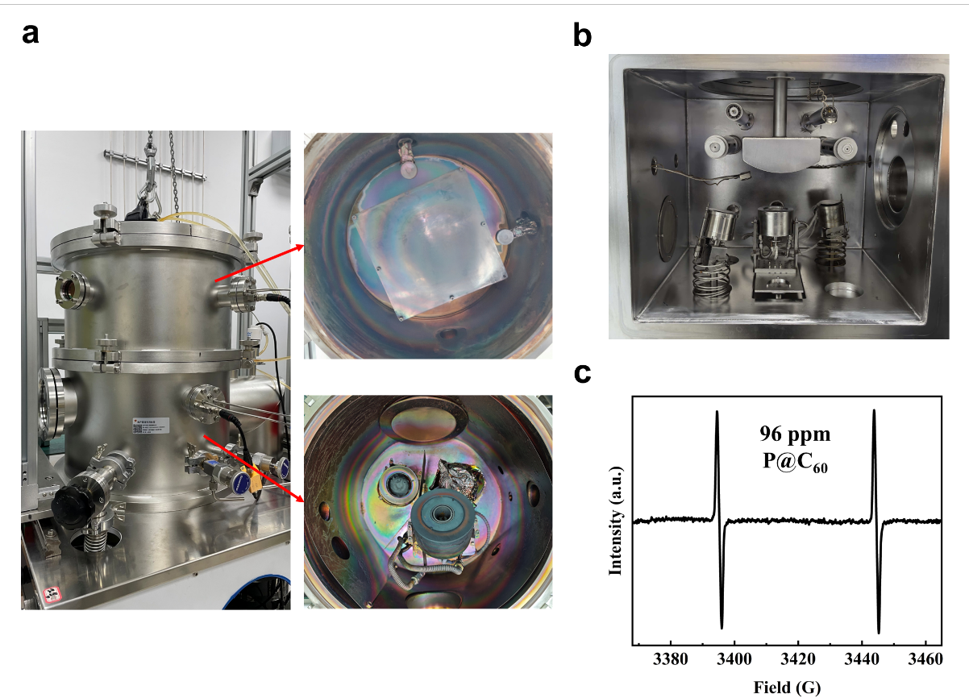
Supplementary Figure 1. Experimental setups for the synthesis of P@C₆₀. (a) Photograph of the in situ static deposition magnetron sputtering ion-implantation system. The upper part is the deposition region, while the lower part contains the fullerene sublimation and target sputtering region. (b) Photograph of the roll-to-roll deposition magnetron sputtering ion-implantation system. (c) Continuous-wave EPR spectrum of 96 ppm P@C₆₀ toluene solution at room temperature.

Supplementary Table 1. Purity and recovery ratio of P@C₆₀ using targets with different compositions
Target (wt%) |  | Purity/ ppm | Recovery Ratio/ %
Red phosphorous | TPU | Purity/ ppm | Recovery Ratio/ %
Red phosphorous | 5 | \ | \
Red phosphorous | 10 | 50~100 | 10
Red phosphorous | 20 | 10~20 | 10
Red phosphorous | LDPE
Red phosphorous | 5 | 10~20 | 5
Red phosphorous | 10 | 20 | 5
Red phosphorous | 20 | 10~20 | 5
1-2 Separation
The crude P@C₆₀ product, containing a large amount of unreacted C₆₀, was separated using HPLC. The system operates in two separation modes, repeat injection and recycling. For initial separation, 3 mL aliquots of the crude material were injected at fixed intervals in repeat injection mode, removing the bulk of unreacted C₆₀ (Supplementary Figure 2a). After this step, the sample volume decreased to ≤3 mL and was further purified in recycling mode, where a single injection was circulated repeatedly through the columns to achieve complete separation of P@C₆₀ from residual C₆₀. The fractions exhibiting spin signals were collected (Supplementary Figure 2b), yielding P@C₆₀ with a purity of 78.4% (Supplementary Figure 2c and Table 2).
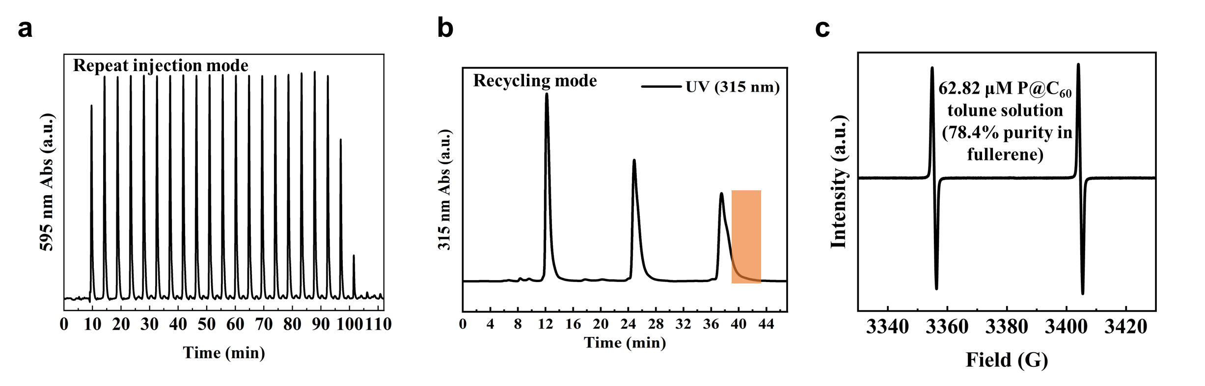
Supplementary Figure 2. (a) Repeat injection mode for batch separation of gram-scale crude P@C₆₀ samples (BuckyPrep-M columns, 12 mL/min, toluene). (b) Recycling mode for high-resolution separation of refined P@C₆₀ samples (PBB columns, 12 mL/min, toluene). The orange box indicates the elution window collected as P@C₆₀. (c) Continuous-wave EPR spectrum of 78.4% pure P@C₆₀ toluene solution at room temperature.

Supplementary Table 2. Purity and concentration of P@C₆₀
C₆₀/ μmol | P@C₆₀/ μmol | Purity of P@C₆₀/ % | Concentration of P@C₆₀/ μM
1.25× 10⁻³ | 0.980 × 10⁻³ | 78.4 | 62.82

Supplementary Note 2. Spin Hamiltonian and resonance of P@C₆₀
2-1 Spin Hamiltonian and energy level
P@C₆₀ has electron spin S = 3/2 coupled to the ³¹P nuclear spin I = 1/2 via an isotropic hyperfine interaction. The Spin Hamiltonian is therefore:
$$\hat{H}=μ_{B}{B_{0}}^{T}g_{e}\hat{S}-μ_{n}{B_{0}}^{T}g_{n} {\hat{I}}_{P}+{\hat{I}}_{P}^{T}A\hat{S}+{\hat{S}}^{T}\overset{̿}{D}\hat{S}$$
where $μ_{B}$ and $μ_{n}$ are the Bohr and nuclear magnetons, $B_{0}$ is the external magnetic field, $\hat{S}$ is the electron-spin operator, ${\hat{I}}_{P}$ is the ³¹P nuclear-spin operator, $g_{e}$ and $g_{n}$ are the isotropic Landé g-factor of the electron- and ³¹P nuclear- spin, respectively, A is the isotropic hyperfine-coupling constant, and $\overset{̿}{D}$ is the zero-field splitting (ZFS) tensor, which vanishes when the P@C₆₀ structure maintains I_{h} symmetry. In the high-field limit, the energy levels are listed in Supplementary Table 3, where $γ_{e}=g_{e}μ_{B}/ℏ$ and $γ_{n}=g_{n}μ_{n}/ℏ$ are defined as the electron and nuclear gyromagnetic ratios, respectively, with $ℏ$ being the reduced Planck constant.

Supplementary Table 3. Eigenvalues of P@C₆₀ spin levels
Spin state | |m_{S}, m_{I}⟩ | Eigenvalues
$$|\left.↑, ⇑\right\rangle$$ | $$|\left.+\frac{3}{2}, +\frac{1}{2}\right\rangle$$ | $$\frac{1}{4}(3A+9D+6B_{0}γ_{e}-2{B_{0}γ}_{n})$$
$$|\left.↑, ⇓\right\rangle$$ | $$|\left.+\frac{3}{2}, -\frac{1}{2}\right\rangle$$ | $$\frac{1}{4}\left[-A+5D+4γ_{e}B_{0}+2\sqrt{4A^{2}-2A\left(2D+\left(γ_{e}+γ_{n}\right)B_{0}\right)+{\left(2D+\left(γ_{e}+γ_{n}\right)B_{0}\right)}^{2}}\right]$$
$$|\left.↗, ⇑\right\rangle$$ | $$|\left.+\frac{1}{2}, +\frac{1}{2}\right\rangle$$ | $$\frac{1}{4}\left[-A+5D+4γ_{e}B_{0}-2\sqrt{4A^{2}-2A\left(2D+\left(γ_{e}+γ_{n}\right)B_{0}\right)+{\left(2D+\left(γ_{e}+γ_{n}\right)B_{0}\right)}^{2}}\right]$$
$$|\left.↗, ⇓\right\rangle$$ | $$|\left.+\frac{1}{2}, -\frac{1}{2}\right\rangle$$ | $$\frac{1}{4}\left[-A+D+2\sqrt{4A^{2}+{\left(γ_{e}+γ_{n}\right)}^{2}B_{0}^{2}}\right]$$
$$|\left.↘, ⇑\right\rangle$$ | $$|\left.-\frac{1}{2}, +\frac{1}{2}\right\rangle$$ | $$\frac{1}{4}\left[-A+D-2\sqrt{4A^{2}+{\left(γ_{e}+γ_{n}\right)}^{2}B_{0}^{2}}\right]$$
$$|\left.↘, ⇓\right\rangle$$ | $$|\left.-\frac{1}{2}, -\frac{1}{2}\right\rangle$$ | $\frac{1}{4}\left[-A+5D-4γ_{e}B_{0}+2\sqrt{4A^{2}+2A\left(\left(γ_{e}+γ_{n}\right)B_{0}-2D\right)+{\left(\left(γ_{e}+γ_{n}\right)B_{0}-2D\right)}^{2}}\right]$
$$|\left.↓, ⇑\right\rangle$$ | $$|\left.-\frac{3}{2}, +\frac{1}{2}\right\rangle$$ | $$\frac{1}{4}\left[-A+5D-4γ_{e}B_{0}-2\sqrt{4A^{2}+2A\left(\left(γ_{e}+γ_{n}\right)B_{0}-2D\right)+{\left(\left(γ_{e}+γ_{n}\right)B_{0}-2D\right)}^{2}}\right]$$
$$|\left.↓, ⇓\right\rangle$$ | $$|\left.-\frac{3}{2}, -\frac{1}{2}\right\rangle$$ | $$\frac{1}{4}(3A+9D-6B_{0}γ_{e}+2{B_{0}γ}_{n})$$

Using a second-order Taylor expansion, $\sqrt{1+x}=1+\frac{x}{2}-\frac{x^{2}}{8}$, Supplementary Table 3 can be simplified to:

Supplementary Table 4. Eigenvalues of P@C₆₀ spin levels (second-order Taylor expansion)
Spin state | |m_{S}, m_{I}⟩ | Eigenvalues
$$|\left.↑, ⇑\right\rangle$$ | $$|\left.+\frac{3}{2}, +\frac{1}{2}\right\rangle$$ | $$\frac{1}{2}\left(3γ_{e}-γ_{n}\right)B_{0}+\frac{3}{4}\left(A+3D\right)$$
$$|\left.↑, ⇓\right\rangle$$ | $$|\left.+\frac{3}{2}, -\frac{1}{2}\right\rangle$$ | $$\frac{1}{2}\left(3γ_{e}+γ_{n}\right)B_{0}+\frac{3}{4}\left(3D-A\right)+\frac{3A^{2}}{4\left(γ_{e}+γ_{n}\right)B_{0}}+\frac{3A^{2}\left(A-2D\right)}{4{\left(γ_{e}+γ_{n}\right)}^{2}B_{0}^{2}}$$
$$|\left.↗, ⇑\right\rangle$$ | $$|\left.+\frac{1}{2}, +\frac{1}{2}\right\rangle$$ | $$\frac{1}{2}\left(γ_{e}-γ_{n}\right)B_{0}+\frac{1}{4}\left(A+D\right)-\frac{3A^{2}}{4\left(γ_{e}+γ_{n}\right)B_{0}}-\frac{3A^{2}\left(A-2D\right)}{4{\left(γ_{e}+γ_{n}\right)}^{2}B_{0}^{2}}$$
$$|\left.↗, ⇓\right\rangle$$ | $$|\left.+\frac{1}{2}, -\frac{1}{2}\right\rangle$$ | $$\frac{1}{2}\left(γ_{e}+γ_{n}\right)B_{0}+\frac{1}{4}\left(D-A\right)+\frac{A^{2}}{\left(γ_{e}+γ_{n}\right)B_{0}}$$
$$|\left.↘, ⇑\right\rangle$$ | $$|\left.-\frac{1}{2}, +\frac{1}{2}\right\rangle$$ | $$-\frac{1}{2}\left(γ_{e}+γ_{n}\right)B_{0}+\frac{1}{4}\left(D-A\right)-\frac{A^{2}}{\left(γ_{e}+γ_{n}\right)B_{0}}$$
$$|\left.↘, ⇓\right\rangle$$ | $$|\left.-\frac{1}{2}, -\frac{1}{2}\right\rangle$$ | $$-\frac{1}{2}\left(γ_{e}-γ_{n}\right)B_{0}+\frac{1}{4}\left(A+D\right)+\frac{3A^{2}}{4\left(γ_{e}+γ_{n}\right)B_{0}}-\frac{3A^{2}\left(A-2D\right)}{4{\left(γ_{e}+γ_{n}\right)}^{2}B_{0}^{2}}$$
$$|\left.↓, ⇑\right\rangle$$ | $$|\left.-\frac{3}{2}, +\frac{1}{2}\right\rangle$$ | $$-\frac{1}{2}\left(3γ_{e}+γ_{n}\right)B_{0}+\frac{3}{4}\left(3D-A\right)-\frac{3A^{2}}{4\left(γ_{e}+γ_{n}\right)B_{0}}+\frac{3A^{2}\left(A-2D\right)}{4{\left(γ_{e}+γ_{n}\right)}^{2}B_{0}^{2}}$$
$$|\left.↓, ⇓\right\rangle$$ | $$|\left.-\frac{3}{2}, -\frac{1}{2}\right\rangle$$ | $$-\frac{1}{2}\left(3γ_{e}-γ_{n}\right)B_{0}+\frac{3}{4}\left(A+3D\right)$$

Using the experimental parameters at $B_{0}=3476.9 G$, $g_{e}=2.00145$, $g_{n}=2.2632$, $A=136.91 MHz$, and $D=0$ MHz, along with $μ_{B}=13996.24 MHz/T$ and $μ_{n}=7.62259 MHz/T$, we calculate the nuclear-spin transition frequencies, showing excellent agreement with the experimental results (Fig. 2e in main text), as summarized in Supplementary Table 5.

Supplementary Table 5. Energy differences of nuclear-spin transitions
Transitions | Energy difference/ MHz
$|\left.↑, ⇑\right\rangle$↔$|\left.↑, ⇓\right\rangle$ | $${\frac{3}{2}A-γ}_{n}B_{0}-\frac{3A^{2}}{4B_{0}\left(γ_{e}+γ_{n}\right)}-\frac{3A^{2}\left(A-2D\right)}{4B_{0}^{2}{\left(γ_{e}+γ_{n}\right)}^{2}}$$ | 197.90
$|\left.↗, ⇑\right\rangle$↔$|\left.↗, ⇓\right\rangle$ | $${\frac{1}{2}A-γ}_{n}B_{0}-\frac{7A^{2}}{4B_{0}\left(γ_{e}+γ_{n}\right)}-\frac{3A^{2}\left(A-2D\right)}{4B_{0}^{2}{\left(γ_{e}+γ_{n}\right)}^{2}}$$ | 59.07
$|\left.↘, ⇑\right\rangle$↔$|\left.↘, ⇓\right\rangle$ | $$\frac{1}{2}A{+γ}_{n}B_{0}+\frac{7A^{2}}{4B_{0}\left(γ_{e}+γ_{n}\right)}-\frac{3A^{2}\left(A-2D\right)}{4B_{0}^{2}{\left(γ_{e}+γ_{n}\right)}^{2}}$$ | 77.80
$|\left.↓, ⇑\right\rangle$↔$|\left.↓, ⇓\right\rangle$ | $${\frac{3}{2}A+γ}_{n}B_{0}+\frac{3A^{2}}{4B_{0}\left(γ_{e}+γ_{n}\right)}-\frac{3A^{2}\left(A-2D\right)}{4B_{0}^{2}{\left(γ_{e}+γ_{n}\right)}^{2}}$$ | 212.79

2-2 Second-order hyperfine effect
At room temperature, the CW-EPR spectrum (Supplementary Fig. 3) exhibits an additional triplet splitting within each hyperfine line of the quartet pattern, in agreement with the simulated spectrum (Fig.1c in main text). This splitting originates from second-order hyperfine coupling and corresponds to the three allowed electron-spin transitions within the $S=3/2$ manifold. Molecular tumbling averages out the anisotropic interactions, effectively setting $D=0$. Using $g_{e}=2.00145$, $g_{n}=2.2632$, $A=137.82$MHz, and a microwave frequency of $ν=9.5360$ GHz, we calculated the energy differences and resonance fields for the electron-spin transitions. The results show excellent agreement with experiment (Supplementary Fig. 3) and are summarized in Supplementary Table 6.
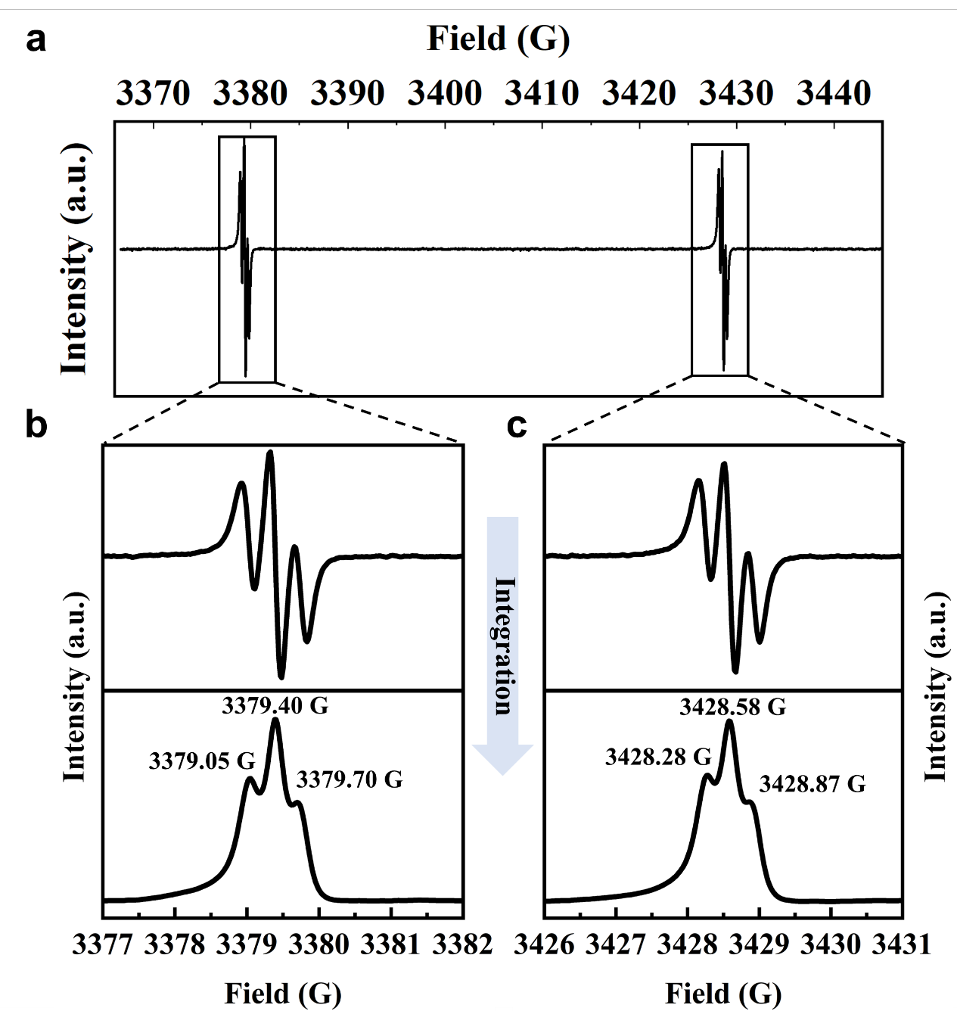
Supplementary Figure 3. Continuous-wave EPR spectra of P@C₆₀ in toluene-d₈ at room temperature: (a) full spectrum; (b) zoom-in and single-scan integrated spectrum of the $m_{I}=+\frac{1}{2}$ transition; (c) zoom-in and single-scan integrated spectrum of the $m_{I}=-\frac{1}{2}$ transition.

Supplementary Table 6. Energy differences and resonance fields of electron-spin transitions
Transition | Energy difference | Resonance field/ G
$|\left.↑, ⇑\right\rangle$↔$|\left.↗, ⇑\right\rangle$ | $$γ_{e}B_{0}+\frac{A}{2}+\frac{3A^{2}}{4B_{0}(γ_{e}+γ_{n})}+\frac{3A^{3}}{4B_{0}^{2}{(γ_{e}+γ_{n})}^{2}}$$ | $$\frac{ν}{γ_{e}}-\frac{A}{2γ_{e}}-\frac{3A^{2}}{4ν(γ_{e}+γ_{n})}-\frac{3A^{3}\left(3γ_{e}+γ_{n}\right)}{8ν^{2}{(γ_{e}+γ_{n})}^{2}}$$ | 3379.05
$|\left.↗, ⇑\right\rangle$↔$|\left.↘, ⇑\right\rangle$ | $$γ_{e}B_{0}+\frac{A}{2}+\frac{A^{2}}{4B_{0}(γ_{e}+γ_{n})}-\frac{3A^{3}}{4B_{0}^{2}{(γ_{e}+γ_{n})}^{2}}$$ | $$\frac{ν}{γ_{e}}-\frac{A}{2γ_{e}}-\frac{A^{2}}{4ν(γ_{e}+γ_{n})}+\frac{A^{3}\left(5γ_{e}-γ_{n}\right)}{8ν^{2}{(γ_{e}+γ_{n})}^{2}}$$ | 3379.39
$|\left.↘, ⇑\right\rangle$↔$|\left.↓, ⇑\right\rangle$ | $$γ_{e}B_{0}+\frac{A}{2}-\frac{A^{2}}{4B_{0}(γ_{e}+γ_{n})}-\frac{3A^{3}}{4B_{0}^{2}{(γ_{e}+γ_{n})}^{2}}$$ | $$\frac{ν}{γ_{e}}-\frac{A}{2γ_{e}}+\frac{A^{2}}{4ν(γ_{e}+γ_{n})}+\frac{A^{3}\left(7γ_{e}+γ_{n}\right)}{8ν^{2}{(γ_{e}+γ_{n})}^{2}}$$ | 3379.75
$|\left.↑, ⇓\right\rangle$↔$|\left.↗, ⇓\right\rangle$ | $$γ_{e}B_{0}-\frac{A}{2}-\frac{A^{2}}{4B_{0}(γ_{e}+γ_{n})}+\frac{3A^{3}}{4B_{0}^{2}{(γ_{e}+γ_{n})}^{2}}$$ | $$\frac{ν}{γ_{e}}+\frac{A}{2γ_{e}}+\frac{A^{2}}{4ν(γ_{e}+γ_{n})}-\frac{A^{3}\left(7γ_{e}+γ_{n}\right)}{8ν^{2}{(γ_{e}+γ_{n})}^{2}}$$ | 3428.93
$|\left.↗, ⇓\right\rangle$↔$|\left.↘, ⇓\right\rangle$ | $$γ_{e}B_{0}-\frac{A}{2}+\frac{A^{2}}{4B_{0}(γ_{e}+γ_{n})}+\frac{3A^{3}}{4B_{0}^{2}{(γ_{e}+γ_{n})}^{2}}$$ | $$\frac{ν}{γ_{e}}+\frac{A}{2γ_{e}}-\frac{A^{2}}{4ν(γ_{e}+γ_{n})}+\frac{A^{3}\left(γ_{n}-5γ_{e}\right)}{8ν^{2}{(γ_{e}+γ_{n})}^{2}}$$ | 3428.58
$|\left.↘, ⇓\right\rangle$↔$|\left.↓,⇓\right\rangle$ | $$γ_{e}B_{0}-\frac{A}{2}+\frac{3A^{2}}{4B_{0}(γ_{e}+γ_{n})}-\frac{3A^{3}}{4B_{0}^{2}{(γ_{e}+γ_{n})}^{2}}$$ | $$\frac{ν}{γ_{e}}+\frac{A}{2γ_{e}}-\frac{3A^{2}}{4ν(γ_{e}+γ_{n})}+\frac{3A^{3}\left(3γ_{e}+γ_{n}\right)}{8ν^{2}{(γ_{e}+γ_{n})}^{2}}$$ | 3428.24

2-3 Q-distribution visualization
The Q-distribution provides a visualization of arbitrary single-spin states, analogous to the Bloch vector representation. While the Bloch vector represents a spin state as an arrow indicating the mean angular momentum, the Q-distribution depicts the state by coloring a distribution function on the surface of the Bloch sphere. The intensity and spread of the color encode both the mean spin momentum and the variance (i.e., the uncertainty) of the state. Unlike the Bloch vector, which can map distinct quantum states to the same vector, the Q-distribution establishes a one-to-one correspondence with the spin state.
The Q-distribution, also known as the Husimi-Q function, shown in Fig. 1, 3 and 4, is calculated using the standard definition¹:
$$Q\left(θ,φ\right)=\left\langle θ,φ\left|ρ\right|θ,φ\right\rangle$$
Where $ρ$ is the density matrix of the spin state, and $\left|θ,φ\right\rangle$ is the spin-coherent state with polar angle $θ∈\left[0,π\right]$ and azimuthal angle $φ∈\left[0,2π\right]$.
The spin-coherent states are defined as:
$$\left|θ,φ\right\rangle =\sum_{m=-j}^{+j}{{\left(\begin{aligned}2j \\ m+j\end{aligned}\right)}^{1/2}{\left(cos\frac{θ}{2}\right)}^{j+m}{\left(sin\frac{θ}{2}\right)}^{j-m}e^{-i\left(j+m\right)φ}}\left|j m\right\rangle$$
Where $\left|j m\right\rangle$ are the standard spin-momentum (Dicke) states². Equivalently, spin-coherent states can be obtained by rotating the maximum Dicke state $\left|j j\right\rangle$ by angles $\left(θ,φ\right)$ in spin space.
In the present work, the electron spin is S=3/2 and the nuclear spin is I=1/2. For states in which the electron and nuclear spins are separable, we assign a distinct Bloch sphere to each: a blue sphere for the electron spin and a green sphere for the nuclear spin, allowing their quantum states to be visualized individually.
The panel below shows the Q-distribution plots of the eigenstates for the electron and nuclear spins.
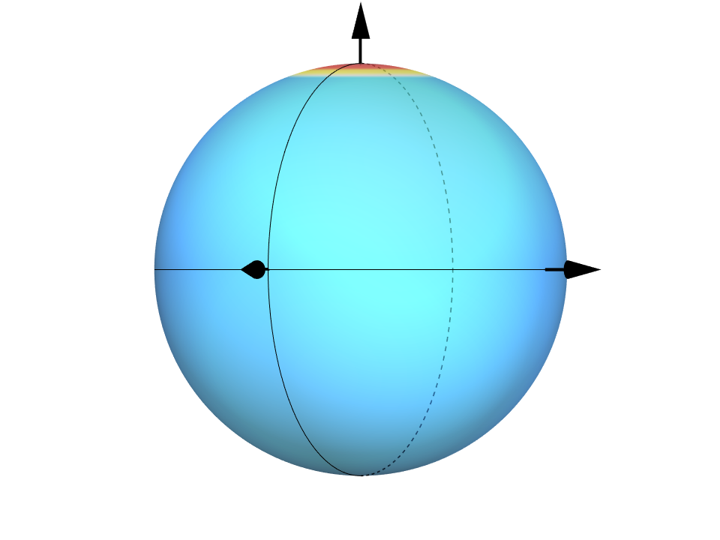  Electron spin state: $\left|↑\right\rangle$ | 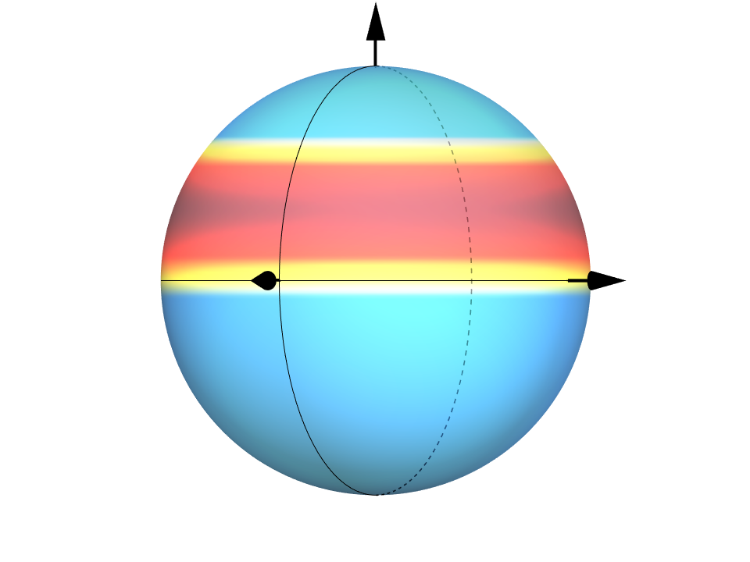  Electron spin state: $\left|↗\right\rangle$
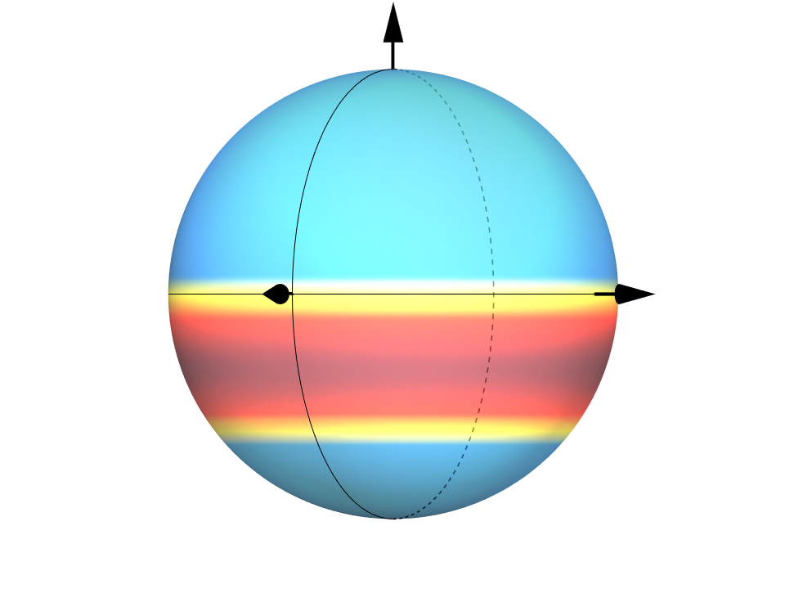  Electron spin state: $\left|↘\right\rangle$ | 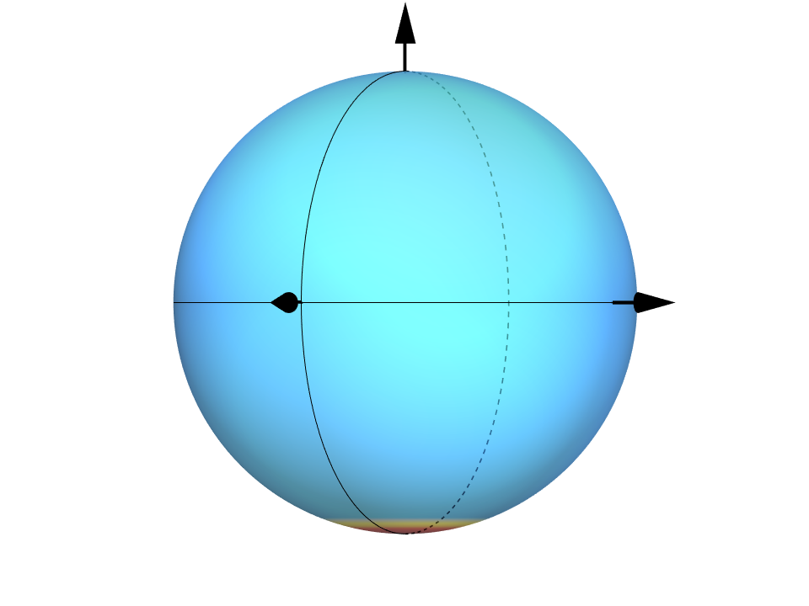  Electron spin state: $\left|↓\right\rangle$
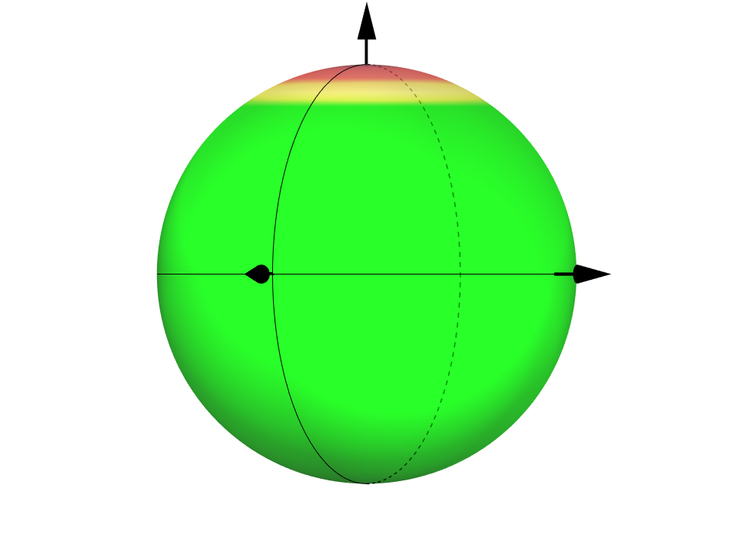  Nuclear spin state: $\left|⇑\right\rangle$ | 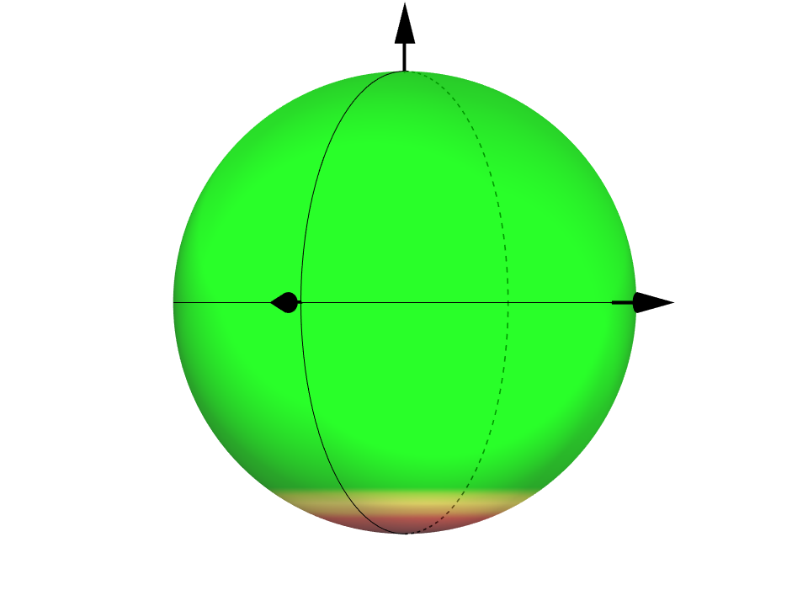  Nuclear spin state: $\left|⇓\right\rangle$

The panel below shows the Q-distribution plots of several superposition states.
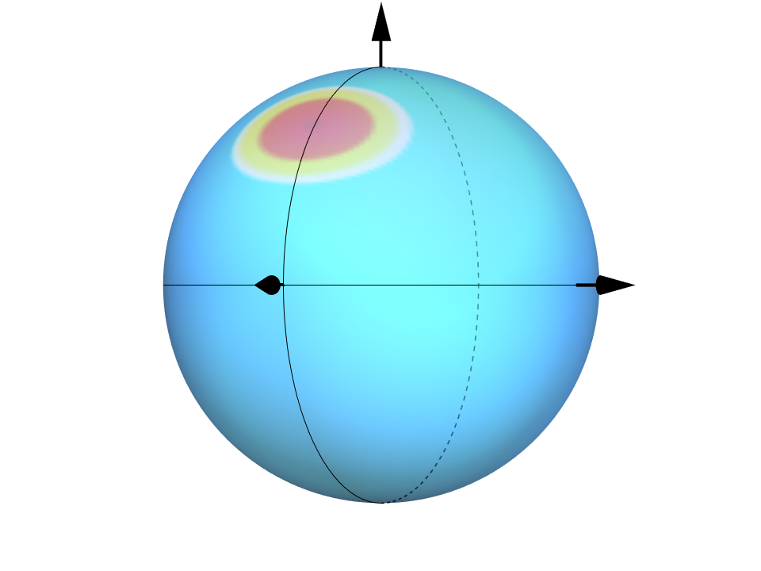  $$\frac{1}{\sqrt{2}}\left(\left|↑\right\rangle +\left|↗\right\rangle \right)$$ | 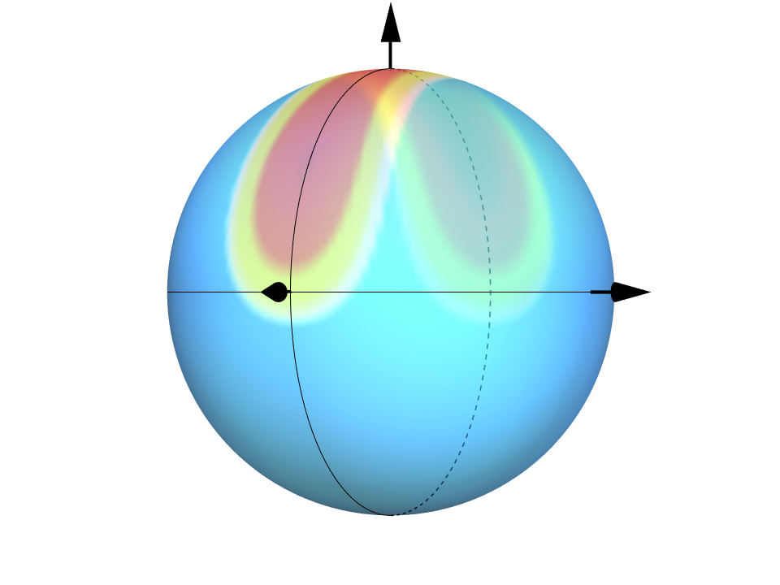  $$\frac{1}{\sqrt{2}}\left(\left|↑\right\rangle +\left|↘\right\rangle \right)$$
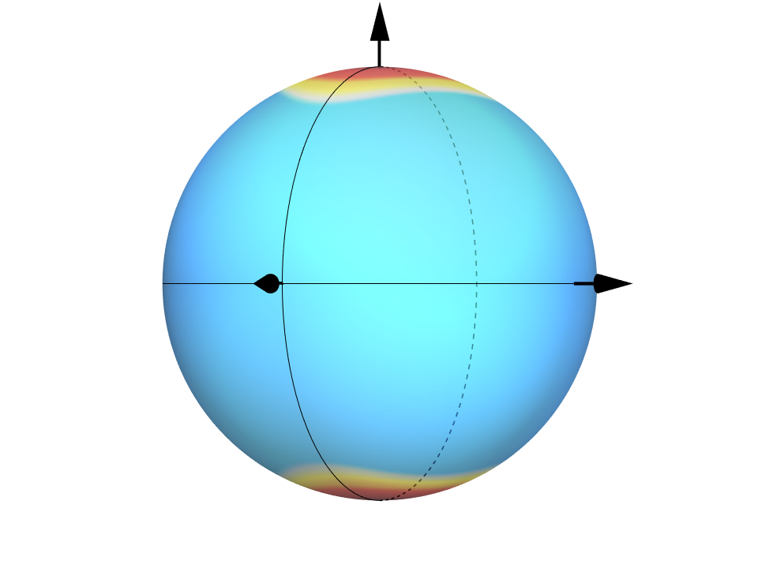  $$\frac{1}{\sqrt{2}}\left(\left|↑\right\rangle +\left|↓\right\rangle \right)$$ | 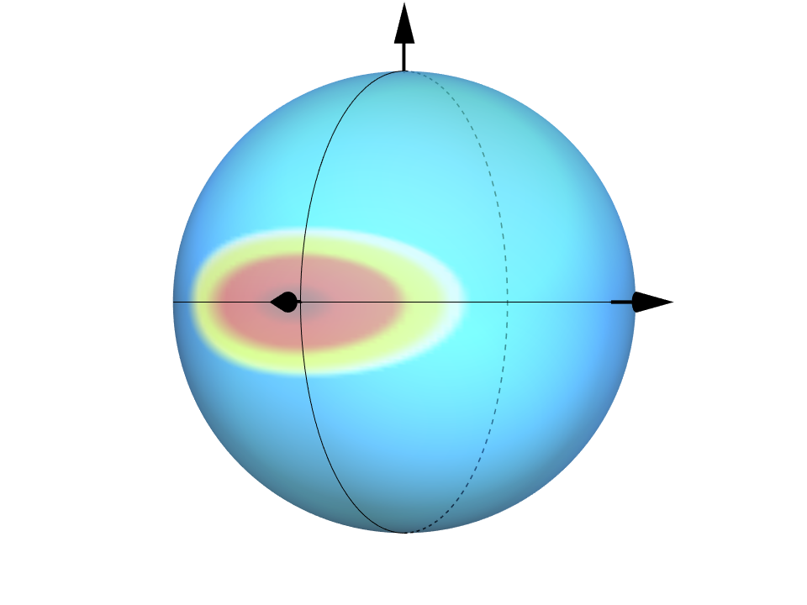  $$\frac{1}{\sqrt{2}}\left(\left|↗\right\rangle +\left|↘\right\rangle \right)$$
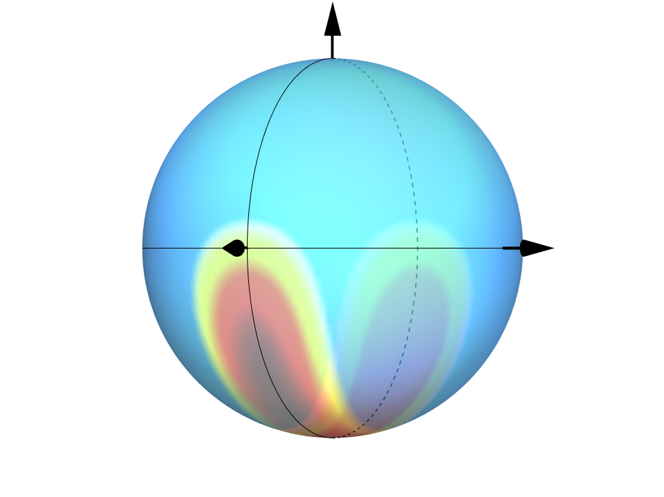  $$\frac{1}{\sqrt{2}}\left(\left|↗\right\rangle +\left|↓\right\rangle \right)$$ | 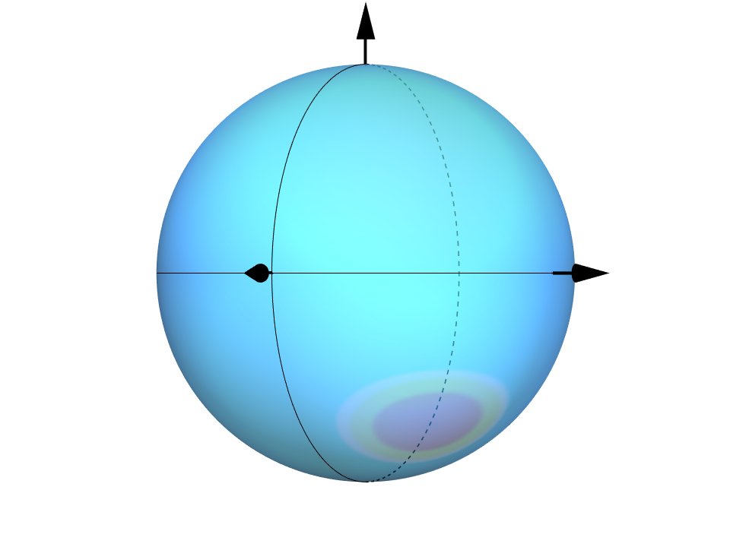  $$\frac{1}{\sqrt{2}}\left(\left|↘\right\rangle -\left|↓\right\rangle \right)$$
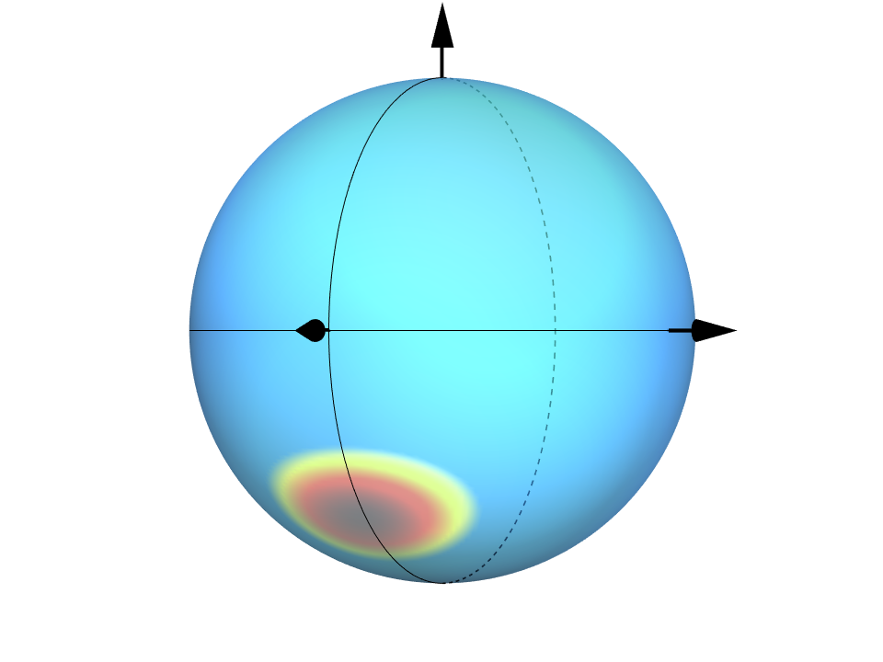  $$\frac{1}{\sqrt{2}}\left(\left|↘\right\rangle +\left|↓\right\rangle \right)$$ | 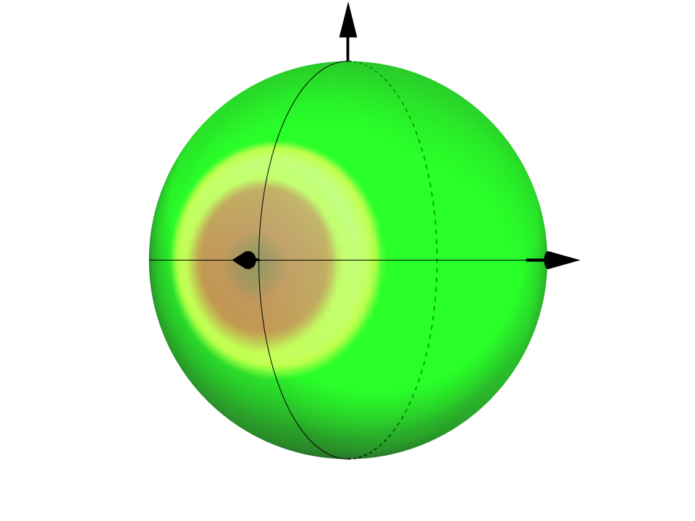  $$\frac{1}{\sqrt{2}}\left(\left|⇑\right\rangle +\left|⇓\right\rangle \right)$$

In the main text, we also present Q-distribution plots for the thermal state and for entangled states. For the thermal state, the Q-distribution is defined as above. For an entangled state, however, the density matrix is not separable, and the single-spin Q-distribution cannot be directly applied. Although recent works have proposed various methods to visualize Q-distributions for bipartite entangled spins ³, a simpler and more intuitive approach is to define a new Bloch sphere directly on the entangled two-spin manifold ⁴ and to draw the Q-distribution on that sphere. The panel below shows the Q-distribution plots of several entangled states.

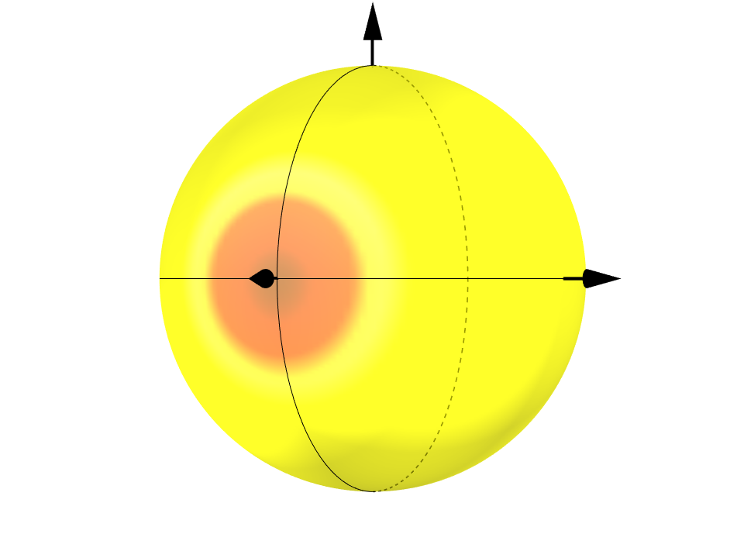  $$\frac{1}{\sqrt{2}}(\left|↗,⇑\right\rangle +|↘,⇓⟩)$$ | 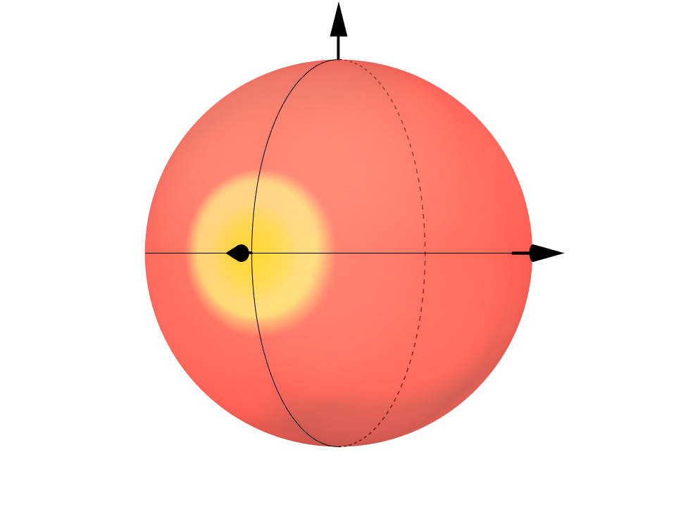  $$\frac{1}{\sqrt{2}}(\left|↗,⇓\right\rangle +|↘,⇑⟩)$$

Supplementary Note 3. Electron and Nuclear Spin Resonance Experiments
3-1 Temperature-dependent Field-swept ESE spectra
Field-swept ESE spectra of P@C₆₀ were recorded over the temperature range 20–80 K and fitted using a combination of components with and without D_{strain}. Zero-field splitting emerges below 80 K, and the D_{strain} fraction increases upon cooling, completely dominating the spectra below 40 K.
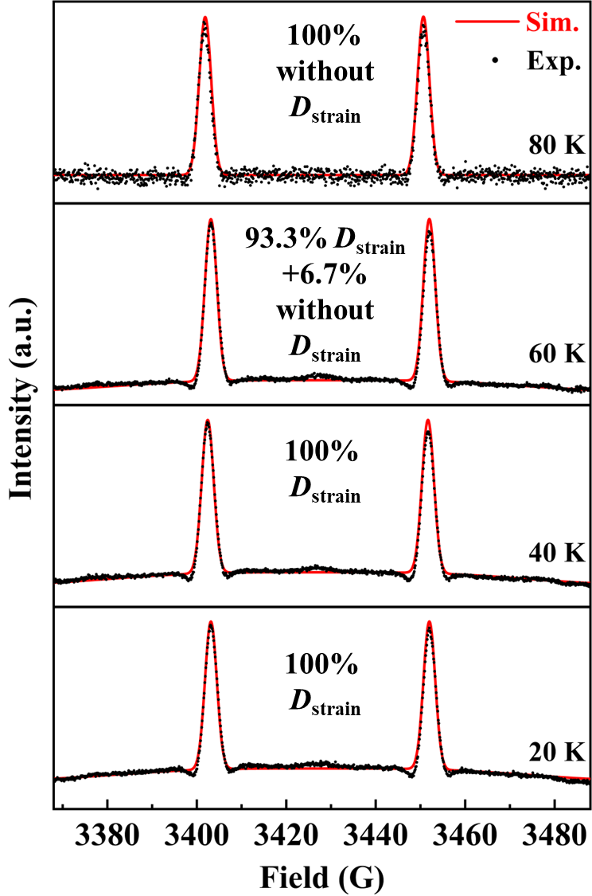
Supplementary Figure 4. Field-swept ESE spectra of P@C₆₀ (20-80 K), fitted with D_{strain} and without-D_{strain} components.

We consider that the temperature dependence of the single-quantum transition $∣↗,⇓⟩↔∣↘,⇓⟩$ shown in Figure 3d is related to the emergence of D_{strain} in the field-swept ESE spectra. Between 30 and 70 K, its coherence time decreases with decreasing temperature, roughly coinciding with the onset of the zero-field splitting. In this range, the spectrum consists of a mixture of both the non-degenerate components induced by zero-field splitting and the degenerate components unaffected by zero-field splitting, and the reduced coherence time is likely influenced by the relatively short coherence times of the transitions |$↑,⇓$⟩↔|$↗,⇓$⟩ and |$↘,⇓$⟩↔|$↓,⇓$⟩, which arise from the lifting of degeneracy due to zero-field splitting. Below 30 K, the non-degenerate fraction saturates and the coherence times of |$↑,⇓$⟩↔|$↗,⇓$⟩ and |$↘,⇓$⟩↔|$↓,⇓$⟩ gradually increase, resulting in the recovery and growth of the coherence time of $∣↗,⇓⟩↔∣↘,⇓⟩$.

3-2 Field-swept ESE spectrum of P@C₆₀ powder
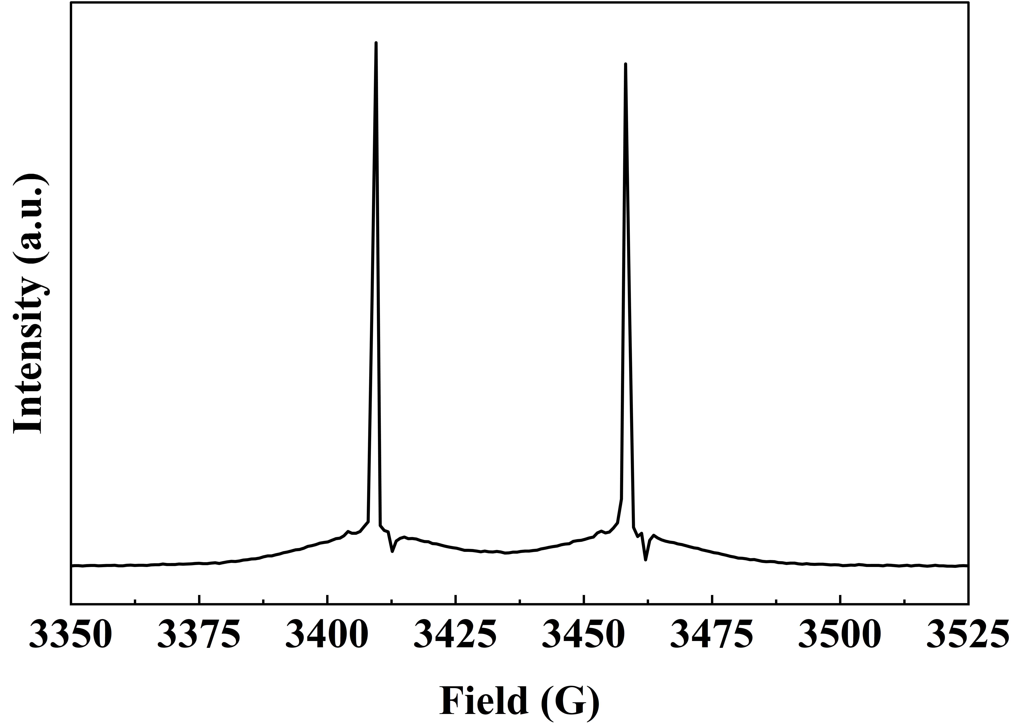
Supplementary Figure 5. Field-swept ESE spectrum of P@C₆₀ powder at 5 K.

3-3 ENDOR and nuclear-spin Rabi oscillation experiments
ENDOR measurements were performed to characterize the four ³¹P nuclear-spin transitions. Both Davies (selective microwave π pulse) and Mims (non-selective microwave pulses) ENDOR sequences were used to read out these transitions through electron-spin echo signals (Supplementary Fig. 6a). The corresponding ENDOR spectra recorded at 5 K resolved all four lines at the predicted RF1–RF4 frequencies (Supplementary Fig. 6b).
Field-swept Davies ENDOR measurements revealed distinct magnetic-field distributions for the four nuclear-spin transitions (Supplementary Fig. 6c). The RF2 (|↗,⇑⟩ ↔ |↗,⇓⟩) and RF3 (|↘,⇑⟩ ↔ |↘,⇓⟩) transitions were detected almost exclusively through the non-ZFS electron-spin signals. In contrast, the RF1 (|↑,⇑⟩ ↔ |↑,⇓⟩) and RF4 (|↓,⇑⟩ ↔ |↓,⇓⟩) transitions were detected through the ZFS-related electron-spin signals, which were distributed symmetrically in the lower- and higher-field regions.
Coherent nuclear-spin manipulation was demonstrated through Rabi oscillations obtained by varying the RF2 pulse length in the Davies ENDOR sequence (Supplementary Fig. 6d).

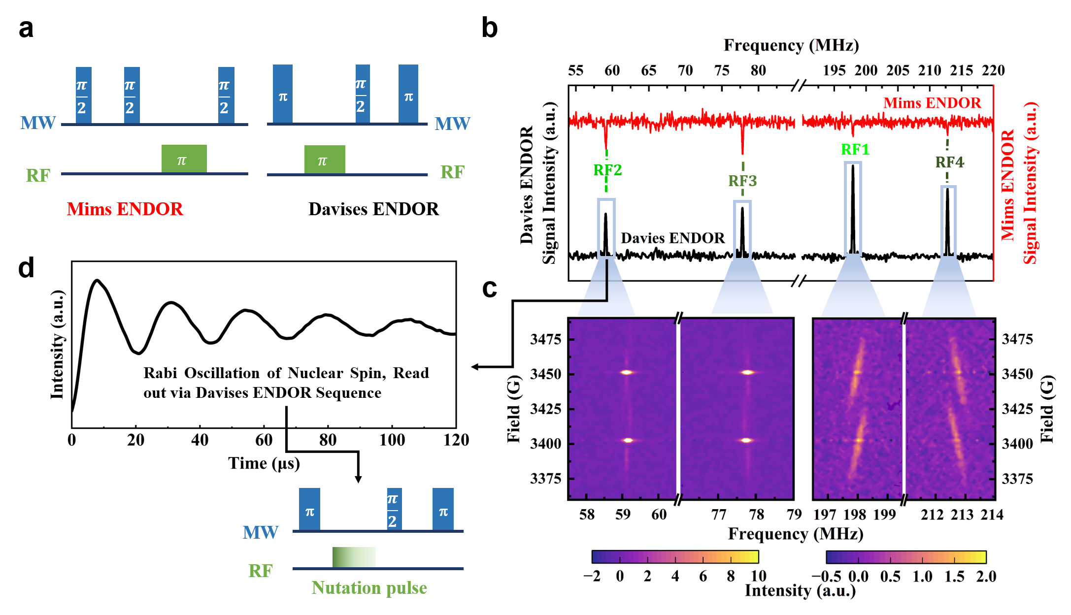
Supplementary Figure 6. Pulse sequences (a) for Mims and Davies ENDOR and (b) corresponding spectra at 5 K, shown in red and black, respectively. (c) Field-swept Davies ENDOR spectra recorded separately at frequencies near RF1, RF2, RF3, and RF4. (d) Pulse sequence and corresponding nuclear-spin Rabi oscillation obtained by varying the RF2 pulse length.

3-4 Field-swept ENDOR Experiment
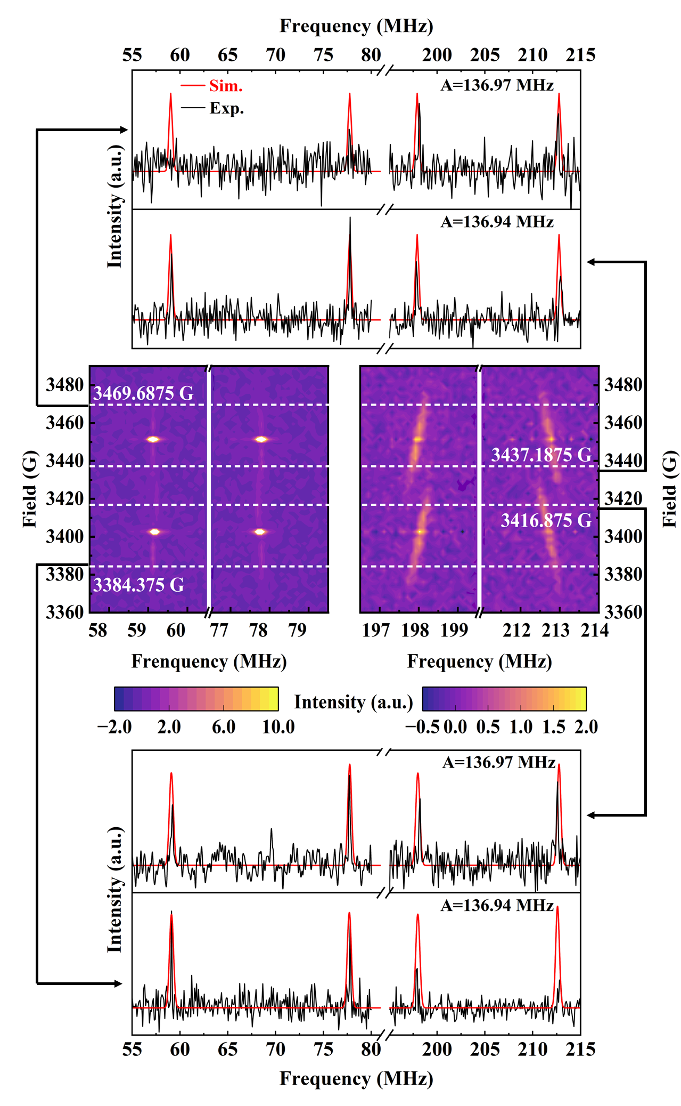
Supplementary Figure 7. Field-swept Davies ENDOR spectra recorded separately near the RF1, RF2, RF3, and RF4 resonance frequencies together with ENDOR spectra recorded at the magnetic-field edges of the RF1 and RF4 responses, corresponding to different values of the hyperfine coupling constant A.

Field-dependent ENDOR measurements at 5 K (Supplementary Figure 6c) revealed a continuous shift of the RF1 and RF4 transition frequencies as the external magnetic field was varied. Based on the energy differences of the nuclear-spin transitions derived in Supplementary Table 5, we analyzed the magnetic-field dependence of the resonance frequencies. We found that the observed frequency shifts were inconsistent with the linear magnetic-field dependence expected from the nuclear Zeeman term ($γ_{n}B_{0}$), while the direct contribution of the zero-field splitting parameter D to the nuclear-spin transition frequencies was negligible over the experimental field range.
This observation suggested that the hyperfine coupling constant A was slightly field dependent. Analysis of the ENDOR spectra recorded at the magnetic-field edges of the RF1 and RF4 signals showed that A varied slightly from approximately 136.94 to 136.97 MHz across the measured field range (Supplementary Figure 7). This small variation may arise from subtle changes in the electronic environment of the encapsulated phosphorus atom or from the selective probing of different molecular orientations at different fields, each with a slightly different A value. In either case, the continuous frequency shifts observed in the field-swept ENDOR spectra were primarily attributed to the field dependence of A, rather than to the nuclear Zeeman effect.
Supplementary Note 4. Initialization of pseudopure spin states
Three-level electron-spin manifold
A pseudo-pure state in the three-level electron-spin manifold is prepared by applying a $\frac{π}{2}$ pulse on the $∣↗,⇓⟩↔∣↘,⇓⟩$ transition, which equalizes the populations of these two levels and effectively initializes the system to a pseudo-pure state corresponding to $∣↓,⇓⟩$ (Supplementary Figure 8a, left).
Four-level electron-spin manifold
For the four-level electron-spin subspace, the initial populations are ordered as follows: ∣↓,⇓⟩ has the largest population, ∣↘,⇓⟩ has a relatively large population, ∣↗,⇓⟩ has a smaller population, and ∣↑,⇓⟩ has the smallest population. First, a π pulse is applied on the ∣↗,⇓⟩↔∣↘,⇓⟩ transition to invert their populations. Then, a π/2 pulse is applied on the ∣↑,⇓⟩↔∣↗,⇓⟩ transition, which mixes the populations of ∣↑,⇓⟩, ∣↗,⇓⟩, and ∣↘,⇓⟩, bringing them approximately equal and effectively initializing the system to the pseudo-pure state ∣↓,⇓⟩ (Supplementary Figure 8a, right).
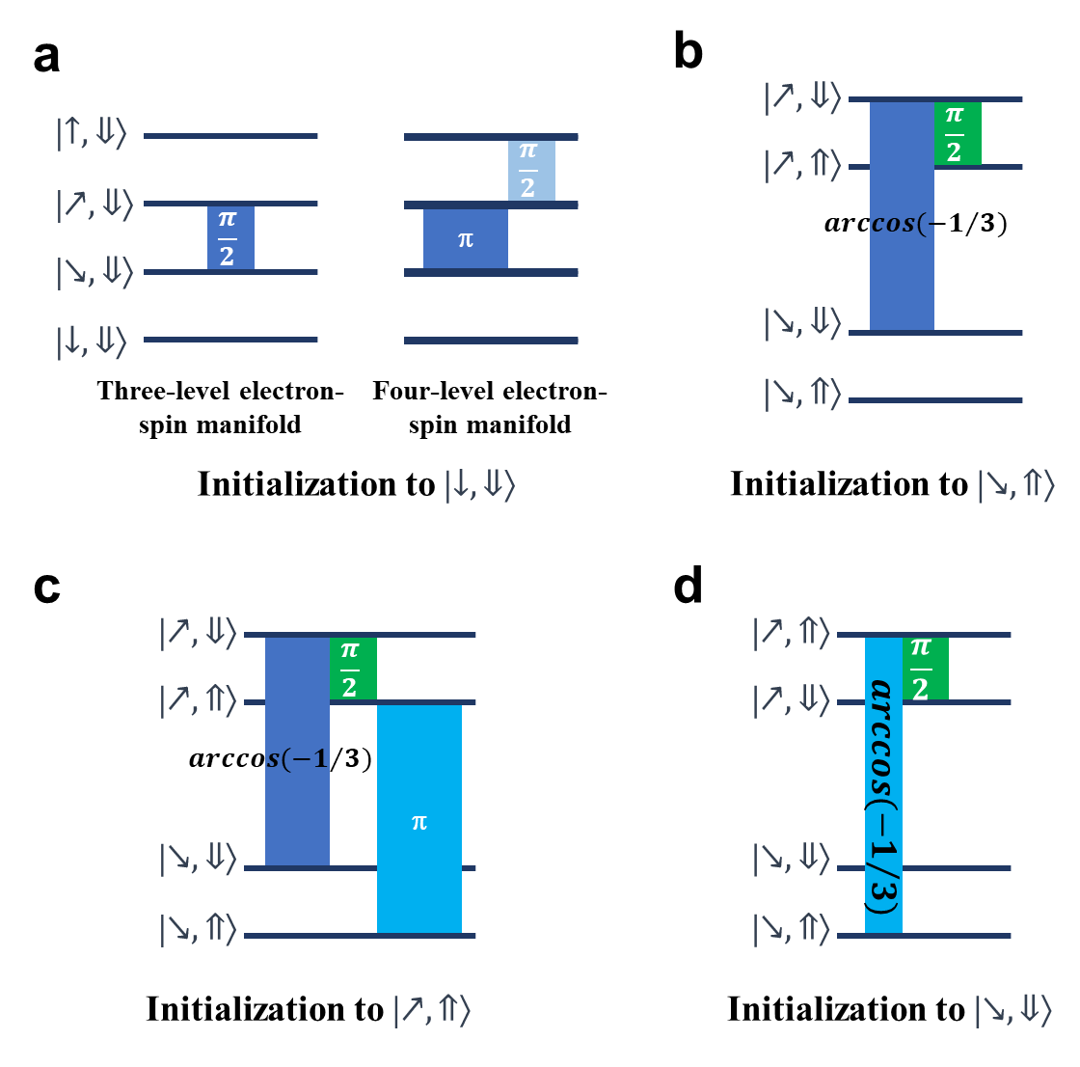
Supplementary Figure 8. Pulse sequences for the initialization to ∣↓,⇓⟩ (a), ∣↘,⇑⟩ (b), ∣↗,⇑⟩ (c), and ∣↘,⇓⟩ (d).
Electron–nuclear spin level manifold
The electron-nuclear spin manifold can be initialized to the pseudo-pure state ∣↘,⇑⟩, ∣↗,⇑⟩ or ∣↘,⇓⟩. First, an arccos(–1/3) pulse is applied on the ∣↗,⇓⟩↔∣↘,⇓⟩ transition, adjusting their populations such that ∣↘,⇓⟩ and ∣↗,⇓⟩ contains 1/3 and 2/3 of their combined population, respectively. Next, a π/2 pulse is applied on the ∣↗,⇓⟩↔∣↗,⇑⟩ transition, which mixes the populations of ∣↘,⇓⟩, ∣↗,⇓⟩, and ∣↗,⇑⟩, bringing them approximately equal, effectively initializing the system to the pseudo-pure state ∣↘,⇑⟩ (Supplementary Figure 8b). To prepare the pseudo-pure state ∣↗,⇑⟩ instead, a π pulse is applied on the ∣↗,⇑⟩↔∣↘,⇑⟩ transition after the initialization to ∣↘,⇑⟩, swapping the populations of∣↗,⇑⟩ and ∣↘,⇑⟩ (Supplementary Figure 8c).
To initialize the system into the pseudo-pure state ∣↘,⇓⟩, an arccos(–1/3) pulse is applied on the ∣↗,⇑⟩↔∣↘,⇑⟩ transition, adjusting their populations such that ∣↘,⇑⟩ and ∣↗,⇑⟩ contains1/3 and 2/3 of their combined population, respectively. Next, a π/2 pulse is applied on the ∣↗,⇓⟩↔∣↗,⇑⟩ transition, which mixes the populations of ∣↘,⇑⟩, ∣↗,⇓⟩, and ∣↗,⇑⟩, bringing them approximately equal, effectively initializing the system to the pseudo-pure state ∣↘,⇓⟩ (Supplementary Figure 8d).

Supplementary Note 5. Hahn-echo measurements for the double-quantum transition
5-1 ELDOR techniques for forbidden-transition manipulation
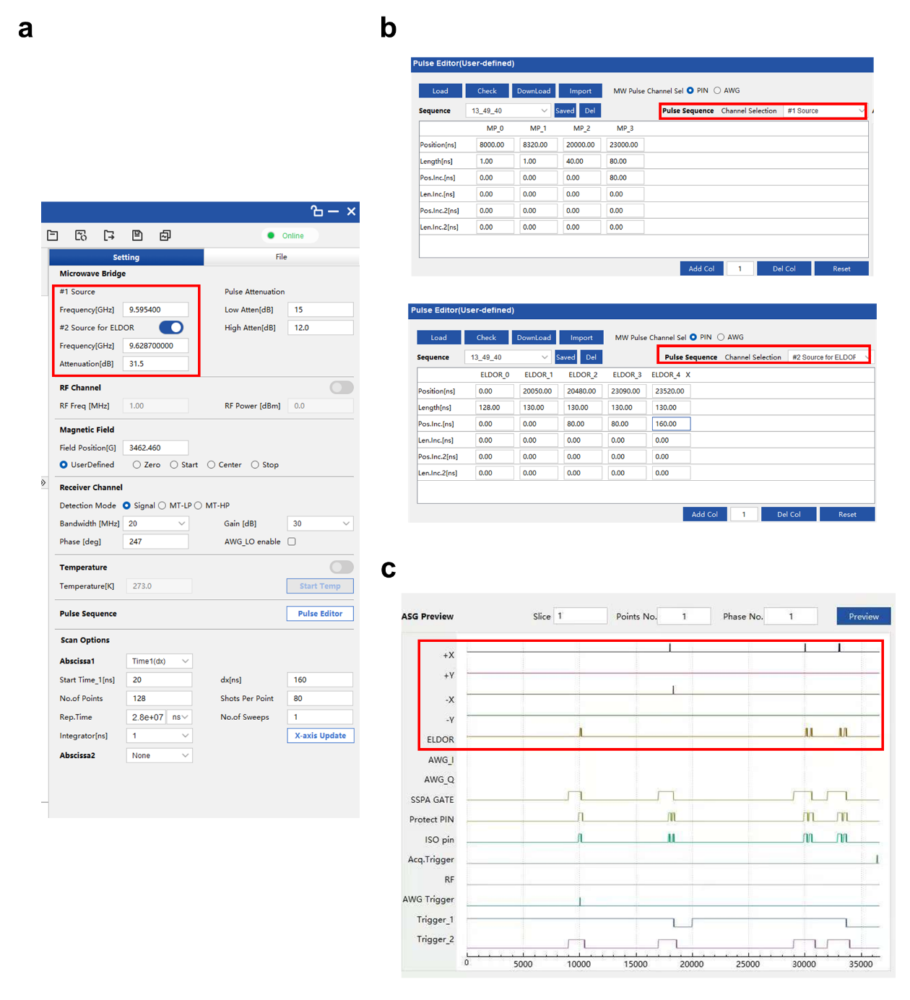
Supplementary Figure 9. Software interface for dual-source ELDOR pulse control (CIQTEK). (a) Microwave Bridge panel showing the frequency settings for Source 1 and Source 2. (b) Pulse Editor window illustrating the definition of pulse sequences on two independent channels corresponding to the two microwave sources. (c) ASG (arbitrary sequence generator) preview displaying the resulting dual-frequency pulse timing, where pulses from both channels are visualized.

ELDOR experiments were performed on a CIQTEK pulsed EPR spectrometer with two independent microwave sources. The sources were assigned to separate pulse-sequence channels in the control software, allowing microwave pulses at two distinct frequencies within a single, synchronized pulse sequence. As described in the main text, this dual-channel ELDOR setup enabled coherent manipulation across multiple spin levels and refocusing of the quantum-phase evolution associated with forbidden transitions using a modified Hahn-echo sequence.

5-2 Effectiveness of refocusing pulses: experimental and theoretical demonstration
Theoretical calculation: The evolution of the density matrix when implementing the double-quantum coherence time measurement of the transition $\left|↗,⇓\right|↓,⇓$, was calculated. The density matrix of the initialization state is $ρ_{0}=\left[\begin{matrix}0 & 0 & 0 & 0 \\ 0 & 0 & 0 & 0 \\ 0 & 0 & 0 & 0 \\ 0 & 0 & 0 & 1\end{matrix}\right]$. The subsequent evolution of the density matrix under the pulse sequence shown in Supplementary Figure 9a is detailed below, where T_{2,SQ} and T_{2,DQ} are the coherence times of the single- and double-quantum transitions |$↘,⇓$⟩↔|$↓,⇓$⟩ and |$↗,⇓$⟩↔|$↓,⇓$⟩, respectively, and t₀ (fixed) and τ (variable) denote the corresponding evolution times for these transitions.

initialization state: $ρ_{0}=\left[\begin{matrix}0 & 0 & 0 & 0 \\ 0 & 0 & 0 & 0 \\ 0 & 0 & 0 & 0 \\ 0 & 0 & 0 & 1\end{matrix}\right]$
$\frac{π}{2}$ Pulse between |$↘,⇓$⟩↔|$↓,⇓$⟩: ${ρ_{1}=\hat{R}}_{x}\left(\frac{π}{2}\right)ρ_{0}{\hat{R}}_{x}^{†}\left(\frac{π}{2}\right)=\left[\begin{matrix}0 & 0 & 0 & 0 \\ 0 & 0 & 0 & 0 \\ 0 & 0 & \frac{1}{2} & -\frac{i}{2} \\ 0 & 0 & \frac{i}{2} & \frac{1}{2}\end{matrix}\right]$
Evolution $t_{0}$: $ρ_{2}=\hat{U}\left(t_{0}\right)ρ_{1}{\hat{U}}^{†}\left(t_{0}\right)=\left[\begin{matrix}0 & 0 & 0 & 0 \\ 0 & 0 & 0 & 0 \\ 0 & 0 & \frac{1}{2} & -\frac{1}{2}{ie}^{-{it}_{0}-\frac{t_{0}}{T_{2,SQ}}} \\ 0 & 0 & \frac{1}{2}{ie}^{{it}_{0}-\frac{t_{0}}{T_{2,SQ}}} & \frac{1}{2}\end{matrix}\right]$
$π$ Pulse between |$↗,⇓$⟩↔|$↘,⇓$⟩: ${ρ_{3}=\hat{R}}_{x}\left(π\right)ρ_{2}{\hat{R}}_{x}^{†}\left(π\right)=\left[\begin{matrix}0 & 0 & 0 & 0 \\ 0 & \frac{1}{2} & 0 & -\frac{1}{2}{ie}^{-it_{0}-\frac{t_{0}}{T_{2,SQ}}} \\ 0 & 0 & 0 & 0 \\ 0 & \frac{1}{2}{ie}^{{it}_{0}-\frac{t_{0}}{T_{2,SQ}}} & 0 & \frac{1}{2}\end{matrix}\right]$

Evolution $τ$: $ρ_{4}=\hat{U}\left(τ\right)ρ_{3}{\hat{U}}^{†}\left(τ\right)=$ $\left[\begin{matrix}0 & 0 & 0 & 0 \\ 0 & \frac{1}{2} & 0 & -\frac{1}{2}ⅈⅇ^{-{ⅈt}_{0}-\frac{t_{0}}{T_{2,SQ}}-ⅈτ-\frac{τ}{T_{2,DQ}}} \\ 0 & 0 & 0 & 0 \\ 0 & \frac{1}{2}ⅈⅇ^{ⅈt_{0}-\frac{t_{0}}{T_{2,SQ}}+ⅈτ-\frac{τ}{T_{2,DQ}}} & 0 & \frac{1}{2}\end{matrix}\right]$
$π$ Pulse between |$↗,⇓$⟩↔|$↘,⇓$⟩: ${ρ_{5}=\hat{R}}_{x}\left(π\right)ρ_{4}{\hat{R}}_{x}^{†}\left(π\right)=\left[\begin{matrix}0 & 0 & 0 & 0 \\ 0 & 0 & 0 & 0 \\ 0 & 0 & \frac{1}{2} & -\frac{1}{2}ⅈⅇ^{-{ⅈt}_{0}-\frac{t_{0}}{T_{2,SQ}}-ⅈτ-\frac{τ}{T_{2,DQ}}} \\ 0 & 0 & \frac{1}{2}ⅈⅇ^{ⅈt_{0}-\frac{t_{0}}{T_{2,SQ}}+ⅈτ-\frac{τ}{T_{2,DQ}}} & \frac{1}{2}\end{matrix}\right]$
$π$ Pulse between |$↘,⇓$⟩↔|$↓,⇓$⟩: ${ρ_{6}=\hat{R}}_{x}\left(π\right)ρ_{5}{\hat{R}}_{x}^{†}\left(π\right)=\left[\begin{matrix}0 & 0 & 0 & 0 \\ 0 & 0 & 0 & 0 \\ 0 & 0 & \frac{1}{2} & \frac{1}{2}ⅈⅇ^{ⅈt_{0}-\frac{t_{0}}{T_{2,SQ}}+ⅈτ-\frac{τ}{T_{2,DQ}}} \\ 0 & 0 & -\frac{1}{2}ⅈⅇ^{-{ⅈt}_{0}-\frac{t_{0}}{T_{2,SQ}}-ⅈτ-\frac{τ}{T_{2,DQ}}} & \frac{1}{2}\end{matrix}\right]$
$π$ Pulse between |$↗,⇓$⟩↔|$↘,⇓$⟩: ${ρ_{7}=\hat{R}}_{x}\left(π\right)ρ_{6}{\hat{R}}_{x}^{†}\left(π\right)=\left[\begin{matrix}0 & 0 & 0 & 0 \\ 0 & \frac{1}{2} & 0 & \frac{1}{2}ⅈⅇ^{ⅈt_{0}-\frac{t_{0}}{T_{2,SQ}}+ⅈτ-\frac{τ}{T_{2,DQ}}} \\ 0 & 0 & 0 & 0 \\ 0 & -\frac{1}{2}ⅈⅇ^{-{ⅈt}_{0}-\frac{t_{0}}{T_{2,SQ}}-ⅈτ-\frac{τ}{T_{2,DQ}}} & 0 & \frac{1}{2}\end{matrix}\right]$
Evolution $τ$: $ρ_{8}=\hat{U}\left(τ\right)ρ_{7}{\hat{U}}^{†}\left(τ\right)=$ $\left[\begin{matrix}0 & 0 & 0 & 0 \\ 0 & \frac{1}{2} & 0 & \frac{1}{2}ⅈⅇ^{-\frac{t_{0}}{T_{2,SQ}}-\frac{2τ}{T_{2,DQ}}+{ⅈt}_{0}} \\ 0 & 0 & 0 & 0 \\ 0 & -\frac{1}{2}ⅈⅇ^{-\frac{t_{0}}{T_{2,SQ}}-\frac{2τ}{T_{2,DQ}}-ⅈt_{0}} & 0 & \frac{1}{2}\end{matrix}\right]$

$π$ Pulse between |$↗,⇓$⟩↔|$↘,⇓$⟩: ${ρ_{9}=\hat{R}}_{x}\left(π\right)ρ_{8}{\hat{R}}_{x}^{†}\left(π\right)=\left[\begin{matrix}0 & 0 & 0 & 0 \\ 0 & 0 & 0 & 0 \\ 0 & 0 & \frac{1}{2} & \frac{1}{2}ⅈⅇ^{-\frac{t_{0}}{T_{2,SQ}}-\frac{2τ}{T_{2,DQ}}+{ⅈt}_{0}} \\ 0 & 0 & -\frac{1}{2}ⅈⅇ^{-\frac{t_{0}}{T_{2,SQ}}-\frac{2τ}{T_{2,DQ}}-ⅈt_{0}} & \frac{1}{2}\end{matrix}\right]$
Evolution $t_{0}$: $ρ_{10}=\hat{U}\left(t_{0}\right)ρ_{9}{\hat{U}}^{†}\left(t_{0}\right)=\left[\begin{matrix}0 & 0 & 0 & 0 \\ 0 & 0 & 0 & 0 \\ 0 & 0 & \frac{1}{2} & \frac{1}{2}ⅈⅇ^{-\frac{2t_{0}}{T_{2,SQ}}-\frac{2τ}{T_{2,DQ}}} \\ 0 & 0 & -\frac{1}{2}ⅈⅇ^{-\frac{2t_{0}}{T_{2,SQ}}-\frac{2τ}{T_{2,DQ}}} & \frac{1}{2}\end{matrix}\right]$
Detection: P_{y}=Trace (${σ_{y}ρ}_{10}$)=$\frac{1}{2}e^{-\frac{2t_{0}}{T_{2,SQ}}-\frac{2τ}{T_{2,DQ}}}$

Notably, in the $τ$-dependent term, only $T_{2,\text{DQ}}$ appears, while $T_{2,\text{SQ}}$ is absent. This indicates that the experimentally observed variation of the signal intensity with $τ$, which is varied as the evolution time of the double-quantum transition, arises solely from the double-quantum coherence and is unaffected by single-quantum decoherence. These results confirm that the refocusing pulses in the sequence effectively eliminate the contribution of single-quantum decoherence, allowing measurement of the double-quantum coherence time.

Experimental comparison: Control experiments were performed using a pulse sequence without refocusing pulses to assess their effectiveness, as shown in Supplementary Figure 10b. In this sequence, t₀ (fixed) and τ (variable) denote the evolution times of the single- and double-quantum transitions |$↘,⇓$⟩↔|$↓,⇓$⟩ and |$↗,⇓$⟩↔|$↓,⇓$⟩, respectively, while T₀ (fixed) is the total time between the π/2 and π pulses of the transition |$↘,⇓$⟩↔|$↓,⇓$⟩.
In the absence of refocusing pulses, single-quantum dephasing cannot be symmetrically refocused, leading to a rapid signal decay. As a result, the coherence time of the double-quantum transition $∣↗,⇓⟩↔∣↓,⇓⟩$ is reduced to approximately 300 ns at 5 K (Supplementary Figure 10c). We therefore attribute the observed decay to the inhomogeneously broadened double-quantum coherence time, $T_{2,DQ}^{*}$.

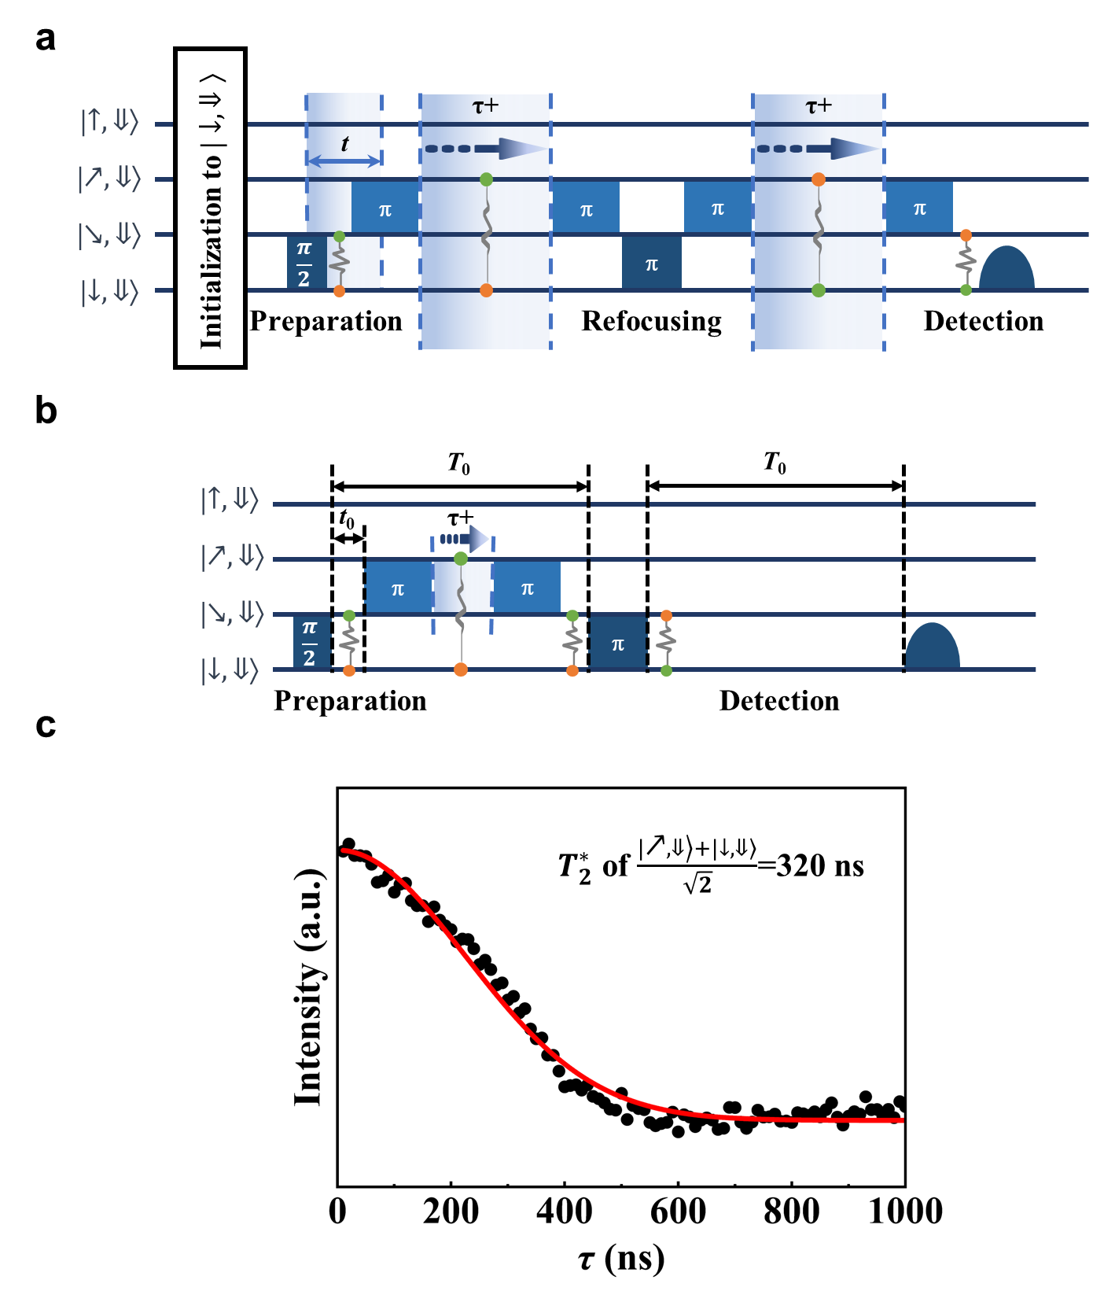
Supplementary Figure 10. Pulse sequences for the double-quantum coherence time measurement of the transition $\left|↗,⇓\right|↓,⇓$ with (a) and without (b) a refocusing pulse, and the decay of the superposition between ∣↗,⇓⟩ and ∣↓,⇓⟩ at 5 K (c).
5-3 Measurement of double-quantum $T_{2,\text{DQ}}^{*}$
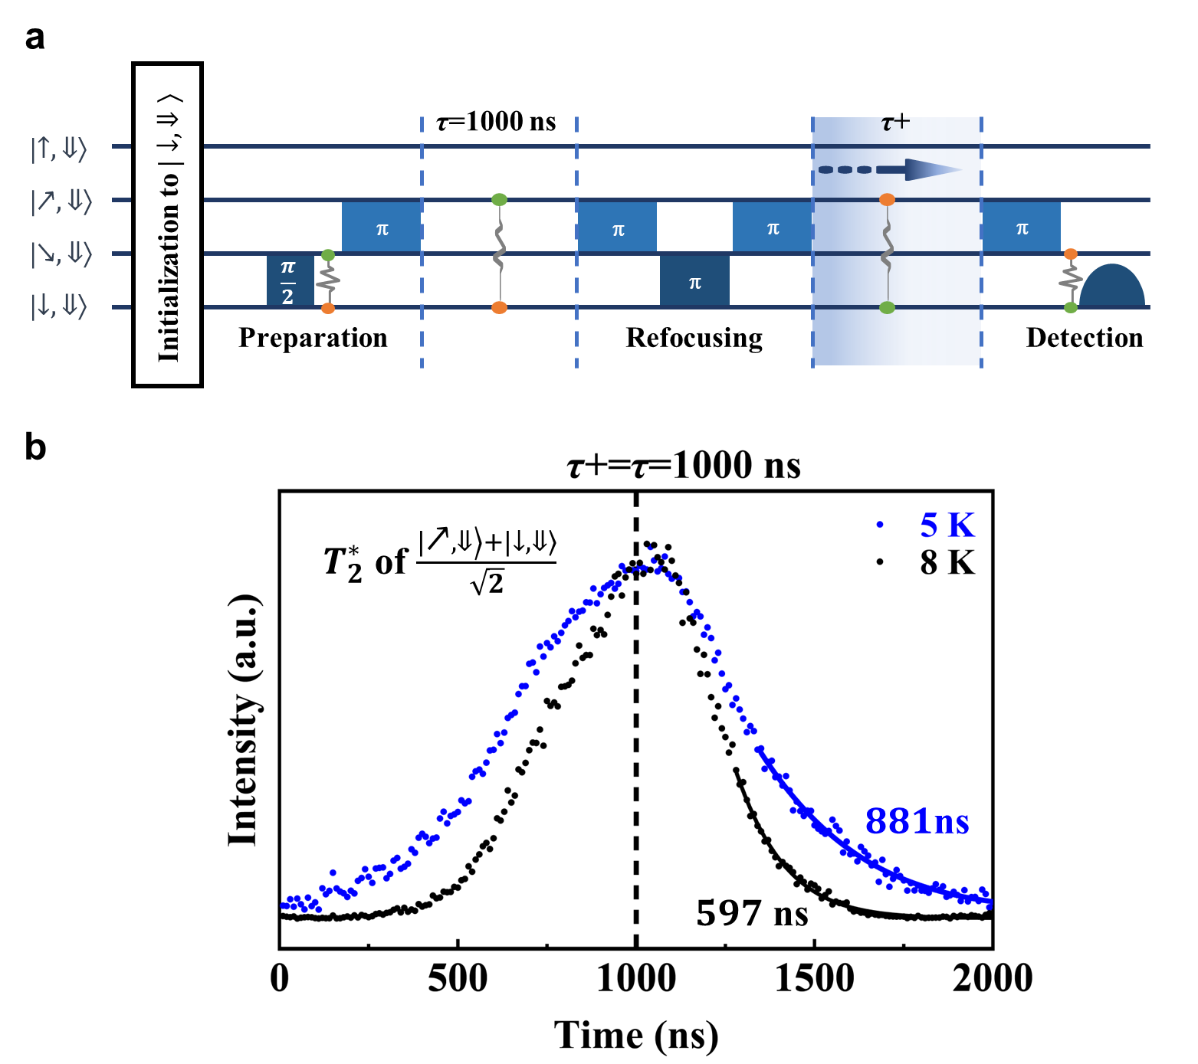
Supplementary Figure 11. Pulse sequences for the measurement of double-quantum $T_{2,\text{DQ}}^{*}$ (a), and the resulting double-quantum echo of the superposition between $\left|↗, ⇓\right\rangle$ and $\left|↓, ⇓\right\rangle$ at 5 K and 8 K (b), with the decay of the second half of the echo (free induction decay, FID) fitted to extract the double-quantum $T_{2,\text{DQ}}^{*}$.

An alternative method to measure the double-quantum $T_{2,\text{DQ}}^{*}$ was explored using an improved pulse sequence (Supplementary Figure 11a), based on the double-quantum coherence time measurement sequence (Supplementary Figure 10a), since the previous sequence (Supplementary Figure 10b) exhibited very rapid signal decay (Supplementary Figure 10c). In this sequence, the first $τ$ was fixed at $τ_{0}=1000$ ns, while the second $τ$ was scanned from 0 to 2000 ns to obtain a complete echo. The echo signal reaches its maximum when $τ=τ_{0}$=1000 ns. By fitting the decay of the second half of the echo (free induction decay, FID), the double-quantum $T_{2,\text{DQ}}^{*}$ was determined to be approximately 900 ns and 600 ns at 5 K and 8 K, respectively (Supplementary Figure 11b), demonstrating that this improved method yields a significantly longer $T_{2,DQ}^{*}$ compared with the previous one without refocusing pulses (Supplementary Figure 10c, 320 ns).
Supplementary Note 6. Arbitrary Waveform Generation using I/Q Modulation
I/Q modulation (in-phase and quadrature modulation) enables the generation of a single microwave-frequency (MW) signal from one carrier and two independent baseband waveforms, allowing flexible control of the signal’s instantaneous amplitude, phase, and frequency.
Carrier Signals (Local Oscillator, LO)
Let the angular frequency of the carrier be
$$ω_{0}=2πf_{0},$$
where $f_{0}$is the carrier frequency. Two orthogonal carrier signals are defined as
- In-phase (I) carrier:
$$c_{I}\left(t\right)=\cos\left(ω_{0}t\right),$$
- Quadrature (Q) carrier:
$$c_{Q}\left(t\right)=\sin\left(ω_{0}t\right).$$
Baseband signals
Two independent low-frequency baseband signals, generated by an arbitrary waveform generator (AWG), are applied to the I and Q channels:
- In-phase baseband signal: $I\left(t\right)$,
- Quadrature baseband signal: $Q\left(t\right)$.
The bandwidths of $I\left(t\right)$and $Q\left(t\right)$are assumed to be much smaller than $f_{0}$.

Modulation process
In I/Q modulation, the baseband signals are multiplied by the orthogonal carriers and linearly combined to produce the RF output signal:
$$\begin{matrix} & s\left(t\right)=I\left(t\right)\cos\left(ω_{0}t\right)-Q\left(t\right)\sin\left(ω_{0}t\right). & & \text{(S1)}\end{matrix}$$
Amplitude–phase representation
Using trigonometric identities, Eq. (S1) can be rewritten in an amplitude–phase form,
$$\begin{matrix} & s\left(t\right)=A\left(t\right)cos\left[ω_{0}t+ϕ\left(t\right)\right], & & \text{(S2)}\end{matrix}$$
where the instantaneous amplitude and phase are given by
$$\begin{matrix} & A\left(t\right)=\sqrt{I^{2}\left(t\right)+Q^{2}\left(t\right)}, & & \text{(S3)}\end{matrix} \\ \begin{matrix} & ϕ\left(t\right)=arctan\left(\frac{Q\left(t\right)}{I\left(t\right)}\right). & & \text{(S4)}\end{matrix}$$
Example: frequency and phase modulation
As an illustrative example, let
$$\begin{matrix} & I\left(t\right)=B\left(t\right)\cos\left(αt+φ\right),Q\left(t\right)=B\left(t\right)\sin\left(αt+φ\right), & & \text{(S5)}\end{matrix}$$
where $B\left(t\right)$is a slowly varying envelope and $α≪ω_{0}$.
Substitution into Eqs. (S3) and (S4) yields
$$A\left(t\right)=B\left(t\right), \\ ϕ\left(t\right)=αt+φ.$$ This demonstrates that by appropriately programming the baseband waveforms $I\left(t\right)$and $Q\left(t\right)$using an AWG, precise control over the carrier’s amplitude, phase, and instantaneous frequency can be achieved.
In this work, a microwave source from a CIQTEK EPR100 spectrometer is used as the local oscillator (LO), while an AWG from SpinQ provides the programmable $I\left(t\right)$and $Q\left(t\right)$inputs.
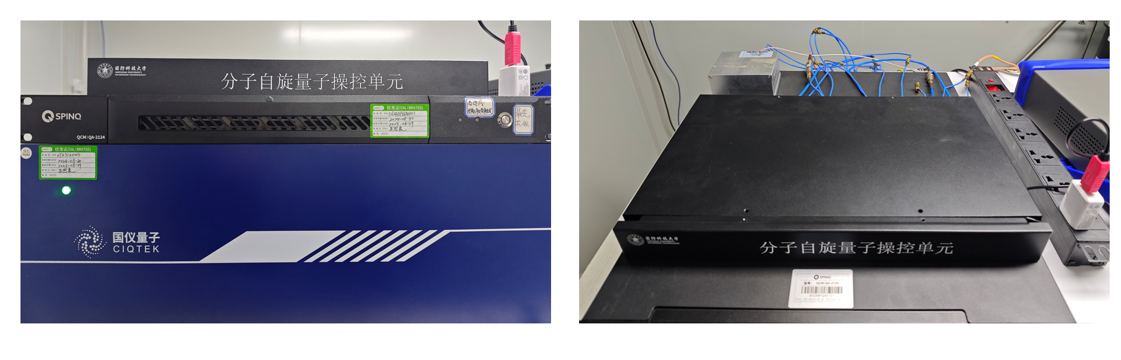
Supplementary Figure 12. Photograph of a home-made arbitrary waveform generator (AWG) pulse module.

Supplementary Note 7 Double-quantum ESEEM experiment
7-1 Conventional 2-pulse ESEEM and double-quantum ESEEM
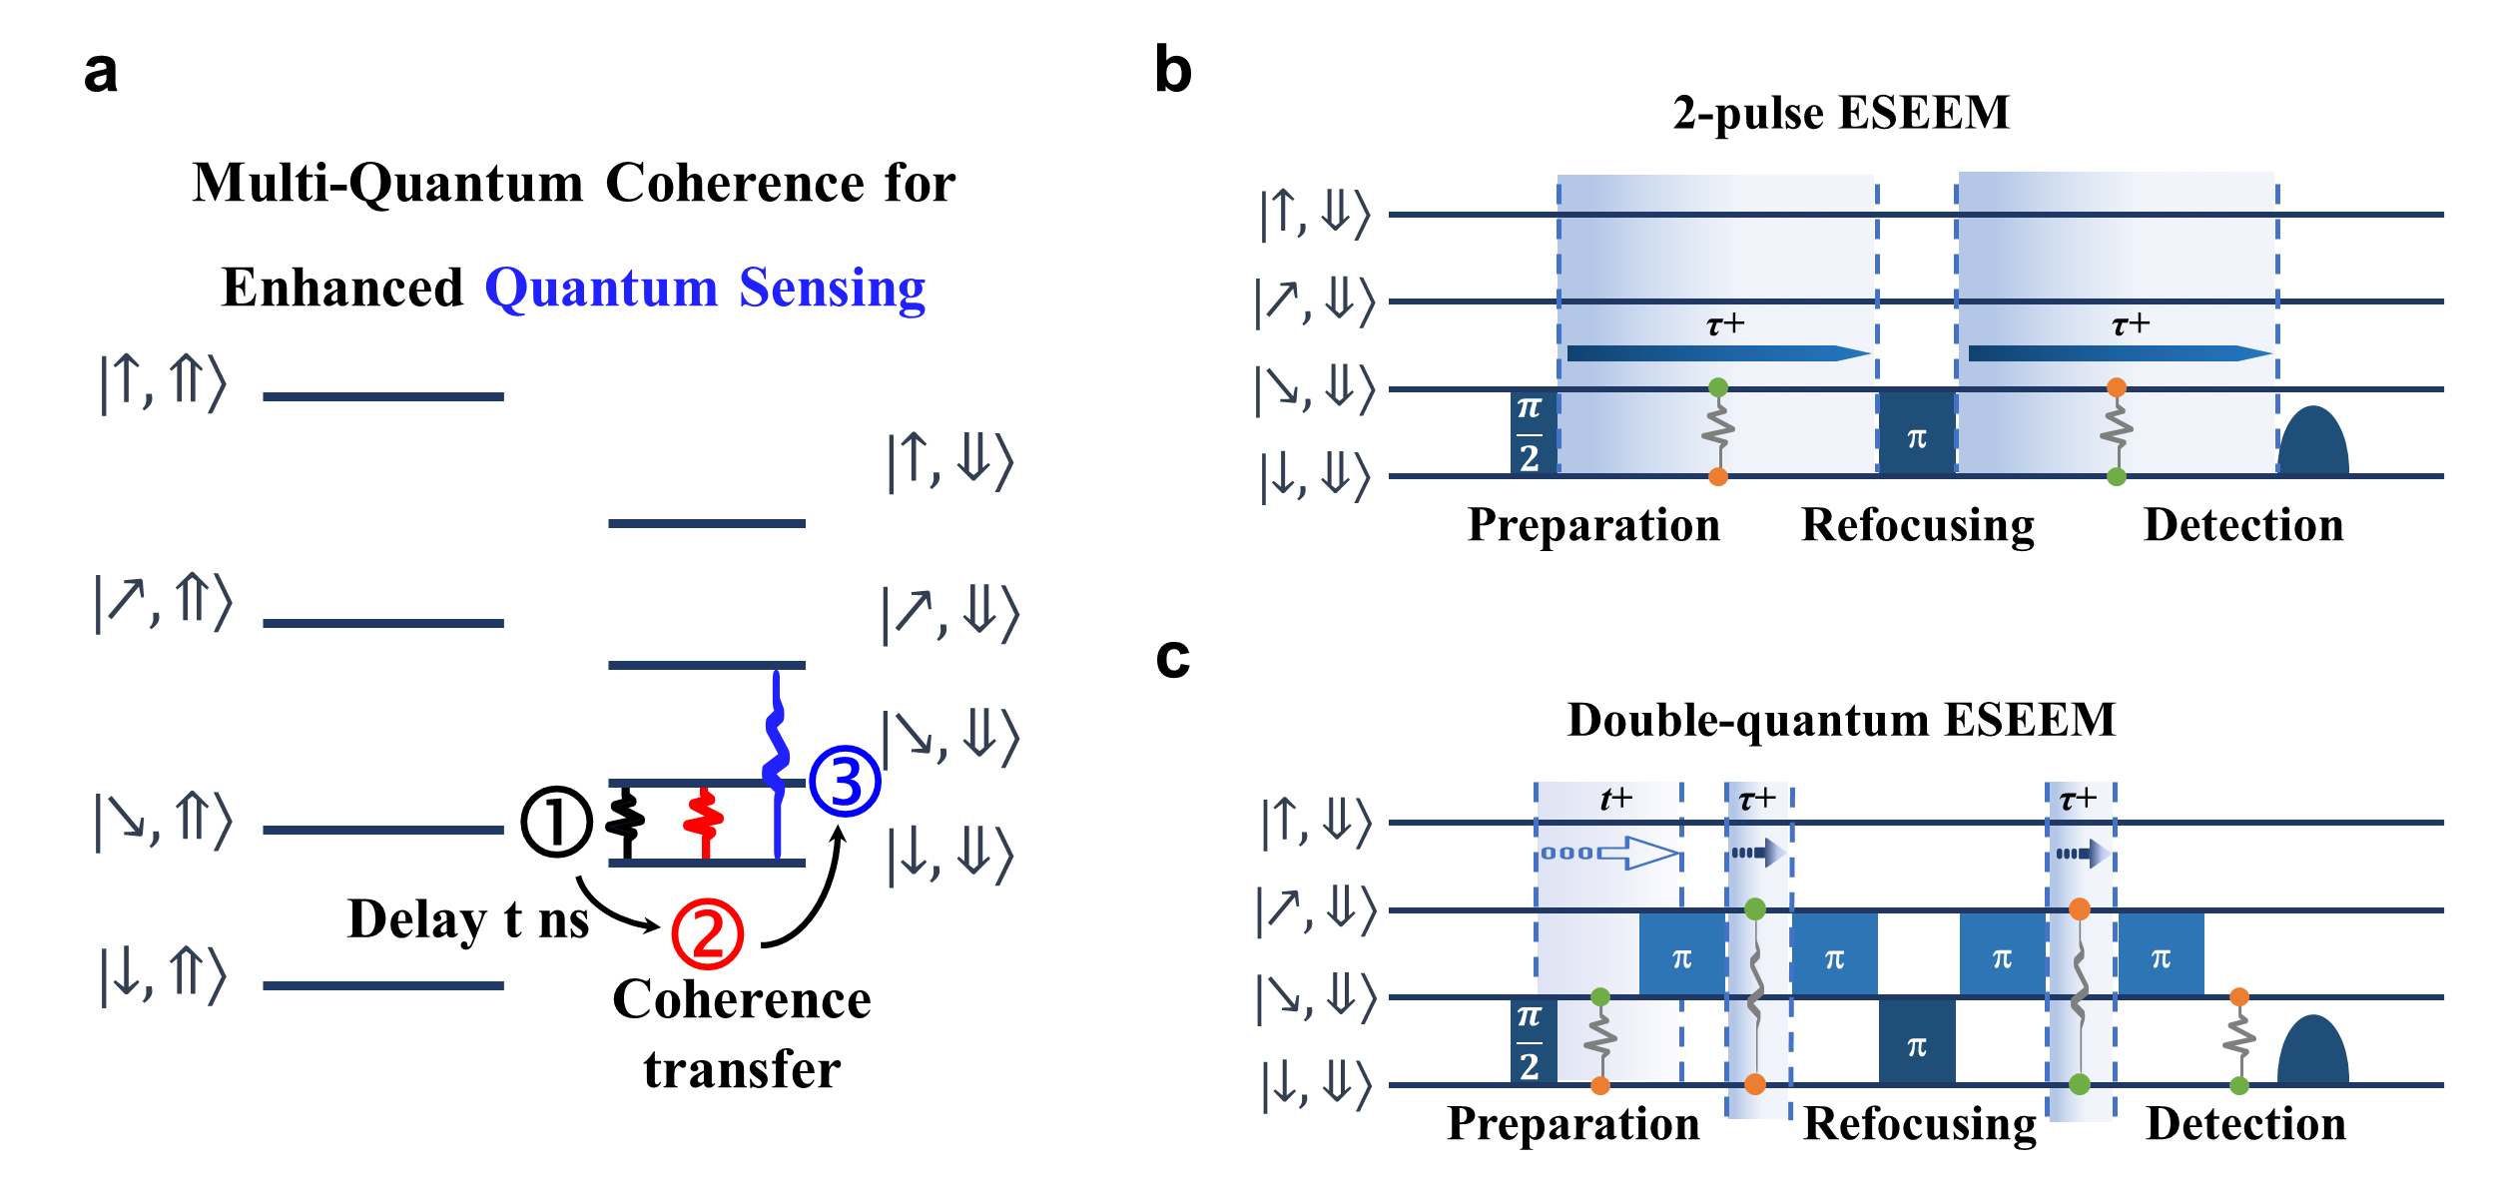
Supplementary Figure 13. (a) Scheme of quantum sensing enhancement via double quantum transition. (b-c) Pulse sequences for the 2-pulse ESEEM, and double-quantum ESEEM. τ denotes the evolution time of the superposition between |↘,⇓⟩ and |↓,⇓⟩ in the 2-pulse ESEEM, while t and τ indicate the evolution times of the superpositions between |$↘,⇓$⟩ and |$↓,⇓$⟩ and $|↗,⇓$ and $|↓,⇓$, respectively, in the double-quantum ESEEM.

7-2 Evolution time t in double-quantum ESEEM experiment
The evolution time $t$ of the superpositions between |$↘,⇓$⟩ and |$↓,⇓$⟩ was varied from 571 ns to 1471 ns in 50/100 ns increments, and the double-quantum ESEEM signal as a function of $τ$ was recorded at each step. The ESEEM signal was enhanced when $t=nT$ and suppressed when $t=\left(n+\frac{1}{2}\right)T$, where $T=445$ ns is the ²H Larmor period, demonstrating controllable interference in the ESEEM effect.
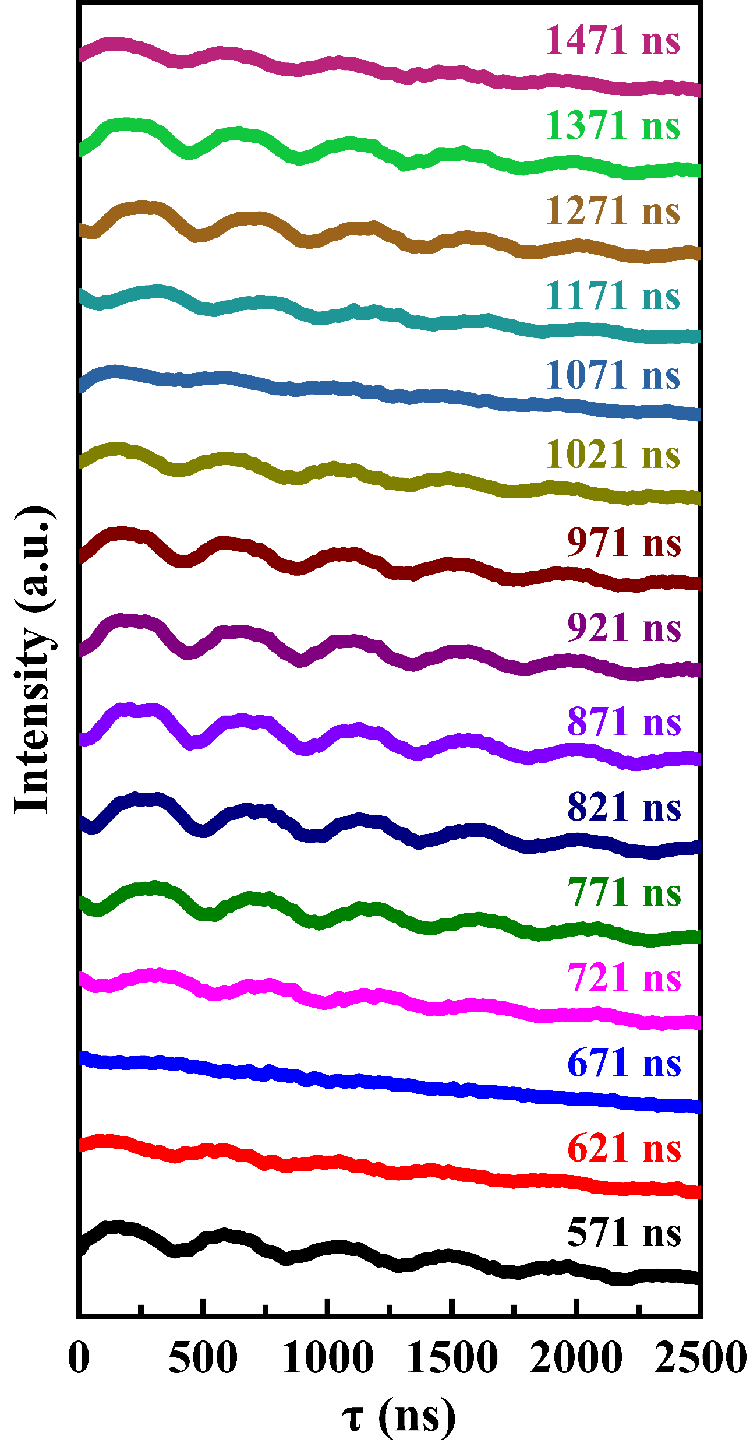
Supplementary Figure 14. Double-quantum ESEEM experiment. ESEEM signal intensity versus τ, measured at t = 571 to 1471 ns in 50 ns steps.

7-3 Calculation of the FFT signal-to-noise ratio
The time-domain ESEEM traces were multiplied by a Hann window and transformed into one-sided, normalized FFT amplitude spectra. The dominant FFT peak was identified within the frequency range of 0.5-20 MHz. Assuming Rayleigh-distributed noise amplitudes, the robust noise estimate was calculated from the full-spectrum median as
$$σ=\frac{median\left[S(f)\right]}{\sqrt{2ln2}}$$
where $S\left(f\right)$is the FFT amplitude spectrum, median [$S\left(f\right)$] is the median amplitude over the full frequency range, and $σ$ is the Rayleigh scale parameter used as a robust estimate of the noise amplitude. The FFT signal-to-noise ratio was then calculated as
$$SNR=\frac{A_{peak}}{σ}$$
where $A_{peak}$ is the amplitude of the dominant FFT peak. The SNR enhancement in decibels was calculated as
$$∆{SNR}_{dB}=20log\log_{10}{(}\frac{{SNR}_{DQ}}{{SNR}_{SQ}})$$
For conventional two-pulse ESEEM, $A_{peak}=0.18123$, $σ=0.010429$, and $SNR=17.38$; for double-quantum ESEEM, $A_{peak}=0.42271$, $σ=0.010116$, and $SNR=41.78$. The SNR of double-quantum ESEEM was therefore 2.40 times that of conventional two-pulse ESEEM, corresponding to an increase of 7.62 dB.
For the 0-5000 ns time window, $A_{peak}=0.65565$, $σ=0.012891$, and $SNR=50.86$ for conventional two-pulse ESEEM; $A_{peak}=1.73995$, $σ=0.017794$, and $SNR=97.80$ for double-quantum ESEEM. The corresponding SNR enhancement was 1.92-fold, equivalent to 5.68 dB. Both time windows showed a higher FFT signal-to-noise ratio for double-quantum ESEEM. For the 0–5000 ns time window, the increased noise estimate of double-quantum ESEEM reduced the SNR enhancement from 2.40-fold to 1.92-fold.
The 2.40-fold enhancement calculated over the entire acquired time window was used for the quantitative comparison in the main text.

Supplementary Note 8. Quantum coherence storage in the nuclear spin
8-1 Coherence transfer from electron spin to nuclear spin
In the pulse sequence in Supplementary Figure 15, the first MW5 π/2 generates a superposition between $|\left.↗, ⇓\right\rangle and |\left.↘, ⇓\right\rangle$. A subsequent RF2 $π$ pulse transfers this superposition into an electron–nuclear entangled state, and the following MW5 $π$ pulse generates nuclear-spin coherence. The coherence is then stored in the nuclear spin and later transferred back to the electron spin for readout via a symmetry pulse sequence (MW5 π - RF2 π). During this process, the second RF2 π pulse refocuses the nuclear coherence, while the first and fourth MW5 π pulses refocus the electron coherence.
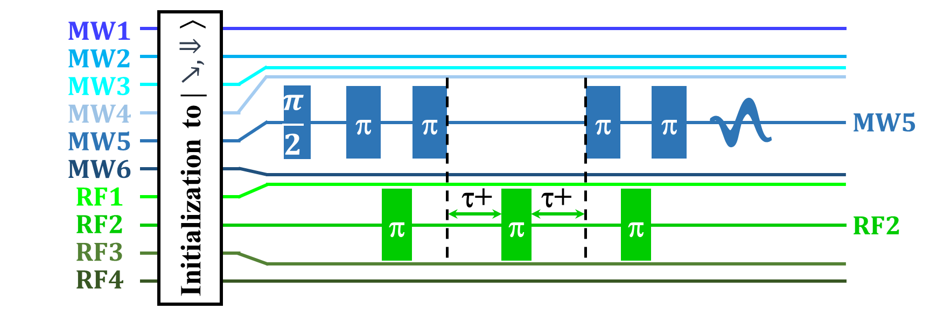
Supplementary Figure 15. Pulse sequence used to transfer coherence from the electron spin to the nuclear spin via electron–nuclear entanglement.
8-2 Dynamical decoupling for extending coherence time
Dynamical decoupling is a widely used approach for extending spin coherence times by suppressing the coupling between a spin system and its environment, and it has found broad application in molecular magnets, including transition-metal complexes ^{6–8}, rare-earth complexes ^{9,10} and organic radicals^{10–13}. Repeated microwave π pulses are applied to flip the electron spin by 180° about the y axis, thereby refocusing the spin magnetization and averaging out low-frequency interactions with the surrounding magnetic environment.

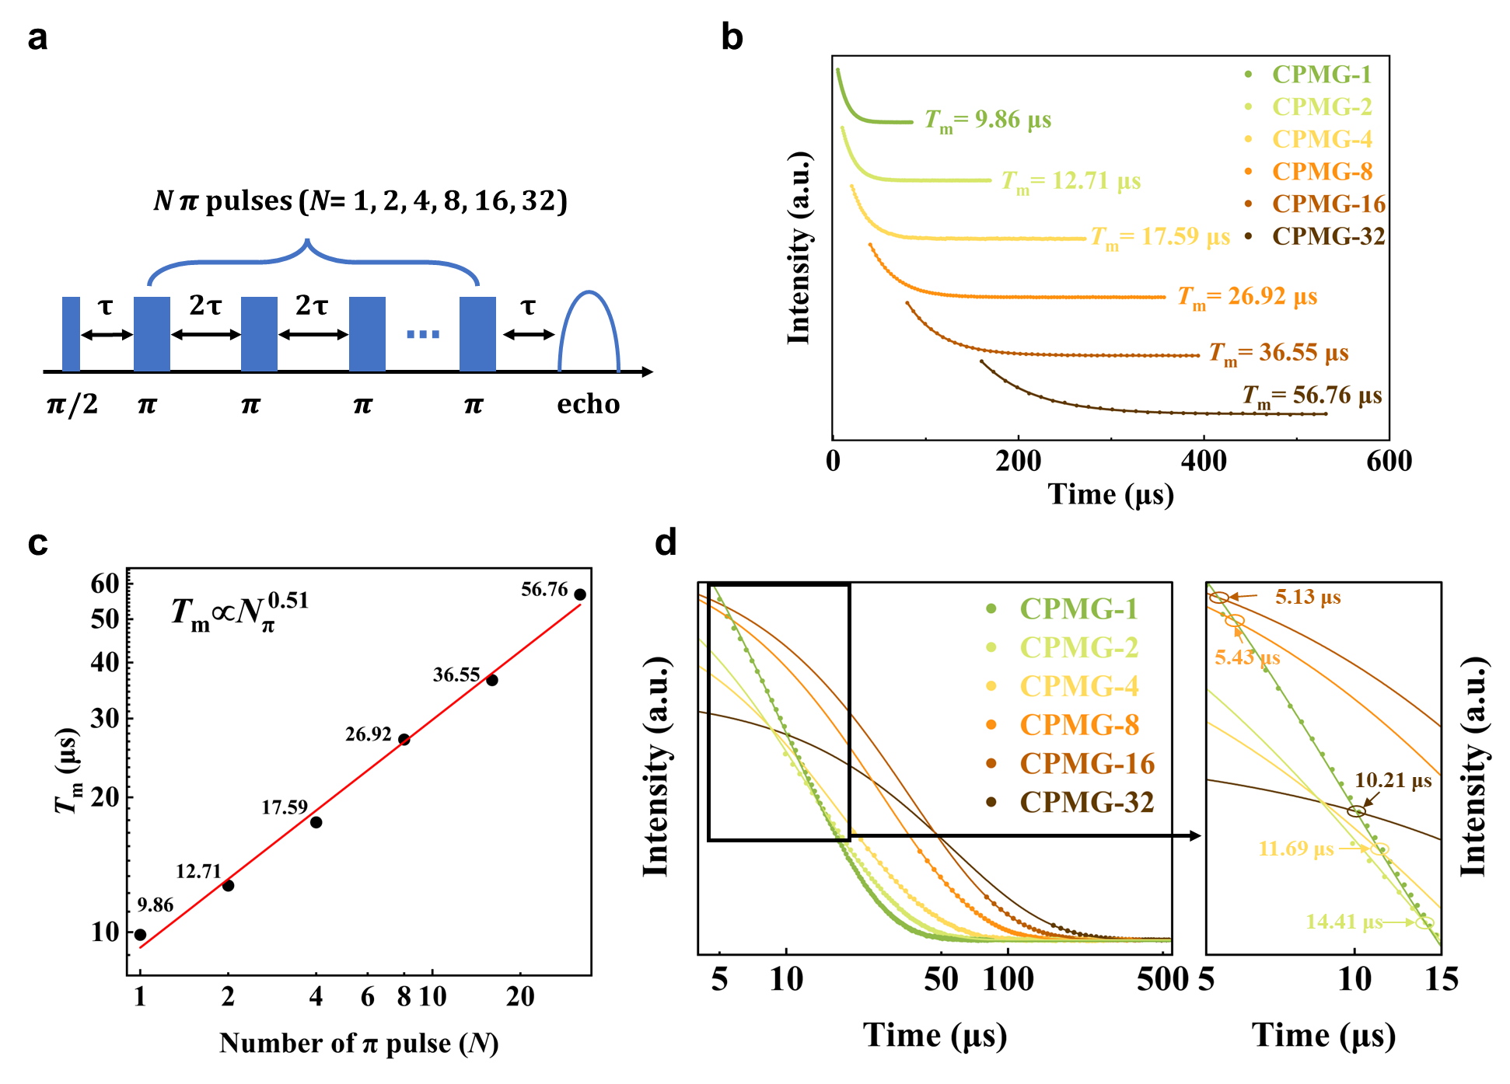
Supplementary Figure 16. Dynamical decoupling. (a) CPMG pulse sequence, with N π pulses (CPMG-N), where N = 1, 2, 4, 8, 16, and 32. (b) CPMG results for the electron-spin superpositions between $|\left.↗, ⇓\right\rangle and |\left.↘, ⇓\right\rangle$ in P@C₆₀ powder at 5 K. (c) Coherence time (T_{m}) as a function of the number of π pulses (N) in the applied CPMG sequence, with a power-law scaling $T_{m}∝N_{π}^{0.51}$. (d) Absolute signal intensities of different CPMG results and a zoom-in of their intersection points with CPMG-1 (Hahn echo).

Dynamical decoupling is a widely used approach for extending spin coherence times by suppressing the coupling between a spin system and its environment, and it has found broad application in molecular magnets, including transition-metal complexes ^{6–8}, rare-earth complexes ^{9,10} and organic radicals^{10–13}. Repeated microwave π pulses are applied to flip the electron spin by 180° about the y axis, thereby refocusing the spin magnetization and averaging out low-frequency interactions with the surrounding magnetic environment.
In this work, Carr-Purcell-Meiboom-Gill (CPMG) measurements were performed on P@C₆₀ powder at 5 K. After preparing the electron-spin superposition with an initial π/2 pulse, a series of equally spaced π pulses was applied along the y axis (Supplementary Figure 16a). Sequences with different numbers of π pulses (CPMG-1, 2, 4, 8, 16, 32) were tested. As the number of π pulses increases, the electron-spin coherence time increases progressively, from ~10 μs for CPMG-1 to ~57 μs for CPMG-32 (Supplementary Figure 16b). This increase in spin coherence time is comparable to those reported for dynamical decoupling in molecular magnets. However, it is substantially smaller than that achieved by transferring coherence to the nuclear spin, which enables quantum storage over much longer timescales.
In addition, the coherence time $T_{m}$ as a function of the number of applied π pulses $N_{π}$ follows a power-law scaling, $T_{m}∝N_{π}^{0.51}$ (Supplementary Figure 16c), suggesting a decoherence mechanism arising from the combined contributions of a white-noise-like environment and residual spin-bath interactions^{14–16}. In contrast, our strategy harnesses the nuclear spins, transforming one of the sources of electron-spin decoherence into a resource for long-term quantum storage.

8-3 Fidelity and crossover time
The signal decay curves shown in Fig. 4c for coherence retained in the electron spin (Hahn-echo measurement) and that transferred to the nuclear spin for storage were converted into fidelity decay curves shown in Fig. 4d as follow.
For each coherence measurement, the relevant spin subspace was treated as an effective two-level system spanned by |0⟩ and |1⟩, with equal populations assumed at all times, p₀(t)=p₁(t)=1/2. Let I_{i}(t) denote the measured signal intensity for electron-spin (i=e)) or nuclear-spin (i=n) storage, with t expressed in microseconds (μs). Both datasets were normalized to the global maximum signal intensity, I_{max}=max [I_{i}(t)] = 63, The normalized coherence amplitude was then defined as C_{i}(t)= I_{i}(t)/I_{max}. Under these assumptions, the density matrix can be written as ρ_{i}(t)=$\frac{1}{2}(|00|+|11|)+\frac{C_{i}(t)}{2}(\left|00\right|+\left|11\right|)$. The corresponding fidelity with respect to the equal superposition state $|ψ_{+}⟩=\left(\left|0⟩+\right|1⟩\right)/\sqrt{2}$ is therefore
$$F_{i}\left(t\right)=\left\langle ψ_{+}\left|ρ_{i}\left(t\right)\right|ψ_{+}\right\rangle =\frac{1+C_{i}\left(t\right)}{2}.$$
When C_{i}(t) = 1, the fidelity reaches its maximum value $F_{i}\left(t\right)=1$; when phase coherence is completely lost, C_{i}(t) = 0.5 and $F_{i}\left(t\right)=0.5$.
The fidelity decay curves for electron- and nuclear-spin storage intersect at 49 μs, marking the crossover time between the two storage strategies.

Supplementary Table 7. Coherence (T_{m}) and crossover times for different CPMG sequences to enhance quantum storage (CPMG-1, i.e., Hahn echo).
Dynamical decoupling |  | T_{m}/μs | Crossover times /μs
CPMG | 1 | 9.86
CPMG | 2 | 12.71 | 14.41
CPMG | 4 | 17.59 | 11.69
CPMG | 8 | 26.92 | 5.43
CPMG | 16 | 36.55 | 5.13
CPMG | 32 | 56.76 | 10.21

For dynamical decoupling, the crossover time for each multi-pulse CPMG sequence was determined from the intersection of its absolute signal-intensity decay curve with the CPMG-1 (Hahn-echo) curve (Supplementary Figure 16d). Before each crossover time, the Hahn-echo signal is stronger, whereas beyond it, the corresponding multi-pulse CPMG sequence yields a higher absolute signal. The corresponding crossover times are all within 15 μs, as summarized in Supplementary Table 7. For CPMG-2, however, the crossover time lies beyond its coherence time, indicating no practical signal advantage over the Hahn echo.

Supplementary References:
1. Agarwal, G. S. Relation between atomic coherent-state representation, state multipoles, and generalized phase-space distributions. Phys. Rev. A (Coll. Park). 24, 2889–2896 (1981).
2. Arecchi, F. T., Courtens, E., Gilmore, R. & Thomas, H. Atomic Coherent States in Quantum Optics. Phys. Rev. A (Coll. Park). 6, 2211–2237 (1972).
3. Rundle, R. P., Mills, P. W., Tilma, T., Samson, J. H. & Everitt, M. J. Simple procedure for phase-space measurement and entanglement validation. Phys. Rev. A (Coll. Park). 96, 22117 (2017).
4. Pedrozo-Peñafiel, E. et al. Entanglement on an optical atomic-clock transition. Nature 588, 414–418 (2020).
5. Zhou, S. et al. Implementation of Quantum Level Addressability and Geometric Phase Manipulation in Aligned Endohedral Fullerene Qudits. Angew. Chem. Int. Ed. 61, e202115263 (2022).
6. McGuire, J., Tesi, L., Endeward, B., Frey, W. & van Slageren, J. Dynamic Decoupling Doubles Coherence Times in a Nuclear Spin “Lite” Vanadium(IV) Tris(dithiolate). Inorg. Chem. 64, 18643–18654 (2025).
7. Swain, A. et al. Encapsulation Enhances the Quantum Coherence of a Solid-State Molecular Spin Qubit. Angew. Chem. Int. Ed. 64, e202510603 (2025).
8. Dai, Y. et al. Experimental Protection of the Spin Coherence of a Molecular Qubit Exceeding a Millisecond. Chinese Physics Letters 38, 030303 (2021).
9. Hansen, S. H. et al. Probing decoherence in molecular 4f qubits. Chem. Sci. 15, 20328–20337 (2024).
10. Soetbeer, J. et al. Dynamical decoupling in water–glycerol glasses: a comparison of nitroxides, trityl radicals and gadolinium complexes. Physical Chemistry Chemical Physics 23, 5352–5369 (2021).
11. Soetbeer, J., Hülsmann, M., Godt, A., Polyhach, Y. & Jeschke, G. Dynamical decoupling of nitroxides in o-terphenyl: a study of temperature, deuteration and concentration effects. Physical Chemistry Chemical Physics 20, 1615–1628 (2018).
12. Soetbeer, J., Ibáñez, L. F., Berkson, Z., Polyhach, Y. & Jeschke, G. Regularized dynamical decoupling noise spectroscopy – a decoherence descriptor for radicals in glassy matrices. Physical Chemistry Chemical Physics 23, 21664–21676 (2021).
13. Du, J. et al. Preserving electron spin coherence in solids by optimal dynamical decoupling. Nature 461, 1265–1268 (2009).
14. Bar-Gill, N. et al. Suppression of spin-bath dynamics for improved coherence of multi-spin-qubit systems. Nat. Commun. 3, 858 (2012).
15. Pham, L. My. Magnetic Field Sensing with Nitrogen-Vacancy Color Centers in Diamond. (Harvard University, 2013).
16. Bar-Gill, N., Pham, L. M., Jarmola, A., Budker, D. & Walsworth, R. L. Solid-state electronic spin coherence time approaching one second. Nat. Commun. 4, 1743 (2013).

