ELECTRONIC SUPPLEMENTARY MATERIAL
Time-Varying Monetary–Fiscal Policy Interaction and Inflation Dynamics: Evidence from Indonesia using a TVP-VAR-SV Approach

This supplementary material contains the following figures:
• Figure S1. Scatter Matrix and Correlation Heatmap
• Figure S2. Sup-Wald parameter stability test
• Figure S3. Sup-Wald Parameter Stability Test
• Figure S4. TV-FEVD Credible Bands – Respons CPI (t = 2012Q3)
• Figure S5. Volatility Heatmap – All Variables
• Figure S6. Verifikasi Historical Decomposition (Actual vs HD Total)
• Figure S7. Residual Diagnostics TVP-VAR-SV

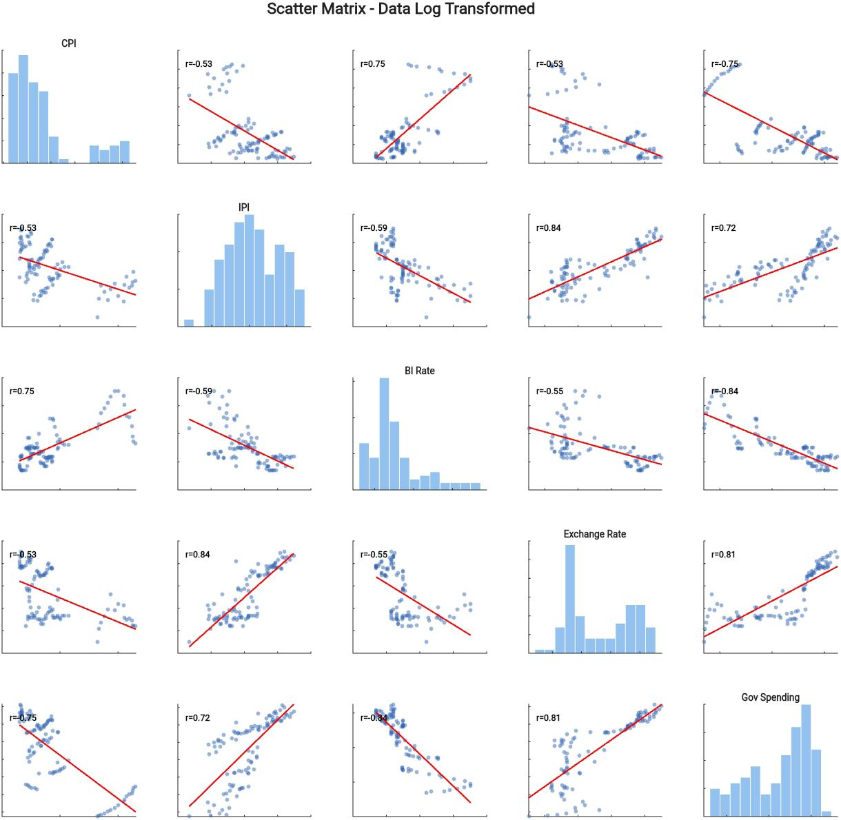
Figure S1. Scatter Matrix and Correlation Heatmap

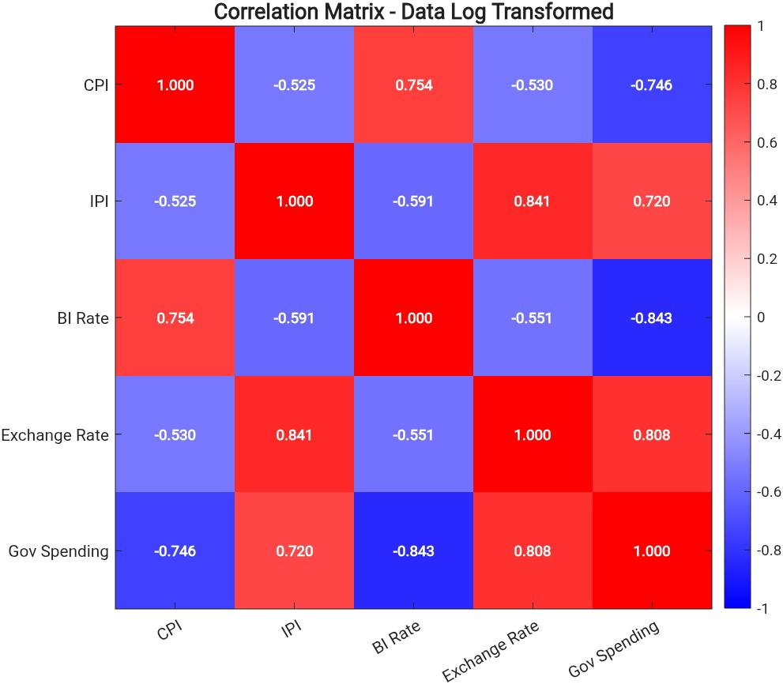
Figure S1. Scatter matrix dan correlation heatmap variabel dalam transformasi log. Angka pada setiap panel menunjukkan koefisien korelasi Pearson; semua korelasi signifikan pada tingkat 1% (***).
Catatan: Sumber: diolah dari FRED dan Bank Indonesia.

Figure S2. Sup-Wald parameter stability test...
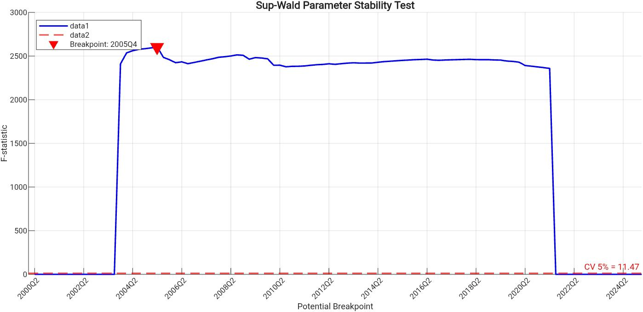
Figure S2. Sup-Wald parameter stability test. F-statistic = 2604.59 with a potential breakpoint at 2005Q4, far exceeding the 5% critical value of 11.47, confirming parameter instability that justifies the use of TVP-VAR-SV.
Note: H0: parameters are stable throughout the sample period. Rejection of H0 confirms the need for a time-varying approach.

Figure S3. IRF CPI pre vs post krisis...
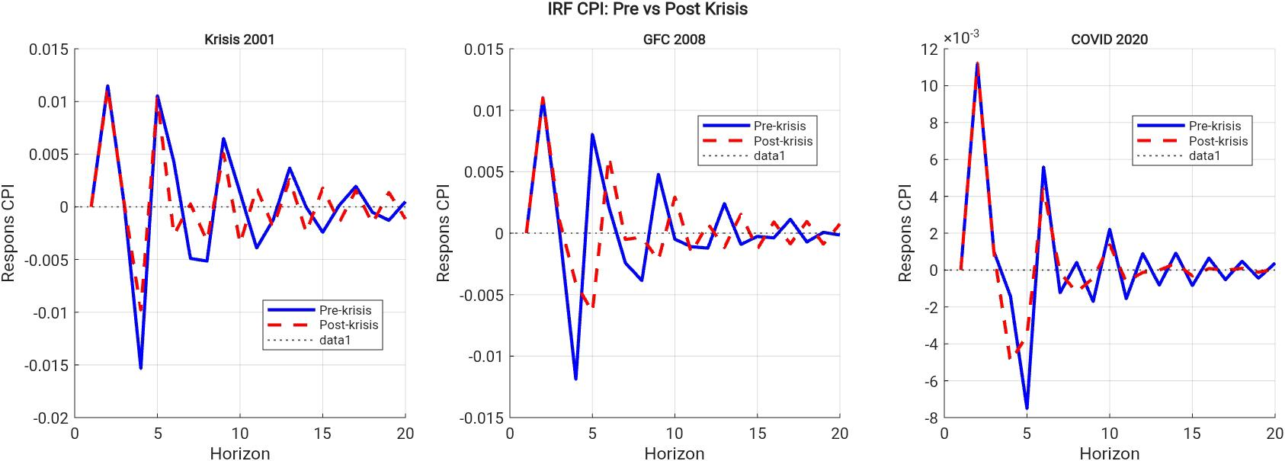
Figure S3. Comparison of CPI IRF pre vs. Post crisis episodes (2001, 2008, 2020). Blue line: pre-crisis period; red dashed line: post-crisis period. The horizontal line indicates the baseline.

Figure S4. TV-FEVD Credible Bands – Respons CPI (t = 2012Q3)
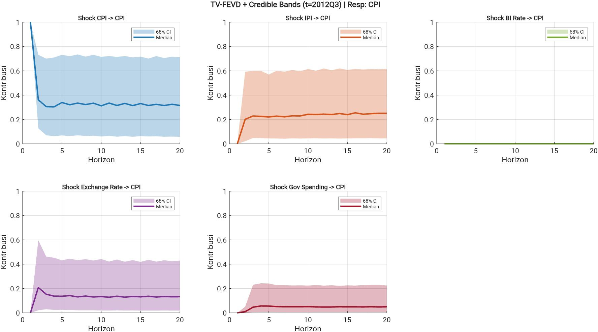
Time-varying forecast error variance decomposition (TV-FEVD) with 68% credible intervals for each shock to CPI at the mid-sample period (2012Q3). The shaded area indicates estimation uncertainty (68% posterior credible interval); the solid line represents the posterior median. The horizontal axis shows the horizon in quarters (1–20); the vertical axis shows the relative contribution (0–1).
Note: Credible intervals are computed from 10,000 posterior draws using Gibbs Sampling.g.

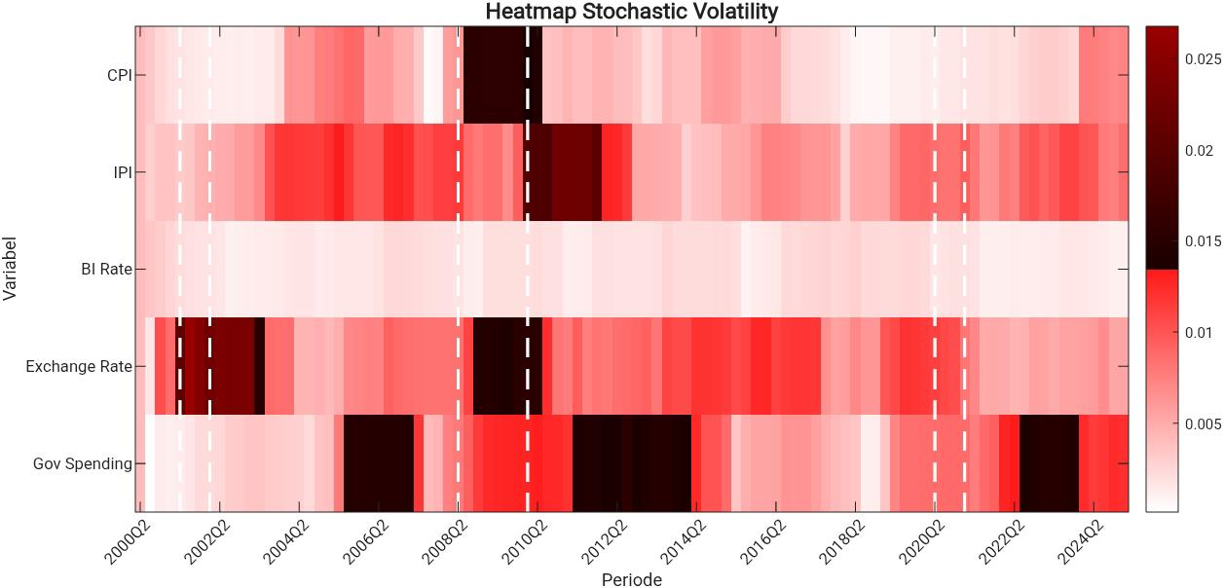
Figure S5. Volatility Heatmap – All Variables

Rolling volatility proxy heatmap (rolling standard deviation, window = 8 quarters) for all macroeconomic variables over the sample period 2000Q1–2025Q1. Darker colors (dark red) indicate higher volatility; lighter colors indicate lower volatility. Vertical dashed lines mark major crisis episodes: 2001 (post-reform), 2008–09 (GFC), and 2020 (COVID-19).
Note: The rolling volatility proxy is a descriptive representation and is not identical to the latent log-volatility estimated within the TVP-VAR-SV system.

Figure S6. Verifikasi Historical Decomposition (Actual vs HD Total)
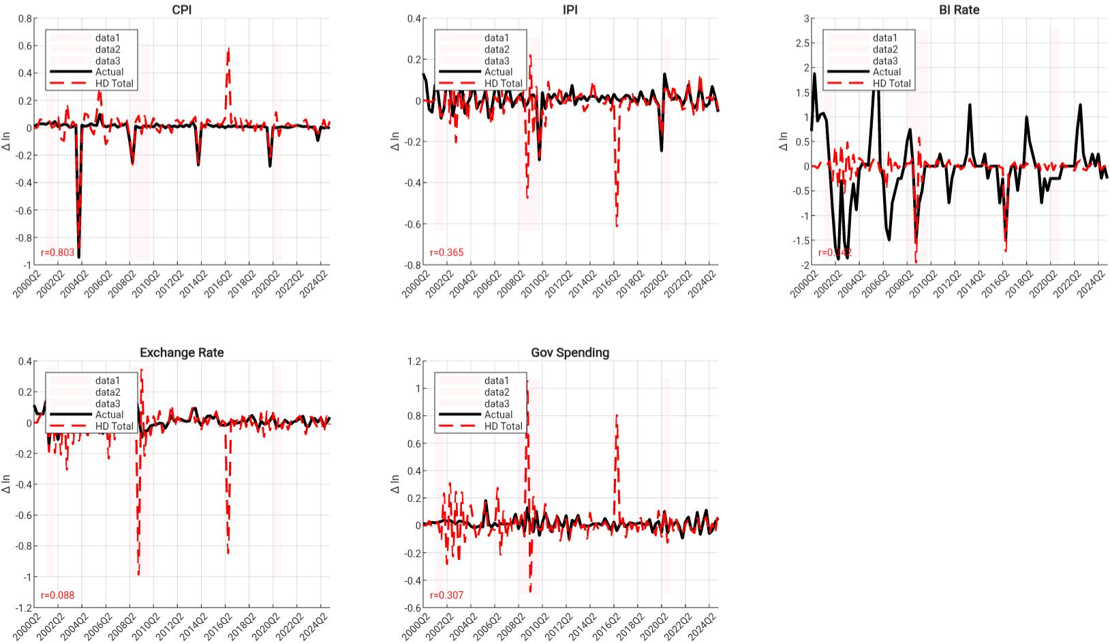

Comparison between actual values (solid black line) and total historical decomposition (red dashed line) for all variables: CPI, IPI, BI Rate, Exchange Rate, and Government Spending. The Pearson correlation coefficient (r) between the actual and HD total is displayed in the lower-left corner of each panel.
Note: r(CPI) = 0.800; r(IPI) = 0.365; r(Exchange Rate) = 0.088; r(Gov Spending) = 0.397. The lower fit for Exchange Rate and Gov Spending reflects the model’s limitations in capturing very short-run dynamics of more volatile variables.

Figure S7. Residual Diagnostics TVP-VAR-SV
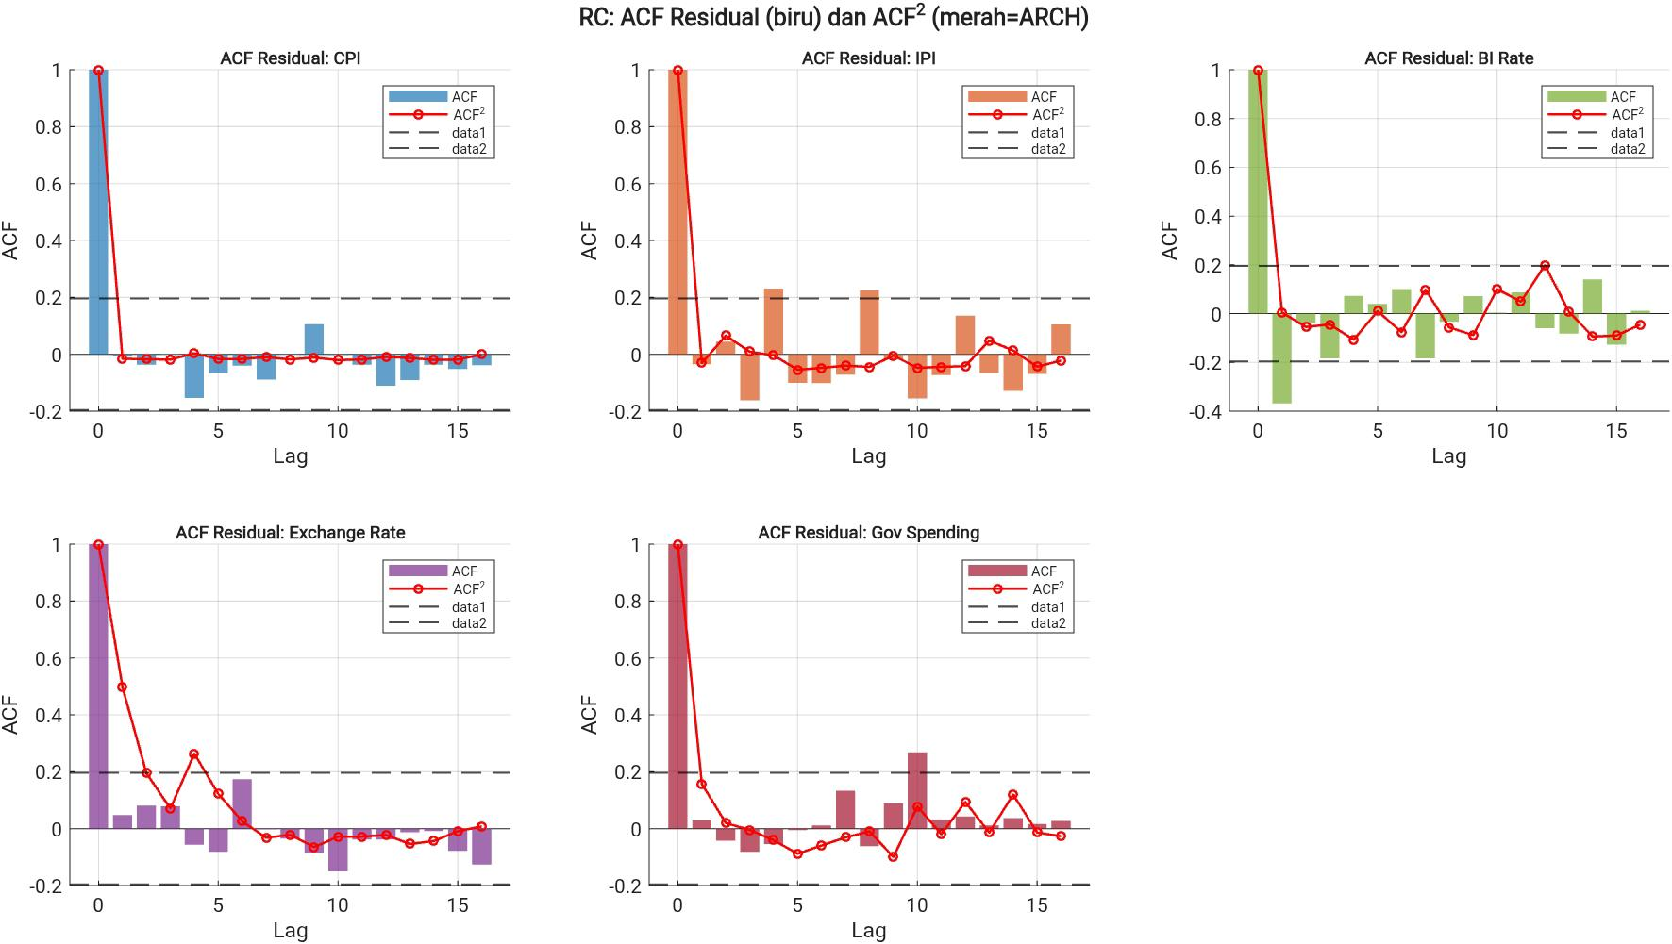
i
Residual diagnostics for all variables in the TVP-VAR-SV system. Upper panel: ACF of residuals (blue bars) testing for remaining autocorrelation. Lower panel: ACF of squared residuals (red line, proxy for ARCH effects) testing for conditional heteroskedasticity. Horizontal dashed lines indicate the 5% significance bounds (±1.96/√T).
Note: Ljung-Box Q-test: BI Rate exhibits residual autocorrelation (p = 0.001); CPI, IPI, Exchange Rate, and Government Spending show no significant autocorrelation. ARCH effects are detected in Exchange Rate (p = 0.000), consistent with the widely documented heteroskedasticity of exchange rates.

