Supplementary Materials
Table S1. shRNA sequences targeting TACSTD2/TROP2
Gene | shRNA ID | Target sequence (5’ −> 3’) | Clone ID | Vector
TACSTD2 | Sh1 | GCGGCAGAACACGTCTCAGAA | TRCN0000056418 | Plko.1 puro
TACSTD2 | Sh2 | GAGAAAGGAACCGAGCTTGTA | TRCN0000056419 | Plko.1 puro
TACSTD2 | Sh3 | CGTGGACAACGATGGCCTCTA | TRCN0000056421 | Plko.1 puro
Table S1. shRNA sequences targeting TACSTD2/TROP2.
Target sequences, clone IDs, and vector information for shRNAs targeting TACSTD2/TROP2 used in this study.

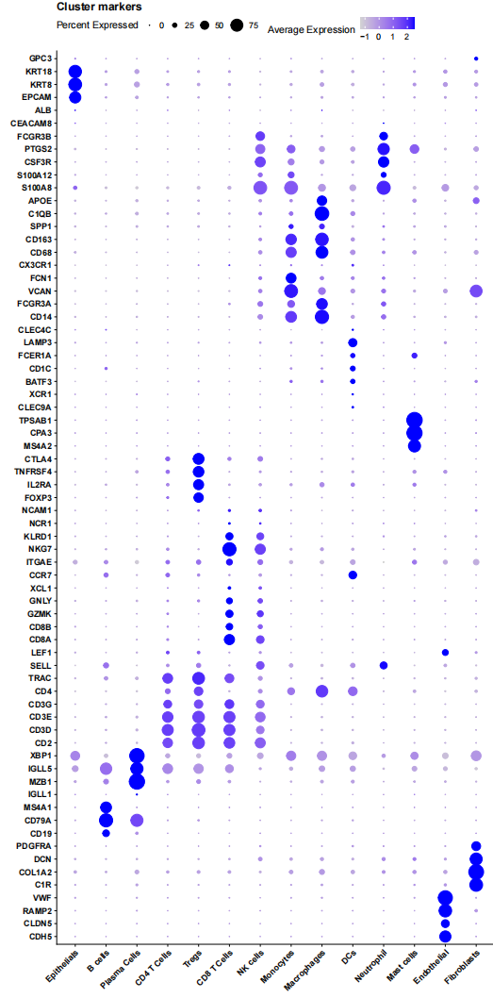
Figure.S1 Distribution of each marker gene on the UMAP plot.
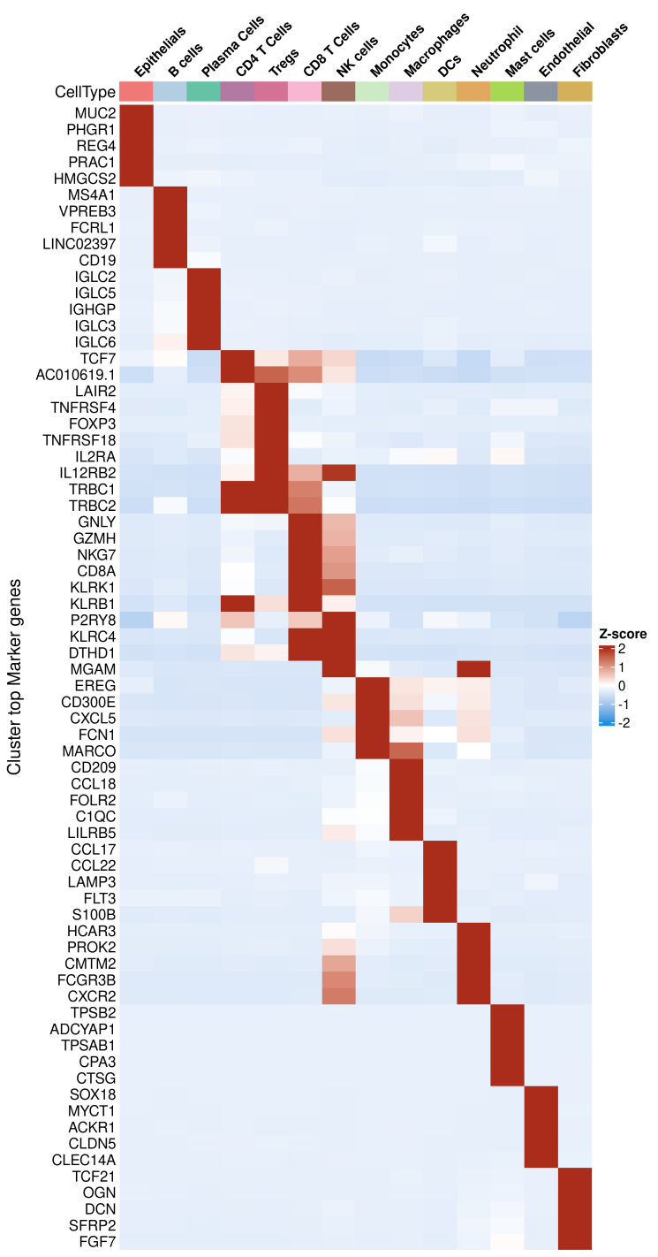
Figure.S2 Heatmap of top marker genes for each cluster delineating major cellular identities.UMAP, Uniform Manifold Approximation and Projection. CRC, colorectal cancer.

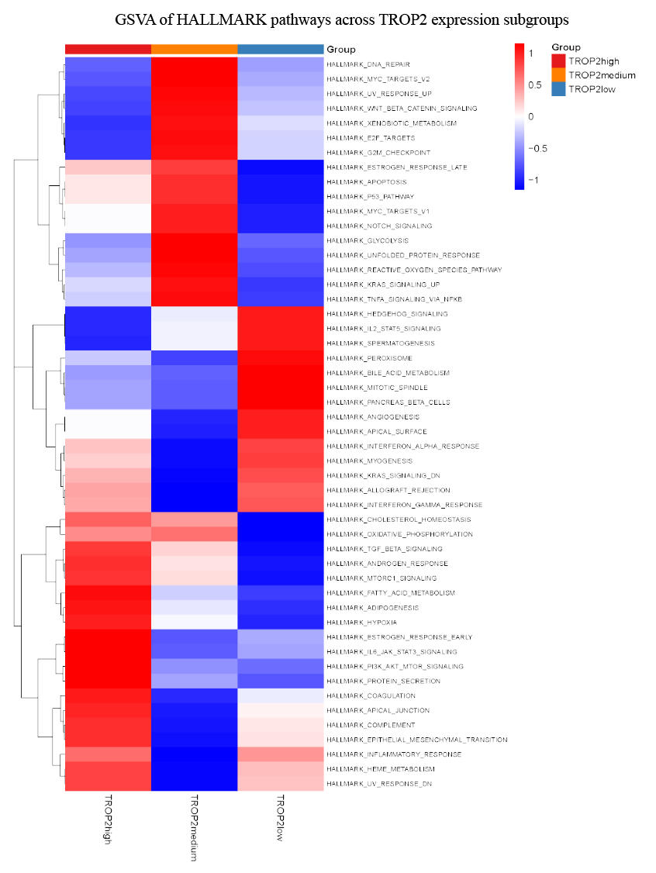
Figure S3. GSVA heatmap of HALLMARK pathways across TROP2 epithelial subgroups.
Heatmap showing GSVA-based HALLMARK pathway activity across TROP2-high, TROP2-medium, and TROP2-low epithelial subgroups.

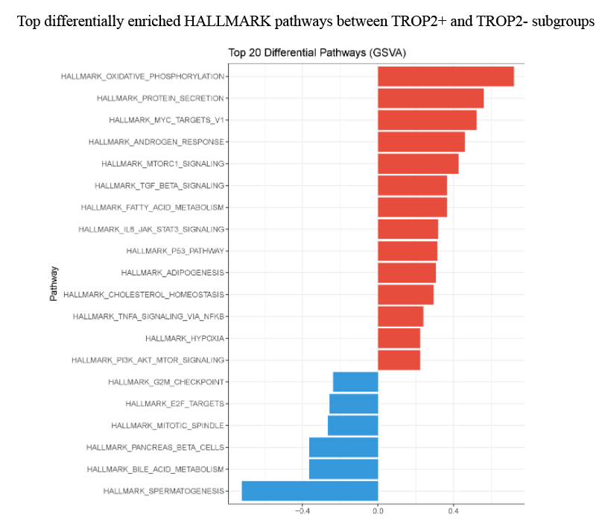
Figure S4. Top differentially enriched HALLMARK pathways between TROP2⁺ and TROP2⁻ epithelial subgroups.
Bar plot or enrichment summary showing the top HALLMARK pathways differentially enriched between TROP2⁺ and TROP2⁻ malignant epithelial cells.

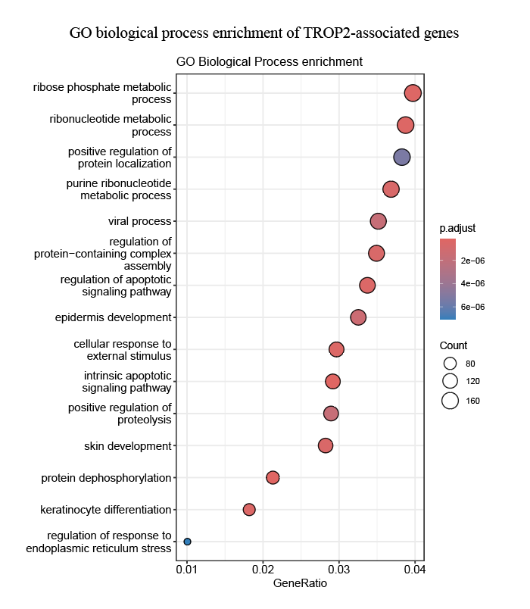
Figure S5. GO biological process enrichment analysis.
Gene Ontology biological process enrichment analysis of genes associated with TROP2-defined epithelial states.

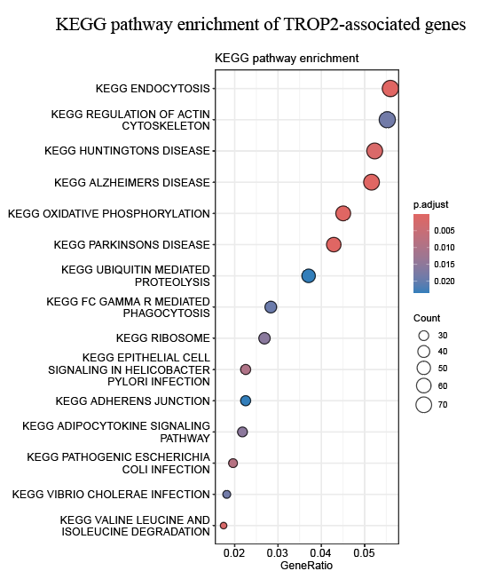
Figure S6. KEGG pathway enrichment analysis.
KEGG pathway enrichment analysis of genes associated with TROP2-defined epithelial states.

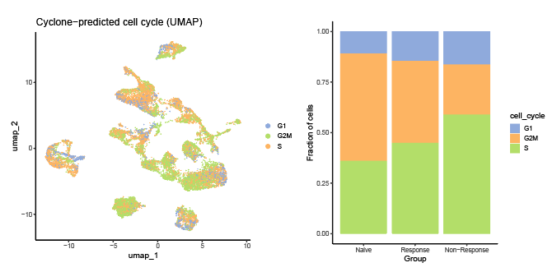
Figure S7. Cyclone-based cell-cycle analysis of CRC single-cell transcriptomes.
(A) UMAP plot showing Cyclone-predicted G1, S, and G2/M phases in CRC single-cell transcriptomes.
(B) Bar plot showing the fraction of cells assigned to each cell-cycle phase across Naive, Response, and Non-Response groups.

