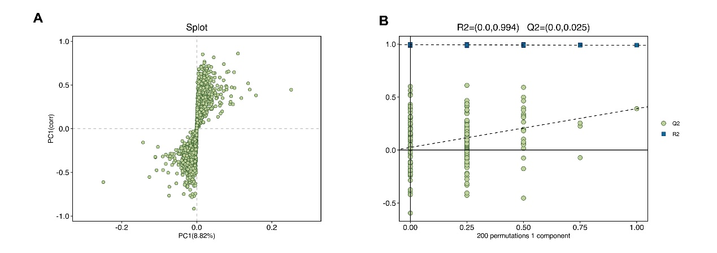
Figure S1. Validation of the OPLS-DA model for fecal metabolomic analysis.
(A) S-plot derived from the OPLS-DA model showing metabolites contributing to discrimination between control and PCOS groups; (B) Permutation test assessing the robustness of the OPLS-DA model.
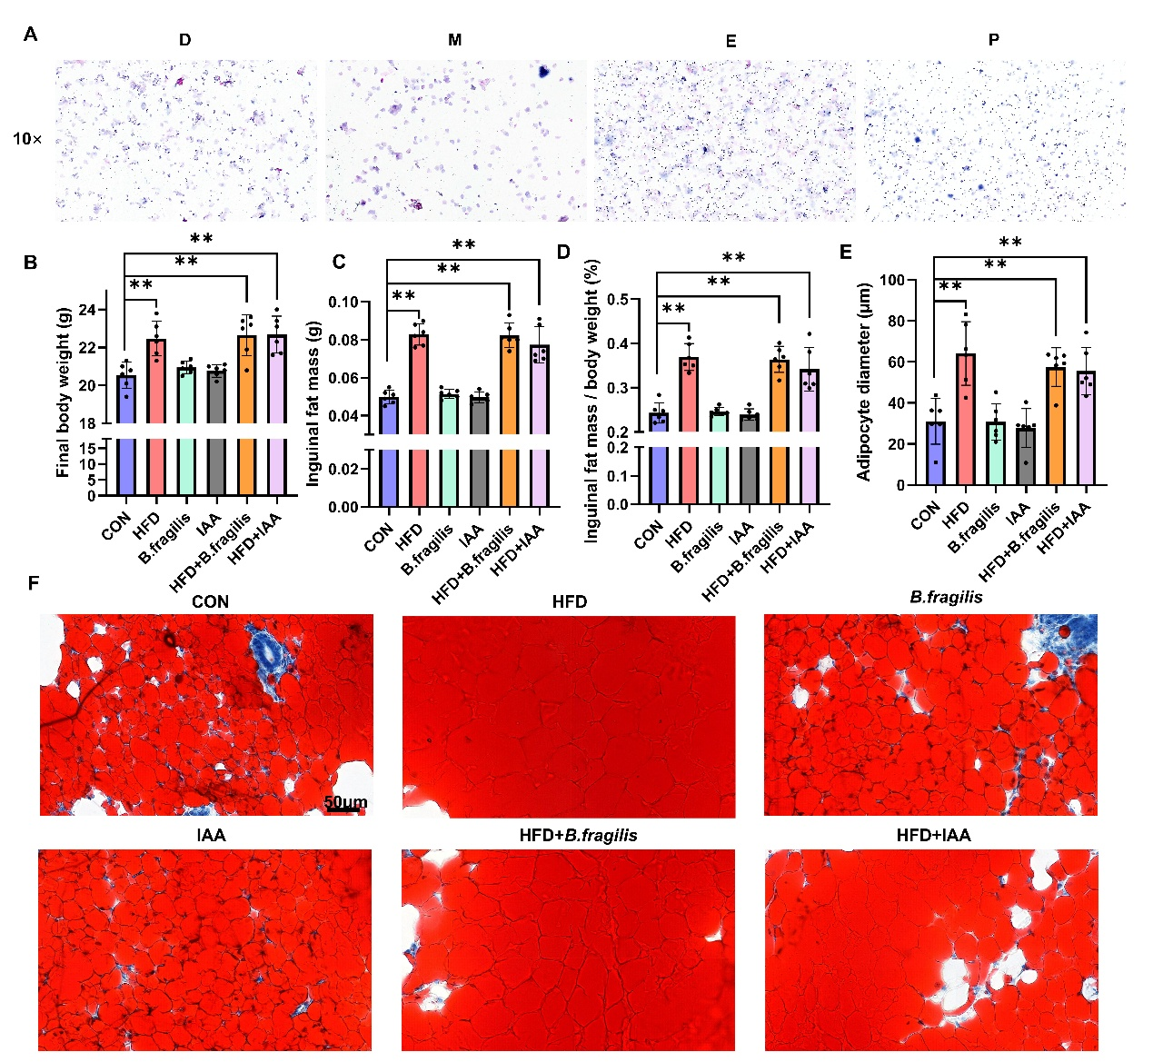
Figure S2. Metabolic phenotypes induced by high-fat diet
(A) Representative vaginal smear images; (B) Body weight; (C) Inguinal fat mass; (D) Fat-to-body weight ratio; (E) Adipocyte morphology; (F) Representative Oil Red O staining.
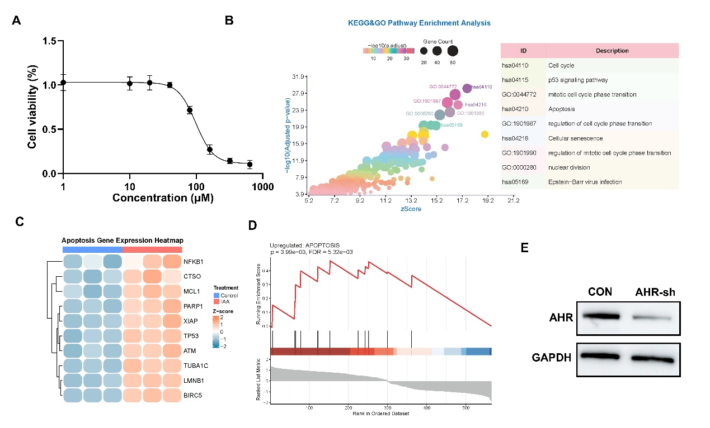Figure S3. Supplementary analysis following IAA treatment and validation of AHR knockdown
(A) Cell viability of granulosa cells assessed by CCK8 assay under IAA treatment; (B) Supplementary pathway enrichment analysis; (C) Heatmap of apoptosis-related genes; (D) Gene set enrichment analysis (GSEA) of apoptosis-related pathways; (E) Validation of AHR knockdown efficiency.

