Table
Table A1. UAV flights and biomass sampling dates of soybean during the 2024 and 2025 growing seasons
Date | BBCH code | Illumination | Wind (m∙s⁻¹) | GDD (℃∙day⁻¹) | Number of samples | Dataset
8/06/2024 | sowing | Clear sky | 1.2 | 0 | - | Digital Terrain Model
21/06/2024 | 10 | Clear sky | 1.0 | 205.27 | 20 | Calibration
26/06/2024 | 12 | Clear sky | 0.5 | 275.46 | 25 | Calibration
28/06/2024 | 13 | Clear sky | 1.0 | 305.43 | 20 | Calibration
04/07/2024 | 15 | Clear sky | 1.5 | 397.21 | 25 | Calibration
09/07/2024 | 16 | Cloudy | 0.8 | 469.06 | 30 | Calibration
11/07/2024 | 17 | Cloudy | 1.0 | 501.07 | 29 | Calibration
14/07/2024 | 18 | Clear sky | 2.1 | 551.89 | 48 | Calibration
19/07/2024 | 19 | Cloudy | 1.3 | 635.55 | 48 | Calibration
25/07/2024 | 60 | Clear sky | 1.3 | 741.99 | 44 | Calibration
06/08/2024 | 63 | Clear sky | 0.7 | 975.69 | 48 | Calibration
14/08/2024 | 71 | Clear sky | 1.1 | 1133.28 | 48 | Calibration
06/09/2024 | 79 | Cloudy | 1.5 | 1532.08 | 25 | Calibration
30/05/2025 | sowing | Clear sky | 1.9 | 0 | - | Digital Terrain Model
13/06/2025 | 10 | Clear sky | 0.9 | 177.15 | 40 | Test
19/06/2025 | 12 | Clear sky | 2.0 | 266.36 | 45 | Test
27/06/2025 | 13 | Clear sky | 0.9 | 373.80 | 45 | Test
04/07/2025 | 15 | Cloudy | 1.7 | 497.66 | 45 | Test
11/07/2025 | 17 | Clear sky | 2.1 | 636.70 | 45 | Test
20/07/2025 | 60/19 | Clear sky | 1.7 | 773.66 | 40 | Test
25/07/2025 | 63/60 | Clear sky | 0.8 | 869.42 | 40 | Test
03/08/2025 | 69/63 | Cloudy | 1.1 | 1055.66 | 40 | Test
07/08/2025 | 71/65 | Clear sky | 2.0 | 1126.01 | 40 | Test
17/08/2025 | 75/73 | Clear sky | 1.3 | 1293.34 | 40 | Test
23/08/2025 | 79/75 | Clear sky | 1.1 | 1427.54 | 30 | Test
The reproductive growth stage begins at a BBCH code of 60 or higher.. GDD stands for growing degree days.

Table A2. Vegetation index formulas used in this study for RGB.
Vegetation Index | Acronym | Equation
Normalized Excess Green | ExG | $$\frac{2g - r - b}{r + g + b}$$
Normalized Excess Green-Red | ExGR | $$\frac{(2g - r - b) - (1.4r - g)}{r + g + b}$$
Green Leaf Index | GLI | $$\frac{2g - r - b}{2g + r + b}$$
Visible Atmospherically Resistant Index | VARI | $$\frac{g - r}{g + r - b}$$
Normalized Green-Red Difference Index | NGRDI | $$\frac{g - r}{g + r}$$
Red-Green-Blue Vegetation Index | RGBVI | $$\frac{g^2 - r*b}{g^2 + r*b}$$
Normalized Pigment Chlorophyll Index | NPCI | $$\frac{r - b}{r + b}$$
Color Index of Vegetation Extraction | CIVE | $$\frac{0.441r - 0.881g + 0.385b + 18.78745}{r + g + b}$$
Vegetative Index | VEG | $$\frac{g}{r^a * b^(1 - a)}$$
Triangular Greenness Index | TGI | $$\frac{-0.5 (190(r - g) - 120(r - b))}{r + g + b}$$
Green-Red Ratio Index | GRRI | $$\frac{g}{r}$$
Green-Red Vegetation Index | GRVI | $$\frac{g - r}{g + r}$$

Table A3. Vegetation index formulas used in this study for multispectral sensor.
Vegetation Index | Acronym | Equation
Ratio Vegetation Index | RVI | $$\frac{NIR}{R}$$
Green Chlorophyll Index | GCI | $$\frac{NIR - G}{G}$$
Red Edge Chlorophyll Index | RECI | $$\frac{NIR - RE}{RE}$$
Normalized Difference Vegetation Index | NDVI | $$\frac{NIR - R}{NIR + R}$$
Green Normalized Difference Vegetation Index | GNDVI | $$\frac{NIR - G}{NIR + G}$$
Normalized Difference Red Edge | NDRE | $$\frac{NIR - RE}{NIR + RE}$$
Normalized Difference Red Edge Index | NDREI | $$\frac{RE - R}{RE + R}$$
Simplified Canopy Chlorophyll Content Index | SCCCI | $$\frac{(NIR - RE) / (NIR + RE)}{(RE - R) / (RE + R)}$$
Enhanced Vegetation Index | EVI | $$\frac{2.5(NIR - R)}{(NIR + 6R - 7.5B + 1)}$$
Enhanced Vegetation Index 2 | EVI2 | $$\frac{2.5(NIR - R)}{(NIR + R + 1)}$$
Optimized Soil Adjusted Vegetation Index | OSAVI | $$\frac{NIR - R}{NIR + R + 0.16}$$
Modified Chlorophyll Absorption Ratio Index | MCARI | $$\frac{(RE - R) - 0.2(RE - G)}{R}$$
Transformed Chlorophyll Absorption in Reflectance Index / Optimized Soil Adjusted | TCARI/OSAVI | $$\frac{3((RE - R) - 0.2(RE - G)(RE / R))}{(NIR - R) / (NIR + R + 0.16)}$$
Wide Dynamic Range Vegetation Index | WDRVI | $$\frac{0.2NIR - R}{0.2NIR + R}$$
Atmospherically Resistant Vegetation Index | ARVI | $$\frac{NIR - (2R - B)}{NIR + (2R - B)}$$

Table A4. GLCM texture index formulas used in this study.
Texture Index | Equation
Contrast | $$\sum_{i=0}^{N_g-1}{\sum_{j=0}^{N_g-1}{(i - j)^2 · p(i, j)}}$$
Dissimilarity | $$\sum_{i=0}^{N_g-1}{\sum_{j=0}^{N_g-1}{|i - j| · p(i, j)}}$$
Homogeneity | $$\sum_{i=0}^{N_g-1}{\sum_{j=0}^{N_g-1}{\frac{p(i, j)}{1 + (i - j)^2}}}$$
Energy | $$\sum_{i=0}^{N_g-1}{\sum_{j=0}^{N_g-1}{[p(i, j)]^2}}$$
Correlation | $$\frac{\sum_{i=0}^{N_g-1}{\sum_{j=0}^{N_g-1}{(i - μ_i)(j - μ_j) p(i, j)}}}{σ_i σ_j}$$
Entropy | $$- \sum_{i=0}^{N_g-1}{\sum_{j=0}^{N_g-1}{p(i, j) log(p(i, j))}}$$

Table A5. Machine learning architectures and hyperparameter setting
Model | Hyperparameter | Range
Support Vector Regression (SVR) | Kernel | ['linear']
Support Vector Regression (SVR) | C | 1e−2 – 1e4 (loguniform)
Support Vector Regression (SVR) | Epsilon | 1e−3 – 1.0 (loguniform)
Support Vector Regression (SVR) | Tolerance | 1e−5 – 1e−2 (loguniform)
Support Vector Regression (SVR) | Shrinking | [True, False]
Random Forest  (RF) | N estimators | [200, 400, 600, 800, 1000]
Random Forest  (RF) | Max depth | [None, 8, 12, 16, 24]
Random Forest  (RF) | Min samples split | 2–20
Random Forest  (RF) | Min samples leaf | 1–10
Random Forest  (RF) | Max features | ['sqrt', 'log2', 0.5, 0.7, 1.0]
Random Forest  (RF) | Bootstrap | [True, False]
Random Forest  (RF) | CCP alpha | 1e−6 – 1e−2 (loguniform)
XGBoost (XGB) | N estimators | [500, 800, 1200]
XGBoost (XGB) | Max depth | [3, 4, 5, 6, 8]
XGBoost (XGB) | Learning rate | 0.005 – 0.15 (loguniform)
XGBoost (XGB) | Subsample | 0.6 – 1.0 (uniform)
XGBoost (XGB) | Colsample bytree | 0.6 – 1.0 (uniform)
XGBoost (XGB) | Min child weight | 1 – 20 (loguniform)
XGBoost (XGB) | Gamma | 0.0 – 2.0 (uniform)
XGBoost (XGB) | Reg alpha | 1e−8 – 1e−1 (loguniform)
XGBoost (XGB) | Reg lambda | 1e−2 – 10 (loguniform)
XGBoost (XGB) | Max delta step | [0, 1, 2, 5]
XGBoost (XGB) | Objective | ['reg:squarederror', 'reg:tweedie']

Figure
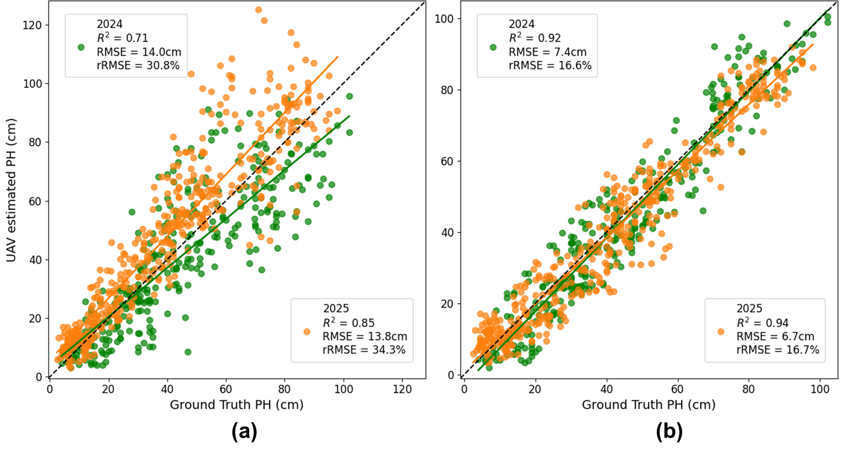
Fig. A1. Comparison of crop height estimation performance using RGB images with different spatial resolutions: (a) low-resolution RGB images (1600 × 1300) acquired from the DJI P4 Multispectral and (b) high-resolution RGB images (5472 × 3684) acquired from the DJI Phantom 4 Pro V2.0.

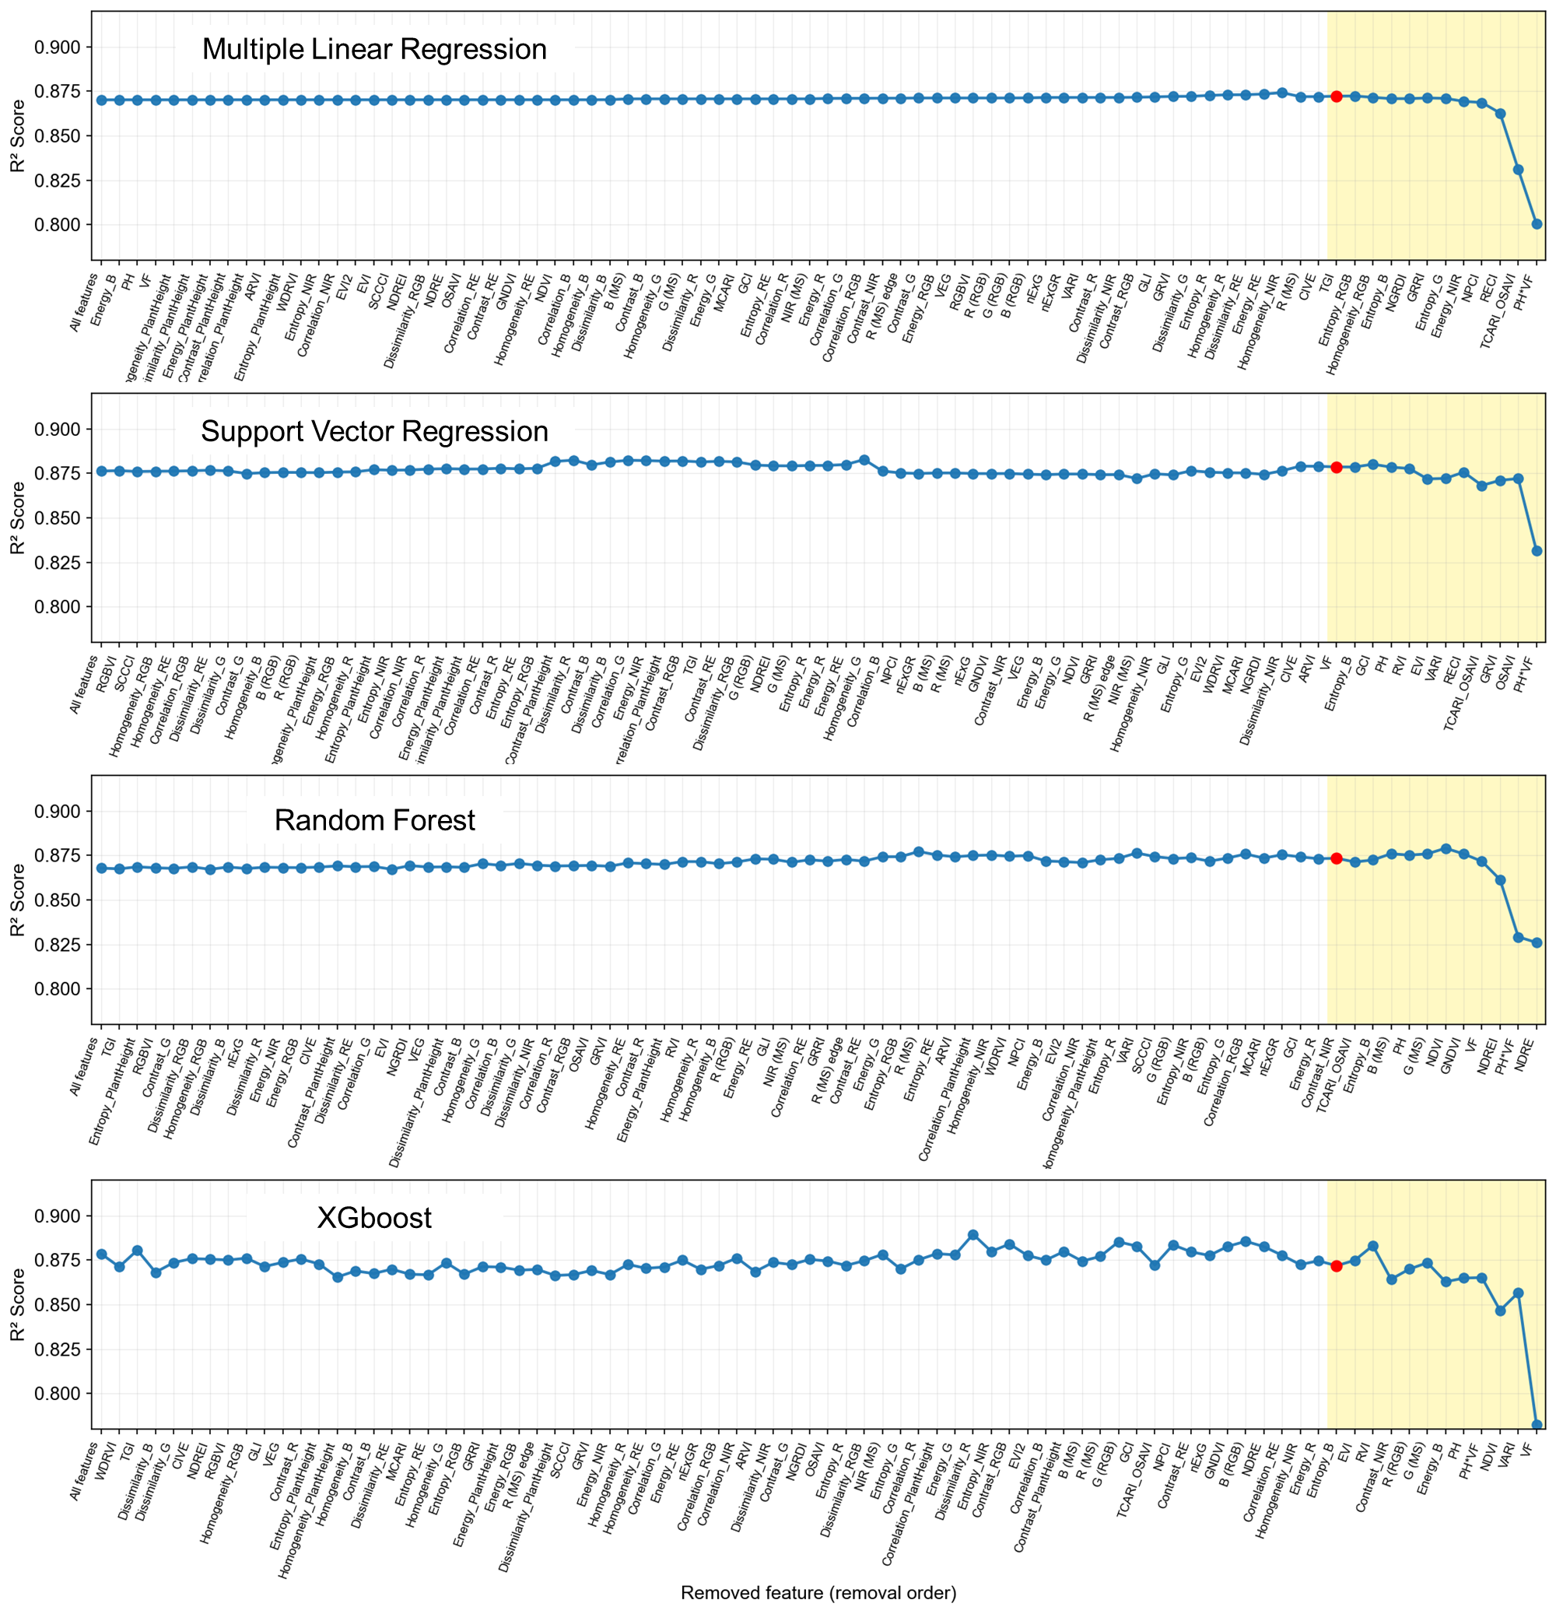
Fig. A2. Recursive Feature Elimination process of MLR, SVR, RF, and XGB models. The x-axis represents the features removed at each iteration (from left to right). The yellow region denotes the finally selected features, and the blue line indicates the cross-validated R² scores. The red dot marks the best-performing model.

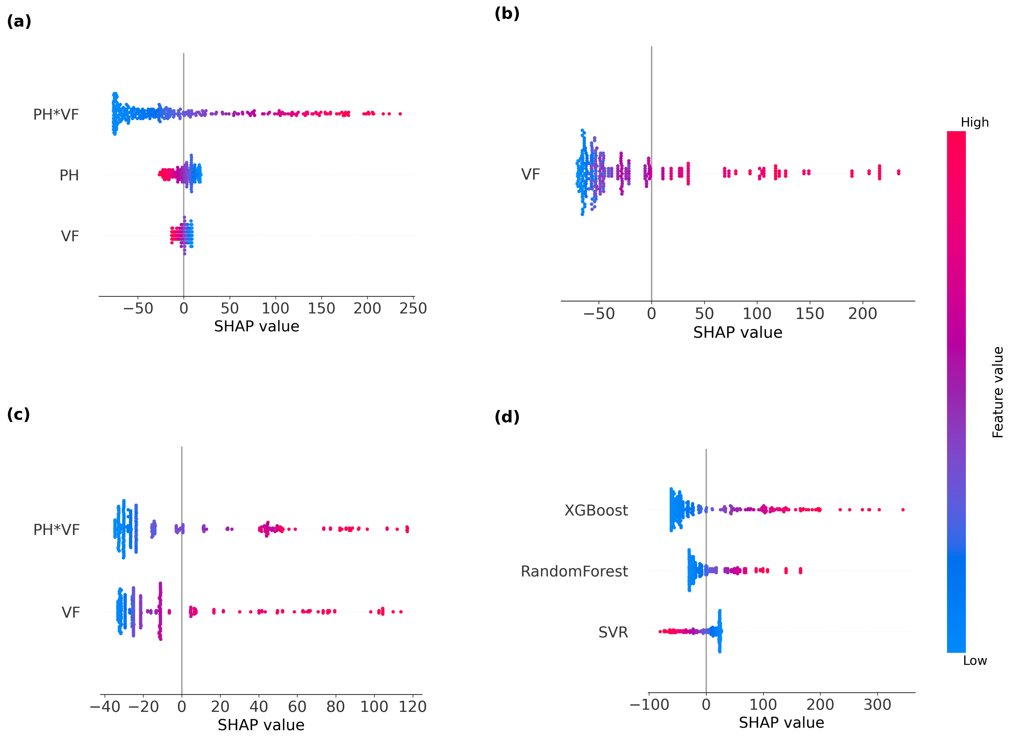

Fig. A3. Bee swarm plots of SHAP values presenting RGB-SI feature contributions across various machine learning models: (a) SVR, (b) RF, (c) XGB, and (d) SE.

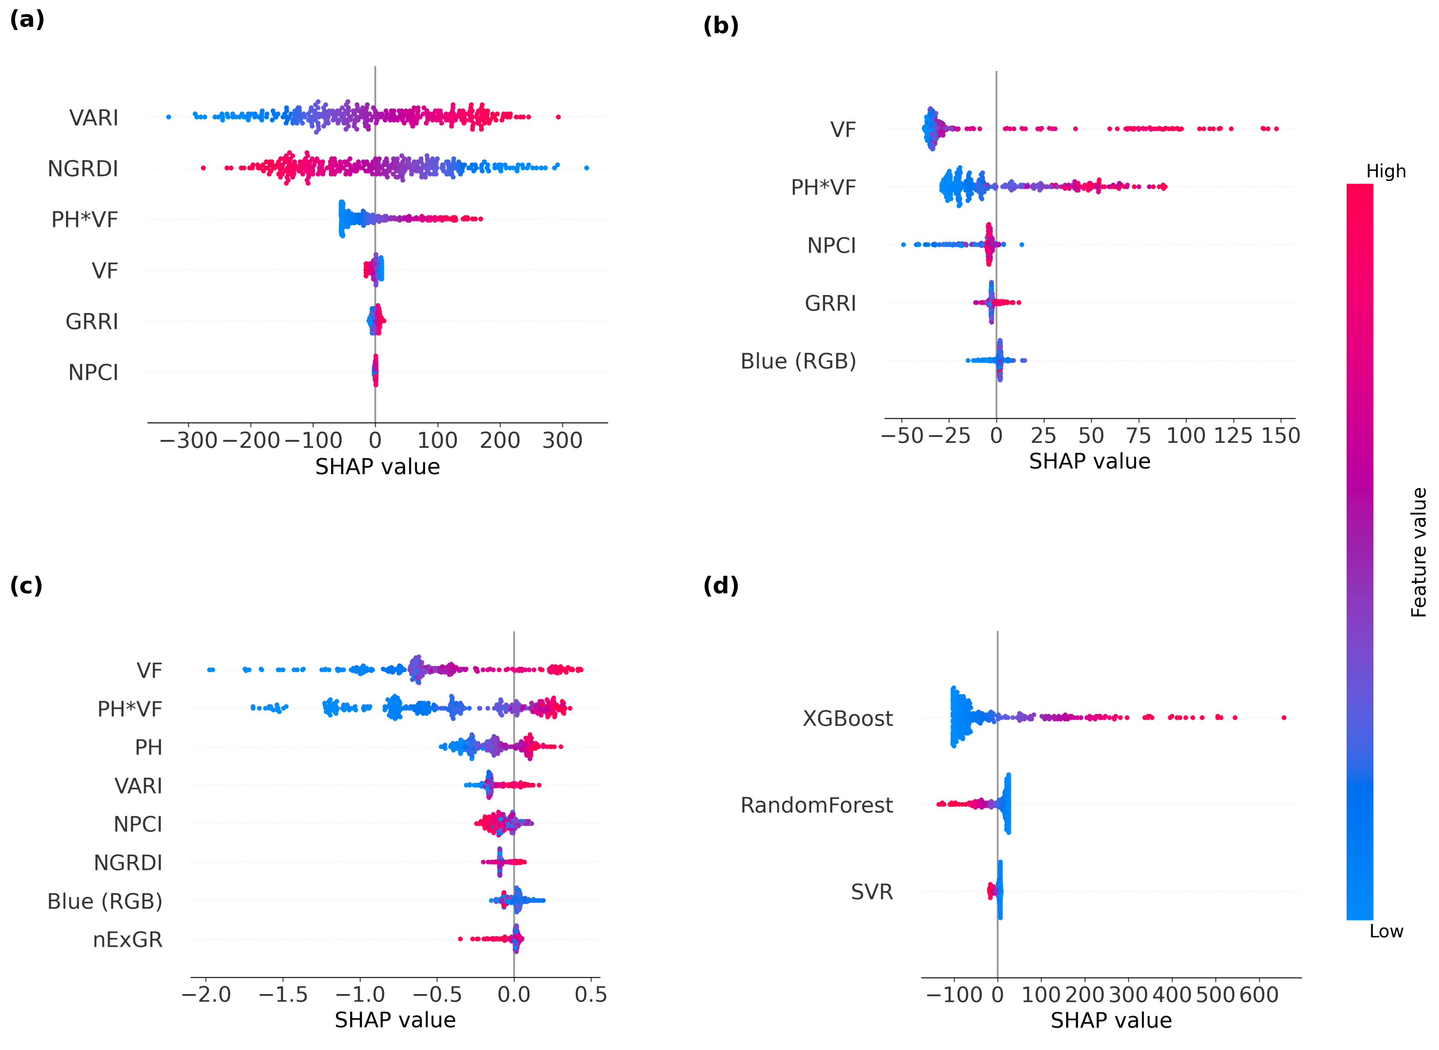
Fig. A4. Bee swarm plots of SHAP values presenting RGB-VI feature contributions across various machine learning models: (a) SVR, (b) RF, (c) XGB, and (d) SE.

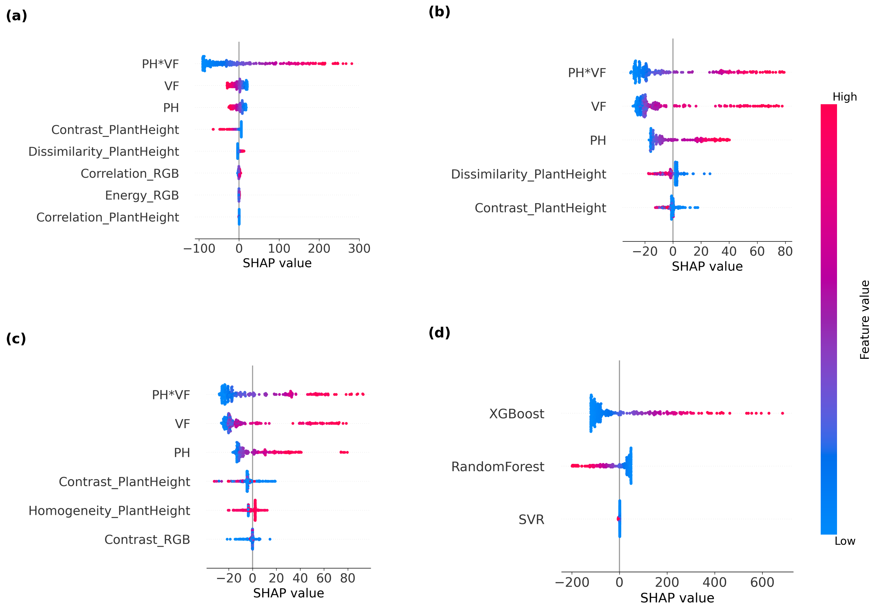
Fig. A5. Bee swarm plots of SHAP values presenting RGB-TI feature contributions across various machine learning models: (a) SVR, (b) RF, (c) XGB, and (d) SE.

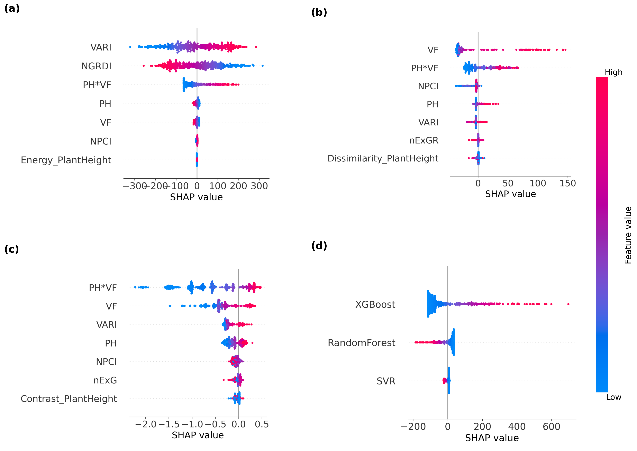
Fig. A6. Bee swarm plots of SHAP values presenting RGB-All feature contributions across various machine learning models: (a) SVR, (b) RF, (c) XGB, and (d) SE.

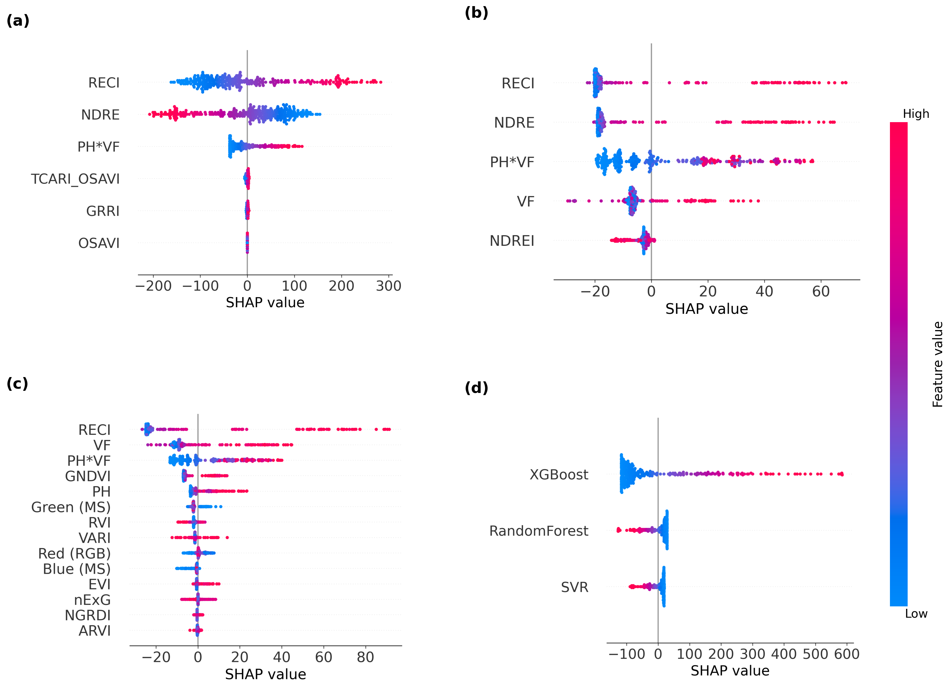
Fig. A7. Bee swarm plots of SHAP values presenting RGB+MS-VI feature contributions across various machine learning models: (a) SVR, (b) RF, (c) XGB, and (d) SE.

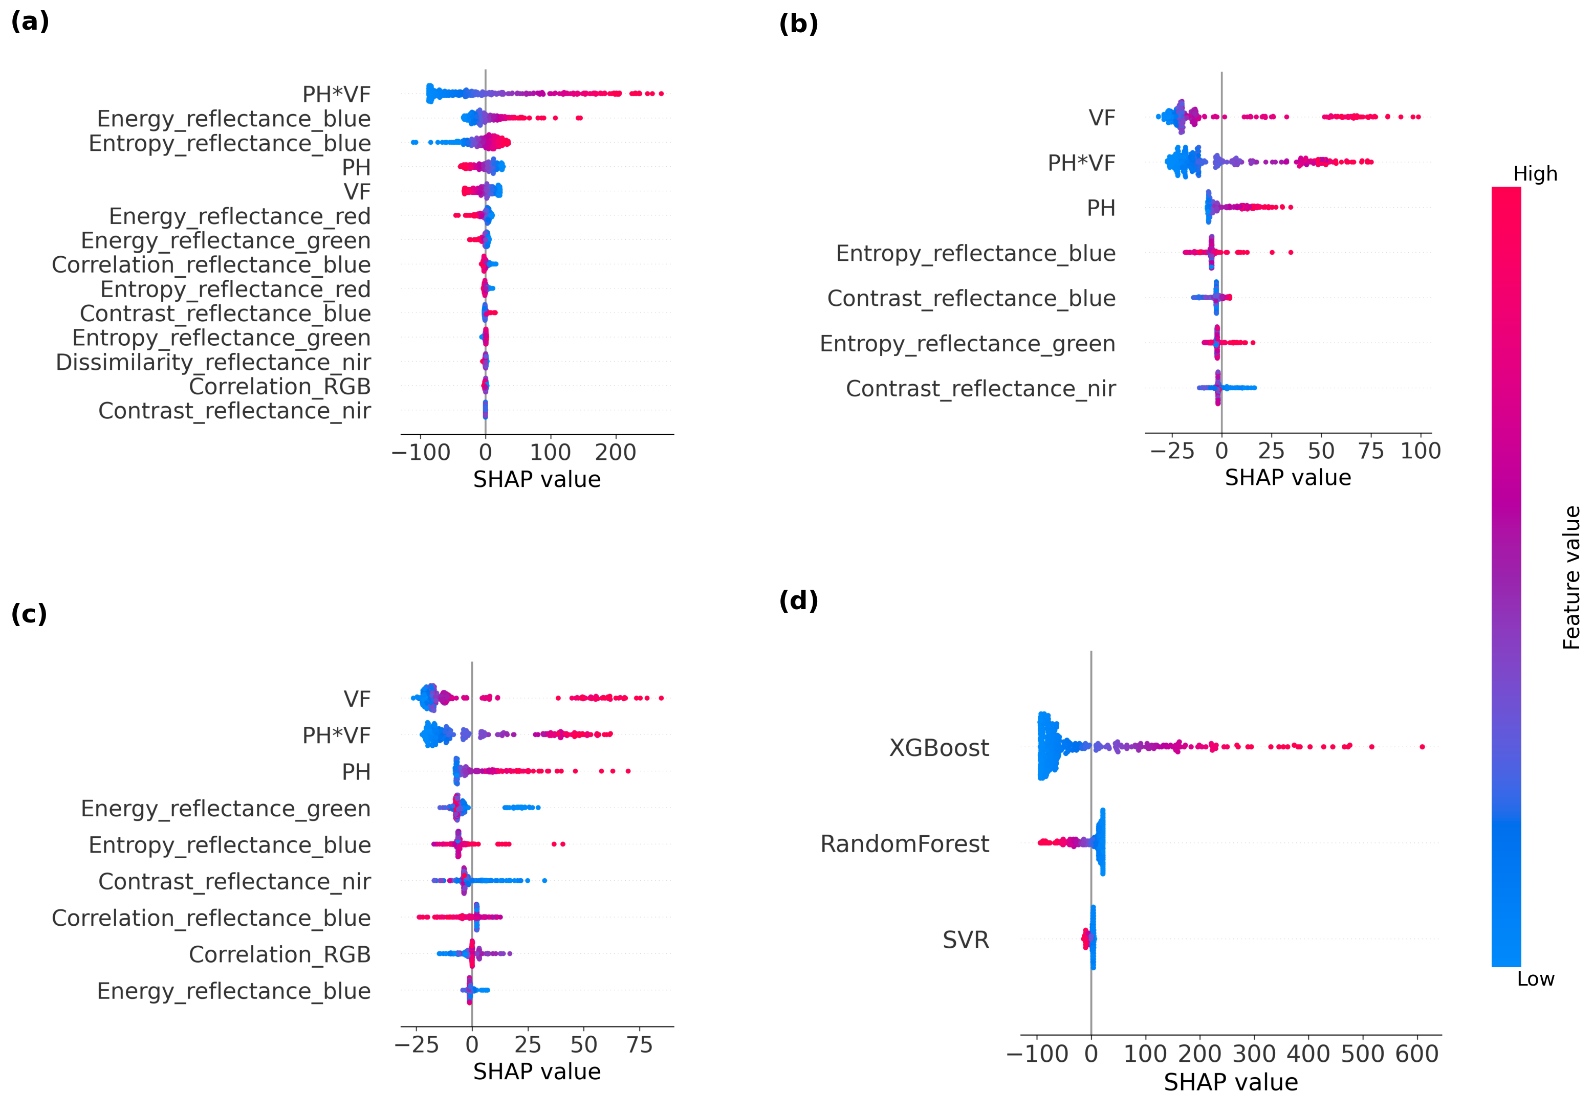
Fig. A8. Bee swarm plots of SHAP values presenting RGB+MS-TI feature contributions across various machine learning models: (a) SVR, (b) RF, (c) XGB, and (d) SE.

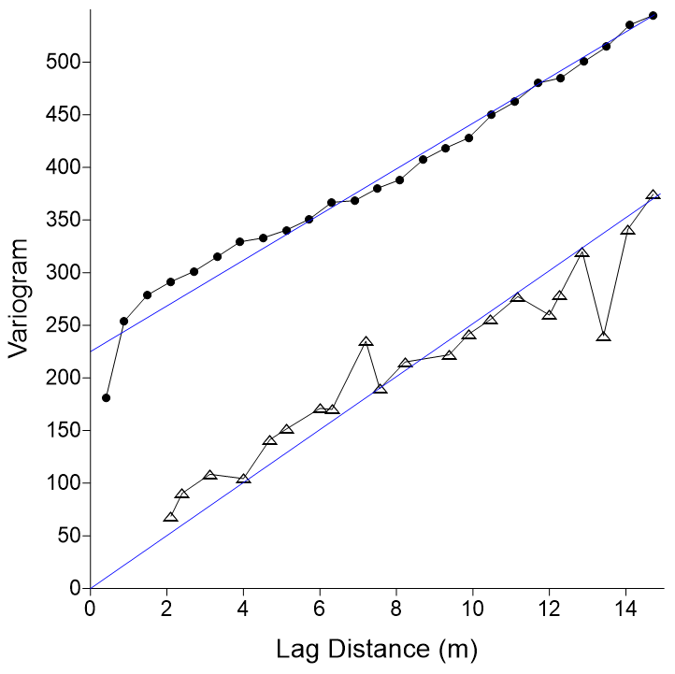
Fig. A9. Semivariogram comparison between individual plant level (IPL) and plot-level biomass data, where black circles represent IPL and open triangles represent plot-level measurements. The IPL semivariogram exhibits a larger nugget effect and higher semivariance, indicating stronger plant-to-plant variability, while both datasets show clear spatial dependence, as evidenced by increasing semivariance with lag distance.

