5Extended Data: figures and table
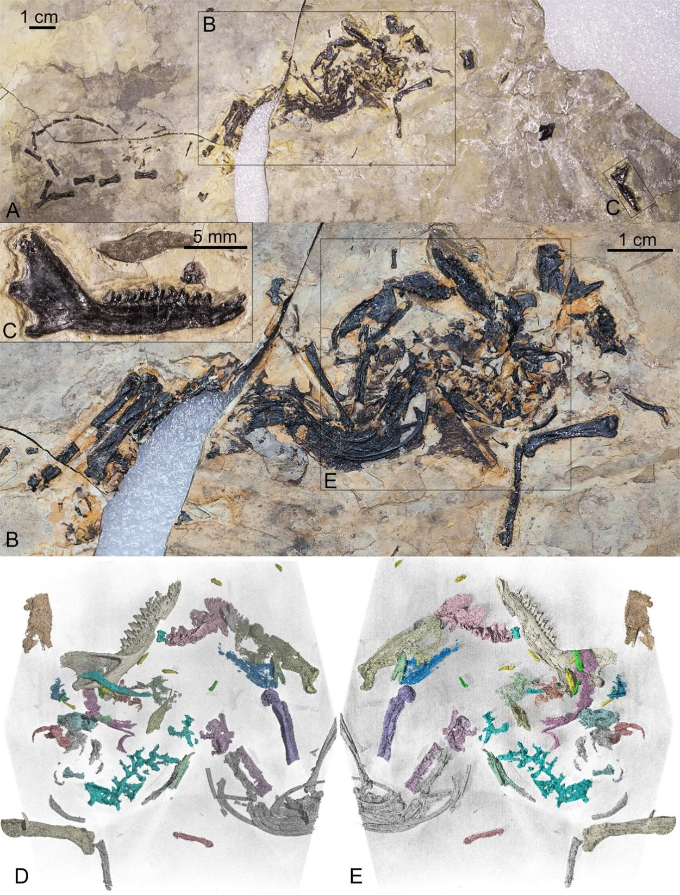
Extended Data Fig. 1. The holotype of Kielantherium cuii (ZGY0054). A, The holotype preserved in one slab. B-C, Close-up views of corresponding boxed areas in (A). D-E, CT-scan rendered images of the imbedded (D) and exposed (E) sides of the main concentrated remains of the specimen.

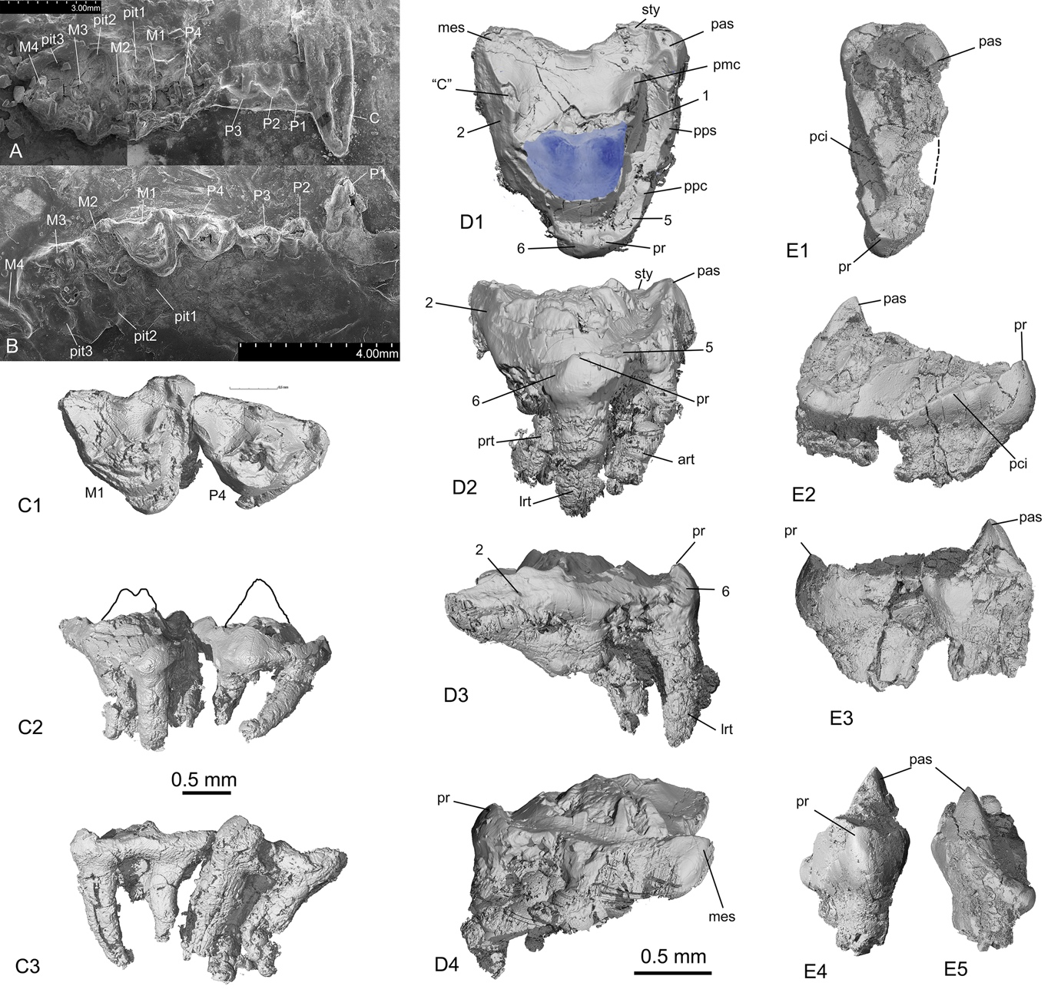 Extended Data Fig. 2. Upper dentitions of Kielantherium cuii (ZGY0054). A, SEM image of remains of the left upper canine and postcanines. P1-3 have only impressions preserved. P4-M4 have the roots preserved in the maxilla. B, SEM image of the right upper dentition in occlusal view except for P1. Most teeth are broken or damaged. C1-3, Occlusal, lingual, and labial views of P4 and M1. The cusp outline in C2 is based on the broken base of the cusps. D1-4, Occlusal, lingual, distal, and mesial views of M1 (The reconstructed paracone and metacone based on K. gobiense; Lopatin and Averianov, 2006a). E1-5, Occlusal, distal, mesial, lingual, and labial views of M4. Abbreviations: 1-2 and 5-6, wear facets 1, 2, 5 and 6; art, anterior root; bcu, buccal cuspule; “C”, cusp C of Crompton (1971); lrt, lingual root; me, metacone; mes, metastyle; pa, paracone; pas, parastyle; pci, posterior cingulum; pmc, postmetacrista; ppc, preprotocrista; pps, preparastyle; pr, protocone; prt, posterior root; sty, stylocone.

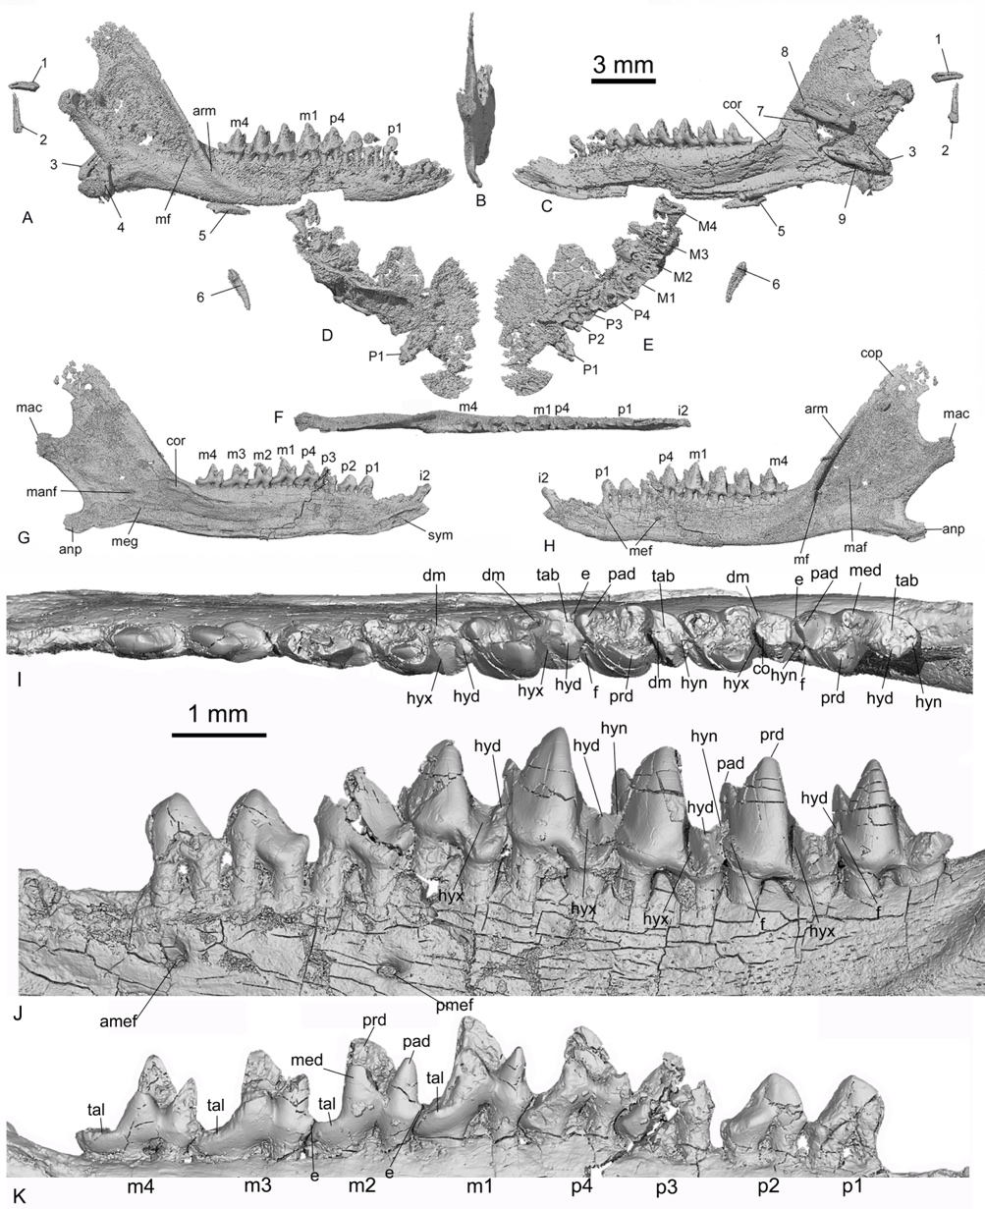
Extended Data Fig. 3. Mandibles, maxilla and lower cheek teeth of Kielantherium cuii. A-C, Lateral, posterior, and medial views of the right mandible. D, E, Dorsal and ventral views of the fragmentary right maxilla with tooth remains. F-H, Occlusal, medial, and lateral views of the left mandible. I-K, Occlusal, labial, and lingual views of the left postcanine teeth. Abbreviations: 1-7, displaced incisors (The loci of the displaced incisors cannot be determined, but along with the left i2 preserved in the lower jaw, there are a total of eight lower incisors, suggesting four lower incisors in each lower jaw; 8-9, displaced left and right lower canines; amef, anterior mental foramen; anp, angular process; arm, anterior ridge of masseteric fossa; e, cusp e; cop, coronoid process; cor, coronoid bone; f, cusp f; hyd, hypoconid; hyn, hypoconulid; hyx, hypoflexid; mac, mandibular condyle; maf, masseteric fossa; manf, mandibular foramen; med, metaconid; mef, mental foramen; meg, Meckelian groove; mf, masseteric foramen; mnc, mandibular canal; msf, masseteric foramen; pad, paranonid; pmef, posterior mental foramen; prd, protoconid; sym, symphysis; tab, talonid basin; tal, talonid.

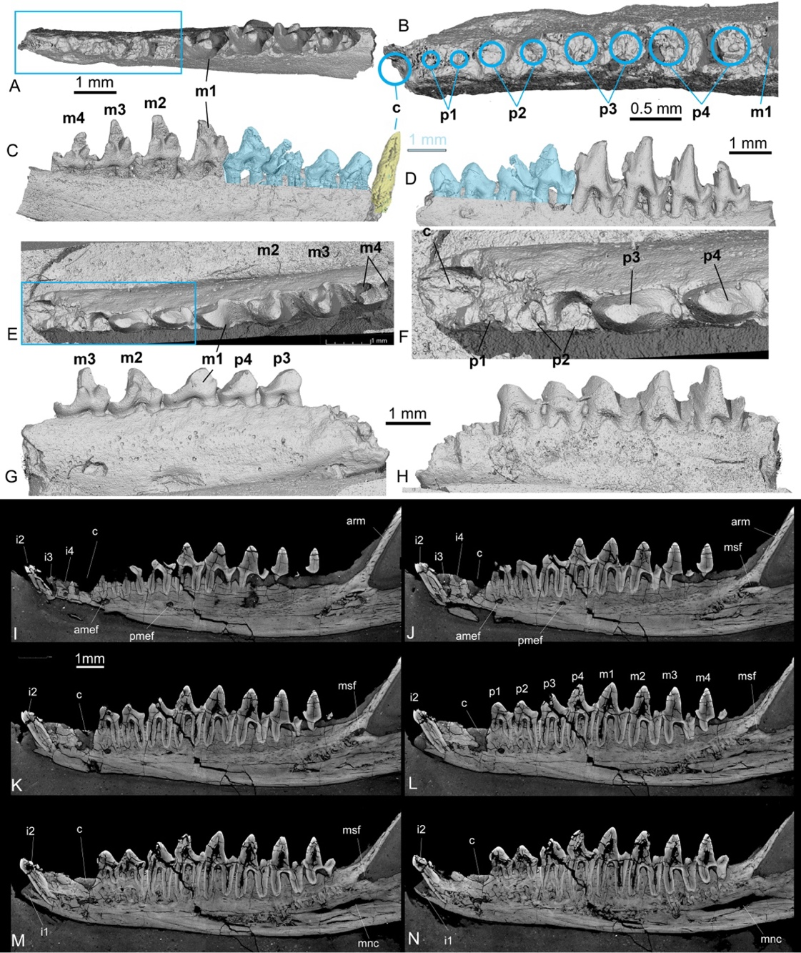Extended Data Fig. 4. Postcanines in Kielantherium gobiense and Arguinus khosbajari in comparison with K. cuii. A, Occlusal view of the partial mandible of K. gobiense (cast of GI PST 10-16). B, Close-up view of the premolar region (boxed in A) showing the alveoli in which the mesial partial alveolus is much larger in diameter than those of the mesial premolar. C, D, Reconstructed canine and premolars in lingual and labial views (in blue), based on the corresponding teeth from K. cuii. E, Occlusal view of the holotype of Arguimus khosbajari (AMNH FM 147006, cast of PSS no. 10-15). F, Close-up view (boxed region in E) of p3-4 and the alveoli for the canine, the single-rooted p1, and double-rooted p2. G, H, Lingual and labial view of PSS no. 10-15; note the deeply worn m1. If the identification of m1 is correct, there are only four premolars with p1 being single-rooted. I-N, Six parallel CT-scan slices from the labial to lingual sequence through the left mandible, showing the number of lower teeth (4i-1c-4p-4m) from their alveoli and preserved teeth. Abbreviations: amef, anterior mental foramen; arm, anterior ridge of masseteric fossa; mnc, mandibular canal; msf, masseteric foramen; pmef, posterior mental foramen.

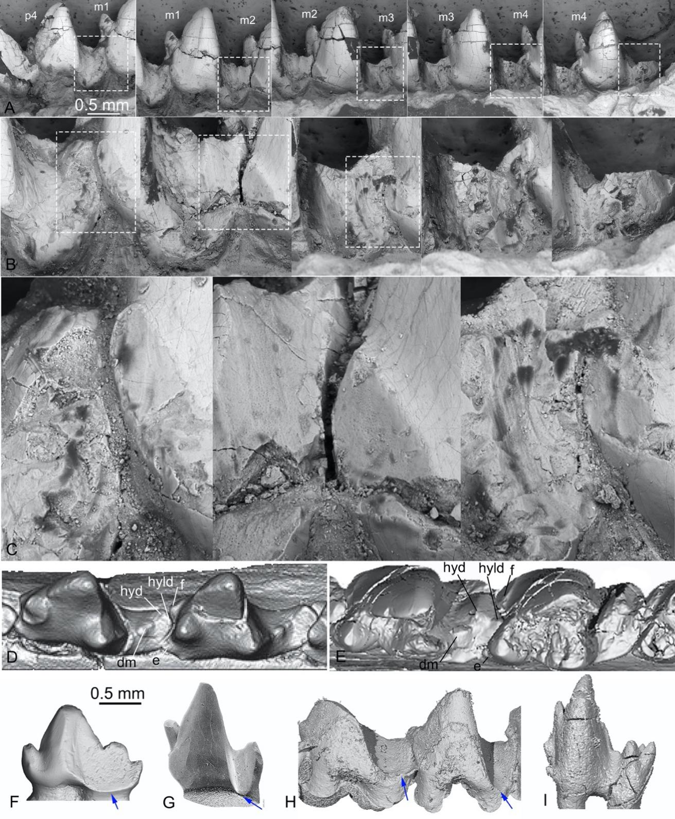
Extended Data Fig. 5. SEM images showing wear of lower molars of Kielantherium cuii in comparison with other taxa. A row, p4-m4 in labial views. B row, Close-up views of the five boxed areas in (A). C row, Still close-up views of the boxed areas in (B), showing the wear striations and exposed dentin. D, Occlusal view of lower molars of Peramus (Davis, 2012); note the hypoconulid is deeply embayed in the concavity formed by cusps e and f of the following tooth so that wear facet 4 is small. E, Occlusal view of lower molars of K. cuii, showing a distinct talonid angle (Davis, 2011a) and wear facets 3 and 4 are extensive, converging dorsally at the sharp tip of the hypoconid, indicating that the cusp did not have ‘crushing’ contact with the upper molar to for the double-opposition typical for tribospheny (Simpson, 1936). F-I, Labial views of lower molars of Morganucodon sp. (uncatalogued specimen of IVPP), Nanolestes drescherae (modified from Martin, 2002), Arguimus khosbajari (cast, AMNH FM 147006), and Jeholotherium (JZT-DB0062); some images were reversed for comparison. Blue arrow points to the ventral limit of the wear facet in the hypoflexid. The smoothly arc wear facet was created by contact with the paracone; such a wear configuration is no longer present in Kielantherium and tribosphenidans, such as Jeholotherium.

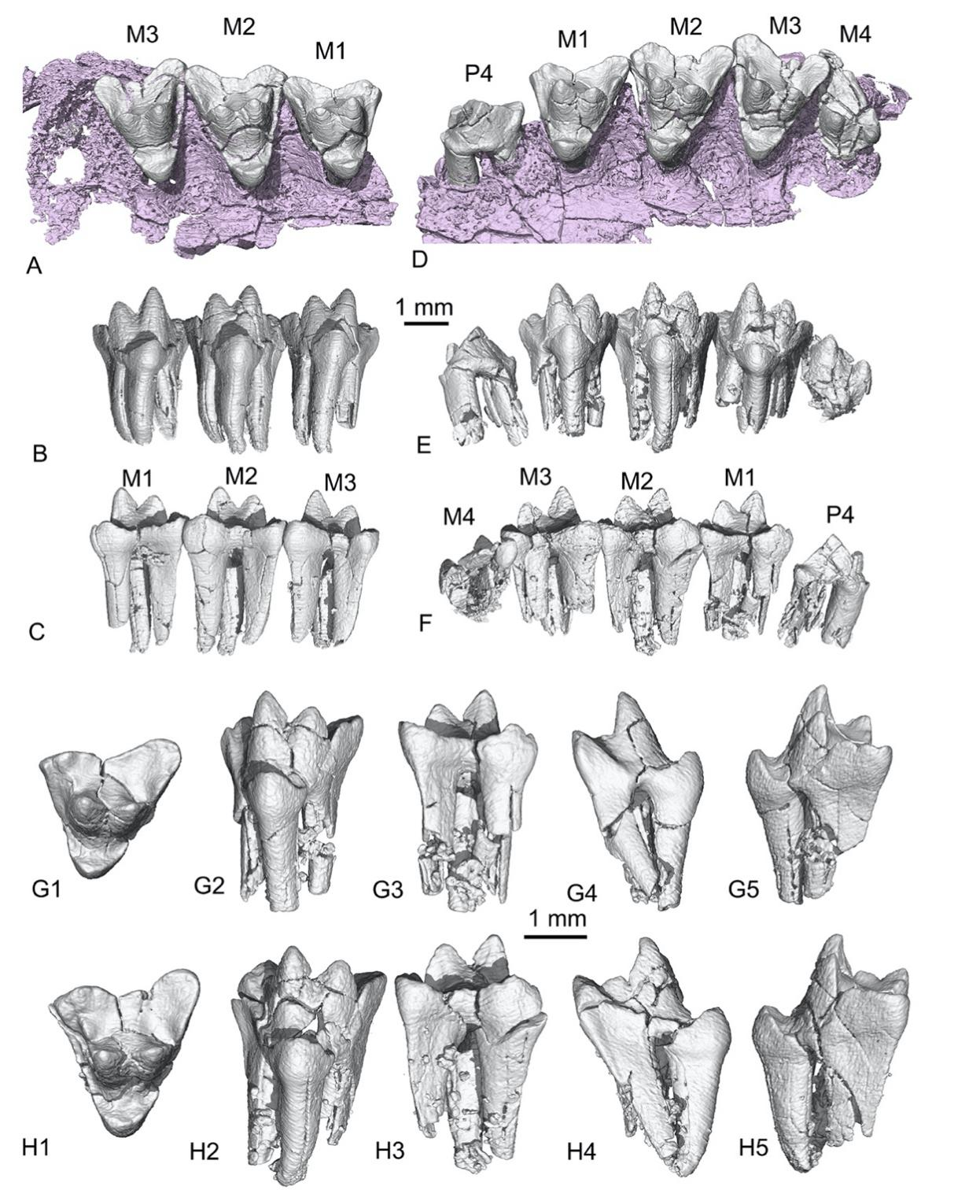
Extended Data Fig. 6. CT-data rendered upper teeth of the holotype (IVPP V34585) of Liaodelta angusta. A-C, Occlusal, lingual, and labial views of the right M1-3, with the M4 alveolus in the maxilla. D-F, The same views of the left P4-M4. Note P4 and M4 are in lower positions relative to M1-3, indicating that they are not fully erupted; this suggests P4 is a successional tooth. G1-5, Occlusal, lingual, labial, mesial, and distal views of M1. H1-5, The same views of M1. Note the lower protocone and the narrow space between it and the merged base of the paracone and metacone. Also, the metastyle region is well-developed, the postmetacrista is strong, and the posterior root supporting this region is stronger than the anterior root.

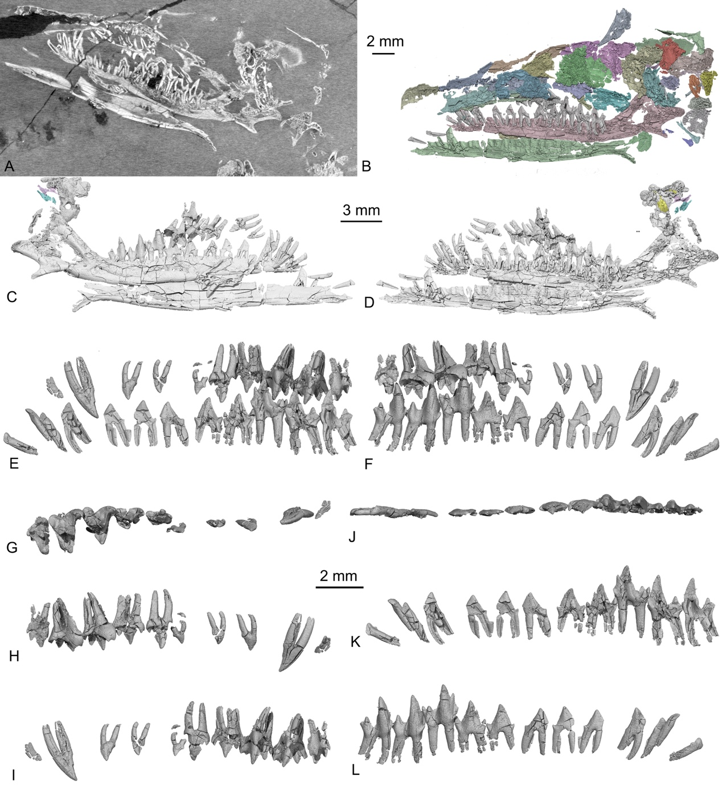
Extended Data Fig. 7. The holotype (JZT-DB0062) of Jeholotherium antiguum. A, CT-scan section through the skull, showing the contrast of the bone and the matrix. B, The exposed (left), thus damaged, side of the skull, contrasting the embedded right side of the skull (Fig. 3). C, D, Lower jaws with teeth in preserved condition. E, F, Right upper and lower dentitions in lingual and labial views. The displaced upper teeth are restored relative to the in situ lower teeth, showing the relative positive and their occlusal relationship. G-I, Occlusal, labial, and lingual views of the right upper teeth (C-M3). J-L, Occlusal, lingual and labial views of the right lower dentition.

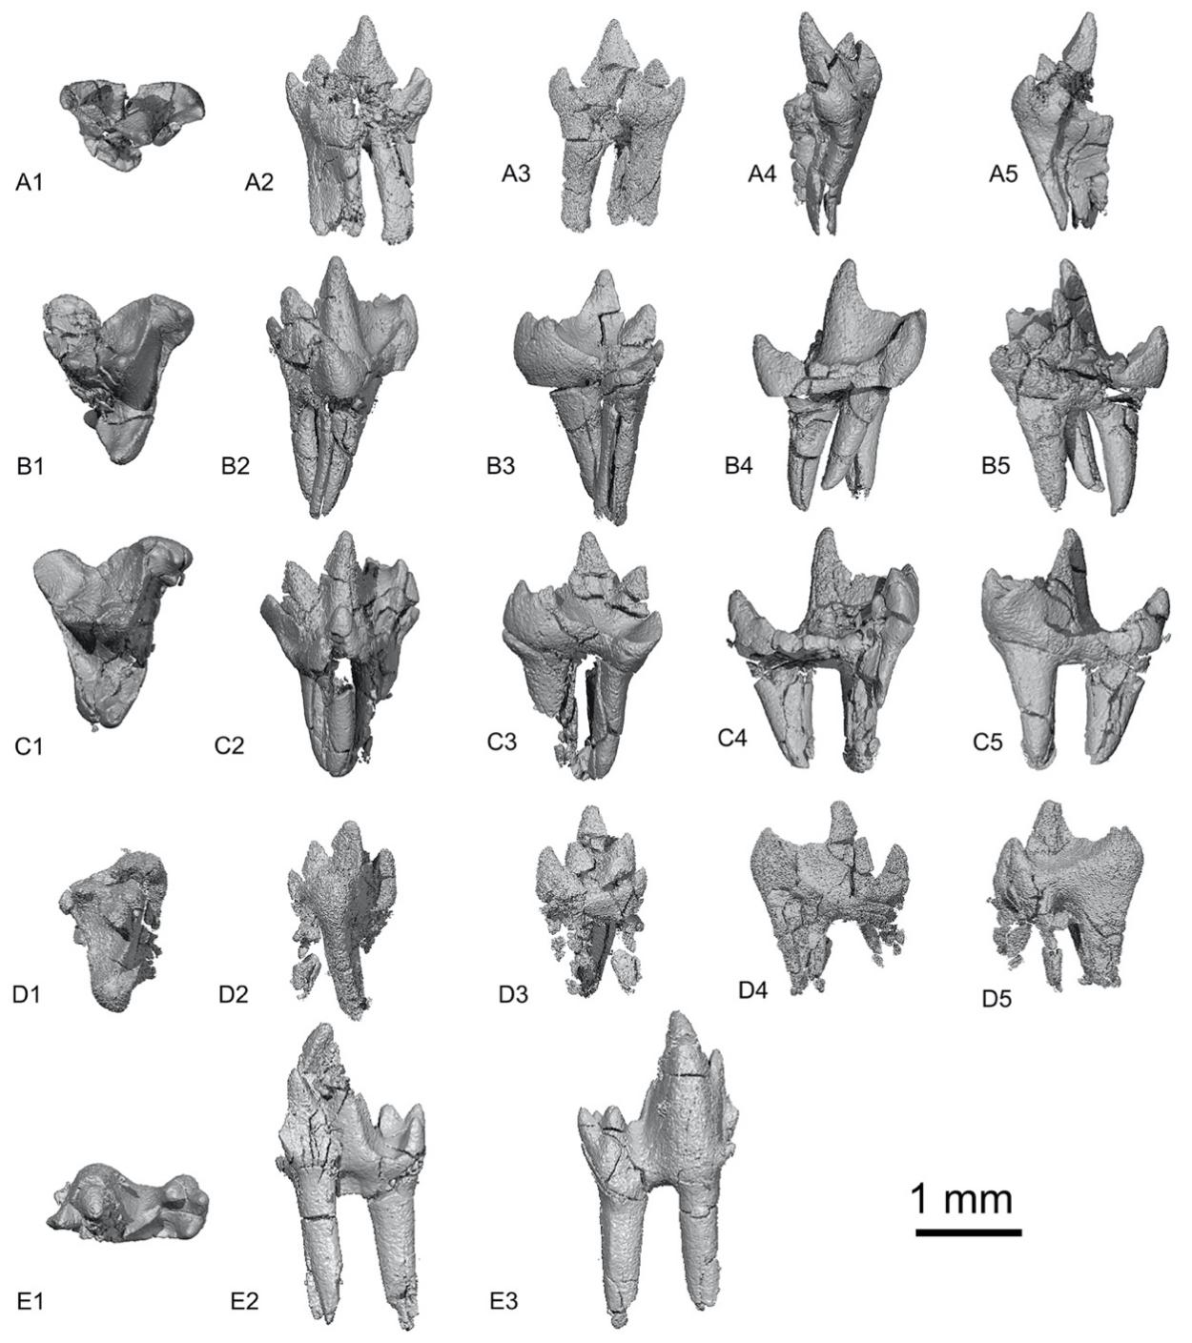
Extended Data Fig. 8. CT-data rendered isolated right cheek teeth of Jeholotherium antiguum. A1-5, Occlusal, lingual, labial, mesial, and distal views P5; note that P4 is transversely narrow, the metacone is small but distinct, the lingual cingulum bears no protocone, and the distal root is transversely widened but not divided to form a lingual root. B1-5, Occlusal, lingual, labial, mesialm and distal views of M1; note that there is no conule, the protocone is low, the paracone is notably larger than the metacone, and the parastyle region is robust. C1-5, Occlusal, lingual, labial, mesial, and distal views of M2; note the general morphology is similar M1. D1-5, Occlusal, lingual, labial, mesial, and distal views of reversed left M3; note the parastyle is small and the metastyle region is reduced. The paracone is fractured. E1-3, Occlusal, lingual, and labial views of m1; note that the metaconid is taller than the paraconid but pushed toward the protoconid; the distal metacristid is strong, and the talonid basin is lingual to the distal metacristid, mesial to the entoconid.

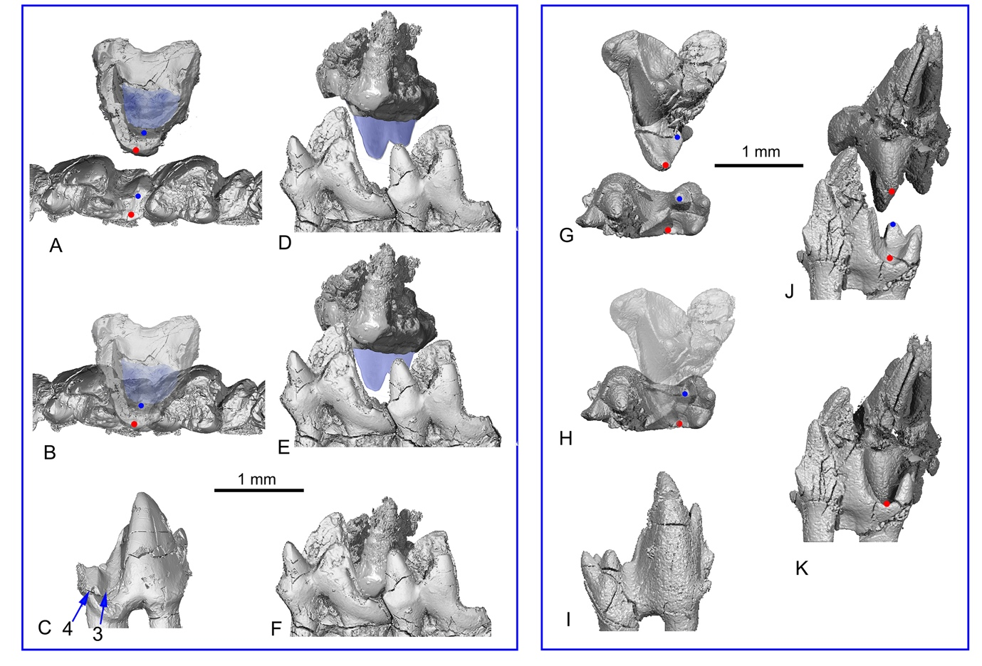 Extended Data Fig. 9. Occlusal relationship of the upper and lower molars of Kielantherium cuii and Jeholotherium antiguum. A, Occlusal view of M1 and m1-2 of K. cuii. The red and blue dots represetnt the protocone and the hypoconid, respectively, and their corresponding positions when the teeth are in centrical occlusion. B, The relative positions of the M1 and m1-2 in occlusion, with M1 being photographically converted as semitransparent. C, Labial view of m1 with the blue arrows pointing to the wear facets 3 and 4 on the talonid. D-F, The relative positions of M1 and m1-2 during occlusion. The light blue part represents reconstructed paracone and metacone based on the upper molar of K. gobiense (Lopatin and Averianov, 2006a, 2007). G-K, The same occlusal relationships of M1 and m1 as shown in (A-F). Note the position of the deepest point of the talonid basin in relation to the endoconid, the lingually open talonid basin as the protocone is centrical position, and the concavity receiving the hypoconid in the secondary trigon basin.

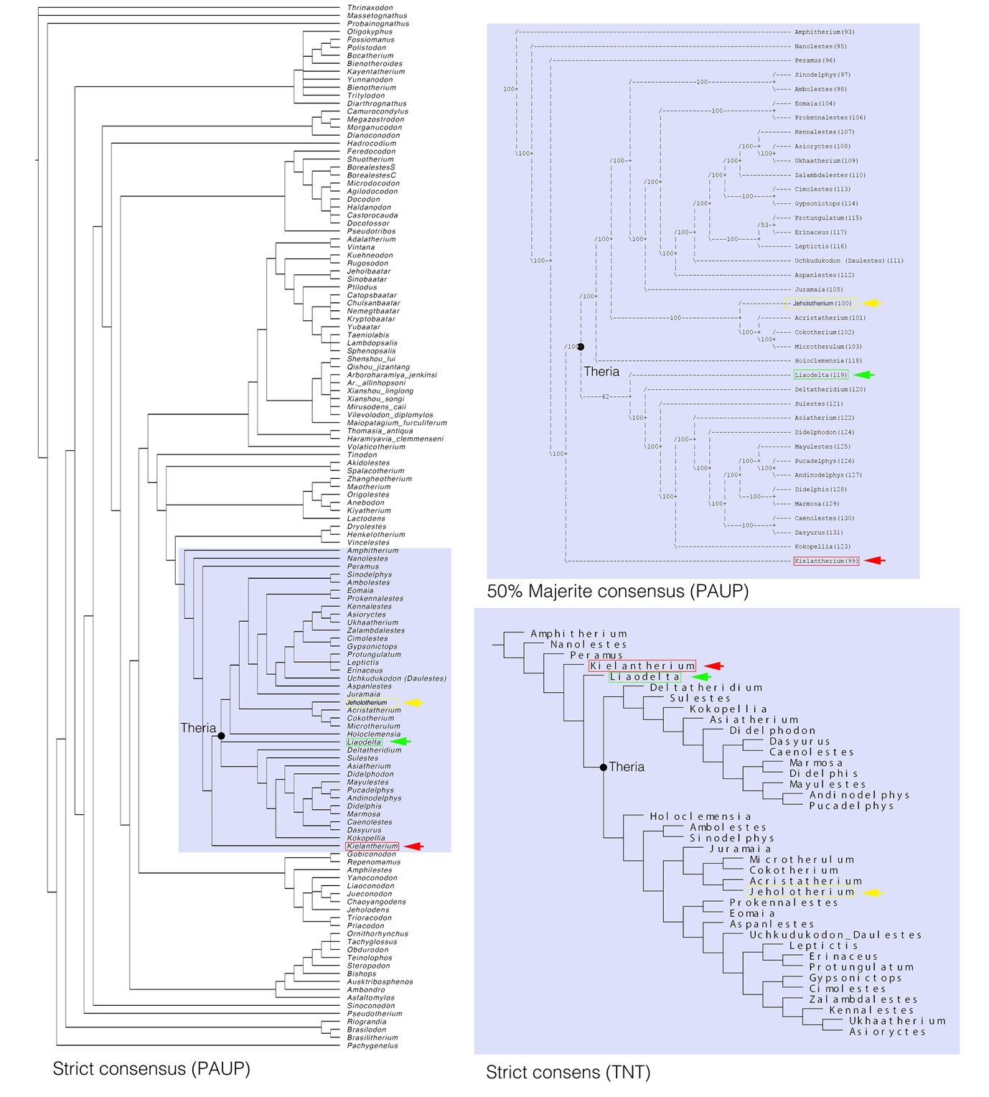 Extended Data Fig. 10. Phylogenetic results including Kielantherium, Liaodelta, and Jeholotherium. A, The strict consensus tree (PAUP). B, The partial 50% majority-rule consensus (PAUP) focusing on cladotherians. C, The partial strict consensus tree (TNT) focusing on cladotherians. See Methods and Supplementary Information for the phylogenetic analyses.

Extended Data Table 1. Tooth Measurements (length/width in mm) of Kielantherium cuii, Liaodelta angusta, and Jeholotherium antiquum. *=Estimated.

Kielantherium cuii (ZGY0054)
Upper | Left | Right | Lower | Left | Right
I1 |  |  | i1
I2 |  |  | i2
I3 |  |  | i3
C | 1.16/ |  | c
P1 | 0.88*/ |  | p1 | 0.87/0.34 | 0.79/0.41
P2 | 0.65*/ |  | p2 | 0.96/0.45 | 0.87*/0.45*
P3 | 0.92*/ |  | p3 | 1.08/0.54* | 1.11/0.57
P4 | 1.55/0.89 |  | p4 | 1.19/0.63 | 1.25/0.67
M1 | 1.35/1.50 |  | m1 | 1.24/0.73 | 1.35/0.77
M2 |  |  | m2 | 1.27/0.79 | 1.42/0.81
M3 |  |  | m3 | 1.33/0.72 | 1.47/0.78
M4 | 0.7*/1.56 |  | m4 | 1.36/0.7 | 1.37/0.72
Liaodelta angusta (IVPP V 34585)
Upper | Left | Right | Lower | Left | Right
P4 |  | 1.93/1.07
M1 | 2.22/2.56 | 2.28/2.29
M2 | 2.42/2.56 | 2.48/2.39
M3 | 2.26/2.15 | 2.33/2.45
M4 |  | 2.529/1.512

Jeholotherium antiquum (JZT-DB0062)
Upper | Left | Right | Lower | Left | Right
I1 |  |  | i1 |  | 0.5/0.24
I2 |  | 0.31/0.24 | i2 |  | 0.45/0.31
I3 |  | 0.38/0.29 | i3 | 0.31*/0.22* | 0.44/0.26
C | 0.82/0.35 |  | c | 0.69/0.37 | 0.64/0.26
P1 | 0.61/0.36 |  | p1 |  | 0.81/0.27
P2 | 0.45/0.36* |  | p2 | 0.37*/0.2* | 0.89/0.29
P3 | 0.49/0.27 |  | p3 |  | 0.97/0.34
P4 | 1.15/0.55 |  | p4 |  | 1.17/0.46
P5 | 1.39/0.9 |  | p5 |  | 1.33/0.51*
M1 | 1.45/1.6 |  | m1 |  | 1.52/0.76
M2 | 1.51/1.78 |  | m2 |  | 1.56/0.78
M3 | 1.36/1.06 |  | m3 |  | 1.41/0.55*

