Supplementary figures.

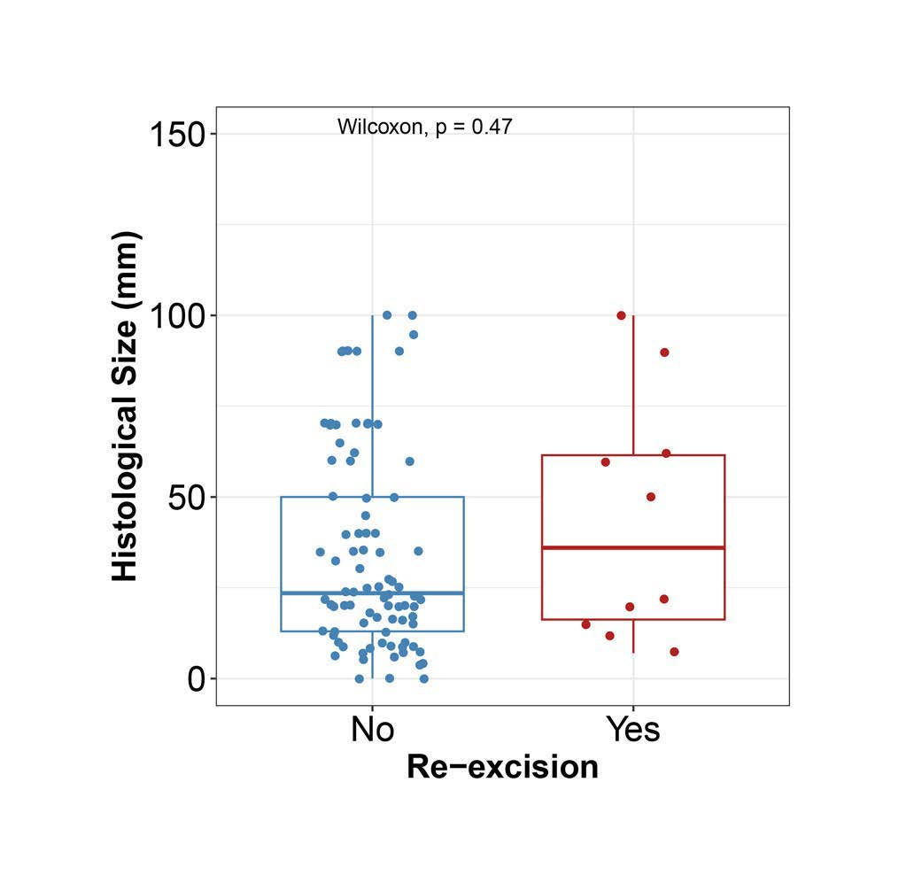

Supplementary Figure S1. Histological tumor size and re-excision status. Histological tumor size stratified by re-excision status: no re-excision (blue) and re-excision performed (red). The y-axis represents the final histological size. Differences in tumor size between the two groups were assessed using the Wilcoxon rank sum test; the corresponding p-value is shown.

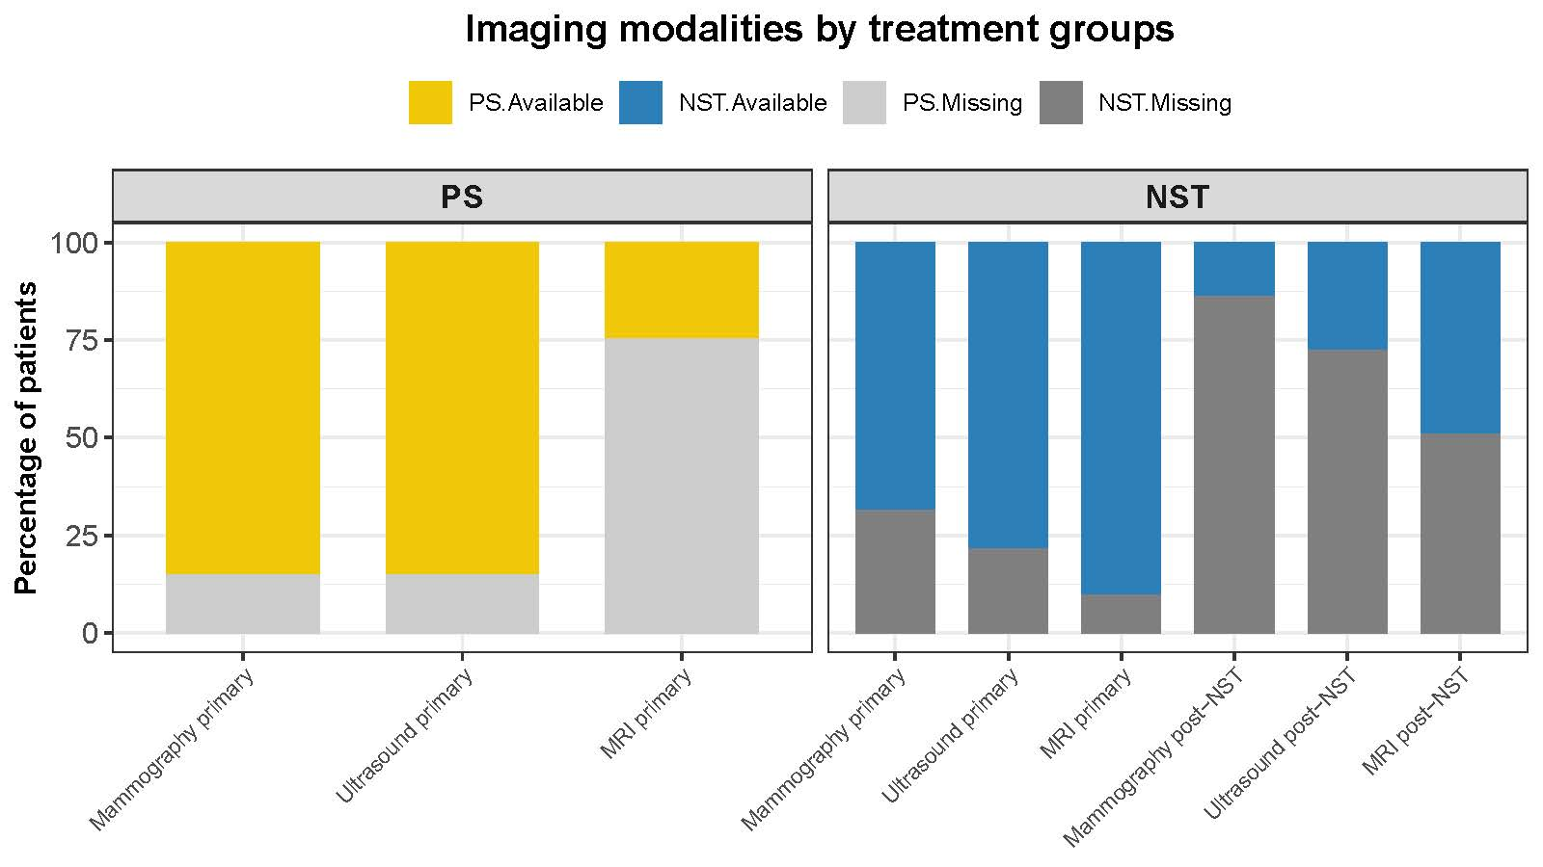
Supplementary Figure S2. Imaging modalities by treatment groups: Stacked bar plots depicting the percentage of patients with documented imaging measurements for each modality, classified as performed or not performed, according to treatment group (PS; yellow vs NST; blue).

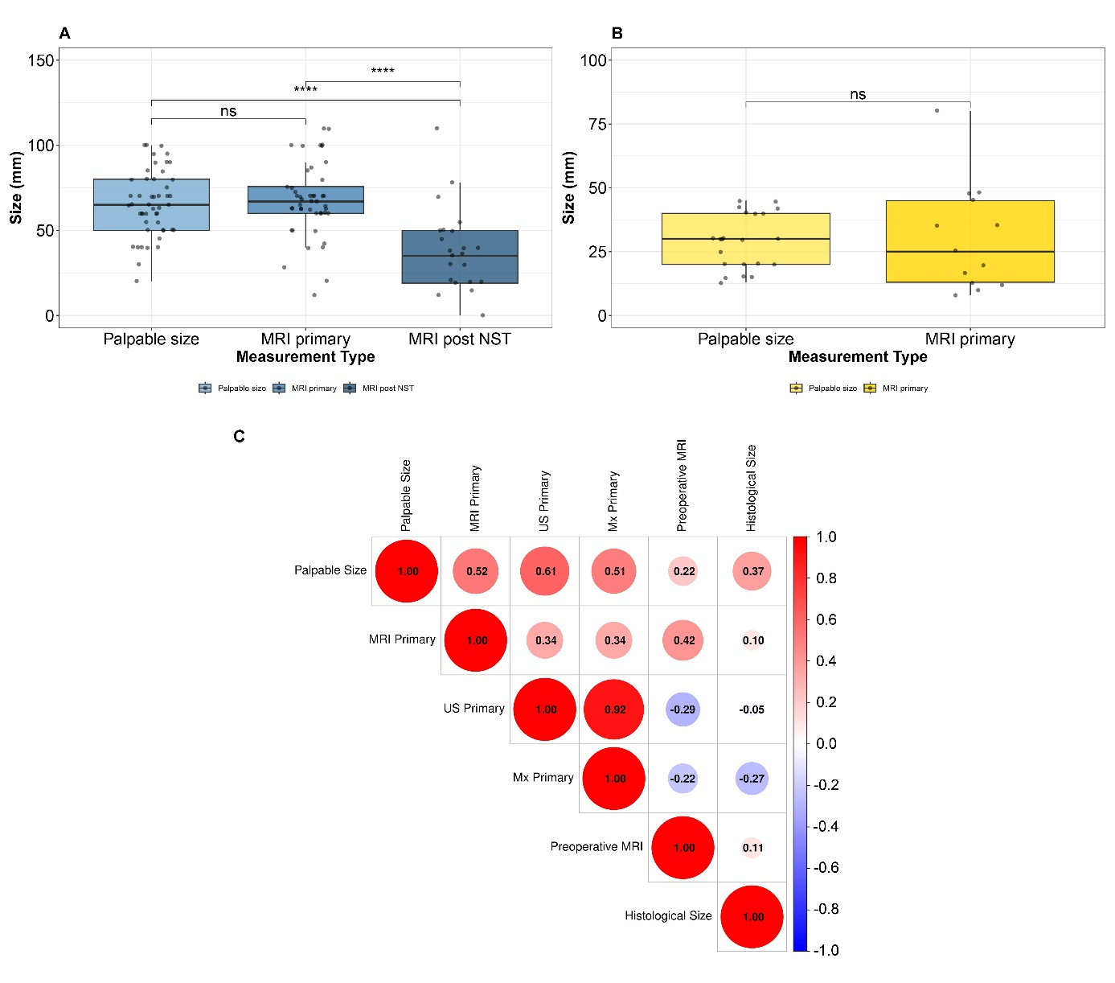
Supplementary Figure S3. Comparison and correlation of tumor size measurements. Distribution of tumor size according to clinical and radiological size estimates in the NST group (A) and PS group (B). Pairwise comparisons were performed using the Wilcoxon rank sum test; Statistical significance is indicated as follows: **** indicates p < 0.0001; ns, not significant. The y-axis represents the final histological tumor size. (C) Correlation matrix of tumor size measurements in the NST group, including palpable size, primary mammography (MX), primary ultrasound (US), primary MRI, preoperative MRI, and final histological size. The right-side annotation indicates the strength and direction of the correlation coefficients. The circle size correlates with the magnitude of correlation.

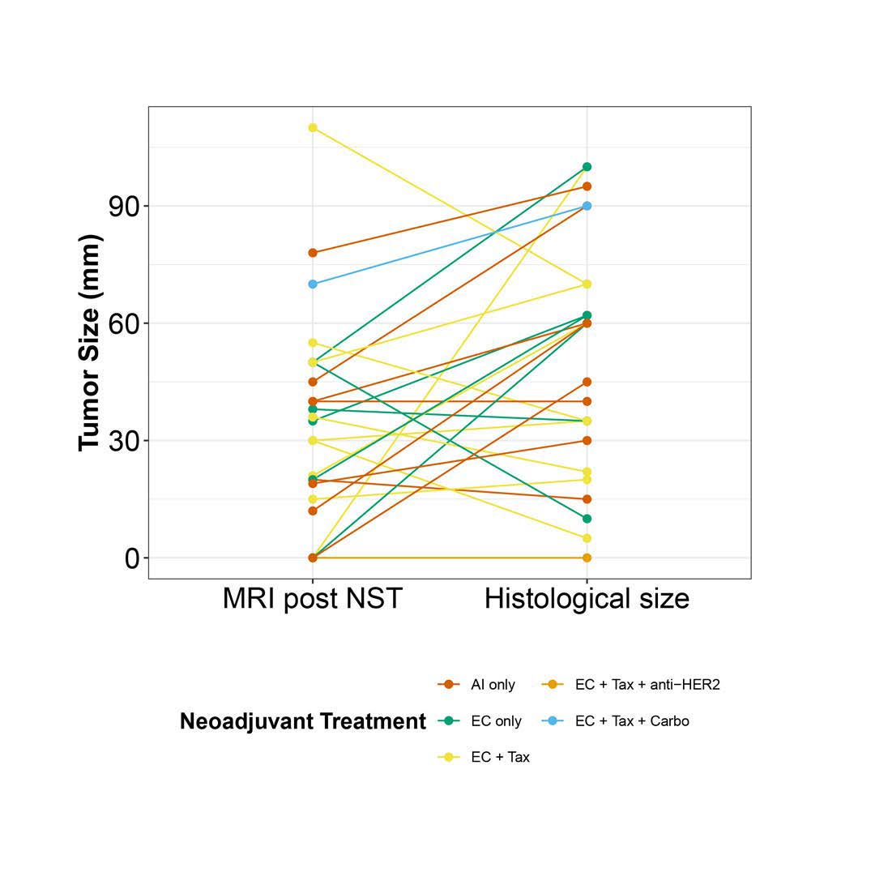

Supplementary Figure S4. Response to NST: Individual patient trajectories from clinical tumor size (post-NST) to pathological tumor size (ypT, post-treatment). Each line represents one patient, with the y-axis indicating tumor size in millimeters. Lines are color-coded according to treatment type: variants of standard chemotherapy, endocrine therapy, and anti-HER2 therapy. Cases without an MRI post-NST are not shown in this plot.

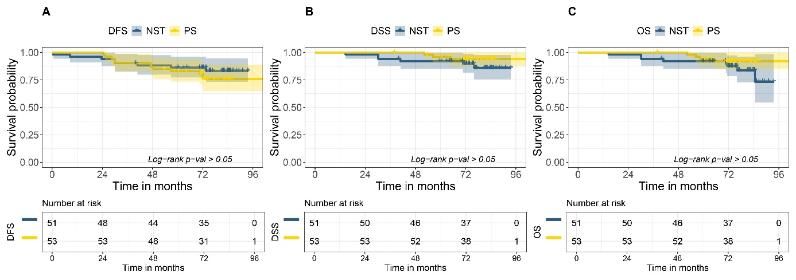

Supplementary Figure S5 Survival outcomes according to treatment strategy in cases with invasive lobular carcinoma (ILC). Kaplan–Meier curves comparing (A) DFS, (B) DSS, and (C) OS between patients treated with NST (blue) and PS (yellow). Shaded areas represent 95% confidence intervals. Time is shown in months from definitive surgery. Numbers at risk are displayed below each panel. Survival distributions were compared using the log-rank test; no statistically significant differences were observed between treatment groups for DFS, DSS, or OS (all log-rank p > 0.05).

