SUPPLEMENTAL DATA AND MATERIALS
Reliability Assessment of Metal Quantification in Formalin-fixed, Paraffin-embedded Human Liver Tissue for Studying Liver Diseases
Authors: Nivisa Vakeesan¹, Jason Xu², Jamie Roberman^{3,4,5}, Li Tao¹, Yang Jiang¹, Amanda Vitale⁷, Andrea E. Cassidy-Bushrow^{3,4,6}, Lu Cai², Wanqing Liu^{1,8*}
Affiliations:
¹Department of Pharmaceutical Sciences, Eugene Applebaum College of Pharmacy and Health Sciences, Wayne State University, Detroit, MI, USA;
²Department of Pediatrics, Pediatric Research Institute, University of Louisville, KY, USA;
³Department of Public Health Sciences, Henry Ford Health, Detroit, MI, USA;
⁴Henry Ford Health + Michigan State University Health Sciences, Detroit, MI, USA;
⁵Department of Epidemiology & Biostatistics, Michigan State University College of Human Medicine, East Lansing, MI, USA;
⁶Department of Pediatrics and Human Development, College of Human Medicine, Michigan State University, East Lansing, MI, USA;
⁷Department of Pathology, Henry Ford Hospital, Detroit, MI, USA;
⁸Department of Pharmacology, School of Medicine, Wayne State University, Detroit, MI, USA
*Corresponding author: Wanqing Liu, PhD. 6135 Woodward Ave, Detroit, MI 48202. wliu@wayne.edu; Tel.: 1-313-577-3375.Supplementary Tables and Figures
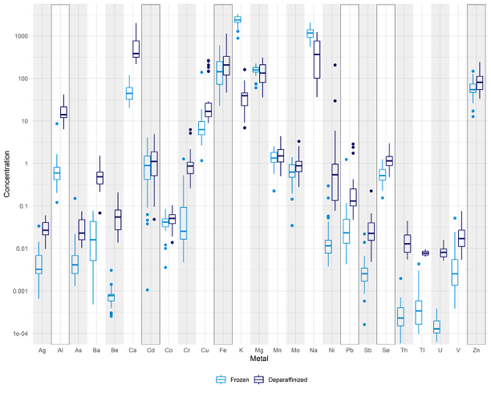Figure S1: Boxplots for the concentrations of the metals quantified within the study. The frozen samples are in light blue and the FFPE (Deparaffinized) samples are in dark blue. Outliers are noted as individual dots. The boxed metals are the metals with a Pearson correlation value over 0.6 between frozen and FFPE sample pairs.
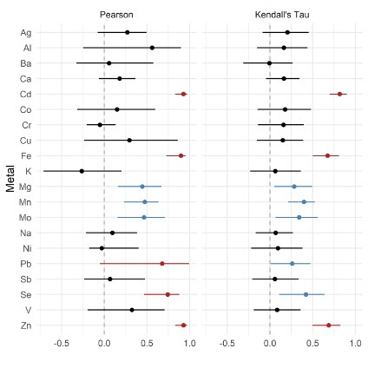
Figure S2: Forest plots of the metal correlation values when assessing correlation between frozen and FFPE samples utilizing Pearson correlation and Kendall’s Tau. Red indicates a high correlation estimate (over 0.6) while blue denotes a significantly positive correlation (the interval does not cross 0) but it is not a high estimate. Metals with more than 10 below quantifiable levels readings for either frozen or FFPE sample types were removed from this analysis.
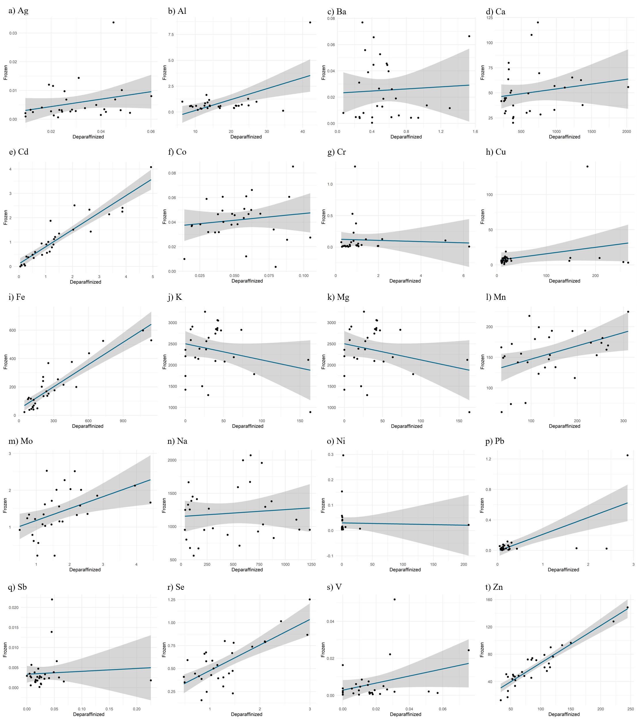
Figure S3: Correlation plots of all the metals analyzed by Pearson correlation and Kendall’s Tau. The following metals are presented: a) Silver (Ag), b) aluminum (Al), c) barium (Ba), d) calcium (Ca), e) cadmium (Cd), f) cobalt (Co), g) chromium (Cr), h) copper (Cu), i) iron (Fe), j) potassium (K), k) magnesium (Mg), l) manganese (Mn), m) molybdenum (Mo), n) sodium (Na), o) nickel (Ni), p) lead (Pb), q) antimony (Sb), r) selenium (Se), s) vanadium (V), t) zinc (Zn). The x and y axes units are in ng/mm³ which is from the concentration of each metal in the respective sample type per sample.
Characteristic | CHTN  N = 19 | NICHD  N = 11 | Overall  N = 30
Race (n (%))
White | 13 (68.4%) | 8 (72.7%) | 21 (70.0%)
Black | 3 (15.8%) | 3 (27.3%) | 6 (20.0%)
Other | 1 (5.3%) | 0 (0.0%) | 1 (3.3%)
Unknown | 2 (10.5%) | 0 (0.0%) | 2 (6.7%)
Biological Sex (n (%))
Female | 16 (84.2%) | 3 (27.3%) | 19 (63.3%)
Male | 2 (10.5%) | 8 (72.7%) | 10 (33.3%)
Unknown | 1 (5.3%) | 0 (0.0%) | 1 (3.3%)
Age (years)
Mean (SD) | 48.1 (19.6) | 27.9 (9.4) | 40.4 (19.1)
Min - Max | 3.0 - 79.0 | 10.4 - 41.9 | 3.0 - 79.0
Median (Q1, Q3) | 46.5 (38.0, 64.0) | 28.6 (24.3, 34.5) | 38.0 (28.6, 52.0)

Table S1: Overview of demographic information of the samples utilized in this study. Samples were either from Cooperative Human Tissue Network (CHTN) or National Institute of Child Health and Human Development (NICHD) Brain and Tissue Bank for Developmental Disorders.

Metal | Sample Type | White (median(min, max)) | Non-White (median(min, max)) | Race p value | Male (median(min, max)) | Female (median(min, max)) | Biological sex p value | Age Kendall's Tau
Ag | Frozen | 0.00 (0.00, 0.03) | 0.00 (0.00, 0.01) | 0.46 | 0.00 (0.00, 0.03) | 0.00 (0.00, 0.01) | 0.41 | -0.04
Al | Frozen | 0.56 (0.20, 8.66) | 0.64 (0.12, 1.65) | 0.35 | 0.48 (0.12, 1.65) | 0.61 (0.35, 8.66) | 0.10 | 0.02
Ba | Frozen | 0.01 (0.00, 0.08) | 0.02 (0.00, 0.07) | 0.97 | 0.01 (0.00, 0.07) | 0.03 (0.00, 0.08) | 0.29 | 0.27
Ca | Frozen | 41.73 (20.16, 120.19) | 56.80 (25.93, 79.90) | 0.38 | 47.43 (20.16, 79.90) | 44.82 (28.43, 120.19) | 0.62 | 0.11
Cd | Frozen | 0.79 (0.04, 4.08) | 1.35 (0.00, 2.33) | 0.40 | 0.44 (0.00, 2.25) | 0.94 (0.04, 4.08) | 0.20 | 0.25
Co | Frozen | 0.04 (0.00, 0.09) | 0.05 (0.01, 0.07) | 0.11 | 0.03 (0.01, 0.06) | 0.05 (0.00, 0.09) | 0.07 | 0.13
Cr | Frozen | 0.02 (0.01, 1.28) | 0.05 (0.00, 0.38) | 0.16 | 0.02 (0.00, 1.28) | 0.03 (0.01, 0.38) | 0.12 | 0.14
Cu | Frozen | 6.17 (1.17, 139.86) | 5.97 (3.10, 10.02) | 0.47 | 6.14 (3.10, 139.86) | 6.17 (1.17, 11.99) | 0.87 | -0.01
Fe | Frozen | 152.29 (40.98, 597.93) | 199.55 (22.64, 524.45) | 0.53 | 129.30 (40.98, 597.93) | 176.12 (22.64, 528.61) | 0.88 | 0.16
K | Frozen | 2561.86 (890.58, 3287.77) | 2246.41 (1292.28, 2905.43) | 0.47 | 2363.83 (890.58, 3257.18) | 2561.86 (1419.10, 3287.77) | 0.62 | 0.17
Mg | Frozen | 162.55 (60.55, 224.55) | 156.76 (75.43, 217.75) | 0.30 | 150.54 (60.55, 224.55) | 169.49 (73.65, 217.75) | 0.44 | 0.18
Mn | Frozen | 1.22 (0.22, 2.43) | 1.85 (0.57, 2.53) | 0.03 | 1.16 (0.23, 1.67) | 1.56 (0.22, 2.53) | 0.10 | 0.10
Mo | Frozen | 0.58 (0.03, 1.35) | 0.76 (0.20, 1.41) | 0.30 | 0.54 (0.14, 1.25) | 0.79 (0.03, 1.41) | 0.32 | 0.11
Na | Frozen | 972.93 (561.25, 1996.67) | 1379.59 (676.49, 2071.61) | 0.36 | 1037.97 (561.25, 2071.61) | 1226.76 (670.49, 1996.67) | 0.51 | 0.06
Ni | Frozen | 0.01 (0.00, 0.30) | 0.02 (0.00, 0.15) | 0.09 | 0.01 (0.00, 0.30) | 0.01 (0.01, 0.04) | 0.28 | -0.08
Pb | Frozen | 0.02 (0.00, 1.25) | 0.03 (0.01, 0.07) | 0.83 | 0.02 (0.01, 1.25) | 0.02 (0.00, 0.12) | 0.41 | 0.10
Sb | Frozen | 0.00 (0.00, 0.02) | 0.00 (0.00, 0.00) | 0.42 | 0.00 (0.00, 0.02) | 0.00 (0.00, 0.01) | 0.92 | 0.08
Se | Frozen | 0.54 (0.23, 1.25) | 0.43 (0.16, 0.80) | 0.58 | 0.49 (0.16, 1.01) | 0.58 (0.23, 1.25) | 0.40 | 0.13
V | Frozen | 0.00 (0.00, 0.02) | 0.00 (0.00, 0.05) | 0.32 | 0.00 (0.00, 0.02) | 0.00 (0.00, 0.05) | 0.27 | 0.10
Zn | Frozen | 54.08 (12.73, 148.57) | 60.78 (17.16, 107.12) | 0.83 | 47.62 (17.16, 79.05) | 71.27 (12.73, 148.57) | 0.07 | 0.41

Table S2: Demographics analysis for frozen samples utilized within the study. Median (minimum (min), maximum (max)) concentration values for the two racial and biological sex groups are presented. Respective p values (without adjustment for multiple comparisons) for race and biological sex differences assessed by Mann Whitney U are also presented. Correlation analysis for age was performed utilizing Kendall’s Tau. Metals that had more than 10 below quantifiable levels values for either frozen or FFPE samples were removed.

Parameter | Setting
Forward power | 1600w
Detection mode | He
Number of replicas | 3
Measurement time (s) | 1 for trace metals, 0.1 for Na, K, Ca, Mg and Fe
Operation Conditions
Plasma mode | HMI
Extract 2 | -200V
Omega Bisa | -80V
Omega Lens | 9.2V
He flow | 5ml/min
OctP RF | 200V
RF Power | 1600 w
Auxiliary gas flow | 0.9L/min
Plasma gas | 15.0 L/min
Sample introduction | PeriPump
Replicates | 3

Table S3: Settings and operation conditions for inductively coupled plasma mass spectrometry (ICP-MS) utilized for the quantification of metals of all samples in this study.

