Additional file 1
Metabolic Rewiring in Yeast for Sustainable Production of Aviation Fuel Precursor Germacrene D
Jiajia Liu ^{1#}, Ge Yao¹, Xiukun Wan ¹, Yunfei Zhang ¹, Shaoheng Bao ¹, Hui Jiang ¹, Penggang Han ^{1*}
1 State Key Laboratory of Chemistry for NBC Hazards Protection, Beijing, 102205, People’s Republic of China
# The first author, * The corresponding author

Email addresses of authors:
Jiajia Liu, Email: jiajialiu0802@163.com
Ge Yao, Email: bzyaoge@163.com
Xiukun Wan, Email: xiukunwan@126.com
Yunfei Zhang, Email: yfzhang2024@126.com
Shaoheng Bao, Email: 603716673@qq.com
Hui Jiang, Email: ylplkmc@163.com
Penggang Han, Email: hanpeng1021@163.com

Table S1 Strains used in this study.
Strains | Characteristics | Source
Strains
LSc81 | rox1Δ:: P_{GAL10}-Actps1, P_{GAL1}-tHMG1, P_{GAL7}-ERG20; exg1Δ:: P_{GAL1}-Actps1, P_{GAL10}-tHMG1; dpp1Δ:: P_{GAL1}-Actps1, P_{GAL10}-tHMG1; ERG9Δ:: P_{HXT1}-ERG9 | [1]
LSc193 | Base on LSc81, ADH1Δ | This study
LSc194 | Base on LSc81, ADH2Δ | This study
LSc195 | Base on LSc81, ADH3Δ | This study
LSc196 | Base on LSc81, ADH4Δ | This study
LSc197 | Base on LSc81, ADH5Δ | This study
LSc198 | Base on LSc81, ADH6Δ | This study
LSc205 | Base on LSc193, YPRCδ15cΔ:: P_{GAL1}-ADH1 | This study
LSc206 | Base on LSc194, YPRCδ15cΔ:: P_{GAL1}-ADH2 | This study
LSc207 | Base on LSc195, YPRCδ15cΔ:: P_{GAL1}-ADH3 | This study
LSc208 | Base on LSc196, YPRCδ15cΔ:: P_{GAL1}-ADH4 | This study
LSc209 | Base on LSc197, YPRCδ15cΔ:: P_{GAL1}-ADH5 | This study
LSc210 | Base on LSc198, YPRCδ15cΔ:: P_{GAL1}-ADH6 | This study
LSc223 | Base on LSc197, 1309Δ:: P_{GAL1}-ALD6 | This study
LSc224 | Base on LSc197, YPRCδ15cΔ:: P_{GAL1}-ACS1 | This study
LSc225 | Base on LSc197, YPRCδ15cΔ:: P_{GAL1}- ACS2 | This study
LSc226 | Base on LSc197, 1014aΔ:: P_{GAL1-}YlACL1, P_{GAL10-}YlACL2, P_{GAL7-}CTP1 | This study
LSc227 | Base on LSc197, MLS1Δ | This study
LSc228 | Base on LSc197, 1414aΔ:: P_{GAL1}- ACS1, P_{GAL10-}ACS2 | This study
LSc229 | Base on LSc197, 1414aΔ:: P_{GAL1}- ACS1, P_{GAL10-}ACS2, 1309Δ:: P_{GAL1}-ALD6 | This study
LSc230 | Base on LSc197, 1414aΔ:: P_{GAL1}- ACS1, P_{GAL10-}ACS2, 1309Δ:: P_{GAL1}-ALD6, 1014aΔ:: P_{GAL1-}YlACL1, P_{GAL10-}YlACL2, P_{GAL7-}CTP1 | This study
LSc231 | Base on LSc197, 1414aΔ:: P_{GAL1}- ACS1, P_{GAL10-}ACS2, 1309Δ:: P_{GAL1}-ALD6, 1014aΔ:: P_{GAL1-}YlACL1, P_{GAL10-}YlACL2, P_{GAL7-}CTP1, MLS1Δ | This study
LSc233 | Base on LSc197, 1414aΔ:: P_{GAL1}- ACS1, P_{GAL10-}ACS2, 1014aΔ:: P_{GAL1-}YlACL1, P_{GAL10-}YlACL2, P_{GAL7-}CTP1 | This study
LSc82 | Base on LSc82, Gal80Δ:: URA3_HIS3_TRP1_LEU2 | This study
LSc245 | Base on LSc225, Gal80Δ:: URA3_HIS3_TRP1_LEU2 | This study
Escherichia coli DH5α | Used for routine cloning | Gibco BRL
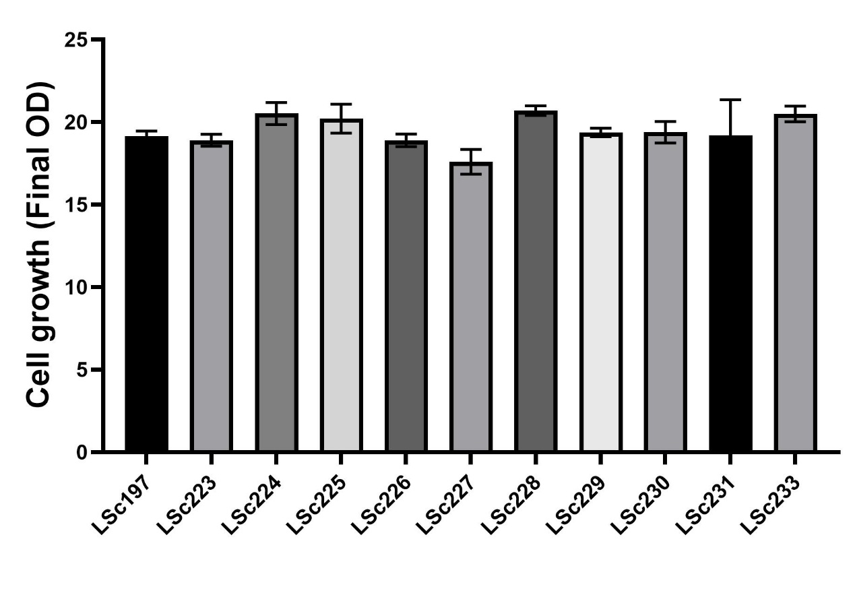
Fig. S1 The cell growth of engineered strains.
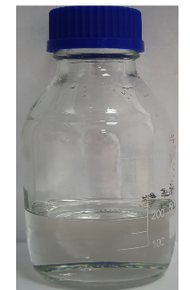
Fig. S2 Germacrene D sample
Supplementary references
[1] Liu J, Chen C, Wan X, Yao G, Bao S, Wang F, Wang K, Song T, Han P, Jiang H. Identification of the sesquiterpene synthase AcTPS1 and high production of (-)-germacrene D in metabolically engineered Saccharomyces cerevisiae. Microb Cell Fact. 2022 May 18;21(1):89.

