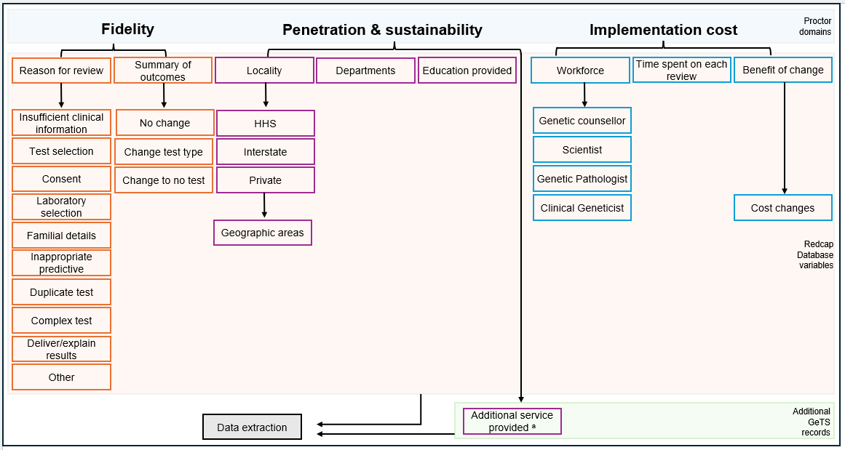

Supplementary Figure 1. Data sources mapped using Proctor Implementation Framework late phases¹⁶. Queensland, Australia, 2023-2025. HHS, Hospital and Health Services.
ª Structured education, resource development, and laboratory process improvements.

