Mineral Association State Regulates Microbial Contributions to Persistent Soil Carbon
Hongfei Liu¹, Chao Liang², Katerina Georgiou^{3,4}, and Mengqiang Zhu^{1*}
¹Department of Geological, Environmental, and Planetary Sciences, University of Maryland, College Park, MD 20742, USA
²State Key Laboratory for Development and Utilization of Forest Food Resource, College of Environmental and Resource Sciences, Zhejiang A&F University, Hangzhou 311300, China
³Department of Biological and Ecological Engineering, Oregon State University, Corvallis, Oregon, USA
⁴Physical and Life Sciences Directorate,Lawrence Livermore National Laboratory, Livermore, California, USA

* Corresponding author: Mengqiang Zhu

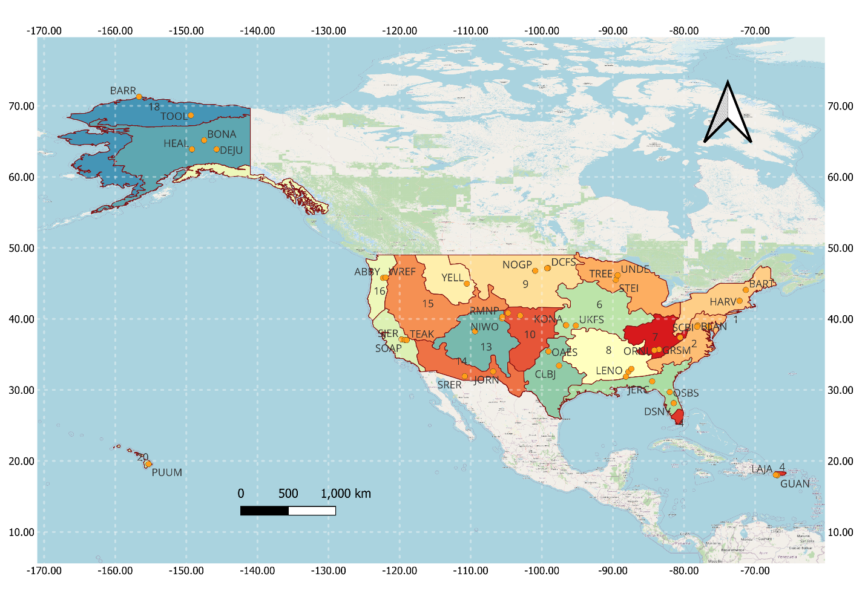
Figure S1 | Geographic distribution of the 48 terrestrial NEON sites included in this study for amino sugar analysis of bulk soils.

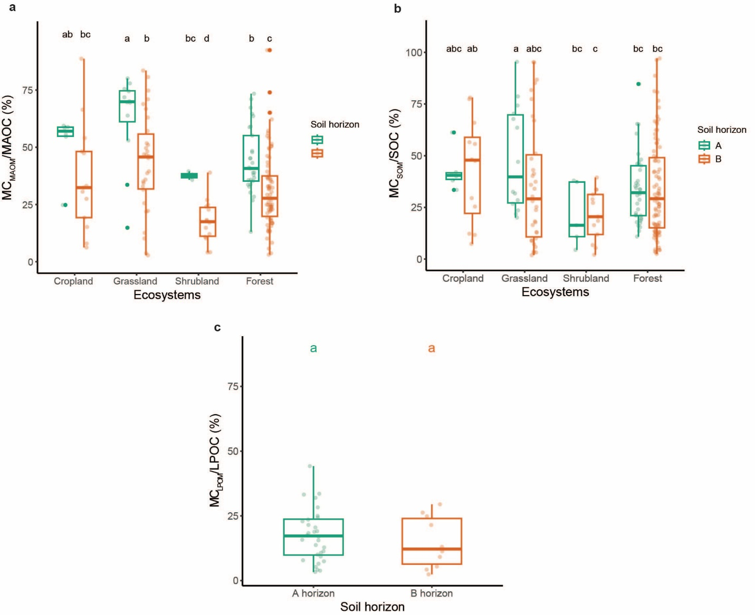
Figure S2 | Microbial contributions to MAOC, bulk SOC and LPOC. a, The microbial contribution to MAOC (MC_{MAOM}/MAOC) across ecosystems and soil horizons. b, The microbial contribution to SOC (MC_{SOM}/SOC) across ecosystems and soil horizons. c, The microbial contribution to LPOC (MC_{LPOM}/MAOC) across soil horizons. In boxplots, boxes represent the interquartile range (25th–75th percentiles), horizontal lines indicate medians, whiskers show the data range excluding outliers, and solid dots denote outliers.

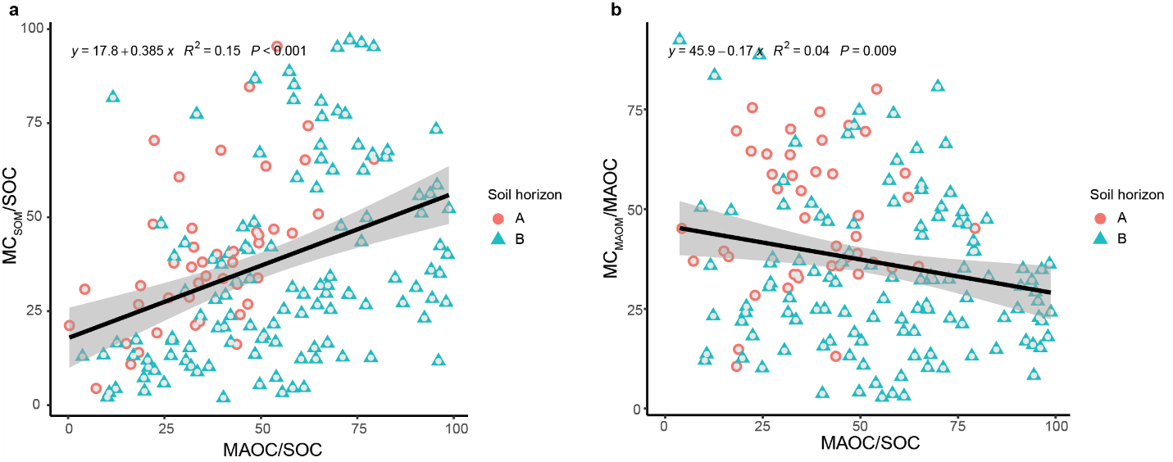
Figure S3 | Relationships between MAOC/SOC and microbial contributions to SOC and MAOC. a, Linear relationship between MAOC/SOC and microbial contribution to bulk SOC (MC_{SOM}/SOC). b, Linear relationship between MAOC/SOC and microbial contribution to bulk MAOC (MC_{MAOM}/MAOC). The shaded grey band indicates the 95% confidence interval.

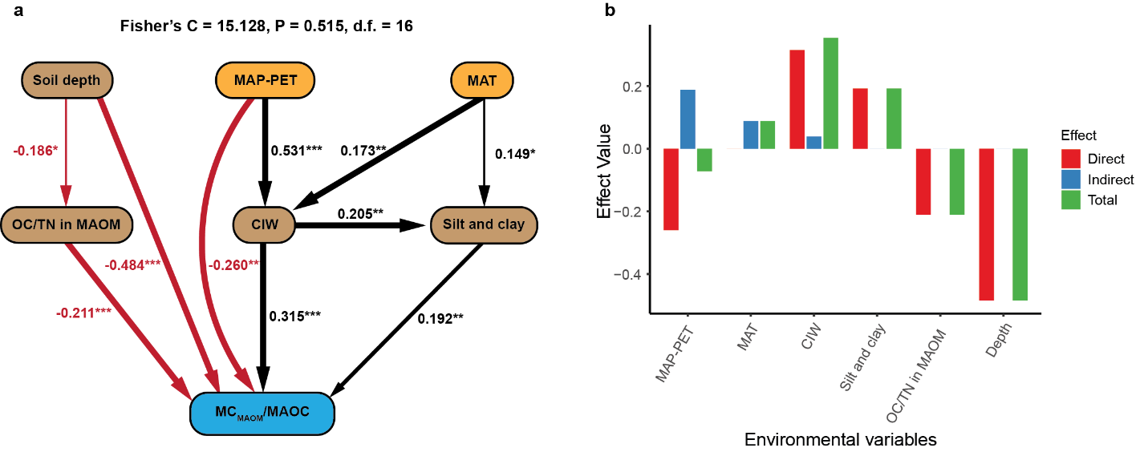
Figure S4 | Structural equation modelling of environmental controls on microbial contributions to MAOC. a, SEM for the contribution of MC_{MAOM} to MAOC (MC_{MAOM}/MAOC). b, Corresponding direct, indirect, and total effects of environmental variables. In SEMs, Solid arrows indicate statistically significant pathways, with black and red arrows denoting positive and negative relationships, respectively. Arrow widths are proportional to the magnitude of standardized path coefficients, which are shown on the arrows. Numbers on arrows are standardized path coefficients, with significance levels indicated as *p < 0.05, **p < 0.01, and ***p < 0.001.

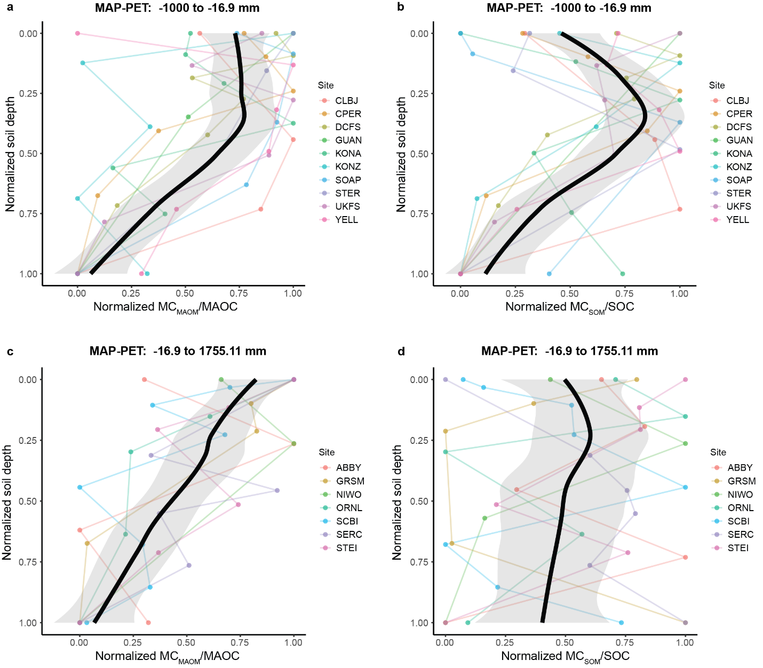
Figure S5 | Depth-dependent patterns of the microbial contribution to MAOC (MC_{MAOM}/MAOC) and bulk SOC (MC_{SOM}/SOC) in dry and wet systems. a, Variation in the MC_{MAOM}/MAOC with soil depth in dry systems. b, Variation in the MC_{SOM}/SOC with soil depth in dry systems. c, Variation in the MC_{MAOM}/MAOC with soil depth in wet systems. d, Variation in the MC_{SOM}/SOC with soil depth in wet system. In each panel, the black dashed curve is a LOESS (locally weighted) regression. Points of the same colour denote soil horizons from the same NEON site; same-coloured straight lines connect horizons within a site to indicate within-site depth trajectories.

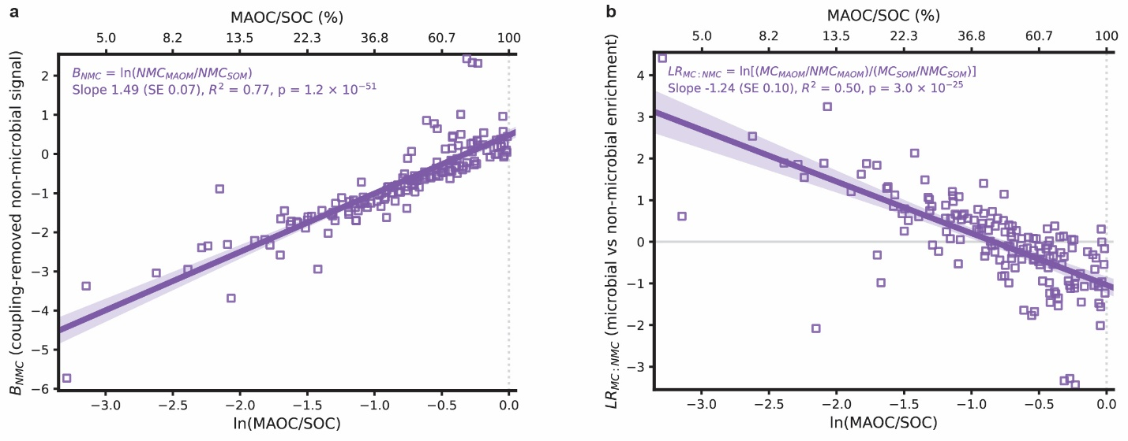
Figure S6 | Coupling-removed non-microbial signal and microbial-to-non-microbial log-ratio enrichment along the MAOC/SOC gradient. Relationships between ln(MAOC/SOC) and (a) the coupling-removed non-microbial signal, B_{NMC} = ln(NMC_{MAOM}/NMC_{SOM}), and (b) the microbial-to-non-microbial log-ratio enrichment, LR_{MC:NMC} = ln[(MC_{MAOM}/NMC_{MAOM})/(MC_{SOM}/NMC_{SOM})]. MAOC/SOC was expressed as a fraction for regression analysis and as a percentage on the upper x-axis. Points represent individual soil samples; solid lines show ordinary least-squares fits, with shaded bands indicating 95% confidence intervals. The positive relationship in panel (a) indicates increasing partitioning of non-microbial carbon into MAOM with increasing MAOC/SOC, whereas the negative relationship in panel (b) shows that MAOC becomes relatively depleted in microbial-derived carbon compared with non-microbial carbon along this gradient. MC, microbial-derived carbon; NMC, non-microbial carbon calculated by difference; MAOC, mineral-associated organic carbon; SOC, soil organic carbon; MAOM, mineral-associated organic matter; SOM, soil organic matter.

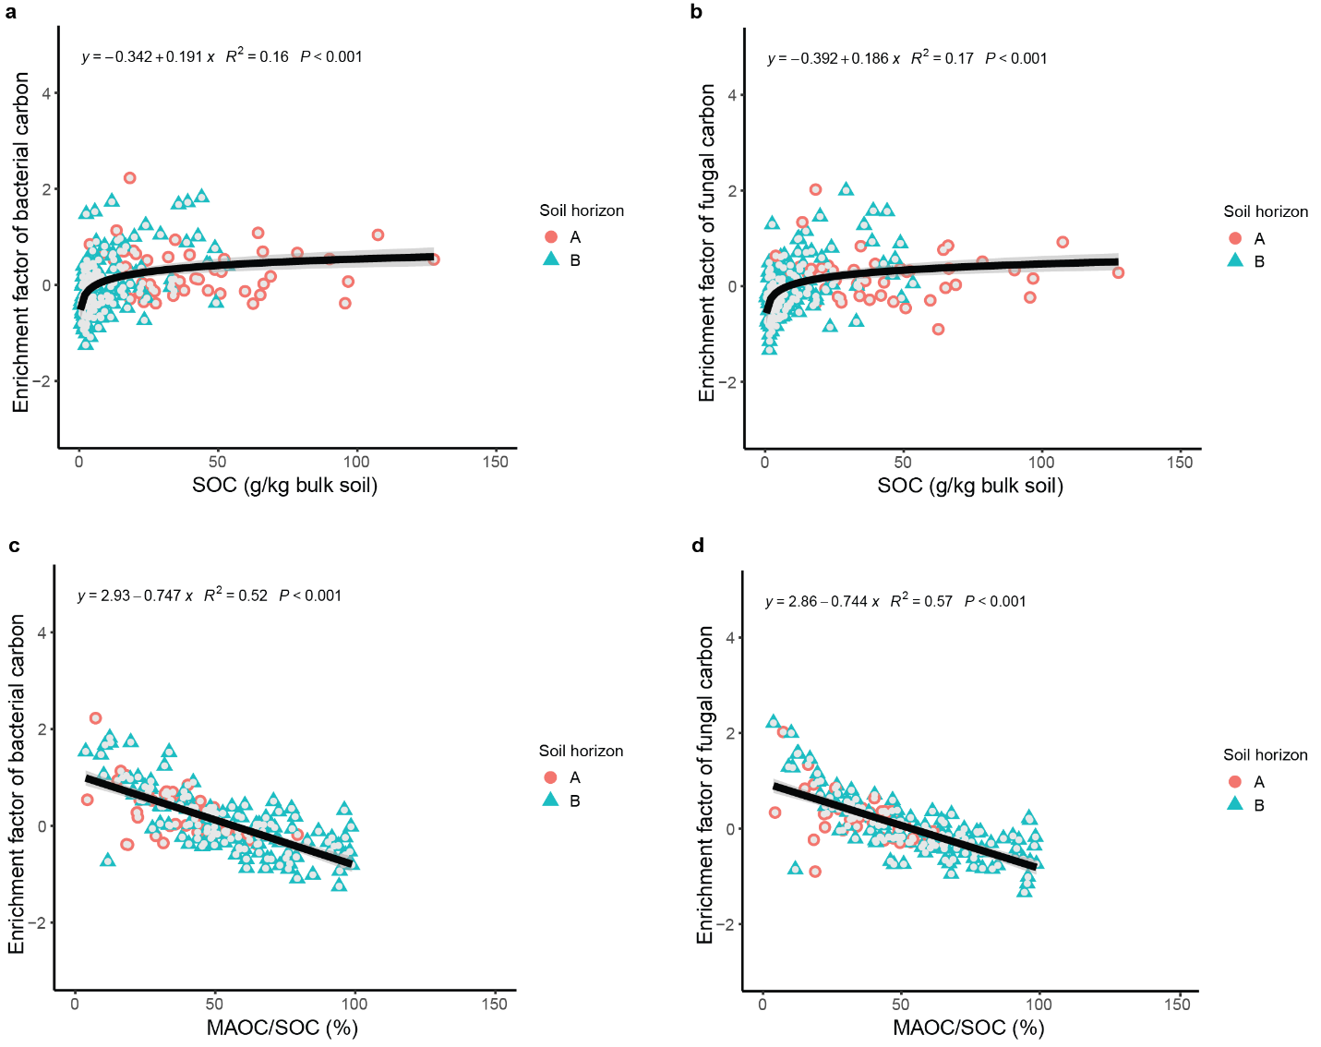
Figure S7 | Relationships of bacterial and fungal necromass-carbon enrichment factors with SOC and MAOC/SOC. a, Logarithmic relationship between the enrichment factor of bacterial necromass carbon (EF_{BC}) and soil organic carbon (SOC). b, Logarithmic relationship between the enrichment factor of fungal necromass carbon (EF_{FC}) and SOC. c, Linear relationship between EF_{BC} and the ratio of mineral-associated organic carbon to soil organic carbon (MAOC/SOC). d, Linear relationship between EF_{FC} and MAOC/SOC. Grey shading indicates 95% confidence intervals for the fitted relationships. MAOC, mineral-associated organic carbon; SOC, soil organic carbon.

