Supplementary Materials for
Entropy-engineered perovskite heterointerfaces suppress lattice-distortion-induced carrier localization and operational fatigue
Shaoyu Liu et al.

Corresponding author: Zhi Xing, xingzhi@gnnu.edu.cn and Jinwei Gao, gaojinwei@m.scnu.edu.

The PDF file includes:

Materials and Methods
Supplementary Text
Figs. S1 to S26
References (1–3)

Materials and Methods
Materials.
All reagents are used without any further purification. [2-(3,6-dimethoxy-9H-carbazol-9-yl)ethyl]phosphonic acid (MeO-2PACz) and 2,9-Dimethyl-4,7-diphenyl-1,10-phenanthroline (BCP) are purchased from TCI. N, N-dimethylformamide (DMF), dimethyl sulfoxide (DMSO) are purchased from Sigma-Aldrich. [6,6]-phenyl-C₆₁-butyric acid methyl ester (PC₆₁BM) is purchased from Xi’an Yuri Solar. Formamidinium iodide (FAI), methylammonium bromide (MABr), methylamine hydrochloride (MACl), cesium iodide (CsI), phenylethylamine hydroiodide (PEAI), lead (II) iodide (PbI₂) are purchased from Liaoning Youxuan New Energy Technology Co., Ltd. Unless stated otherwise, all solvents and reagents are purchased from Sigma-Aldrich and used as received. Silver (Ag) is purchased from commercial sources with high purity (≥99.999%).

Preparation of chiral ammonium iodide.
For the preparation of R-MBAI, 1.1 g of (R)-(+)-α-methylbenzylamine and 1.16 g of HI solution (57 wt.% in H₂O) were introduced into a flask under nitrogen atmosphere with continuous stirring in an ice bath (0 °C). The reaction mixture was maintained for 2 h, followed by removal of the solvent via rotary evaporation at 80 °C for another 2 h. The obtained crude product was repeatedly rinsed with diethyl ether until the washing solution became clear. Subsequently, the precipitate was collected by filtration and dried under vacuum for approximately 12 h. The synthesis of (S)-MBAI was carried out using the same method.
For the synthesis of (R)-3-TFMPEAI, 189.2 mg R-1-(3-trifluoromethylphenyl)ethylamine was dissolved in anhydrous ethyl acetate under ice-bath conditions. Subsequently, 110 μL HI (57 wt.% in H₂O) was slowly added under nitrogen protection with stirring. After reacting at room temperature for 1 h, the solvent was removed by rotary evaporation at 40 °C. The resulting product was washed with diethyl ether, collected, and dried in a vacuum oven at 40 °C for 4 h. A similar procedure was also applied to synthesize (S)-3-TFMPEAI.

Device fabrication.
Glass/ITO substrates were successively cleaned in detergent solution, deionized water, and isopropanol using ultrasonic treatment for 20 min in each solvent. After drying with flowing nitrogen, the substrates were exposed to UV–ozone for 20 min and then transferred into a nitrogen-filled glovebox for subsequent processing. MeO-2PACz self-assembled monolayer was deposited by spin-coating a 0.5 mg mL⁻¹ ethanol solution at 3000 rpm for 30 s, followed by thermal annealing at 100 ℃ for 10 min. To construct the buried interface, a 2 mg mL⁻¹ isopropanol solution of (R)-3-TFMPEAI or (R)-MBAI is spin-coated onto the substrate and subsequently annealed at 100 ℃ for 5 min. The perovskite precursor was prepared by dissolving 19.8 mg CsI, 17.6 mg MABr, 224.4 mg FAI, 746.8 mg PbI₂, and 12.66 mg MACl in 1 mL of a mixed DMF/DMSO solvent (v/v = 3:1). The resulting solution was deposited onto the substrates by spin-coating at 4000 rpm for 45 s with an acceleration rate of 2000 rpm s⁻¹. During the final 15 s of spinning, 150 μL chlorobenzene was dropped onto the spinning substrate as the antisolvent. The obtained films were subsequently annealed at 60 ℃ for 5 min, followed by a second annealing step at 105 ℃ for 10 min. For surface passivation, a PEAI solution in isopropanol (2 mg mL⁻¹) was spin-coated onto the perovskite films at 3000 rpm for 30 s and then annealed at 70 ℃ for 5 min. Afterwards, PCBM solution (20 mg mL⁻¹ in chlorobenzene) was deposited as the electron-transport layer by spin-coating at 3000 rpm for 30 s, followed by thermal treatment at 90 ℃ for 30 min. A BCP interlayer (0.5 mg mL⁻¹ in isopropanol) was then deposited by spin-coating at 4000 rpm for 30 s. Finally, a 100 nm Ag electrode was thermally evaporated under a vacuum of 10⁻⁴ Pa. The effective device area was 0.04 cm².

Device characterizations.
The current density-voltage (J-V) curves are characterized using Keithley 2400 Sourcemeter. The currents are measured under the solar simulator (Enli Tech, 100 mW·cm⁻², AM 1.5G irradiation) and the reference silicon solar cell is corrected from NREL. All the measurements are performed under nitrogen at room temperature. The reverse scan range is from 1.25 V to -0.2 V and the forward scan range is -0.2 V to 1.25 V, with 20.0 mV for each step, the scan rate is 0.2 V·s⁻¹, the delay time is 1 ms. The EL properties are characterized with a multifunctional laser scanning fluorescence imaging microscope (FLIM300) supplied by Time-Tech Spectra, Co., Ltd. (China). The electrical impedance spectroscopy (EIS) is performed under dark with a Zahner CIMPS electrochemical workstation. To evaluate the ion migration activation energy, vertical devices were fabricated and characterized using an electrochemical workstation (Princeton VersaSTAT 3F), and the activation energy (Ea) can be derived from the slope of the ln(σT)⁻¹/kT relation extracted from the temperature dependent ion conductivity by the Nernst-Einstein relation: 𝜎(𝑇) = (𝜎₀/𝑇) exp (−𝐸_{𝑎}/𝑘𝑇), where k is the Boltzmann constant, σ₀ is a constant, and T is absolute temperature.

Film characterizations.
The morphology of the films is characterized by scanning electron microscopy (JEOL JSM-7500F, Japan) operated at an accelerating voltage of 5.0 kV. Grazing-incidence X-ray diffraction measurements are performed on a D8-Discover 25 diffractometer (Bruker). The carrier transport properties and TRPL mapping were characterized with a multifunctional laser scanning fluorescence imaging microscope (FLIM300) supplied by Time-Tech Spectra, Co., Ltd. (China).

Supplementary Text
Polarized Raman spectroscopy.
Polarization-dependent Raman spectra of the perovskite single crystals were measured using a Horiba Jobin Yvon LabRAM Odyssey Raman microscope equipped with a 633 nm diode-pumped solid-state laser at polarization angles of 0°, 30°, 60°, and 90°.
DOS fluctuation analysis.
The DOS roughness was calculated according to the following equation:
Where D is the density of states and E is the energy. A smaller roughness factor indicates a more homogeneous electronic energy landscape.

DFT calculation.
The calculations were performed in the framework of density-functional theory (DFT) implemented in the Vienna ab initio simulation package (VASP) code¹. The interaction between ions and electrons is described by the projector augmented wave method and the exchange correlation functional is given by the generalized gradient approximation (GGA) of the Perdew-Burke-Ernzerhof (PBE) functional. A cutoff energy of 450 eV was used for the plane-wave basis set, and the energy convergence criterion for self-consistent field iterations was set to 1×10⁻⁵ eV, ensuring high accuracy. During structural relaxation, a quasi-Newton algorithm was employed for ionic relaxation, with the force convergence criterion set to 0.02 eV/Å. The electronic (interband) contribution was obtained from frequency-dependent linear response in the independent-particle approximation. Empirical dispersion correction of DFT-D3 was applied in all the calculations. Furthermore, background charge was tuned to simulate the existence of hole carrier in the crystal.

Carrier diffusion.
The carrier diffusion behavior in perovskite films can be described using a three-dimensional diffusion framework²:
where ϕ(x, y, z, t) represents the carrier density at spatial coordinates (x, y, z) and time t, while D denotes the carrier diffusion coefficient. The parameters k₁ and k₂ correspond to the first-order and second-order recombination rates, respectively. Since the PL mapping measurements are performed under relatively weak excitation conditions, the second-order recombination term related to exciton–exciton Auger interactions can generally be ignored. Therefore, the measured PL intensity profile mainly reflects the in-plane diffusion behavior of photogenerated carriers within the perovskite film (Figure 4a). In contrast, carrier transport along the out-of-plane direction (z-axis) is expected to be governed by the initial optical absorption distribution immediately after excitation (t = 0 ns). Since the out-of-plane transport (z direction) does not significantly affect the lateral distribution, the in-plane carrier distribution can be approximated by a two-dimensional Gaussian function³:
and the PL intensity profile I_{PL}(x, y, t) is expressed as:
where x₀ and y₀ represent the position of the excitation spot center, whereas and denote the variances along the x and y directions as functions of time. Monitoring the temporal evolution of these parameters enables quantitative evaluation of the carrier diffusion behavior. The spatial expansion along the x direction can be expressed as:
where I = 2(Dt)^{1/2} corresponds to the average diffusion distance of carriers away from the original excitation region. By analyzing the time-dependent evolution of the variance through fitting, the carrier diffusion coefficient D can be determined using the following relationship:
A linear fit of versus delay time yields the value of the carrier diffusion coefficient D.
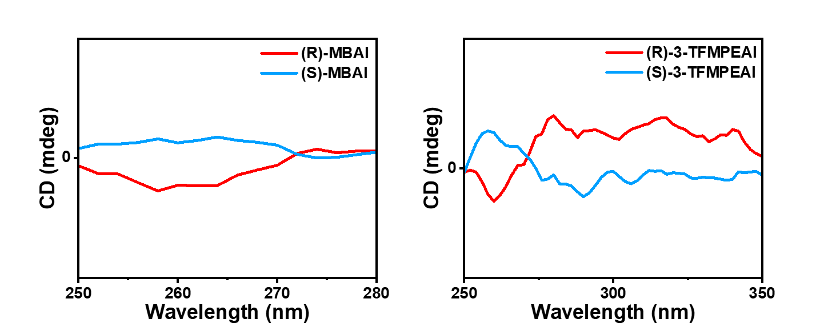
Supplementary Figures

Supplementary Fig. 1. Circular dichroism spectra of (R)-MBAI and (R)-3-TFMPEAI.

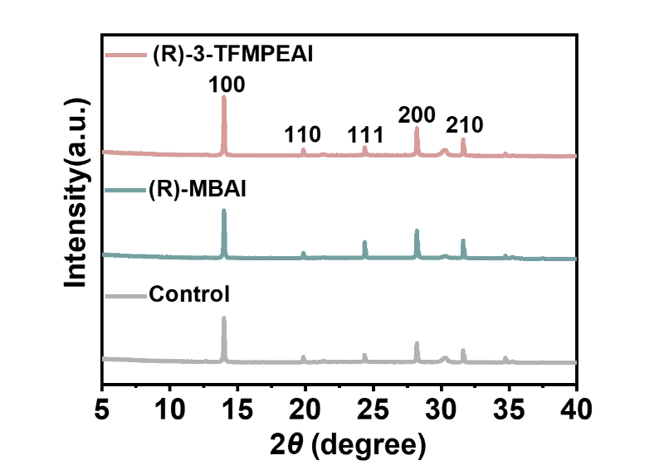
Supplementary Fig. 2. XRD patterns of perovskite films with buried-bottom modification.

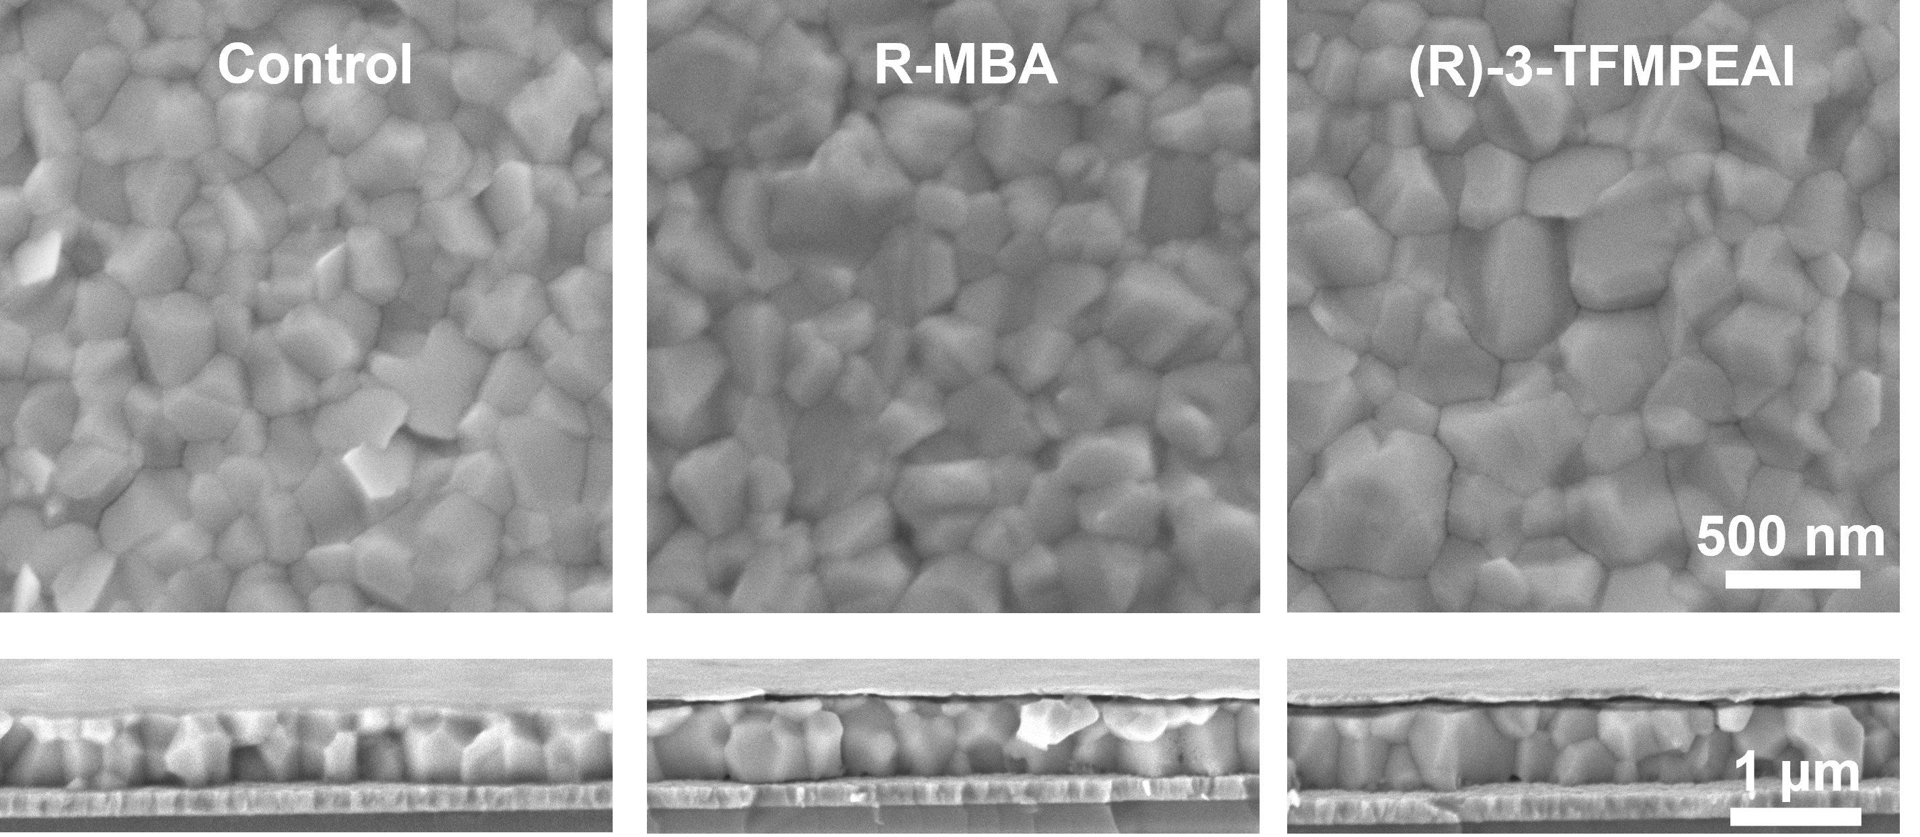
Supplementary Fig. 3. SEM images of the surface and cross-section of perovskite after buried interface modification.

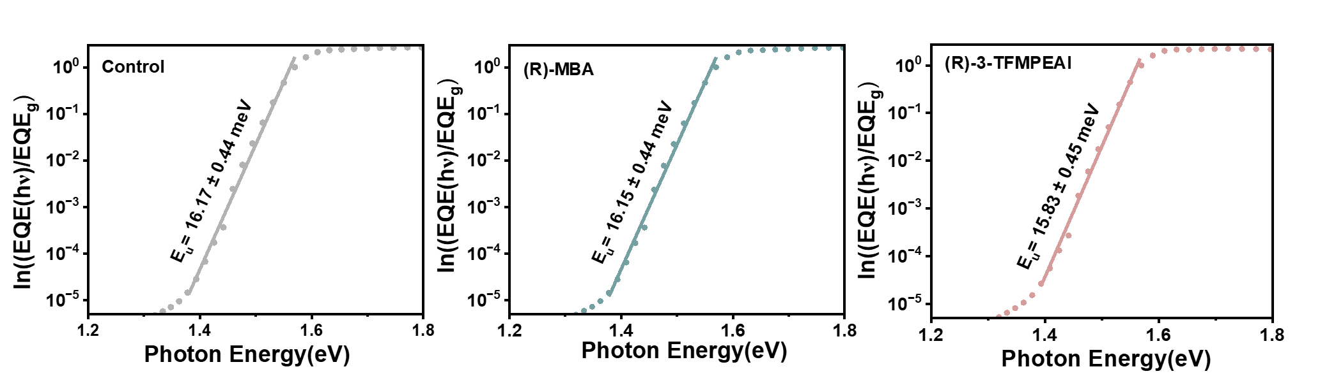
Supplementary Fig. 4. Urbach Energy of Control, (R)-MBAI and (R)-3-TFMPEAI Modified Perovskites.

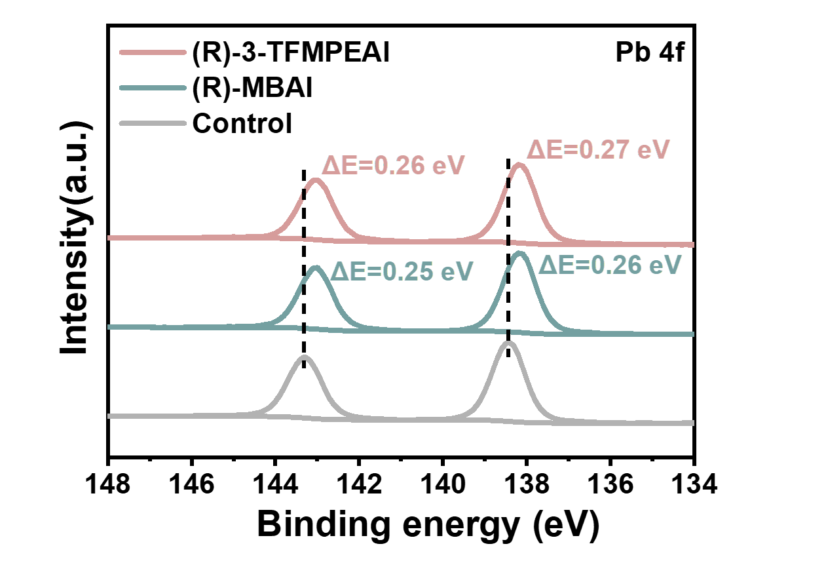
Supplementary Fig. 5. XPS spectra of perovskite films modified with Control, (R)-MBAI and (R)-3-TFMPEAI.

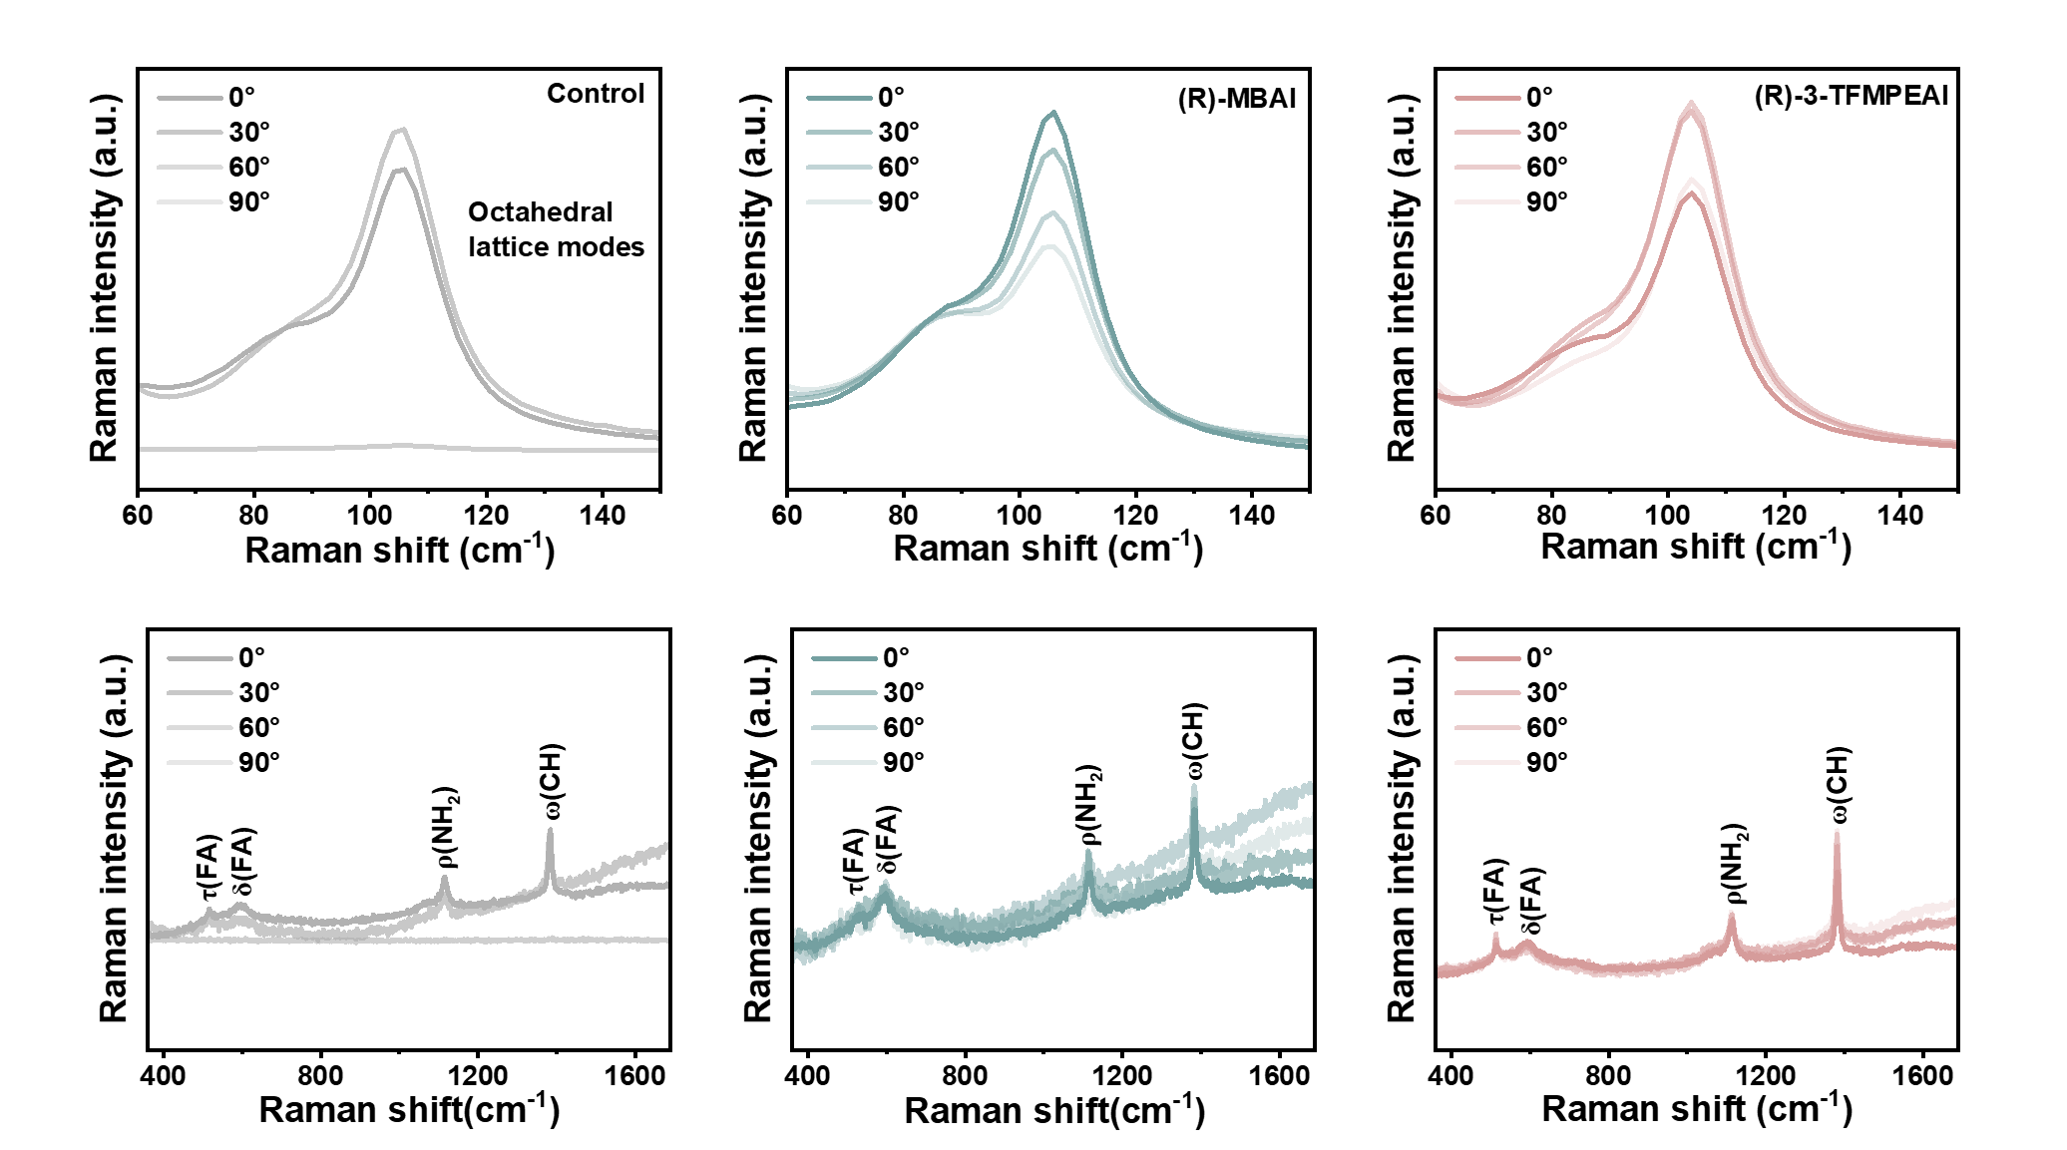
Supplementary Fig. 6. Polarized Raman of Control, (R)-MBAI and (R)-3-TFMPEAI Modified Perovskite.

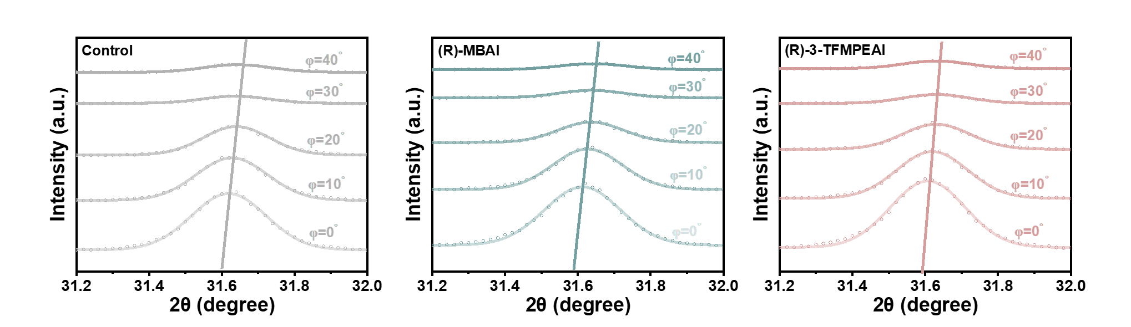
Supplementary Fig. 7. Grazing incidence XRD patterns at different incident angles.

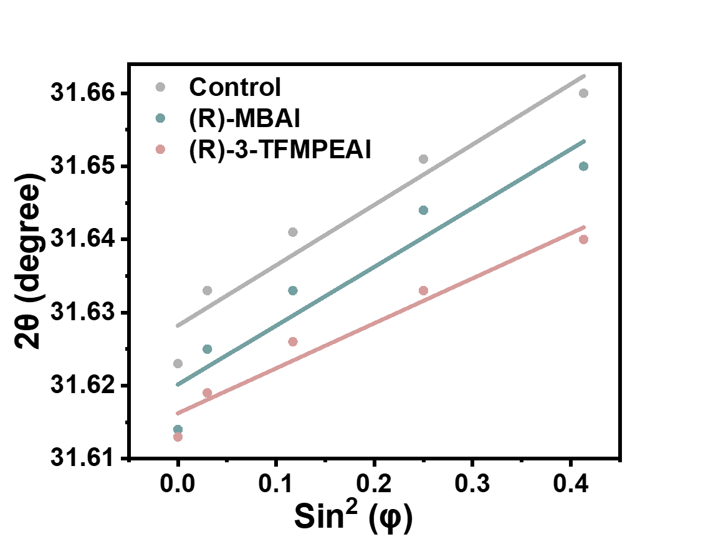
Supplementary Fig. 8. Stress Fitting Curves of Control, (R)-MBAI and (R)-3-TFMPEAI Modified Samples.

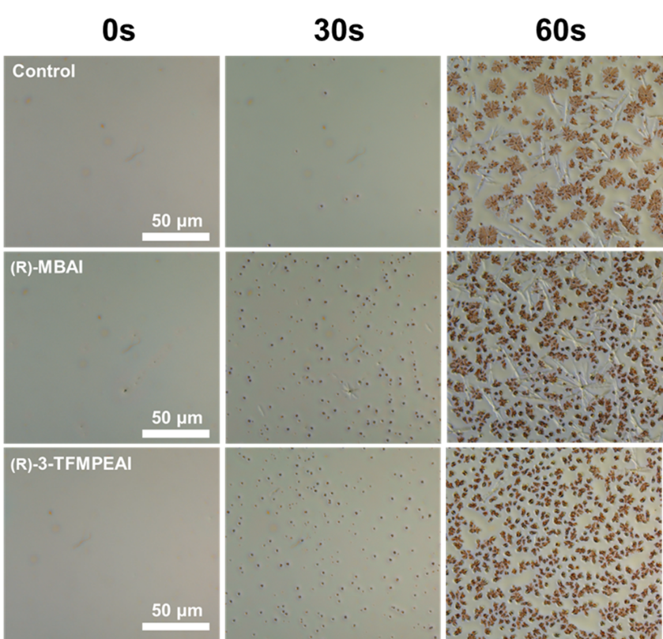

Supplementary Fig. 9. Time-dependent evolution of perovskite solution under in-situ optical microscopy.

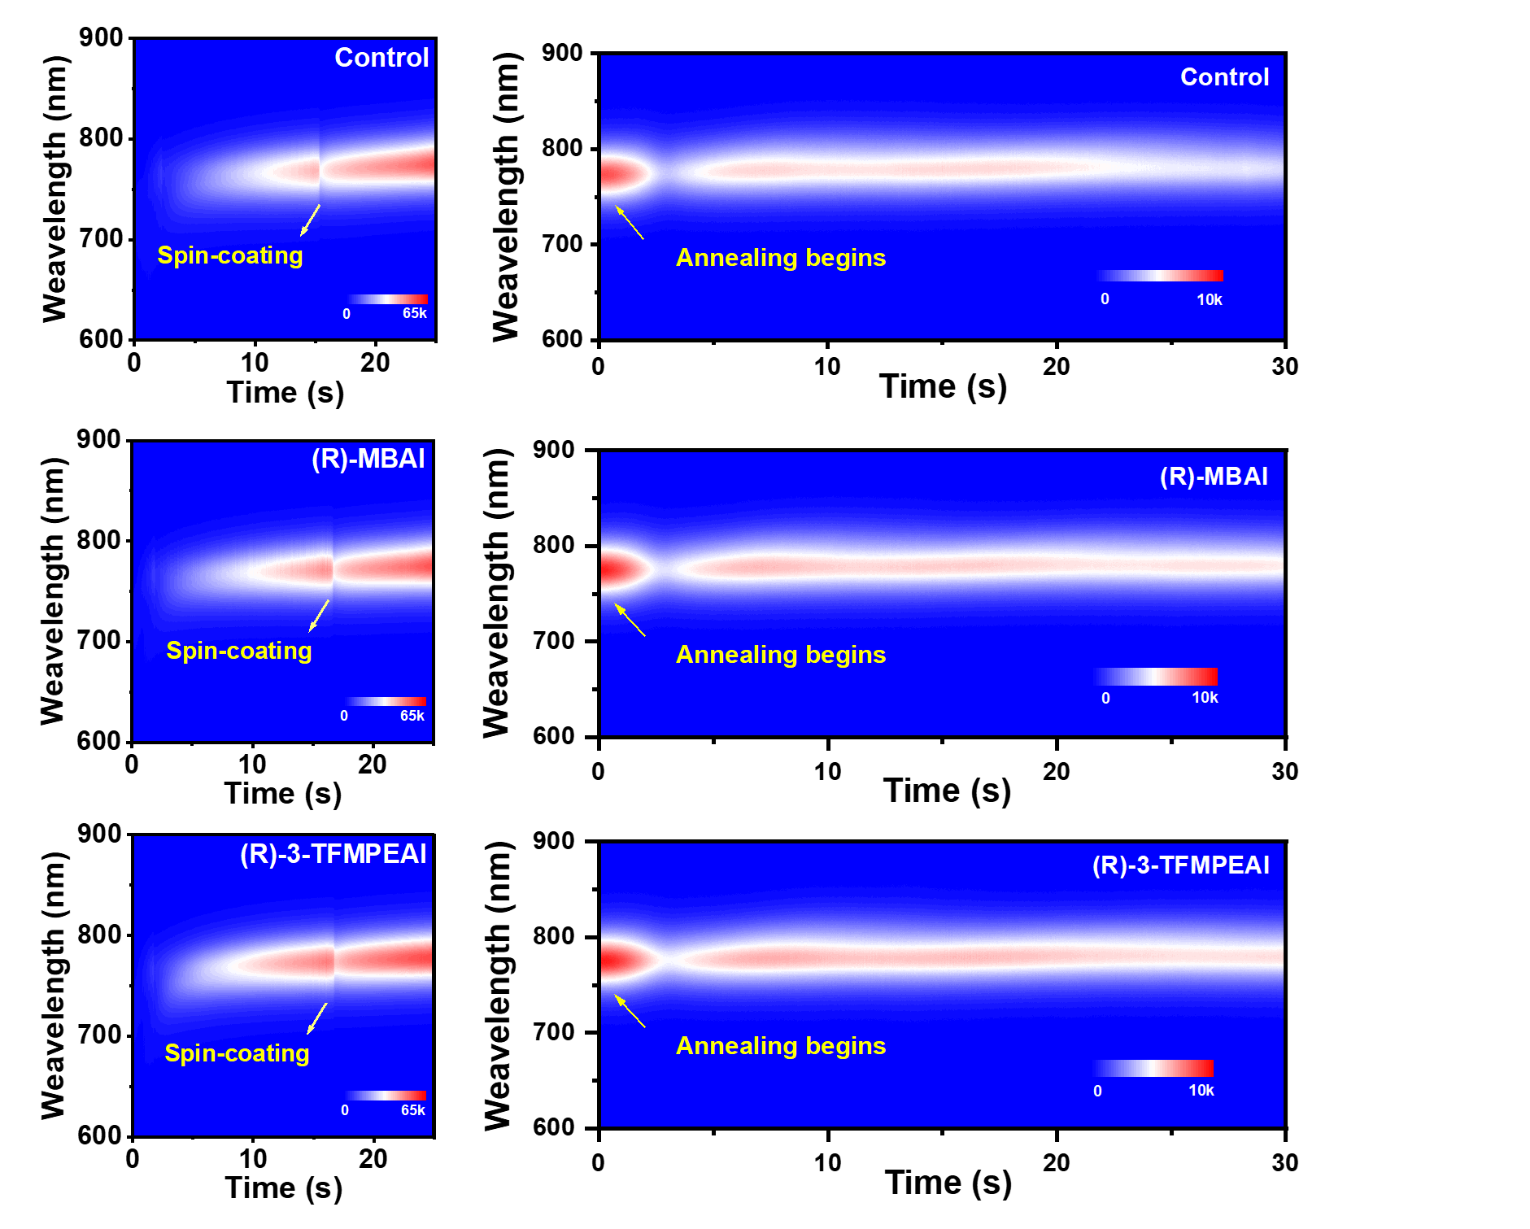
Supplementary Fig. 10. In-situ PL during perovskite spin-coating and annealing.

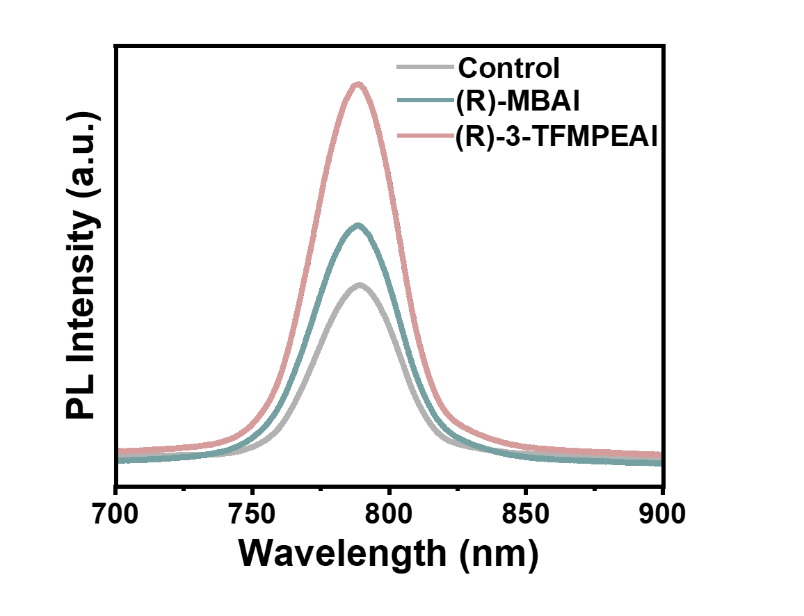
Supplementary Fig. 11. Photoluminescence (PL) spectra of Control, (R)-MBAI-modified and (R)-3-TFMPEAI-modified perovskite films.

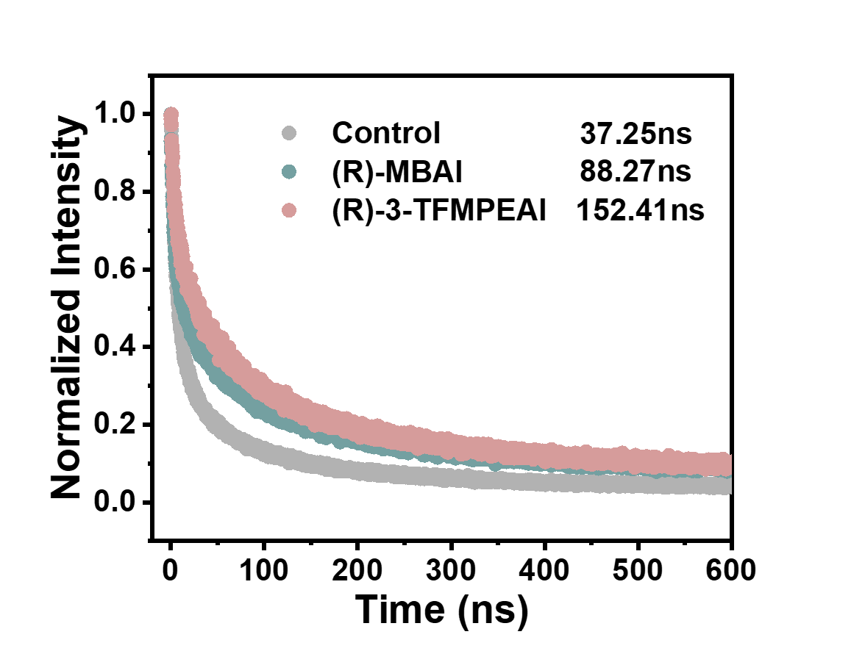
Supplementary Fig. 12. Normalized time-resolved photoluminescence (TRPL) of Control, (R)-MBAI and (R)-3-TFMPEAI Modified Perovskite Films.
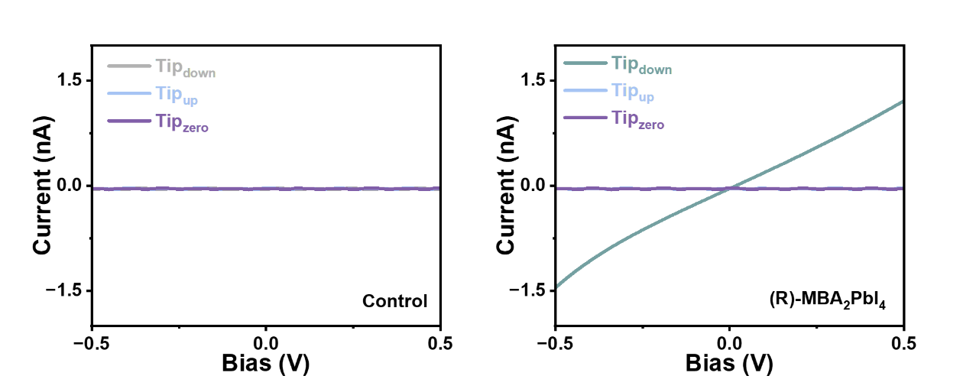
Supplementary Fig. 13. Magnetic force atomic force microscopy of Control and (R)-MBAI.

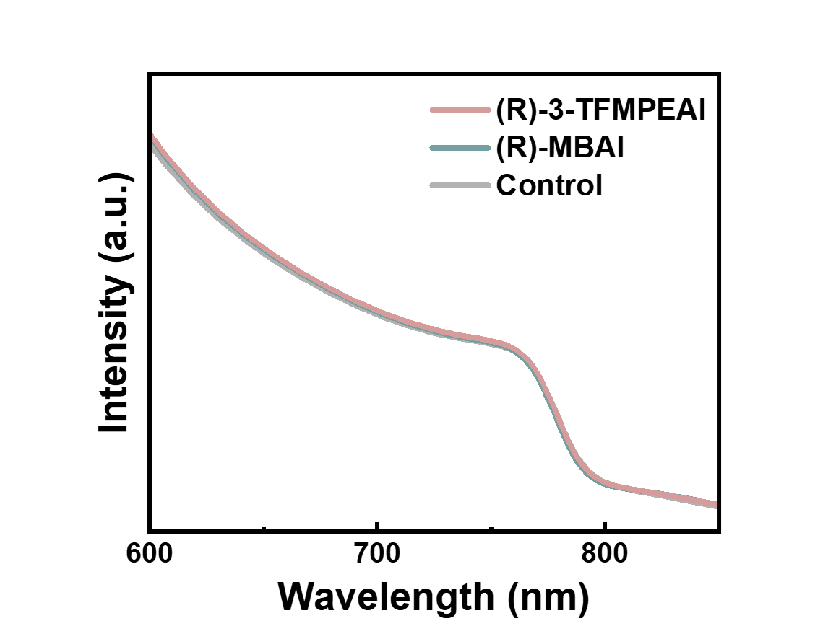
Supplementary Fig. 14. UV–Vis absorption spectra of Control, (R)-MBAI and (R)-3-TFMPEAI Modified Perovskite Films.

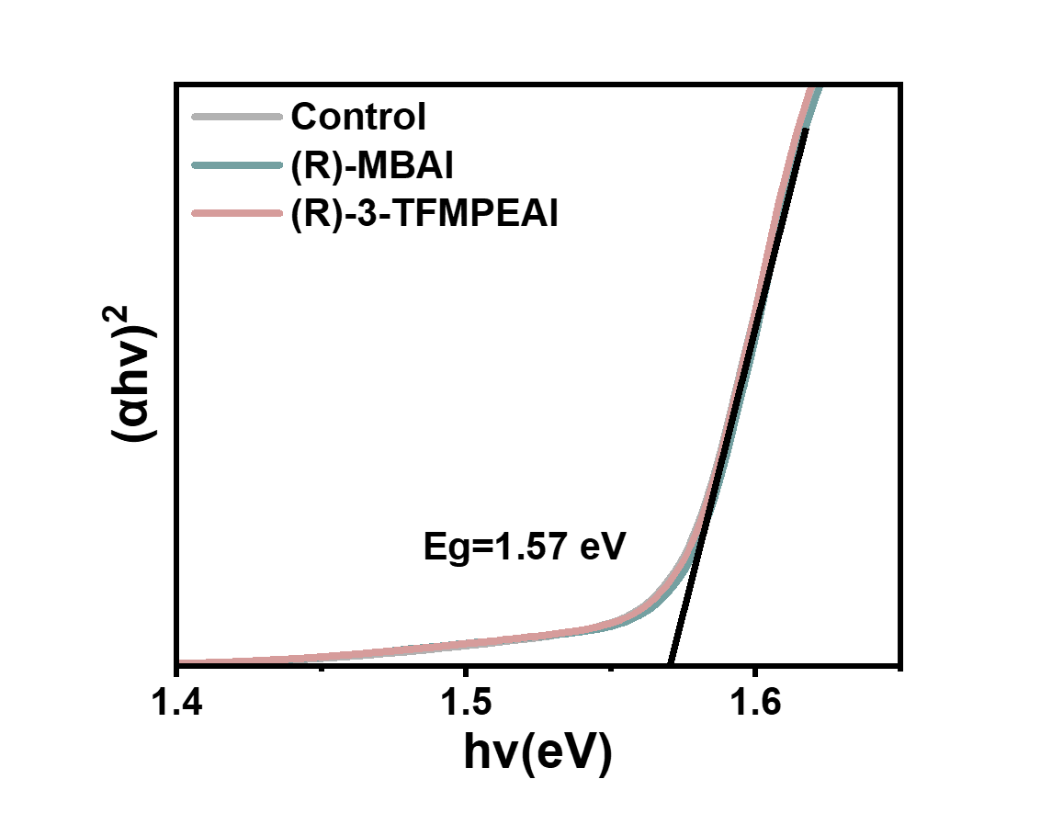
Supplementary Fig. 15. Band gaps of Control, (R)-MBAI and (R)-3-TFMPEAI modified perovskites were derived from UV–Vis absorption spectrum fitting.

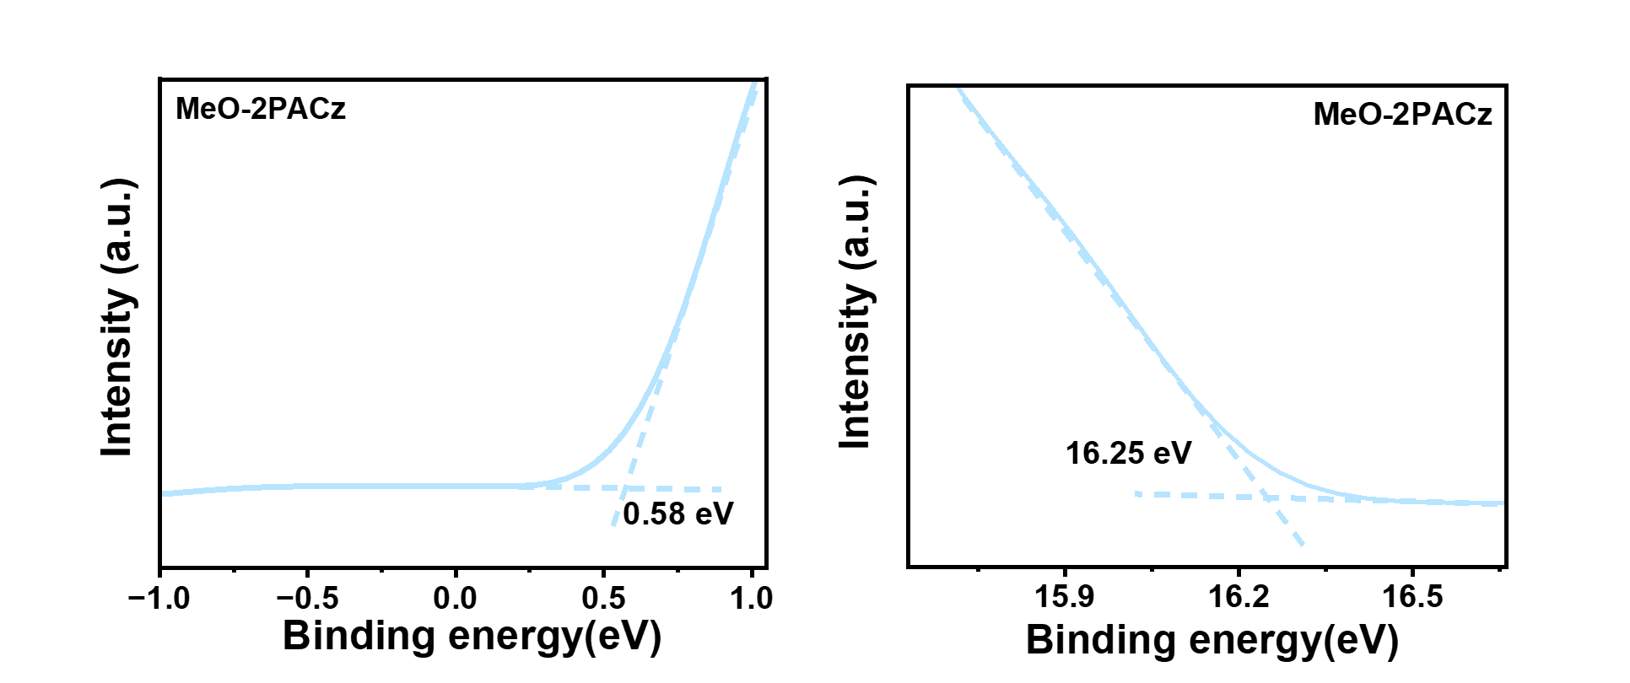
Supplementary Fig. 16. The valence band maximum (VBM) and secondary electron cutoff (E_{cutoff}) of MeO-2PACz were determined by UPS measurements.

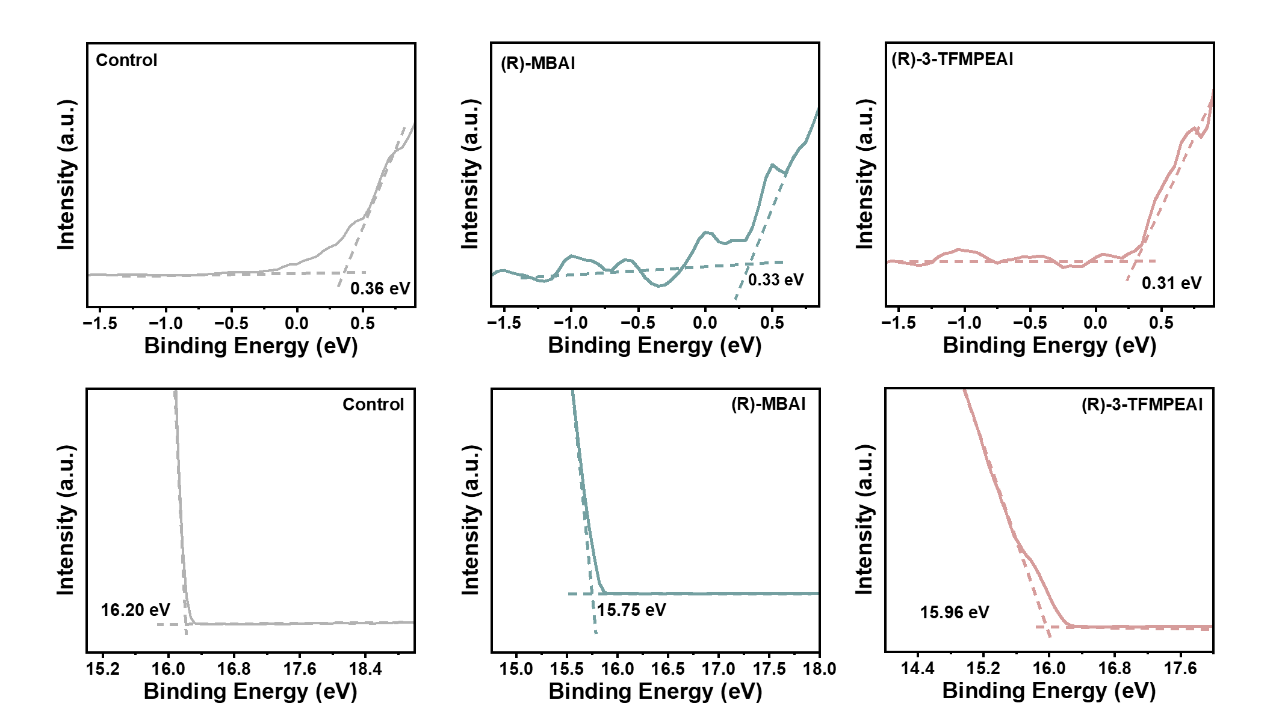
Supplementary Fig. 17. Valence Band Maximum (VBM) and Secondary Electron Cutoff Edge (E_{cutoff}) of Control, (R)-MBAI and (R)-3-TFMPEAI Modified Perovskites from UPS.

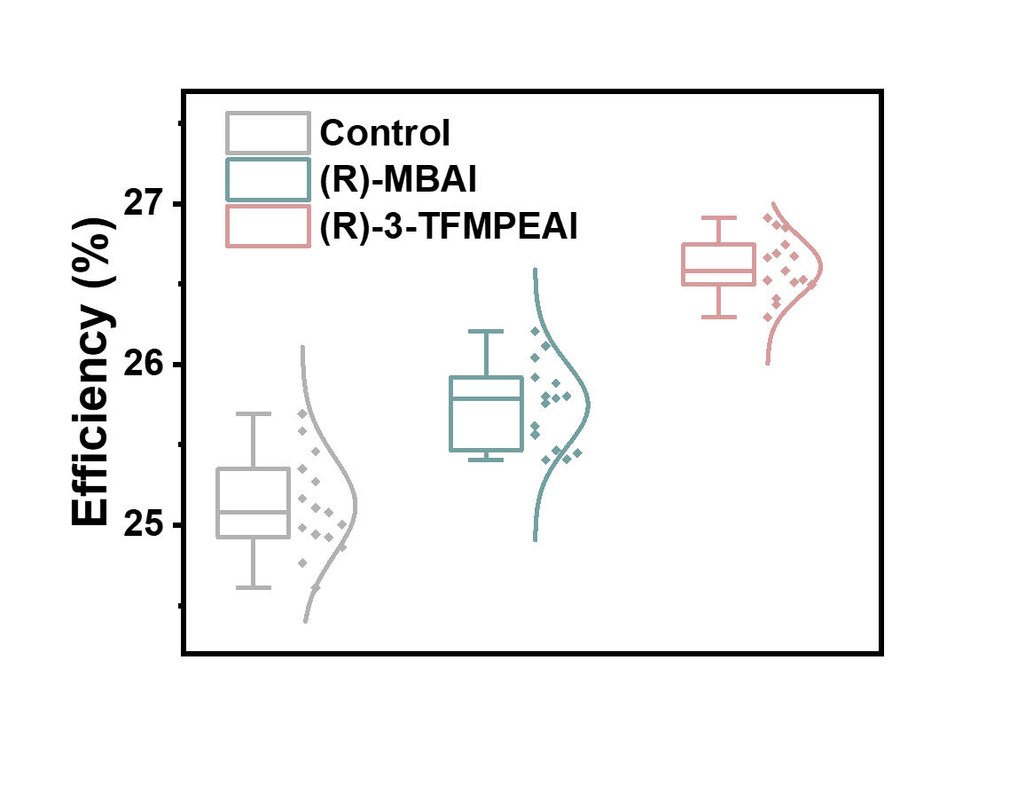

Supplementary Fig. 18. Box plots of device efficiency for Control, (R)-MBAI-modified and (R)-3-TFMPEAI-modified devices.

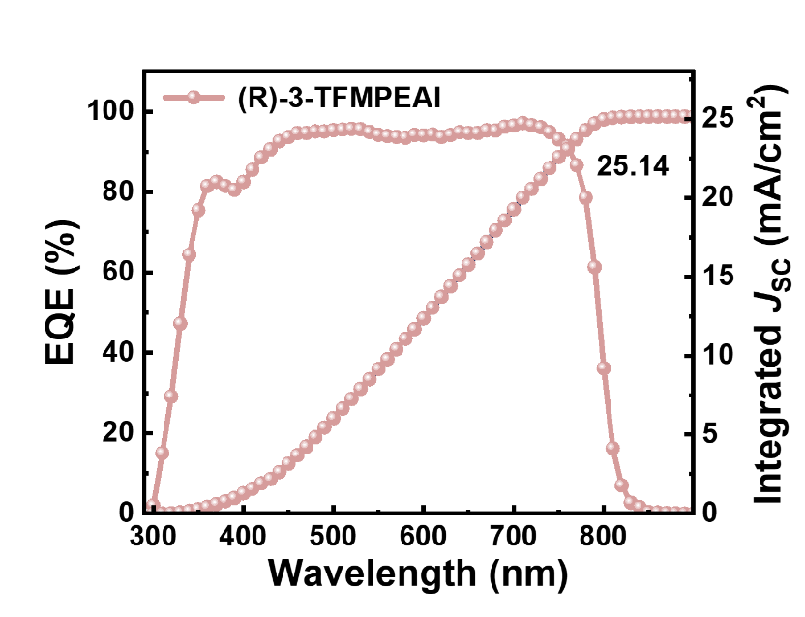
Supplementary Fig. 19. External quantum efficiency (EQE) spectrum of the (R)-3-TFMPEAI-based device.

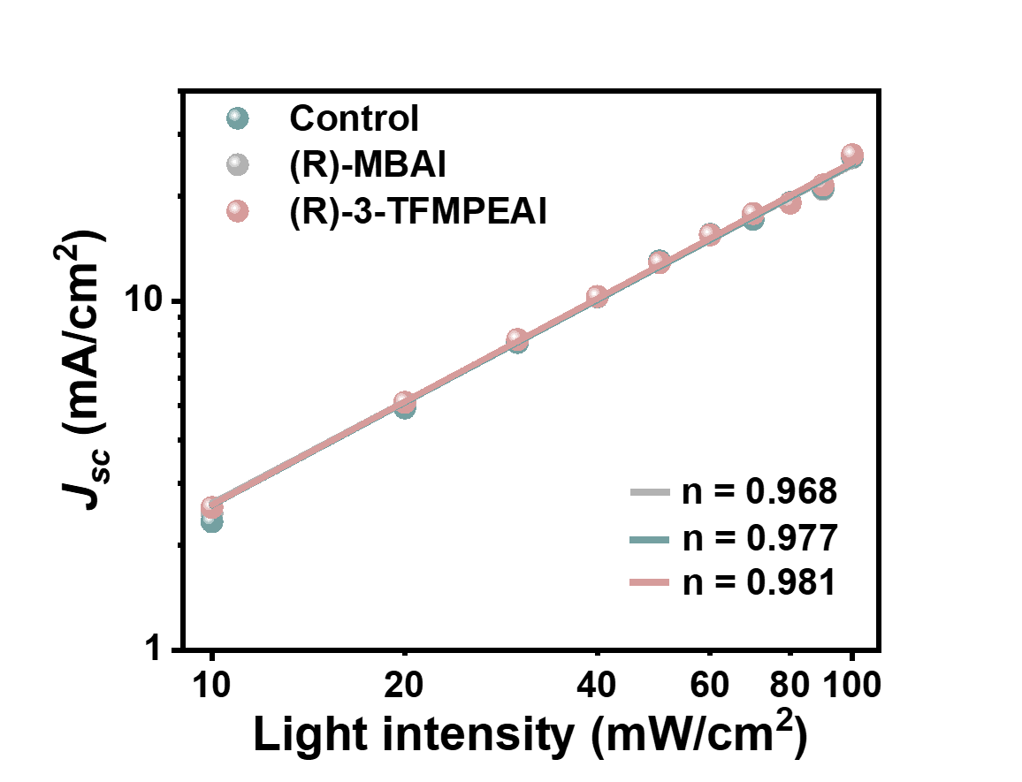
Supplementary Fig. 20. Light intensity dependence of Control, (R)-MBAI and (R)-3-TFMPEAI Modified Devices.

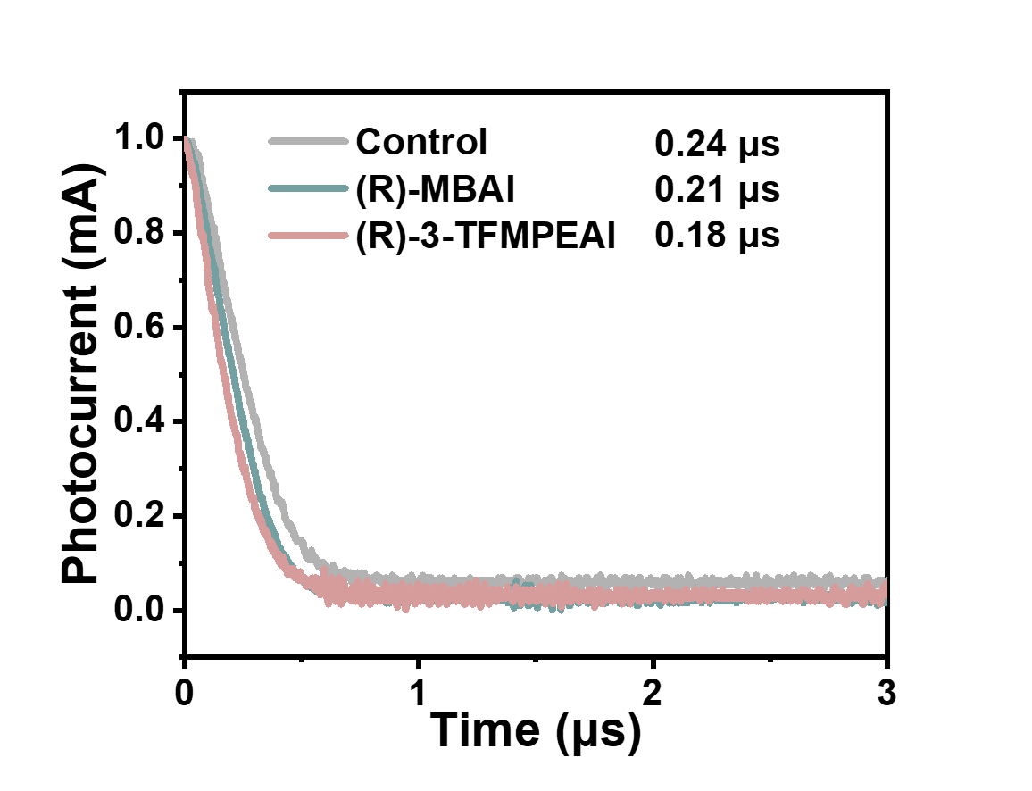
Supplementary Fig. 21. Transient photocurrent (TPC) responses of Control, (R)-MBAI and (R)-3-TFMPEAI Modified Devices.

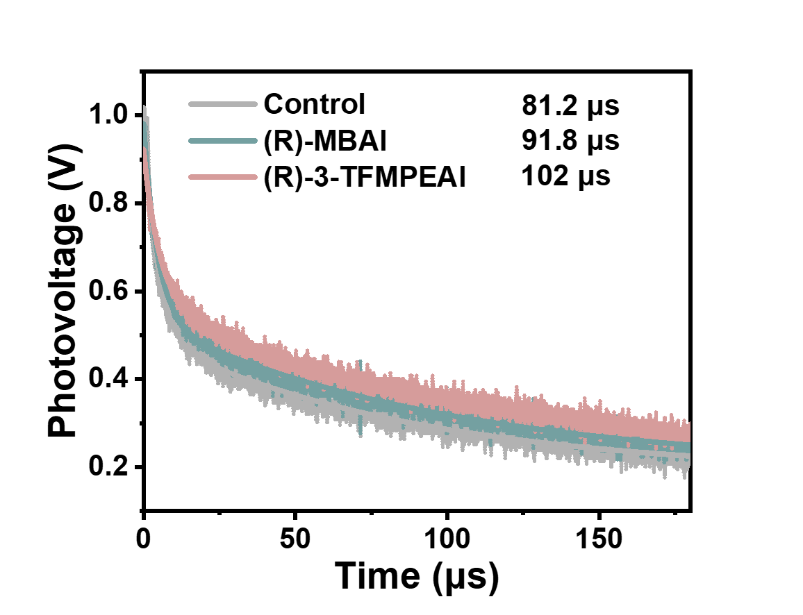
Supplementary Fig. 22. Transient photovoltage (TPV) responses of Control, (R)-MBAI and (R)-3-TFMPEAI Modified Devices.

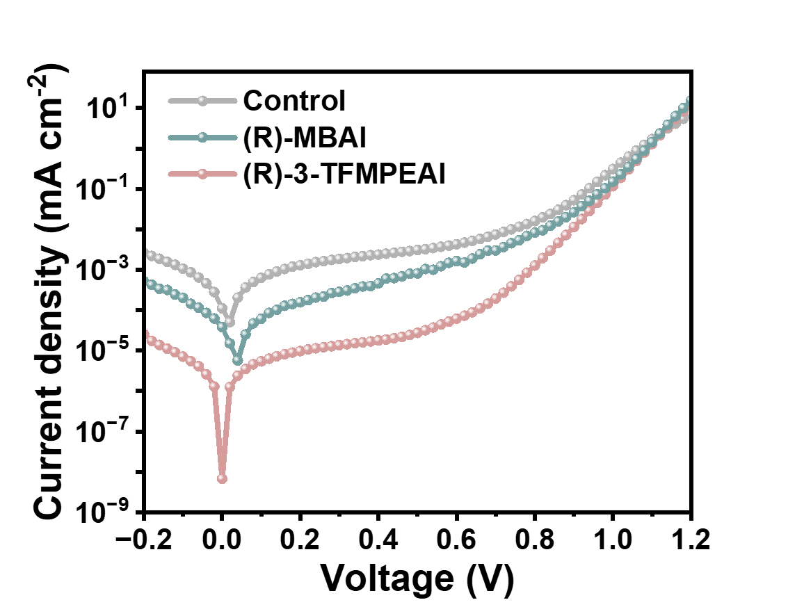
Supplementary Fig. 23. Dark current measurements of Control, (R)-MBAI and (R)-3-TFMPEAI Modified Devices.

Supplementary Fig. 24. Water contact angle measurements of Control, (R)-MBAI and (R)-3-TFMPEAI Modified Perovskite Films.

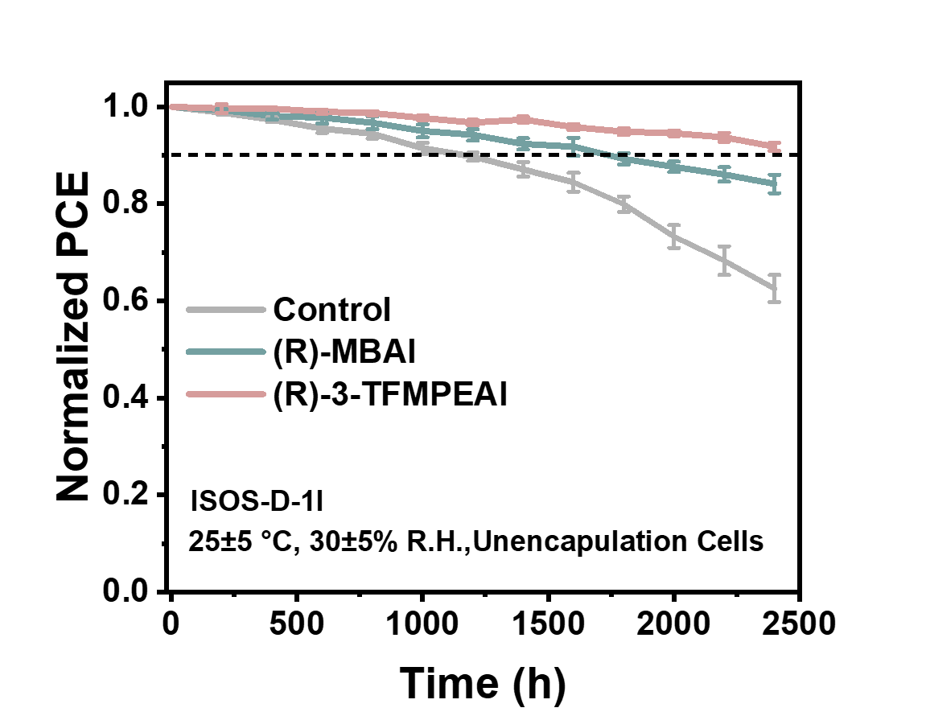
Supplementary Fig. 25. Long-Term Stability in Nitrogen of Control, (R)-MBAI and (R)-3-TFMPEAI Modified Perovskite Devices.

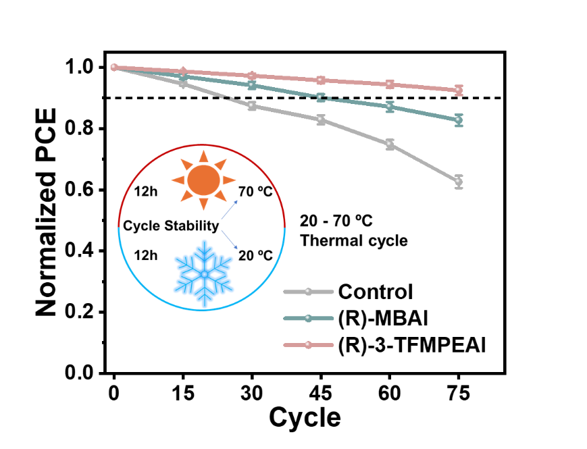
Supplementary Fig. 26. Cold–heat cycling stability of control, (R)-MBAI-modified and (R)-3-TFMPEAI-modified perovskite devices under nitrogen atmosphere (12 h cold/12 h hot per cycle).

Reference:

1 Kresse, G. & Furthmüller, J. Efficiency of ab-initio total energy calculations for metals and semiconductors using a plane-wave basis set. Computational Materials Science 6, 15–50 (1996). https://doi.org/https://doi.org/10.1016/0927-0256(96)00008-0
2 Tian, W., Zhao, C., Leng, J., Cui, R. & Jin, S. Visualizing Carrier Diffusion in Individual Single-Crystal Organolead Halide Perovskite Nanowires and Nanoplates. J Am Chem Soc 137, 12458–12461 (2015). https://doi.org/10.1021/jacs.5b08045
3 Guo, Z., Manser, J. S., Wan, Y., Kamat, P. V. & Huang, L. Spatial and temporal imaging of long-range charge transport in perovskite thin films by ultrafast microscopy. Nat Commun 6, 7471 (2015). https://doi.org/10.1038/ncomms8471

