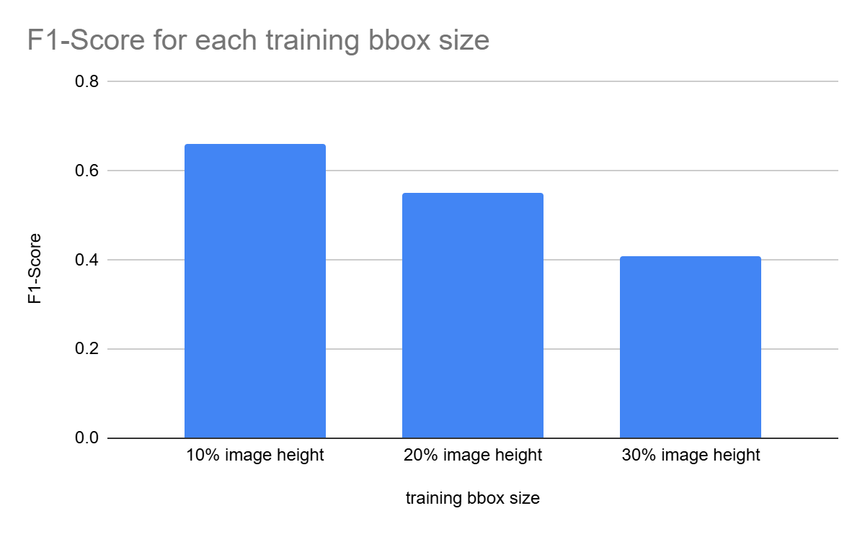
Supplementary Figure 1. Comparison of F1 scores in the development set across candidate pseudobox sizes.
Pseudobox sizes corresponding to 10%, 20%, and 30% of the image height were evaluated. The highest F1 score was obtained with a pseudobox size of 10% of the image height, which was therefore selected for the final model.

