Supporting Information
Study on lithium battery heat dissipation based on a fence structure of liquid cooling and phase change optimization
Youliang Chen¹, Bo Zhao^{1,2*}, fengye Li²
1 Hubei Key Laboratory for Efficient Utilization and Agglomeration of Metallurgic Mineral Resources, Wuhan University of Science and Technology, Wuhan, 430081, P.R. China
2 Industrial Safety Engineering Technology Research Center of Hubei Province, Wuhan University of Science and Technology, Wuhan, 430081, P.R. China
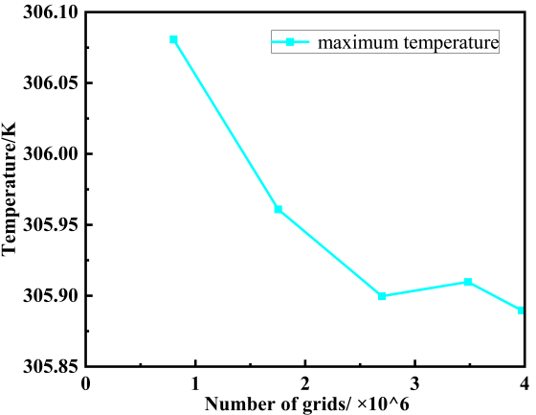
Fig. S1 Mesh independence verification
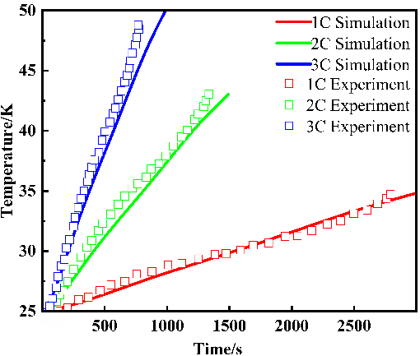
Fig. S2 The accuracy of the lithium battery thermal behavior model

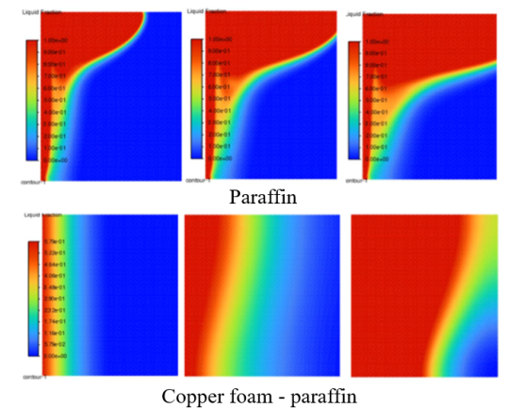
Fig. S3 Numerical simulation contours of liquid fraction for paraffin and copper foam-paraffin
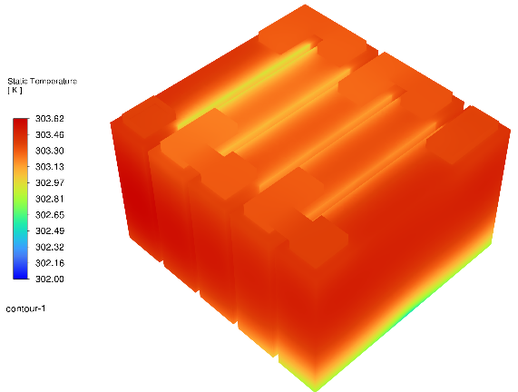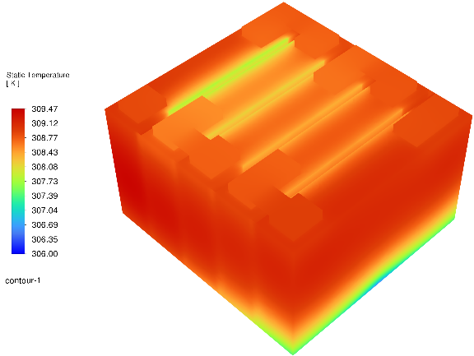
1C 2C
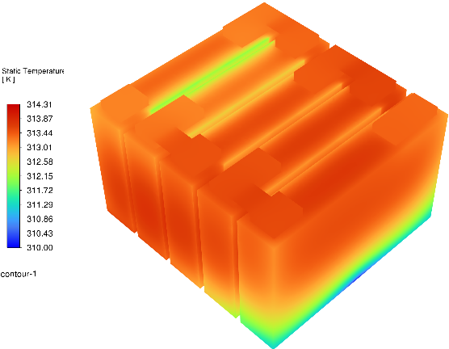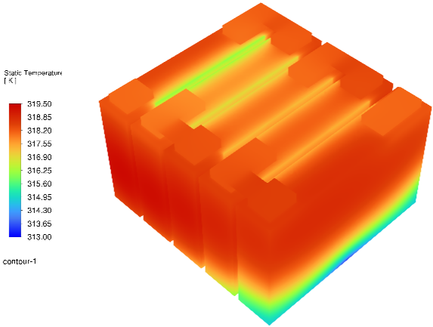
3C 4C
Fig. S4 The temperature cloud at different discharge rates

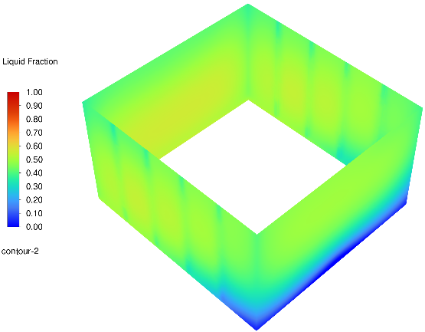
Fig. S5 Liquid fraction contours for hybrid cooling at discharge rates 3 C and 4 C

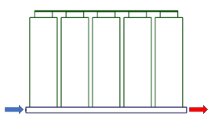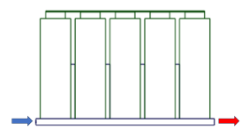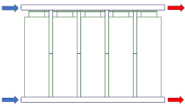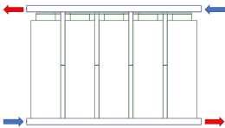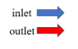
Case1 case2 Case3 case4
Fig. S6 Different arrangement of clod plate

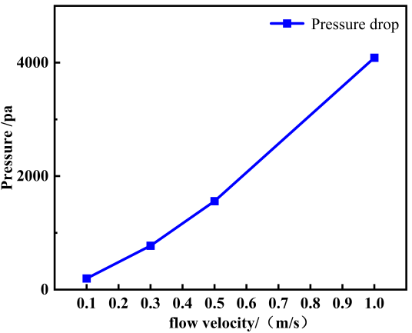
Fig. S7 Pressure drop under different flow velocity

