Supporting Information
Dynamic-Static Coordination-Crosslinked Hybrid Polyimides with Ultrahigh Thermal Stability and Closed-Loop Recyclability
Rui Shang^{1,2}, Peiyan Zhang¹, Di Wu³, Xiuting Li^{1,2*}, Xin Zhao^{1*}, Jie Dong¹, Qinghua Zhang¹
¹ State Key Laboratory of Advanced Fiber Materials, College of Materials Science and Engineering, Donghua University, Shanghai, 201620, China.
² Shanghai Key Laboratory of Lightweight Composite, Donghua University，Shanghai 201620, China.
³ Textile and Clothing Materials College, Shazhou Professional Institute of Technology, Suzhou, 215600, China.
*:Corresponding Author.
*Email: lixiuting@dhu.edu.cn (Xiuting Li); xzhao@dhu.edu.cn (Xin Zhao)
Number of pages: 13
Number of figures: 15
Number of tables: 1

Contents
Experimental section
Supplementary Figures
Fig. S1 (a) XPS survey scans and (b) Cu 2p spectra of PI-6FTB and PI-Cu films
Fig. S2 Fluorescence spectra of PI-6FTB and PI-Cu films
Fig. S3 Rheology analyses of Gʹ and Gʺ on a frequency sweep
Fig. S4 Frequency-sweep curves of the PI-Cu50% coordination complexes at different temperatures
Fig. S5 (a-b) Cross-sectional SEM of PI-6FTB and PI-Cu50%; (c-d) Elemental mapping analyses of PI-Cu50%
Fig. S6 ICP-OES data for the PI-Cu films
Fig. S7 TGA and derivative thermogravimetry (DTG) curves of PI-6FTB and PI-Cu films
Fig. S8 Creep curves of PI-6FTB and PI-Cu50% at 30 °C
Fig. S9 Normalized stress-relaxation curves of PI-6FTB and PI-Cu50% films at different temperatures
Fig. S10 TMA curves and calculated CTE values of PI-6FTB and PI-Cu films
Fig. S11 (a) SEM images of PI-6FTB surfaces: (a1, a2) Pristine front/back surfaces; (a3, a4) Corresponding front/back surfaces after 50,000 bending cycles; (b) SEM images of the cross section of PI-6FTB after 100,000 bending cycles; (c) SEM images of PI-Cu50% surfaces: (c1, c2) Pristine front/back surfaces; (c3, c4) Corresponding front/back surfaces after 400,000 bending cycles
Fig. S12 Temperature-dependent dielectric constant and tanδ of PI-6FTB film
Fig. S13 Frequency-dependent temperature coefficient of the dielectric constant for PI-6FTB and PI-Cu50% films
Fig. S14 Digital photos showing the degradation behavior of PI-6FTB and PI-Cu50% films in different solvents
Fig. S15 FTIR, ¹H NMR and DMA curves of RPI-6FTB films
Supplementary Table
Table S1. Solubility properties of PI-6FTB and PI-Cu50% films.

1．Experimental section

1.1 Materials
4,4′-(Hexafluoroisopropylidene) diphthalic anhydride (6FDA, 99.5%), 2,2′-bis(trifluoromethyl)-4,4′-diaminobiphenyl (TFMB, 99.8%), and 5-amino-2-(4-aminophenyl) benzimidazole (BIA, 99%) were purchased from ChinaTech Chemical Co., Ltd. (Tianjin, China). Anhydrous cupric acetate (CuAc₂, 99%) was obtained from Aladdin Biochemical Technology Co., Ltd. (Shanghai, China). N-Methyl-2-pyrrolidone (NMP), toluene, dimethyl sulfoxide (DMSO), chloroform, ethyl acetate (EA), acetone, tetrahydrofuran (THF), N,N-dimethylacetamide (DMAc), isoquinoline and ethylenediaminetetraacetic acid (EDTA) were supplied by Meryer Chemical Technology Co., Ltd. (Shanghai, China) and were used as received without further purification.

1.2 Characterization
Chemical structure of synthesized PI-6FTB and PI-Cu films was verified by Fourier-transform infrared spectroscopy (FT-IR), proton nuclear magnetic resonance (¹H NMR), and X-ray photoelectron spectroscopy (XPS). FT-IR spectra were recorded via a Thermo Scientific Nicolet iS50 spectrometer. ¹H NMR spectra were acquired using a Bruker Avance III HD 600 MHz spectrometer with DMSO‑d₆ as the solvent. XPS was performed using a Thermo Scientific Escalab 250Xi spectrometer equipped with an Al Kα source. Elemental composition was quantified by inductively coupled plasma mass spectrometry (ICP‑MS, Thermo Scientific iCAP Q). Steady‑state and time‑resolved fluorescence spectra were recorded on a PTI QM/TM spectrofluorometer.
Rheological characterization was carried out using an Anton Paar MCR 702 rheometer equipped with 25 mm parallel plates at a gap of 1.0 mm. Prior to measurements, all PI-Cu complex samples were equilibrated at 10 °C for 24 h to ensure complete structural recovery. Steady shear tests were performed at 25 °C over a shear rate range from 0.01 to 1000 s⁻¹. Dynamic frequency sweeps were conducted at a strain amplitude of 5% over an angular frequency range from 1.0 to 100 rad/s at 25 °C. Temperature sweeps were performed from 25 °C to 70 °C.
Morphology and elemental distribution of the films were observed by field-emission scanning electron microscopy (SEM). SEM was conducted using a GeminiSEM 560 equipped with an energy-dispersive X-ray spectrometer (EDS). X-ray diffraction (XRD) patterns were obtained on a Bruker D8 Advance diffractometer with Cu-Kα radiation to determine the interchain spacing.
The thermal stability of the samples was analyzed by means of a Netzsch TG 209 F1 thermogravimetric analyzer (TGA) at a heating rate of 10 °C/min from 30 °C to 800 °C under N₂ atmosphere.
Dynamic mechanical analysis (DMA) was performed using a TA Instruments Q800 analyzer in the film tension mode. DMA measurements for glass transition analysis were conducted from 50 °C to 500 °C at a heating rate of 5 °C/min and a frequency of 1 Hz. Additionally, stress relaxation tests were performed with a fixed strain of 2%, and creep tests were conducted after equilibrating at 30 °C under a constant stress of 20 MPa for 10 min. Meanwhile, high-temperature tensile tests were conducted on a DMA Q800 under a 10-3 N preload with a force ramp rate of 1.0 N/min. All tests were performed with a sample size of 30 × 5 × 0.05 mm³.
The tensile properties of PI-Cu films were characterized using an Instron 5966 universal testing system according to ASTM D882. Rectangular specimens were tested at a constant crosshead speed of 5 mm/min with five replicates per sample.
The dynamic mechanical cycling tests were performed using an MTS Exceed E42 electronic universal testing machine under the following conditions, including a strain amplitude of 4%, 20 loading cycles, and a crosshead speed of 5 mm/min.
The coefficient of thermal expansion (CTE) was measured using a TMA 402 F3 Hyperion thermomechanical analyzer under a nitrogen purge. The temperature was increased from 30 to 250 °C at a heating rate of 5 °C min⁻¹.
The dielectric properties of PI-Cu films were measured using a Novocontrol Concept 40 broadband impedance spectrometer over the frequency range from 10⁻¹ Hz to 10⁶ Hz at room temperature. Prior to testing, circular metal electrodes with a diameter of 10 mm were deposited on both sides of the films via ion sputtering to ensure reliable electrical contact. Temperature-dependent dielectric measurements were also conducted over the temperature range from −150 °C to 250 °C at a heating rate of 5 °C/min.
The dielectric breakdown strength of the PI-6FTB and PI-Cu films was measured by a DC voltage withstand tester (CS9916BX, China). Samples were immersed in silicone oil to prevent surface discharge, and a linearly ramped DC voltage (500 V/s) was applied until breakdown occurred. The breakdown strength distribution was analyzed using the Weibull model:
$P\left(E\right)=1-exp⁡[-{(\frac{E}{E_{0}})}^{β}]$ (1)
Where E is the measured DC breakdown electric field, E₀ is the characteristic breakdown strength (corresponding to a 63.2% cumulative failure probability), and β is the shape parameter, which reflects the data dispersion.
The solvent resistance of the PI-Cu film was systematically evaluated by immersing samples (10 mm × 20 mm) in 7 organic solvents , including nonpolar (chloroform), and polar aprotic (Ethyl Acetate, Acetone, THF, DMAc, NMP, DMSO) solvents. Each film was fully submerged in 20 mL of solvent at room temperature for 0-24 h.
The Gel fraction (GF) were determined via gravimetric analysis. Film samples (30 ± 2 mg, n = 5) were immersed in 20 mL of NMP at room temperature for varying durations. The initial mass (m_{i}) was recorded before immersion. After swelling, surface solvent was carefully removed. The samples were then dried in a vacuum oven at 120 °C until a constant dry mass (m_{d}) was obtained. The swelling parameters were calculated as:
$GF=\frac{m_{d}}{m_{i}}×100\%$ (2)
Water contact angles and water absorption rates of PI-6FTB and PI-Cu films were measured using an OCA40 Micro contact angle meter (2 µL water droplet, five measurements per sample) and by immersing dried specimens (20 × 20 mm²) in deionized water for 24 h at room temperature (three replicates), respectively. The water absorption rate was calculated according to the equation:
$Water absorption (\%)=\frac{m_{2}-m_{1}}{m_{1}}×100\%$ (3)
where 𝑚₁ is the mass of the dried film and 𝑚₂ is the mass of the film after immersion.
The binding energies between Cu²⁺ and ligands (imidazole and EDTA) were calculated using density functional theory (DFT) performed with Gaussian 16 at the B3LYP/GENECP level. The GENECP basis set applied the 6-31G(d) basis set for C, H, O, and N atoms and the LanL2DZ effective core potential for Cu atoms. The binding energy (ΔE) was calculated according to the following equation:
$ΔE=E_{\text{complex}}-(E_{\text{metal}}+E_{\text{ligand}})$ (4)
Where E_{complex} is the total energy of the metal–ligand complex, E_{metal} and E_{ligand} are the energies of the isolated metal ion and the ligand, respectively. A more negative ΔE indicates a stronger binding affinity. All structures were fully optimized without symmetry constraints, and vibrational frequency analyses were performed to confirm that the optimized geometries correspond to local energy minima (no imaginary frequencies).

2. Supplementary Figures
Fig. S1 (a) XPS survey scans and (b) Cu 2p spectra of PI-6FTB and PI-Cu films

Fig. S2 Fluorescence spectra of PI-6FTB and PI-Cu films
Fig. S3 Rheology analyses of Gʹ and Gʺ on a frequency sweep (strain = 1%, 25 ℃)
Fig. S4 Frequency-sweep curves of the PI-Cu50% coordination complexes at different temperatures
Fig. S5 (a-b) Cross-sectional SEM of PI-6FTB and PI-Cu50%; (c-d) elemental mapping analyses of PI-Cu50%

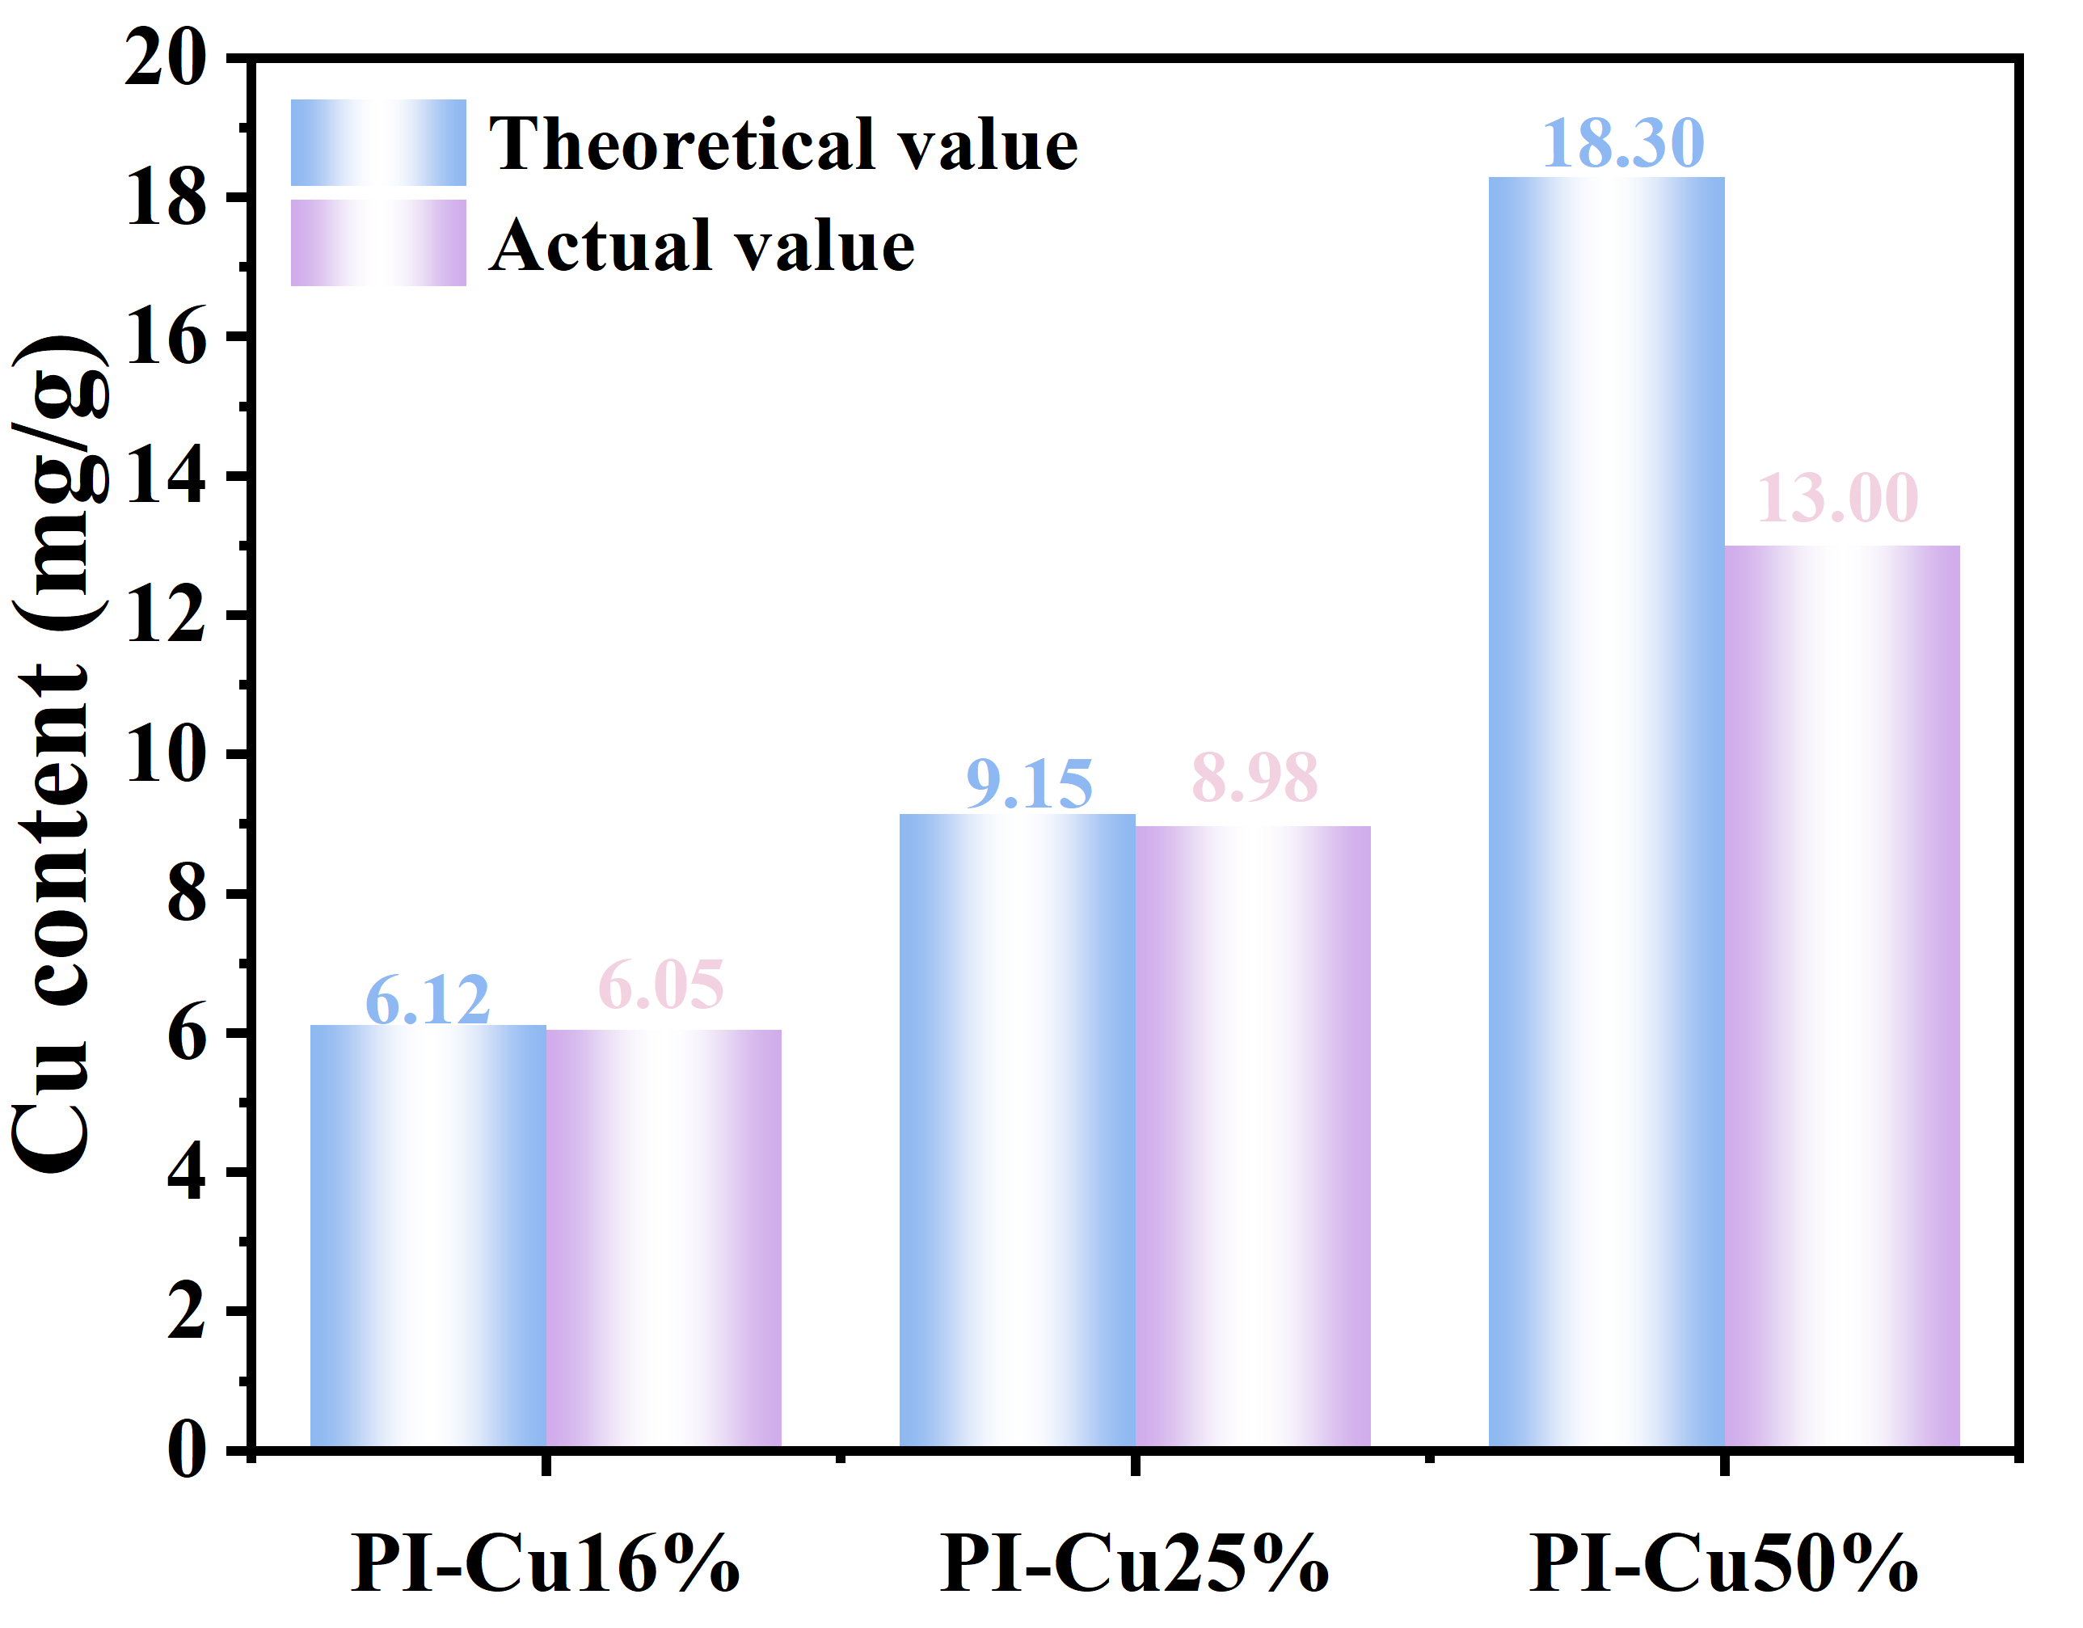
Fig. S6 ICP-OES data for the PI-Cu films
Fig. S7 TGA and derivative thermogravimetry curves of PI-6FTB and PI-Cu films
Fig. S8 Creep curves of PI-6FTB and PI-Cu50% at 30 °C
Fig. S9 Normalized stress-relaxation curves of PI-6FTB and PI-Cu50% films at different temperatures

Fig. S10 TMA curves and calculated CTE values of PI-6FTB and PI-Cu films
Fig. S11 (a) SEM images of PI-6FTB surfaces: (a1, a2) pristine front/back surfaces; (a3, a4) corresponding front/back surfaces after 50,000 bending cycles; (b) SEM images of the cross section of PI-6FTB after 100,000 bending cycles; (c) SEM images of PI-Cu50% surfaces: (c1, c2) pristine front/back surfaces; (c3, c4) corresponding front/back surfaces after 400,000 bending cycles
Fig. S12 Temperature-dependent dielectric constant and tanδ of PI-6FTB film
Fig. S13 Frequency-dependent temperature coefficient of the dielectric constant for PI-6FTB and PI-Cu50% films

Fig. S14 Digital photos showing the degradation behavior of PI-6FTB and PI-Cu50% films in different solvents
Fig. S15 FTIR, ¹H NMR and DMA curves of RPI-6FTB films

3. Supplementary Table
Table S1. Solubility properties of PI-6FTB and PI-Cu50% films.
Sample | Immerse time |  | CHCl₃ | EA | Acetone | THF | DMAc | NMP | DMSO
PI-6FTB | 20 min | - |  | +- | ++ | ++ | ++ | ++ | ++
PI-6FTB | 24 h | - |  | +- | ++ | ++ | ++ | ++ | ++
PI-Cu50% | 20 min | - |  | - | - | - | +- | - | +-
PI-Cu50% | 24 h | - |  | - | - | - | +- | +- | +-
++: soluble; +-: partial soluble; -:insoluble at room temperature.

