Supplementary Information

A. Random Forest model training and error rates
For each of the eight cities with available training data, we provide paired figures summarising the spatial distribution of labelled training polygons used in model calibration, and the performance of the Random Forest classifier as measured by the out-of-bag (OOB) error rate (Supplementary Figures 1–8). Training polygons includes formal settlements and informal settlements. Know Your City community-mapped areas are also illustrated for comparison. These polygons illustrate the spatial diversity of Know Your City data within each urban extent.
The corresponding OOB error plots display error rates across the number of decision trees included in the ensemble. Curves are reported separately for formal settlements, informal settlements, and overall model performance. Across all cities, OOB error rates declined sharply as the number of trees increased and stabilized after ~100–150 trees, indicating robust model convergence. Informal settlements consistently exhibited higher error rates than formal settlements, reflecting greater morphological and spectral variability within slum areas. Nevertheless, overall model errors remained low (<0.07), providing confidence in the predictive capacity of the models. These training diagnostics validate the reliability of the city-specific classifiers used to generate informal settlement probability maps across Africa.

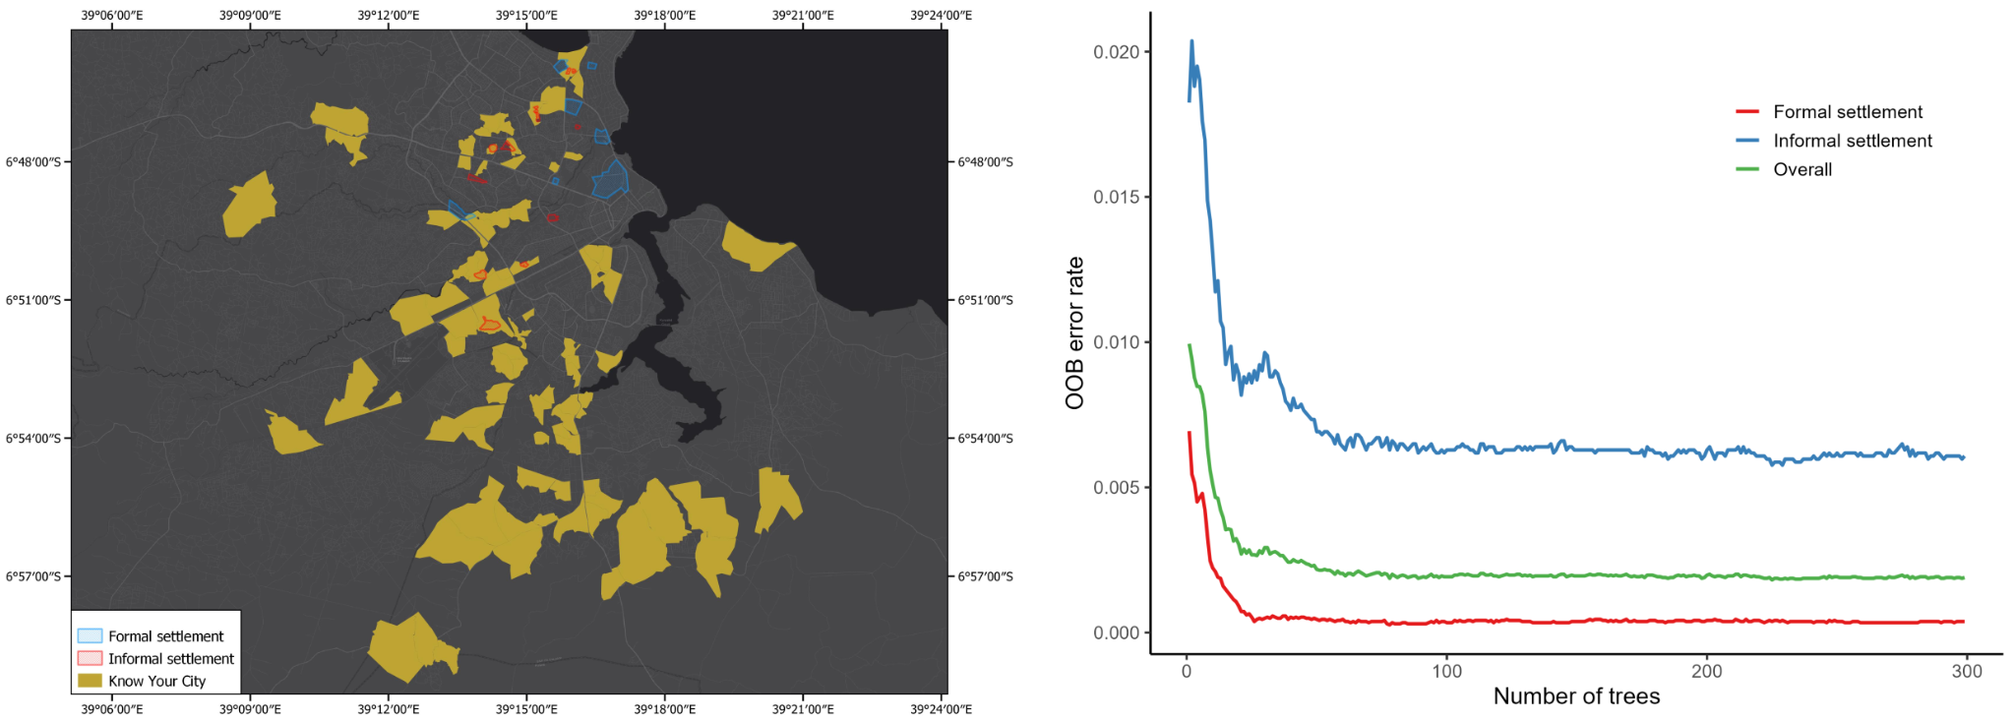
Supplementary Figure 1 Training data and model performance for Dar es-Salaam, Tanzania
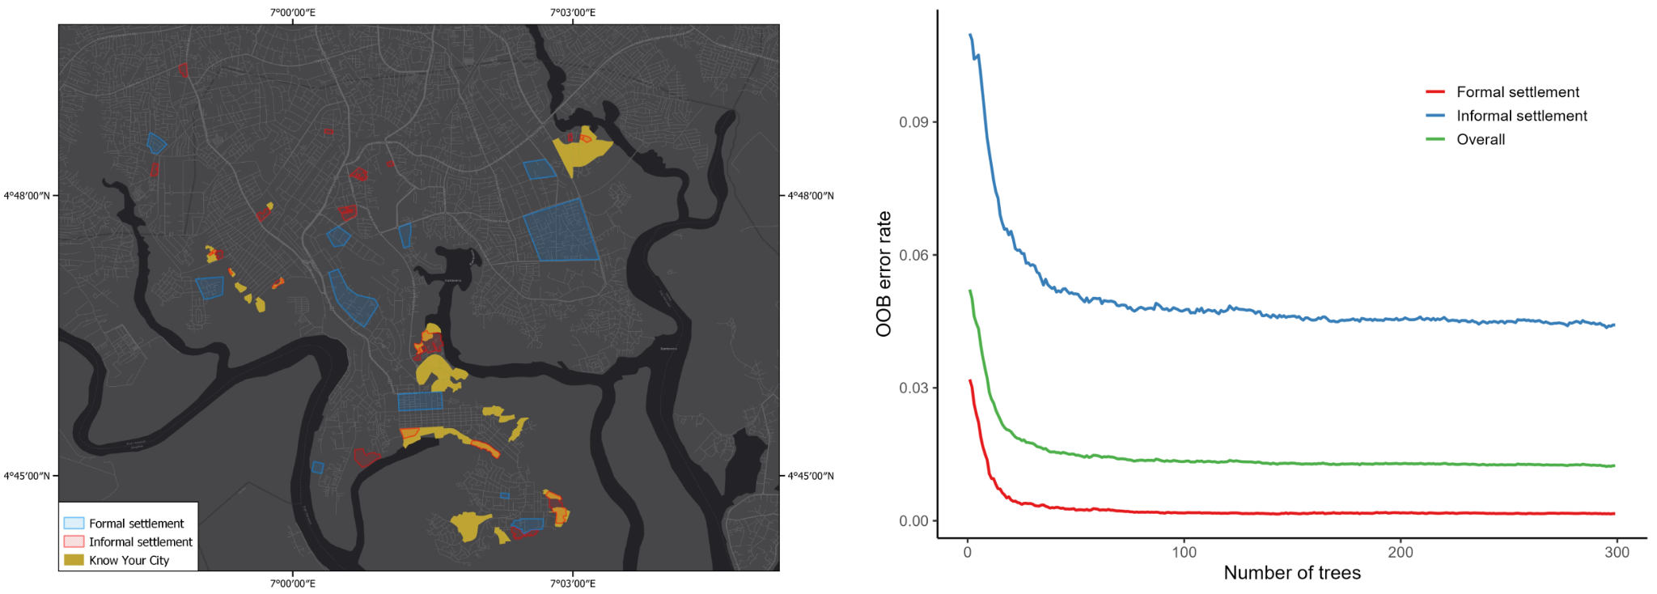
Supplementary Figure 2 Training data and model performance for Port Harcourt, Nigeria

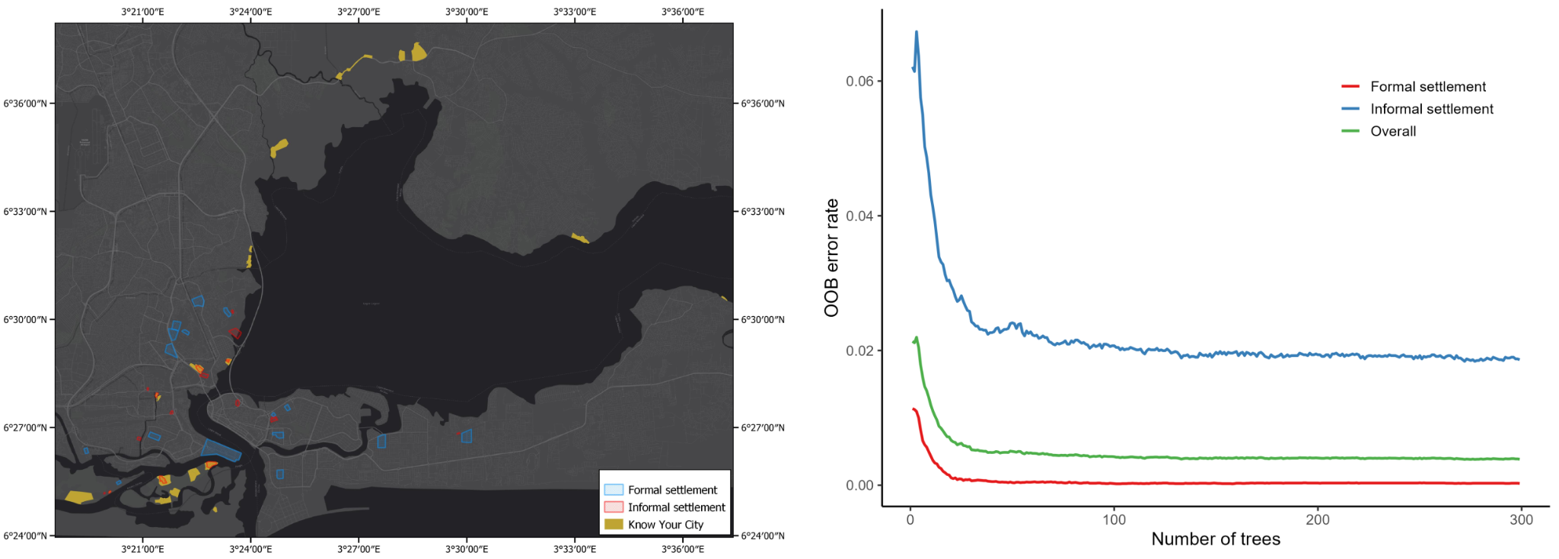
Supplementary Figure 3 Training data and model performance for Lagos, Nigeria

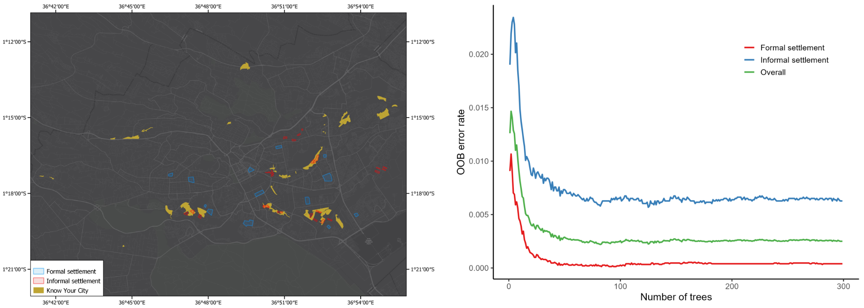
Supplementary Figure 4 Training data and model performance for Nairobi, Kenya
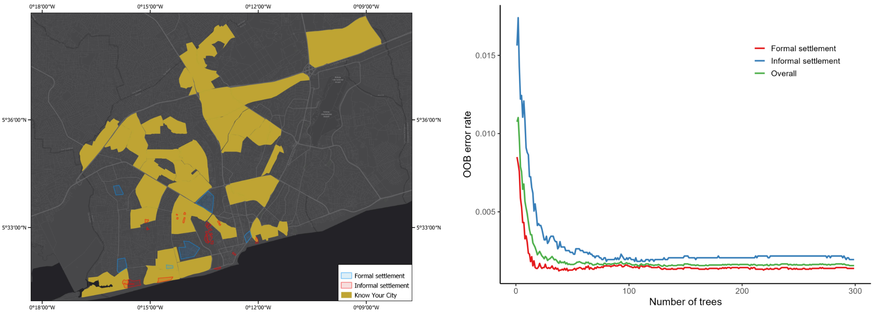
Supplementary Figure 5 Training data and model performance for Accra, Ghana

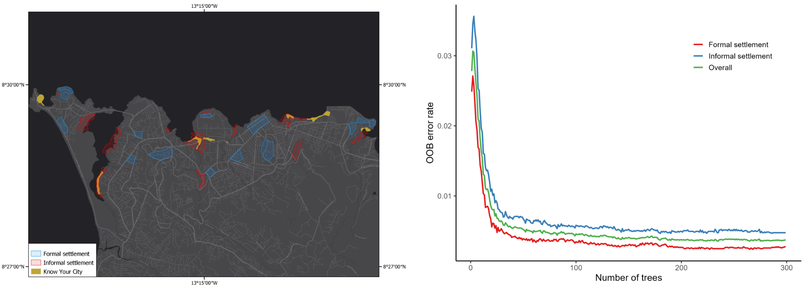
Supplementary Figure 6 Training data and model performance for Freetown, Sierra Leone

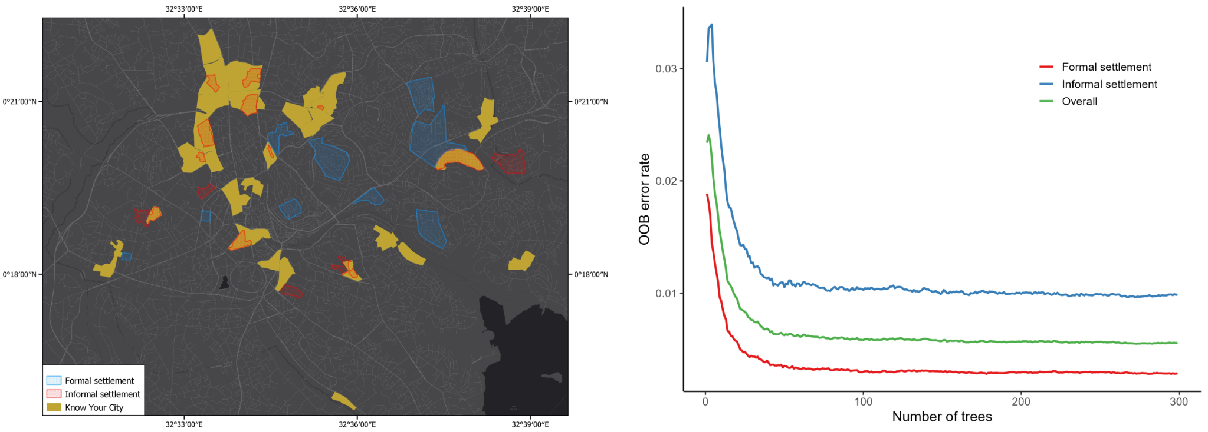
Supplementary Figure 7 Training data and model performance for Kampala, Uganda
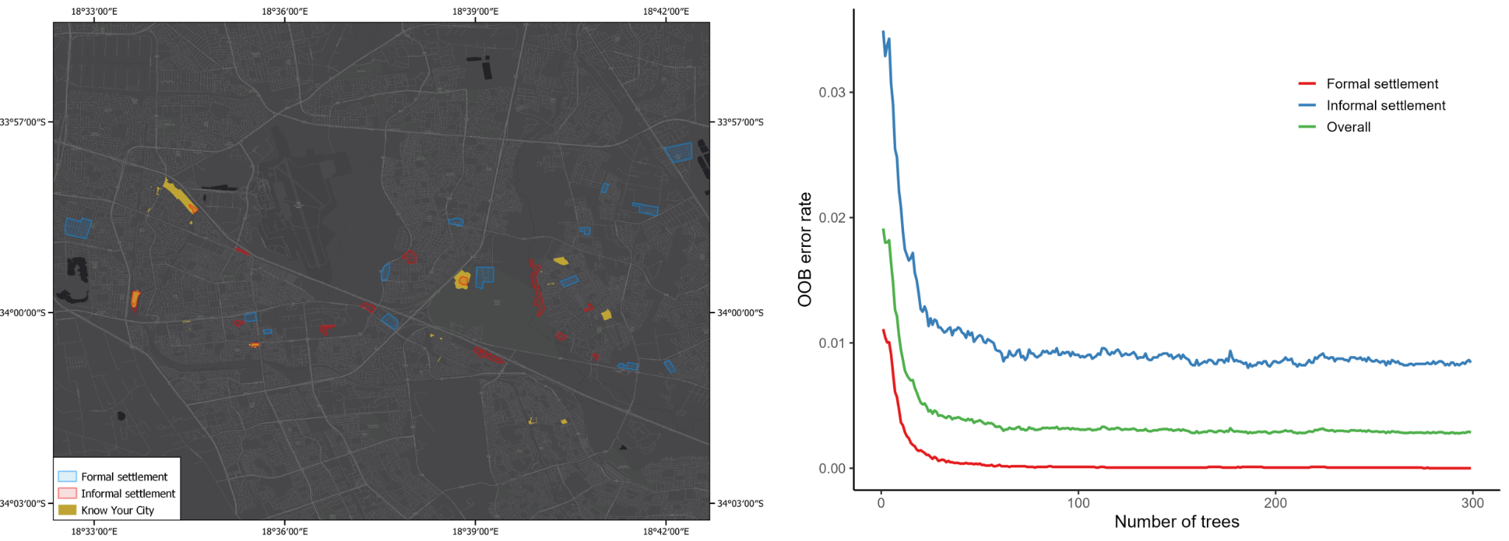
Supplementary Figure 8 Training data and model performance for Cape Town, South Africa

B. Similarity of cities
To assess cross-city transferability of informal settlement detection models, we constructed a feature space combining multiple indicators of urban form, growth, and service access. These included:
- Population density (2025, people per km²): calculated as projected total population divided by urban extent area.
- Building morphology: average, maximum, and standard deviation of building heights (2020).
- Residential share (2020): proportion of residential pixels relative to total built-up pixels.
- Population growth rate: compound annual growth rate (2000–2020).
- Building stock growth: change in total building stock over 2000–2020.
- Urban service readiness (2025): categorical indices for water/infrastructure (WIG) and utility/service readiness (USR).
These indicators were harmonised into a feature matrix across all 84 cities. All the data used to calculate these indicators are listed in Supplementary Table 1 and are available from GHS Urban Centre Database - Stats in the City (R2024A) (https://human-settlement.emergency.copernicus.eu/download.php?ds=ucdb). We calculated Gower dissimilarity to handle both continuous and categorical inputs. In Supplementary Figure 9, we illustrate city-to-city dissimilarities, highlighting contrasts between the eight training cities and all other cities in the dataset. The resulting dissimilarity matrix was then inverted to a similarity matrix (1/distance), which served as a weighting scheme when combining model predictions across cities.
Supplementary Table 1. City descriptor variables used for ensemble similarity weighting
Variable Name | Description | Units | Year
GC_POP_TOT_2025 | Projected total population within urban boundary | persons | 2025
GC_UCA_KM2_2025 | Urban extent (area of city polygon) | km² | 2025
GH_BUH_AVG_2020 | Average building height | m | 2020
GH_BUH_STD_2020 | Standard deviation of building height | m | 2020
GH_BUH_MAX_2020 | Maximum building height | m | 2020
GH_BPC_RES_2020 | Residential built-up area | km² | 2020
GH_BPC_TOT_2020 | Total built-up area | km² | 2020
GH_POP_CAG_2020 | Compound annual growth rate of population | % per year | 2020
GH_BUS_TOT_2000 | Total building-stock volume (year 2000) | m³ | 2000
GH_BUS_TOT_2020 | Total building-stock volume (year 2020) | m³ | 2020
GC_DEV_WIG_2025 | Weighted infrastructure gap index | index (0–1) | 2025
GC_DEV_USR_2025 | Urban service readiness index | index (0–1) | 2025

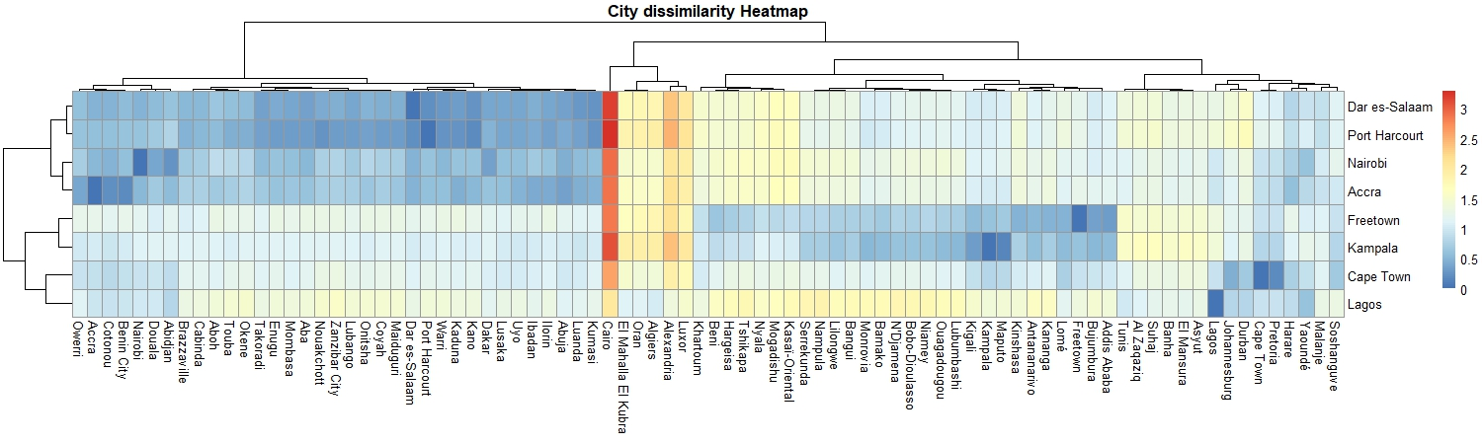
Supplementary Figure 9 City dissimilarity heatmap

C. Spatial variation in informal settlement prevalence
We group pixel probabilities into five bins in Supplementary Figure 10 to describe how common morphological informality is within each city’s mapped settlement area: Baseline (0.0-0.2) very low; Diffuse (0.2-0.4) low; Mixed (0.4-0.6) mid; Elevated (0.6-0.8) high; and Peak (0.8-1.0) very high. These bins summarize the proportion of settlement area associated with different probability levels, rather than the spatial configuration or clustering of morphologically informal settlements. Across 84 cities, most settlement extents fall into Baseline accounting for 63.8% (median, IQR: 51.3-77.8) of settlement areas, Diffuse 16.4% (11.7-23.1), Mixed 7.6% (4.7-11.5), Elevated 4.1% (2.1-7.3) and Peak 2.2% (0.8-5.2), demonstrating many cities are dominated by low probabilities, while a smaller subset carries notable shares in the upper bins.
Examining the Peak bin alone, ~26% of cities exceed 5% and ~6% exceed 10% settlement area belonging to Peak. Using both the Elevated and Peak (≥0.6) bins as a simple indicator of how often strong informal-settlement signals occur within a city, ~39% of cities have ≥10% of settlement areas in these upper bins and ~5% reach ≥20%. Using a broad operational cut (Mixed + Elevated + Peak ≥0.4), ~23% of cities have ≥25% of settlement pixels at or above this level, indicating that non-Baseline probabilities are widespread even in cities where the highest-probability (Peak) areas remain limited in extent.
Regional contrasts exist in the data. Central Africa has the lowest Baseline share and the strongest Peak presence (48.5% Baseline; 27.5% Diffuse; 11.6% Mixed; 6.3% Elevated; 6.1% Peak). East Africa (65.1/17.6/8.4/5.1/3.9) and North Africa (62.2/18.9/10.1/5.1/3.6) sit mid-range, while Southern Africa shows a broadly comparable distribution (66.3/16.9/8.2/5.0/3.6). West Africa shows the highest Baseline and the smallest Peak share (70.1/14.1/7.8/4.9/3.1). A complementary city-level perspective, in which each city is weighted equally rather than by settlement area, shows a consistent pattern. The fraction of cities with ≥10% of settlement area in the Elevated + Peak bins is highest in East Africa (60%) and North Africa (57.1%), followed by Southern (40%), Central (36.4%), and West Africa (26.5%). Across all regions, few cities have ≥20% of settlement pixels in the Elevated + Peak bins, indicating that very high prevalence is uncommon even where moderate levels of morphological informality are widespread.
Supplementary Figure 10 City-level distributions of morphological informality probabilities in 2023. Proportion of settlement pixels across five probability intervals for 84 African cities with populations greater than one million in 2025. Bars are ordered by the share of pixels in the highest probability bin [0.8,1.0] (red). Colors indicate probability intervals, from [0,0.2) (grey) to [0.8,1.0] (red).

D. Estimating thresholds for binary classification
To translate continuous slum probability surfaces into binary maps, we implemented a two-step calibration procedure at the country level.
Input data.
We used 10 m resolution informal-settlement probability maps produced by ensemble models (see Methods, main text), aggregated to 100 m to align with WorldPop Global 2 population data (2025 release). Urban boundaries for each city were defined from the GHSL settlement polygons. National reference statistics on the percentage of urban populations living in slums were compiled from UN-Habitat sources (https://data.unhabitat.org/pages/housing-slums-and-informal-settlements).
Threshold search.
For each country, all cities within national boundaries were processed jointly. Within each city, we masked WorldPop population surface data to the urban extent, and overlaid them with aggregated slum probability grids. Candidate thresholds were tested from 0.00 to 1.00 in 0.01 increments. For each threshold, we calculated the share of the national urban population classified as informal, summing across all city extents. The optimal threshold was defined as the value minimizing the absolute difference between estimated and reported national shares.
Model-based calibration
To improve consistency across countries, we fitted a nonlinear logistic model relating calibrated thresholds (Y) to predictors including reported share, estimated share, and their ratio. The model took the form:
$Y=threshold+\left(1-threshold\right)*L(a+b1⋅reported_share+b2⋅estimated_share+b3⋅share_ratio)$,
where $L(∙)$ is the logistic function. Model fitting used nonlinear least squares, with performance evaluated via R² = 0.48, RMSE = 0.097, MAE = 0.072. Information criteria indicated good model fit (AIC = –4.65; BIC = –4.25). The fitted model was then used to update country-level thresholds, ensuring coherence with both city-level probabilities and national statistics.
E. AI-based validation with image analysis
To independently validate probability surfaces, we developed a complementary approach using Google Maps imagery and OpenAI GPT-4o. Below is the workflow:
Sampling strategy
For each of the 84 study cities, we randomly sampled 20 locations stratified by predicted probability: 10 points from the low range [0, 0.5) and 10 from the high range [0.5, 1]. This yielded a total of 1,680 points.
Imagery collection
For each location, we queried the Google Maps API. If Street View was available, we retrieved panoramic street-level imagery, oriented toward the nearest buildings. Otherwise, we downloaded satellite imagery at zoom level 19.
AI-based interpretation
Each image was transmitted to the GPT-4o model with a structured prompt. The model returned:
- prob_bin (slum probability, 0.001–1.0),
- confidence score (1–10),
- categorical classification into settlement types,
- detailed justification of classification.
We asked GPT-4o to consider the following indicators for informal settlements classification.

Indicators of Informal Settlements:
- Building density: Very high density with minimal spacing between structures
- Layout: Chaotic, irregular patterns with no organized street grid
- Roofing materials: Corrugated metal sheets, tarpaulins, mixed materials
- Infrastructure: Absence of paved roads, drainage systems, utilities
- Construction materials: Temporary, makeshift structures
- Architecture: Lack of formal planning or design
- Sanitation: Visible waste, poor sanitary conditions

Indicators of Formal Settlements:
- Layout: Organized street grid with adequate spacing
- Materials: Concrete, brick, quality roofing
- Infrastructure: Presence of roads, utilities, drainage
- Architecture: Regular building patterns, formal planning
- Maintenance: Well-maintained surroundings
Categories.
Outputs were collapsed into five ordered classes for consistency: formal, probable formal, mixed, probable informal, and informal. Categories unknown and no buildings were excluded.
Supplementary Table 2 Pairwise t-test results comparing predicted probabilities between adjacent OpenAI-assigned settlement categories.
A | B | Mean (A) | Mean (B) | t | df | p-value
Formal | Probable formal | 0.165 | 0.280 | –5.36 | 338 | 1.5e–7
Probable formal | Mixed | 0.280 | 0.348 | –2.73 | 255 | 0.007
Mixed | Probable informal | 0.348 | 0.569 | –9.06 | 228 | 5.9e–17
Probable informal | Informal | 0.569 | 0.717 | –7.94 | 308 | 3.7e–14

