Supplementary Material
Towards Monolithic Branching Heat Pipe Radiators with Laser Powder Bed Fusion: Effects of Print Orientation and Surface Oxidation on Wick Performance

Supplementary Figures
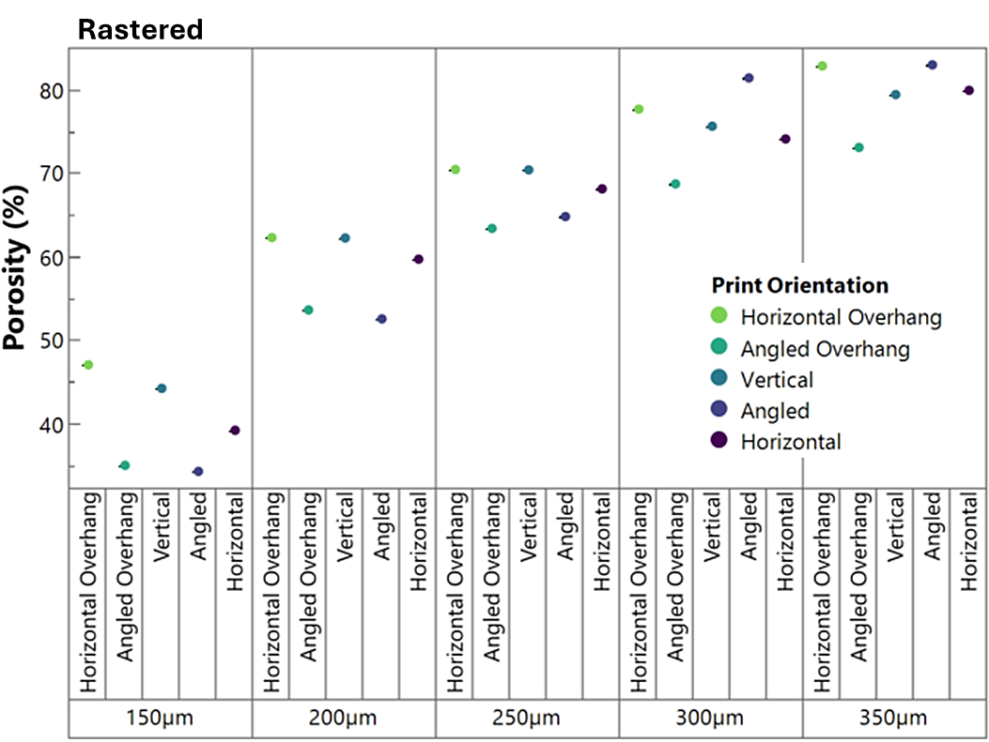
(a)
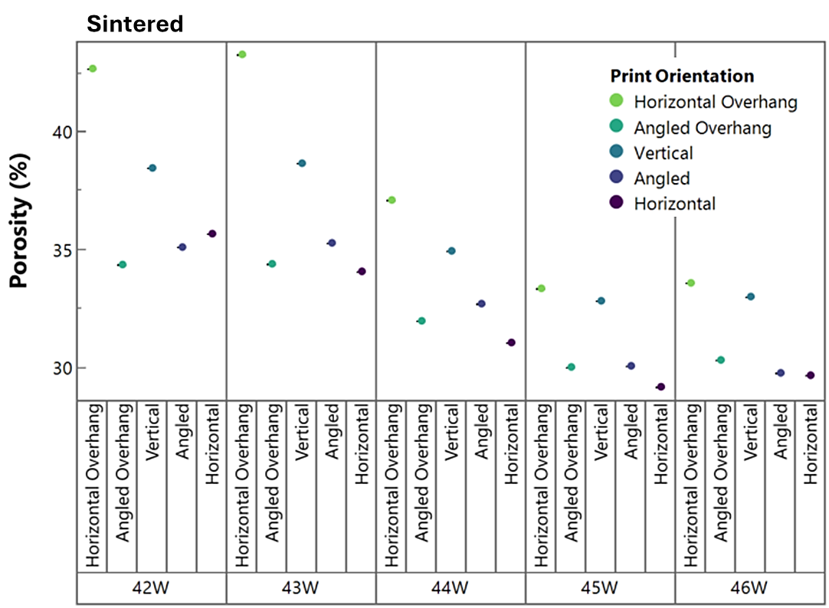
(b)
Figure S1. Experimentally measured porosity as a function of print orientation and laser parameter settings for (a) rastered and (b) sintered wicks.

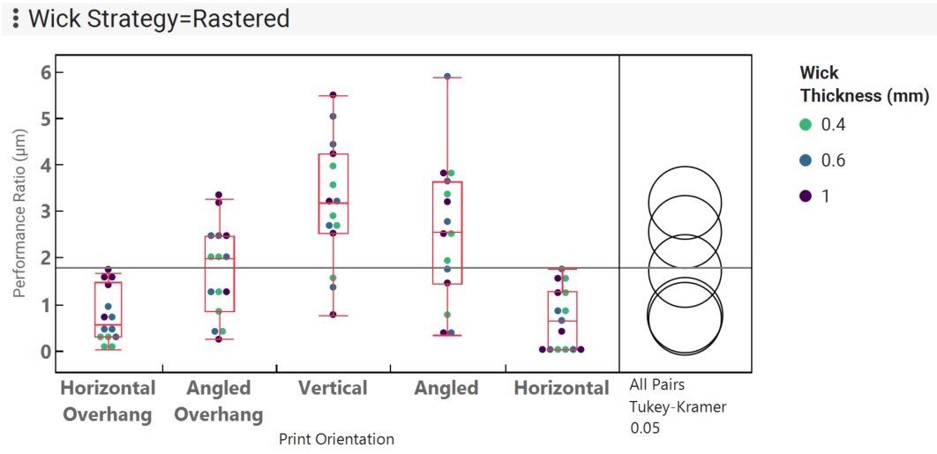
(a)
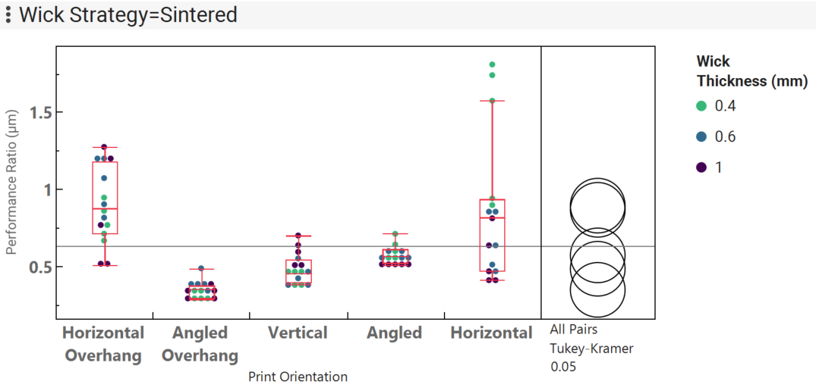
(b)
Figure S2. Performance ratio for (a) rastered and (b) sintered wicks for water as working fluid, and tests conducted post-oxidation

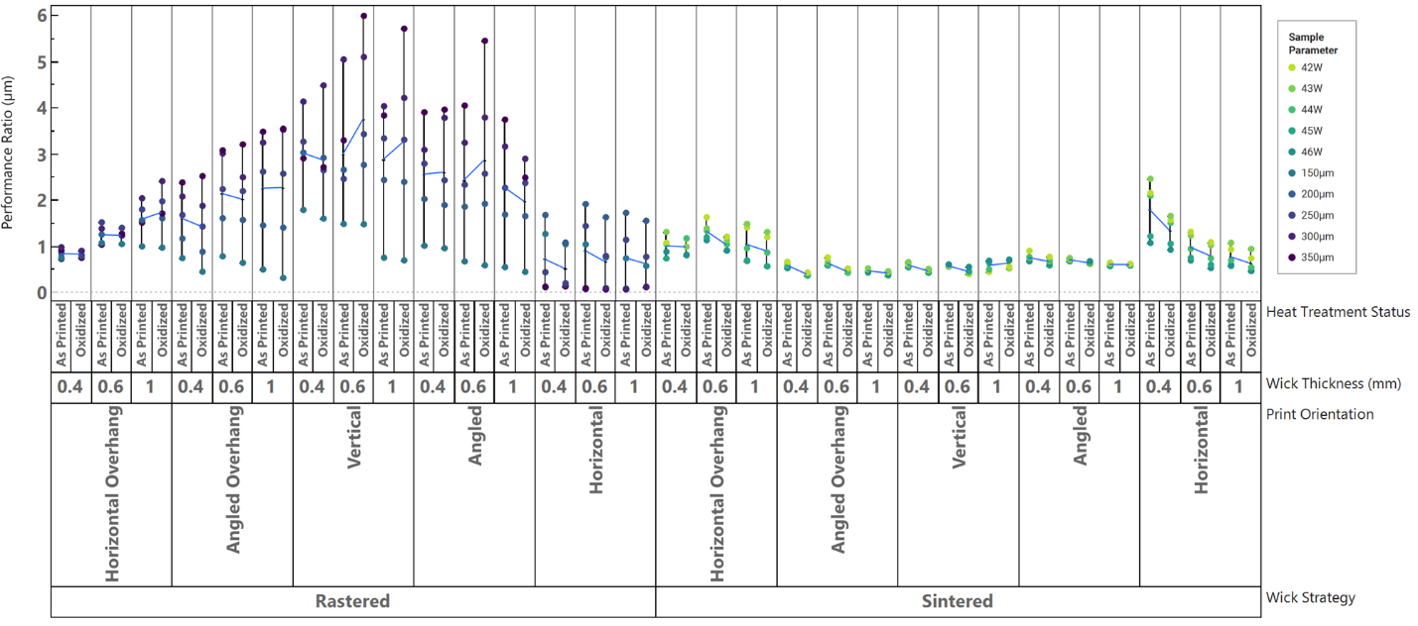
(a)
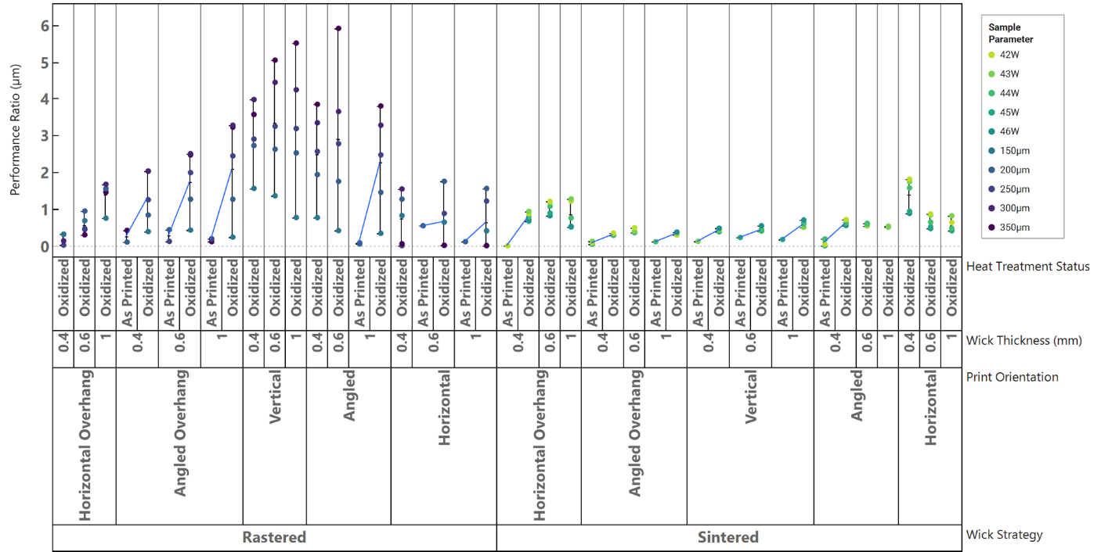
(b)
Figure S3. Performance ratio for (a) ethanol and (b) DI water working fluids, showing effects of oxidation for specific thicknesses, orientations and wick strategy (rastered and sintered), showing significant improvement due to oxidation when DI water is the working fluid, but no significant change (and slight reductions) when ethanol is the fluid.

Supplementary Tables
Table S1: Comparison of Wick Performance Ratios C
Wick Description | Porosity ($ε$) | K/$R_{eff}$ (µm)
350µm-Rastered-0.6-Ethanol-Vertical-Oxidized | 0.79 | 5.987
350µm-Rastered-1.0-Ethanol-Vertical-Oxidized | 0.79 | 5.709
43W-Sintered-0.4-Ethanol-Horizontal-As Printed | 0.34 | 2.449
350µm-Rastered-0.6-Water-Angled-Oxidized | 0.83 | 5.900
350µm-Rastered-1-Water-Vertical-Oxidized | 0.79 | 5.511
Robinson Wicks [1] | 0.46-0.59 | 0.27-0.45
Sintered Copper Powder [1] | 0.5 | 0.16
Hybrid grooved-sintered copper powder [1] | 0.57 | 0.15-0.77
Regular and Multi-Scale Composite Sintered Copper Powder [1] | 0.43-0.65 | 0.15-0.31
Copper Foam [1] | 0.68-0.82 | 0.32-0.70
Patterned Flame-Sprayed Copper [1] | 0.57-0.89 | 0.08-0.44
SLM Stainless Steel Powder [1] | 0.36-0.43 | 0.24-0.37
Sintered Stainless Steel Powder [1] | 0.39-0.60 | 0.13-0.52
Ni 123 [2] | 0.626 | 0.194
Ni 255 [2] | 0.635 | 0.298
Cu Spherical [2] | 0.582 | 0.472
Cu irregular [2] | 0.576 | 0.604
3D Printed, 500µm, D=216µm [3] | 0.46 | 1.04
3D Printed, 300µm unit cell [3] | 0.027 | 0.02
3D Printed, 500µm, D=280µm [3] | 0.58 | 7.14
Composite, spherical powder [3] | 0.57 | 0.15
Composite, irregular powder [3] | 0.57 | 0.43
Sintered, spherical powder [3] | 0.57 | 0.46
Sintered, irregular powder [3] | 0.57 | 0.60
Sintered, spherical powder [3] | 0.25 | 0.19
Sintered, spherical powder [3] | 0.43 | 0.39
Sintered, spherical powder [3] | 0.56 | 0.22
Sintered [3] | 0.36 | 0.254
Grooved [3] | 0.50 | 12.90
Monel beads mesh (140-200) [3] | 0.40 | 0.25
Metallic Weave [3] | 0.24 | 0.05
[1] A. J. Robinson, J. Colenbrander, T. Deaville, J. Durfee, and R. Kempers, “A wicked heat pipe fabricated using metal additive manufacturing,” International Journal of Thermofluids, vol. 12, 2021, doi: 10.1016/j.ijft.2021.100117.
[2] D. Deng, D. Liang, Y. Tang, J. Peng, X. Han, and M. Pan, “Evaluation of capillary performance of sintered porous wicks for loop heat pipe,” Exp Therm Fluid Sci, vol. 50, pp. 1–9, Oct. 2013, doi: 10.1016/j.expthermflusci.2013.04.014.
[3] D. Jafari, W. W. Wits, and B. J. Geurts, “Metal 3D-printed wick structures for heat pipe application: Capillary performance analysis,” Appl Therm Eng, vol. 143, pp. 403–414, Oct. 2018, doi: 10.1016/j.applthermaleng.2018.07.111.

