Supplementary file

Supplementary Table S1. Reconstructed 11-run experimental emulgel dataset extracted from the source study.
This table reports the complete formulation dataset used for model development, including Carbopol concentration, mixing time, mixing speed and experimental viscosity. Experimental viscosity was used as the target response in the present forward viscosity-prediction workflow. Mixing-speed units should be reported exactly as stated in the source study.
Formulation / run | Carbopol concentration (% w/w) | Mixing speed as reported in source table | Mixing time (min) | Experimental viscosity (Pa·s)
1 | 0.20 | 241.7 | 0.50 | 1.80
2 | 0.40 | 341.7 | 0.75 | 26.10
3 | 0.60 | 191.7 | 1.00 | 47.30
4 | 0.80 | 158.3 | 1.25 | 81.70
5 | 1.00 | 133.3 | 1.50 | 89.40
6 | 0.20 | 500.0 | 1.50 | 1.60
7 | 0.40 | 241.7 | 1.25 | 26.30
8 | 0.60 | 341.7 | 1.00 | 49.70
9 | 0.80 | 158.3 | 0.75 | 85.00
10 | 1.00 | 500.0 | 0.50 | 77.60
11 | 1.20 | 133.3 | 2.00 | 95.80

Supplementary Table S2. Source-study ANN-INQA-100 prediction table for Carbopol concentration.
This table reproduces the ANN-INQA-100 validation data reported in the source study. In the original workflow, mixing time and viscosity were used as ANN input variables, while Carbopol concentration was the predicted output. This table is included to clarify that the source ANN model predicted Carbopol concentration rather than directly predicting viscosity.

Run | Mixing time (min) | Viscosity used as ANN input (Pa·s) | Experimental Carbopol concentration (% w/w) | ANN-predicted Carbopol concentration (% w/w) | Reported error
1 | 0.50 | 1.80 | 0.20 | 0.24 | 0.17
2 | 0.75 | 26.10 | 0.40 | 0.36 | 0.10
3 | 1.00 | 47.30 | 0.60 | 0.60 | 0.00
4 | 1.25 | 81.70 | 0.80 | 0.89 | 0.11
5 | 1.50 | 89.40 | 1.00 | 0.92 | 0.08
6 | 1.50 | 1.60 | 0.20 | 0.23 | 0.15
7 | 1.25 | 26.30 | 0.40 | 0.36 | 0.10
8 | 1.00 | 49.70 | 0.60 | 0.62 | 0.03
9 | 0.75 | 85.00 | 0.80 | 0.91 | 0.14
10 | 0.50 | 77.60 | 1.00 | 0.87 | 0.13
11 | 2.00 | 95.80 | 1.20 | 0.95 | 0.21

Supplementary Figure S1. Descriptor-correlation ranking for the reconstructed emulgel formulation dataset.
The figure presents the correlation-based ranking of candidate formulation and process descriptors against experimental viscosity. Carbopol-related descriptors showed the strongest positive association with viscosity, supporting their inclusion in the forward viscosity-prediction workflow. This figure should be interpreted as exploratory correlation evidence and not as formal feature importance or mechanistic proof.
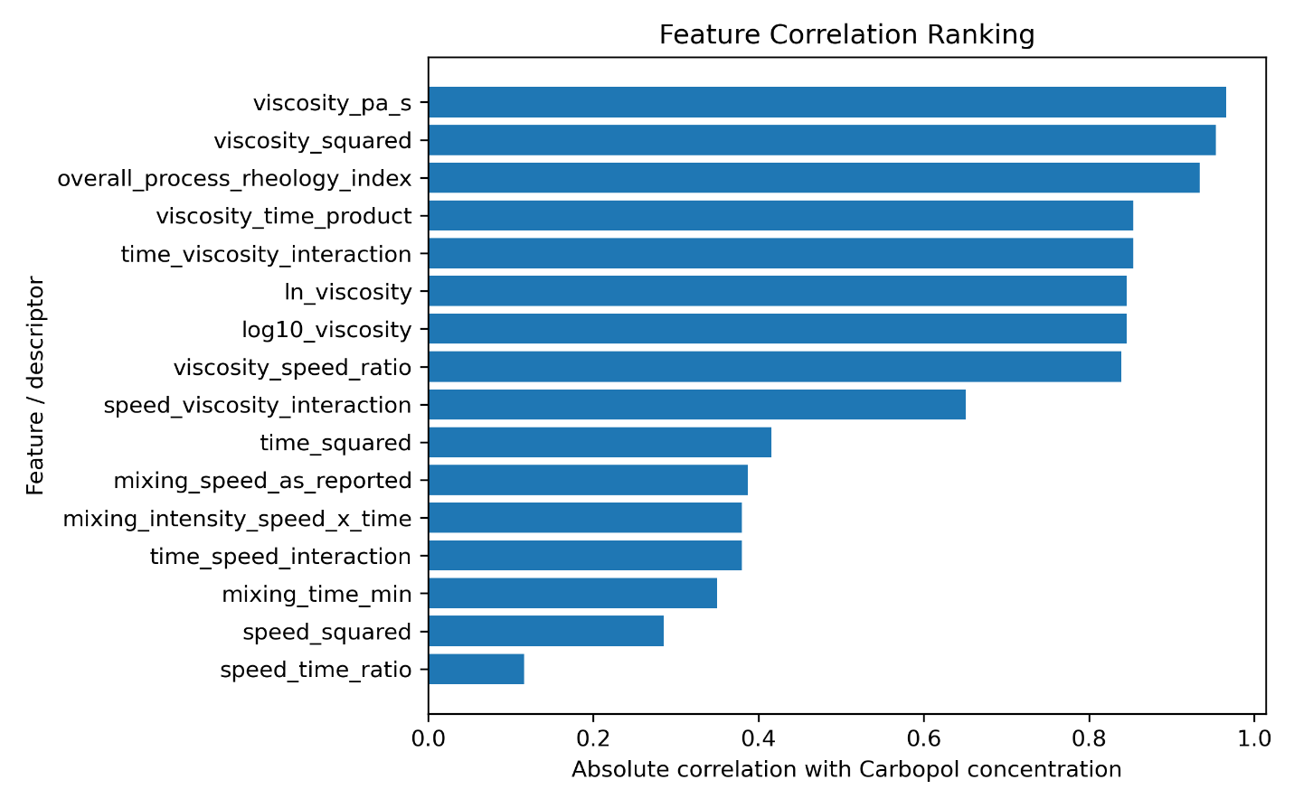

Supplementary Figure S2. Reported formulation comparison based on experimental, ANN-guided reference/target and ML-predicted viscosity values.
The figure compares viscosity values for the reported available emulgel formulations using experimentally measured viscosity, source-study ANN-guided reference/target viscosity and present ML-predicted viscosity. The comparison supports the formulation-wise error analysis presented in the main manuscript. Any figure label referring to “ANN” should be interpreted as the source-study ANN-guided reference/target viscosity value, not as a direct ANN-predicted viscosity output.

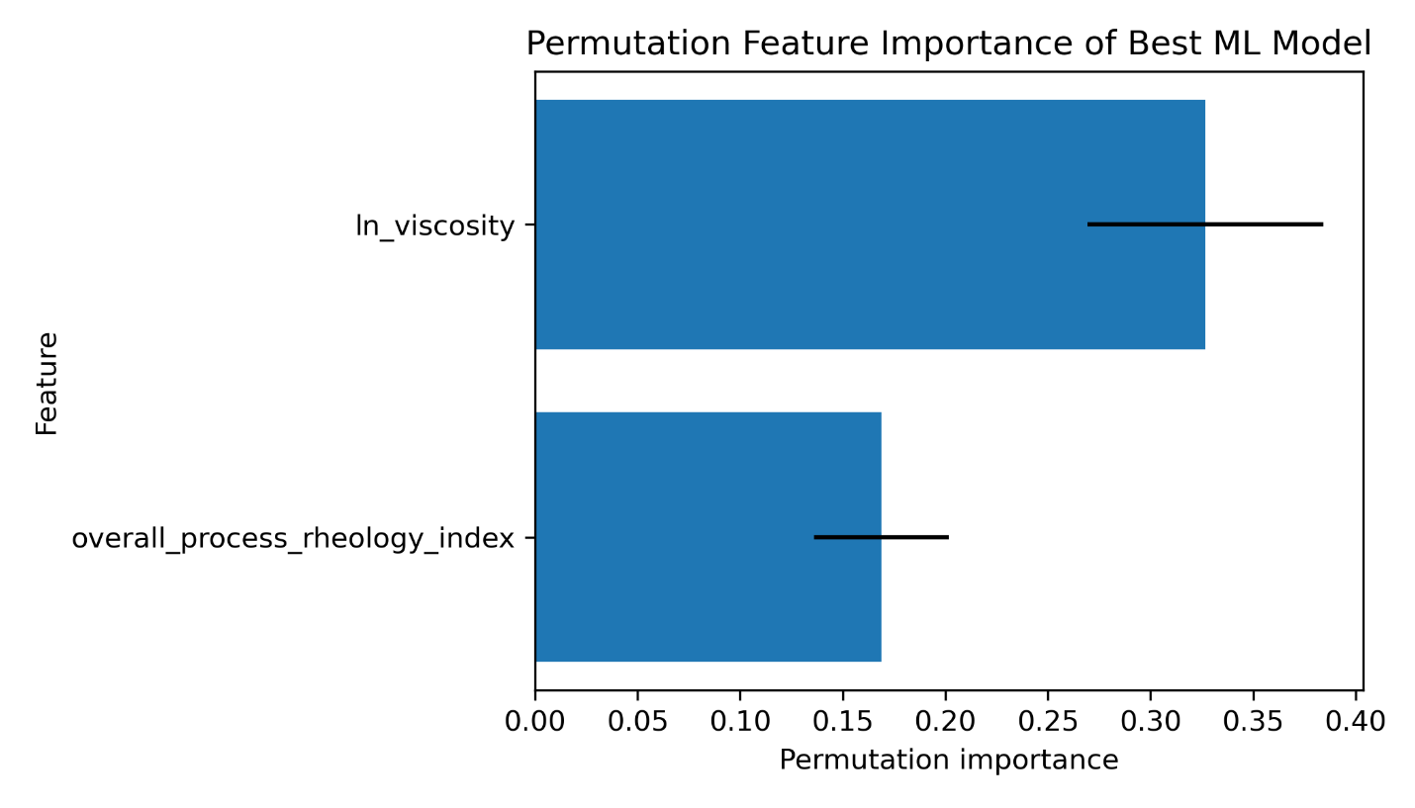

Supplementary Figure S3. Alternative visualization of reported-case viscosity prediction error.
The figure shows formulation-wise differences between experimentally measured viscosity and predicted or reference/target viscosity values for the reported available emulgel formulations. The largest deviation was observed for the low-viscosity Voltaren/Voltarem formulation, whereas closer agreement was observed for the medium- and high-viscosity formulations. Percentage error should be interpreted cautiously because low experimental viscosity values can inflate relative error.
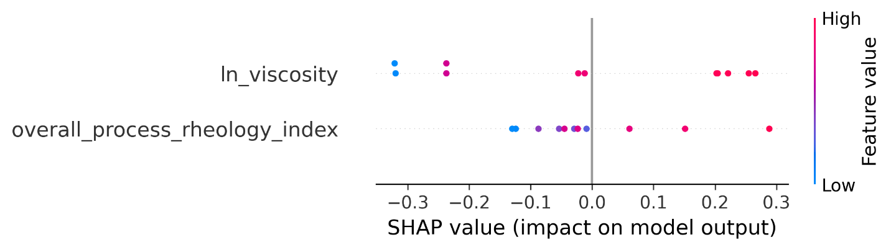
Supplementary Figure S4. Relationship between experimental Carbopol concentration and viscosity in the reconstructed dataset.
The figure illustrates the association between Carbopol concentration and experimentally measured viscosity across the reconstructed formulation dataset. The trend supports the dominant role of Carbopol concentration in governing viscosity and provides visual support for the inclusion of Carbopol and Carbopol² in the final forward viscosity-prediction model.
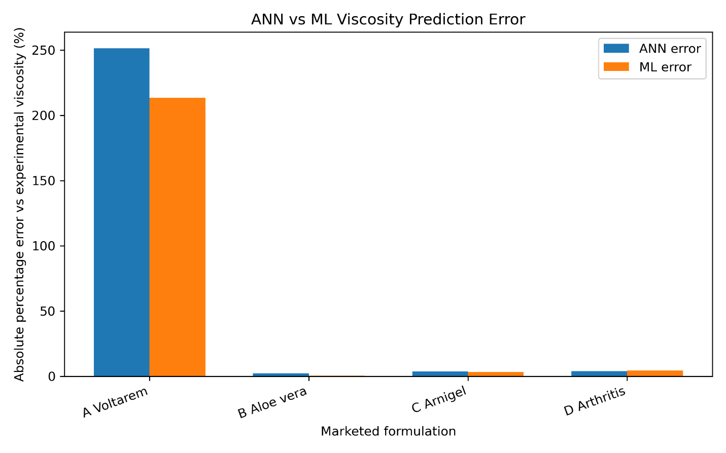

Supplementary Figure S5. Exploratory permutation-based predictor importance from the machine-learning workflow.
The figure presents permutation-based importance values generated during the exploratory modelling workflow. These values provide supportive information on predictor contribution but should not be interpreted as the primary basis for model explanation unless calculated specifically for the final forward viscosity model using the retained predictors. The main manuscript therefore relies on selected predictor structure and correlation-supported interpretation.
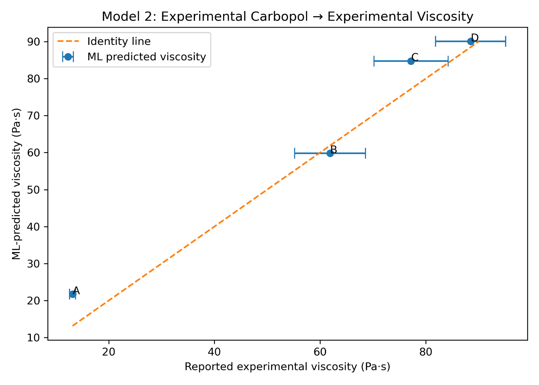

Supplementary Figure S6. Exploratory SHAP-based interpretation from the machine-learning workflow.
The figure presents SHAP-based exploratory interpretation generated during model analysis. SHAP values indicate how variables contributed to individual model outputs in the corresponding workflow. Because the final manuscript interpretation is based on the selected forward viscosity model and its retained predictors, this supplementary figure should be interpreted as supportive exploratory evidence rather than the primary explanation of the final model.
