Appendix
Appendix A: Pairwise Comparison of Total Language Performance Score Between Intervention Types
Table A1 Pairwise comparison of the difference in the total language performance score between intervention types (N = 75)
Group | Compared with | Mean difference (SE) | 95% CI | p value
Control | ChatGPT | −1.84 (0.43) | (−2.89, −0.79) | <0.001*
Control | Multimodal AI | −3.54 (0.43) | (−4.59, −2.49) | <0.001*
ChatGPT | Multimodal AI | −1.70 (0.43) | (−2.75, −0.65) | <0.001*
SE Standard error; CI Confidence interval; Bonferroni post hoc test; *Statistically significant at p < 0.05

Appendix B: Figures
Fig. 2 Difference between intervention types in the estimated marginal means (EMM) of the total language performance score across time
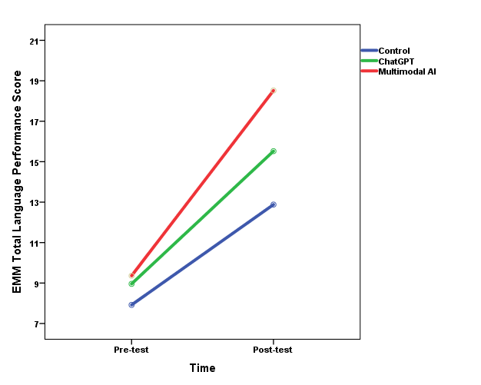
Figure 1 Difference between conditions in the estimated marginal means (EMM) of the total language performance score across time

Fig. 3 Difference between intervention types in the estimated marginal means (EMM) of heart rate across time

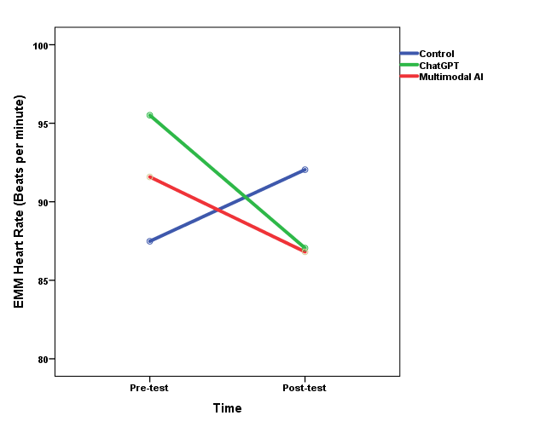
Figure 2 Difference between conditions in the estimated marginal means (EMM) of heart rate across time

Fig. 4 Difference between conditions in the estimated marginal means (EMM) of FLCAS across time
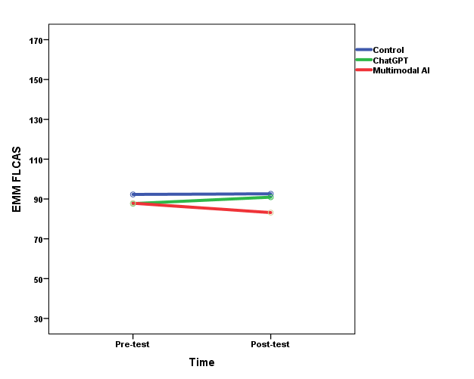
Figure 3 Difference between conditions in the estimated marginal means (EMM) of FLCAS across time

