Supplementary Figure S1. Exploratory subgroup meta-analysis of the accelerometer wear location (hip vs. wrist).
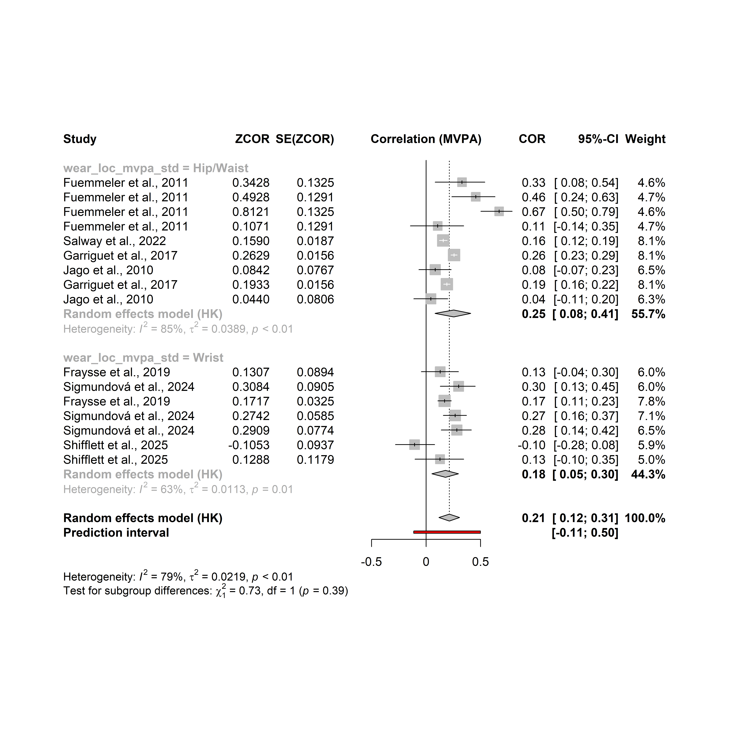

An exploratory subgroup meta-analysis examined whether location of wearing accelerometer (hip or wrist) influenced the pooled association between parents’ and children’s MVPA. Hip-worn protocols yielded a pooled correlation of r = 0.25 (95% CI 0.08-0.41; I² = 85%), whereas wrist-worn protocols showed a pooled correlation of r = 0.18 (95% CI 0.05-0.30; I² = 63%). The overall pooled estimate across all effects was r = 0.21 (95% CI 0.12-0.31; I² = 79%), with a prediction interval of -0.11 to 0.50, indicating substantial between-study variability. The difference between hip and wrist subgroups was not statistically significant (χ² = 0.73, df = 1, p = 0.39), suggesting no clear evidence that wear location moderates the parent-child MVPA association.

